Supplementary Figure 9. Case9 A) T2WI, B) T1WI, C) DWI, D) Evaluated the images of readers a–e.

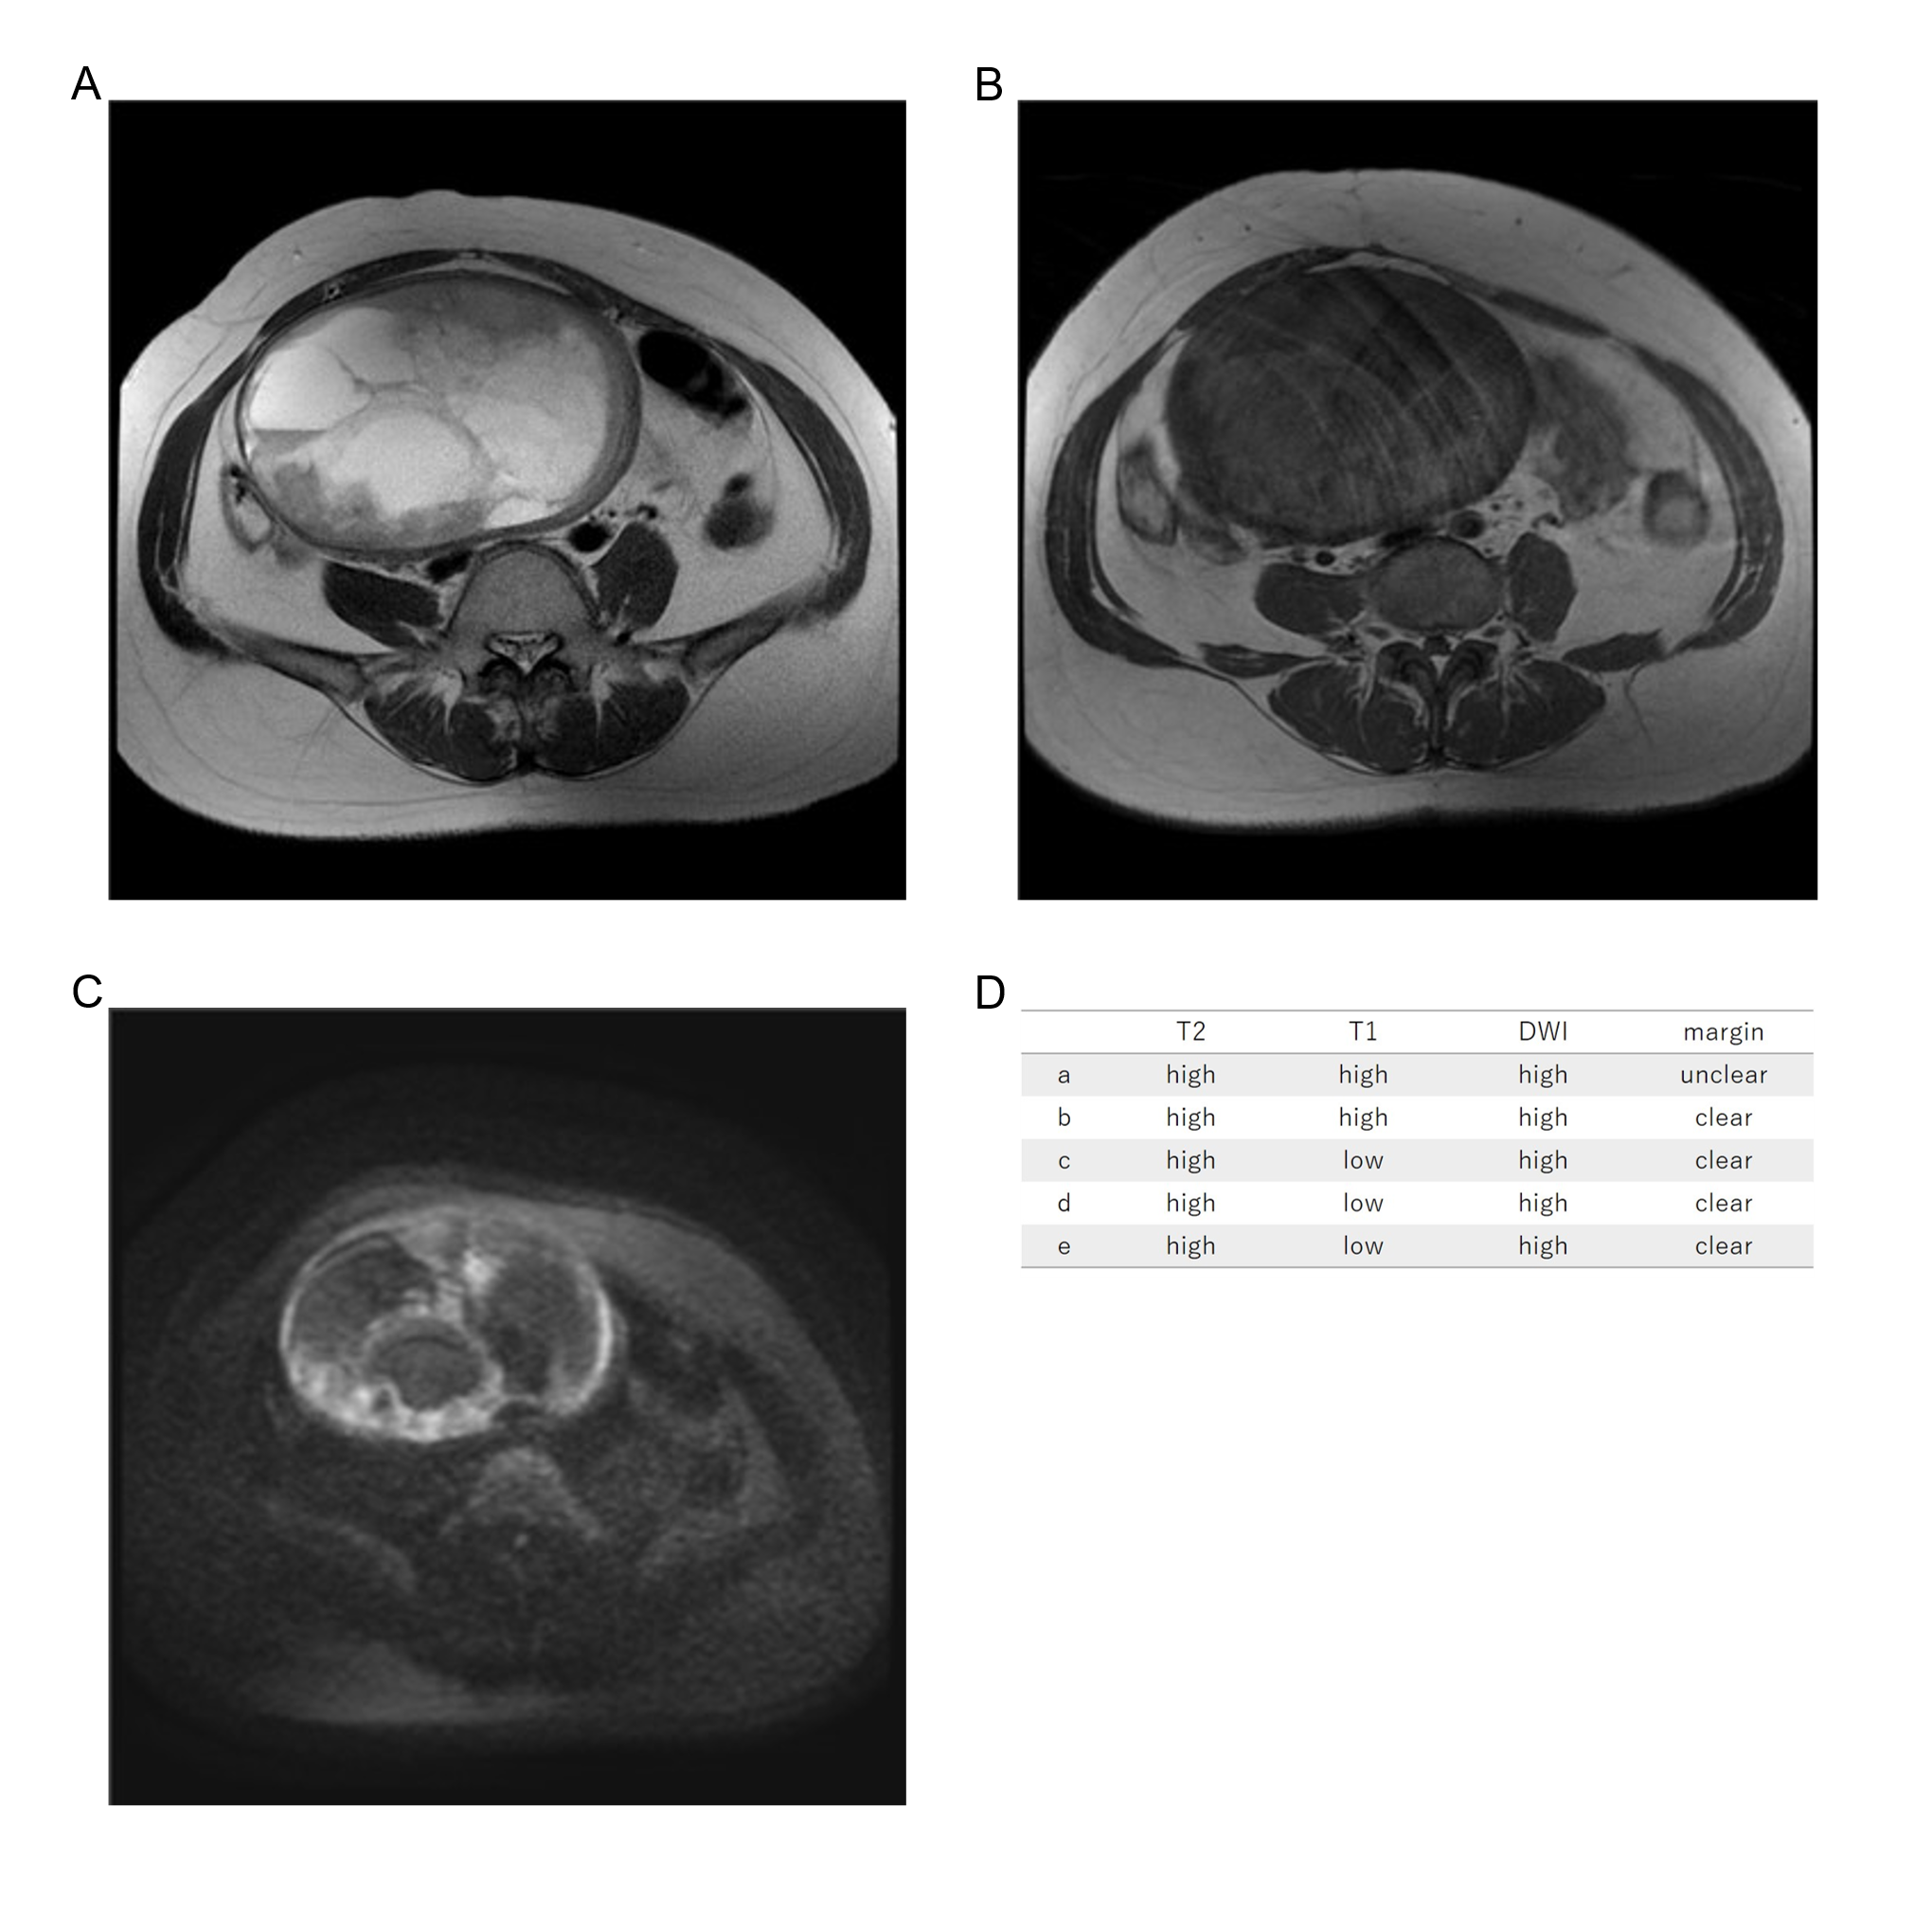
Forty-nine years old, leiomyosarcoma, high T2WI intensity, high T1WI intensity, high DWI intensity, clear margin, LDH 279IU/L.

