Supplementary Figure 10. Case10 A) T2WI, B) T1WI, C) DWI, D) Evaluated the images of readers a–e.

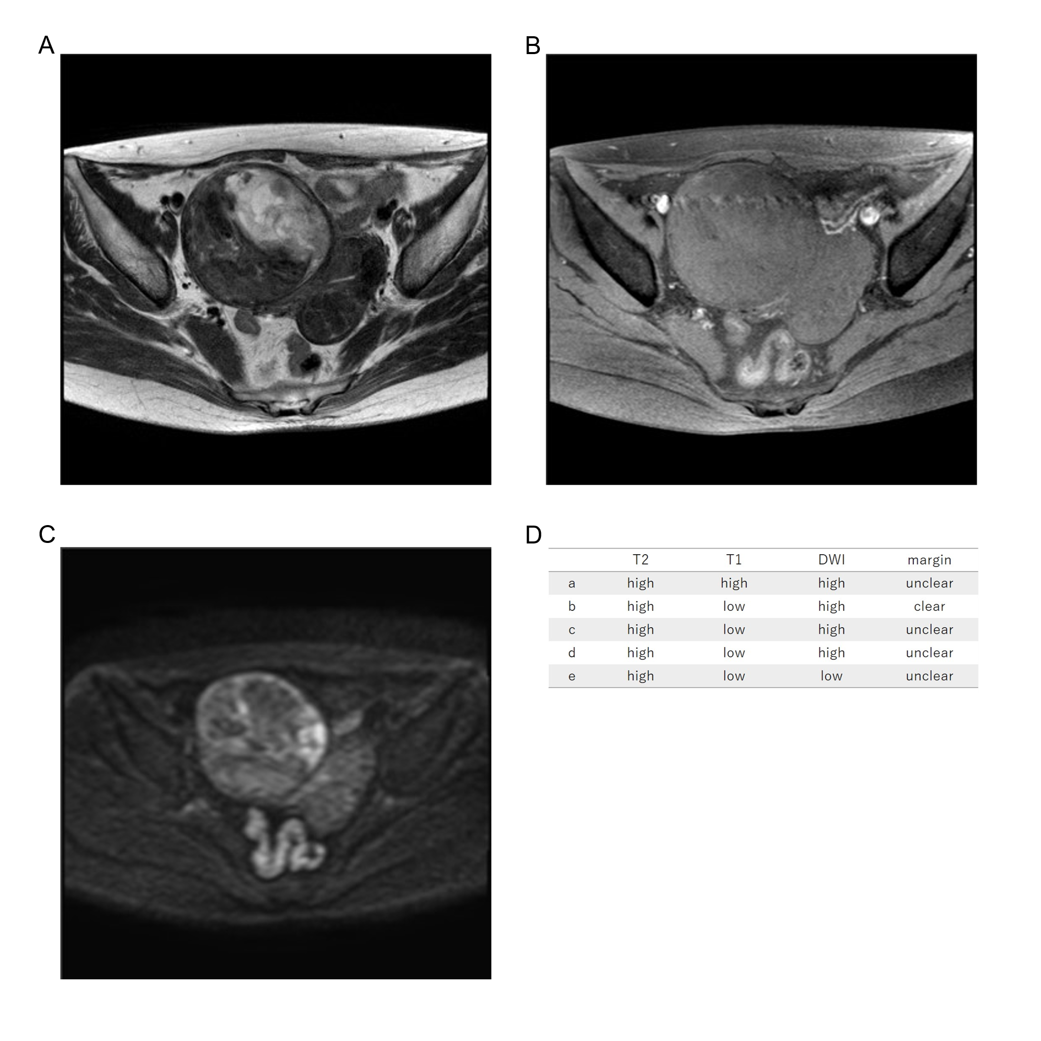
Fifty-nine years old, leiomyosarcoma, high T2WI intensity, low T1WI intensity, high DWI intensity, unclear margin, LDH 228IU/L.

