Supplementary Figure 26. Case26 A) T2WI, B) T1WI, C) DWI, D) Evaluated the images of readers a–e.

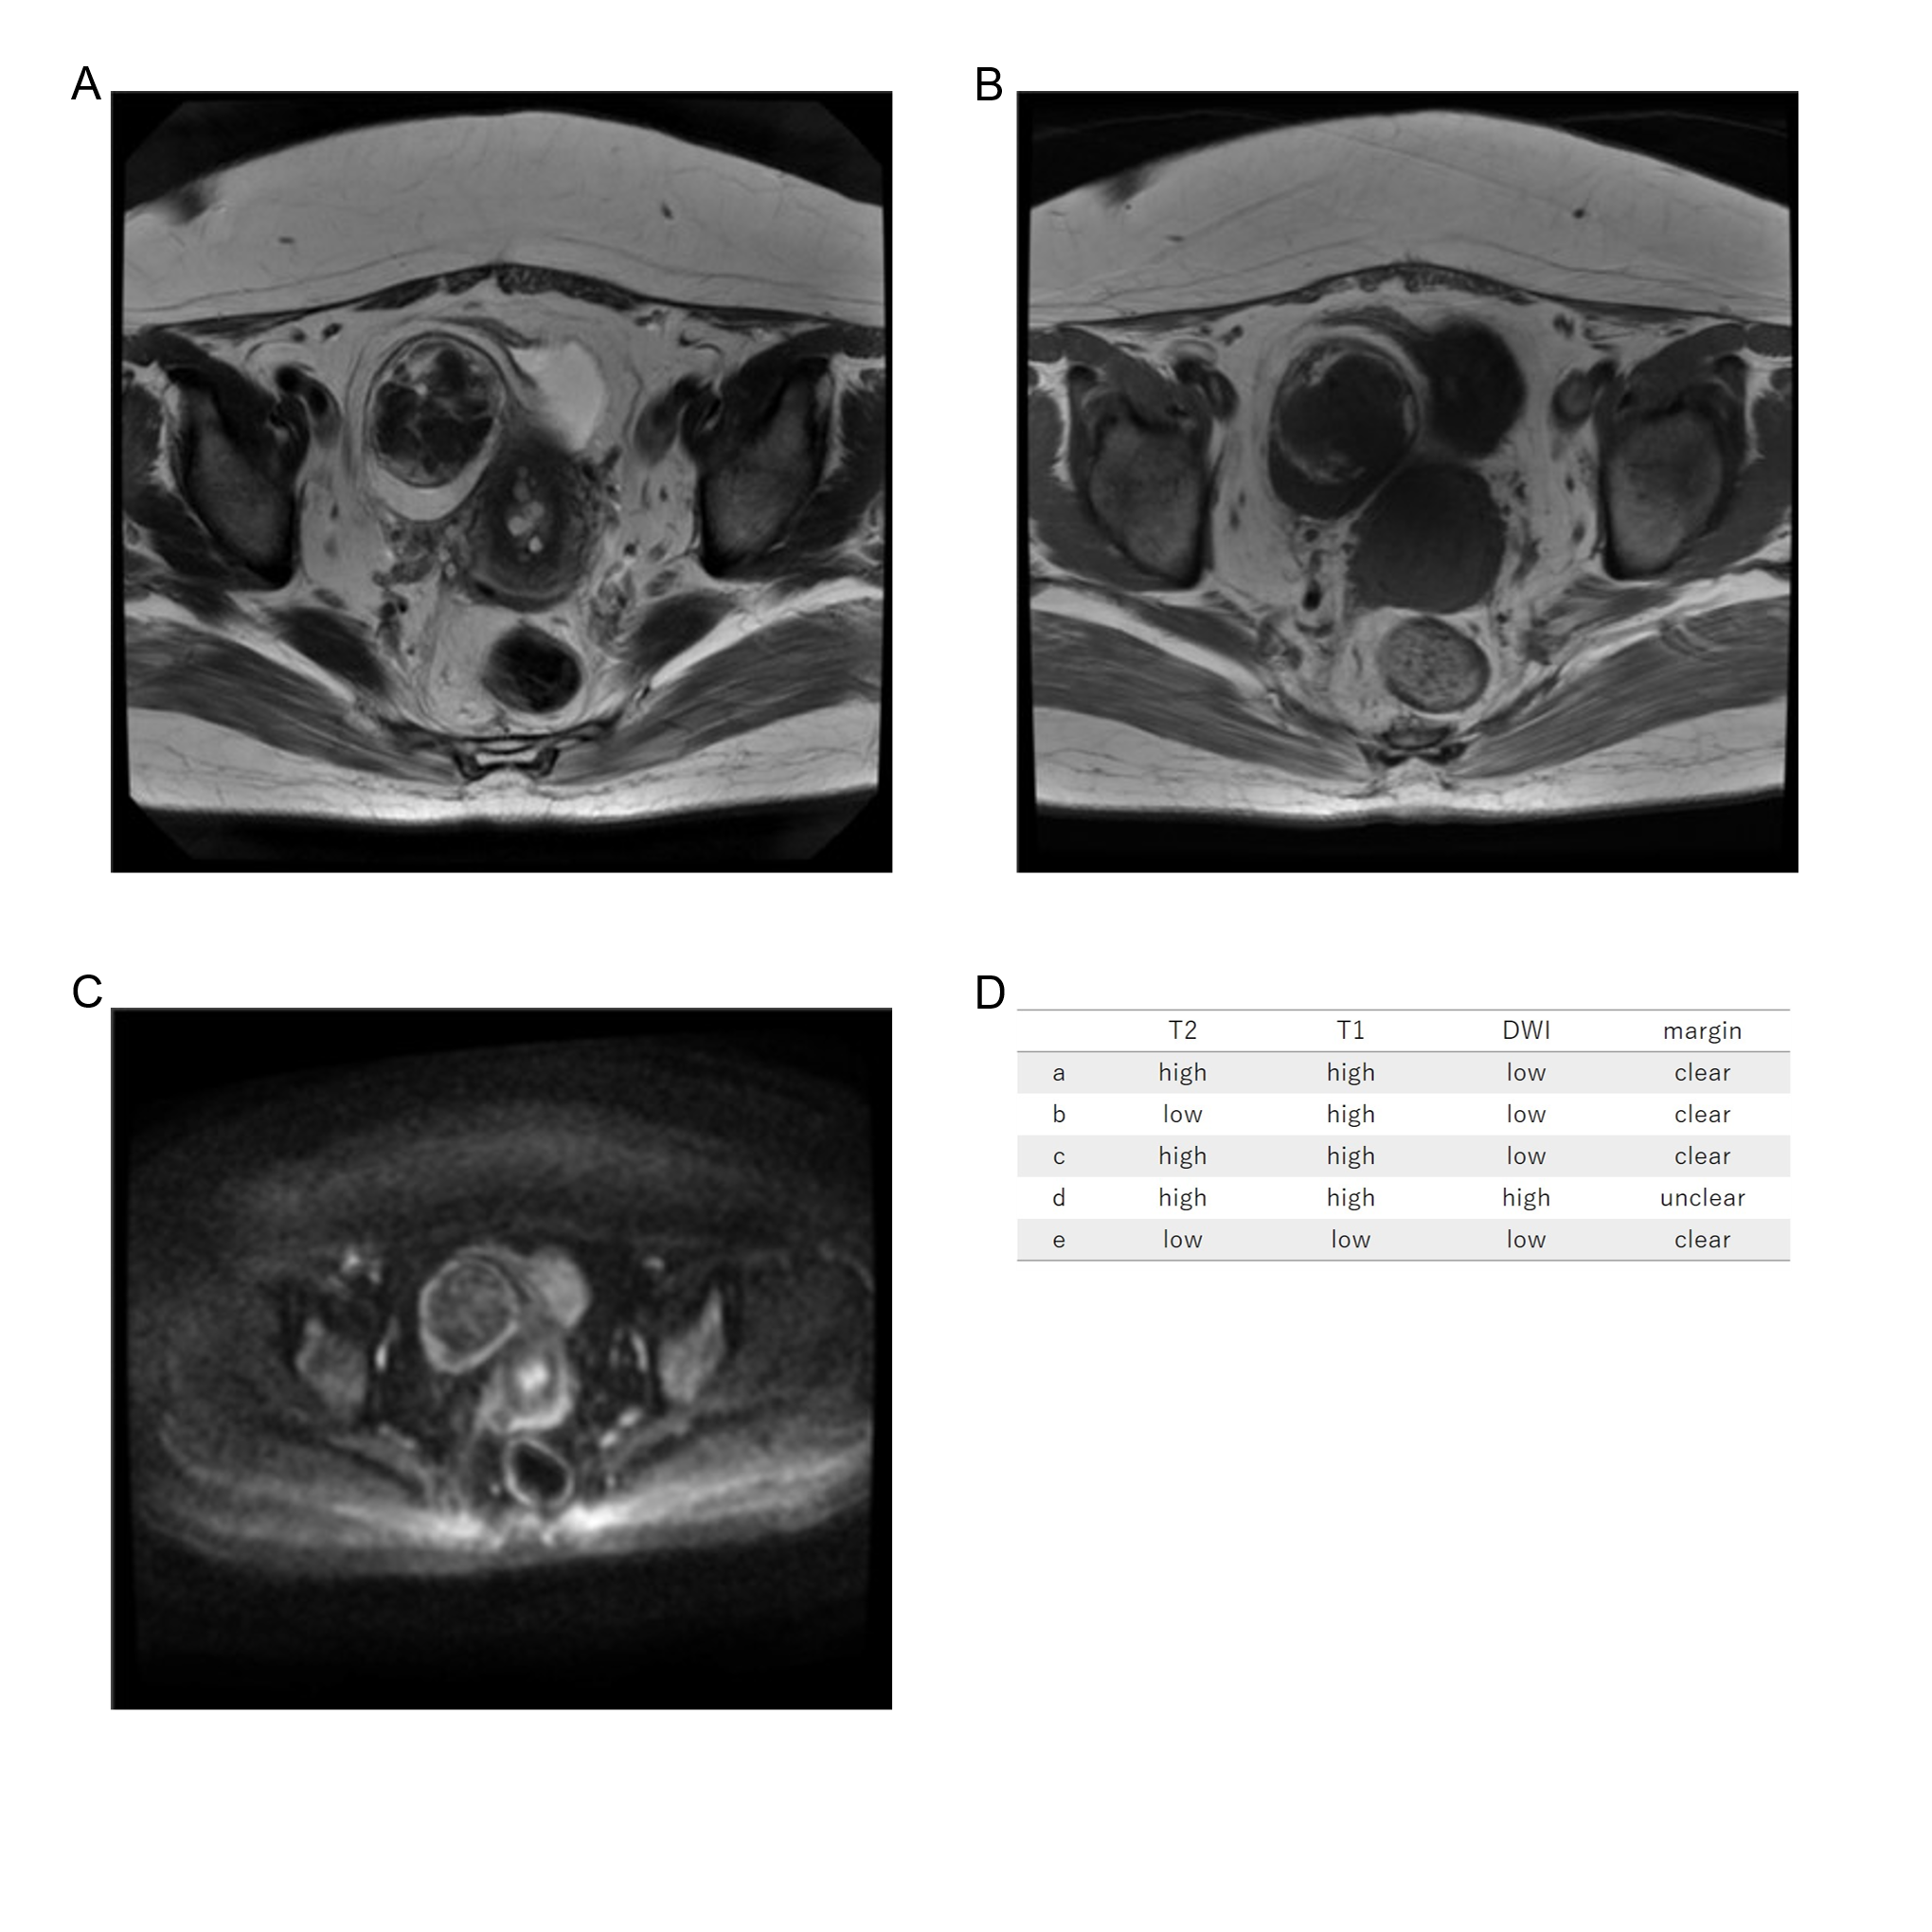
Fifty-seven years old, leiomyoma, high T2WI intensity, high T1WI intensity, low DWI intensity, clear margin, LDH 209IU/L. There is some lipomyoma component within the myoma, and the T2WI is high intensity if fat is included and low intensity if fat is excluded. We finally determined the T2WI to be high intensity.

