Supplementary Figure 45. Case45 A) T2WI, B) T1WI, C) DWI, D) Evaluated the images of readers a–e.

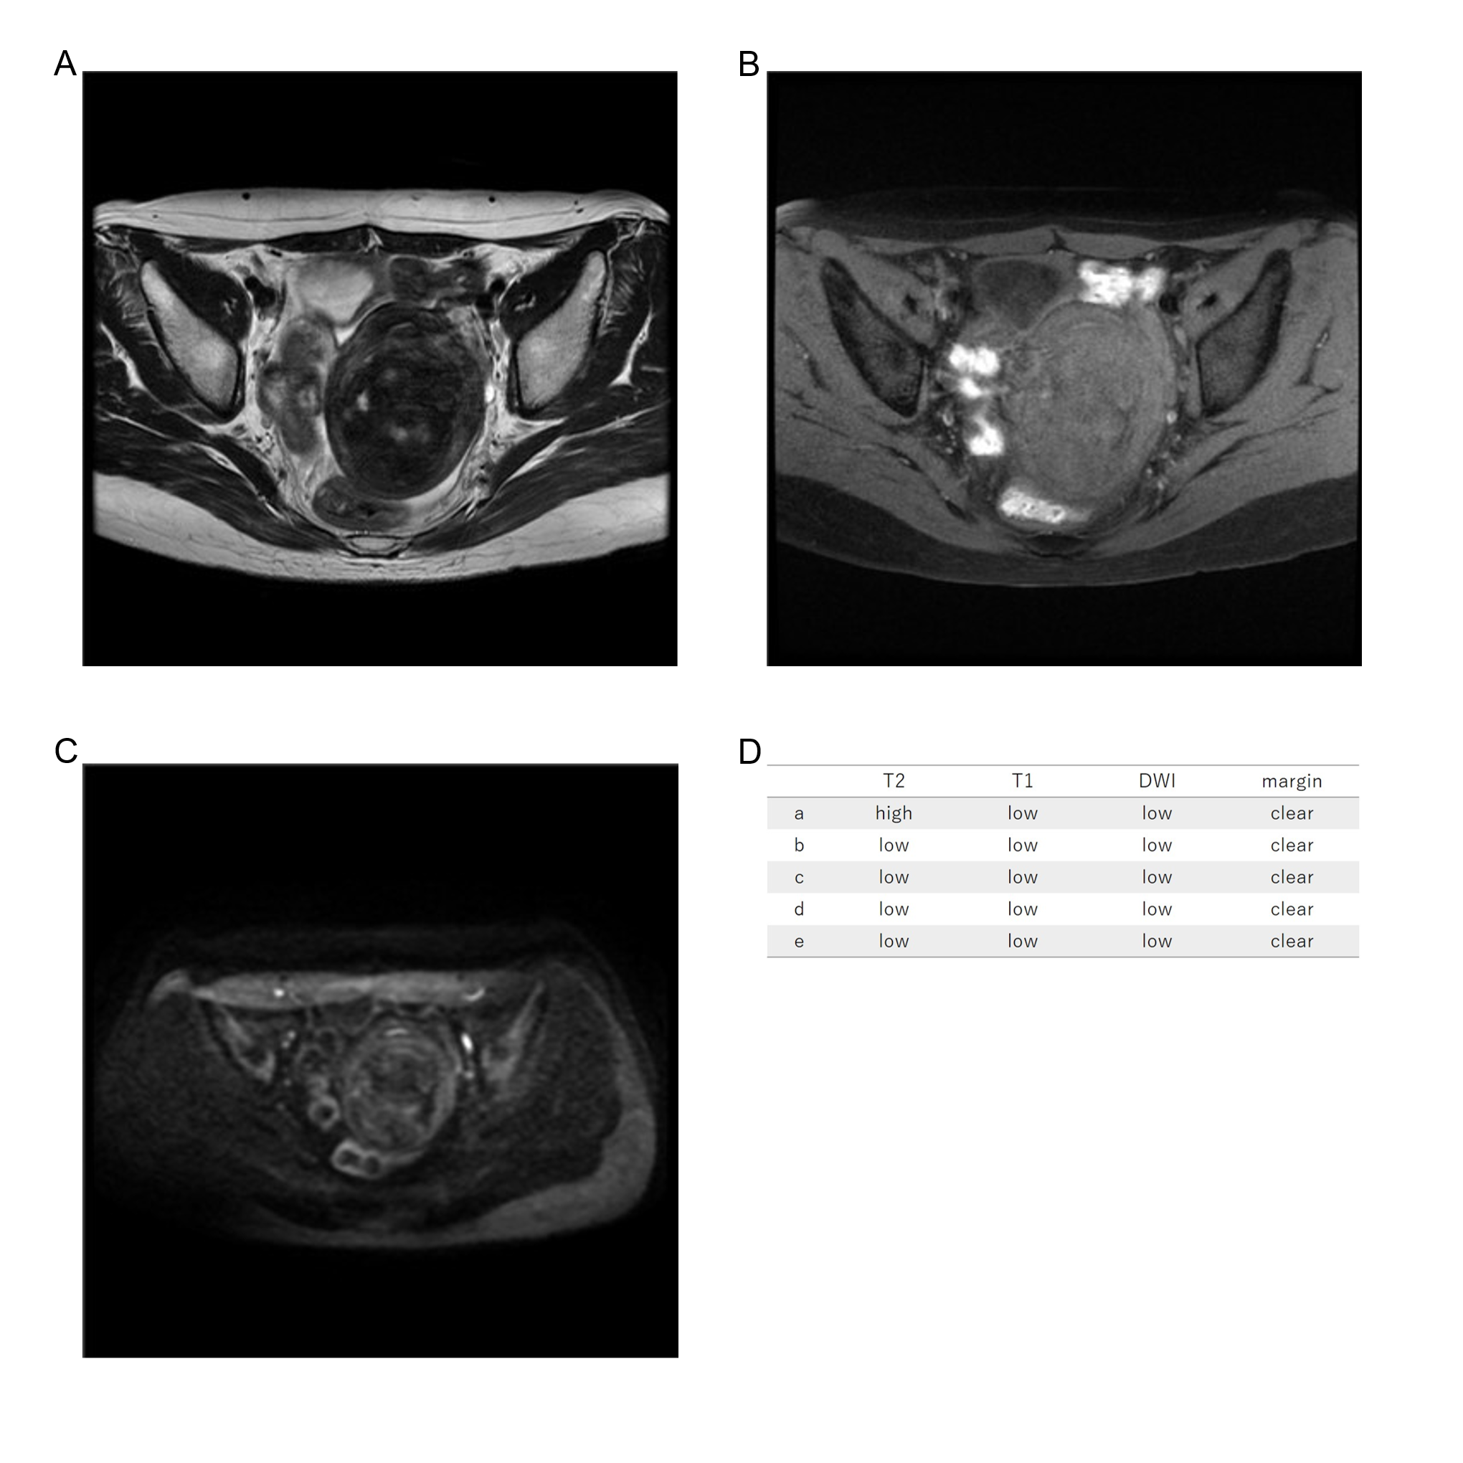
Forty-two years old leiomyoma, low T2WI intensity, low T1WI intensity, low DWI intensity, clear margin, LDH 148IU/L. We reviewed the images and determined that the T2WI was Oguchi3.

