Supplementary Figure 53. Case53 A) T2WI, B) T1WI, C) DWI, D) Evaluated the images of readers a–e.

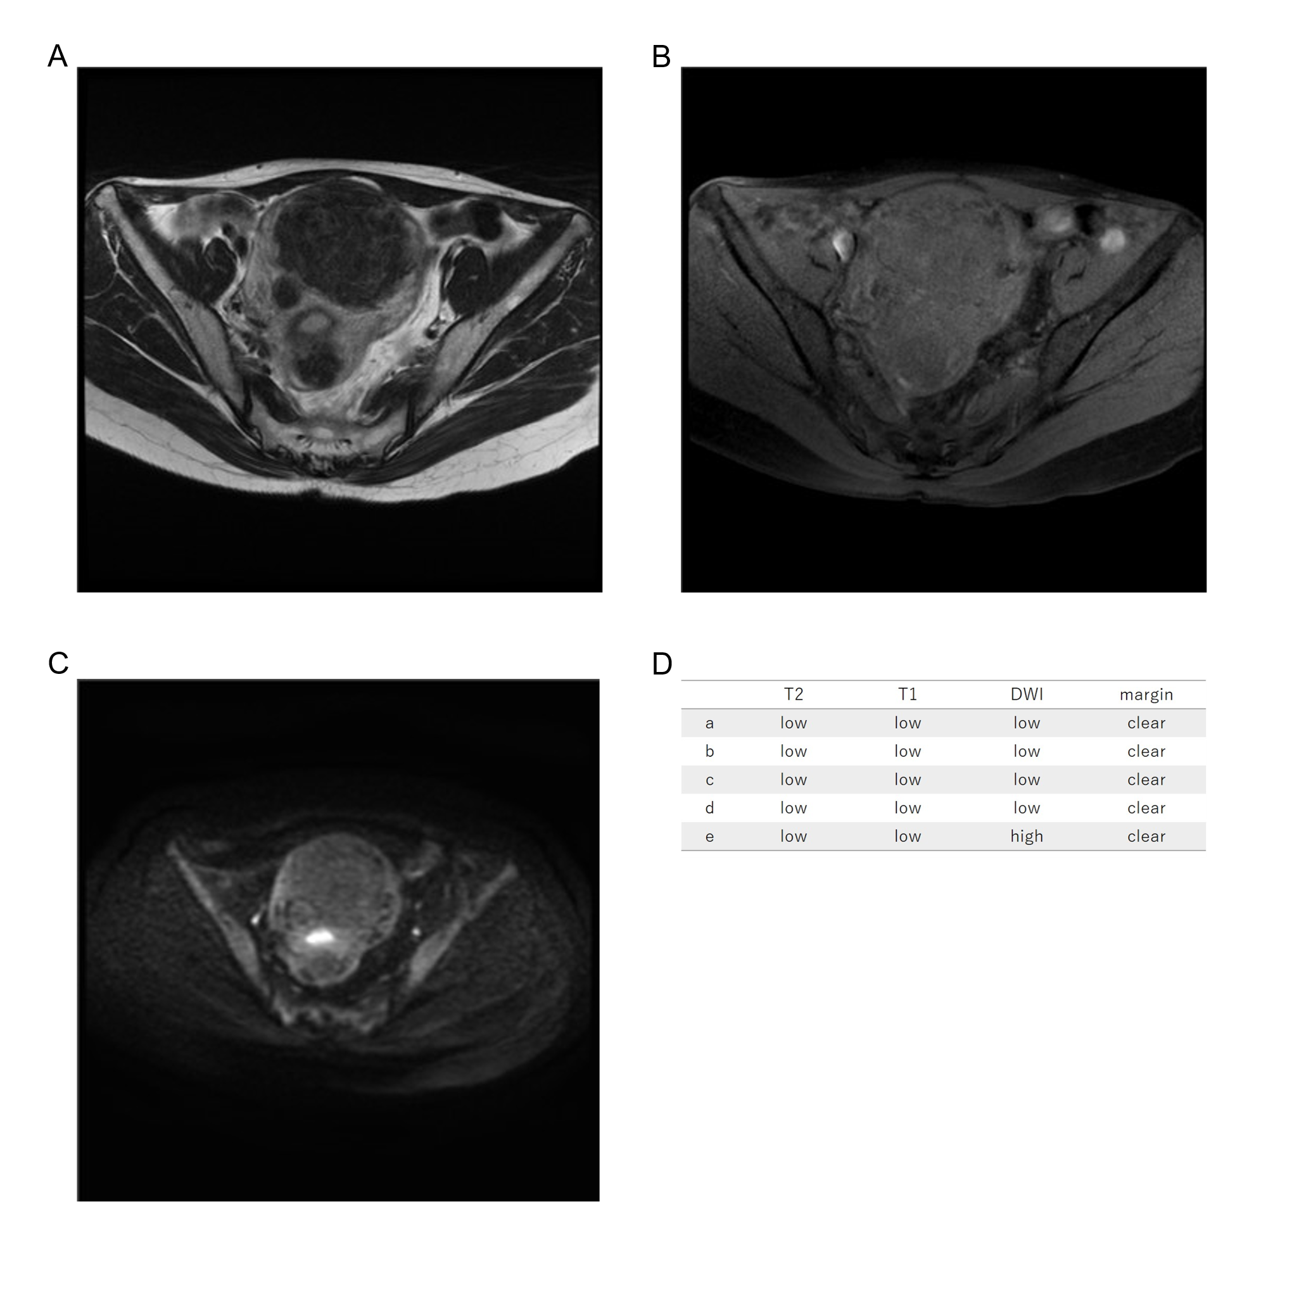
Thirty-nine years old, leiomyoma, low T2WI intensity, low T1WI intensity, low DWI intensity, clear margin, LDH 179IU/L.

