Supplementary Figure 8. Case8 A) T2WI, B) T1WI, C) DWI, D) Evaluated the images of readers a–e.

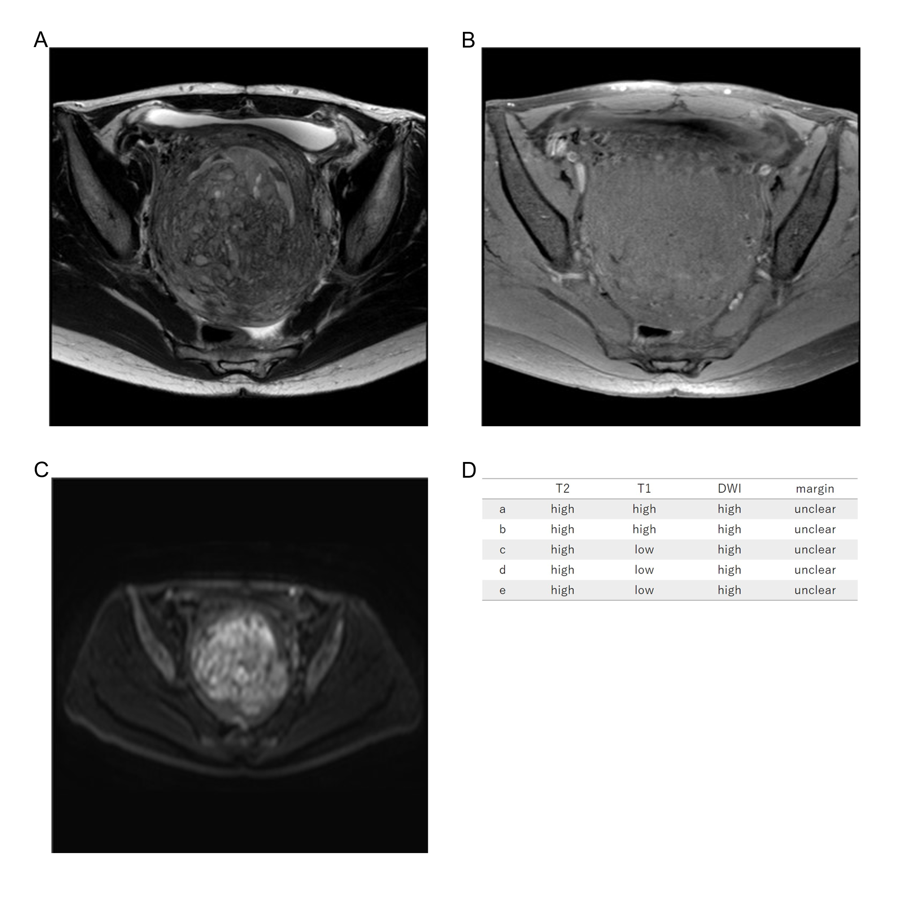
Forty-one years old, low grade ESS, high T2WI intensity, low T1WI intensity, high DWI intensity, unclear margin, LDH 157IU/L.

