Supplementary Materials
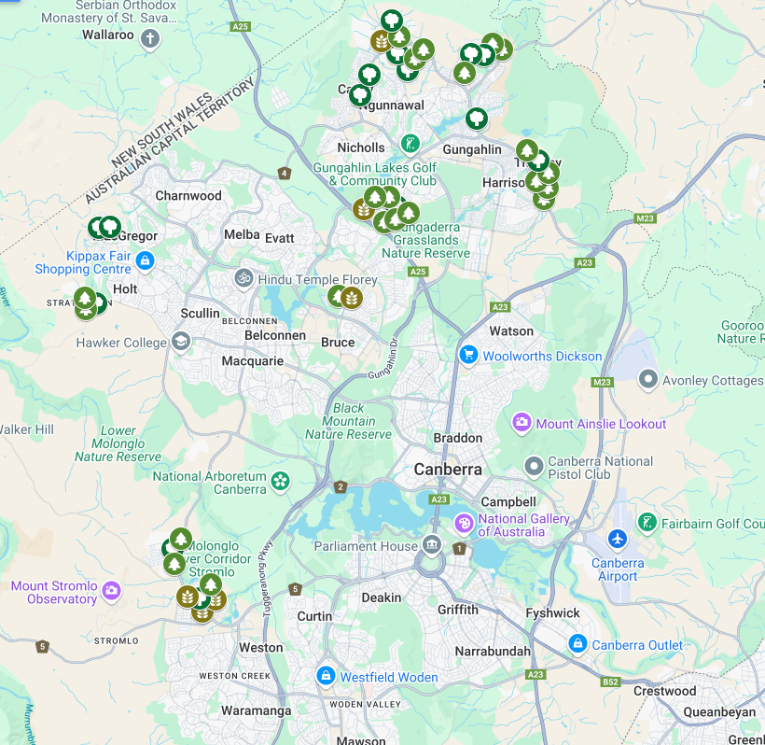

Figure S1. Site locations across the Australian Capital Territory (ACT) (Google 2025). Brown leaf symbols indicate sites with less than five mature trees (≥40cm DBH) present, green tree symbols indicate sites with approximately five to ten mature trees present, and dark green tree symbols indicate sites with over ten mature trees present.

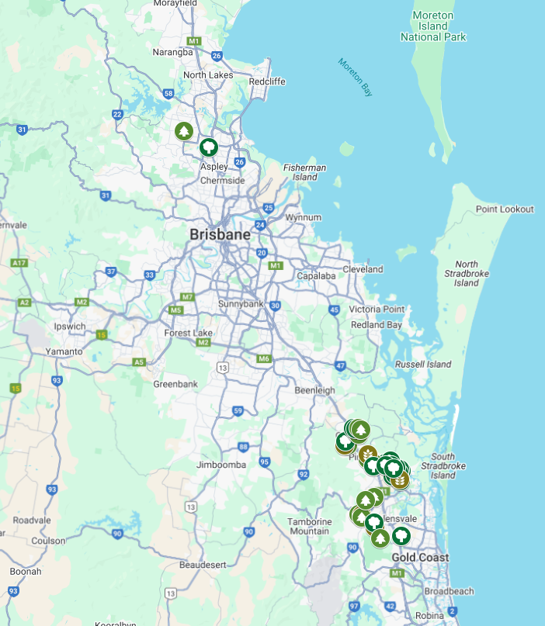

Figure S2. Site locations across South-East Queensland (SEQ) (Google 2025). Brown leaf symbols indicate sites with less than five mature trees (≥40cm DBH) present, green tree symbols indicate sites with approximately five to ten mature trees present, and dark green tree symbols indicate sites with over ten mature trees present.
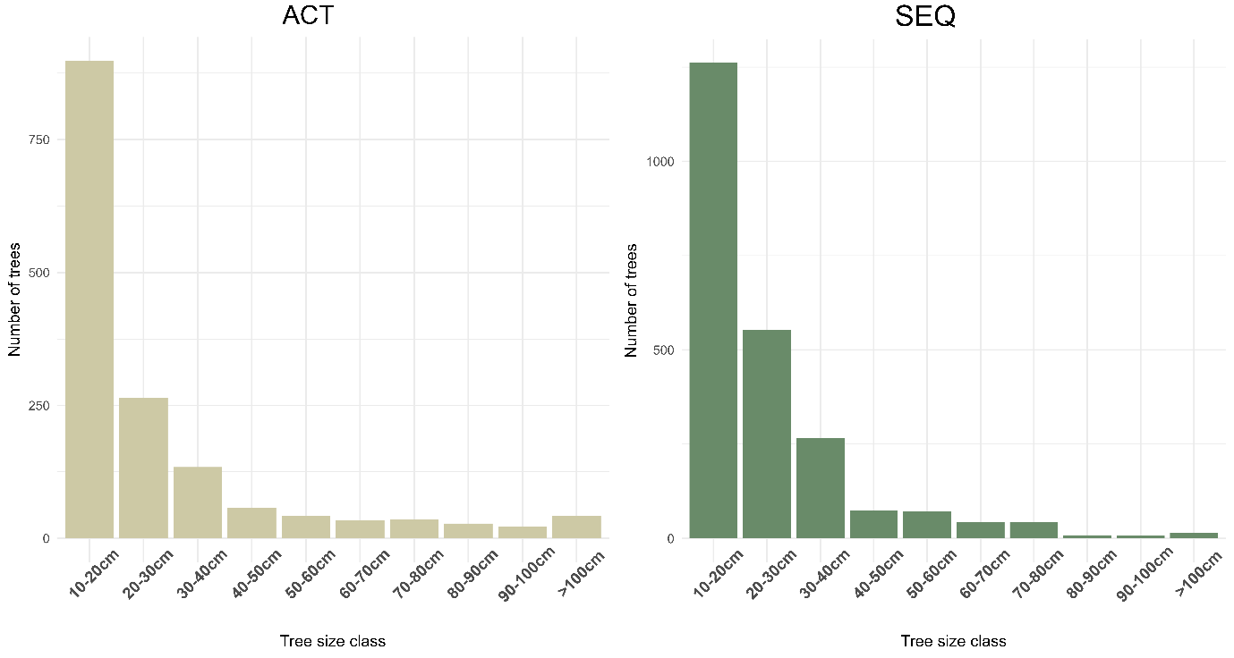

Figure S3. Frequency histograms of all trees in each region (ACT and SEQ). Tree sizes have been separated into bins of 10cm DBH.

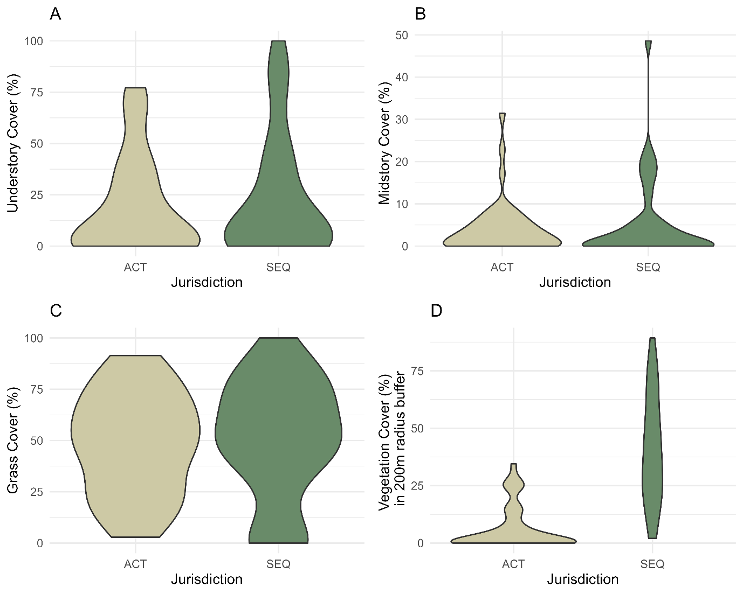

Figure S4. Violin plots indicating the distribution of site data according to region (ACT and SEQ). The width of the ‘violins’ indicate the proportion of sites with the corresponding y-value. All plots display the two regions sampled on the x-axis with the range of each habitat variable presented on the y-axis. A) Understorey cover (%); B) Midstorey cover (%); C) Grass cover (%) and D) Vegetation cover (woody vegetation) (%) within a 200m radius of each site.

Table S1. All models tested for multi-species occupancy modelling, for ACT.
Tree Size Class | Model results
Tree Size Class | k-foldIC | Δk-foldIC
≥70cm DBH | 1796.307 | 0.00
≥60cm DBH | 1803.768 | 7.461
≥80cm DBH | 1808.341 | 12.034
≥50cm DBH | 1810.784 | 14.477
≥40cm DBH | 1820.13 | 23.823
≥90cm DBH | 1823.73 | 27.423
≥100cm DBH | 1837.434 | 41.127

Table S2. Posterior predictive checks for each species included in the multispecies occupancy models. Bayesian P-values are given for each species for each region they were modelled in. Bayesian P-values > 0.05 indicated an adequate fit.
Bird species | Bayesian P-value
Bird species | ACT | SEQ
Australasian Figbird |  | 0.3717
Australian Magpie | 0.3667 | 0.4041
Australian Raven | 0.227
Common Myna | 0.3483 | 0.3852
Common Starling | 0.8807
Crested Pigeon | 0.4504 | 0.3207
Crimson Rosella | 0.5285
Eastern Rosella | 0.5172
Galah | 0.6385
Grey Butcherbird |  | 0.3591
House Sparrow | 0.7878
Magpie Lark | 0.1776 | 0.3441
Masked Lapwing |  | 0.3683
Noisy Miner | 0.2856 | 0.5759
Rainbow Lorikeet |  | 0.4939
Red Wattlebird | 0.4519
Red-rumped Parrot | 0.66
Scaly-breasted Lorikeet |  | 0.6472
Striated Pardalote | 0.6898
Sulphur-crested Cockatoo | 0.6828 | 0.5044
Superb Fairy-wren | 0.4183
Torresian Crow |  | 0.3957
Welcome Swallow | 0.37 | 0.6043

Table S3. The range, mean and standard error (SE) for each habitat covariate, measured per site. Values shown for both regions calculated separately.
Variable | Range |  | Mean (± se)
Variable | ACT | SEQ | ACT | SEQ
Total no. trees | 1 – 282 | 1 – 237 | 36.19 ± 7.22 | 58.6 ± 8.42
No. trees ≥40cm | 0 – 28 | 0 – 18 | 6.05 ± 1.07 | 6.58 ± 0.79
No. trees ≥50cm | 0 – 18 | 0 – 13 | 4.72 ± 0.76 | 4.73 ± 0.61
No. trees ≥60cm | 0 – 13 | 0 – 11 | 3.74 ± 0.56 | 2.93 ± 0.44
No. trees ≥70cm | 0 – 10 | 0 – 8 | 2.95 ± 0.44 | 1.85 ± 0.31
No. trees ≥80cm | 0 – 8 | 0 – 3 | 2.14 ± 0.31 | 0.78 ± 0.15
No. trees ≥90cm | 0 – 6 | 0 – 3 | 1.49 ± 0.24 | 0.55 ± 0.13
No. trees ≥100cm | 0 – 4 | 0 – 3 | 0.98 ± 0.18 | 0.38 ± 0.11
Community weighted mean DBH | 5.5 – 48.8 | 5.36 – 35.16 | 16.36 ± 1.13 | 15.05 ± 1.11
% Grass cover | 2.86 – 91.43 | 0.00 – 100 | 48.24 ± 3.81 | 50.07 ± 4.67
% Leaf litter cover | 0.00 – 74.29 | 0.00 – 54.29 | 19.34 ± 2.64 | 17.64 ± 2.23
% Understorey cover | 0.00 – 77.14 | 0.00 – 100 | 18.80 ± 3.65 | 23.14 ± 4.68
% Midstorey cover | 0.00 – 31.43 | 0.00 – 48.57 | 4.12 ± 0.97 | 5.36 ± 1.53
% Hard surface cover | 0.00 – 74.29 | 0.00 – 34.29 | 14.02 ± 2.38 | 9.43 ± 1.68
% Tree cover within 200 m radius of site | 0.00 – 34.52 | 2.03 – 89.34 | 6.39 ± 1.47 | 40.75 ± 3.72

Table S4. All bird species observed during this study.
Scientific Name | Common Name | Hollow dependent? | Presence (Percentage of Sites) |  | Pooled abundance
Scientific Name | Common Name | Hollow dependent? | SEQ | ACT | SEQ | ACT
Sphecotheres vieilloti | Australasian Figbird | NA | 52.5 | 0.0 | 154 | 0
Alectura lathami | Australian Brush-turkey | NA | 2.5 | 0.0 | 1 | 0
Alisterus scapularis | Australian King Parrot | Hollow dependent | 0.0 | 20.9 | 0 | 13
Gymnorhina tibicen | Australian Magpie | NA | 80.0 | 83.7 | 103 | 154
Corvus coronoides | Australian Raven | NA | 0.0 | 25.6 | 0 | 23
Acrocephalus australis | Australian Reed-Warbler | NA | 0.0 | 2.3 | 0 | 4
Threskiornis molucca | Australian White Ibis | NA | 2.5 | 4.7 | 15 | 6
Chenonetta jubata | Australian Wood Duck | Hollow dependent | 12.5 | 16.3 | 18 | 20
Geopelia humeralis | Bar-shouldered Dove | NA | 7.5 | 0.0 | 5 | 0
Coracina novaehollandiae | Black-faced Cuckoo-shrike | NA | 0.0 | 4.7 | 0 | 7
Elanus axillaris | Black-shouldered Kite | NA | 0.0 | 2.3 | 0 | 1
Entomyzon cyanotis | Blue-faced Honeyeater | NA | 12.5 | 0.0 | 9 | 0
Gerygone mouki | Brown Gerygone | NA | 0.0 | 4.7 | 0 | 14
Lichmera indistincta | Brown Honeyeater | NA | 22.5 | 0.0 | 21 | 0
Acanthiza pusilla | Brown Thornbill | NA | 0.0 | 11.6 | 0 | 12
Climacteris picumnus | Brown Treecreeper | Hollow dependent | 0.0 | 2.3 | 0 | 6
Phaps chalcoptera | Common Bronzewing | NA | 0.0 | 2.3 | 0 | 1
Edolisoma tenuirostre | Common Cicadabird | NA | 2.5 | 0.0 | 1 | 0
Acridotheres tristis | Common Myna (I) | Hollow dependent | 45.0 | 48.8 | 66 | 80
Sturnus vulgaris | Common Starling (I) | Hollow dependent | 0.0 | 81.4 | 0 | 123
Ocyphaps lophotes | Crested Pigeon | NA | 35.0 | 60.5 | 40 | 65
Platycercus elegans | Crimson Rosella | Hollow dependent | 0.0 | 76.7 | 0 | 127
Strizoptera bichenovii | Double-barred Finch | NA | 2.5 | 0.0 | 1 | 0
Gallinula tenebrosa | Dusky Moorhen | NA | 0.0 | 4.7 | 0 | 2
Eudynamys orientalis | Eastern Koel | NA | 2.5 | 2.3 | 1 | 1
Platycercus eximius | Eastern Rosella | Hollow dependent | 0.0 | 72.1 | 0 | 184
Fulica atra | Eurasian Coot | NA | 2.5 | 2.3 | 1 | 2
Alauda arvensis | Eurasian Skylark (I) | NA | 0.0 | 4.7 | 0 | 2
Carduelis carduelis | European Goldfinch (I) | NA | 0.0 | 7.0 | 0 | 6
Petrochelidon ariel | Fairy Martin | NA | 0.0 | 2.3 | 0 | 5
Eolophus roseicapilla | Galah | Hollow dependent | 7.5 | 79.1 | 8 | 114
Cracticus torquatus | Grey Butcherbird | NA | 32.5 | 2.3 | 38 | 1
Anas gracilis | Grey Teal | Hollow dependent | 2.5 | 0.0 | 2 | 0
Passer domesticus | House Sparrow | NA | 0.0 | 34.9 | 0 | 75
Microeca fascinans | Jacky Winter | NA | 0.0 | 2.3 | 0 | 3
Dacelo novaeguineae | Laughing Kookaburra | Hollow dependent | 2.5 | 0.0 | 1 | 0
Meliphaga lewinii | Lewin's Honeyeater | NA | 2.5 | 0.0 | 1 | 0
Cacatua saguinea | Little Corella | Hollow dependent | 17.5 | 2.3 | 81 | 2
Philemon citreogularis | Little Friarbird | NA | 7.5 | 9.3 | 4 | 4
Anthochaera chrysoptera | Little Wattlebird | NA | 0.0 | 2.3 | 0 | 1
Grallina cyanoleuca | Magpie-lark | NA | 22.5 | 62.8 | 19 | 88
Vanellus miles | Masked Lapwing | NA | 35.0 | 7.0 | 37 | 6
Dicaeum hirundinaceum | Mistletoebird | NA | 0.0 | 2.3 | 0 | 1
Philemon corniculatus | Noisy Friarbird | NA | 27.5 | 20.9 | 20 | 27
Manorina melanocephala | Noisy Miner | NA | 90.0 | 65.1 | 386 | 193
Oriolus sagittatus | Olive-backed Oriole | NA | 2.5 | 0.0 | 2 | 0
Eurystomus orientalis | Oriental Dollarbird | Hollow dependent | 12.5 | 0.0 | 10 | 0
Anas superciliosa | Pacific Black Duck | Hollow dependent | 2.5 | 2.3 | 1 | 2
Platycercus adscitus | Pale-headed Rosella | Hollow dependent | 22.5 | 0.0 | 13 | 0
Cacomantis pallidus | Pallid Cuckoo | NA | 0.0 | 2.3 | 0 | 1
Geopelia placida | Peaceful Dove | NA | 0.0 | 2.3 | 0 | 1
Centropus phasianinus | Pheasant Coucal | NA | 2.5 | 0.0 | 1 | 0
Cracticus nigrogularis | Pied Butcherbird | NA | 17.5 | 0.0 | 11 | 0
Strepera graculina | Pied Currawong | NA | 10.0 | 16.3 | 4 | 19
Porphyrio melanotus | Purple Swamphen | NA | 5.0 | 2.3 | 5 | 1
Merops ornatus | Rainbow Bee-eater | NA | 2.5 | 0.0 | 2 | 0
Trichoglossus moluccanus | Rainbow Lorikeet | Hollow dependent | 72.5 | 11.6 | 233 | 22
Anthochaera carunculata | Red Wattlebird | NA | 0.0 | 62.8 | 0 | 83
Psephotus haematonotus | Red-Rumped Parrot | Hollow dependent | 0.0 | 76.7 | 0 | 205
Columba livia | Rock Dove (I) | NA | 0.0 | 14.0 | 0 | 33
Pachycephala rufiventris | Rufous Whistler | NA | 0.0 | 4.7 | 0 | 3
Todiramphus sanctus | Sacred Kingfisher | Hollow dependent | 10.0 | 2.3 | 5 | 1
Trichoglossus chlorolepidotus | Scaly-breasted Lorikeet | Hollow dependent | 27.5 | 0.0 | 52 | 0
Zosterops lateralis | Silvereye | NA | 2.5 | 11.6 | 1 | 12
Spilopelia chinensis | Spotted Dove (I) | NA | 17.5 | 0.0 | 14 | 0
Pardalotus striatus | Striated Pardalote | Hollow dependent | 0.0 | 2.3 | 7 | 52
Plectorhyncha lanceolata | Striped Honeyeater | NA | 12.5 | 34.9 | 4 | 0
Cacatua galerita | Sulphur-crested Cockatoo | Hollow dependent | 2.5 | 0.0 | 31 | 86
Malurus cyaneus | Superb Fairy-wren | NA | 22.5 | 58.1 | 4 | 50
Polytelis swainsonii | Superb Parrot | Hollow dependent | 0.0 | 20.9 | 0 | 20
Corvus orru | Torresian Crow | NA | 35.0 | 9.3 | 30 | 0
Petrochelidon nigricans | Tree Martin | Hollow dependent | 0.0 | 0.0 | 0 | 1
Smicrornis brevirostris | Weebill | NA | 0.0 | 2.3 | 0 | 10
Hirundo neoxena | Welcome Swallow | NA | 40.0 | 9.3 | 61 | 38
Sericornis frontalis | White-browed Scrubwren | NA | 0.0 | 44.2 | 0 | 5
Epthianura albifrons | White-fronted Chat | NA | 0.0 | 9.3 | 0 | 8
Columba leucomela | White-headed Pigeon | NA | 0.0 | 4.7 | 0 | 4
Melithreptus lunatus | White-naped Honeyeater | NA | 0.0 | 2.3 | 0 | 4
Ptilotula penicillata | White-plumed Honeyeater | NA | 0.0 | 7.0 | 0 | 1
Rhipidura leucophrys | Willie Wagtail | NA | 20.0 | 2.3 | 20 | 7
Caligavis chrysops | Yellow-faced Honeyeater | NA | 0.0 | 11.6 | 0 | 48
Acanthiza chrysorrhoa | Yellow-rumped Thornbill | NA | 0.0 | 16.3 | 0 | 6
(I) indicates introduced species

