Supplementary information
Table S1 List of primers used in this study.
Primer | Sequence（5'→3')
M14A | CACTGATTACCGCAGCAACCGGTTA
Y18A | GCAACCGGTGCAGTTGGTCCGGCAC
14-18R | CCAGGCATGCACTATCCAGGCGACC
V100A | GTGCATGCCTGGCAACCGGCCTGAT
T101A | GCATGCCTGGTGGCAGGCCTGATTG
L103A | GCCTGGTGACCGGCGCAATTGTTAC
I104A | GGTGACCGGCCTGGCAGTTACCGGCAAA
100-104R | CCACTGCGCGAACAATACCATTGGC
T151A | GTGTGTTGTGTTTGCAAGTGCCACCGG
151R | GGAACCTGGGCTTCAATCATTGCGC
T195A | GCAATTGGTGCAAATTATATGGATTTCCCG
N196A | GCAATTGGTACCGCATATATGGATTTCCCG
F200A | CCAATTATATGGATGCACCGGGCTTTCT
F203A | GATTTCCCGGGCGCACTGAAAGCAAG
195-203R | GAAAACGATTACTACCATCCAGCAGGCC

Table S2 Alanine-scanning mutagenesis of wild-type IcHheG with 1a. ª
Variants | Relative activity(%) | Substrate ee(%) | Product ee(%)
IcHheG | 83 | 53 | 18(S)
M14A | 26 | 3 | 16(S)
Y18A | 0
V100A | 0
T101A | 0
L103A | 99 | 0 | 0
I104A | 0
T151A | 0
T195A | 22 | 0 | 39(R)
N196A | 0
F200A | 0
F203A | 0
ª Reactions were carried out in 1 mL Tris-SO₄ buffer (50 mM, pH 7.5) containing E. coli (IcHheG) wet cells (50 g/L), 1% v/v DMSO, 1a (10 mM) and NaOCN (15 mM) at 30 °C, 200 rpm for 3 h. The activity of WT-IcHheG towards 1a was defined as 100%.

Table S3 Relative activity and stereoselectivity of IcHheG and single mutants towards 1a. ª
Variant | Relative activity(%) | Substrate ee(%) | Product ee(%)
WT | 83 | 53 | 18(S)
L103S | 100 | 0 | 0
L103G | 87 | 8 | 7(S)
L103Q | 98 | 35 | 3(S)
L103E | 99 | 0 | 0
L103T | 97 | 0 | 0
L103W | 98 | 0 | 0
L103K | 98 | 53 | 7(S)
L103D | 99 | 0 | 0
L103R | 74 | 10 | 11(S)
L103V | 96 | 60 | 7(S)
L103Y | 88 | 51 | 7(S)
L103M | 92 | 30 | 7(S)
L103N | 97 | 44 | 4(S)
L103H | 97 | 0 | 0
L103F | 14 | 0 | 29(S)
L103I | 47 | 17 | 26(S)
L103C | 99 | 0 | 0
L103A | 99 | 0 | 0
I104M | 35 | 13 | 27(R)
I104L | 77 | 6 | 6(S)
I104Y | 67 | 22 | 23(S)
I104C | 58 | 70 | 72(R)
I104H | 24 | 4 | 25(S)
I104F | 33 | 16 | 85(R)
N196M | 90 | 60 | 23(S)
N196G | 47 | 10 | 18(R)
N196C | 88 | >99 | 16(S)
N196F | 27 | 12 | 57(S)
N196H | 52 | 35 | 44(S)
N196L | 41 | 20 | 32(S)
N196W | 40 | 62 | 67(R)
ª Reactions were carried out in 1 mL Tris-SO₄ buffer (50 mM, pH 7.5) containing E. coli (IcHheG) wet cells (50 g/L), 1% v/v DMSO, 1a (10 mM) and NaOCN (15 mM) at 30 °C, 200 rpm for 3 h.

Table S4 Relative activity and stereoselectivity of IcHheG and single mutants towards 1a. ª
Variant | Relative activity(%) | Substrate ee(%) | Product ee(%)
WT | 83 | 53 | 18 (S)
V100A/N196W | 4 | 3 | 100 (R)
V100L/N196W | 4 | 7 | 100 (R)
V100M/N196W | 5 | 7 | 56 (R)
V100G/N196W | 17 | 29 | 92 (R)
V100Q/N196W | 4 | 7 | 100 (R)
V100Y/N196W | 10 | 14 | 96 (R)
L103A/N196W | 58 | 87 | 84 (R)
L103C/N196W | 55 | 23 | 88 (R)
L103D/N196W | 55 | 82 | 85 (R)
L103E/N196W | 60 | 81 | 92 (R)
L103G/N196W | 47 | 56 | 88 (R)
L103H/N196W | 37 | 80 | 95 (R)
L103I/N196W | 8 | ND | ND
L103M/N196W | 69 | 26 | 92 (R)
L103N/N196W | 25 | 18 | 88 (R)
L103Q/N196W | 61 | 76 | 85 (R)
L103V/N196W | 45 | 43 | 93 (R)
L103Y/N196W | 40 | 45 | 85 (R)
I104F/N196W | 26 | 30 | 85 (R)
I104W/N196W | 10 | 7 | 67 (R)
I104Y/N196W | 7 | ND | ND
ND, not detected.
ª Reactions were carried out in 1 mL Tris-SO₄ buffer (50 mM, pH 7.5) containing E. coli (IcHheG) wet cells (50 g/L), 1% v/v DMSO, 1a (10 mM) and NaOCN (15 mM) at 30 °C, 200 rpm for 3 h.

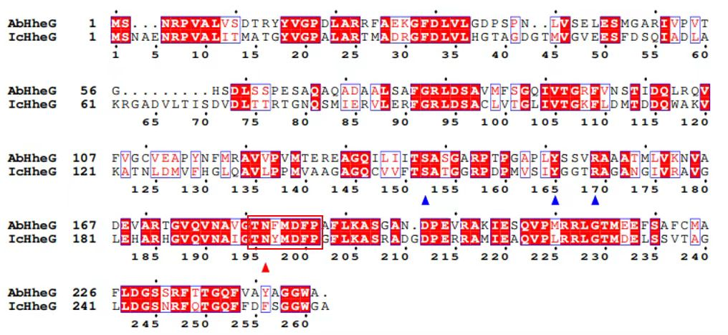
Fig. S1 Protein sequence alignment of IcHheG and AbHheG. The catalytic triad are marked by blue triangles.

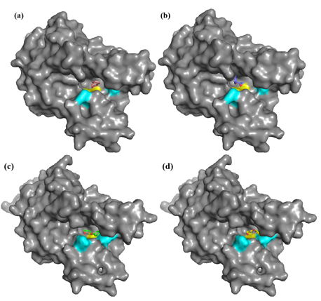
Fig. S2 Docking results of IcHheG and mutant L103H/N196W with PGE (blue: residues 103 and 196; yellow: catalytic triad; a, b: WT-IcHheG with (R)- and (S)-substrates; c, d: mutant L103H/N196W with (R)- and (S)-substrates)

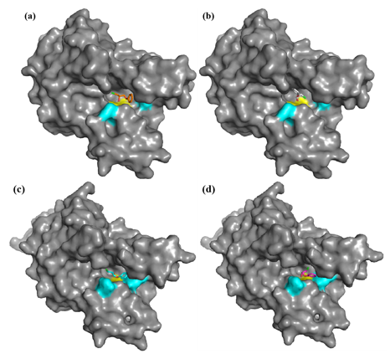
Fig. S3 Docking results of IcHheG and mutant L103H/N196W with 1-chloro-3-phenoxy-2-propanol (blue: residues 103 and 196; yellow: catalytic triad; a, b: WT-IcHheG with (R)- and (S)-substrates; c, d: mutant L103H/N196W with (R)- and (S)-substrates)

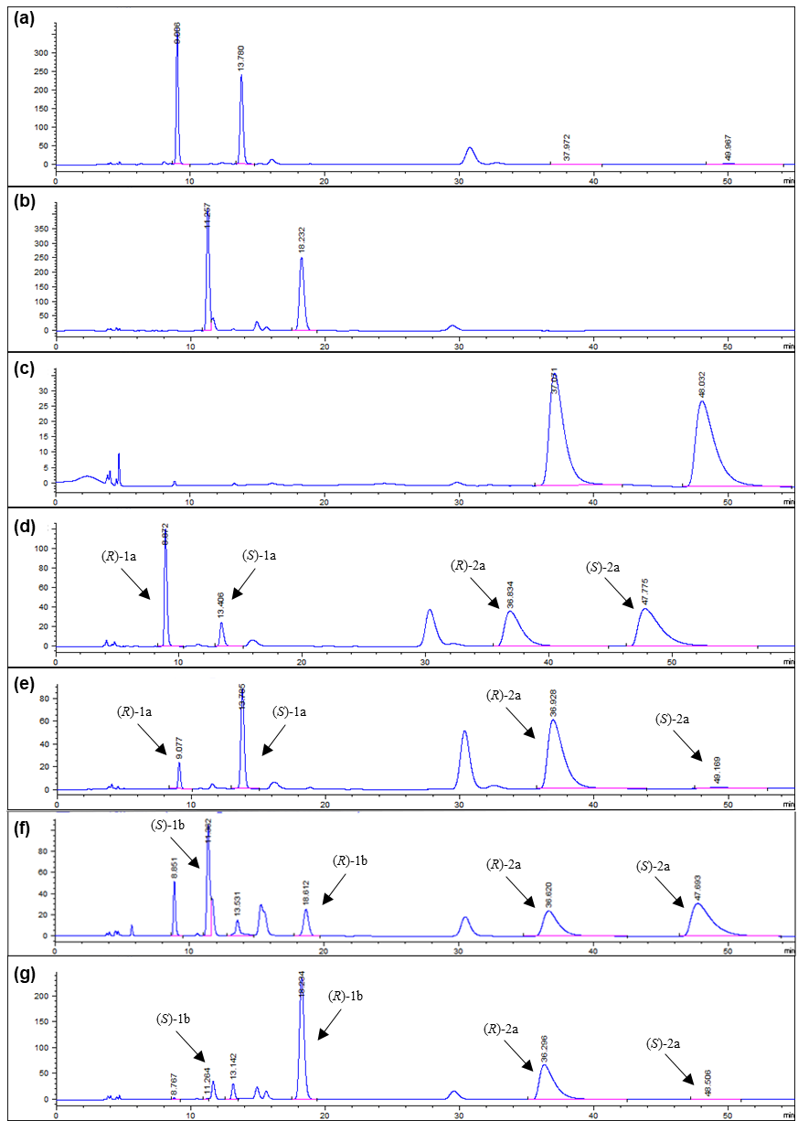
Fig. S4 Chiral HPLC chromatograms of (R, S)-PGE (a); Chiral HPLC chromatograms of (R, S)-1-chloro-3-phenoxy-2-propanol (b); Chiral HPLC chromatograms of (R, S)-5-Phenoxymethyl-2-Oxazolidinone (c); Chiral HPLC chromatogram analysis of biotransformation of (R, S)-PGE by WT-IcHheG (d); Chiral HPLC chromatogram analysis of biotransformation of (R, S)-PGE by mutant L103H/N196W (e); Chiral HPLC chromatogram analysis of biotransformation of (R, S)-1-chloro-3-phenoxy-2-propanol by WT-IcHheG (f); Chiral HPLC chromatogram analysis of biotransformation of (R, S)-1-chloro-3-phenoxy-2-propanol by mutant L103H/N196W(g).

