Supporting information

Pt/TiO₂ Catalyzed Hydrogenation of Benzoic Acid with Unprecedented High Activity
Miao Guo,¹ Xiangtao Kong,² Chunzhi Li,^{1,3} Qihua Yang^{1*}
¹ State Key Laboratory of Catalysis, Dalian Institute of Chemical Physics, Chinese Academy of Sciences, Dalian 116023, China.
² College of Chemistry and Chemical Engineering, Anyang Normal University, Anyang 455000, China.
³ University of Chinese Academy of Sciences, Beijing 100039, China.

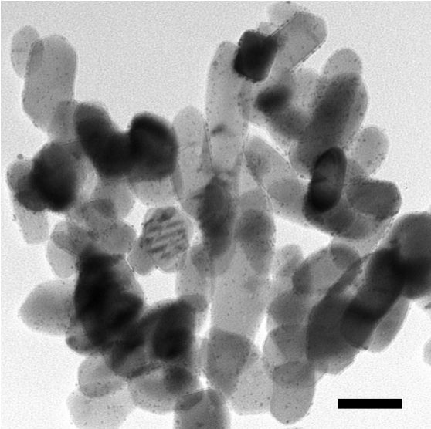
Figure S1. TEM image of Pt/TiO₂. Scale bar, 50 nm.

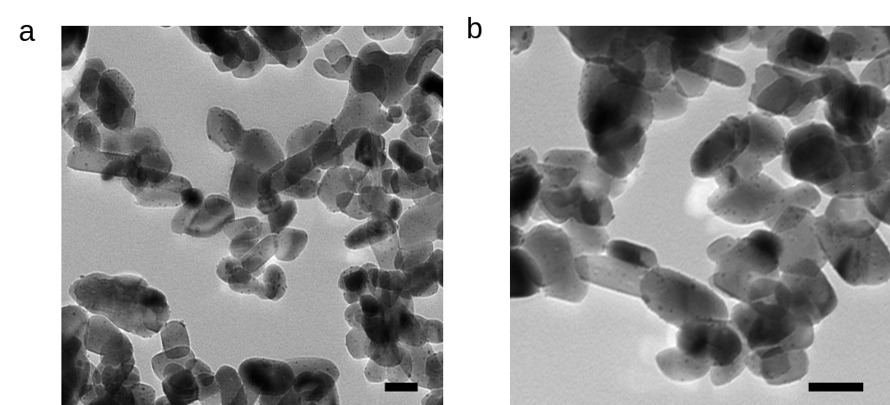
Figure S2. TEM images of (a) Pt/TiO₂-200 and (b) Pt/TiO₂-450. Scale bar, 50 nm.

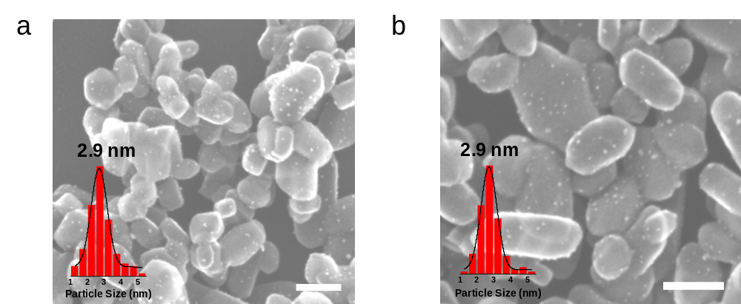
Figure S3. HRSEM image of (a) Pt/TiO₂-200 and (b) Pt/TiO₂-450. Scale bar, 50 nm. The inset in panel a and b show particle size distribution of Pt/TiO₂-200 and Pt/TiO₂-450, respectively.

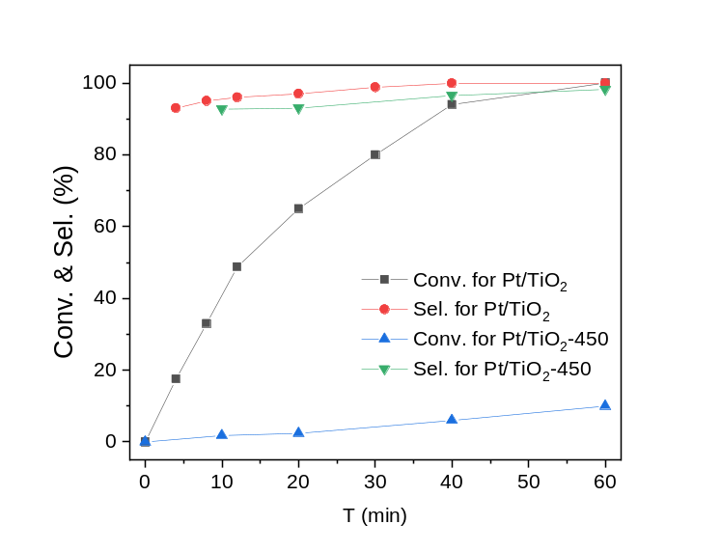
Figure S4. Reaction profiles of Pt/TiO₂ and Pt/TiO₂-450. Reaction conditions: 40 ºC, 10 bar H₂, 0.12 mmol BA, S/C=250, 3 mL hexane.

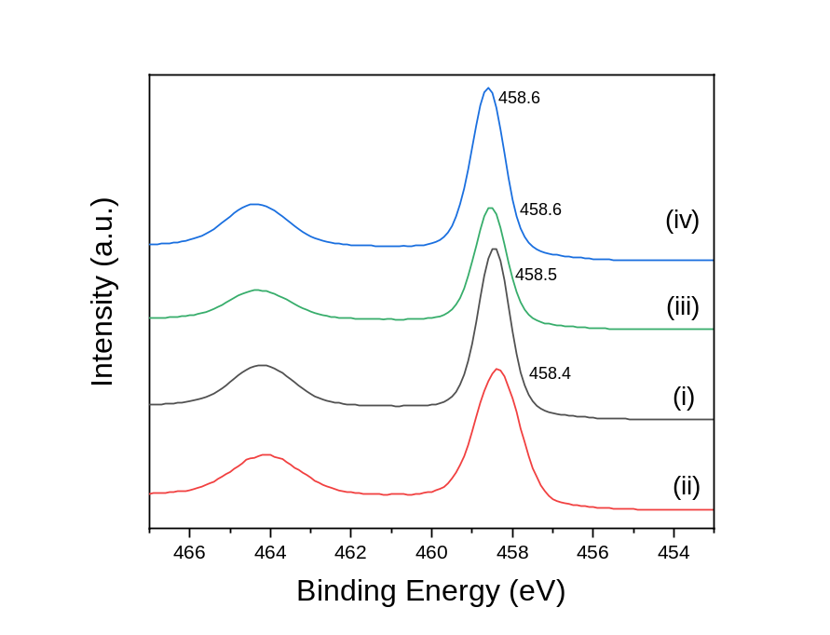
Figure S5. XPS spectra of Ti 2p of (i) TiO₂, (ii) Pt/TiO₂, (iii) Pt/TiO₂-200 and (iv) Pt/TiO₂-450.

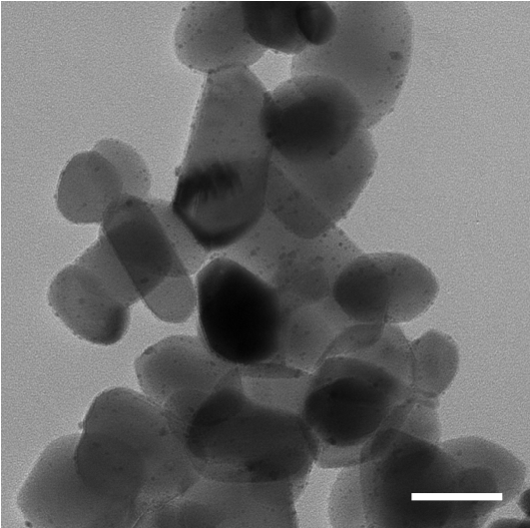
Figure S6. TEM image of Pt/TiO₂ after 5th recycle. Scale bar, 50 nm.

Table S1. The summarized results of BA hydrogenation under mild conditions in literatures.
Catalyst | Conditions | TOF (h⁻¹)ª | Ref.
Pd/CN | 85 ºC, 1 bar H₂, H₂O | 0.883 | 1
Pd/AC | 85 ºC, 15 bar H₂, H₂O | 5.7 | 2
Pd/CNF | 85 ºC, 15 bar H₂, H₂O | 0.35 | 3
Pd/MCN | 85 ºC, 25 bar H₂, H₂O | 26 | 4
Pd/CNT | 100 ºC, 35 bar H₂, H₂O | 87 | 5
Pd/UiO-66-2OH | 85 ºC, 1 bar H₂, H₂O | 0.416 | 6
Pd/800N-AC | 110 ºC, 25 bar H₂, H₂O | 35 | 7
Ru/C-TiO₂ | 70 ºC, 25 bar H₂, H₂O | 45 | 8
Ru/NFPC | 55 ºC, 10 bar H₂, H₂O | 69.8 | 9
Ru/C | 60 ºC, 5 bar, iPrOH | 0.36 | 10
Rh/N-C-700 | 55 ºC, 10 bar H₂, H₂O | 320 | 11
Rh/C | 50 ºC, 20 bar H₂, 100 bar CO₂ | 45 | 12
Pt NWs | 60 ºC, 1 bar H₂, H₂O | 2.03 | 13
Pt NWs | 70 ºC, 10 bar H₂, acetic acid | 5.3 | 14
Ir/CN | 55 ºC, 10 bar H₂, H₂O | 57 | 15
RuPd/CN | 85 ºC, 1 bar H₂, H₂O | 2.2 | 16
Pt/TiO₂ | 40 ºC, 10 bar H₂, hexane | 638 (2200)^{b} | This work
Pt/TiO₂ | 80 ºC, 50 bar H₂, hexane and acetic acid | 4490 (15480)^{b} | This work
Pd/C | 80 ºC, 50 bar H₂, hexane and acetic acid | ~11 | This work
Ru/C | 80 ºC, 50 bar H₂, hexane and acetic acid | 94 | This work
ªApparent TOF; ^{b}Data in parentheses was normalized by CO chemisorption.

Table S2. Pt/TiO₂ catalyzed BA hydrogenation with different solvents.ª
Solvent | Conv. (%) | Sel. (%)^{b} | p^{c} | δ^{d}
n-hexane | > 99 | > 99 | 0.009 | 4.98
H₂O | 84 | > 99 | 1.000 | 0.792
cyclohexane | 78 | > 99 | 0.006 | 3.84
Acetic acid | 68 | 96 | 0.648 | 2.61
isopropyl alcohol | 34 | 98 | 0.546 | 3.48
Ethyl acetate | 30 | 97 | 0.228 | 3.53
EtOH | 19 | 96 | 0.654 | 3.66
Tetrahydrofuran | 10 | 89 | 0.207 | 3.37
Acetone | 4 | 93 | 0.355 | 3.12
ªReaction conditions: BA = 0.12 mmol, S/C = 250, 3 mL solvent, 40 ºC and 10 bar H₂, 1 h. ^{b} Selectivity to CCA. ^{c}Relative polarity. The values are normalized from measurements of solvent shifts of absorption spectra and were extracted from Christian Reichardt, Solvents and Solvent Effects in Organic Chemistry, Wiley-VCH Publishers, 3rd ed., 2003. ^{d}Solubility of H₂ (10⁻³ mol L⁻¹, taken from ref. 18, 298.15 K, 1 atm H₂).

Table S3. Reaction orders for BA hydrogenation with Pt/TiO₂ and Pt/TiO₂-450.
Reaction rate: r = k[BA]^{α}[H₂]^{β}
Cat. | BA order (α) | H₂ order (β) | Overall (α+β)
Pt/TiO₂ | -0.29 | +0.50 | +0.21
Pt/SiO₂-450 | +0.45 | +0.02 | +0.47

Table S4. The H₂-D₂ exchange results of Pt/TiO₂ catalysts.
Cat. | Conv. (%) | Normalized activity
Pt/TiO₂ | 5.96 | 100
Pt/TiO₂-200 | 1.37 | 23
Pt/SiO₂-450 | 0.67 | 11
Reaction conditions see experimental section.

Characterization of the pure products using ¹H NMR and ¹³C NMR:
- 4-Methylcyclohexanecarboxylic acid
¹H NMR (400 MHz, CDCl₃): δ 11.76 (s, 1H), 2.56 (m, J = 4.8 Hz, 0.7H), 2.24 (tt, J = 12.4, 3.6 Hz, 0.3H), 2.03-1.98 (m, 2H), 1.78-1.19 (m, 7H), 0.9 (t, 6 Hz, 3H) ppm, (cis:trans = 70:30) ;
¹³C NMR (100 MHz, CDCl₃): δ 181.63, 181.01, 41.91, 39.15, 33.14, 30.93, 30.29, 29.55, 27.82, 24.90, 21.42, 20.00 ppm.
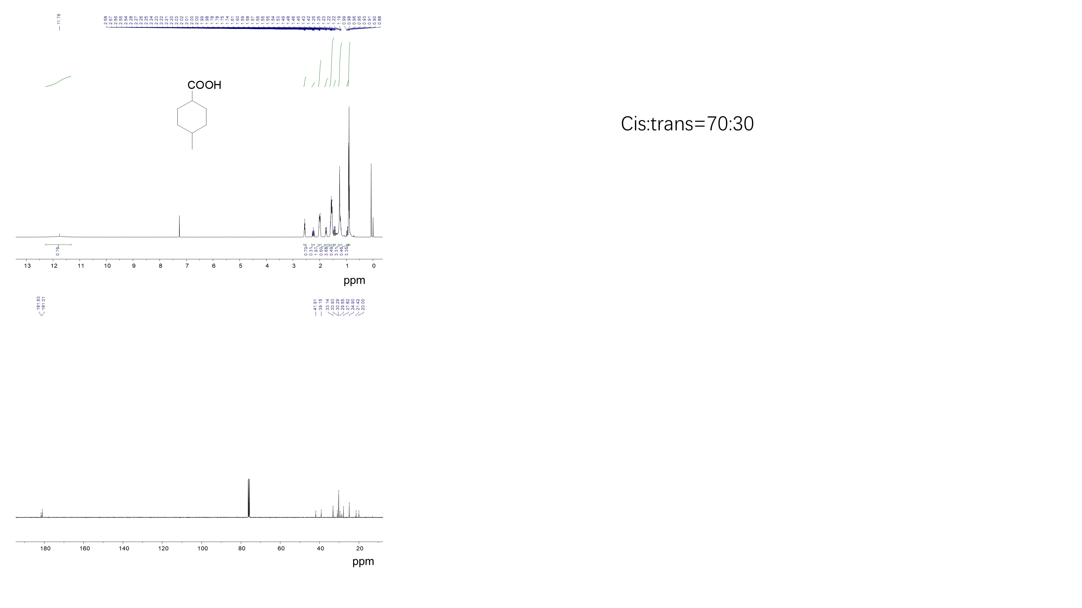

- 3-Methylcyclohexanecarboxylic acid
¹H NMR (400 MHz, CDCl₃): δ 11.71 (s, 1H), 2.712-2.520 (m, J =4.8 Hz, 0.21H), 2.333 (tt, J = 12, 3.6 Hz, 0.79H), 1.98-1.94 (2H, m), 1.82-1.65 (m, 2H), 1.45-0.81 (9H, m) ppm, (cis:trans=79:21) ;
¹³C NMR (100 MHz, CDCl₃): δ 182.49, 43.25, 39.03, 37.18, 35.25, 34.35, 33.64, 32.01, 29.71, 28.43, 28.30, 27.46, 25.42, 22.59, 21.88 ppm.
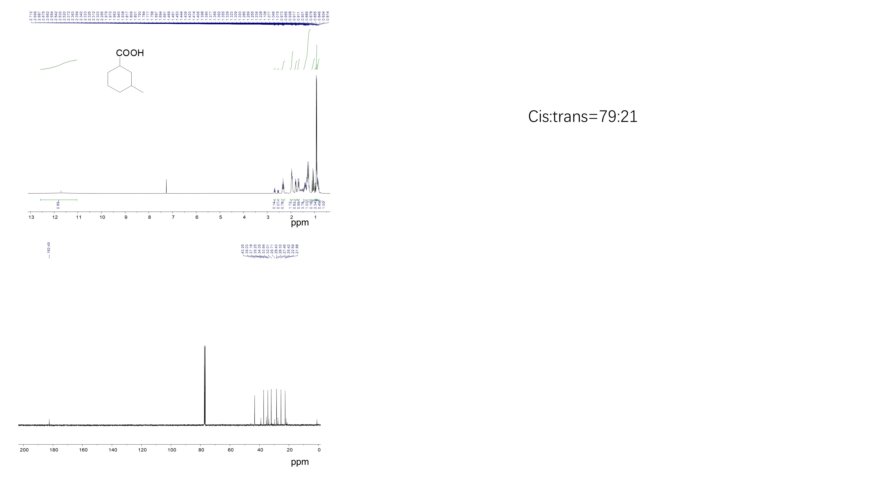

- 2-Methylcyclohexanecarboxylic acid
¹H NMR (400 MHz, CDCl₃): δ 11.67 (s, 1H), 2.57-2.15 (2 m, H), 1.75-1.22 (m, 9H), 0.98-0.96 (d, 7.2 Hz, 2.6H), 0.94-0.93 (d, 6.8 Hz, 0.4 H) ppm, cis:trans=86:14;
¹³C NMR (100 MHz, CDCl₃): δ 181.29, 45.76, 34.14, 34.06, 31.75, 31.02, 29.83, 29.71, 25.77, 25.31, 24.38, 23.70, 21.45, 20.63 ppm.
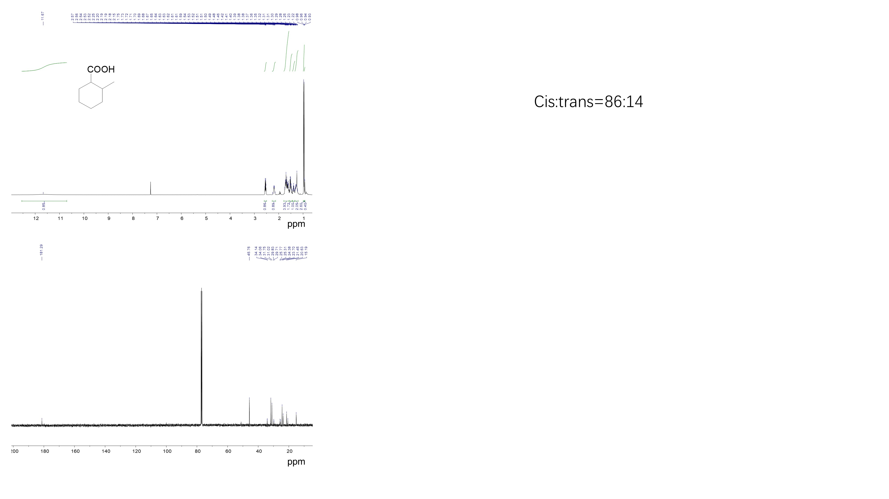

- 4-Ethylcyclohexanecarboxylic acid
¹H NMR (400 MHz, CDCl₃): δ 11.71 (s, 1H,), 2.60-2.55 (m, J = 4.8 Hz, 0.72H), 2.25 (tt, J = 12.4, 3.6 Hz, 0.28H), 2.03-1.96 (m, 2H), 1.85-1.19 (m, 9H), 0.96-0.84 (m, 3H) ppm, (cia:trans=72:28);
¹³C NMR (100 MHz, CDCl₃): δ 183.20, 182.62, 43.81, 40.94, 39.09, 37.96, 32.27, 30.22, 29.51, 29.28, 28.36, 26.46, 12.10, 11.85 ppm.
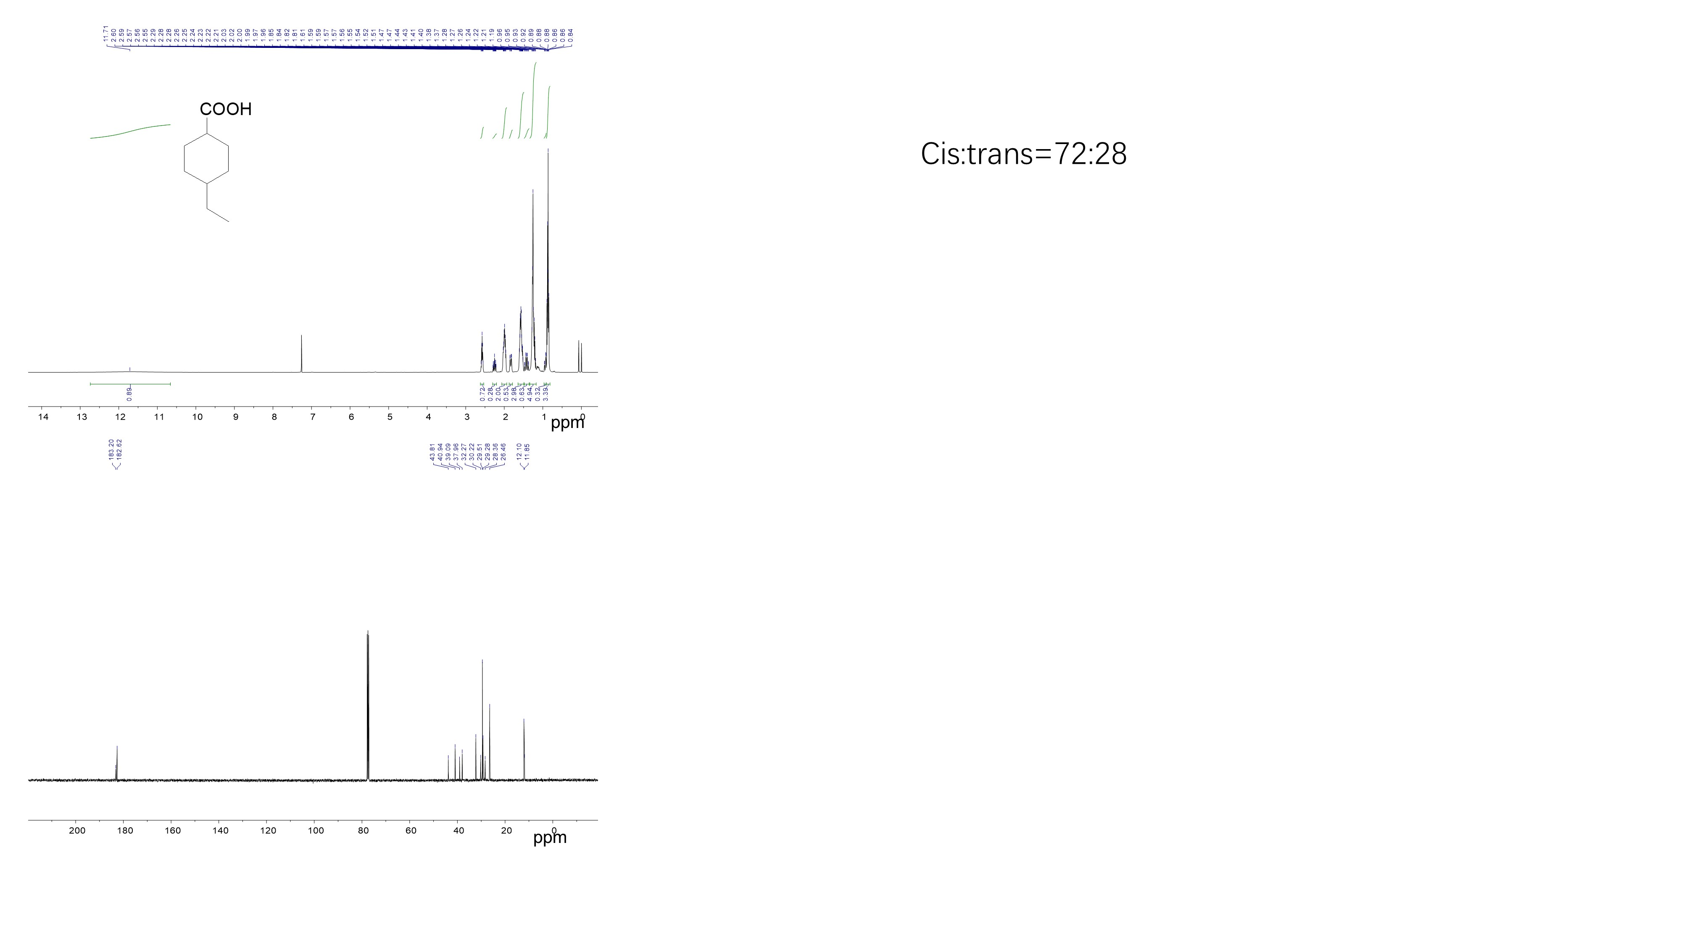

- 4-Pentylcyclohexanecarboxylic acid
¹H NMR (400 MHz, CDCl₃): δ 11.47 (s, 1H), 2.59-2.54 (m, J = 4.8 Hz, 0.72H), 2.25 (tt, J = 12.4, 3.6 Hz, 0.28H), 2.02-1.14 (m, 17H), δ 0.88 (t, J = 6.8 Hz, 3H) ppm, (cis:trans=72:28);
¹³C NMR (100 MHz, CDCl₃): δ 181.73, 181.17, 42.33, 39.50, 36.11, 35.88, 34.59, 34.13, 31.21, 31.10, 28.42, 27.82, 25.74, 25.49, 24.96, 21.65 ppm.
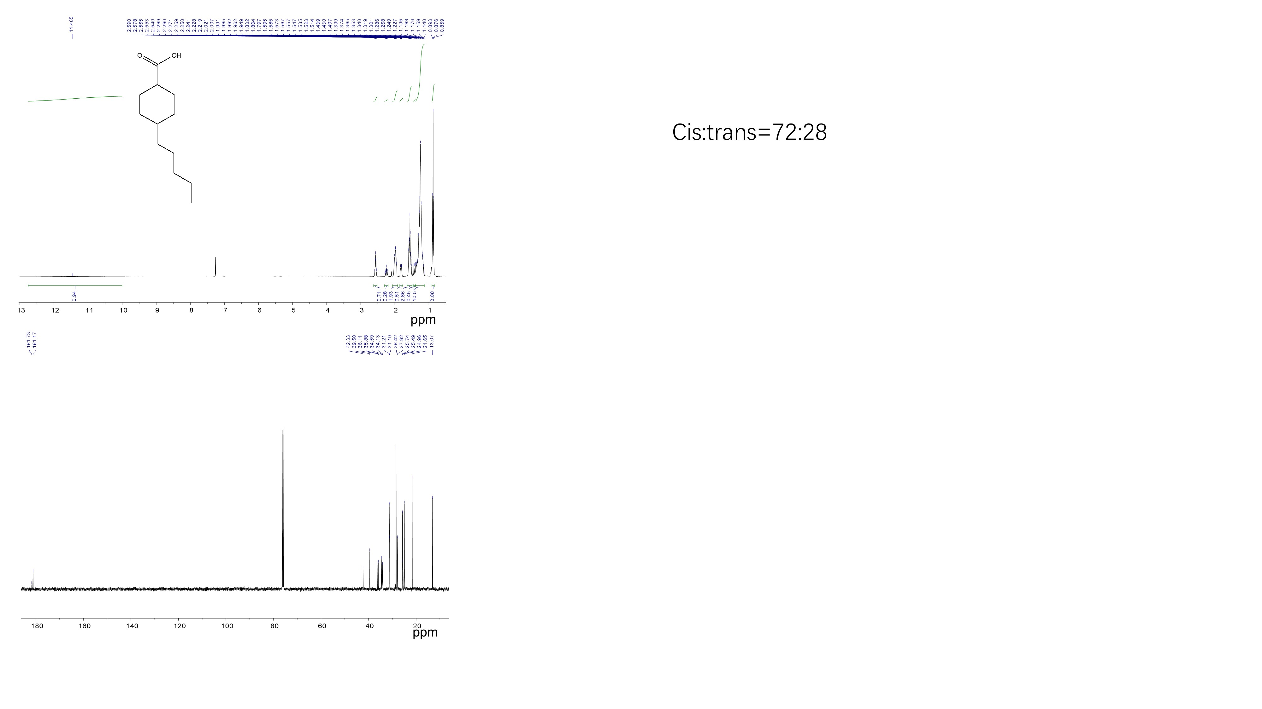

- 4-Isopropylcyclohexane-1-carboxylic acid
¹H NMR (400 MHz, CDCl₃): δ 10.47 (s, 1H), 2.64-2.60 (m, J = 4.4 Hz, 0.68H), 2.24 (tt, J = 12.4, 3.6 Hz, 0.32H), 2.11-2.02 (m, 2H), 1.58-0.95 (m, 9H), 0.87-0.84 (m, 6H) ppm, (cis:trans=68:32);
¹³C NMR (100 MHz, CDCl₃): δ 181.69, 181.11, 42.34, 42.22, 41.98, 38.93, 31.72, 30.43, 28.00, 27.78, 25.64, 25.46, 19.01, 18.71 ppm.
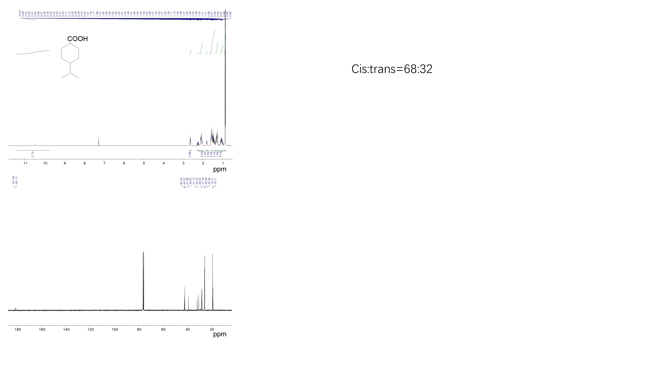

- 4-Trifluoromethylcyclohexanecarboxylic acid
¹H NMR (400 MHz, CDCl₃): δ 10.47 (s, 1H), 2.72-2.71 (m, J = 3.2 Hz, 0.64H), 2.32 (tt, J = 12.4, 3.6 Hz, 0.36H), 2.26-1.98 (m, 3H), 1.85-1.25 (m, 6H) ppm, (cis:trans=64:36);
¹³C NMR (100 MHz, CDCl₃): δ 180.38, 179.77, 127.94, 127.81, 41.13, 40.36, 40.31, 40.09, 40.04, 39.83, 39.56, 37.50, 26.15, 24.45, 23.09, 23.07, 20.71, 20.68, 20.65, 20.63 ppm.
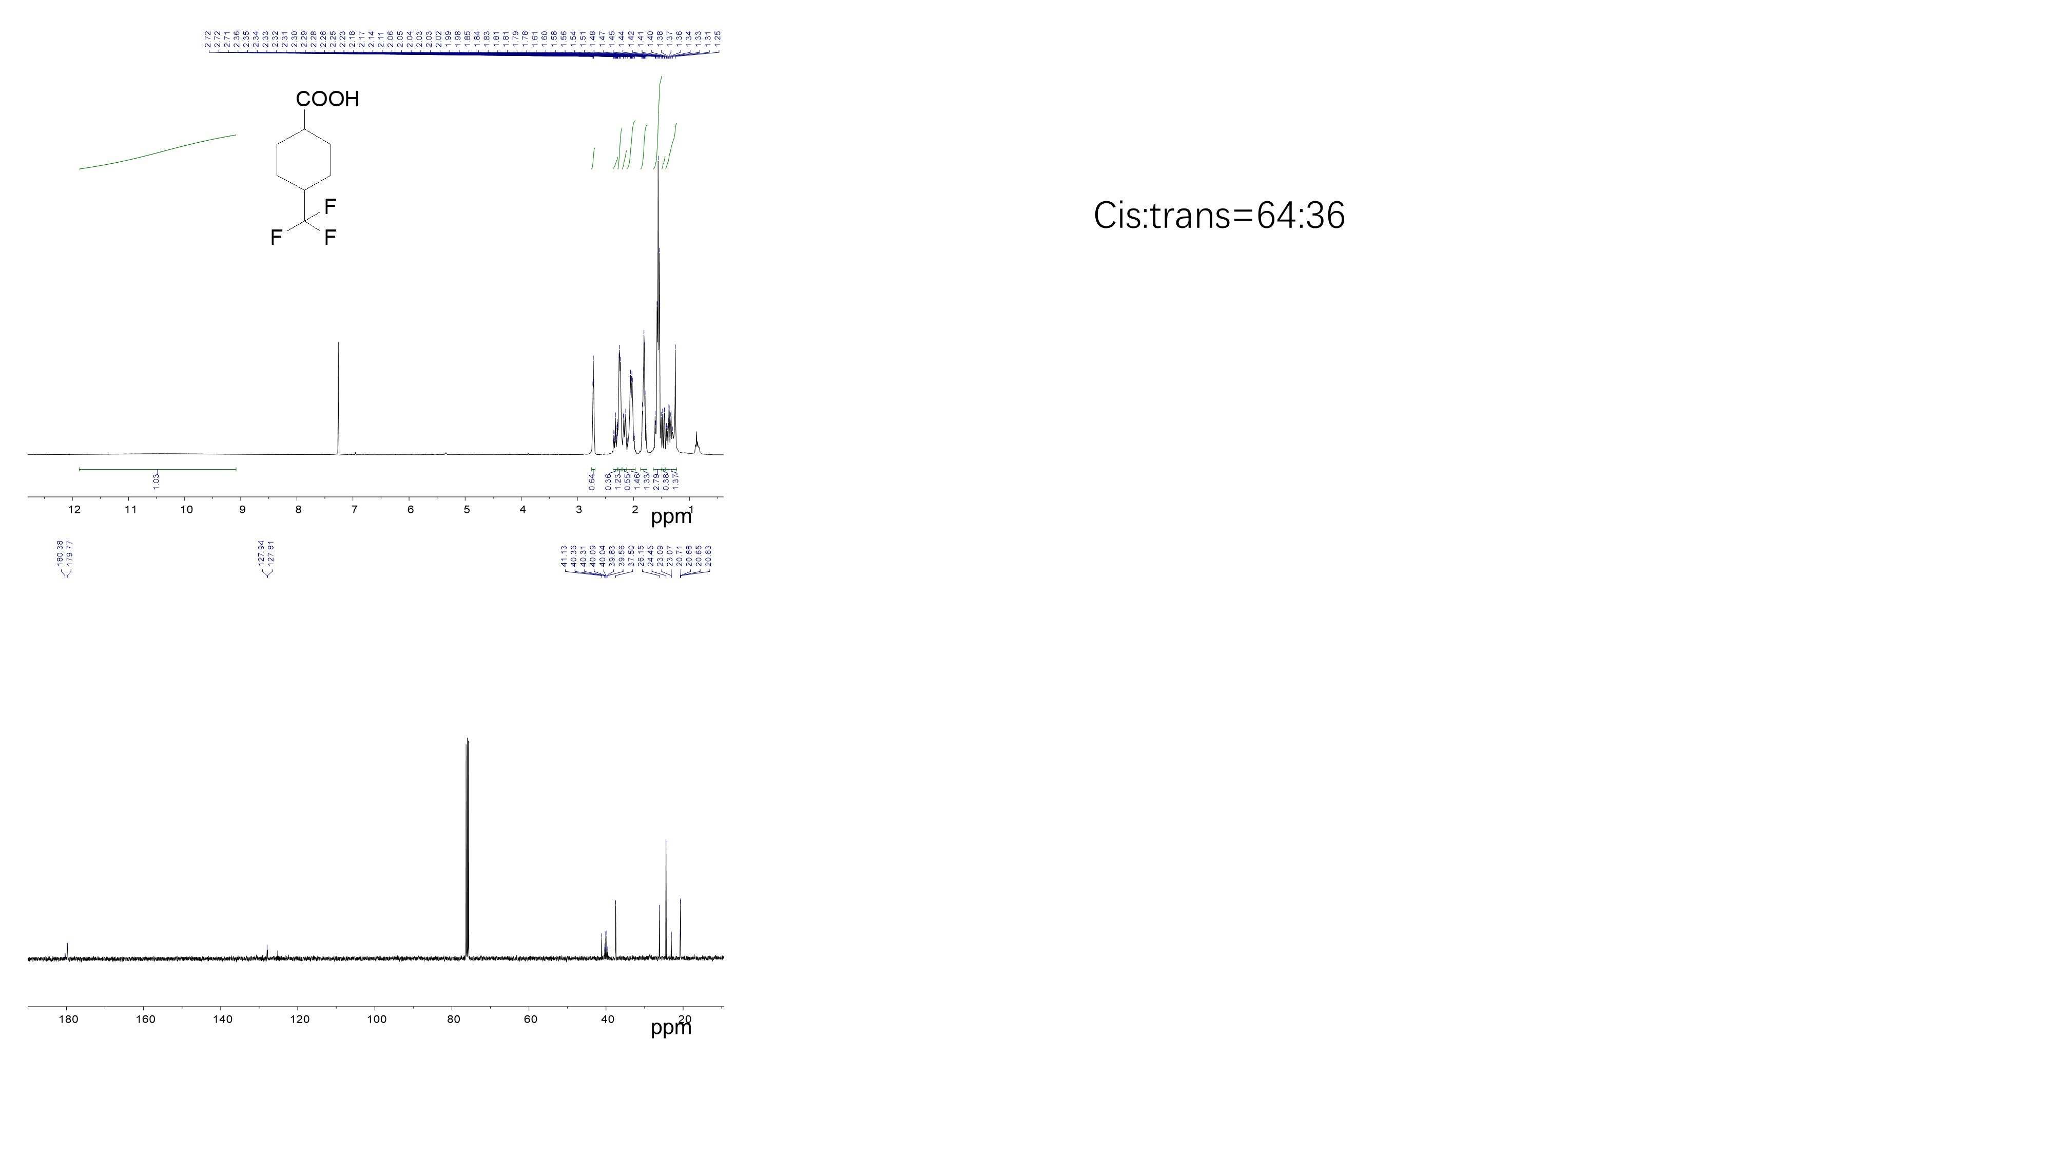

- 4-Hydroxycyclohexanecarboxylic acid
¹H NMR (400 MHz, CDCl₃): δ 8.55 (s, 1H), 4.13-4.07 (q, J = 7.2 Hz, 0.1H), 3.81-3.76 (m, J= 4.8 Hz, 0.34H), 3.63-3.58 (q, J = 7.2 Hz , 0.22H), 3.5 (tt, J = 10.8, 4 Hz, 0.23H), 2.41-2.17 (m, 1H), δ 2.01-1.16 (9H, m) ppm, (cis:trans = 60:40);
¹³C NMR (100 MHz, CDCl₃): δ 178.62, 178.12, 177.84, 69.19, 66.37, 42.92, 42.11, 40.88, 33.95, 31.42, 28.93, 27.10, 25.55, 25.14, 23.64 ppm.
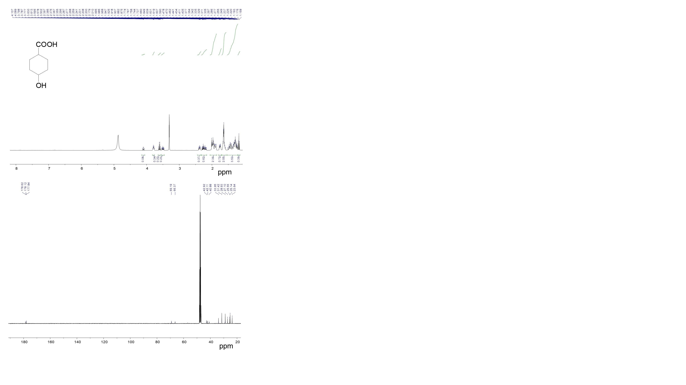

- 3-Cyclohexylpropionic acid
¹H NMR (400 MHz, CDCl₃): δ 11.63 (s, 1H), 2.36 (t, J = 8 Hz, 2H), 1.72-1.63 (m, 5H), 1.56-1.51 (q, J = 7.2 Hz,2H), 1.28-1.09 (m, 6H), 0.94-0.84 (m, 2H) ppm.
¹³C NMR (100 MHz, CDCl₃): δ 179.6, 36.1, 31.9, 31.0, 30.6, 25.5, 25.2 ppm.

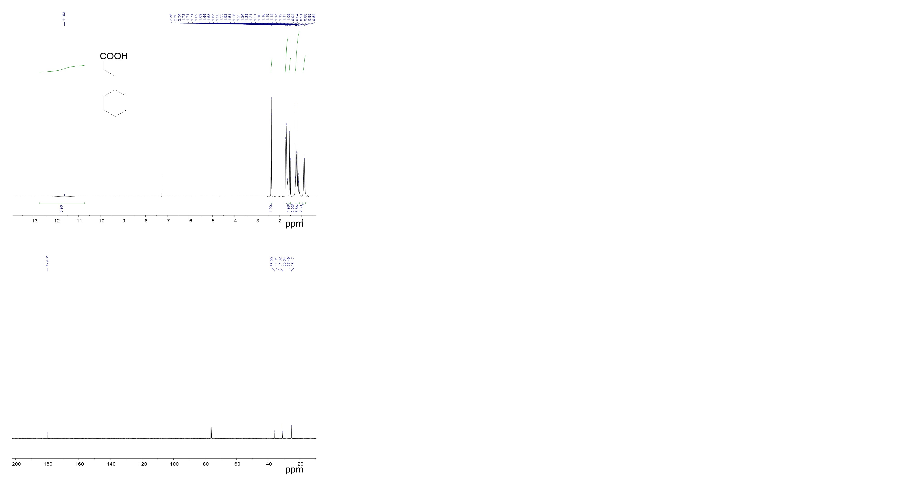

- 5-cyclohexylvaleric acid
¹H NMR (400 MHz, CDCl₃): δ 10.84 (s, 1H), 2.38-2.34 (t, J = 7.2 Hz, 2H), 1.71-1.63 (m, 5H), 1.53 (q, J = 7.2 Hz, 2H), 1.30-1.08 (m, 5H), 0.94-0.84 (m, 2H) ppm.
¹³C NMR (100 MHz, CDCl₃): δ 179.63, 36.09, 31.91, 31.02, 30.66, 25.49, 25.17 ppm.
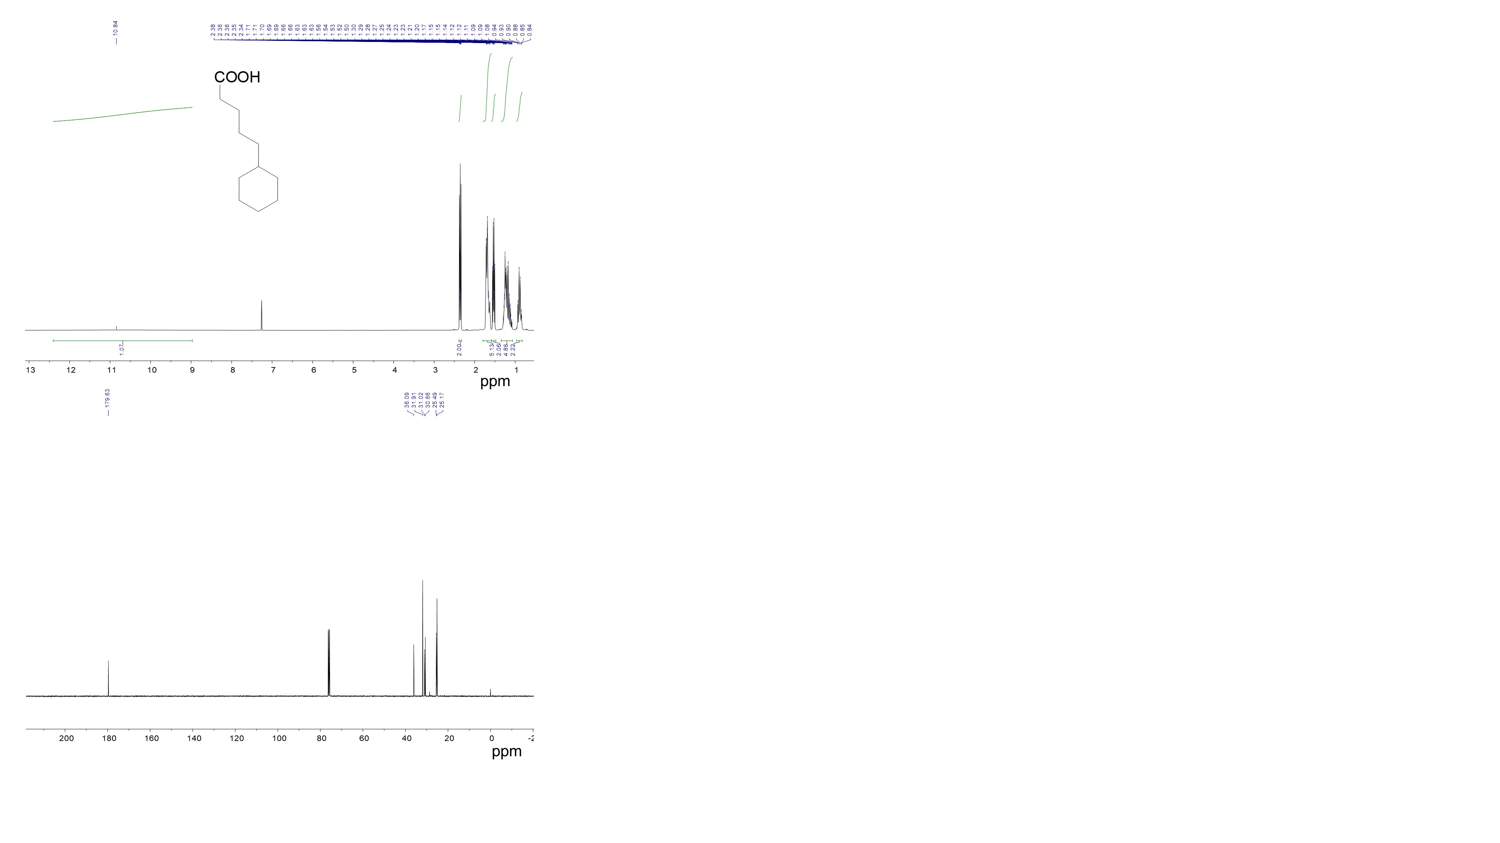

- Cyclohexanecarboxylic acid methyl ester
¹H NMR (400 MHz, CDCl₃): δ 3.66 (s, 3H), 2.30 (tt, J= 11.2, 3.6 Hz, 1H), 1.91-1.25 (m, 10H) ppm.
¹³C NMR (100 MHz, CDCl₃): δ 176.59, 51.44, 43.12, 29.03, 25.75, 25.45 ppm.
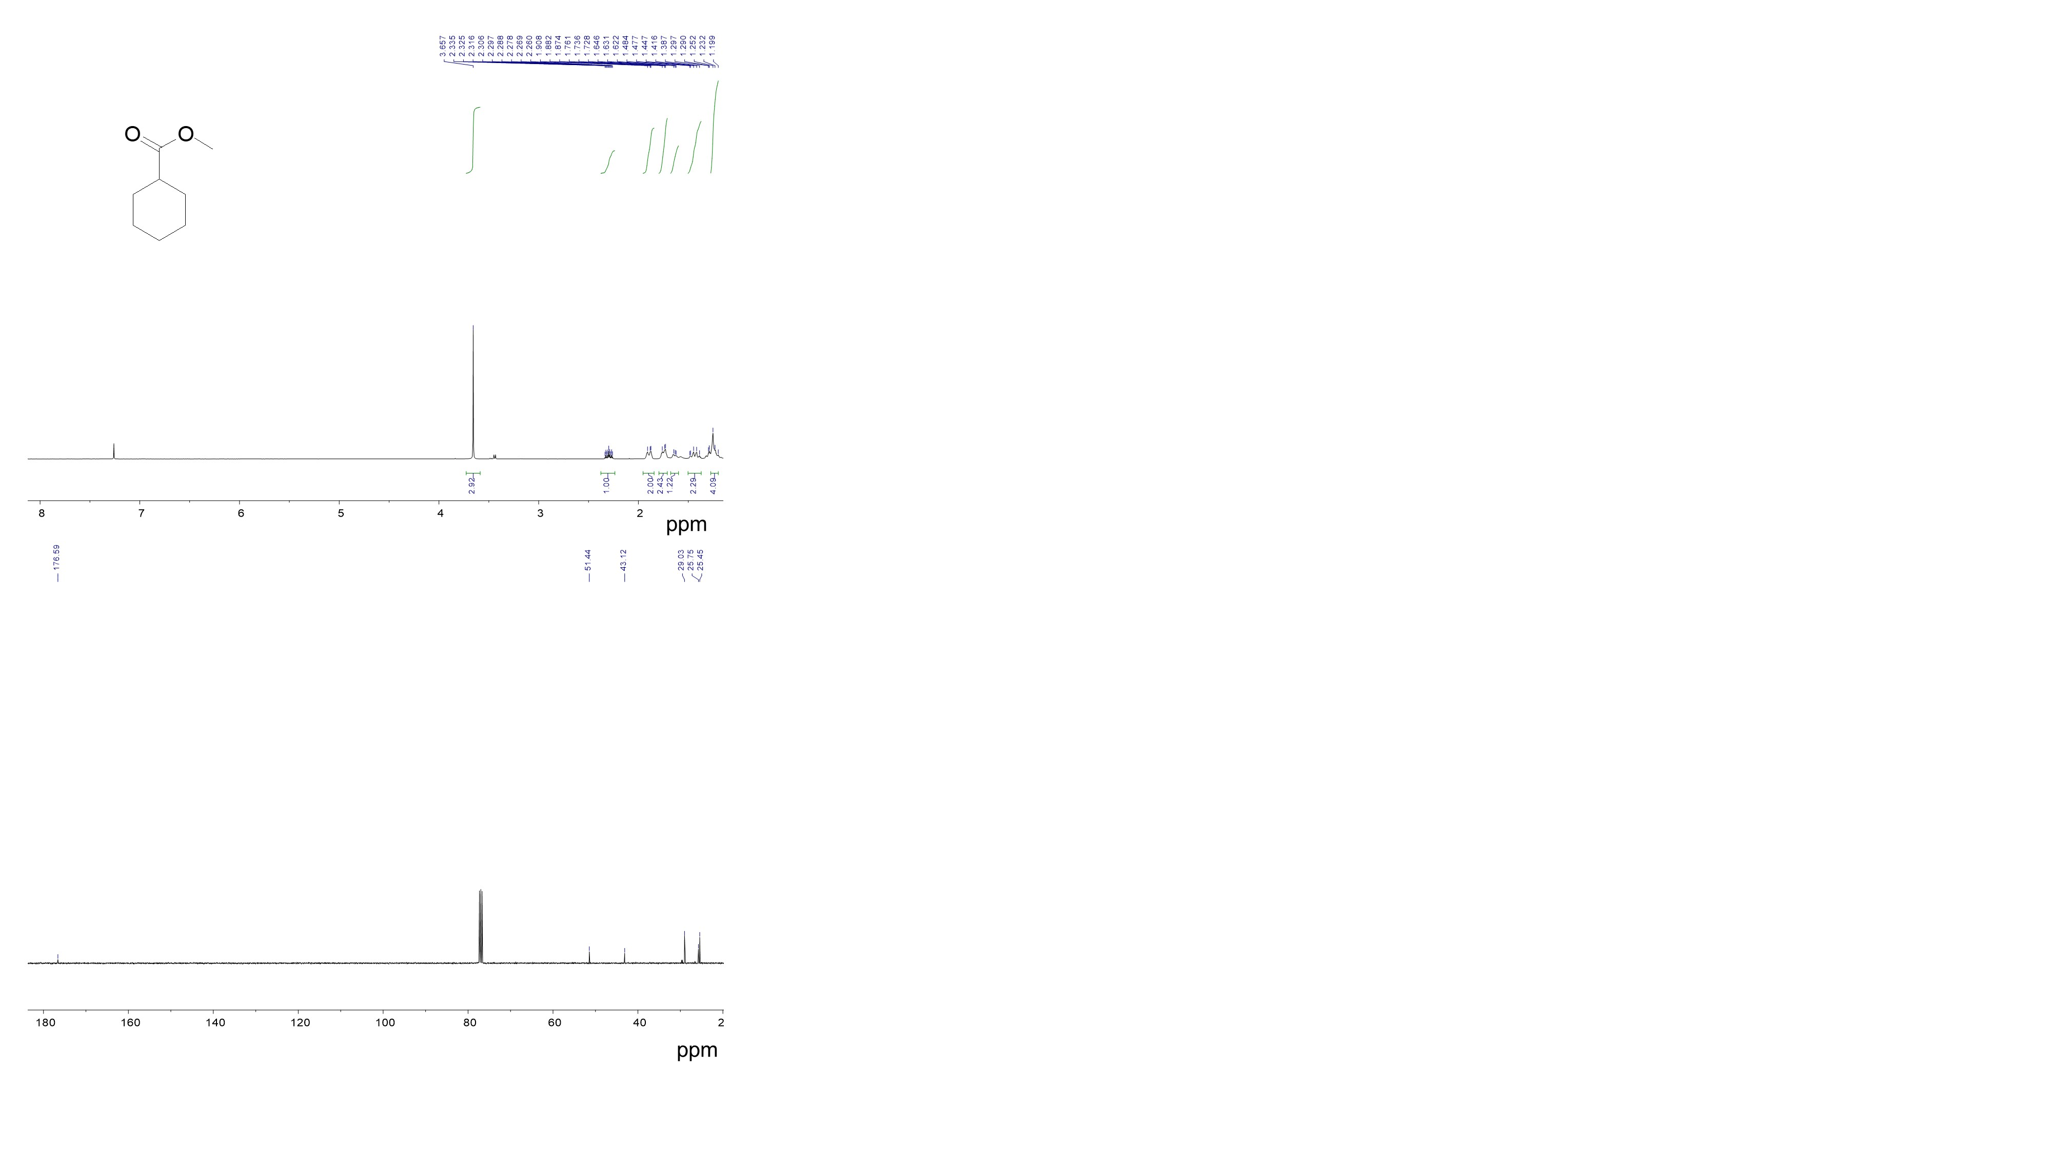

- Mono-methyl terephthalate
¹H NMR (400 MHz, CDCl₃): δ 7.69 (s, 1H), 3.68 (s, 2 H), 3.67 (s, 1H), 3.68-3.67 (m, 3H), 2.54-2.24 (m, 2H), 2.10-1.87 (m, 4H, m), 1.72-1.66 (m, 3H), 1.52-1.44 (m, 1H) ppm, (cis:trans = 66:34);
¹³C NMR (100 MHz, CDCl₃): δ 180.23, 179.89, 174.86, 174.45, 50.64, 50.62, 41.32, 41.18, 39.67, 39.33, 26.90, 26.78, 24.89, 24.77 ppm.
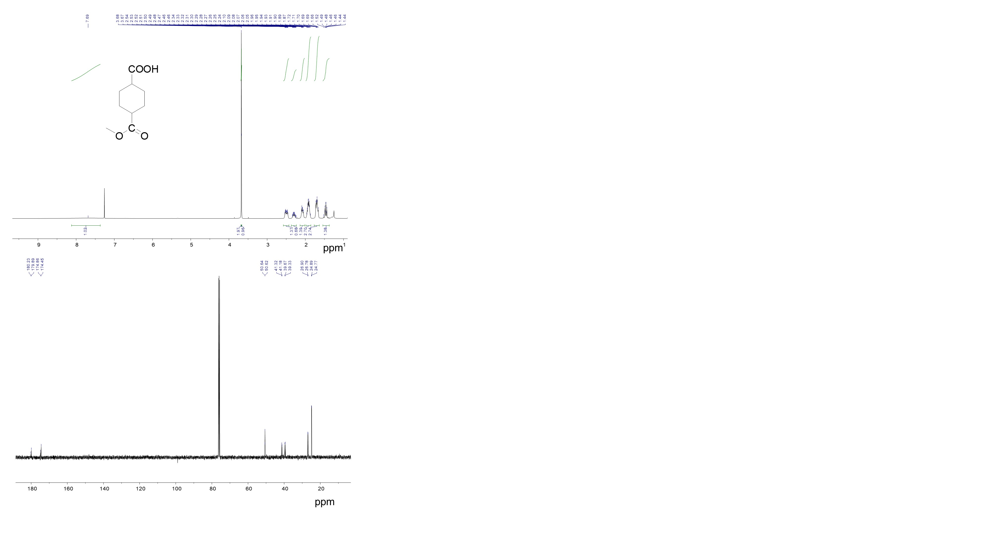

- Trans-cyclohexane-1,2-dicarboxylic acid
¹H NMR (400 MHz, DMSO-d⁶): δ 11.59 (s, 1H), 2.66-2.65 (m, 2H), δ 1.90-1.84 (m, 2H), 1.66-1.63 (m, 2H), 1.36-1.34 (m, 4H) ppm, (cis:trans = 0:~100);
¹³C NMR (100 MHz, DMSO-d⁶): δ 175.4, 42.1, 26.4, 23.8 ppm.
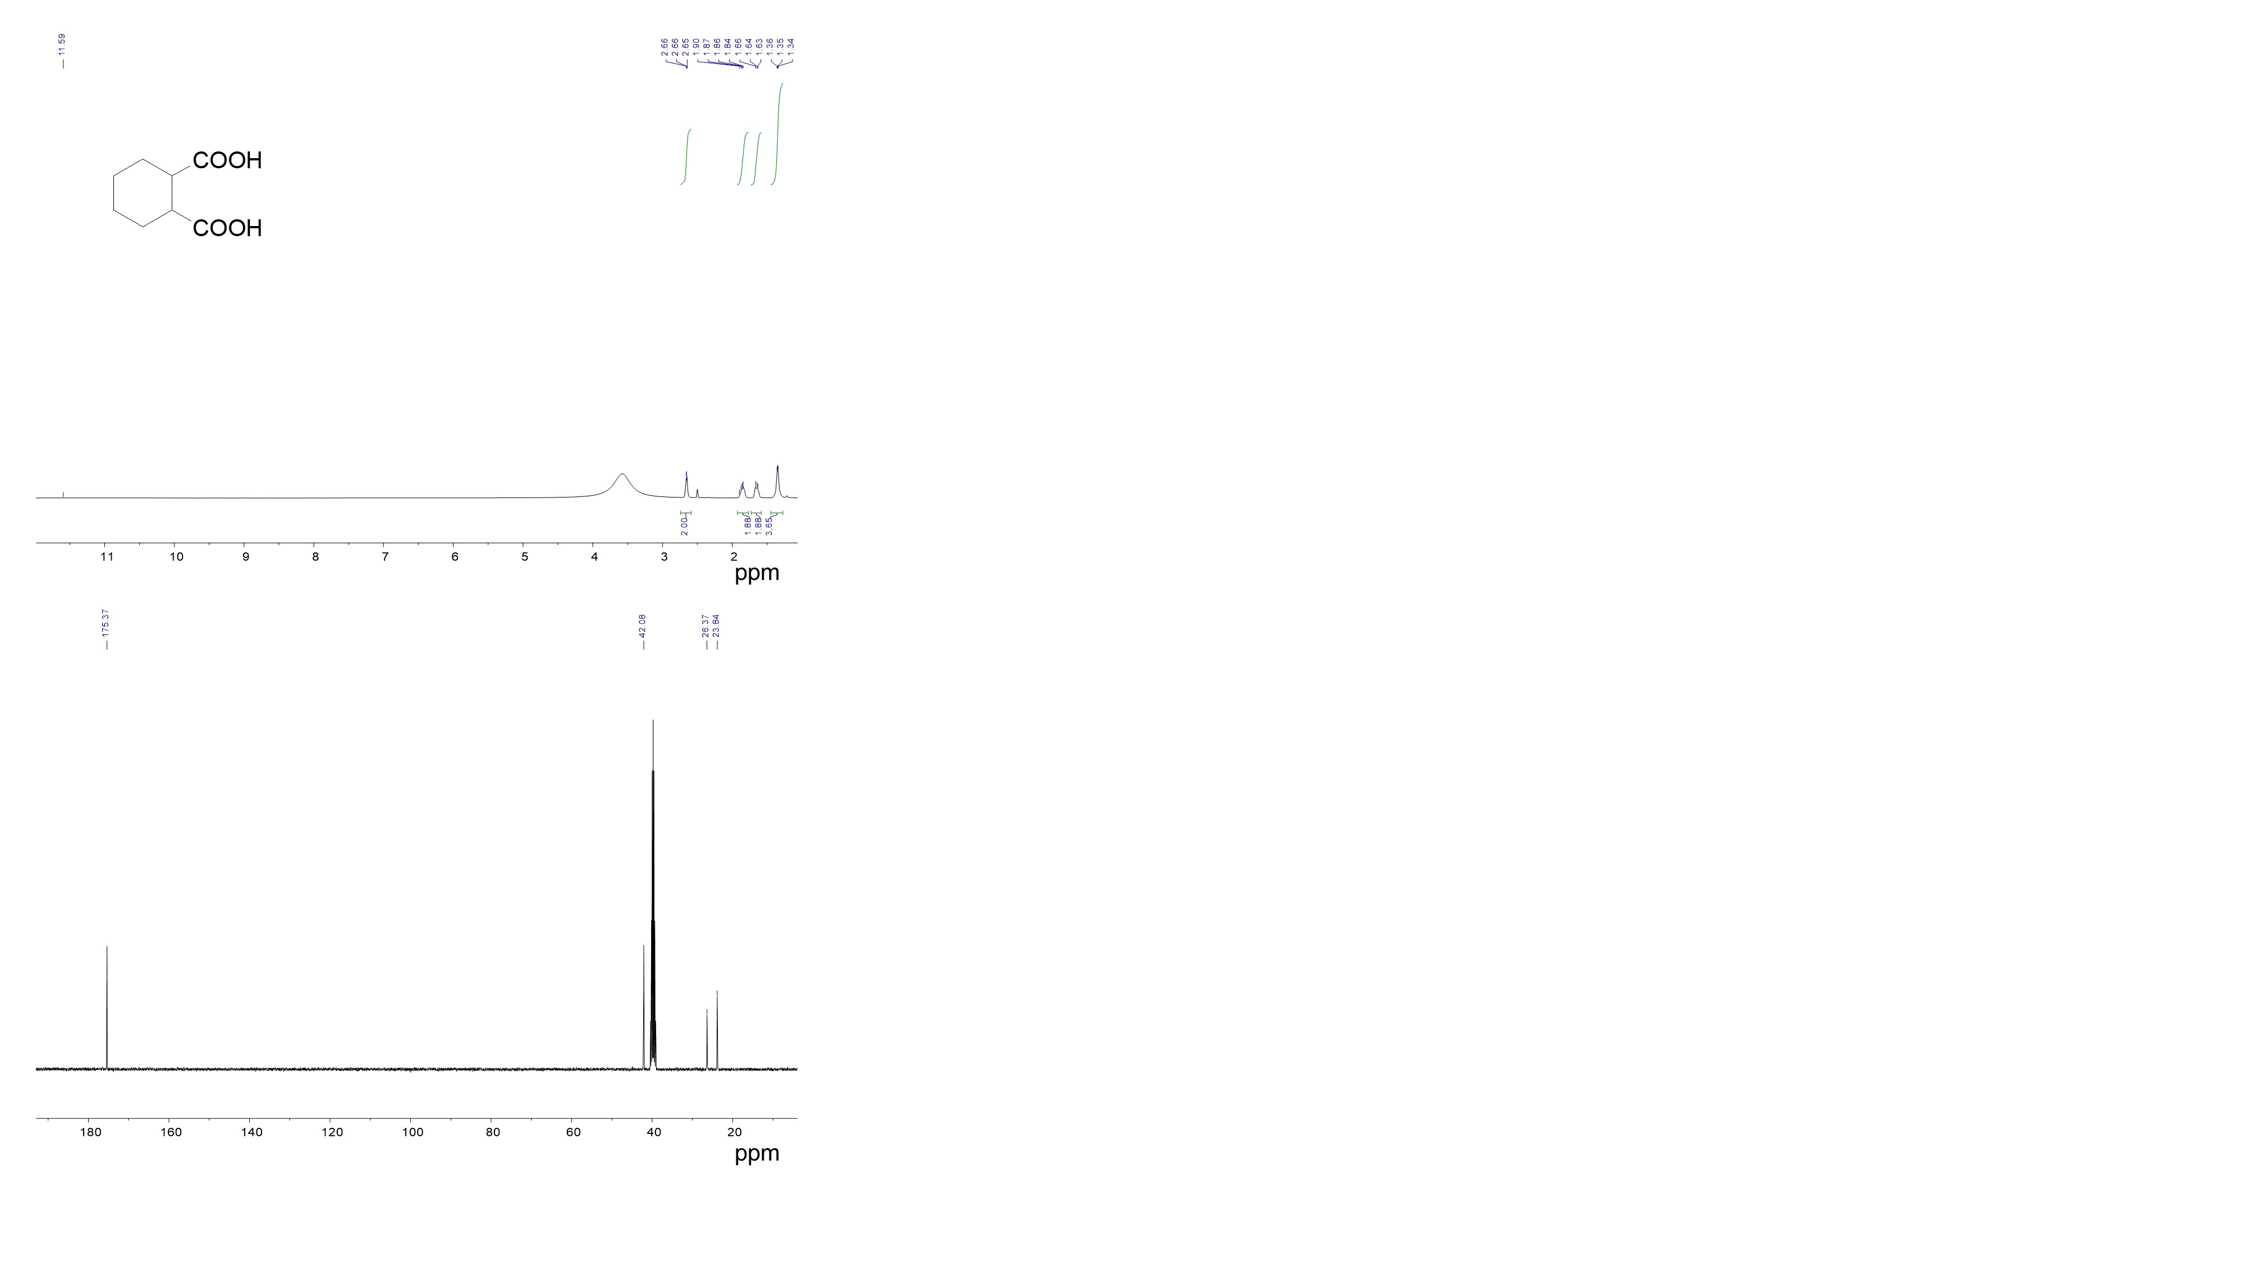

- 1-Heptyl 2-octylcyclohexane-1,2-dicarboxylate
¹H NMR (400 MHz, DMSO-d⁶): δ 4.03-3.91 (m, 4H), δ 2.82-2.81 (m, 2H), 2.02-1.79 (m, 2H), 1.65-1.27 (m, 24H), 0.89-0.85 (12H, m) ppm, (cis:trans = 0: ~100)
¹³C NMR (100 MHz, DMSO-d⁶): δ 173.93, 66.85, 66.83, 42.83, 38.88, 30.57, 30.55, 29.07, 29.06, 26.55, 24.01, 23.96, 23.93, 23.12, 14.18, 11.12 ppm.
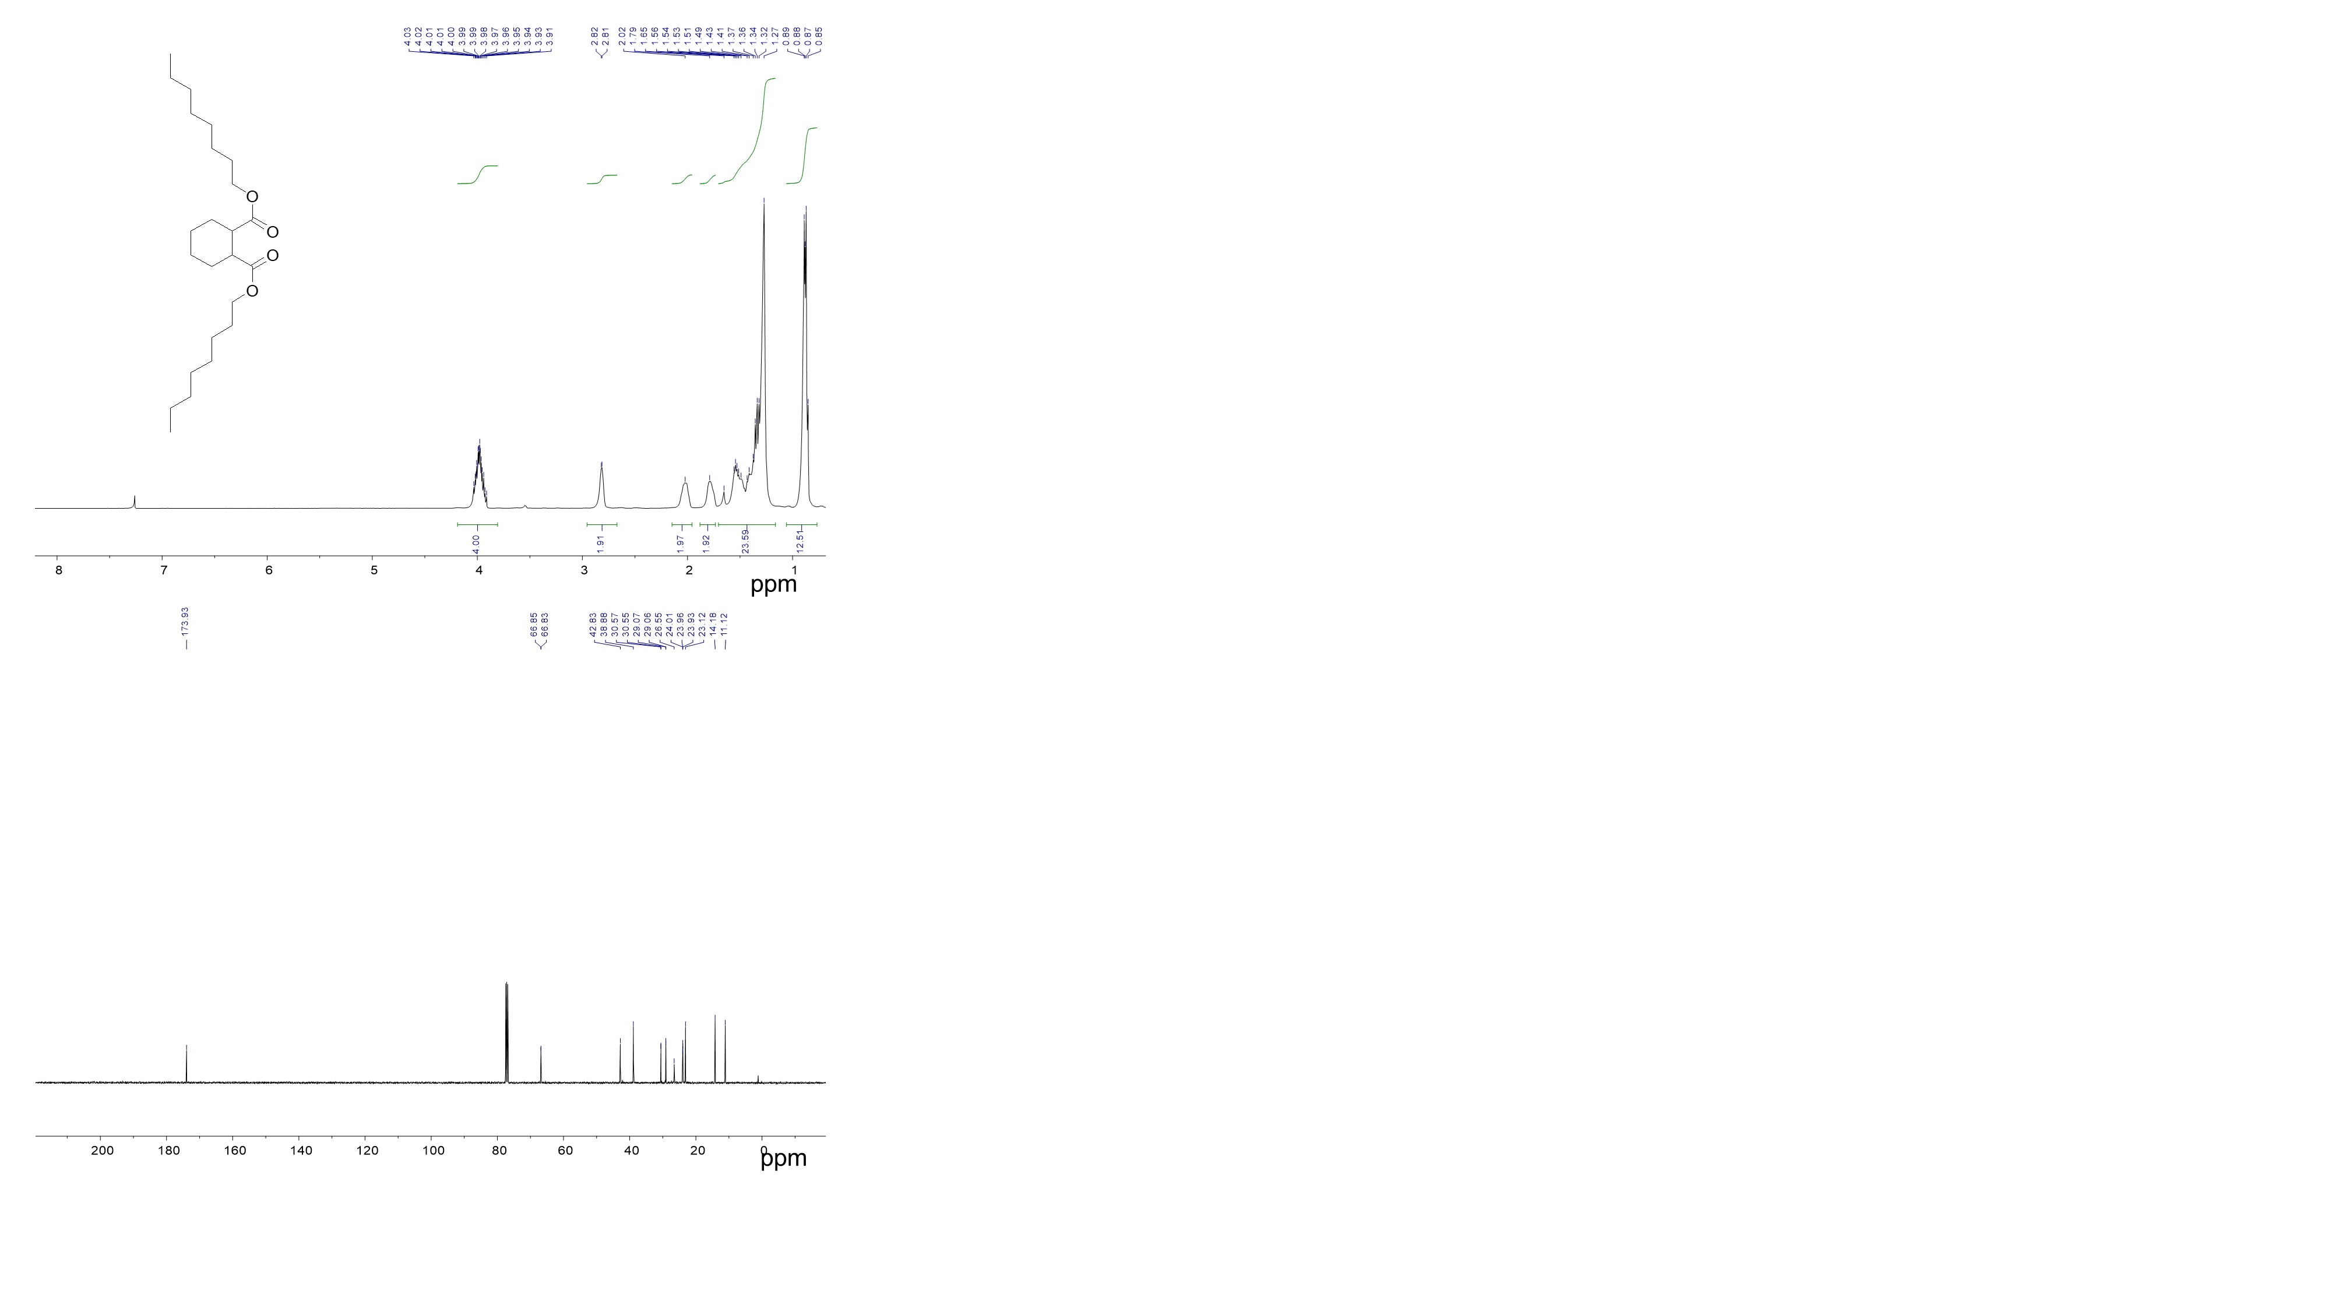

- Cyclohexane-1,3-dicarboxylic acid
¹H NMR (400 MHz, MeOD): δ 2.59-2.53 (m, J = 6 Hz, 0.47H), 2.24 (tt, J = 12 ,3.2 Hz, 1.54H), 1.91-1.79 (m, 3H), 1.67-1.62 (m, 1H), 1.50-1.17 (m, 4H) ppm, (cis:trans = 77:23);
¹³C NMR (100 MHz, MeOD):δ 179.12, 178.98, 43.64, 40.25, 32.49, 30.62, 29.75, 29.01, 25.97, 23.23 ppm.
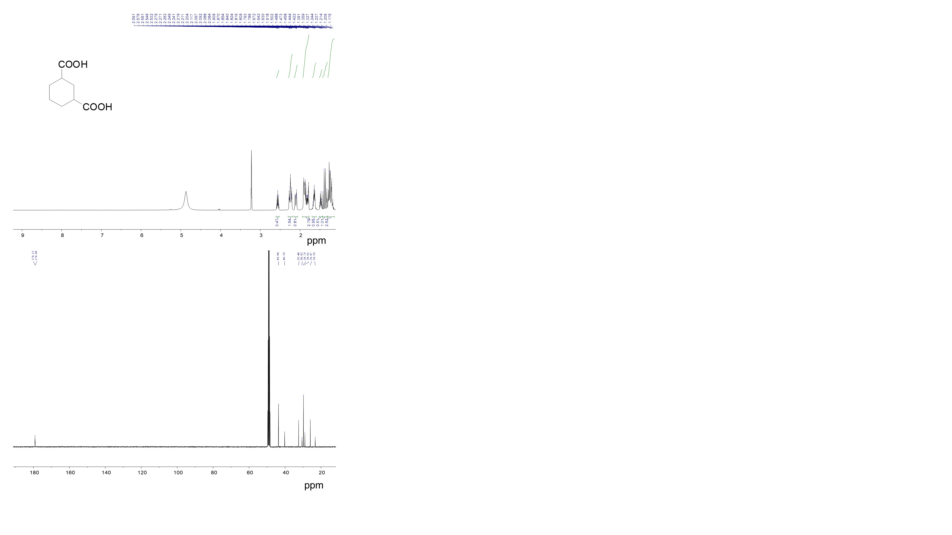

- Cyclohexane-1,4-dicarboxylic acid
¹H NMR (400 MHz, MeOD): δ 2.49-2.20 (m, 2H), 2.04-2.02 (m, 1H), 1.91-1.84 (m, 3H), 1.70-1.63 (m, 3H), 1.46-1.40 (m, 1H) ppm, (cis:trans = 77:23);
¹³C NMR (100 MHz, MeOD): δ 179.16, 178.37, 44.00, 41.94, 29.40, 27.13 ppm.

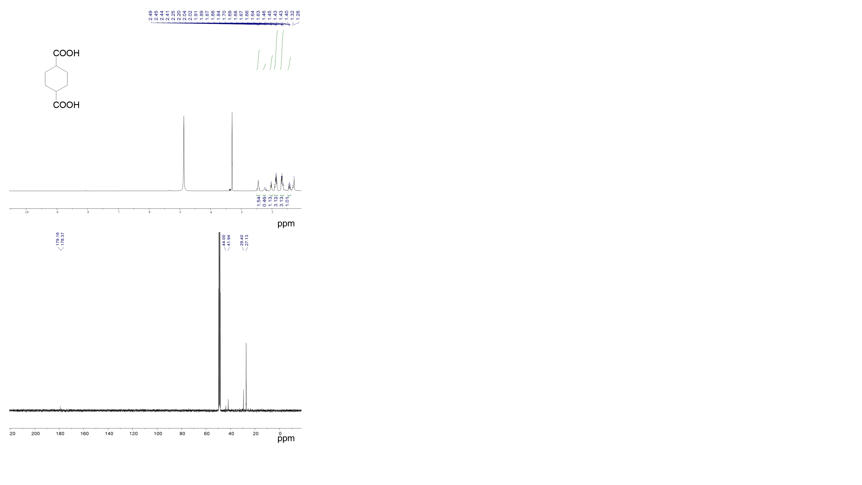

- Cis-cyclohexane-1,3,5-tricarboxylic acid
¹H NMR (400 MHz, MeOD): δ 2.39 (tt, J = 12.4, 3.2 Hz, 3H), 2.21-2.18 (d, J = 12.4 Hz, 3H), 1.42-1.32 (q, J = 12.8 Hz, 3H) ppm, (cis:trans = ~100:0);
¹³C NMR (100 MHz, MeOD): δ 178.22, 42.81, 32.09 ppm.
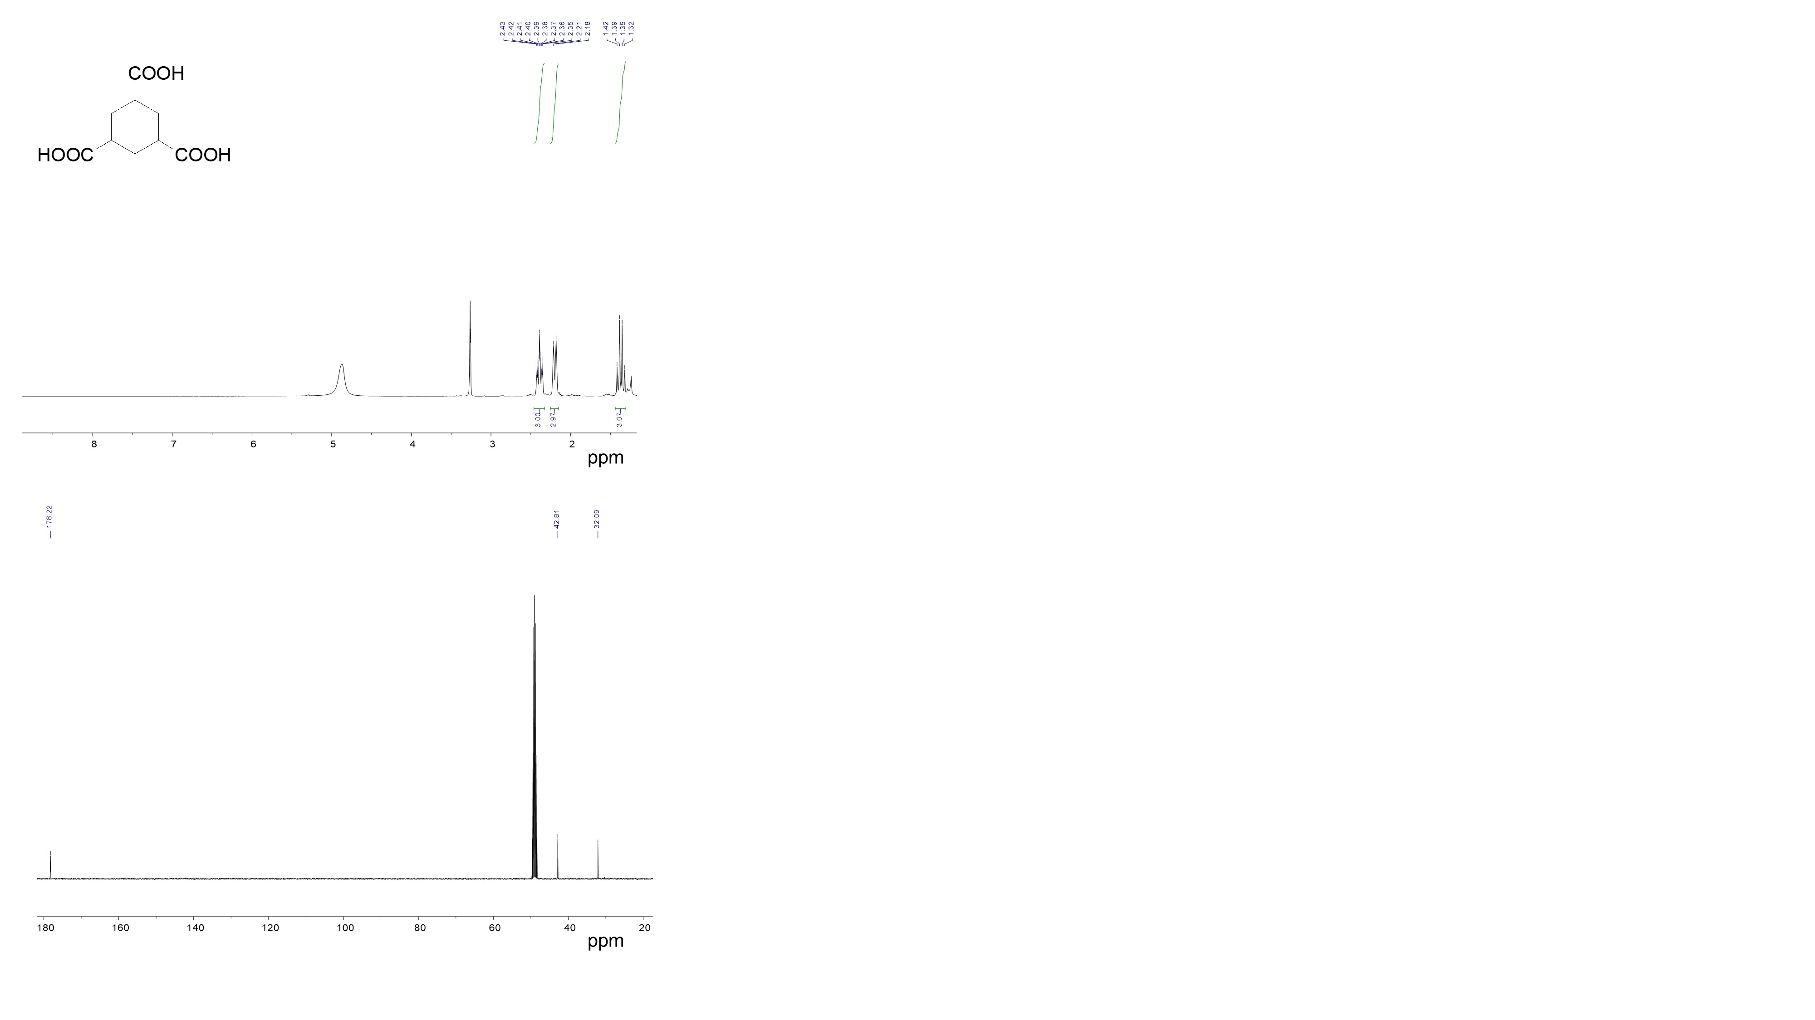

- Cis-cyclohexane-1,3,5-tricarboxylic acid trimethyl ester
¹H NMR (400 MHz, CDCl₃): δ 3.68 (s, 9H), 2.38 (tt, J = 12.4, 3.2 Hz, 3H), 2.28-2.25 (d, J = 12.4 Hz, 3H), 1.57-1.48 (q, J = 12.8 Hz, 3H) ppm, (cis:trans = ~100:0);
¹³C NMR (100 MHz, CDCl3): δ 174.58, 52.02, 41.86, 30.56 ppm.
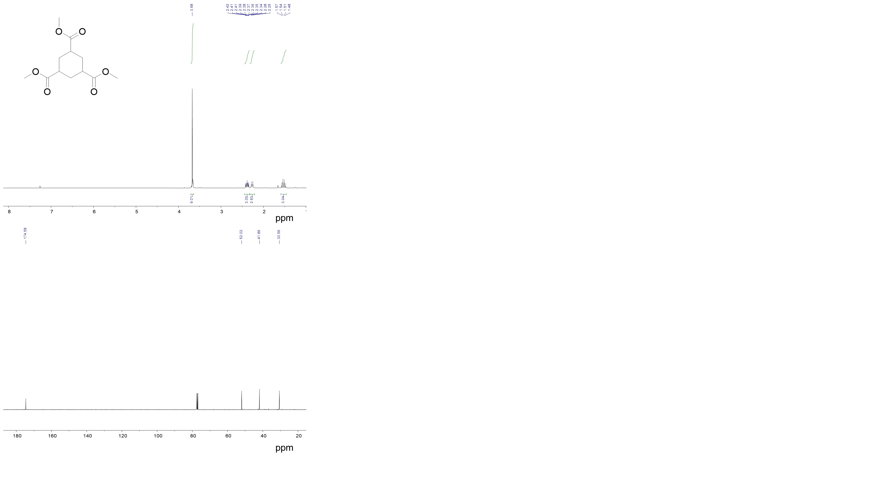

REFERENCES
(1) Xu, X.; Tang, M.; Li, M.; Li, H.; Wang, Y. Hydrogenation of Benzoic Acid and Derivatives over Pd Nanoparticles Supported on N‑Doped Carbon Derived from Glucosamine Hydrochloride. ACS Catal., 2014, 4, 3132-3135.
(2) Anderson, J. A.; Athawale, A. Imrie, F. E.; McKenna, F. M.; McCue, A.; Molyneux, D.; Power, K.; Shand, M.; Wells, R. P. K. Aqueous Phase Hydrogenation of Substituted Phenyls over Carbon Nanofibre and Activated Carbon Supported Pd. J. Catal., 2010, 270, 9–15.
(3) Anderson, J.; McKenna, F. M.; Linares-Solano, A.; Wells, R. K. Use of Water as a Solvent in Directing Hydrogenation Reactions of Aromatic Acids over Pd/carbon Nanofibre Catalysts. Catal. Lett., 2007, 119, 16-20.
(4) Jiang, H.; Yu, X.; Nie, R.; Lu, X.; Zhou, D.; Xia, Q. Selective Hydrogenation of Aromatic Carboxylic Acids over Basic N-Doped Mesoporous Carbon Supported Palladium Catalysts. Appl. Catal. A Gen., 2016, 520 , 73-81.
(5) Hu, Y.; Chen, W.; Xie, X.; Song, W. Carbon Nanotubes-Supported Well-Dispersed Pd Nanoparticles for the Efficiently Selective Hydrogenation of Benzoic Acid to Synthesize Cyclohexane Carboxylic Acid. Nano 2019, 14, 1950008.
(6) Chen, D.; Yang, W.; Jiao, L.; Li, L.; Jiang, H. L. Boosting Catalysis of Pd Nanoparticles in MOFs by Pore Wall Engineering: The Roles of Electron Transfer and Adsorption Energy. Adv. Mater., 2020, 2000041.
(7) Nie, R.; Jiang, H.; Lu, X.; Zhou, D.; Xia, Q. Highly Active Electron-Deficient Pd Clusters on N-Doped Active Carbon for Aromatic Ring Hydrogenation. Catal. Sci. Technol., 2016, 6, 1913-1920.
(8) Zhang, H.; Li, G.; Nie, R.; Lu, X.; Xia, Q. One-Pot Synthesized Mesoporous C-TiO₂ Hybrid for Ru Catalyzed Low-Temperature Hydrogenation of Benzoic Acid. J. Mater. Sci., 2019, 54, 7529–7540.
(9) Li, M.; Tang, M.; Deng, J.; Wang, Y. Nitrogen-Doped Flower-Like Porous Carbon Materials Directed by In Situ Hydrolysed MgO: Promising Support for Ru Nanoparticles in Catalytic Hydrogenations. Nano Res., 2016, 9, 3129-3140.
(10) Maegawa, T.; Akashi, A.; Yaguchi, K.; Iwasaki, Y.; Shigetsura, M.; Monguchi, Y.; Sajiki, H. Efficient and Practical Arene Hydrogenation by Heterogeneous Catalysts under Mild Conditions. Chem.-Eur. J., 2009, 15, 6953-6963.
(11) Cao, Y.; Tang, M.; Li, M.; Deng, J.; Xu, F.; Xie, L.; Wang, Y. In Situ Synthesis of Chitin-Derived Rh/N–C Cataylsts: Efficient Hydrogenation of Benzoic Acid and Derivatives. ACS Sustainable Chem. Eng., 2017, 5, 9894–9902.
(12) Wang, H.; Zhao, F. Catalytic Ring Hydrogenation of Benzoic Acid with Supported Transition Metal Catalysts in scCO₂. Int. J. Mol. Sci., 2007, 8, 628–634.
(13) Yu, T.; Wang, J.; Li, X.; Cao, X.; Gu, H. An Improved Method for the Complete Hydrogenation of Aromatic Compounds under 1 Bar H₂ with Platinum Nanowires, ChemCatChem 2013, 5, 2852-2855.
(14) Guo, Z.; Hu, L.; Yu, H.; Cao, X.; Gu, H. Controlled Hydrogenation of Aromatic Compounds by Platinum Nanowire Catalysts. RSC Adv., 2012, 2, 3477-3480.
(15)Tang, M.; Mao, S.; Li, X.; Chen, C.; Li, M.; Wang, Y. Highly Effective Ir-based Catalysts for the Benzoic Acid Hydrogenation: Experiment and Theory Guided Catalysts Rational Design. Green Chem., 2017, 19, 1766-1774.
(16) Tang, M.; Mao, S.; Li, M.; Wei, Z.; Xu, F.; Li, H.; Wang, Y. RuPd Alloy Nanoparticles Supported on N-doped Carbon as An Efficient and Stable Catalyst for Benzoic Acid Hydrogenation. ACS Catal., 2015, 5, 3100-3107.

