Supplementary Information
Title: Hydrothermal thresholds and microbial carbon use efficiency regulate seasonal litter decomposition dynamics in an arid ecosystem

Authors: Meiqi Li^{1, 2, 3, 4}, Yalan Liu^{1, 2, 3, 4}, Peng Wang^{1, 2, 3, 4}, Xiangyi Li^{1, 2, 3, 4}
¹Xinjiang Key Laboratory of Desert Plant Root Ecology and Vegetation Restoration, Xinjiang Institute of Ecology and Geography, Chinese Academy of Sciences, Urumqi 830011, China
²State Key Laboratory of Desert and Oasis Ecology, Xinjiang Institute of Ecology and Geography, Chinese Academy of Sciences, Urumqi, 830011
³National Field Scientific Observation and Experimental Station of Cele Desert Grassland Ecosystem, Celle 848300, Xinjiang, China
⁴University of Chinese Academy of Sciences, Beijing, 100049

* Corresponding authors
Corresponding authors’ address: Xinjiang Institute of Ecology and Geography, Chinese Academy of Sciences, Urumqi, 830011, China. E-mail: lixy@ms.xjb.ac.cn

Internal Reviewer Information: Fanjiang Zeng, Institute of Ecology and Geography, Xinjiang, zengfj@ms.xjb.ac.cn; Lei Li, Institute of Ecology and Geography, Xinjiang, lilei@ms.xjb.ac.cn
Appendix S1. Methodologies for precipitation manipulation and P addition

The Taklamakan Desert, located in the core of Central Asia's arid zone, is a major source of Asian dust. Regional atmospheric P deposition primarily originates from wind-eroded sediments in the Tarim Basin and surrounding deserts, supplemented by long-range transported mineral aerosols. Previous studies report that atmospheric P deposition fluxes in Central Asian arid regions range from 0.3 to 1.2 kg P ha⁻¹ yr⁻¹. Values near the southern edge of the Taklamakan Desert average 0.5–0.8 kg P ha⁻¹ yr⁻¹ (Tipping et al. 2014; Pan et al. 2021). Increasing human activities in the region have elevated atmospheric P inputs from agricultural fertilization and industrial emissions. Given this context, our P gradients span from ambient background levels to potential enrichment scenarios. This design systematically evaluates how litter decomposition responds to varying P inputs in an extremely arid environment. Additionally, P is a key limiting nutrient in arid ecosystems, and its effects are often modulated by precipitation availability. By elevating precipitation, we aim to reveal the "activation effect" of P addition on biogeochemical processes (Wang et al. 2022). To align with the natural precipitation regime of arid zones—low total volume, high frequency, and strong seasonality concentrated in warm seasons—supplemental rainfall was applied exclusively during the growing season (May–September). Precipitation was delivered in six equal monthly applications of 25 mm each (approximately 40 L per plot). This approach avoids risks associated with single heavy rainfall events, such as preferential flow, surface runoff, and nutrient leaching. Irrigation used portable suspended sprinkler systems. Rainfall intensity was strictly controlled at 10 mm h⁻¹, close to the median intensity of local intense precipitation events. Each irrigation lasted approximately 2.5 hours. All irrigations were conducted uniformly between 07:00 and 10:00 in the early morning to minimize evaporation losses and ensure uniform precipitation infiltration.
These levels cover a range from environmental background concentrations to critical thresholds sufficient to alleviate microbial P limitation (Gao et al. 2022; Gong et al. 2022). The P source was analytical-grade NaH₂PO₄·2H₂O (≥99.9%), prepared as stock solutions of 0, 2.0, 5.0, and 10.0 g P L⁻¹. The total annual liquid application per plot was strictly controlled at 2 L. Solutions were applied uniformly using a handheld compressed sprayer equipped with a fan nozzle under windless conditions (wind speed < 2 m s⁻¹). No surfactants were added, ensuring complete vertical infiltration without surface runoff or splash loss. P fertilizer was applied in two equal doses annually: on 10 May (vegetative regrowth stage) and 5 July (peak flowering stage). These dates coincide with key phenological stages of desert plants. The spraying sequence for each treatment was randomized daily to avoid operational bias and aerosol cross-contamination.

Appendix S2. Procedure for lignin determination

The samples underwent sequential pretreatment comprising cold acid hydrolysis with 72% (w/w) sulfuric acid, followed by high-pressure steam treatment at 121 °C for complete polysaccharide depolymerization, and subsequent acetone extraction to eliminate lipid interference. The resulting residue was dried to constant weight and gravimetrically quantified to determine the acid-insoluble lignin content (commonly referred to as Klason lignin). Acid-soluble lignin in the hydrolysate filtrate was quantified spectrophotometrically at 280 nm using a calibrated UV–Vis spectrophotometer. Total lignin content was calculated as the sum of acid-insoluble and acid-soluble lignin fractions, expressed as a mass percentage of the original dry sample weight. All analyses were performed in triplicate or more using independent biological replicates; procedural blanks were concurrently analyzed to correct for background interference. The relative standard deviation (RSD) across replicate measurements was consistently below 3.0%, indicating satisfactory analytical precision.

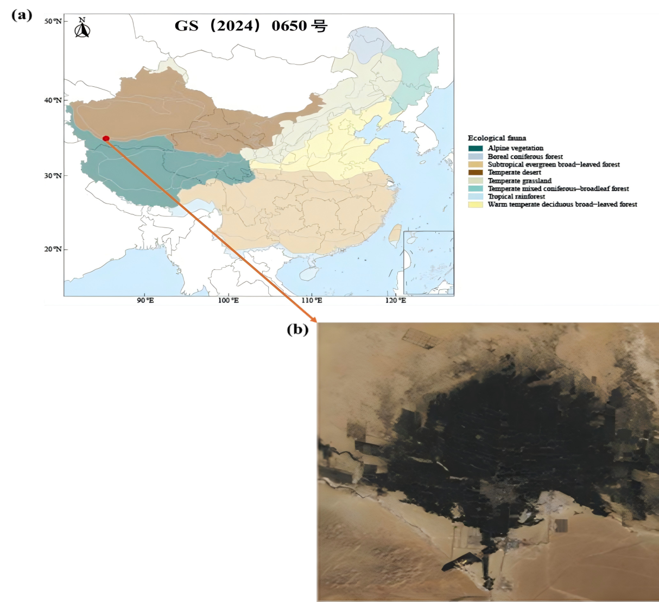
Fig. S1 Illustrations depicting the experimental study sites.

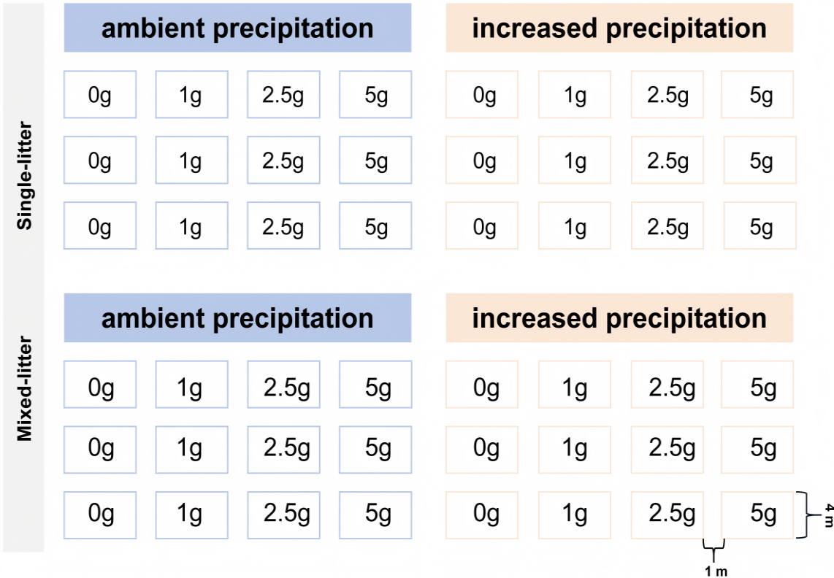
Fig. S2 Schematic diagram of the experimental design.

Table S1 Linear mixed-effects models revealed the effects of phosphorus addition (P), precipitation increase (W), and litter type (S) on soil physicochemical properties and stoichiometric ratios during summer and winter
Time | Factors |  | pH |  | SOC |  | TN |  | TP |  | AP |  | NO₃⁻ |  | NH₄⁺ |  | SOC/TN |  | SOC/TP |  | TN/TP
 |  | df | F | P | F | P | F | P | F | P | F | P | F | P | F | P | F | P | F | P | F | P
 | P | 3 | 8.308 | < .001 | 10.080 | < .001 | 81.986 | < .001 | 129.183 | < .001 | 118.233 | < .001 | 35.237 | < .001 | 76.909 | < .001 | 54.079 | < .001 | 85.607 | < .001 | 209.435 | < .001
 | W | 1 | 117.594 | < .001 | 45.233 | < .001 | 265.867 | < .001 | 31.444 | < .001 | 1.074 | .308 | .815 | .373 | 2.496 | .124 | 30.737 | < .001 | 76.963 | < .001 | 333.490 | < .001
 | S | 1 | .851 | .363 | 27.441 | < .001 | 70.597 | < .001 | .020 | .888 | 155.989 | < .001 | 501.463 | < .001 | 949.641 | < .001 | 21.478 | < .001 | 9.254 | .005 | 43.528 | < .001
Summer | P×W | 3 | 35.611 | < .001 | 6.869 | .001 | 156.404 | < .001 | 2.913 | .049 | 89.509 | < .001 | 386.303 | < .001 | 821.261 | < .001 | 88.687 | < .001 | 8.287 | < .001 | 113.786 | < .001
 | P×S | 3 | 20.309 | < .001 | 22.941 | < .001 | 25.452 | < .001 | 1.468 | .242 | 49.239 | < .001 | 178.954 | < .001 | 398.576 | < .001 | 20.150 | < .001 | 4.254 | .012 | 20.165 | < .001
 | W×S | 1 | 17.006 | < .001 | 37.857 | < .001 | 4.822 | .035 | 1.002 | .999 | 32.857 | < .001 | .703 | .408 | 1.590 | .216 | 27.392 | < .001 | 15.125 | < .001 | .006 | .941
 | P×W×S | 3 | 5.088 | .005 | 3.905 | .017 | 65.803 | < .001 | 11.066 | < .001 | 195.380 | < .001 | 115.476 | < .001 | 270.662 | < .001 | 26.574 | < .001 | 5.022 | .006 | 26.312 | < .001
 | P | 3 | 39.838 | < .001 | 56.733 | < .001 | 56.292 | < .001 | 100.514 | < .001 | 579.174 | < .001 | 255.039 | < .001 | 431.950 | < .001 | 34.277 | < .001 | 35.933 | < .001 | 66.818 | < .001
 | W | 1 | 259.669 | < .001 | 315.813 | < .001 | 181.582 | < .001 | 12.154 | .001 | 66.869 | < .001 | 182.285 | < .001 | 310.492 | < .001 | 24.234 | < .001 | 26.943 | < .001 | 59.171 | < .001
Winter | S | 1 | 30.289 | < .001 | 57.082 | < .001 | 4.862 | .035 | 2.510 | .123 | 277.723 | < .001 | 576.134 | < .001 | 897.121 | < .001 | 18.979 | < .001 | 21.397 | < .001 | 1.120 | .298
 | P×W | 3 | 3.410 | .029 | 65.456 | < .001 | 43.063 | < .001 | 22.039 | < .001 | 119.600 | < .001 | 216.064 | < .001 | 337.640 | < .001 | 14.684 | < .001 | 15.156 | < .001 | 13.683 | < .001
 | P×S | 3 | 2.029 | .130 | 39.401 | < .001 | 86.808 | < .001 | 12.879 | < .001 | 45.758 | < .001 | 105.974 | < .001 | 174.492 | < .001 | 35.317 | < .001 | 35.501 | < .001 | 40.436 | < .001
 | W×S | 1 | 20.482 | < .001 | 74.930 | < .001 | 253.640 | < .001 | .787 | .382 | 270.449 | < .001 | 28.338 | < .001 | 60.850 | < .001 | 174.090 | < .001 | 165.905 | < .001 | 107.177 | < .001
 | P×W×S | 3 | 6.964 | .001 | 140.820 | < .001 | 26.549 | < .001 | 4.978 | .006 | 62.148 | < .001 | 207.884 | < .001 | 341.490 | < .001 | 22.880 | < .001 | 24.998 | < .001 | 2.402 | .086
Note: Values shown in bold denote statistically significant effects at p < 0.05.
Table S2 Linear mixed-effects models revealed the effects of phosphorus addition (P), precipitation increase (W), and litter type (S) on soil microbial biomass C, N, and P, their stoichiometric ratios, and nutrient use efficiencies during summer and winter
Time | Factors |  | MBC |  | MBN |  | MBP |  | MBC/MBN |  | MBC/MBP |  | MBN/MBP |  | CUE |  | NUE |  | PUE
 |  | df | F | P | F | P | F | F | P | P | F | P | F | P | F | P | F | P | F | P
 | P | 3 | 219.467 | < .001 | 152.867 | < .001 | 127.657 | < .001 | 9.827 | < .001 | 167.002 | < .001 | 32.835 | < .001 | 12.293 | < .001 | .991 | .409 | .874 | .465
 | W | 1 | 389.210 | < .001 | 794.799 | < .001 | 44.793 | < .001 | 453.984 | < .001 | 390.776 | < .001 | 607.877 | < .001 | 240.225 | < .001 | 15.687 | < .001 | 9.692 | < .001
 | S | 1 | 171.314 | < .001 | 530.190 | < .001 | 279.974 | < .001 | 72.314 | < .001 | 349.139 | < .001 | 561.486 | < .001 | 6.384 | .017 | 4.166 | .050 | 4.583 | .040
Summer | P×W | 3 | 146.628 | < .001 | 412.308 | < .001 | 401.663 | < .001 | 16.467 | < .001 | 923.757 | < .001 | 182.230 | < .001 | 6.754 | < .001 | 1.782 | .170 | 2.026 | .130
 | P×S | 3 | 254.308 | < .001 | 162.609 | < .001 | 60.795 | < .001 | 56.041 | < .001 | 895.547 | < .001 | 714.028 | < .001 | 2.690 | .063 | .820 | .492 | .659 | .583
 | W×S | 1 | 195.322 | < .001 | 30.186 | < .001 | 101.806 | < .001 | 55.016 | < .001 | 70.374 | < .001 | 185.769 | < .001 | .822 | .371 | 4.738 | .037 | 4.747 | .037
 | P×W×S | 3 | 163.452 | < .001 | 139.023 | < .001 | 410.268 | < .001 | 51.768 | < .001 | 444.580 | < .001 | 770.580 | < .001 | 4.251 | .012 | .737 | .538 | .462 | .711
 | P | 3 | 331.600 | < .001 | 42.346 | < .001 | 225.437 | < .001 | 7.191 | .001 | 103.142 | < .001 | 44.323 | < .001 | .361 | .552 | 2.268 | .100 | 2.120 | .117
 | W | 1 | 93.316 | < .001 | 76.850 | < .001 | 104.894 | < .001 | 15.828 | < .001 | 31.762 | < .001 | 131.783 | < .001 | 15.226 | < .001 | 26.785 | < .001 | 16.266 | < .001
Winter | S | 1 | 1.567 | .220 | 17.961 | < .001 | 318.338 | < .001 | .001 | .977 | 32.972 | < .001 | 28.853 | < .001 | 20.379 | < .001 | .933 | .341 | .025 | .875
 | P×W | 3 | 94.588 | < .001 | 48.612 | < .001 | 345.046 | < .001 | 13.991 | < .001 | 108.761 | < .001 | 77.258 | < .001 | 12.886 | < .001 | 1.475 | .240 | 1.306 | .289
 | P×S | 3 | 315.502 | < .001 | 7.390 | .001 | 353.858 | < .001 | 1.275 | .300 | 86.745 | < .001 | 11.022 | < .001 | 7.426 | < .001 | .201 | .895 | .649 | .590
 | W×S | 1 | 718.083 | < .001 | 82.830 | < .001 | 23.358 | < .001 | 1.859 | .182 | 531.406 | < .001 | 99.780 | < .001 | 17.892 | < .001 | 3.981 | .055 | 3.139 | .086
 | P×W×S | 3 | 211.866 | < .001 | .422 | .738 | 280.246 | < .001 | 10.004 | < .001 | 251.285 | < .001 | 1.820 | .163 | 1.820 | .163 | .088 | .966 | .327 | .806
Note: Values shown in bold denote statistically significant effects at p < 0.05.
Table S3 Linear mixed-effects models revealed the effects of phosphorus addition (P), precipitation increase (W), and litter type (S) on soil extracellular enzyme activities and stoichiometric ratios during summer and winter
Time | Factors |  | BG |  | LAP |  | ALP |  | PPO |  | POD |  | ln(BG)/ln(LAP) |  | ln(BG)/ln(ALP) |  | ln(LAP)/ln(ALP) |  | ln(POD)/ln(LAP) |  | ln(POD)/ln(ALP)
 |  | df | F | P | F | P | F | P | F | P | F | P | F | P | F | P | F | P | F | P | F | P
 | P | 3 | 5.631 | < .001 | 10.650 | < .001 | 10.490 | < .001 | 2.800 | .056 | 5.836 | .003 | .725 | .545 | .731 | .541 | 1.180 | .333 | 2.268 | .099 | 1.895 | .150
 | W | 1 | 2.178 | .040 | 139.499 | < .001 | 106.867 | < .001 | 82.847 | < .001 | 71.260 | < .001 | 11.764 | < .001 | 7.823 | < .001 | 10.529 | < .001 | 14.328 | < .001 | 10.568 | < .001
 | S | 1 | .210 | .650 | 2.473 | .126 | 9.532 | .004 | 47.149 | < .001 | .142 | .709 | .417 | .523 | 3.749 | .062 | 4.881 | .034 | .003 | .956 | 4.242 | .048
Summer | P×W | 3 | .198 | .007 | 2.337 | .022 | 23.056 | < .001 | 1.773 | .172 | 2.577 | .071 | .881 | .461 | 1.469 | .242 | 2.671 | .064 | 1.515 | .230 | 2.872 | .052
 | P×S | 3 | 2.044 | .128 | 4.721 | < .001 | 1.232 | .314 | 1.714 | .184 | .095 | .962 | 1.674 | .192 | .686 | .567 | .660 | .583 | 1.820 | .163 | .978 | .415
 | W×S | 1 | .366 | .550 | 3.905 | .057 | 2.408 | .131 | 17.821 | < .001 | .800 | .378 | .033 | .856 | 4.096 | .051 | 4.770 | .036 | .114 | .738 | 4.329 | .046
 | P×W×S | 3 | .335 | .800 | 5.570 | < .001 | .928 | .439 | .526 | .667 | .679 | .571 | 1.825 | .162 | .550 | .652 | .435 | .730 | 1.791 | .169 | .853 | .475
 | P | 3 | 7.778 | < .001 | 1.001 | .405 | 4.004 | .016 | 2.805 | .045 | .547 | .654 | 1.463 | .243 | 2.513 | .076 | 1.731 | .180 | 1.671 | .193 | 1.292 | .294
 | W | 1 | 2.614 | .116 | 14.410 | < .001 | 27.932 | < .001 | .015 | .903 | .321 | .575 | 20.708 | < .001 | 17.822 | < .001 | 13.525 | .001 | 12.583 | < .001 | 11.735 | < .001
Winter | S | 1 | 1.533 | .225 | .534 | .470 | 1.129 | .296 | 13.133 | .001 | .762 | .389 | 4.987 | .033 | .110 | .742 | 1.005 | .989 | 3.513 | .070 | .064 | .802
 | P×W | 3 | .571 | .038 | .672 | .576 | 2.543 | .074 | .757 | .526 | 1.713 | .184 | 2.678 | .064 | 1.241 | .311 | 1.350 | .276 | 1.737 | .179 | 1.438 | .250
 | P×S | 3 | 1.576 | .214 | .671 | .576 | .136 | .938 | .968 | .420 | .008 | .999 | .486 | .694 | .506 | .681 | .771 | .519 | .349 | .790 | .582 | .631
 | W×S | 1 | 1.201 | .281 | .933 | .341 | 3.978 | .055 | .060 | .809 | 4.362 | .045 | 2.037 | .163 | 3.491 | .071 | 2.699 | .110 | 1.076 | .307 | 2.461 | .127
 | P×W×S | 3 | 1.567 | .216 | .443 | .724 | .173 | .914 | .044 | .988 | .626 | .603 | .023 | .995 | .288 | .834 | .399 | .755 | .034 | .991 | .335 | .800
Note: Values shown in bold denote statistically significant effects at p < 0.05.
References
Tipping E, Benham S, Boyle JF, Crow P, Davies J, Fischer U, Guyatt H, Helliwell R, Jackson-Blake L, Lawlor AJ, Monteith DT, Rowe EC, Toberman H (2014) Atmospheric deposition of phosphorus to land and freshwater. Environ Sci Process Impacts 16:1600–1617. https://doi.org/10.1039/C3EM00641G
Pan Y, Liu B, Cao J, Liu J, Tian S, Du E, et al (2021) Enhanced atmospheric phosphorus deposition in Asia and Europe in the past two decades. Atmos Ocean Sci Lett 14:100051. https://doi.org/10.1016/j.aosl.2021.100051
Wang WX, Luan JW, Wang Y, et al (2022) Effects of simulated drought and phosphorus addition on leaf litter decomposition in a lowland tropical rainforest. Acta Ecol Sin 42:6160–6174.
Gao Y, Tariq A, Zeng FJ, Li XY, Sardans J, Al-Bakre DA, Peñuelas J (2025) Metagenomics reveals divergent functional profiles of soil C and nitrogen cycles in an experimental drought and P-poor desert ecosystem. Appl Soil Ecol 207:105946. https://doi.org/10.1016/j.apsoil.2025.105946
Gong JR, Zhang ZH, Zhu CC, et al (2022) The response of litter decomposition to phosphorus addition in typical temperate grassland in Inner Mongolia. J Arid Environ 197:104677. https://doi.org/10.1016/j.jaridenv.2022.104677

