Supplementary material
Appendix 1: Quality assessment of the included studies with JBI tools
Table 1 Quality assessment of the included studies on risk factors associated with high occurrence of HAIs among TB hospitalized patients with JBI checklist for cross-sectional study
Questions/ Study |  | Xiang et al. (2019) | Jiang et al. (2019) | Zhou et al. (2018) | Huang et al. (2019) | Chen et al. (2018) | Liu et al. (2015) | Dai et al. (2014) | Gong & Wang (2013) | Zhang et al. (2012) | Zhong et al. (2010) | Zeng (2015)
1. Were the criteria for inclusion in the sample clearly defined? | Yes | √ | √ | √ | √ | √ | √ | √ | √ | √ | √ | √
 | Unclear
 | No
 | Not applicable
2. Were the study subjects and the setting described in detail? | Yes
 | Unclear
 | No | √ | √ | √ | √ | √ | √ | √ | √ | √ | √ | √
 | Not applicable
3. Was the exposure measured in a valid and reliable way? | Yes
3. Was the exposure measured in a valid and reliable way? | Unclear | √ | √ | √ | √ | √ |  |  |  | √ | √
3. Was the exposure measured in a valid and reliable way? | No |  |  |  |  |  | √ | √ | √ |  |  | √
3. Was the exposure measured in a valid and reliable way? | Not applicable
4. Were objective, standard criteria used for measurement of the condition? | Yes | √ | √ | √ | √
 | Unclear |  |  |  |  | √ |  |  |  | √ | √
 | No |  |  |  |  |  | √ | √ | √ |  |  | √
 | Not applicable
5. Were confounding factors identified? | Yes | √ | √ | √ | √ | √ | √ | √ | √ | √ | √ | √
5. Were confounding factors identified? | Unclear
5. Were confounding factors identified? | No
5. Were confounding factors identified? | Not applicable
6. Were strategies to deal with confounding factors stated? | Yes | √ | √ | √ | √ |  |  |  | √
6. Were strategies to deal with confounding factors stated? | Unclear
6. Were strategies to deal with confounding factors stated? | No |  |  |  |  | √ | √ | √ |  | √ | √ | √
6. Were strategies to deal with confounding factors stated? | Not applicable
7. Were the outcomes measured in a valid and reliable way? | Yes | √ | √ | √ | √ | √ | √ | √ | √ | √ | √ | √
7. Were the outcomes measured in a valid and reliable way? | Unclear
7. Were the outcomes measured in a valid and reliable way? | No
7. Were the outcomes measured in a valid and reliable way? | Not applicable
8. Was appropriate statistical analysis used? | Yes | √ | √ | √ | √ | √ |  | √ | √ | √ | √ | √
8. Was appropriate statistical analysis used? | Unclear
8. Was appropriate statistical analysis used? | No |  |  |  |  |  | √
8. Was appropriate statistical analysis used? | Not applicable

Appendix 2: Forest plots of the risk factors in the meta-analyses

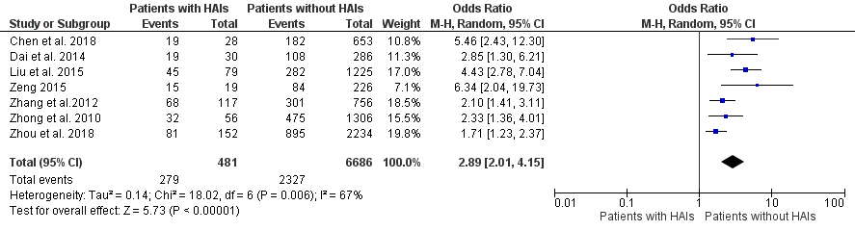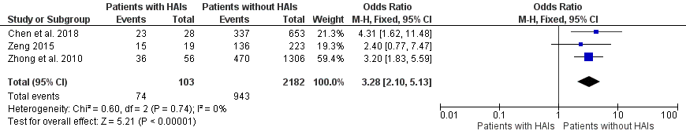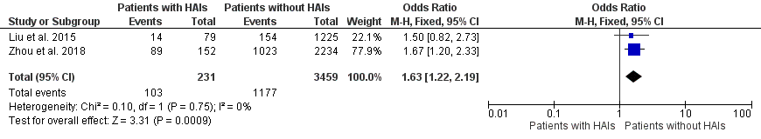
Figure 1-1 Age (≥ 60 years vs. < 60 years) Figure 1-2 Complications (Yes vs. No) Figure 1-3 Diabetes mellitus (Yes vs. No)

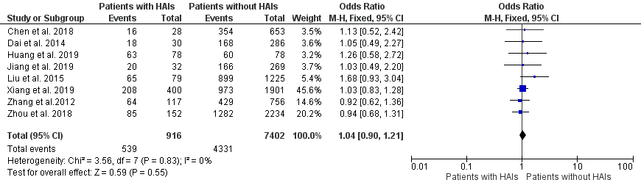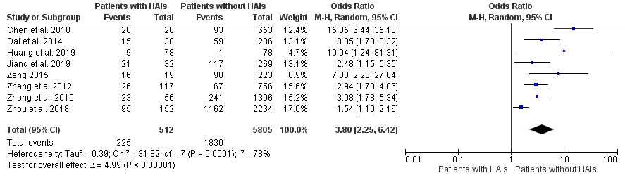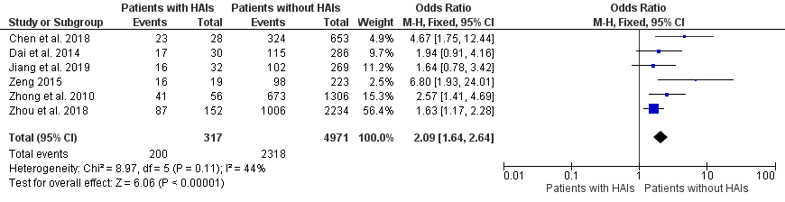
Figure 1-4 Gender (Male vs. Female) Figure 1-5 Invasive procedure (Yes vs. No) Figure 1-6 Length of hospitalization (> 15 days vs. ≤ 15 days)

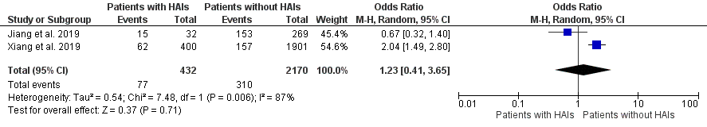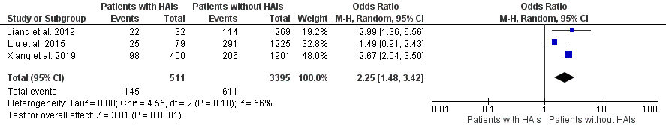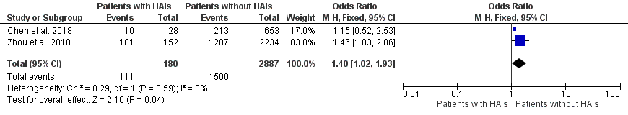
Figure 1-7 Negativity of the sputum smear for acid fact staining (Yes vs. No) Figure 1-8 Secondary tuberculosis (Yes vs. No) Figure 1-9 Smoking (Yes vs. No)

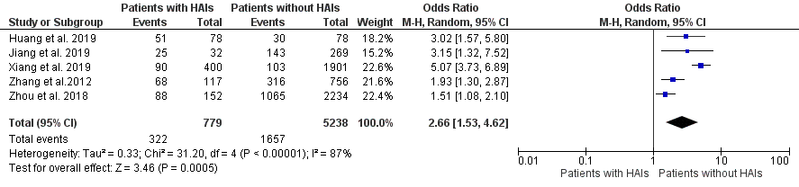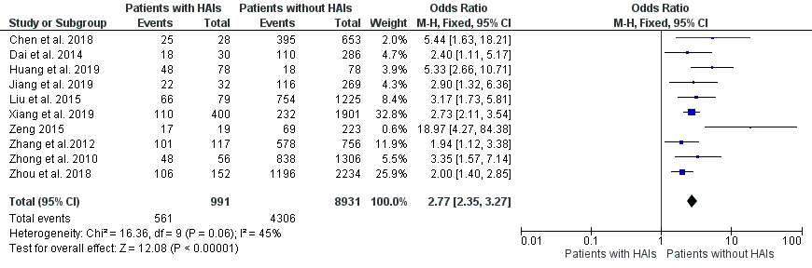
Figure 1-10 Underlying disease (Yes vs. No) Figure 1-11 Use of antibiotics (Yes vs. No)

