Mechanochemically covalently functionalized hexagonal boron nitride with proanthocyanidins for high-performance cellulose packaging toward fresh fruit preservation
Fatima Ait Aissa, Xue Jiang*, Xiuzhi Tian*
College of Bioresources Chemical and Materials Engineering, Shaanxi University of Science & Technology, Xi'an, Shaanxi, 710021, China.
E-mail address: LB01220927@sust.edu.cn (F. Ait Aissa), Xue Jiang, jiangx@sust.edu.cn (X. Jiang) , Xiuzhi Tian, tianxz@sust.edu.cn (X. Tian)

Supporting Information

Degree of polymerization test of cellulose pulp
Preparation method of copper ethylenediamine solution
Copper ethylenediamine (CED) solution must be prepared strictly in accordance with Appendix A of GB/T 1548-2016. The core is the reaction of copper acetate and ethylenediamine in water to form a deep blue complex, and the final copper ion concentration needs to be calibrated to 0.025 mol/L ± 0.0005 mol/L. ‌‌
Standard preparation process:
- Raw material preparation: anhydrous copper acetate (Cu (CH₃COO)₂, analytical grade), ethylenediamine (C₂H₈N₂, analytical grade), freshly boiled and cooled distilled water (deoxygenated).
- Dissolve copper salts: Weigh an appropriate amount of anhydrous copper acetate (theoretical amount corresponds to 0.025 mol/L), dissolve it in partially distilled water, and stir until completely dissolved.
- Complexation reaction: Slowly add a calculated amount of ethylenediamine while stirring, and the solution will appear transparent dark blue; Control the feeding speed to prevent local overheating or side reactions.
- Constant volume and maturation: Dilute with distilled water to the mark, mix well, and let it stand in the dark for maturation (48 hours to stabilize the complexation equilibrium).
- Calibration confirmation: The copper ion concentration were calibrated by iodometric or atomic absorption methods to ensure that it is within the range of 0.025 ± 0.0005 mol/L before use.
Determining the polymerization degree of cellulose using copper ethylenediamine (CED) solution
Instrument: Ubbelohde viscometer (capillary inner diameter 0.5-0.8mm, t ₀>100s), constant temperature water bath (25 ± 0.1℃), electronic balance (accuracy 0.0001g), oven, magnetic stirrer/oscillator, sand core funnel, brown wide mouth bottle, stopwatch.
Reagents: Standard copper ethylenediamine solution (copper concentration of about 0.025 mol/L, to be calibrated), nitrogen, distilled water.
Environment: Avoid light throughout the process, and nitrogen should be used to drive oxygen during the dissolution process to prevent cellulose oxidation and degradation. ‌‌
Detailed operation steps:
- Sample pretreatment: Take cellulose samples, disassemble and cut them to less than 2mm, dry them in an oven at 105-110 ℃ for more than 6 hours to constant weight, and cool them in a dryer to room temperature.
- Accurate weighing and dissolution: Accurately weigh about 25mg (accurate to 0.0002g) of dry sample and place it in a brown bottle. Add about 3g of fine copper wire (anti-oxidation), and add CED solution and distilled water in a specific ratio (usually prepared to a mass concentration of 0.05g/100mL, or 0.5g/L); Remove air by passing nitrogen for 60 seconds, seal and shake at room temperature for 2-3 hours until completely dissolved, filter and set aside for later use.
- Viscometer liquid filling and constant temperature: Place the Ubbelohde viscometer vertically in a 25 ± 0.1 ℃ water bath, inject about 12mL of the test liquid, and maintain constant temperature equilibrium for 15 minutes.
- Measure the outflow time (t₁): Draw liquid above the upper scale of the capillary tube, let it fall freely, and record the time it takes for the liquid level to flow through the upper and lower scale lines; Repeat 3 times with an error of ≤ 0.2s, take the average value t₁.
- Blank determination (t₀): Rinse the viscometer with pure CED solution three times, measure the blank solvent outflow time using the same method, repeat three times, and take the average value t₀. ‌‌
- Data Processing and Computation:
Calculate the increased viscosity: η_{sp}=(t₁− t₀)/t₀.
Calculate the intrinsic viscosity: When the concentration C is 0.05g/100mL, the commonly used Schulz Braunschweig formula simplifies the calculation [η] ≈ η_{sp}/C (strict extrapolation or table correction is required).
Calculate the average degree of polymerization (DP): Substitute into the empirical formula, DP=([η]/K)^{1/α}, the K value is taken as 8 × 10⁻³).
Experimental of composite paper
About 1 g of pure PACI was dissolved in 100 mL of deionized (DI) water, followed by high-power probe sonication at 1800 W for 1 h. The resulting dispersion was then used to fabricate cellulose/pure PACI composite paper. Subsequently, both the prepared paper and the dispersion were compared with cellulose/h-BN-g-PACI composite paper and h-BN-g-PACI dispersion, as illustrated in Fig. S1.
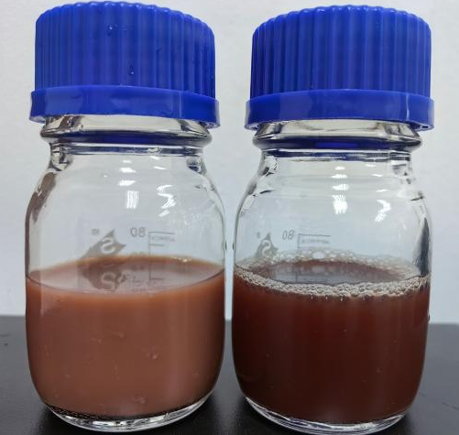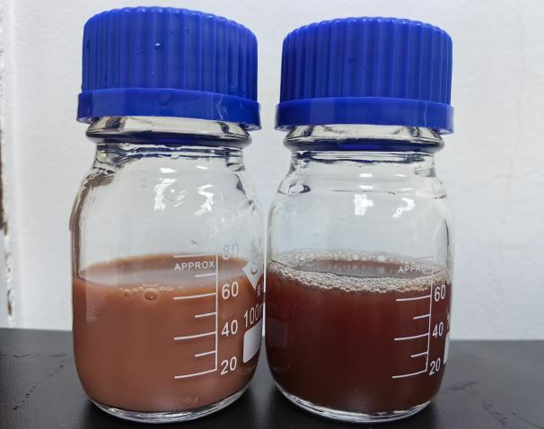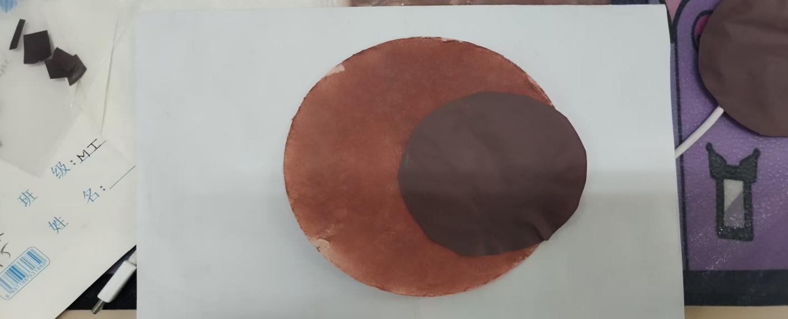
A.
B.
C.
Figure. S1 Photographs of (A) aqueous dispersions of h-BN-g-PACI (left) and pure PACI (right) after sonication/settling comparison and (C) the resulting composite papers: cellulose/h-BN-g-PACI (dark brown) and cellulose/pure PACI (light brown).
Cellulose pulp preparation procedure
Cellulose pulp with a freeness level of 80 °SR was the first to be acquired. To swell the fibers, an aqueous isopropanol solution was added at a certain temperature. The cationic pulp (CMCF) was prepared by a reaction with the cationic reagent 2,3-epoxypropyltrimethylammonium chloride under strongly alkaline conditions. The procedure was as follows: softwood pulp was suspended in deionized (DI) water, and NaOH was added to bring the pH to 10-12. Isopropanol was further added, and the mixture was stirred for 3 hours at 70 °C to achieve full dispersion and swelling. After this time, 2,3-epoxypropyltrimethylammonium chloride was added to the mixture, and the reaction was continued at 70 °C for 5 hours. Finally we neutralise the pH, as shown in the Fig. S2.
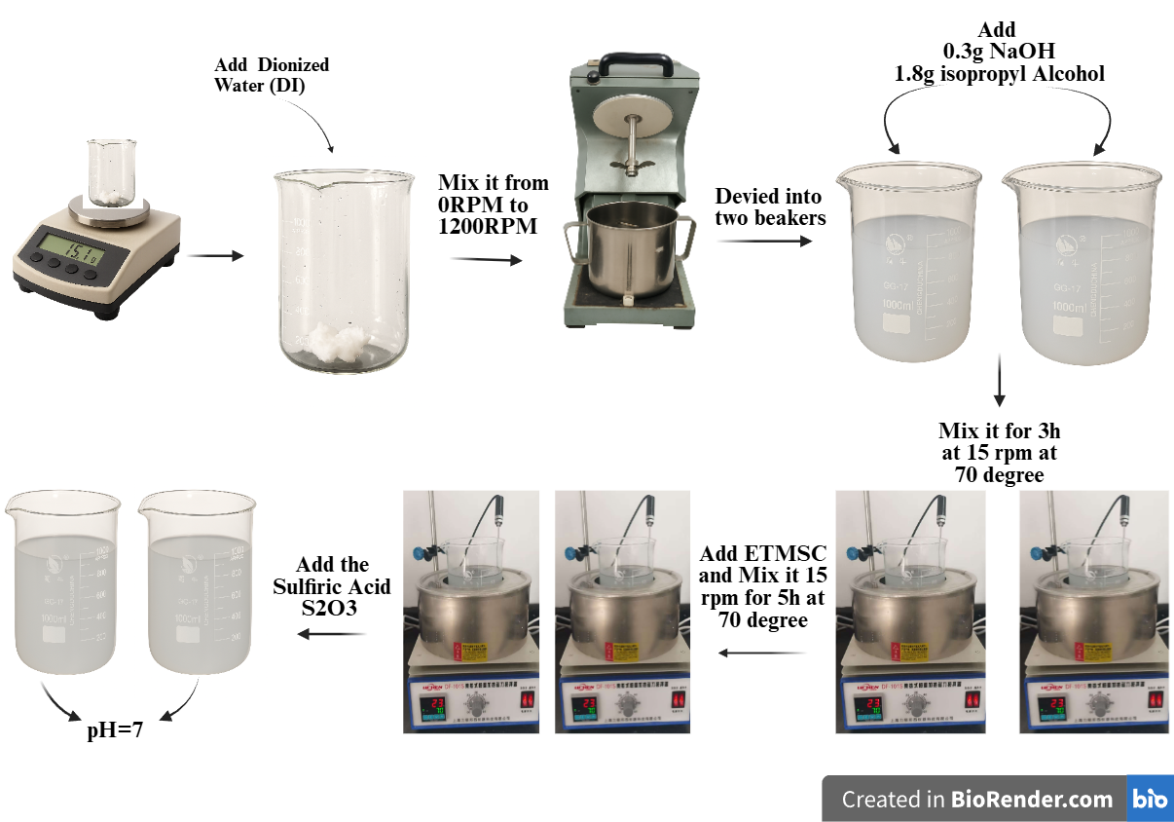
Fig. S2 Procedure of the preparation process of cellulose pulp.
Preservation effect of cellulose/h-BN-g-PACI 40% composite paper on cherry tomatoes
The fresh Cherry tomatoes were purchased directly from the supermarket, weighing around 15 g per tomato, and free of any surface defect, mould or bruises. They were gently washed, blotted dry and air dried for 15 minutes prior to packing. All fruits were from the same batch on the same day of purchase to avoid biological variance. The four packaging groups referenced above had the following specifications: 3 fruits of the same type per package; 6 replicate packages: G1 (uncovered control, Baseline spoilage reference); G2 (commercial PP film); G3 (neat cellulose paper) and G4 (cellulose/h-BN-g-PACI 40 % composite paper). Throughout the experimental period, all groups were kept together at room temperature (25 °C) in a laboratory with no direct sunlight or air drafts. The relative humidity was left uncontrolled, but the Brix value and weight lost was measured each 4 days with a digital refractometer, and reported as a measured value (mean ± SD). The trial lasted from day 0 to day 24. In the case of the G4 fruits still being visibly intact, observations were extended to day 12 as an additional endpoint. Evaluation commenced with baseline film and fruit measurements recorded on day 0 before sealing. Representative photographs were taken at each storage interval to visually document the changes in fruit quality.
FT-IR and XRD Analysis of cellulose/h-BN-g-PACI composite Papers
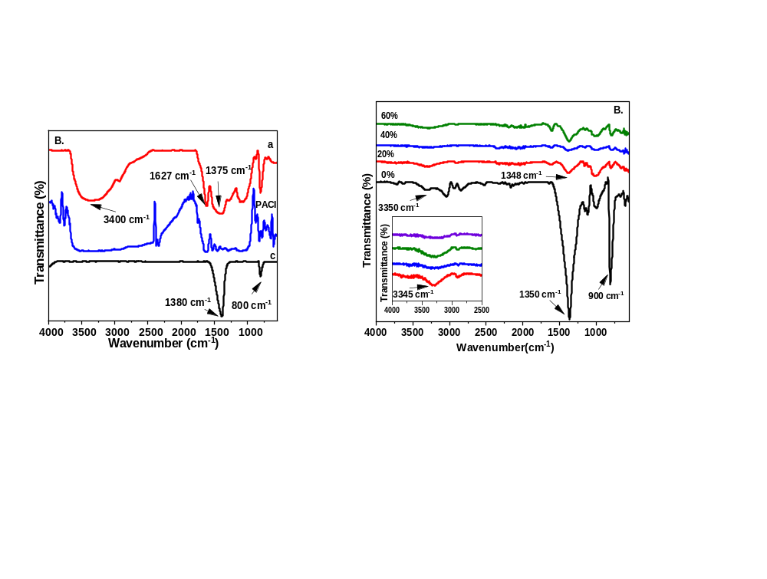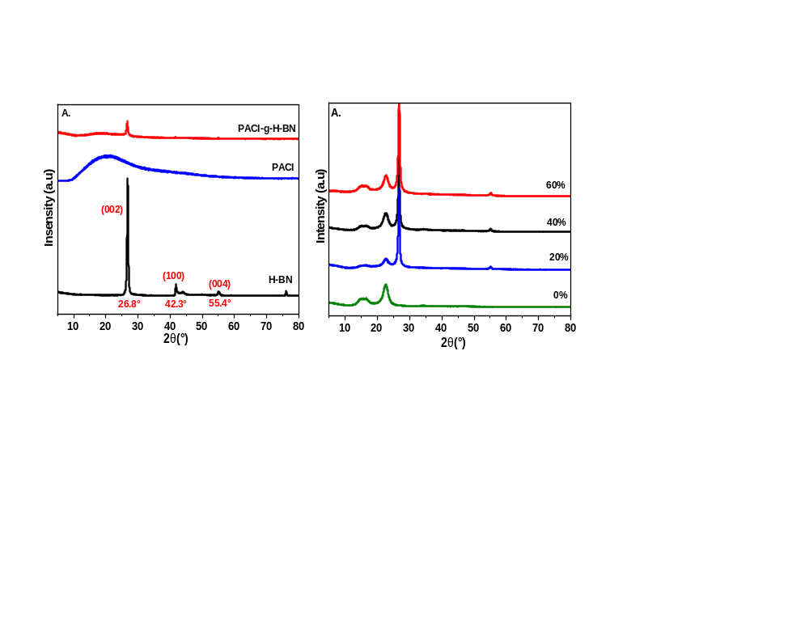Fig. S3 (A) X-ray diffraction (XRD) patterns and (B) Fourier-transform infrared (FTIR) spectra of pure cellulose paper and cellulose/h-BN-g-PACI composite papers with 20 %, 40 %, and 60 % h-BN-g-PACI filler loading.

