SUPLEMENTARY INFORMATION

16S rRNA phylogeny outperforms similarity thresholds for species identification and reveals genus-dependent underestimation of Lactobacillales diversity

Alejandra Rojas-Villegas¹, Verónica Yepes-Medina¹, Valeska Villegas-Escobar², Juan Fernando Díaz-Nieto^{2*}

¹School of Applied Sciences and Engineering, Universidad EAFIT, Medellín, Colombia.
²Area of Fundamental Sciences, School of Applied Sciences and Engineering, Universidad EAFIT, Medellín, Colombia.
³Area of Natural Systems and Sustainability, School of Applied Sciences and Engineering. Universidad EAFIT, Medellín, Colombia.
*Corresponding author: Email: jdiazni@eafit.edu.co

Table of contents

TABLES 3
Table 1. Sampling details for microbiological isolation from the Colombian fermented and plant-derived products. 3
Table 2. Summary of taxonomic assignments obtained for each strain. 3
Table 3. BLASTn results against the NCBI database for strains assigned to order Lactobacillales. 3
Table 4. Genomic accession numbers for the type species of each genus within the order Lactobacillales. 4
Table 5. Species from the order Lactobacillales excluded from the phylogenetic analysis. 6
Table 6. Relative abundance of strains identified at the genus-level within families of the Lactobacillales order. 7
Table 7. Resolution of 16S rRNA-based identification and abundance across isolates within genera of Lactobacillales. 8
Table 8. Amplicon sequencing cost estimation for the MinION-Flongle workflow at Universidad EAFIT. 10
Table 9. GenBank accession numbers assigned to the 16S rRNA gene sequences of LAB isolates included in this study 10
FIGURES 11
Fig. 1 Phylogenetic reconstruction among Bavariicoccus isolates based on 16S rRNA gene sequences. 11
Fig. 2 Phylogenetic reconstruction among Carnobacterium isolates based on 16S rRNA gene sequences. 11
Fig. 3 Phylogenetic reconstruction among Fructobacillus isolates based on 16S rRNA gene sequences. 12
Fig. 4 Phylogenetic reconstruction among Lacticaseibacillus isolates based on 16S rRNA gene sequences. 13
Fig. 5 Phylogenetic reconstruction among Lactococcus isolates based on 16S rRNA gene sequences. 14
Fig. 6 Phylogenetic reconstruction among Limosilactobacillus isolates based on 16S rRNA gene sequences. 15
Fig. 7 Phylogenetic reconstruction among Paucilactobacillus isolates based on 16S rRNA gene sequences. 15
Fig. 8 Phylogenetic reconstruction among Pediococcus isolates based on 16S rRNA gene sequences. 16
Fig. 9 Phylogenetic reconstruction among Weissella isolates based on 16S rRNA gene sequences. 16
Fig. 10 Phylogenetic reconstruction among Liquorilactobacillus isolates based on 16S rRNA gene sequences. 17
Fig. 11 Phylogenetic reconstruction among Loigolactobacillus isolates based on 16S rRNA gene sequences. 17
Fig. 12 Phylogenetic reconstruction among Pseudolactococcus isolates based on 16S rRNA gene sequences. 18
Fig. 13 Phylogenetic reconstruction among Lactiplantibacillus isolates based on 16S rRNA gene sequences. 19
Fig. 14 Phylogenetic reconstruction among Enterococcus isolates based on 16S rRNA gene sequences. 20
Fig. 15 Phylogenetic reconstruction among Latilactobacillus isolates based on 16S rRNA gene sequences. 21
Fig. 16 Phylogenetic reconstruction among Leuconostoc isolates based on 16S rRNA gene sequences. 22
Fig. 18 Phylogenetic reconstruction among Levilactobacillus isolates based on 16S rRNA gene sequences. 24
Fig. 19 Phylogenetic reconstruction among Aerococcus isolates based on 16S rRNA gene sequences. 25
Fig. 21 Phylogenetic reconstruction among Furfurilactobacillus isolates based on 16S rRNA gene sequences. 26

TABLES

Table 1. Sampling details for microbiological isolation from the Colombian fermented and plant-derived products.
The table includes isolate collection code, sampling date, source of isolation, sampling locality, culture conditions, colony morphology and cell staining.
See Supplementary_file1 Table_1.

Table 2. Summary of taxonomic assignments obtained for each strain.
The table includes classifications generated with SILVA v138.2, including taxonomic outputs from EMBL/EBI ENA, GTDB, LTP and RDP classification, as well as NCBI BLASTn results and phylogenetic identification obtained in this study.
See Supplementary_file1 Table_2.

Table 3. BLASTn results against the NCBI database for strains assigned to order Lactobacillales.
The table includes query ID, percent identity, bitscore, e-value, hit description, accession number, query and sequence lengths.
See Supplementary_file1 Table_3

Table 4. Genomic accession numbers for the type species of each genus within the order Lactobacillales.
For species with available genome sequences, GenBank and NCBI RefSeq assembly numbers are reported. All listed species correspond to their respective type strains. “N/A” indicates that no genome assembly accession was available in the corresponding database.

Type species | Type strain | GenBank assembly | NCBI RefSeq assembly
Abiotrophia defectiva | DSM 9849 | GCA_013267415.1 | GCF_013267415.1
Acetilactobacillus jinshanensis | HSLZ-75 | GCA_004359375.1 | GCF_004359375.1
Aerococcus viridans | CCUG 4311 | GCA_001543285.1 | GCF_001543285.1
Agrilactobacillus composti | DSM 18527 | GCA_001436375.1 | GCF_001436375.1
Alkalibacterium olivapovliticum | DSM 13175 | GCA_003003275.1 | GCF_003003275.1
Allofustis seminis | DSM 15817 | GCA_000374325.1 | GCF_000374325.1
Alloicoccus otitis | ATCC 51267 | GCA_000315445.1 | GCF_000315445.1
Amylolactobacillus amylophilus | DSM 20533 | GCA_001936335.1 | GCF_001936335.1
Apilactobacillus kunkeei | YH-15 | GCA_001281265.1 | GCF_001281265.1
Atopobacter phocae | ATCC BAA-285 | GCA_000526675.1 | GCF_000526675.1
Atopococcus tabaci | DSM 17538 | GCA_000429585.1 | GCF_000429585.1
Atopostipes suicloacalis | DSM 15692 | GCA_900129085.1 | GCF_900129085.1
Bavariicoccus seileri | DSM 19936 | GCA_000421665.1 | GCF_000421665.1
Betacoccus arabinosaceus | N/A | N/A | N/A
Bombilactobacillus mellifer | Bin4 | GCA_000970795.1 | GCF_000970795.1
Carnobacterium divergens | NCTC13772 | GCA_900446755.1 | GCF_900446755.1
Carnococcus allantoicus | N/A | N/A | N/A
Catelicoccus marimammalium | M35/04/3 | GCA_000313915.1 | GCF_000313915.1
Cillobacterium moniliforme | N/A | N/A | N/A
Companilactobacillus alimentarius | DSM 20249 | GCA_002849895.1 | GCF_002849895.1
Convivina intestini | DSM 28795 | GCA_003096575.1 | GCF_003096575.1
Dellaglioa algida | DSM 15638 | GCA_001434695.1 | GCF_001434695.1
Desemzia incerta | DSM 20581 | GCA_900115825.1 | GCF_900115825.1
Dolosicoccus paucivorans | DSM 15742 | GCA_900100125.1 | GCF_900100125.1
Dolosigranulum pigrum | ATCC 51524 | GCA_000245815.1 | GCF_000245815.1
Enterococcus faecalis | DSM 20478 | GCA_029024925.1 | GCF_029024925.1
Eremococcus coleocola | DSM 15696 | GCA_000428865.1 | GCF_000428865.1
Eupransor demetentiae | LMG 33000 | GCA_963930865.1 | GCF_963930865.1
Facklamia hominis | CCUG 36813 | GCA_000301035.1 | GCF_000301035.1
Floricoccus tropicus | DF1 | GCA_001832905.1 | GCF_001832905.1
Fructilactobacillus fructivorans | KCTC 3543 | GCA_003368395.1 | GCF_003368395.1
Fructobacillus fructosus | NRIC 1058 | GCA_001047095.2 | GCF_001047095.2
Fundicoccus ignavus | DSM 109652 | GCA_009659375.1 | GCF_009659375.1
Furfurilactobacillus rossiae | DSM 15814 | GCA_001435135.1 | GCF_001435135.1
Globicatella sanguinis | NBRC 15551 | GCA_001552295.1 | GCF_001552295.1
Granulicatella adiacens | DSM 9848 | GCA_019931005.1 | GCF_019931005.1
Holzapfeliella floricola | DSM 23037 | GCA_001436605.1 | GCF_001436605.1
Ignavigranum ruoffiae | DSM 15695 | GCA_900110675.1 | GCF_900110675.1
Isobaculum melis | DSM 13760 | GCA_900111355.1 | GCF_900111355.1
Jeotgalibaca dankookensis | EX-07 | GCA_002005405.1 | GCF_002005405.1
Lacticaseibacillus casei | ATCC 393 | GCA_000829055.1 | GCF_000829055.1
Lacticigenium napthae | DSM 19658 | GCA_000425865.1 | GCF_000425865.1
Lactiplantibacillus plantarum | DSM 20174 | GCA_014131735.1 | GCF_014131735.1
Lactobacillus delbrueckii | NBRC 3202 | GCA_006740305.1 | GCF_006740305.1
Lactococcus lactis | DSM 20481 | GCA_029023865.1 | GCF_029023865.1
Lactovum miscens | DSM 14925 | GCA_014202895.1 | GCF_014202895.1
Lapidilactobacillus concavus | DSM 17758 | GCA_001435835.1 | GCF_001435835.1
Latilactobacillus sakei | ATCC 15521 | GCA_004354475.1 | GCF_004354475.1
Lentilactobacillus buchneri | ATCC 4005 | GCA_018314255.1 | GCF_018314255.1
Leuconostoc mesenteroides | ATCC 8293 | GCA_000014445.1 | GCF_000014445.1
Levilactobacillus brevis | NCTC 13768 | GCA_900475625.1 | GCF_900475625.1
Ligilactobacillus salivarius | CIP 103140T | GCA_965136025.1 | GCF_965136025.1
Limosilactobacillus fermentum | DSM 20052 | GCA_013394085.1 | GCF_013394085.1
Liquorilactobacillus mali | DSM 20444 | GCA_000276905.1 | GCF_000276905.1
Loigolactobacillus coryniformis | DSM 20001 | GCA_002706425.1 | GCF_002706425.1
Marinilactibacillus psychrotolerans | NBRC 100002 | GCA_007989385.1 | GCF_007989385.1
Melissococcus plutonius | ATCC 35311 | GCA_000270185.1 | GCF_000270185.1
Nicoliella spurrieriana | SGEP1_A5 | GCA_023380205.1 | GCF_023380205.1
Oenococcus oeni | DSM 20252 | GCA_000372485.1 | GCF_000372485.1
Okadaella gastrococcus | N/A | N/A | N/A
Paralactobacillus selangorensis | DSM 13344 | GCA_001437205.1 | GCF_001437205.1
Paucilactobacillus vaccinostercus | DSM 20634 | GCA_001436295.1 | GCF_001436295.1
Pediococcus damnosus | JCM 5886 | GCA_039535515.1 | GCF_039535515.1
Periweissella ghanensis | LMG 24286 | GCA_918814755.1 | GCF_918814755.1
Philodulcilactobacillus myokonensis | WR16-4 | GCA_027923585.1 | GCF_027923585.1
Pilibacter termitis | ATCC BAA-1030 | GCA_900167335.1 | GCF_900167335.1
Pisciglobus halotolerans | DSM 27630 | GCA_900113675.1 | GCF_900113675.1
Pseudolactococcus reticulitermitis | Rs-Y01 | GCA_002260845.1 | GCF_002260845.1
Ruoffia tabacinasalis | CCUG 30090 | GCA_042652985.1 | GCF_042652985.1
Schleiferilactobacillus perolens | DSM 12744 | GCA_001435585.1 | GCF_001435585.1
Secundilactobacillus malefermentans | DSM 5705 | GCA_001436395.1 | GCF_001436395.1
Staphylococcus aureus | DSM 20231 | GCA_026167765.1 | GCF_026167765.1
Streptococcus pyogenes | NCTC 8198 | GCA_002055535.1 | GCF_002055535.1
Suicoccus acidiformans | ZY16052 | GCA_003546865.1 | GCF_003546865.1
Tetragenococcus halophilus | DSM 20339 | GCA_003841405.1 | GCF_003841405.1
Trichococcus flocculiformis | DSM 2094 | GCA_900113645.1 | GCF_900113645.1
Tuanshanicoccus yangjingiae | JCM 34096 | GCA_016237705.1 | GCF_016237705.1
Vaginisenegalia massiliensis | Marseille-P5643 | GCA_900604935.1 | GCF_900604935.1
Vagococcus fluvialis | DSM 5731 | GCA_003337315.1 | GCF_003337315.1
Weissella viridescens | DSM 20410 | GCA_001437355.1 | GCF_001437355.1
Xylocopilactobacillus apis | KimC2 | GCA_033095965.1 | GCF_033095965.1

Table 5. Species from the order Lactobacillales excluded from the phylogenetic analysis.
For each excluded species, the nomenclatural status and the reasons for exclusion are reported.

Reference species | Nomenclatural status | Exclusion criteria
Enterococcus bovis | Not validly published | Lack of formal taxonomic description; 16S rRNA sequence unavailable
Enterococcus burkinafasonensis CSUR P0835 | Not validly published | Taxonomic inconsistency between publication and NCBI record
Enterococcus cloacae | Not validly published | Lack of formal taxonomic description; 16S rRNA sequence unavailable
Enterococcus coli | Not validly published | Lack of formal taxonomic description; 16S rRNA sequence unavailable
Enterococcus rattus | Not validly published | Lack of formal taxonomic description; 16S rRNA sequence unavailable
Lacticaseibacillus plantarum | Not validly published | Lack of formal taxonomic description; sequence traceability to type strain not confirmed
Leuconostoc fallax DSM 20189 | Validly published | Unique insertion in conserved alignment region, unusually long-branched lineage
Leuconostoc garlicum GL 50 | Not validly published | Lack of formal taxonomic description; sequence traceability to type strain not confirmed
Pediococcus acidophilus | Not validly published | Lack of formal taxonomic description; 16S rRNA sequence unavailable
Pediococcus homari | Not validly published | 16S rRNA sequence unavailable
Pediococcus lactis | Not validly published | Lack of formal taxonomic description; 16S rRNA sequence unavailable
Pediococcus pernicious | Not validly published | 16S rRNA sequence unavailable
Streptococcus avium | Not validly published | 16S rRNA sequence unavailable
Streptococcus epidermidis | Not validly published | Lack of formal taxonomic description; 16S rRNA sequence unavailable
Streptococcus luceti | Not validly published | Lack of formal taxonomic description; 16S rRNA sequence unavailable
Streptococcus luteciae | Not validly published | Lack of formal taxonomic description; 16S rRNA sequence unavailable
Streptococcus microaerophilica | Not validly published | Lack of formal taxonomic description; 16S rRNA sequence unavailable
Streptococcus pernyi | Not validly published | 16S rRNA sequence unavailable

Table 6. Relative abundance of strains identified at the genus-level within families of the Lactobacillales order.
The table shows the number and percentage of isolates reported for each family, as well as for each genus within families.
Family | Number isolates | Percentage
Lactobacillaceae | 348 | 72.65%
Leuconostoc | 146 | 30.48%
Lactiplantibacillus | 80 | 16.70%
Levilactobacillus | 44 | 9.19%
Lacticaseibacillus | 25 | 5.22%
Weissella | 15 | 3.13%
Lentilactobacillus | 8 | 1.67%
Fructobacillus | 7 | 1.46%
Liquorilactobacillus | 5 | 1.04%
Limosilactobacillus | 4 | 0.84%
Apilactobacillus | 3 | 0.63%
Paucilactobacillus | 3 | 0.63%
Furfurilactobacillus | 2 | 0.42%
Latilactobacillus | 2 | 0.42%
Pediococcus | 2 | 0.42%
Loigolactobacillus | 1 | 0.21%
Schleiferilactobacillus | 1 | 0.21%
Streptococcaceae | 93 | 19.42%
Lactococcus | 79 | 16.49%
Streptococcus | 12 | 2.51%
Pseudolactococcus | 2 | 0.42%
Enterococcaceae | 35 | 7.31%
Enterococcus | 31 | 6.47%
Bavariicoccus | 4 | 0.84%
Carnobacteriaceae | 2 | 0.42%
Carnobacterium | 2 | 0.42%
Aerococcaceae | 1 | 0.21%
Aerococcus | 1 | 0.21%
Total general | 479 | 100.00%

Table 7. Resolution of 16S rRNA-based identification and abundance across isolates within genera of Lactobacillales.
The table shows distribution of isolates across identification level and ordered by abundance within each category.

Family | Number isolates | Percentage
Lactobacillaceae | 348 | 72.65%
Leuconostoc citreum | 23 | 4.80%
Leuconostoc lactis | 22 | 4.59%
Lacticaseibacillus paracasei | 18 | 3.76%
Leuconostoc pseudomesenteroides | 18 | 3.76%
Leuconostoc falkenbergense | 12 | 2.51%
Weissella paramesenteroides | 11 | 2.30%
Fructobacillus tropaeoli | 7 | 1.46%
Lactobacillus rhamnosus | 7 | 1.46%
Lentilactobacillus hilgardii | 6 | 1.25%
Limosilactobacillus fermentum | 4 | 0.84%
Leuconostoc carnosum | 2 | 0.42%
Leuconostoc litchii | 2 | 0.42%
Paucilactobacillus suebicus | 2 | 0.42%
Pediococcus pentosaceus | 2 | 0.42%
Weissella viridescens | 2 | 0.42%
Lactiplantibacillus paraplantarum | 1 | 0.21%
Latilactobacillus sakei | 1 | 0.21%
Lentilactobacillus diolivorans | 1 | 0.21%
Lentilactobacillus parabuchneri | 1 | 0.21%
Leuconostoc koreense | 1 | 0.21%
Paucilactobacillus vaccinostercus | 1 | 0.21%
Weissella cibaria | 1 | 0.21%
Weissella soli | 1 | 0.21%
Liquorilactobacillus aff. hordei | 5 | 1.04%
Latilactobacillus aff. curvatus | 1 | 0.21%
Loigolactobacillus aff. coryniformis | 1 | 0.21%
Schleiferilactobacillus aff. harbinensis | 1 | 0.21%
Lactiplantibacillus sp. | 79 | 16.49%
Leuconostoc sp. | 66 | 13.78%
Levilactobacillus sp. | 44 | 9.19%
Apilactobacillus sp. | 3 | 0.63%
Furfurilactobacillus sp. | 2 | 0.42%
Streptococcaceae | 93 | 19.42%
Lactococcus lactis | 52 | 10.86%
Lactococcus cremoris | 20 | 4.18%
Lactococcus petauri | 6 | 1.25%
Streptococcus gallolyticus | 2 | 0.42%
Streptococcus agalactiae | 2 | 0.42%
Streptococcus infantarius | 2 | 0.42%
Lactococcus taiwanensis | 1 | 0.21%
Streptococcus uberis | 1 | 0.21%
Streptococcus aff. infantarius | 3 | 0.63%
Pseudolactococcus aff. raffinolactis | 2 | 0.42%
Streptococcus sp. | 2 | 0.42%
Enterococcaceae | 35 | 7.31%
Enterococcus faecalis | 13 | 2.71%
Bavariicoccus seileri | 4 | 0.84%
Enterococcus bulliens | 3 | 0.63%
Enterococcus italicus | 3 | 0.63%
Enterococcus durans | 1 | 0.21%
Enterococcus lactis | 1 | 0.21%
Enterococcus raffinosus | 1 | 0.21%
Enterococcus ratti | 1 | 0.21%
Enterococcus sulfureus | 1 | 0.21%
Enterococcus aff. gallinarum | 1 | 0.21%
Enterococcus aff. innesii | 1 | 0.21%
Enterococcus sp. | 5 | 1.04%
Carnobacteriaceae | 2 | 0.42%
Carnobacterium maltaromaticum | 2 | 0.42%
Aerococcaceae | 1 | 0.21%
Aerococcus sp. | 1 | 0.21%
Total | 479 | 100.00%

Table 8. Amplicon sequencing cost estimation for the MinION-Flongle workflow at Universidad EAFIT.
Costs are reported in USD using a TRM of 3697 COP per USD. The final cost is shown per sequencing run and per amplicon, based on an average of 159 amplicons pooled per run.

Phase | Detail | Quantity | Subtotal USD
Equipment | Depreciation | 1 | 4.5
Nanopore | LSK114 Library | 1 | 195.7
Nanopore | Flongle flow cell | 1 | 81.1
Direct cost |  | 281.7
Indirect costs  (10% utilities, facilities) |  | 28.2
Total cost per sequencing run |  |  | 309.5
Number of amplicons | 159
Cost per amplicon |  |  | 1.95

Table 9. GenBank accession numbers assigned to the 16S rRNA gene sequences of LAB isolates included in this study
All sequences were deposited under NCBI submission ID SUB16233083. The table includes isolate collection code and accession numbers of each sequence.
See Supplementary_file1 Table_9.

FIGURES
Phylogenetic reconstructions of LAB based on 16S rRNA gene sequences (Figs. 1 - 21)
Terminals include all the type strains for the genus followed by an alphanumeric code of the strain. Our sequenced material is shown in bolded letters with the EAFIT alphanumeric coding. Numbers above branches correspond to Bootstrap Support (values below 75% are not shown). Species name in quotation marks indicate taxa that have not been validly published.

Fig. 1 Phylogenetic reconstruction among Bavariicoccus isolates based on 16S rRNA gene sequences.
Trichococcus flocculiformis DSM 2094 and Jeotgalibaca dankookensis EX 7 were used as the outgroup. Scale bar was 0.01. Evolutionary model: HKY+F+I.
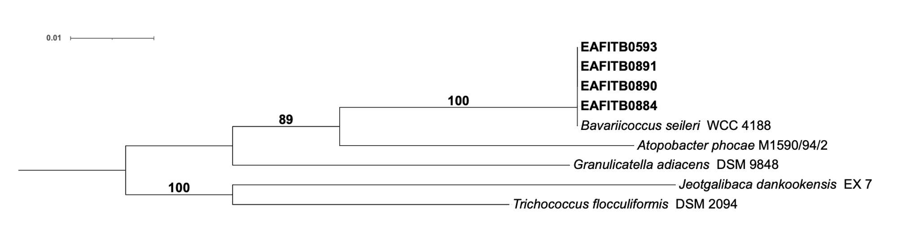

Fig. 2 Phylogenetic reconstruction among Carnobacterium isolates based on 16S rRNA gene sequences.
Isobaculum melis CCUG 37660 was used as the outgroup. Scale bar was 0.01. Evolutionary model: HKY+I+G4.
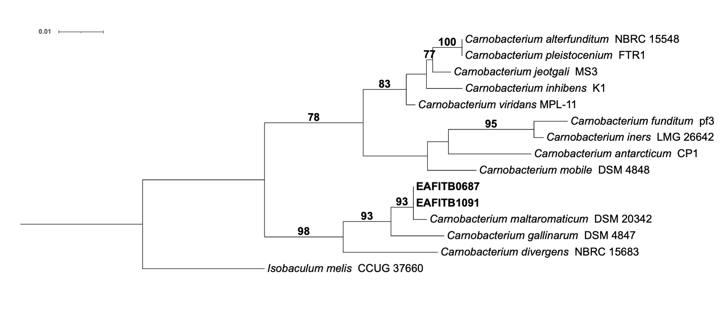

Fig. 3 Phylogenetic reconstruction among Fructobacillus isolates based on 16S rRNA gene sequences.
Eupransor demetentiae LMG 33000 was used as the outgroup. Scale bar was 0.01. Evolutionary model: TPM3u+F+I.
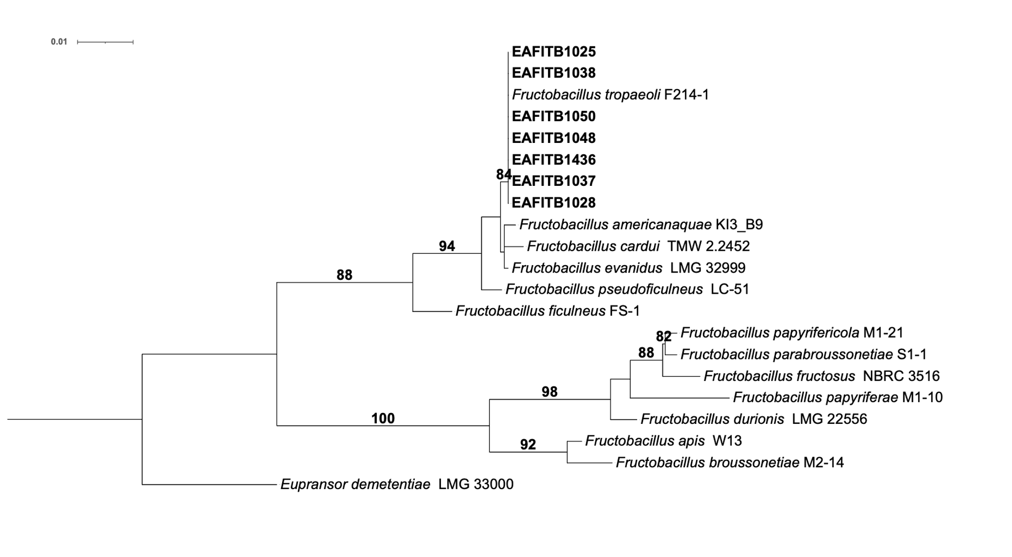

Fig. 4 Phylogenetic reconstruction among Lacticaseibacillus isolates based on 16S rRNA gene sequences.
Paralactobacillus selangorensis LMG 17710 was used as the outgroup. Scale bar was 0.1. Evolutionary model: TPM3+I+R3.
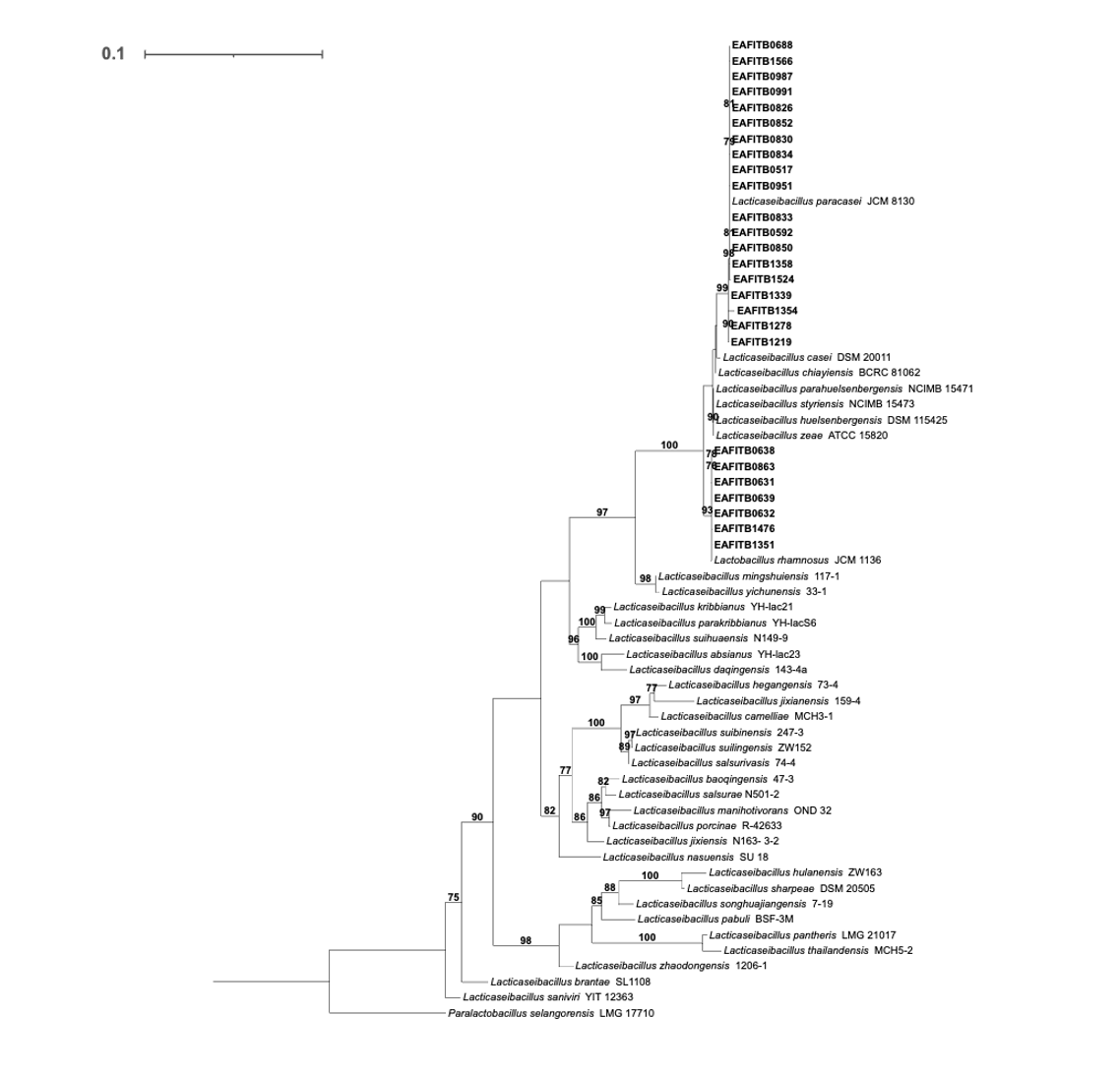

Fig. 5 Phylogenetic reconstruction among Lactococcus isolates based on 16S rRNA gene sequences.
Lactovum miscens anNAG3 was used as the outgroup. Scale bar was 0.1. Evolutionary model: TPM2u+F+I+G4.
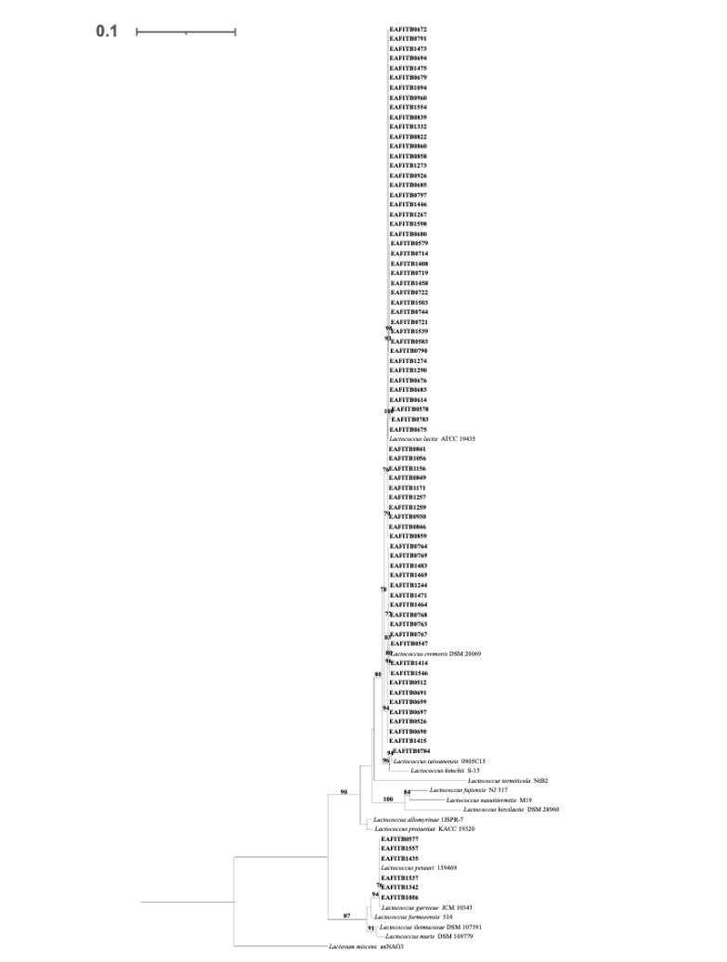

Fig. 6 Phylogenetic reconstruction among Limosilactobacillus isolates based on 16S rRNA gene sequences.
Paucilactobacillus vaccinostercus NRIC 1075 was used as the outgroup. Scale bar was 0.1. Evolutionary model: TVM+I+R3.
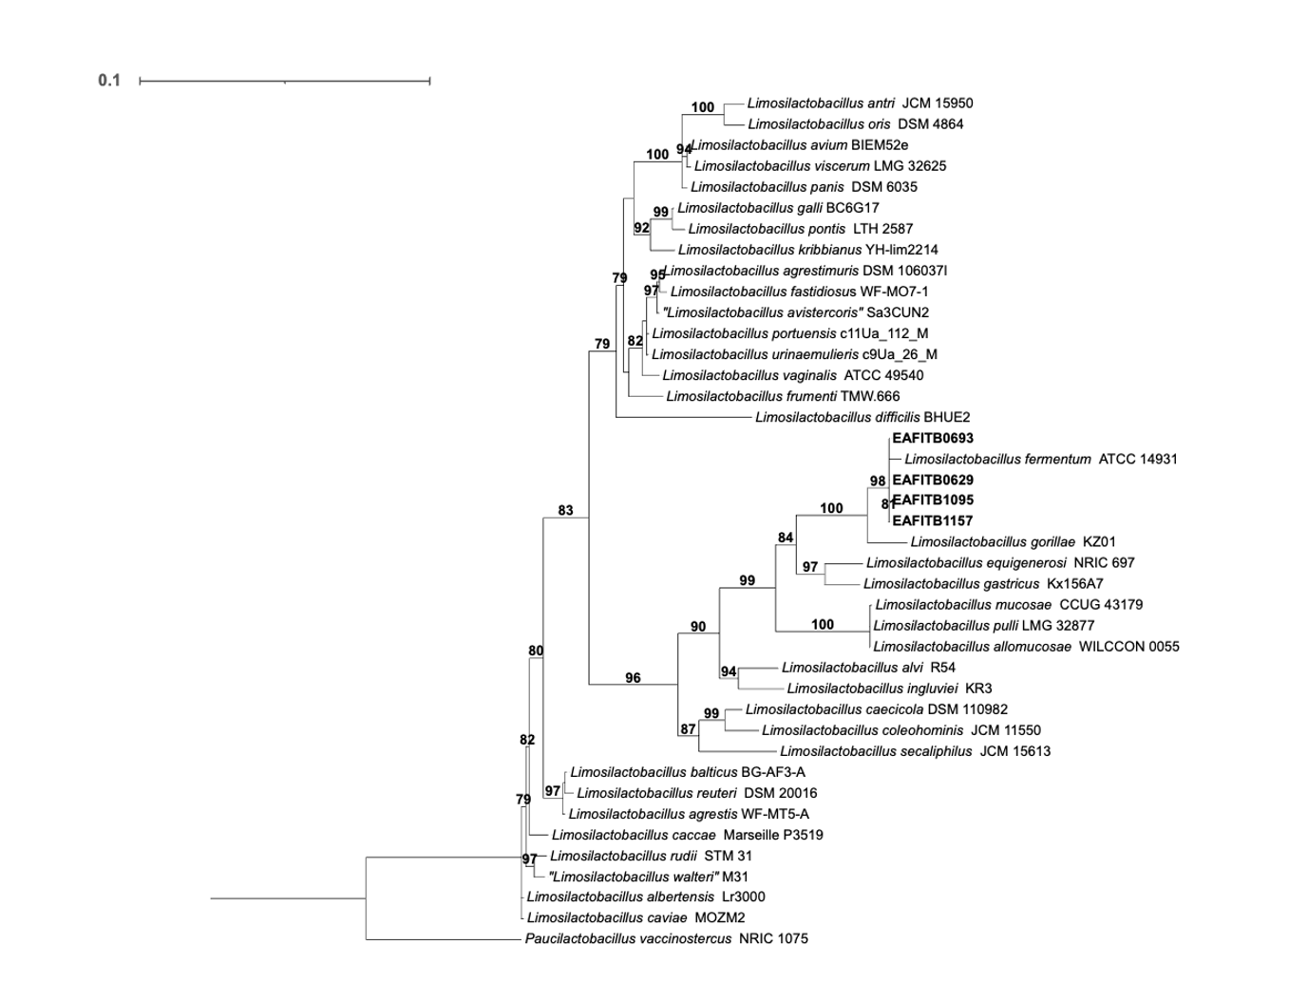

Fig. 7 Phylogenetic reconstruction among Paucilactobacillus isolates based on 16S rRNA gene sequences.
Limosilactobacillus fermentum ATCC 14931 was used as the outgroup. Scale bar was 0.01. Evolutionary model: TPM2+I.
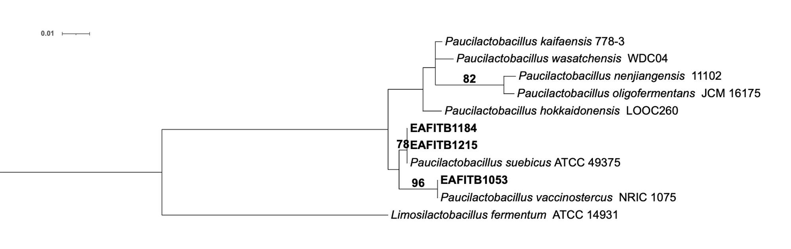

Fig. 8 Phylogenetic reconstruction among Pediococcus isolates based on 16S rRNA gene sequences.
Lactiplantibacillus plantarum CIP 103151 was used as the outgroup. Scale bar was 0.01. Evolutionary model: TPM2u+I.
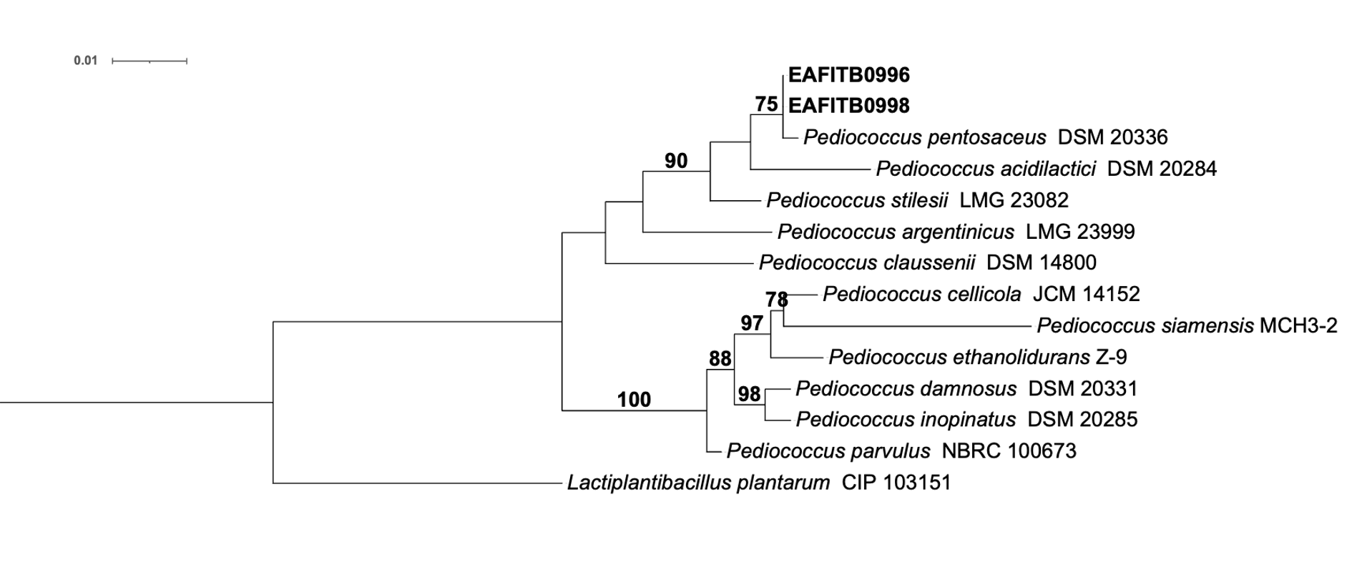

Fig. 9 Phylogenetic reconstruction among Weissella isolates based on 16S rRNA gene sequences.
Leuconostoc mesenteroides NBRC 100496 was used as the outgroup. Scale bar was 0.1. Evolutionary model: TVM+I+R2.

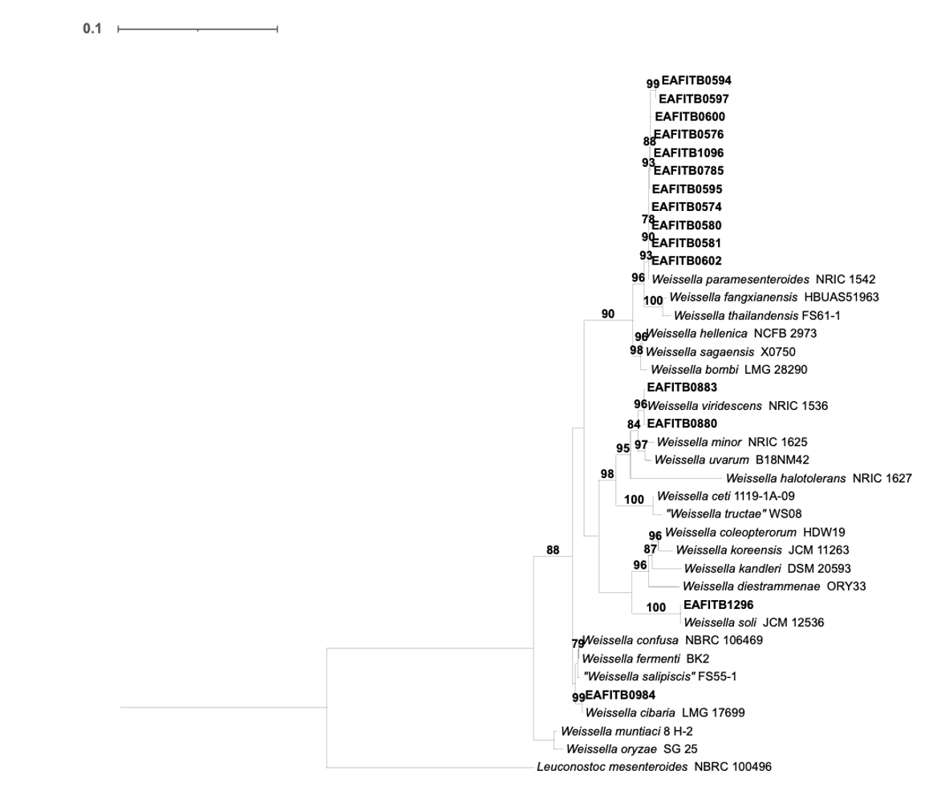

Fig. 10 Phylogenetic reconstruction among Liquorilactobacillus isolates based on 16S rRNA gene sequences.
Ligilactobacillus salivarius JCM 1231 was used as the outgroup. Scale bar was 0.01. Evolutionary model: TVM+I+G4. Only bootstrap values $≥75$ are shown, except for the node uniting Liquorilactobacillus hordei UCC128 and EAFITB1067, EAFITB1075, EAFITB1079, EAFITB1114, EAFITB119.
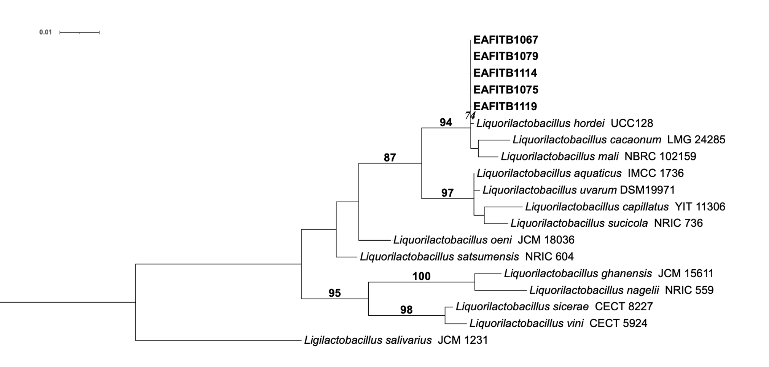

Fig. 11 Phylogenetic reconstruction among Loigolactobacillus isolates based on 16S rRNA gene sequences.
Latilactobacillus sakei DSM 20017 was used as the outgroup. Scale bar was 0.01. Evolutionary model: TPM2u+I. Only bootstrap values $≥75$ are shown, except for the node uniting Loigolactobacillus coryniformis DSM 20001 and EAFITB1204.
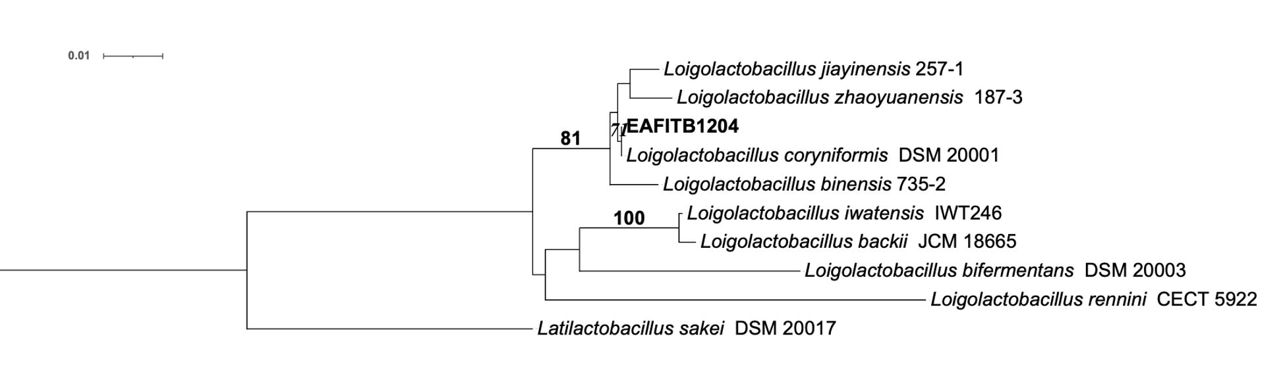

Fig. 12 Phylogenetic reconstruction among Pseudolactococcus isolates based on 16S rRNA gene sequences.
Lactovum miscens anNAG3 was used as the outgroup. Scale bar was 0.1. Evolutionary model: TPM3u+F+R2. Only bootstrap values $≥75$ are shown, except for the node uniting Pseudolactococcus raffinolactis NBRC 100932 and EAFITB0532, EAFITB1008.
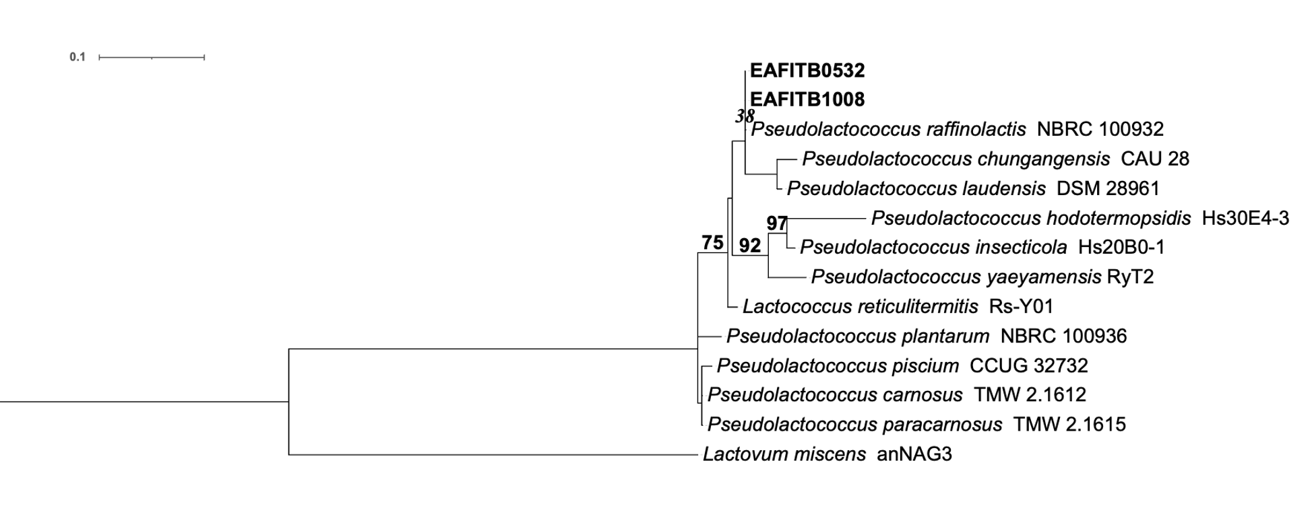

Fig. 13 Phylogenetic reconstruction among Lactiplantibacillus isolates based on 16S rRNA gene sequences.
This tree was rooted by the midpoint. Scale bar was 0.01. Evolutionary model: TPM3u+I.
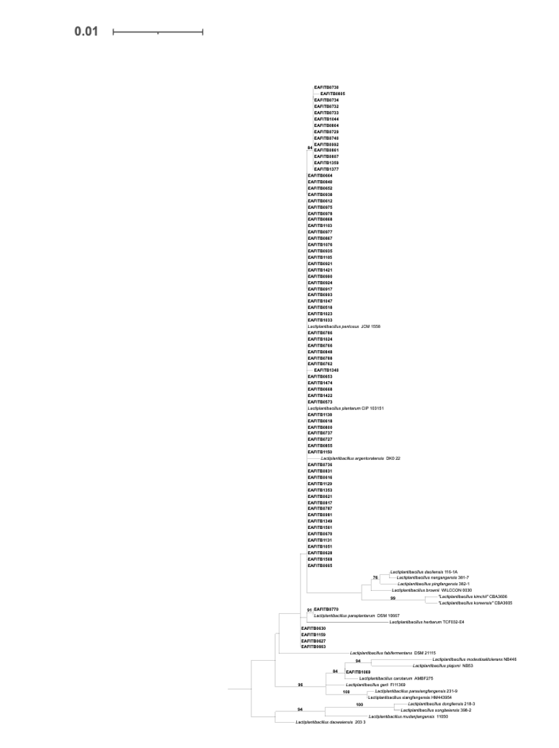

Fig. 14 Phylogenetic reconstruction among Enterococcus isolates based on 16S rRNA gene sequences.
Melissococcus plutonius ATCC 35311 was used as the outgroup. Scale bar was 0.1. Evolutionary model: TVM+F+R3. Only bootstrap values $≥75$ are shown, except for the nodes uniting Enterococcus gallinarum LMG 13129 and EAFITB0913; and Enterococcus innesii GAL 7 and EAFITB1481.
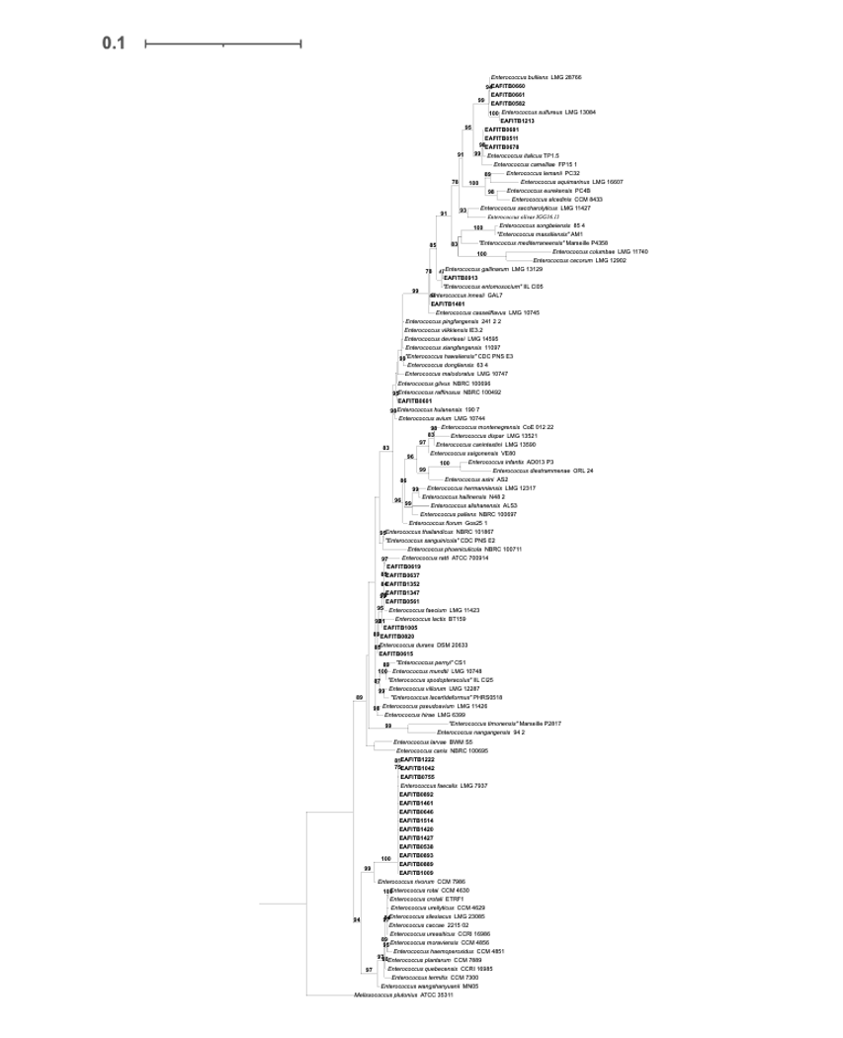

Fig. 15 Phylogenetic reconstruction among Latilactobacillus isolates based on 16S rRNA gene sequences.
Paralactobacillus selangorensis LMG 17710 was used as the outgroup. Scale bar was 0.01. Evolutionary model: TN+F+I. Only bootstrap values $≥75$ are shown, except for the node uniting Latilactobacillus curvatus NBRC 15884 and EAFITB0603
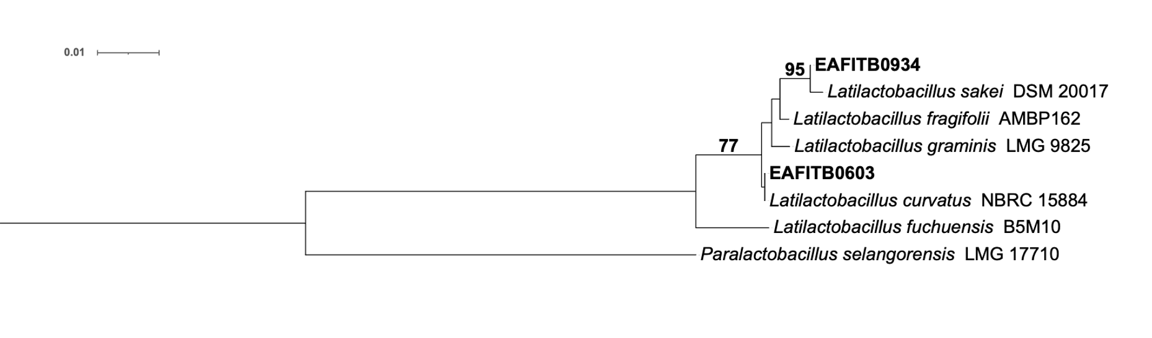

Fig. 16 Phylogenetic reconstruction among Leuconostoc isolates based on 16S rRNA gene sequences.
This tree was rooted by the midpoint. Scale bar was 0.01. Evolutionary model: HKY+F+I+G4.
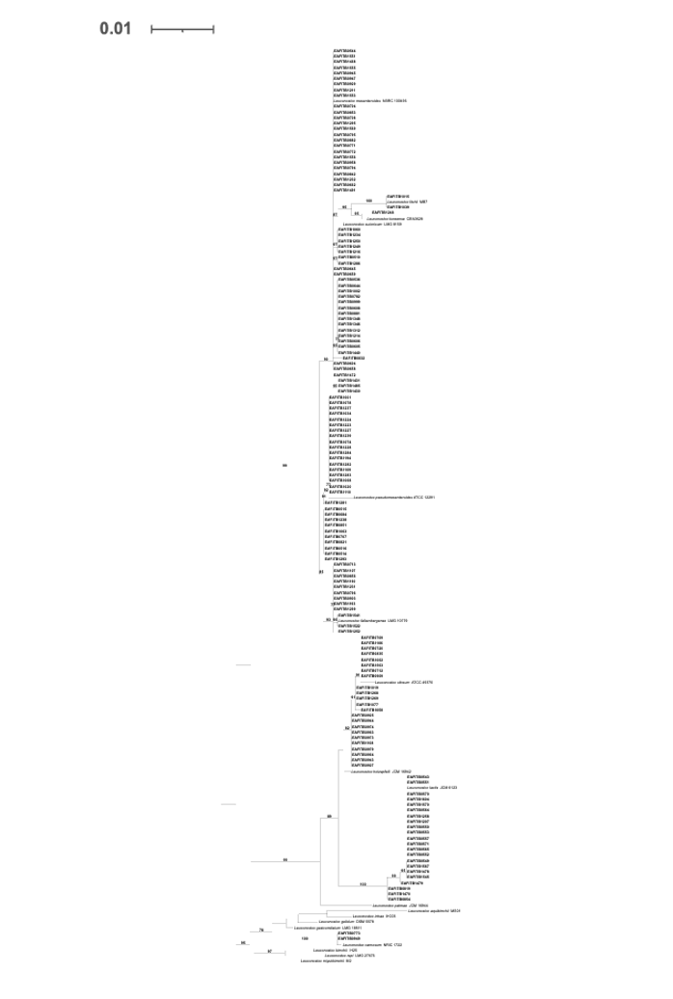
Fig. 17 Phylogenetic reconstruction among Streptococcus isolates based on 16S rRNA gene sequences.
Lactococcus lactis ATCC 19435 was used as the outgroup. Scale bar was 0.1. Evolutionary model: TVM+I+R5.
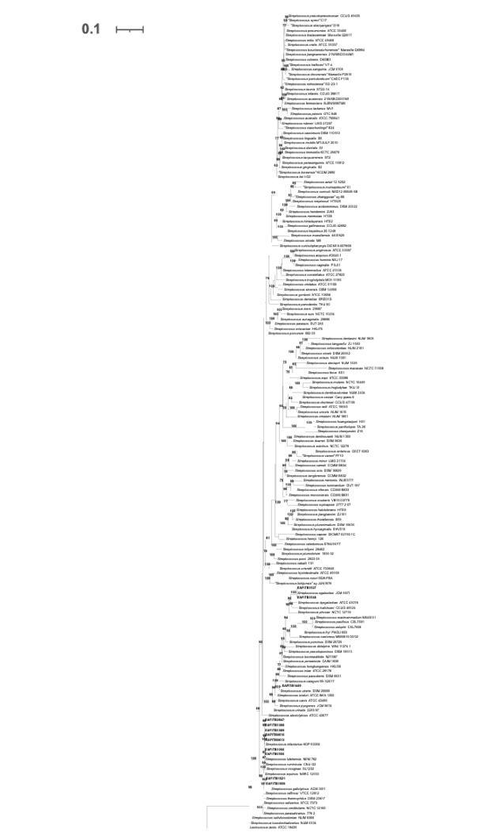

Fig. 18 Phylogenetic reconstruction among Levilactobacillus isolates based on 16S rRNA gene sequences.
Secundilactobacillus malefermentans NBRC 15905 was used as the outgroup. Scale bar was 0.1. Evolutionary model: TIM2+F+R3.
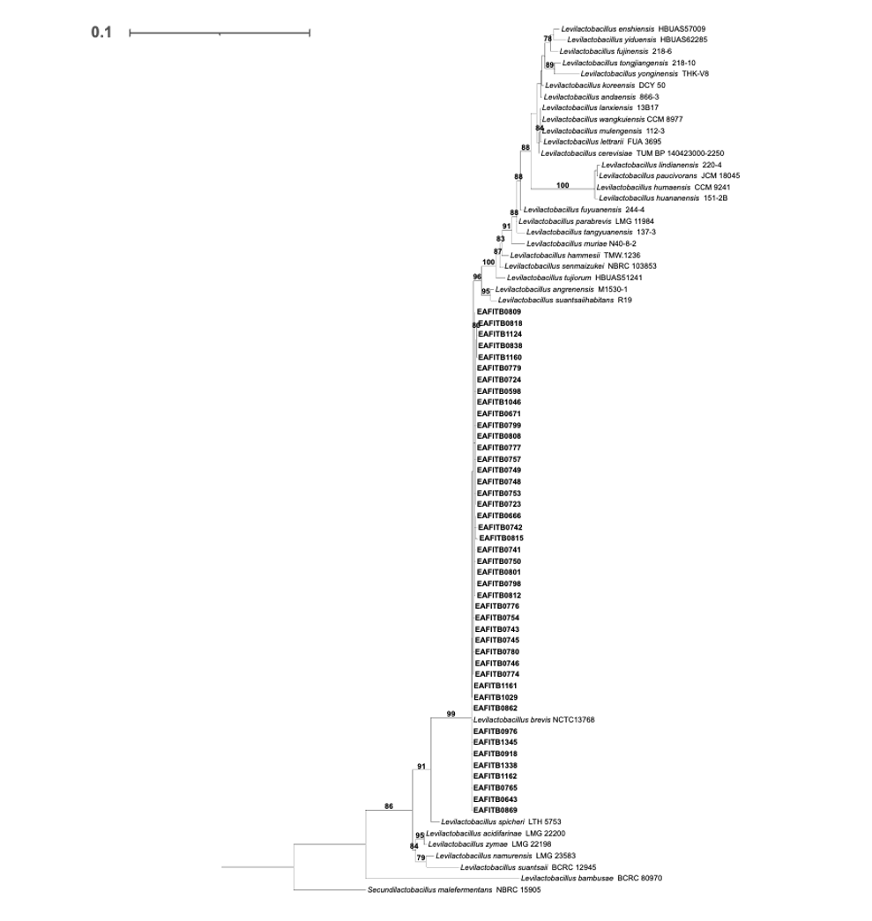

Fig. 19 Phylogenetic reconstruction among Aerococcus isolates based on 16S rRNA gene sequences.
Facklamia hominisi ATCC 700628 was used as the outgroup. Scale bar was 0.1. Evolutionary model: HKY+R3.
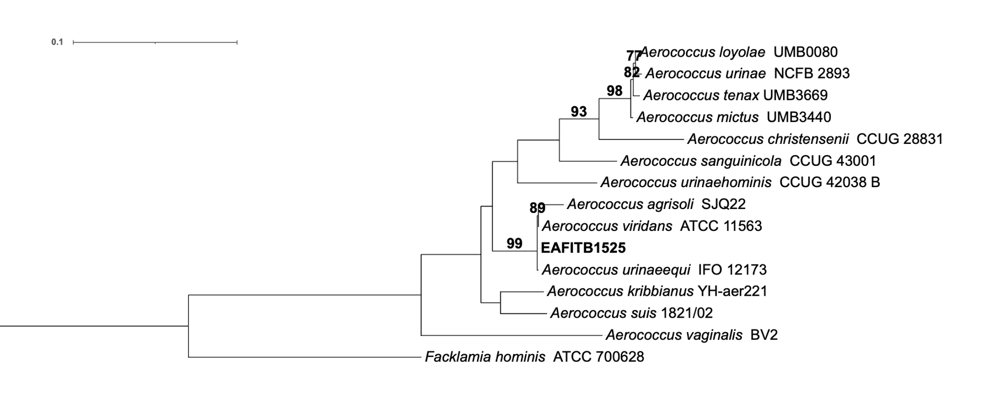Fig. 20 Phylogenetic reconstruction among Apilactobacillus isolates based on 16S rRNA gene sequences.
Acetilactobacillus jinshanensis HSLZ 75 was used as the outgroup. Scale bar was 0.1. Evolutionary model: TIM3+R2.
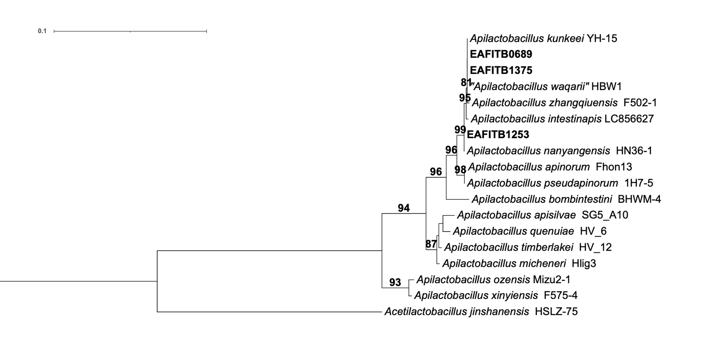

Fig. 21 Phylogenetic reconstruction among Furfurilactobacillus isolates based on 16S rRNA gene sequences.
Weissella viridescens NRIC 1536 was used as the outgroup. Scale bar was 0.01. Evolutionary model: TPM3u+G4.
