Automated Quantification of the Meiotic Spindle–Polar Body Angle and Its Association with Embryo Euploidy - Supplementary material

Irena Kratochvílová^{1*}, Olga Teplá², Simona Jirsová², Martina Moosová², Katerina Komrskova^{3,4}, Jan Kybic⁵, Denis Baručić⁵ and Jaromír Mašata²

¹Institute of Physics of the Czech Academy of Sciences, Na Slovance 2, CZ-182 00, Prague 8, Czech Republic
²Department of Gynaecology, Obstetrics and Neonatology of the First Faculty of Medicine and General Teaching Hospital, Apolinarska 18, 128 51 Prague 2, Czech Republic
³Laboratory of Reproductive Biology, Institute of Biotechnology, Czech Academy of Sciences, BIOCEV, Prumyslova 595, 252 50 Vestec, Czech Republic
⁴Department of Zoology, Faculty of Science, Charles University, 128 00 Praha 2, Czech Republic
⁵Department of Cybernetics of the Faculty of Electrical Engineering, Czech Technical University, Karlovo nam. 13, 121 35 Praha 2

*Corresponding author: Irena Kratochvílová - krat@fzu.cz

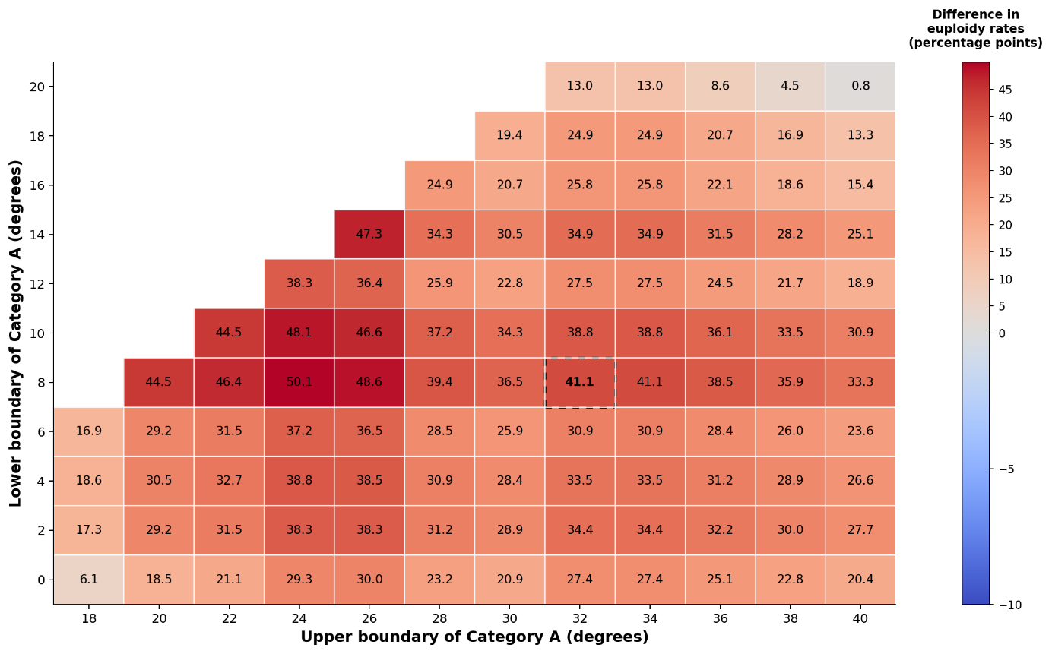

Fig. S1: Sensitivity analysis of candidate MS–PB angle intervals. Candidate Category A intervals were generated by systematically varying the lower and upper MS–PB angle boundaries. Each cell represents the difference in embryo euploidy rates between oocytes whose measured MS–PB angle falls within the corresponding interval (Category A) and those outside the interval (Category B). Warmer colors indicate greater separation between the two groups. The dashed rectangle marks the 8°–32° interval used for the main analysis, which produced a 41.1-percentage-point difference in euploidy rates. The area of high values across neighboring angle boundaries indicates that the observed association is robust to small changes in the selected angle thresholds.

Table S1. Sensitivity analysis of candidate MS–PB angle intervals.

Lower bound (°) | Upper bound (°) | nA | Euploid A (%) | Euploid outside A (%) | Difference (pp) | χ² | p
8 | 32 | 36 | 72.2 | 31.1 | 41.1 | 13.52 | 2.4E-4
13.6 | 24.2 | 20 | 90.0 | 36.1 | 53.9 | 17.53 | 2.8E-5
13.6 | 21.0 | 14 | 92.9 | 40.3 | 52.6 | 12.80 | 3.5E-4
13.6 | 23.9 | 19 | 89.5 | 37.1 | 52.4 | 15.96 | 6.5E-5
14.5 | 24.2 | 19 | 89.5 | 37.1 | 52.4 | 15.96 | 6.5E-5
8.3 | 24.2 | 29 | 82.8 | 30.8 | 52.0 | 20.13 | 7.2E-6
13.6 | 20.0 | 13 | 92.3 | 41.2 | 51.1 | 11.41 | 7.3E-4
14.5 | 21.0 | 13 | 92.3 | 41.2 | 51.1 | 11.41 | 7.3E-4
17.2 | 24.2 | 13 | 92.3 | 41.2 | 51.1 | 11.41 | 7.3E-4
13.6 | 23.4 | 18 | 88.9 | 38.1 | 50.8 | 14.45 | 1.4E-4

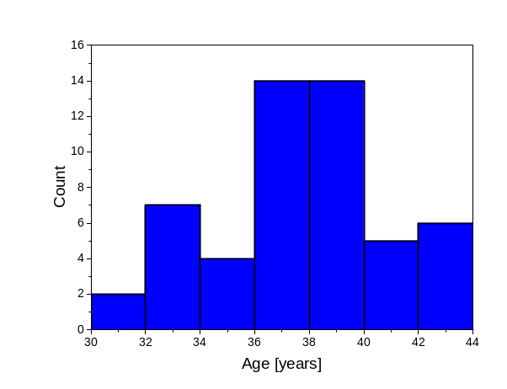

Fig. S2: Histogram of women patients ages.

