Figure S1. Geographic distribution of mycorrhizal fungal association type data. MAP: Mean Annual Precipitation; MAT: Mean Annual Temperature. AM: Arbuscular mycorrhizal fungi; ECM: Ectomycorrhizal fungi; NM: Non-mycorrhizal fungi Using MAP and MAT to map mycorrhizal fungal association types (MFATs) described in our meta-analysis.

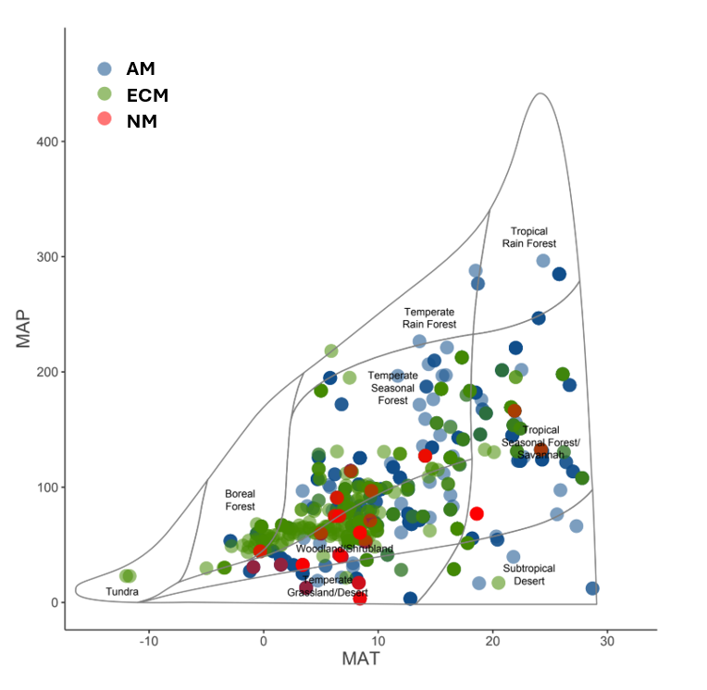

Figure S2. Geographic distribution of plant functional type data. MAP: Mean Annual Precipitation; MAT: Mean Annual Temperature. Using MAP and MAT to map plant functional types (PFTs) described in our meta-analysis.
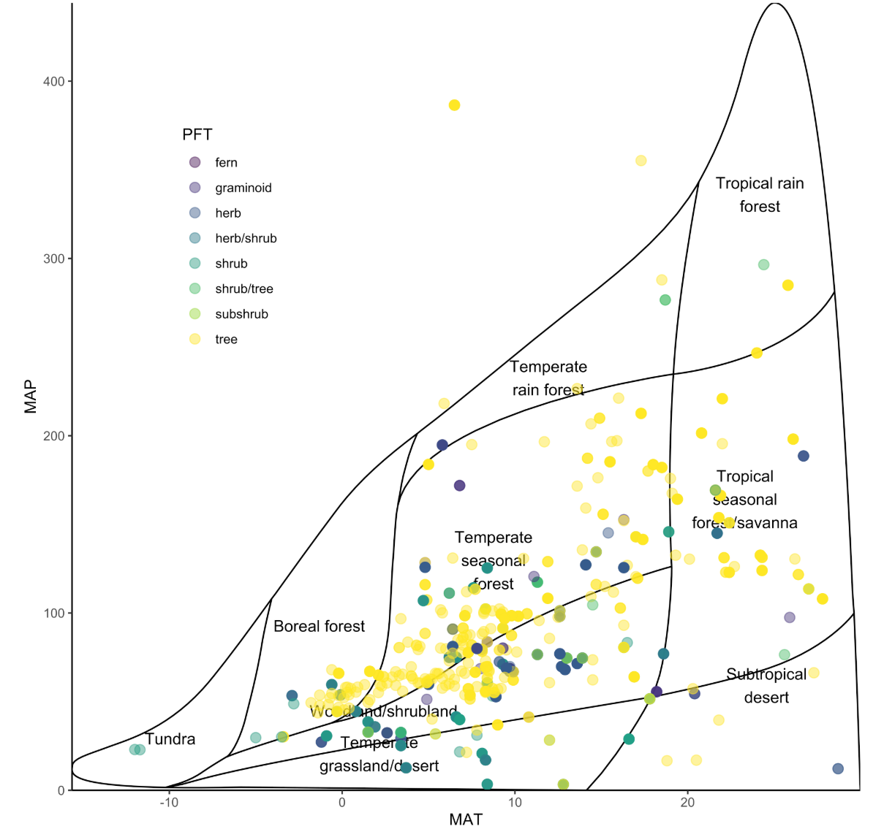

Figure S3. Breakpoint analysis of average SOC values. Here we determined the most appropriate cut-off for categorizing average SOC values to 1m as either mineral (< 19.6 mg/g) or organic soils (> 19.6 mg/g). Error bars represent standard deviation.
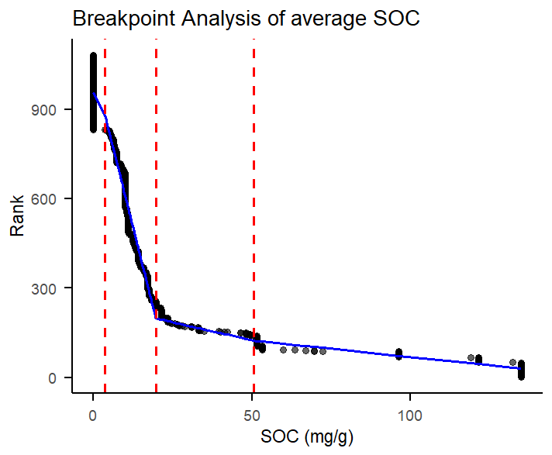

Figure S4. Phylogenetically corrected PCAs. These are similarly styled to our non-phylogenetically corrected PCAs in the main text. Panel A represents plants rooted in both mineral and organic soils, Panel B is representative of plants rooted in mineral soils, and Panel C is representative of plants rooted in organic soils, all corrected for phylogeny.

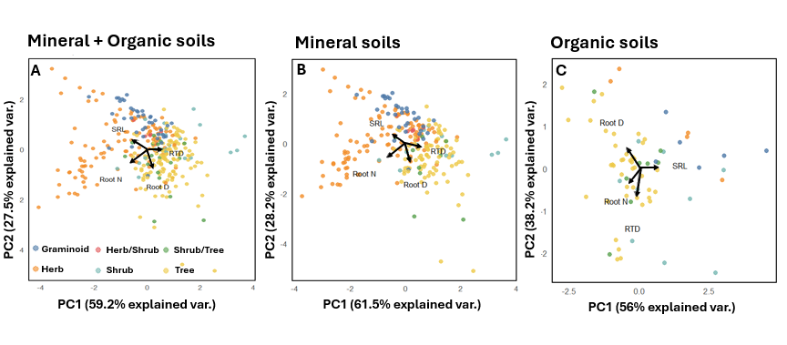
Figure S5. PFT based results for PCAs in mineral vs organic soils. This figure exemplifies that trees are the driving PFT for trends and differences shown in mineral vs organic soils.
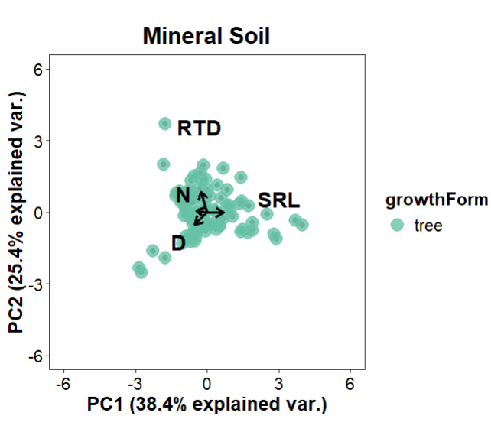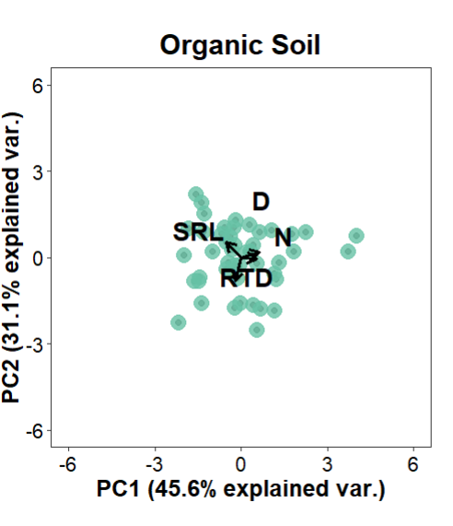

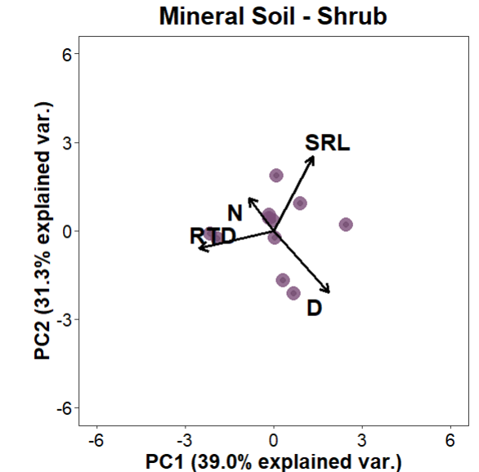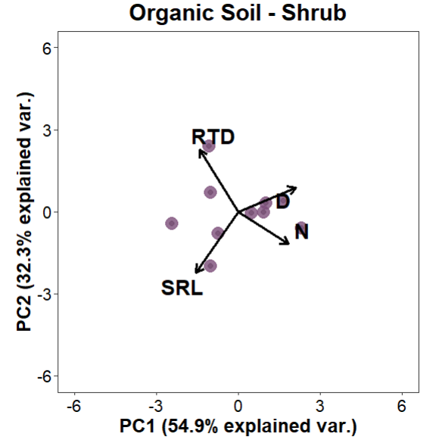
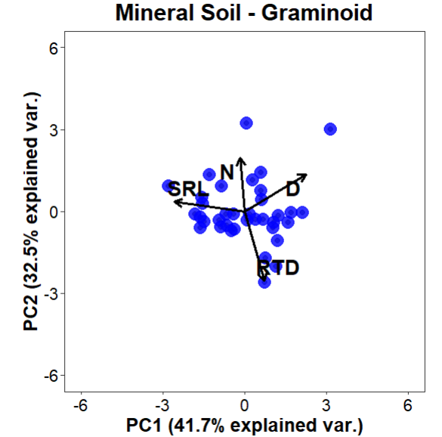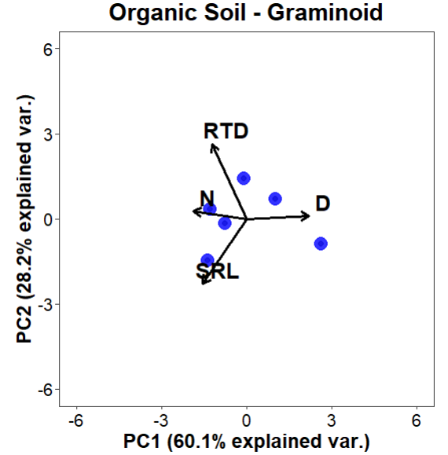
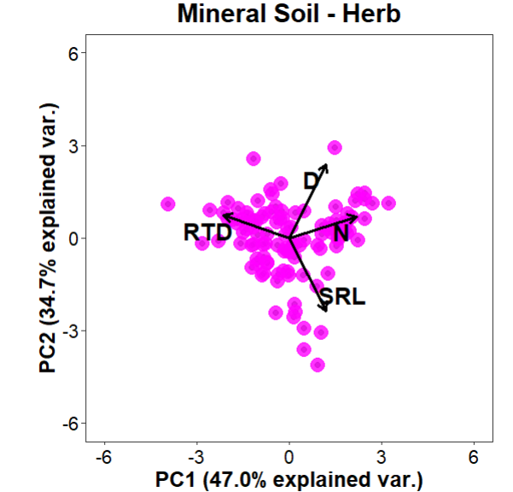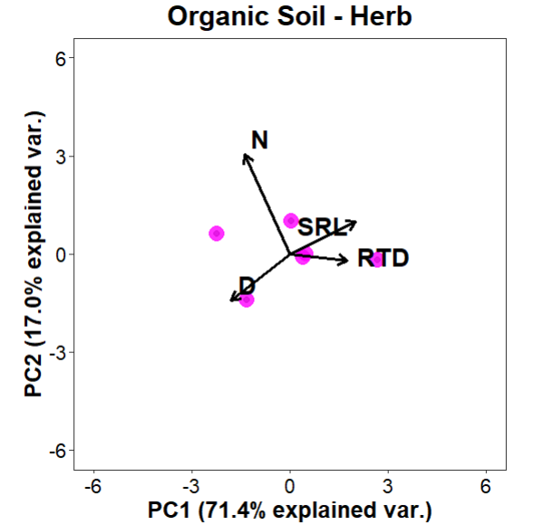
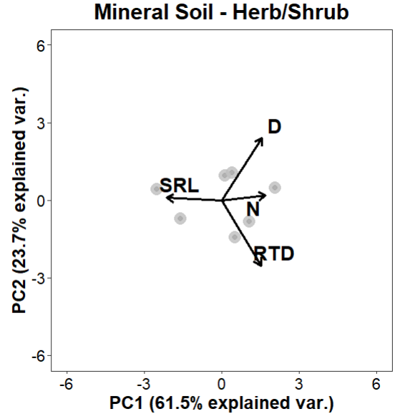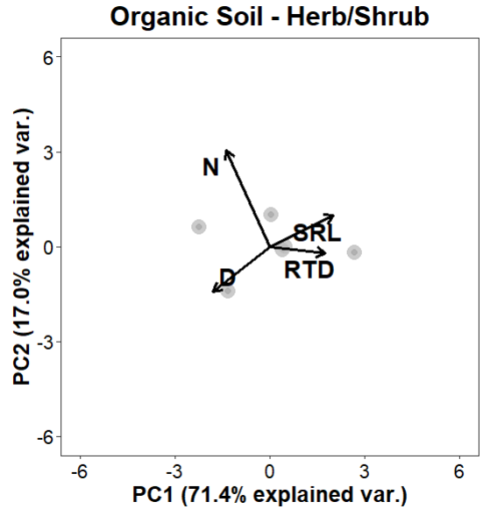
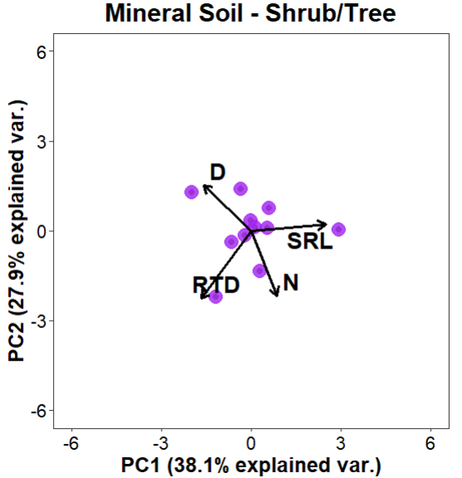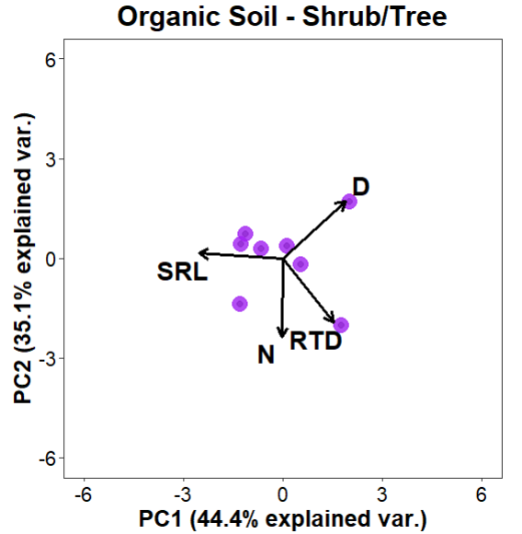

Table S1. T-test results of root N, root D, SRL, and RTD by soil type. This table shows evaluated fine-root trait means from our t-test including trait means +/- standard error (SE), p-valuers, t-values, degrees of freedom (DF), and 95% confidence interval (CI).
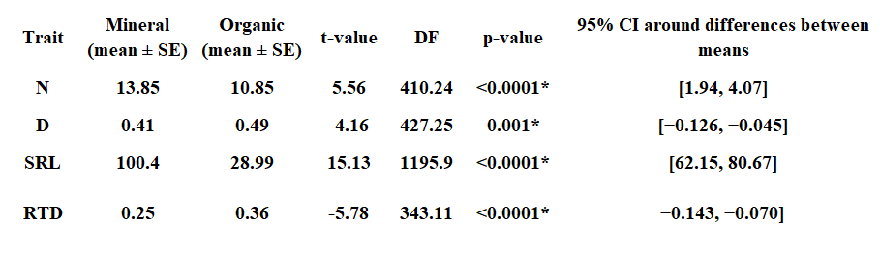

Table S2. Eigenvectors and Importance of components regarding PCA from figure 3 panel A. These eigenvectors represent the PCA conducted with all SOC data before splitting into organic versus mineral soils (n = 376).
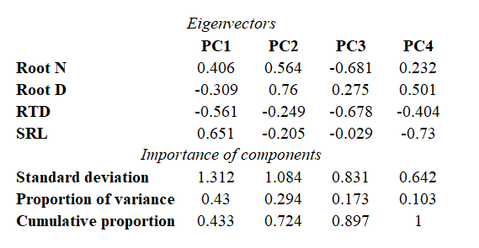

Table S3. Eigenvectors and Importance of components for PCA from figure 3 panel B. These eigenvectors represent the PCA conducted with SOC values only within mineral soils (< 19.6 mg/g SOC; n = 282).
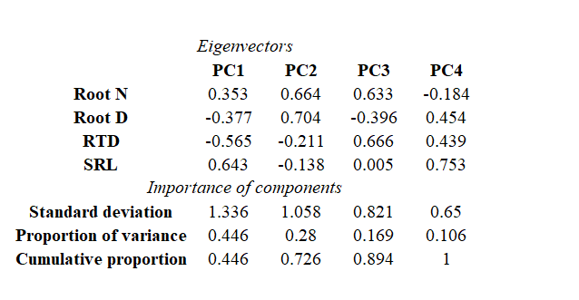

Table S4. Eigenvectors and Importance of components for PCA from figure 3 panel C. These eigenvectors represent the PCA conducted with SOC values only within organic soils (> 19.6 mg/g SOC; n = 94).
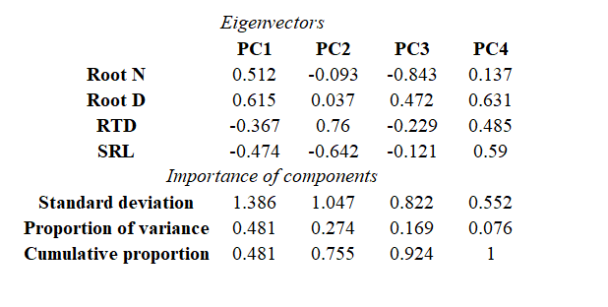

Table S5. Eigenvectors and Importance of components regarding phylogenetically corrected PCA from figure S4 panel A. These eigenvectors represent the PCA conducted with all SOC data before splitting into organic versus mineral soils (n = 376).
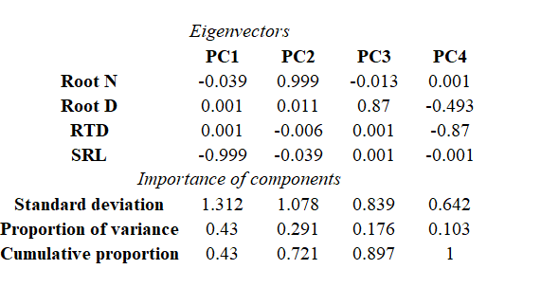

Table S6. Eigenvectors and Importance of components for phylogenetically corrected PCA from figure S4 panel B. These eigenvectors represent the PCA conducted with SOC values only within mineral soils (< 19.6 mg/g SOC; n = 282).
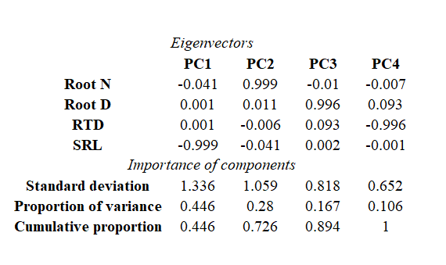

Table S7. Eigenvectors and Importance of components for phylogenetically corrected PCA from figure S4 panel C. These eigenvectors represent the PCA conducted with SOC values only within organic soils (>19.6 mg/g SOC; n = 94).
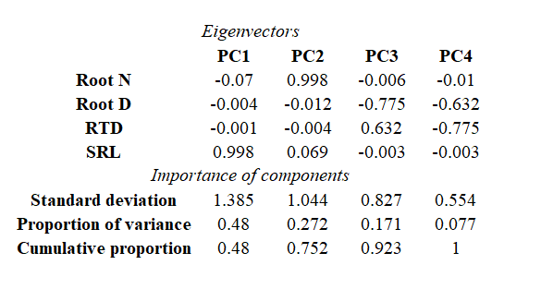

Table S8. Counts of PFT observations for N, D, RTD, and SRL in each soil type. Omitted ferns and subshrubs.
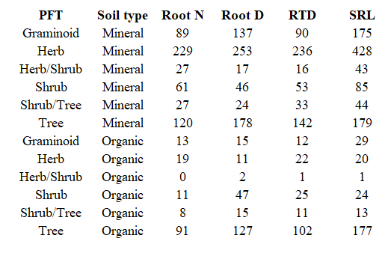

Table S9. Root traits among PFTs in mineral and organic soils. 0 ‘***’ 0.001 ‘**’ 0.01 ‘*’ 0.05
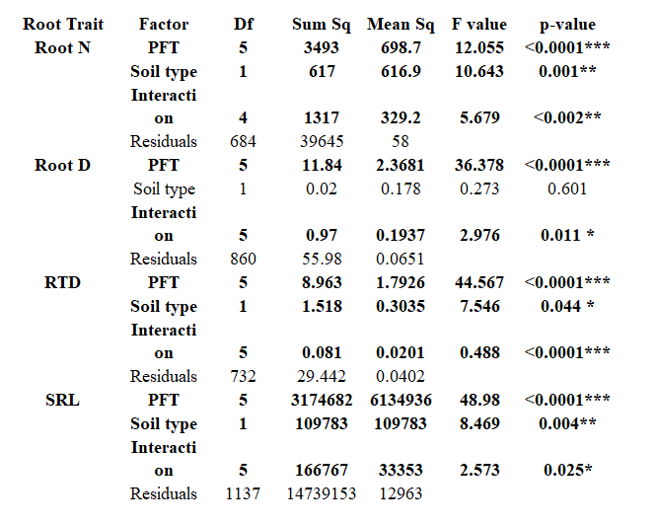

Table S10. Counts of mycorrhizal association type observations for N, D, RTD, and SRL in each soil type. Omitted ErM.

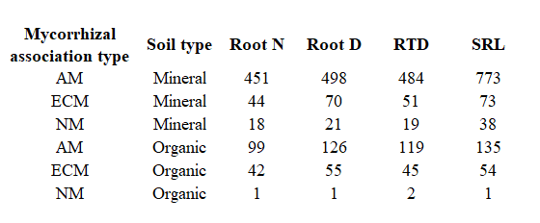

Table S11. Root traits among mycorrhizal types in mineral and organic soils. 0 ‘***’ 0.001 ‘**’ 0.01 ‘*’ 0.05
