Particulate matter removal by precipitation under normal and wildfire conditions across the United States using double machine learning: Supplement Material
Dinesh Neupane¹, Viviana Maggioni², Lucas Henneman¹,
¹Department of Civil, Environmental and Infrastructure Engineering, George Mason University, Fairfax Virginia 22030
²Department of Civil and Environmental Engineering, Politecnico di Milano, Milano, Italy
Table SI-1 Definitions, symbols, units, and brief descriptions for the meteorological variables included in the study. The table lists near-surface temperature, humidity, pressure, wind components, radiation terms, convective indicators, evaporation, precipitation, and derived wind speed used in the modeling framework.
Var | Symbol | Units | Description
TMP | T | °C | Temperature at 2 meters
SPFH | q | Mass fraction | Specific humidity at 2 meters
PRES | P | Pa | Surface pressure
UGRD | u | m/s | U wind component at 10 meters
VGRD | v | m/s | V wind component at 10 meters
DLWRF | L↓ | W/m² | Downward longwave radiation
CONVfrac | f_conv | fraction | Convective precipitation fraction
CAPE | CAPE | J/kg | Convective available potential energy
PEVAP | PEvap | kg/m² | Potential evaporation
APCP | P_tot | kg/m² | Total hourly precipitation
DSWRF | S↓ | W/m² | Downward shortwave radiation
Wind Speed | |V| | m/s | Wind speed (sqrt(u²+v²))

Table SI-2 PM_{2.5} quartiles and percent increases across wildfire smoke density categories relative to no-smoke conditions.
Smoke Density | Q1 | Q1 % Increase | Median | Median % Increase | Q3 | Q3 % Increase
NS | 4 | 0 | 6.5 | 0 | 10.2 | 0
Light | 5.5 | 37.5 | 8.3 | 27.69 | 12.2 | 19.61
Medium | 7.2 | 80 | 11.7 | 80 | 17.9 | 75.49
Heavy | 9 | 125 | 16.9 | 160 | 34.1 | 234.31

Table SI-3 PM₁₀ quartiles and percent increases across wildfire smoke density categories relative to no-smoke conditions.
Smoke Density | Q1 | Q1 % Increase | Median | Median % Increase | Q3 | Q3 % Increase
NS | 9 | 0 | 15.9 | 0 | 26 | 0
Light | 14 | 55.56 | 21.5 | 35.22 | 33.8 | 30
Medium | 18.3 | 103.33 | 28 | 76.1 | 45 | 73.08
Heavy | 24.4 | 171.11 | 42 | 164.15 | 73 | 180.77

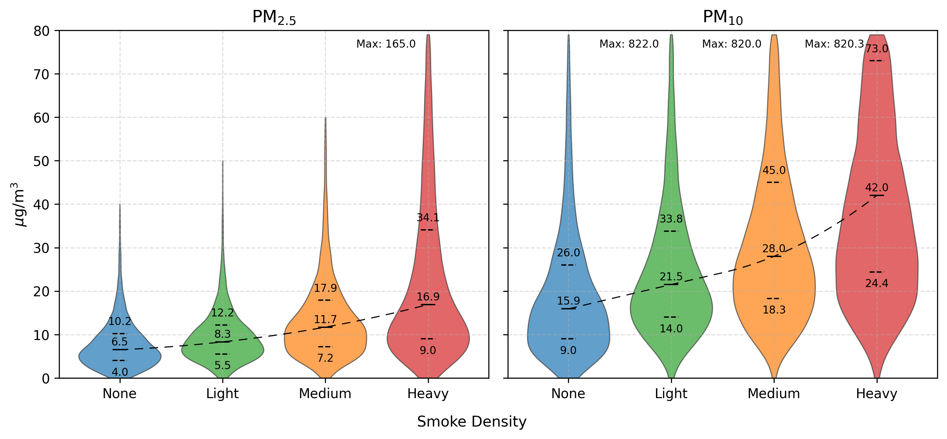
Figure SI-1 Distribution of hourly PM_{2.5} concentrations across wildfire smoke categories from 2014–2023.
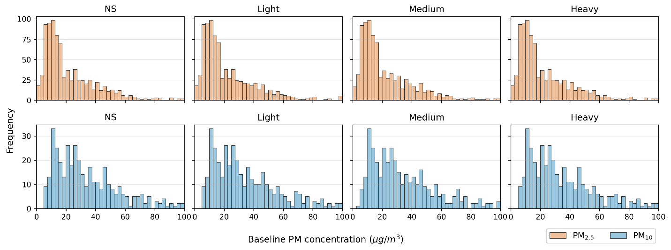
Figure SI-2 Matched baseline PM distributions across smoke categories for PM_{2.5} and PM₁₀.
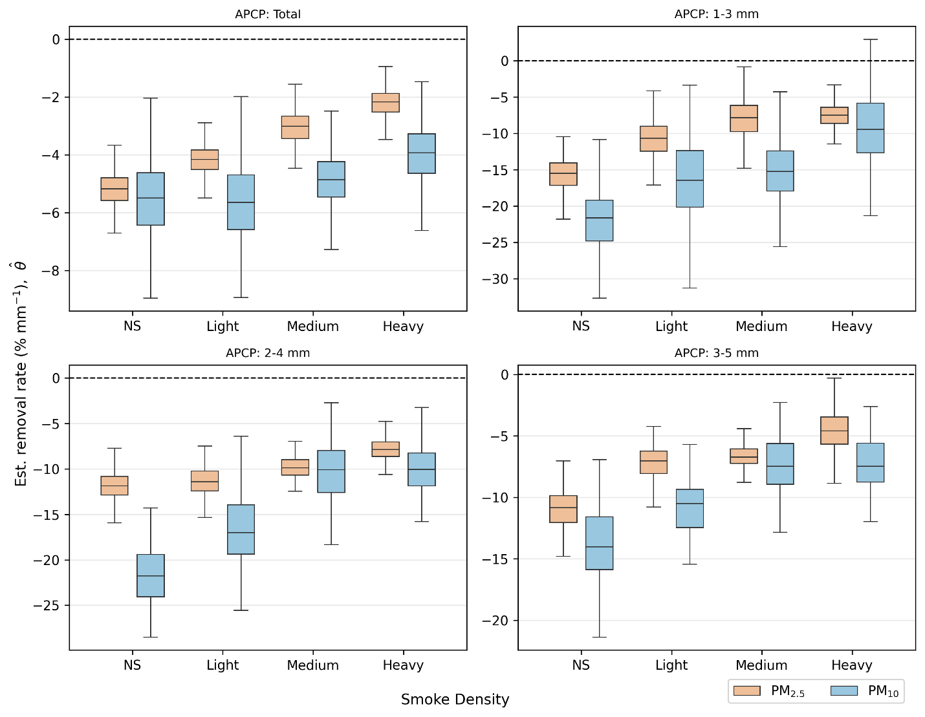
Figure SI-3 Distributions of estimated removal rates for PM_{2.5} and PM₁₀ across wildfire smoke density categories. Boxplots show removal rates under the full precipitation distribution (Total) and within fixed precipitation ranges (1-3 mm, 2-4 mm, and 3-5 mm).

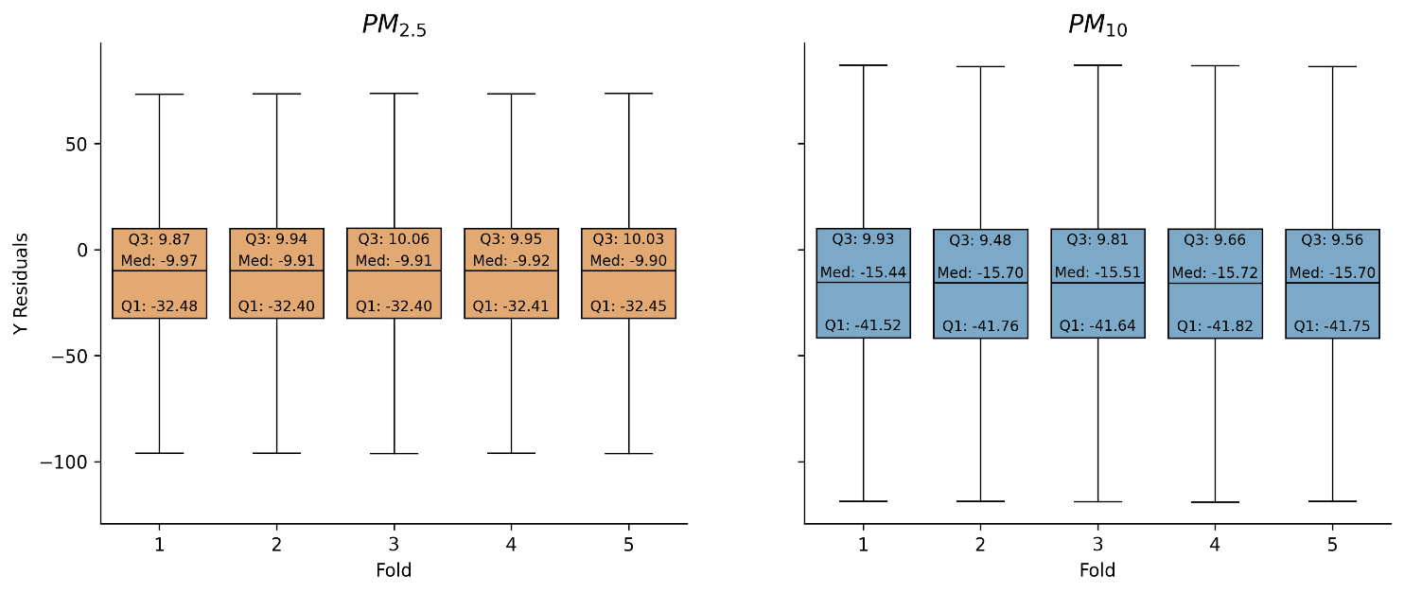
Figure SI-4 Distribution of outcome residuals across five cross-fitting folds for PM_{2.5} and PM₁₀. Quartiles and medians changed little from fold to fold. Median residuals were negative in every fold for both particle fractions. This indicates stable estimates and consistently negative removal-efficiency residuals.
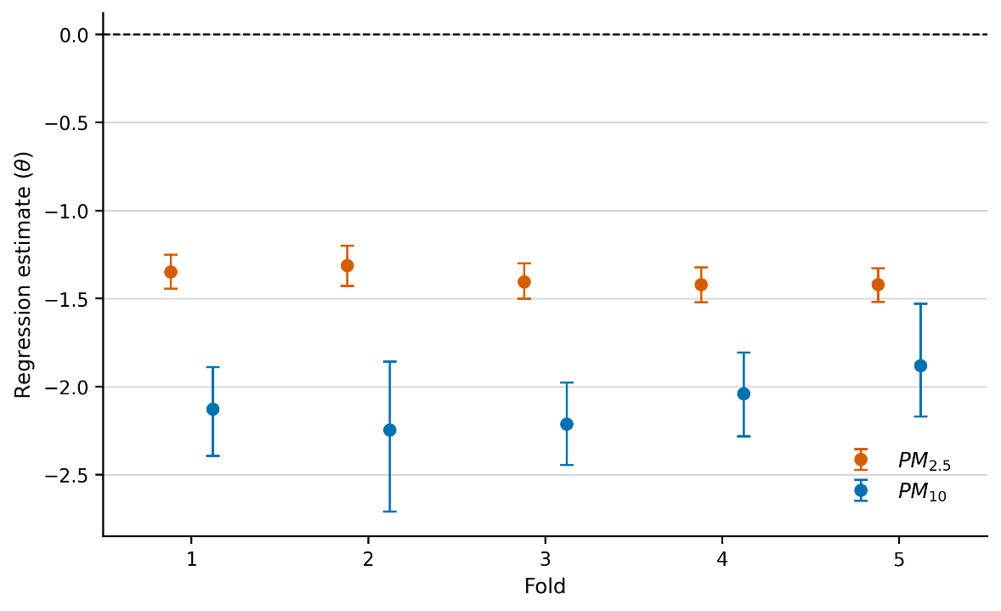
Figure SI-5 Regression estimates across the five folds for PM_{2.5} and PM₁₀. Estimates were negative in every fold for both particle fractions. Fold-to-fold variation was small. PM₁₀ estimates were consistently more negative than PM_{2.5}. Error bars show 95% confidence intervals.

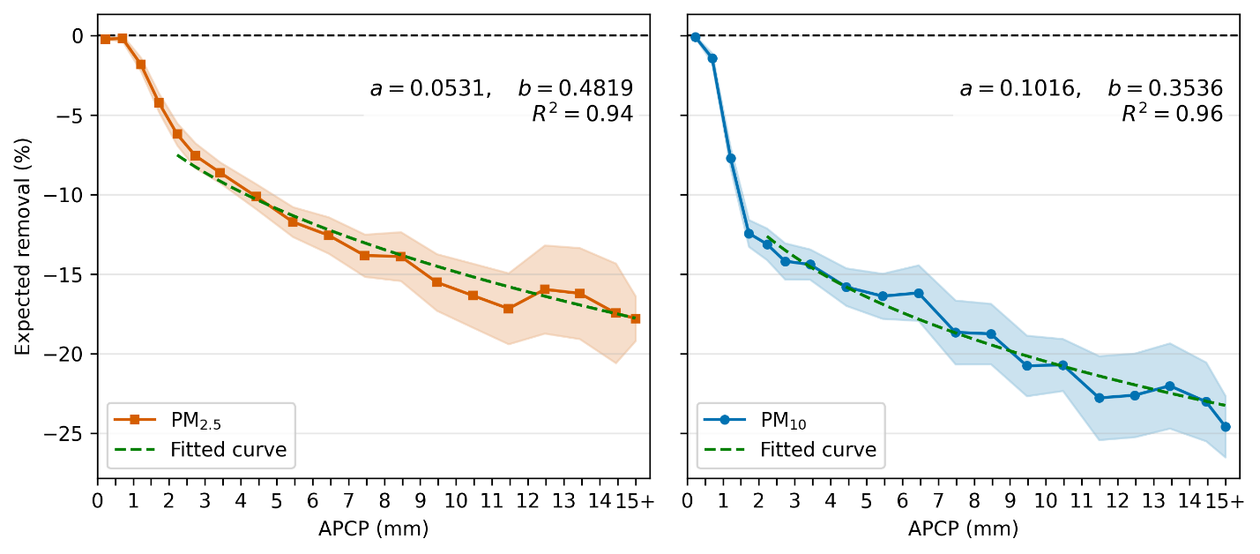
Figure SI- 6 Expected removal of PM_{2.5} (left) and PM₁₀ (right) as a function of precipitation intensity APCP (For APCP > 2mm). Shaded bands show 95% CI. Dashed curves show the fitted power-law washout model with fitted a and b reported in each panel from Equation (10)

