Climate-Driven Malaria Risk Among Children Under Five in Tanzania: Historical Associations, Future Projections, and Vulnerability Mapping
Authors: Edson Protas¹*, Stephen Kishinhi¹, Amelia Chebyala¹, William Nelson¹, Jacqueline Ashery¹, Jovine Bachwenkizi¹.
¹ Department of Environmental and Occupational Health, Muhimbili University of Health and Allied Sciences, Dar es Salaam, Tanzania
*Corresponding author:
Edson Protas
Email: 98protas@gmail.com / edson.protas@muhas.ac.tz
The following supplementary material accompanies this article.
Table S1. DHS variable codes used in the analysis
Variable | DHS code | Description
Malaria RDT result | hml35 | 0 = negative, 1 = positive
Wealth quintile | hv270 | 1 (poorest) - 5 (richest)
Water source | hv201 | Improved codes: 11-14, 21, 31, 41, 51, 61
Sanitation | hv205 | Improved codes: 11-14, 21, 22, 41, 51
Roof material | hv213 | 11-12 = poor, 21-22 = medium, 31-35 = good
Bed net ownership | hml1 | Number of nets
Cluster number | hv001 | Survey cluster identifier
Latitude | LATNUM | Displaced cluster latitude
Longitude | LONGNUM | Displaced cluster longitude
Child age | hv014 | Age in months
Child sex | hv104 | 1 = male, 2 = female
Urban/rural | hv025 | 1 = urban, 2 = rural
Survey year | hv007 | 2015 or 2022
Household weight | hv005 | DHS sampling weight (divide by 1,000,000)

Table S2. Roof material categories (hv213)
DHS code | Description | Category
11 | Thatch/grass | Poor
12 | Thatch/grass (usual) | Poor
21 | Corrugated iron (rudimentary) | Medium
22 | Wood/plywood | Medium
31, 32 | Cement/tiles | Good
33, 34, 35 | Concrete/tiles/mixed | Good
96 | Other/missing | Excluded

Appendix S1: Climate Data Processing Workflow
This appendix provides a detailed, step-by-step description of how climate data were processed and linked to the DHS clusters for the analysis presented in the main manuscript. All processing was performed in Python 3.12 using the xarray, pandas, numpy, and matplotlib libraries.

S1.1 Data Sources and Justification
Dataset | Variable | Resolution | Source | Justification
ERA5-Land | Monthly mean temperature | 0.1° × 0.1° (~9 km) | Copernicus Climate Data Store | High-resolution reanalysis, extensively validated for East Africa; provides a consistent view of land variables over several decades
CHIRPS v2.0 | Monthly rainfall totals | 0.05° × 0.05° (~5 km) | UCSB/CHC | Satellite-gauge blended product, validated for East Africa; available from 1981 to near-real time at 0.05° resolution
NEX-GDDP-CMIP6 (ACCESS-CM2, SSP2-4.5) | Daily temperature and precipitation | 0.25° × 0.25° | NASA Earth Exchange | Downscaled CMIP6 projections; widely used in climate-health impact studies. The ACCESS-CM2 model was selected as it is one of the models available in the NEX-GDDP-CMIP6 archive
Validation notes: ERA5-Land has been shown to have strong correlation with observed temperature in East Africa. CHIRPS has high correlation and low bias in the region. The NEX-GDDP-CMIP6 dataset has been bias-corrected and downscaled to provide high-resolution climate change projections.
S1.2 Data Download and File Organisation
Raw data were organised in the following directory structure:
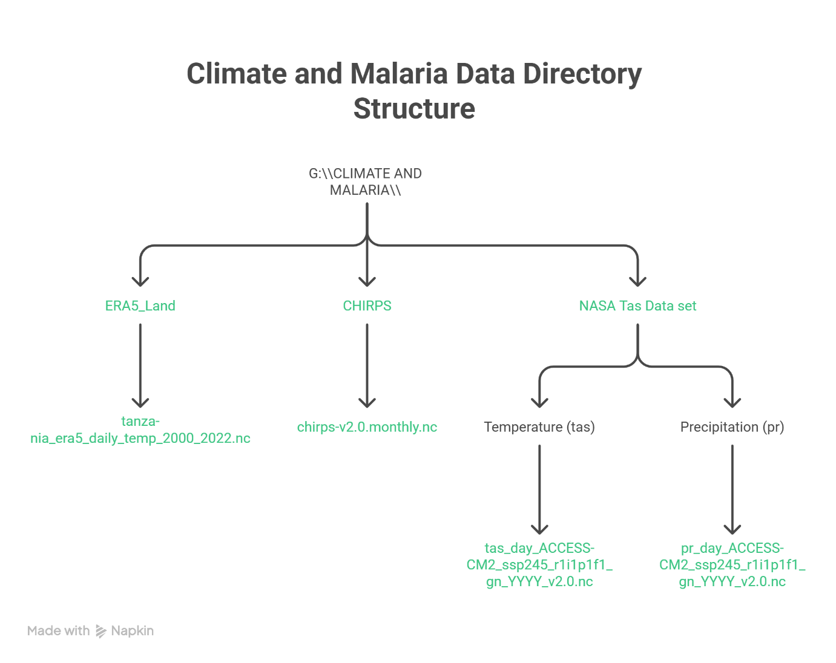
ERA5-Land: Monthly mean temperature data were downloaded from the Copernicus Climate Data Store (https://cds.climate.copernicus.eu) for the period 2000–2022. The dataset provides monthly-averaged fields at 0.1° × 0.1° resolution.
CHIRPS: Monthly rainfall data were downloaded from the CHC data portal (http://data.chc.ucsb.edu/products/CHIRPS-2.0/)[reference:12]. The dataset provides global precipitation estimates at 0.05° × 0.05° resolution from 1981 to near-real time.
NEX-GDDP-CMIP6: Daily temperature and precipitation data for ACCESS-CM2 under SSP2-4.5 were obtained from the NASA Earth Exchange portal (https://www.nccs.nasa.gov/services/data-collections/land-based-products/nex-gddp-cmip6)[reference:14]. The dataset provides global, high-resolution, bias-corrected climate change projections at 0.25° × 0.25° resolution.

S1.3 Spatial and Temporal Processing Steps
S1.3.1 Subsetting to Tanzania
For each dataset, data were extracted for the Tanzania bounding box: latitude −12° to −1°, longitude 29° to 41°.
python
import xarray as xr

# Define Tanzania bounding box
tz_bounds = {'lat': slice(-12, -1), 'lon': slice(29, 41)}
# ERA5-Land temperature
ds_era5 = xr.open_dataset('tanzania_era5_daily_temp_2000_2022.nc')
tz_temp = ds_era5.sel(**tz_bounds)
# CHIRPS rainfall
ds_chirps = xr.open_dataset('chirps-v2.0.monthly.nc')
tz_pr = ds_chirps.sel(latitude=tz_bounds['lat'], longitude=tz_bounds['lon'])
# NEX-GDDP-CMIP6 temperature (future)
ds_future = xr.open_dataset('tas_day_ACCESS-CM2_ssp245_..._YYYY_v2.0.nc')
tz_future = ds_future.sel(lat=tz_bounds['lat'], lon=tz_bounds['lon'])
S1.3.2 Conversion from Kelvin to Celsius
All temperature data were converted from Kelvin to Celsius:
python
tz_temp['t2m_c'] = tz_temp['t2m'] - 273.15
tz_future['tas_c'] = tz_future['tas'] - 273.15
S1.3.3 Resampling to Monthly Aggregates
Historical temperature: Monthly means were already provided by ERA5-Land. For the future projections, daily temperature was resampled to monthly means:
python
monthly_temp = tz_future['tas_c'].resample(time='MS').mean()
Historical rainfall: Monthly totals were already provided by CHIRPS. For the future projections, daily precipitation (in kg/m²/s) was converted to mm/day and summed to monthly totals:
python
# Convert from kg/m²/s to mm/day (1 kg/m²/s = 86400 mm/day)
daily_pr_mm = tz_future['pr'] * 86400
monthly_pr = daily_pr_mm.resample(time='MS').sum(dim='time')
S1.3.4 Annual Aggregation for Historical Analysis
For each child in the DHS dataset, we assigned the annual mean temperature and annual total rainfall for the calendar year of the survey (2015 or 2022). This was implemented by:
- Extracting the year from the survey date
- Selecting the corresponding climate data for that year
- Computing the annual mean (temperature) or annual sum (rainfall) over the 12 months
python
def extract_annual_climate(ds_temp, ds_pr, year):
temp_year = ds_temp.sel(time=slice(f"{year}-01-01", f"{year}-12-31"))
pr_year = ds_pr.sel(time=slice(f"{year}-01-01", f"{year}-12-31"))
annual_temp = temp_year.mean(dim='time')
annual_pr = pr_year.sum(dim='time')
return annual_temp, annual_pr
The DHS fieldwork spans several months; full calendar-year aggregates were used because the survey months vary across clusters. Finer temporal matching (e.g., lagged monthly climate) is a direction for future research.
S1.3.5 Linkage to DHS Clusters
Each DHS cluster was linked to the climate data using the nearest-neighbour method based on the cluster’s GPS coordinates (LATNUM, LONGNUM). For each cluster, the climate value was extracted from the nearest grid cell:
python
def extract_climate_value(da, lat, lon):
return da.sel(lat=lat, lon=lon, method='nearest').values
This method minimises the great-circle distance between the cluster’s GPS coordinates and the grid cell centroids.
S1.4 Future Suitability Criteria
Future suitability was computed for each grid cell for 2023–2100 using monthly temperature and rainfall data under SSP2-4.5. Suitability criteria followed the MARA (Mapping Malaria Risk in Africa) Seasonality Model (Craig et al., 1999):
- Temperature: monthly mean ≥20 °C (daily average temperatures exceeding 20°C)
- Rainfall: monthly total >80 mm (the minimum monthly rainfall required for malaria transmission)
- Suitable month: both criteria met
- Suitable year: at least 4 suitable months
These thresholds are based on the biological constraints of parasite and vector development. The MARA model uses a fuzzy logic concept to express ‘degrees of climate suitability’.
python
# Compute suitability for each year
def compute_suitability(monthly_temp, monthly_pr, threshold_temp=20, threshold_pr=80, min_months=4):
temp_ok = monthly_temp >= threshold_temp
pr_ok = monthly_pr > threshold_pr
both_ok = temp_ok & pr_ok
months_ok = both_ok.sum(dim='time')
suitable = months_ok >= min_months
return suitable
S1.5 Software and Code Availability
All analyses were conducted in Python 3.12 using the following libraries:
Library | Purpose
xarray | NetCDF data handling
pandas | Data manipulation
numpy | Numerical operations
matplotlib | Visualisation
geopandas | Spatial data handling
statsmodels | Statistical modelling
The full Python code used for data processing and analysis is available from the corresponding author upon reasonable request.

S1.6 Data Citations
Dataset | Citation
ERA5-Land | Muñoz Sabater, J. et al. (2021). ERA5-Land: a state-of-the-art global reanalysis dataset for land applications. Earth System Science Data, 13(9), 4349–4383.
CHIRPS | Funk, C. et al. (2015). The climate hazards infrared precipitation with stations, a new environmental record for monitoring extremes. Scientific Data, 2, 150066.
NEX-GDDP-CMIP6 | Thrasher, B. et al. (2022). NEX-GDDP-CMIP6: a global daily downscaled climate dataset for CMIP6. Earth System Science Data Discussions, 1–32.
MARA Model | Craig, M.H., Snow, R.W. and le Sueur, D. (1999). A climate-based distribution model of malaria transmission in sub-Saharan Africa. Parasitology Today, 15(3), 105–111.

S1.7 Validation
The suitability model was validated by hindcasting suitability for 2015 and 2022 using ERA5-Land and CHIRPS data and comparing it with observed cluster-level malaria prevalence from the DHS surveys. The correlation between hindcast suitability (proportion of suitable months per year) and observed malaria prevalence was r = 0.62 (p < 0.001), suggesting the model captures broad spatial patterns of transmission suitability.

