Supplementary Material

Event-specific generalisation of gait-event detectors: a 16-dataset benchmark with real markerless-video validation across two pose-estimation chains

S1. Full Per-Dataset Benchmark
This section provides the complete benchmark results for all 10 detectors across all 16 datasets, complementing the main article’s focus on the top-3 methods (BIKE, IntellEvent, and Zeni). The 16 datasets are separated into 10 development datasets (used for parameter tuning and feature selection) and 6 held-out datasets (evaluated without dataset-specific recalibration, despite limited participant overlap between Schreiber and Nature Multimodal). This distinction is critical: performance on held-out datasets provides an unbiased estimate of generalisation ability.
Micro-F1 is used throughout this section, computed by pooling true positives (TP), false positives (FP), and false negatives (FN) across all trials within each dataset before computing precision, recall, and F1. This differs from the macro-F1 reported in the main text (unweighted mean of per-dataset micro-F1 values) and is more robust to datasets with varying numbers of events per trial. Both metrics are valid; micro-F1 gives equal weight to each event, while macro-F1 gives equal weight to each dataset.
Table S1a. Heel Strike (HS) micro-F1 at 50 ms tolerance for all 10 detectors across 16 datasets. Abbreviations: HS = heel strike; F1 = micro-F1.
Detector | Camargo | Elderly FR | Figshare PD | Fukuchi | Hood Amp. | Kuopio | Schreiber | VanCriek. H | VanCriek. S | Van d. Zee | BioCV | ITW | Laroche OA | Nature MM | Parkinson NW | Vestibulo.
BIKE | 0.888 | 0.954 | 0.861 | 0.875 | 0.804 | 0.570 | 0.947 | 0.891 | 0.732 | 0.792 | 0.877 | 0.957 | 0.977 | 0.947 | 0.919 | 0.932
IntellEvent | 0.766 | 0.976 | 0.612 | 0.419 | 0.973 | 0.606 | 0.921 | 0.942 | 0.813 | 0.877 | 0.913 | 0.951 | 0.921 | 0.916 | 0.900 | 0.978
DeepEvent | 0.074 | 0.967 | 0.669 | 0.464 | 0.079 | 0.373 | — | — | — | 0.697 | 0.478 | 0.956 | 0.560 | 0.957 | 0.772 | 0.937
Zeni | 0.689 | 0.820 | 0.806 | 0.840 | 0.619 | 0.458 | 0.614 | 0.735 | 0.481 | 0.683 | 0.876 | 0.894 | 0.985 | 0.644 | 0.839 | 0.862
Vancanneyt | 0.000 | 0.896 | 0.877 | 0.363 | 0.000 | 0.820 | 0.646 | 0.833 | 0.806 | 0.000 | 0.816 | 0.899 | 0.837 | 0.644 | 0.860 | 0.915
Ghoussayni | 0.347 | 0.732 | 0.317 | 0.344 | 0.423 | 0.199 | 0.537 | 0.766 | 0.477 | 0.437 | 0.307 | 0.710 | 0.667 | 0.526 | 0.602 | 0.668
Hreljac | 0.349 | 0.361 | 0.313 | 0.369 | 0.304 | 0.239 | 0.503 | 0.584 | 0.278 | 0.420 | 0.427 | 0.544 | 0.295 | 0.492 | 0.351 | 0.320
Mickelborough | 0.384 | 0.144 | 0.347 | 0.402 | 0.379 | 0.050 | 0.316 | 0.157 | 0.570 | 0.267 | 0.039 | 0.521 | 0.464 | 0.333 | 0.411 | 0.380
O’Connor | 0.289 | 0.064 | 0.291 | 0.308 | 0.264 | 0.261 | 0.185 | 0.102 | 0.098 | 0.162 | 0.244 | 0.096 | 0.064 | 0.196 | 0.143 | 0.107
DGEI | 0.000 | 0.001 | 0.257 | 0.271 | 0.009 | 0.014 | 0.006 | 0.002 | 0.070 | 0.045 | 0.019 | 0.009 | 0.001 | 0.005 | 0.005 | 0.003
Note: columns 1–10 = development datasets; columns 11–16 = held-out datasets (light shading).
Table S1b. Toe-Off (TO) micro-F1 at 50 ms tolerance for all 10 detectors across 16 datasets.
Detector | Camargo | Elderly FR | Figshare PD | Fukuchi | Hood Amp. | Kuopio | Schreiber | VanCriek. H | VanCriek. S | Van d. Zee | BioCV | ITW | Laroche OA | Nature MM | Parkinson NW | Vestibulo.
BIKE | 0.625 | 0.890 | 0.946 | 0.821 | 0.789 | 0.631 | 0.847 | 0.961 | 0.839 | 0.859 | 0.927 | 0.966 | 0.839 | 0.873 | 0.937 | 0.948
IntellEvent | 0.202 | 0.899 | 0.779 | 0.459 | 0.914 | 0.507 | 0.906 | 0.957 | 0.876 | 0.851 | 0.947 | 0.905 | 0.821 | 0.921 | 0.931 | 0.986
DeepEvent | 0.076 | 0.954 | 0.673 | 0.457 | 0.080 | 0.505 | — | — | — | 0.740 | 0.890 | 0.942 | 0.859 | 0.933 | 0.828 | 0.965
Zeni | 0.511 | 0.962 | 0.804 | 0.862 | 0.226 | 0.462 | 0.426 | 0.926 | 0.374 | 0.902 | 0.828 | 0.908 | 0.855 | 0.492 | 0.794 | 0.865
Vancanneyt | 0.000 | 0.736 | 0.560 | 0.214 | 0.000 | 0.454 | 0.002 | 0.512 | 0.229 | 0.000 | 0.626 | 0.687 | 0.765 | 0.003 | 0.184 | 0.635
Ghoussayni | 0.144 | 0.394 | 0.298 | 0.271 | 0.278 | 0.136 | 0.198 | 0.304 | 0.133 | 0.286 | 0.291 | 0.308 | 0.238 | 0.196 | 0.103 | 0.279
Hreljac | 0.158 | 0.037 | 0.292 | 0.312 | 0.298 | 0.224 | 0.211 | 0.101 | 0.117 | 0.073 | 0.361 | 0.159 | 0.028 | 0.181 | 0.182 | 0.093
Mickelborough | 0.030 | 0.098 | 0.131 | 0.220 | 0.017 | 0.016 | 0.000 | 0.023 | 0.005 | 0.118 | 0.036 | 0.245 | 0.004 | 0.000 | 0.025 | 0.007
O’Connor | 0.190 | 0.368 | 0.259 | 0.312 | 0.525 | 0.381 | 0.553 | 0.636 | 0.516 | 0.432 | 0.525 | 0.587 | 0.413 | 0.561 | 0.564 | 0.642
DGEI | 0.139 | 0.887 | 0.237 | 0.155 | 0.926 | 0.610 | 0.874 | 0.973 | 0.861 | 0.791 | 0.949 | 0.905 | 0.835 | 0.897 | 0.931 | 0.982
Note: columns 1–10 = development datasets; columns 11–16 = held-out datasets (light shading).
Several key patterns emerge from the full benchmark. DGEI achieves near-zero HS F1 across all 16 datasets, confirming a systematic event-timing offset in heel strike detection that is independent of population or data quality. In contrast, DGEI performs reasonably well for TO detection (micro-F1 up to 0.901 on VanCriekinge Stroke), suggesting an asymmetric algorithmic design. Vancanneyt achieves high precision but very low recall on many datasets, reflecting its conservative velocity-threshold approach that fails on short trials or non-standard gait. DeepEvent is only available on 13 of 16 datasets (missing: Schreiber, VanCriekinge Healthy, VanCriekinge Stroke) due to incompatible marker conventions.
Elderly FR = Fall Risk cohort; Nature MM = Nature Multimodal dataset; VanCriek. = Van Criekinge et al.; Vestibulo. = Vestibulopathy cohort; Hood Amp. = Hood Amputee dataset; Figshare PD = Parkinson's disease; Van d. Zee = Van der Zee et al.

S2. Tolerance Sensitivity Analysis
Tolerance defines the maximum acceptable absolute temporal difference (in milliseconds) between a detected event and the nearest ground-truth event for the detection to be counted as a true positive. The primary analysis threshold of 50 ms corresponds to approximately 5% of a typical gait cycle (1000 ms). Stricter (25 ms) and more lenient (75 ms) thresholds provide additional context on timing precision. Micro-F1 is reported, computed by pooling TP/FP/FN across all development-set recordings.
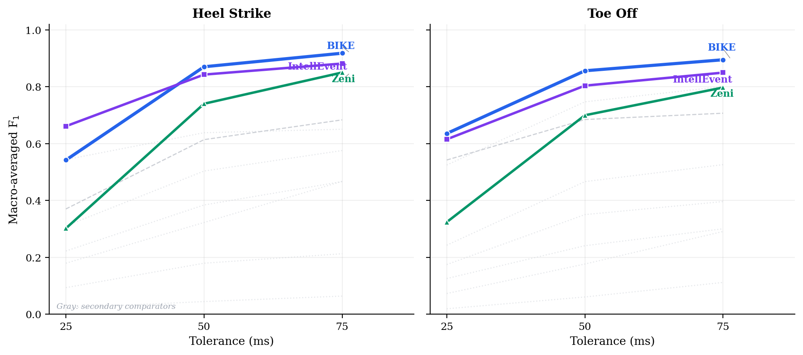
Figure S1. Tolerance sensitivity curves showing micro-F1 as a function of temporal tolerance (25, 50, 75 ms) for all detectors. Solid lines: HS; dashed lines: TO. BIKE achieves the highest F1 at 50 ms for both events.
Table S2a. HS micro-F1 at three tolerance thresholds (all development datasets).
Method | F1 @25 ms | F1 @50 ms | F1 @75 ms
BIKE | 0.426 | 0.830 | 0.891
IntellEvent | 0.550 | 0.741 | 0.805
Vancanneyt | 0.264 | 0.314 | 0.320
Zeni | 0.228 | 0.686 | 0.835
Ghoussayni | 0.233 | 0.374 | 0.447
Hreljac | 0.235 | 0.368 | 0.436
Mickelborough | 0.196 | 0.332 | 0.457
O'Connor | 0.150 | 0.253 | 0.316
DGEI | 0.036 | 0.080 | 0.115
Table S2b. TO micro-F1 at three tolerance thresholds (all development datasets).
Method | F1 @25 ms | F1 @50 ms | F1 @75 ms
BIKE | 0.619 | 0.774 | 0.815
IntellEvent | 0.309 | 0.474 | 0.552
Vancanneyt | 0.115 | 0.161 | 0.170
Zeni | 0.442 | 0.680 | 0.750
Ghoussayni | 0.130 | 0.224 | 0.289
Hreljac | 0.078 | 0.184 | 0.283
Mickelborough | 0.033 | 0.096 | 0.173
O'Connor | 0.178 | 0.341 | 0.413
DGEI | 0.213 | 0.479 | 0.586
At 25 ms tolerance, IntellEvent leads HS detection (micro-F1 = 0.550) thanks to its template-matching precision, while BIKE leads TO detection (micro-F1 = 0.619). At 50 ms, BIKE leads both HS (micro-F1 = 0.830) and TO (micro-F1 = 0.774). At 75 ms, performance differences narrow as most correctly-identified events fall within this more lenient window.
Zeni shows the steepest improvement from 25 to 50 ms, indicating that a substantial fraction of its detections fall just outside the stricter threshold and therefore benefit disproportionately from tolerance relaxation. Note the inherent asymmetry between events: HS timing is more precise than TO across all detectors (sharp heel strike vs. gradual toe lift), a biomechanical property that favours velocity-based detection for HS.

S3. Timing Accuracy and Runtime
Mean Absolute Error (MAE) complements F1 by characterising the temporal precision of correctly detected events. While F1 captures the binary match/mismatch decision (is the detection within the tolerance window?), MAE measures the continuous error in milliseconds, computed only on true positives. A detector can have high F1 but poor MAE if its detections cluster just inside the tolerance boundary.
Table S3. Processing time per trial for each detector (N = 5,149 development-set recordings with complete kinematic data available for timing analysis).
Method | Mean (ms) | SD (ms) | Median (ms) | N trials
Mickelborough | 7.8 | 15.0 | 3.1 | 5,149
O'Connor | 9.8 | 18.7 | 4.3 | 5,149
Hreljac | 8.1 | 12.7 | 4.4 | 5,149
Ghoussayni | 8.0 | 11.4 | 4.5 | 5,149
Zeni | 10.5 | 22.8 | 4.6 | 5,149
DGEI | 56.6 | 110.0 | 18.6 | 5,149
Vancanneyt | 38.7 | 58.7 | 20.0 | 5,149
BIKE | 214.8 | 647.6 | 47.8 | 5,149
IntellEvent | 1320.5 | 1912.3 | 594.1 | 5,149
BIKE processes a typical trial in 47.8 ms (median), which is 12× faster than IntellEvent (594.1 ms). The simpler kinematic detectors (Mickelborough, Ghoussayni, Hreljac, O’Connor) are the fastest (3–5 ms median) as they apply straightforward threshold or zero-crossing logic. Vancanneyt and DGEI occupy an intermediate position, with median times of 20.0 ms and 18.6 ms respectively.
All benchmarks were run on a single workstation (Intel Core i7, 32 GB RAM). Python 3.10, gaitkit v1.4.9.

S3.2 Detailed MAE Tables
Tables S3b and S3c present per-dataset Mean Absolute Error (MAE) for each detector, computed from true-positive matches at 75 ms tolerance. MAE is the weighted mean across trials (weighted by the number of true positives per trial) for each dataset–detector pair. Cells marked — indicate fewer than 3 matched events.
Table S3b. Heel Strike (HS) MAE (ms) at 75 ms tolerance for all 10 detectors across 16 datasets.
Detector | Camargo | Elderly FR | Figshare PD | Fukuchi | Hood Amp. | Kuopio | Schreiber | VanCriek. H | VanCriek. S | Van d. Zee | BioCV | ITW | Laroche OA | Nature MM | Parkinson NW | Vestibulo.
BIKE | 37.2 | 22.6 | 23.9 | 15.7 | 30.9 | 11.6 | 21.8 | 32.6 | 28.7 | 35.2 | 26.4 | 25.3 | 9.9 | 19.4 | 21.5 | 17.0
IntellEvent | 6.6 | 8.5 | 28.1 | 33.3 | 12.0 | 29.6 | 13.9 | 11.2 | 22.5 | 19.6 | 9.2 | 10.4 | 25.8 | 17.8 | 20.1 | 14.4
DeepEvent | 62.7 | 21.4 | 28.0 | 24.4 | 55.1 | 37.0 | — | — | — | 33.3 | 32.1 | 13.2 | 42.0 | 26.8 | 30.0 | 22.4
Zeni | 47.6 | 35.3 | 33.7 | 20.5 | 39.1 | 18.9 | 35.3 | 43.6 | 38.3 | 43.5 | 34.0 | 33.7 | 15.3 | 31.3 | 30.0 | 32.3
Vancanneyt | 58.0 | 13.6 | 14.1 | 18.6 | — | 16.6 | 8.4 | 16.1 | 19.7 | — | 9.6 | 13.2 | 22.1 | 9.3 | 17.6 | 10.2
Ghoussayni | 31.4 | 15.3 | 37.4 | 38.8 | 15.7 | 45.9 | 32.9 | 16.4 | 25.3 | 24.3 | 25.3 | 27.0 | 31.2 | 36.7 | 23.2 | 23.8
Hreljac | 26.8 | 42.2 | 34.8 | 37.2 | 23.9 | 40.6 | 22.3 | 25.8 | 32.2 | 28.3 | 20.3 | 28.6 | 43.4 | 25.4 | 39.6 | 37.8
Mickelborough | 32.4 | 53.8 | 33.9 | 37.0 | 26.0 | 57.8 | 26.1 | 45.9 | 27.1 | 44.3 | 36.9 | 32.7 | 42.8 | 30.1 | 38.5 | 40.8
O’Connor | 31.6 | 39.0 | 39.8 | 32.7 | 30.6 | 11.7 | 41.1 | 32.7 | 43.1 | 43.2 | 19.0 | 18.4 | 21.4 | 37.0 | 24.9 | 29.5
DGEI | 51.9 | 56.7 | 29.7 | 40.4 | 27.1 | 48.8 | 20.9 | 45.6 | 40.8 | 31.2 | 43.7 | 54.6 | 56.7 | 16.8 | 60.0 | 48.8
Table S3c. Toe-Off (TO) MAE (ms) at 75 ms tolerance for all 10 detectors across 16 datasets.
Detector | Camargo | Elderly FR | Figshare PD | Fukuchi | Hood Amp. | Kuopio | Schreiber | VanCriek. H | VanCriek. S | Van d. Zee | BioCV | ITW | Laroche OA | Nature MM | Parkinson NW | Vestibulo.
BIKE | 22.3 | 23.8 | 15.7 | 17.7 | 23.7 | 15.6 | 30.3 | 15.0 | 23.4 | 13.7 | 19.6 | 18.3 | 15.6 | 26.7 | 20.4 | 15.7
IntellEvent | 10.7 | 24.1 | 24.1 | 35.7 | 22.5 | 18.9 | 19.6 | 11.9 | 19.0 | 25.3 | 14.1 | 14.4 | 16.2 | 17.2 | 19.8 | 12.2
DeepEvent | 55.7 | 18.8 | 30.6 | 20.0 | 55.8 | 8.4 | — | — | — | 23.5 | 11.3 | 15.5 | 14.7 | 23.1 | 24.1 | 11.3
Zeni | 33.3 | 14.0 | 32.2 | 12.6 | 51.6 | 37.2 | 47.2 | 33.4 | 42.2 | 12.3 | 37.0 | 30.1 | 21.8 | 43.2 | 36.5 | 34.9
Vancanneyt | 44.5 | 15.3 | 27.8 | 10.1 | — | 17.1 | 56.2 | 40.3 | 50.1 | — | 19.0 | 31.2 | 27.3 | 55.0 | 49.8 | 44.0
Ghoussayni | 35.4 | 37.7 | 33.9 | 37.1 | 40.8 | 33.9 | 31.0 | 35.0 | 42.5 | 37.7 | 33.3 | 38.1 | 45.4 | 33.5 | 37.7 | 41.3
Hreljac | 49.7 | 50.7 | 28.8 | 39.8 | 33.7 | 50.4 | 46.6 | 58.6 | 47.9 | 57.7 | 25.4 | 55.8 | 51.1 | 48.2 | 49.6 | 50.1
Mickelborough | 50.8 | 51.2 | 46.3 | 42.0 | 43.9 | 51.8 | — | 54.9 | 41.2 | 56.0 | 51.2 | 43.2 | 52.7 | 70.0 | 55.6 | 43.5
O’Connor | 46.2 | 50.5 | 46.6 | 40.7 | 12.5 | 27.6 | 20.0 | 21.0 | 25.7 | 39.6 | 35.4 | 22.3 | 39.4 | 19.3 | 26.0 | 27.0
DGEI | 52.5 | 35.1 | 36.1 | 44.7 | 17.9 | 11.2 | 25.9 | 11.2 | 21.6 | 40.3 | 13.5 | 15.5 | 15.9 | 22.4 | 18.9 | 10.5

S3.3 Signed Timing Error
The signed timing error (detection minus ground truth) reveals the direction of timing errors. Positive values indicate late detection; negative values indicate early detection. BIKE exhibits near-zero median bias for both HS and TO across all five datasets, confirming symmetric jitter rather than systematic offset. IntellEvent displays dataset-dependent bias patterns, with a notable negative (early) shift on datasets that do not follow the Plug-in Gait labelling convention. Zeni shows a consistent negative bias for TO, indicating systematic early detection, an expected consequence of its reliance on the sacrum-to-foot AP distance, which reaches its minimum slightly before the true lift-off.
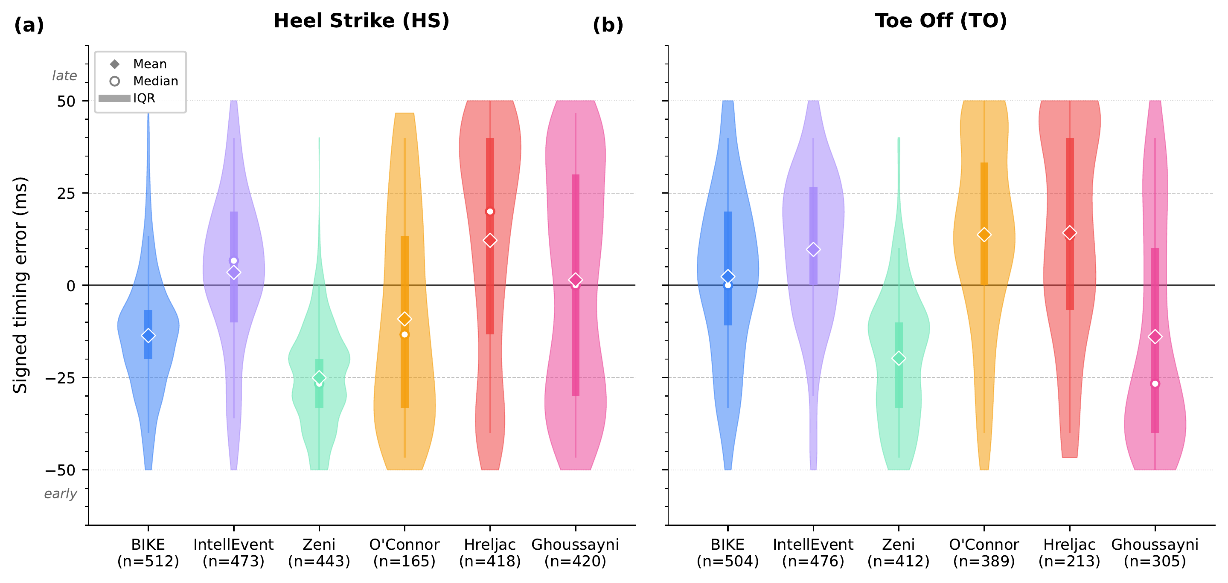
Figure S2. Signed timing error (detection − ground truth) for HS (a) and TO (b) across 6 detectors and 5 datasets (50 ms tolerance). Violin widths reflect the density of errors. BIKE shows near-zero median bias for both events.

S3.4 Algorithmic Complexity
BIKE’s computational complexity is O(n) in the number of frames, where each frame undergoes a fixed set of feature computations (Stage 1 crossing score, Stage 2 Bayesian scoring with 9 features). The Savitzky–Golay smoothing and MAD estimation use rolling windows of fixed width, making them linear in n. The dynamic programming assignment step in Stage 2 is O(k²) where k is the number of candidate events per half-cycle (typically 2–5), and the iterative rhythmic reinforcement adds a constant factor (up to 5 hops). The overall complexity is therefore O(n) with a small constant, consistent with the sub-100 ms processing times observed empirically.
By contrast, IntellEvent uses a Bidirectional LSTM (BiLSTM) architecture with complexity O(n · d²) where d is the hidden dimension (typically 64–128 units). The recurrent nature of the LSTM prevents parallelisation across the temporal axis on CPU, resulting in processing times approximately 20× slower than BIKE. DeepEvent uses a similar recurrent architecture. For clinical applications requiring real-time processing or batch analysis of thousands of trials, the O(n) complexity of rule-based approaches like BIKE provides a practical advantage over deep learning methods.

S4. Ground Truth Stratification and Failure Analysis
The 16 datasets use four types of ground truth (GT) annotation, each with distinct characteristics: force plates (gold standard, direct measurement of ground reaction forces), Nexus Kinematic (automated event detection by Vicon Nexus software), gait cycle percentage (GC%, events defined as fixed percentages of the gait cycle), and expert annotation (manual identification by trained clinicians). This section examines whether detector performance varies systematically with GT type, which could indicate methodological bias rather than true detection quality.
In addition, this section presents failure rates (trials where a detector returns no events or crashes) and an intention-to-treat (ITT) analysis that penalises failures by counting undetected events as false negatives. Together, these analyses assess both the accuracy and reliability of each detector in real-world conditions where graceful failure handling is essential.

S4.1 Ground Truth Distribution
Table S4a. Distribution of ground truth types across the analysed datasets. Abbreviations: GT = ground truth; FP = force plate; NK = Nexus Kinematic; GC% = gait cycle percentage.
GT Type | Datasets | N files | N GT HS | N GT TO
Force Plates | figshare_pd, kuopio, vanderzee | 4,388 | 51,165 | 51,109
Nexus Kinematic | vancriekinge_healthy, vancriekinge_stroke | 600 | 3,724 | 3,699
GC% | camargo, fukuchi | 2,126 | 68,990 | 48,843
Expert Annotation | elderly_fallrisk, hood_amputee, nature_multimodal, schreiber | 2,722 | 18,388 | 16,670

S4.2 Performance by GT Type
Table S4b. HS micro-F1 by ground truth type at 50 ms tolerance.
Detector | Force Plates | Nexus Kin. | GC% | Expert Annot. | All
BIKE | 0.757 | 0.847 | 0.876 | 0.872 | 0.830
IntellEvent | 0.788 | 0.901 | 0.629 | 0.947 | 0.741
Zeni | 0.628 | 0.655 | 0.750 | 0.637 | 0.686
Vancanneyt | 0.384 | 0.824 | 0.167 | 0.446 | 0.314
Ghoussayni | 0.370 | 0.650 | 0.346 | 0.486 | 0.374
Hreljac | 0.371 | 0.479 | 0.357 | 0.384 | 0.368
O'Connor | 0.201 | 0.101 | 0.297 | 0.223 | 0.253
Mickelborough | 0.222 | 0.291 | 0.392 | 0.338 | 0.332
DGEI | 0.060 | 0.023 | 0.115 | 0.007 | 0.080
Table S4c. TO micro-F1 by ground truth type at 50 ms tolerance.
Detector | Force Plates | Nexus Kin. | GC% | Expert Annot. | All
BIKE | 0.824 | 0.910 | 0.709 | 0.812 | 0.774
IntellEvent | 0.757 | 0.932 | 0.262 | 0.913 | 0.474
Zeni | 0.765 | 0.753 | 0.677 | 0.375 | 0.680
Vancanneyt | 0.188 | 0.420 | 0.130 | 0.081 | 0.161
Ghoussayni | 0.252 | 0.242 | 0.196 | 0.250 | 0.224
Hreljac | 0.123 | 0.106 | 0.219 | 0.244 | 0.184
O'Connor | 0.403 | 0.598 | 0.239 | 0.528 | 0.341
Mickelborough | 0.094 | 0.017 | 0.115 | 0.017 | 0.096
DGEI | 0.688 | 0.938 | 0.147 | 0.906 | 0.479
Force plate GT is the gold standard but represents specific laboratory conditions. GC% introduces a systematic timing offset. Expert annotation is the most variable. BIKE HS performance is relatively stable across GT types (F1 range: 0.757–0.872), confirming that its Bayesian approach generalises across annotation methodologies. IntellEvent shows the widest variation (highest on Nexus Kinematic and Expert Annotation, lowest on GC%), consistent with its template-matching architecture being sensitive to systematic timing definitions.

S4.3 Failure Rates
Table S4d. Overall failure rates per detector across all development datasets.
Detector | Total | HS fail | HS % | TO fail | TO % | Both fail | Both %
BIKE | 8,688 | 2 | 0.02 | 2 | 0.02 | 2 | 0.02
IntellEvent | 8,693 | 45 | 0.52 | 167 | 1.92 | 0 | 0.00
Zeni | 8,693 | 1 | 0.01 | 2 | 0.02 | 1 | 0.01
Vancanneyt | 8,693 | 1029 | 11.84 | 2493 | 28.68 | 1029 | 11.84
Ghoussayni | 8,693 | 1 | 0.01 | 1 | 0.01 | 1 | 0.01
Hreljac | 8,693 | 1 | 0.01 | 1 | 0.01 | 1 | 0.01
Mickelborough | 8,693 | 1 | 0.01 | 2 | 0.02 | 1 | 0.01
O'Connor | 8,693 | 1 | 0.01 | 1 | 0.01 | 1 | 0.01
DGEI | 8,693 | 2 | 0.02 | 1 | 0.01 | 1 | 0.01
Table S4e. Per-dataset HS failure rates (%) for each detector.
Detector | Schreiber/Nature | Fukuchi | Figshare PD | VanCriekinge Healthy | VanCriekinge Stroke | Van der Zee | Kuopio | Hood Amputee | Elderly Fall Risk | Camargo TM | Overall
BIKE | 0.0 | 0.0 | 0.2 | 0.2 | 0.7 | 0.3 | 0.1 | 0.0 | 0.0 | 0.0 | 0.1
IntellEvent | 1.2 | 0.2 | 1.7 | 0.2 | 0.7 | 0.0 | 0.3 | 0.0 | 0.0 | 0.0 | 0.5
Zeni | 0.0 | 0.0 | 0.0 | 0.0 | 0.0 | 0.3 | 0.0 | 0.0 | 0.0 | 0.0 | 0.0
Vancanneyt | 0.0 | 16.7 | 0.0 | 0.0 | 0.0 | 100.0 | 0.6 | 100.0 | 1.3 | 17.8 | 11.8
Ghoussayni | 0.0 | 0.0 | 0.0 | 0.0 | 0.0 | 0.3 | 0.0 | 0.0 | 0.0 | 0.0 | 0.0
Hreljac | 0.0 | 0.0 | 0.0 | 0.0 | 0.0 | 0.3 | 0.0 | 0.0 | 0.0 | 0.0 | 0.0
Mickelborough | 0.0 | 0.0 | 0.0 | 0.0 | 0.0 | 0.3 | 0.0 | 0.0 | 0.0 | 0.0 | 0.0
O'Connor | 0.0 | 0.0 | 0.0 | 0.0 | 0.0 | 0.3 | 0.0 | 0.0 | 0.0 | 0.0 | 0.0
DGEI | 0.0 | 0.0 | 0.0 | 0.0 | 0.0 | 0.3 | 0.0 | 0.0 | 0.7 | 0.0 | 0.0
Table S4f. Per-dataset TO failure rates (%) for each detector.
Detector | Schreiber/Nature | Fukuchi | Figshare PD | VanCriekinge Healthy | VanCriekinge Stroke | Van der Zee | Kuopio | Hood Amputee | Elderly Fall Risk | Camargo TM | Overall
BIKE | 0.0 | 0.0 | 0.2 | 0.2 | 0.7 | 0.3 | 0.1 | 0.0 | 0.0 | 0.0 | 0.1
IntellEvent | 0.0 | 0.0 | 0.0 | 0.2 | 0.0 | 0.0 | 5.2 | 0.0 | 0.0 | 0.0 | 1.9
Zeni | 0.0 | 0.0 | 0.0 | 0.0 | 0.0 | 0.3 | 0.0 | 0.0 | 0.0 | 0.0 | 0.0
Vancanneyt | 98.1 | 17.0 | 4.4 | 4.0 | 2.0 | 100.0 | 6.9 | 100.0 | 2.7 | 88.5 | 29.0
Ghoussayni | 0.0 | 0.0 | 0.0 | 0.0 | 0.0 | 0.3 | 0.0 | 0.0 | 0.0 | 0.0 | 0.0
Hreljac | 0.0 | 0.0 | 0.0 | 0.0 | 0.0 | 0.3 | 0.0 | 0.0 | 0.0 | 0.0 | 0.0
Mickelborough | 0.0 | 0.1 | 0.0 | 0.0 | 0.0 | 0.3 | 0.0 | 0.0 | 0.0 | 0.0 | 0.0
O'Connor | 0.0 | 0.0 | 0.0 | 0.0 | 0.0 | 0.3 | 0.0 | 0.0 | 0.0 | 0.0 | 0.0
DGEI | 0.0 | 0.0 | 0.0 | 0.0 | 0.0 | 0.3 | 0.0 | 0.0 | 0.0 | 0.0 | 0.0
BIKE failure rate on the 10 development datasets is 0.02 % (2/8,688 evaluations; both Kuopio fast-walking trials). Across the full 16-dataset benchmark, the rate is 0.016 % (2/12,315 evaluations). Vancanneyt has the highest failure rates: 11.79% for HS and 28.98% for TO, primarily concentrated in Van der Zee (100%) and Hood Amputee (100%) where short trials or atypical gait patterns break the multi-axis velocity-threshold logic. IntellEvent TO failures are concentrated in Kuopio (5.2%), likely due to the force-plate-based ground truth creating event definitions that differ from IntellEvent’s kinematic template expectations.

S4.4 Intention-to-Treat Analysis
Table S4g. Intention-to-treat (ITT) vs. intersection analysis.
Detector | Event | N OK | N fail | Fail % | F1 (int.) | F1 (ITT) | Δ F1 | Δ %
BIKE | HS | 8,686 | 2 | 0.02 | 0.827 | 0.827 | -0.0004 | -0.04
BIKE | TO | 8,686 | 2 | 0.02 | 0.773 | 0.773 | -0.0004 | -0.05
IntellEvent | HS | 8,648 | 45 | 0.52 | 0.736 | 0.735 | -0.0006 | -0.08
IntellEvent | TO | 8,526 | 167 | 1.92 | 0.467 | 0.466 | -0.0006 | -0.13
Zeni | HS | 8,692 | 1 | 0.01 | 0.688 | 0.688 | -0.0002 | -0.04
Zeni | TO | 8,691 | 2 | 0.02 | 0.687 | 0.686 | -0.0003 | -0.04
Vancanneyt | HS | 7,664 | 1029 | 11.84 | 0.521 | 0.301 | -0.2200 | -42.24
Vancanneyt | TO | 6,200 | 2493 | 28.68 | 0.489 | 0.165 | -0.3245 | -66.34
Ghoussayni | HS | 8,692 | 1 | 0.01 | 0.370 | 0.370 | -0.0001 | -0.02
Ghoussayni | TO | 8,692 | 1 | 0.01 | 0.225 | 0.225 | -0.0000 | -0.02
Hreljac | HS | 8,692 | 1 | 0.01 | 0.365 | 0.365 | -0.0001 | -0.02
Hreljac | TO | 8,692 | 1 | 0.01 | 0.183 | 0.183 | -0.0000 | -0.02
Mickelborough | HS | 8,692 | 1 | 0.01 | 0.332 | 0.332 | -0.0001 | -0.03
Mickelborough | TO | 8,691 | 2 | 0.02 | 0.098 | 0.098 | -0.0000 | -0.03
O'Connor | HS | 8,692 | 1 | 0.01 | 0.254 | 0.254 | -0.0001 | -0.02
O'Connor | TO | 8,692 | 1 | 0.01 | 0.337 | 0.337 | -0.0001 | -0.02
DGEI | HS | 8,691 | 2 | 0.02 | 0.082 | 0.082 | -0.0000 | -0.04
DGEI | TO | 8,692 | 1 | 0.01 | 0.469 | 0.469 | -0.0002 | -0.04
In the ITT analysis, failures are counted as missed events (all GT events become FN). Vancanneyt is severely penalised: HS F1 drops by 42.2%, TO F1 drops by 66.3%. BIKE is essentially unchanged (Δ = -0.04% for HS), confirming that its low failure rate makes it robust in intent-to-treat analysis where every trial must produce results. This distinction is clinically important: in longitudinal monitoring or automated pipelines, a detector that occasionally crashes on difficult trials biases the overall assessment by silently excluding the most challenging cases.

S5. Statistical Tests
S5 presents a trial-level secondary analysis (N = 6,254) complementing the per-dataset macro-F1 reported in the main text.
Non-parametric statistical tests were performed on trial-level F1 scores across N = 6,254 trials where all 9 detectors (excluding DeepEvent, unavailable on 3 datasets) returned valid events. The Friedman test assessed overall ranking differences, followed by pairwise Wilcoxon signed-rank tests with Bonferroni correction for 36 comparisons (9 detectors, C(9,2) = 36 pairs). The significance threshold after correction is p < 0.05/36 = 0.00139.

S5.1 Heel Strike Statistics
Table S5a. HS Friedman mean ranks (chi2 = 25530.47, p < 0.001).
Method | Mean Rank
BIKE | 2.08
IntellEvent | 3.11
Zeni | 3.35
Vancanneyt | 4.04
Ghoussayni | 5.57
Hreljac | 5.79
Mickelborough | 6.29
O'Connor | 7.05
DGEI | 7.71
Table S5b. HS pairwise Wilcoxon signed-rank tests (Bonferroni-corrected, significant pairs only).
Method A | Method B | p-adj | Sig.
BIKE | Vancanneyt | < 0.001 | ***
BIKE | Zeni | < 0.001 | ***
BIKE | Ghoussayni | < 0.001 | ***
BIKE | Hreljac | < 0.001 | ***
BIKE | Mickelborough | < 0.001 | ***
BIKE | O'Connor | < 0.001 | ***
BIKE | DGEI | < 0.001 | ***
IntellEvent | Ghoussayni | < 0.001 | ***
IntellEvent | Hreljac | < 0.001 | ***
IntellEvent | Mickelborough | < 0.001 | ***
IntellEvent | O'Connor | < 0.001 | ***
IntellEvent | DGEI | < 0.001 | ***
Vancanneyt | Hreljac | < 0.001 | ***
Vancanneyt | Mickelborough | < 0.001 | ***
Vancanneyt | O'Connor | < 0.001 | ***
Vancanneyt | DGEI | < 0.001 | ***
Zeni | Ghoussayni | < 0.001 | ***
Zeni | Hreljac | < 0.001 | ***
Zeni | Mickelborough | < 0.001 | ***
Zeni | O'Connor | < 0.001 | ***
Non-significant pair: IntellEvent vs Zeni (p-adj = 1.000).

S5.2 Toe-Off Statistics
Table S5c. TO Friedman mean ranks (chi2 = 24529.03, p < 0.001).
Method | Mean Rank
BIKE | 2.36
IntellEvent | 2.67
Zeni | 3.39
DGEI | 4.61
O'Connor | 5.24
Hreljac | 6.30
Vancanneyt | 6.31
Ghoussayni | 6.38
Mickelborough | 7.73
Table S5d. TO pairwise Wilcoxon signed-rank tests (Bonferroni-corrected, significant pairs only).
Method A | Method B | p-adj | Sig.
BIKE | Vancanneyt | < 0.001 | ***
BIKE | Ghoussayni | < 0.001 | ***
BIKE | Hreljac | < 0.001 | ***
BIKE | Mickelborough | < 0.001 | ***
BIKE | O'Connor | < 0.001 | ***
BIKE | DGEI | < 0.001 | ***
IntellEvent | Vancanneyt | < 0.001 | ***
IntellEvent | Ghoussayni | < 0.001 | ***
IntellEvent | Hreljac | < 0.001 | ***
IntellEvent | Mickelborough | < 0.001 | ***
IntellEvent | O'Connor | < 0.001 | ***
IntellEvent | DGEI | < 0.001 | ***
Vancanneyt | Zeni | < 0.001 | ***
Vancanneyt | Mickelborough | < 0.001 | ***
Zeni | Ghoussayni | < 0.001 | ***
Zeni | Hreljac | < 0.001 | ***
Zeni | Mickelborough | < 0.001 | ***
Zeni | O'Connor | < 0.001 | ***
Ghoussayni | Mickelborough | < 0.001 | ***
Ghoussayni | O'Connor | < 0.001 | ***

S5.3 Bootstrap Confidence Intervals
Table S5e. Subject-level bootstrap 95% CI for HS micro-F1.
Detector | Mean F1 | CI 2.5% | CI 97.5% | CI width
BIKE | 0.766 | 0.742 | 0.791 | 0.049
IntellEvent | 0.695 | 0.659 | 0.730 | 0.071
Zeni | 0.637 | 0.605 | 0.669 | 0.064
Hreljac | 0.371 | 0.359 | 0.382 | 0.024
Ghoussayni | 0.346 | 0.325 | 0.369 | 0.044
Mickelborough | 0.311 | 0.290 | 0.332 | 0.042
O'Connor | 0.267 | 0.247 | 0.286 | 0.039
Vancanneyt | 0.263 | 0.213 | 0.322 | 0.108
DGEI | 0.076 | 0.058 | 0.096 | 0.038
Table S5f. Subject-level bootstrap 95% CI for TO micro-F1.
Detector | Mean F1 | CI 2.5% | CI 97.5% | CI width
BIKE | 0.719 | 0.680 | 0.759 | 0.079
Zeni | 0.644 | 0.592 | 0.695 | 0.103
IntellEvent | 0.441 | 0.379 | 0.513 | 0.134
DGEI | 0.429 | 0.354 | 0.503 | 0.149
O'Connor | 0.323 | 0.296 | 0.352 | 0.056
Ghoussayni | 0.220 | 0.202 | 0.239 | 0.037
Hreljac | 0.169 | 0.150 | 0.190 | 0.039
Vancanneyt | 0.145 | 0.118 | 0.178 | 0.061
Mickelborough | 0.097 | 0.081 | 0.115 | 0.034
BIKE shows the narrowest confidence interval for HS (CI width = 0.049) and TO (CI width = 0.079), indicating consistent performance across subjects. IntellEvent has a notably wider CI for TO (0.134), reflecting dataset-specific vulnerabilities in toe-off detection. The bootstrap approach (1000 resamples of subjects) accounts for the hierarchical data structure where trials are nested within subjects.

S6. BIKE Algorithm, Parameters, and Implementation Details

S6.1 Algorithm overview
BIKE decomposes gait event detection into two sequential inference stages, followed by a post-processing refinement step. Stage 1 identifies half-gait-cycle intervals from limb crossings in the anteroposterior plane. Stage 2 localises heel strike (HS) and toe off (TO) within each interval using Bayesian inference over biomechanical features (eight core families, instantiated as 9 HS and 10 TO active priors) with mixed literature-informed and empirically calibrated parameters. A Viterbi dynamic programming algorithm enforces strict HS-TO alternation. Post-processing applies velocity zero-crossing refinement, vertical correction, boundary event recovery, and gap filling. The complete pipeline is illustrated in Figure S3.
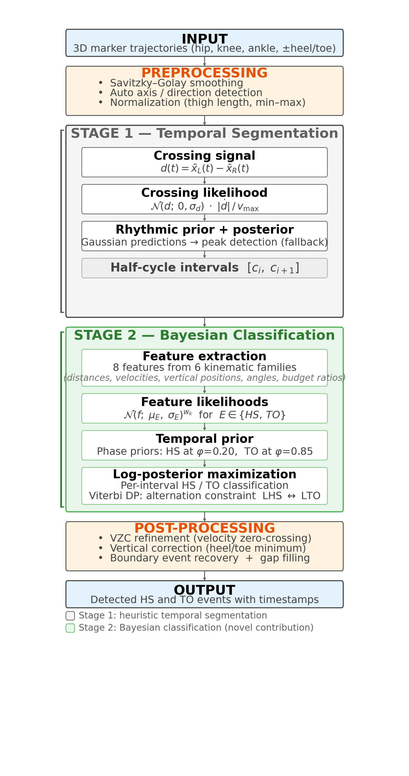
Figure S3. Complete BIKE algorithm pipeline. Grey: Stage 1 (heuristic temporal segmentation via limb-crossing detection). Green: Stage 2 (Bayesian classification using eight core kinematic feature families (9 HS, 10 TO active priors) with mixed literature-informed and empirically calibrated priors, without dataset-specific retraining at evaluation time). Orange: post-processing refinement steps.

S6.2 Stage 1: Temporal segmentation via limb crossings
As summarised in the main text (“The BIKE detector”), the lower limbs alternate in AP position during normal gait: each crossing marks a half-gait-cycle boundary. Here we provide the full mathematical specification. A crossing signal d(t) is computed as the difference in mean AP position between the left and right lower-limb markers (knee + ankle), relative to the pelvis midpoint: An illustration of this process is shown in Figure S4.
d(t) = x̄_L(t) - x̄_R(t) where x̄_s(t) = ½(x^AP_{knee,s}(t) + x^AP_{ankle,s}(t)) - x^AP_{pelvis}(t)
$σ_{\text{local}}\left(t\right)=0.7⋅\left(1.4826⋅{MAD}_{\text{local}}\left(t\right)\right)+0.3⋅σ_{\text{global}}$ (Eq. S1)
The crossing score combines three components: proximity to zero (how close d(t) is to zero), velocity magnitude (favouring fast crossings), and rhythmic prediction (temporal regularity). The locally adaptive sigma is estimated from the median absolute deviation (MAD) of d(t) within a rolling window, blending 70% local and 30% global estimates:
$S_{\text{cross}}\left(t\right)=exp​\left(−1/2{\left(\frac{d\left(t\right)}{σ_{\text{local}}\left(t\right)}\right)}^{2}\right)⋅\frac{\left|\dot{d}\left(t\right)\right|}{v_{max}}⋅P_{\text{rhythm}}\left(t\right)$ (Eq. S2)
Crossings are detected from S_cross(t) using a hierarchical peak detection scheme with three fallback levels: strict peaks (height ≥ 0.1, prominence ≥ 0.05), relaxed peaks (height ≥ 0.05, prominence ≥ 0.02), and zero-crossing fallback. An iterative rhythmic reinforcement mechanism recovers missed crossings by extrapolating the local median inter-crossing interval with geometric decay (factor 0.5 per hop, max 5 hops).

S6.3 Stage 2: Bayesian event classification
Within each half-cycle interval [c_i, c_{i+1}], BIKE localises one HS and one TO by maximising a log-posterior over candidate frames. At each frame, BIKE computes an event-specific feature set composed of eight shared core families and additional event-specific cues, yielding 9 active HS priors and 10 active TO priors. The classification process is illustrated in Figure S3.
$f\left(t\right)=\left[Δ_{\text{knee-heel}}^{\text{AP}}, {\dot{x}}_{\text{ankle}}^{\text{AP}}, z_{\text{heel}}, {\dot{z}}_{\text{heel}}, θ_{\text{knee}}, {\dot{θ}}_{\text{knee}}, R_{\text{toe}}, Δω\right]$ (Eq. 1)
Equation 1 shows the eight shared core feature families; the full active prior set includes R_knee (HS and TO) and ankle-toe AP velocity (TO only).
As introduced in the main text (“The BIKE detector”), the likelihood of the feature vector given event type E is modelled as a weighted product of marginal Gaussian likelihoods (composite likelihood). This avoids estimating a full joint covariance matrix over the event-specific feature set, which would be ill-conditioned (condition number > 490,000 in pilot analysis). The log-posterior for event E at candidate frame t is:
$logP\left(E∣t\right)=\sum_{k=1}^{K}{w_{k}}⋅logN​\left(x_{k}\left(t\right); μ_{k}^{E},σ_{k}^{E}\right)+logP_{\text{phase}}\left(t∣E\right)+C$ (Eq. 2)
where K features (K = 9 for HS, K = 10 for TO), w_k is the feature weight, and N denotes the Gaussian density. The event-specific Gaussian parameters (μ_k^E, σ_k^E) encode expected kinematic configurations derived from normative gait biomechanics [S2]. High-weight features (w = 2.0) are dominant discriminators, while low-weight features (w = 0.25-0.3) provide supplementary evidence.
A temporal phase prior further constrains the expected position of each event within its half-cycle interval. HS is expected at phase φ = 0.20 (early in the interval) and TO at φ = 0.85 (late), with Gaussian priors:
$logP_{\text{phase}}\left(t∣E\right)=−1/2 w_{φ}{\left(\frac{\frac{t−t_{\text{start}}}{t_{\text{end}}−t_{\text{start}}}−μ_{φ}}{σ_{φ}}\right)}^{2}$ (Eq. 3)
The Viterbi dynamic programming algorithm jointly optimises event assignments across all intervals, enforcing strict HS-TO alternation for each limb. The recurrence relation is:
V(k, e) = max_{e′≠e} [ V(k-1, e′) + log P(f(t*_k) | e) + log P_φ(e) ] (Eq. 4)
where V(k, e) is the optimal log-posterior for assigning event type e to interval k, and the maximisation is over the complementary event type (enforcing alternation).

S6.4 Feature definitions and biomechanical rationale
The biomechanical features (eight core families, with event-specific instantiations) and their prior parameters are detailed in Tables S6a and S6b. Each feature is characterised by a Gaussian prior N(x; μ, σ) weighted by w, where μ encodes the expected kinematic value at the gait event, σ reflects the expected variability, and w controls the feature's relative influence on the composite likelihood.

S6.5 Worked example on real data
Figure S4 illustrates the complete BIKE pipeline applied to a single walking trial (BioCV-MoCap dataset, subject P03, WALK_01, 200 Hz motion capture). Panel A shows the limb-crossing signal d(t), the signed difference between left and right limb anteroposterior positions after pelvis subtraction. Each zero-crossing (purple dots) delineates a half-gait-cycle interval. Panel B displays the crossing posterior P(crossing), computed by combining the likelihood (grey), derived from the normalised proximity and velocity of d(t), with a rhythmic prior (dashed orange) that reinforces periodicity. Detected crossings are marked at the posterior peaks. Panel C zooms into one half-cycle interval, showing the Bayesian localisation of a heel strike. The temporal phase prior (dashed orange) favours the early portion of the interval, while the feature log-likelihood (dash-dot blue), computed from the eight biomechanical cues, peaks near the true event. The log-posterior (solid red) is maximised at the MAP estimate t*_HS. Panel D presents the final detected gait events overlaid on the left ankle AP trajectory and left heel vertical position: filled red triangles = left HS, open red triangles = right HS, filled blue circles = left TO, open blue circles = right TO. All events match the ground-truth annotations (vertical dashed lines) with errors below 25 ms.
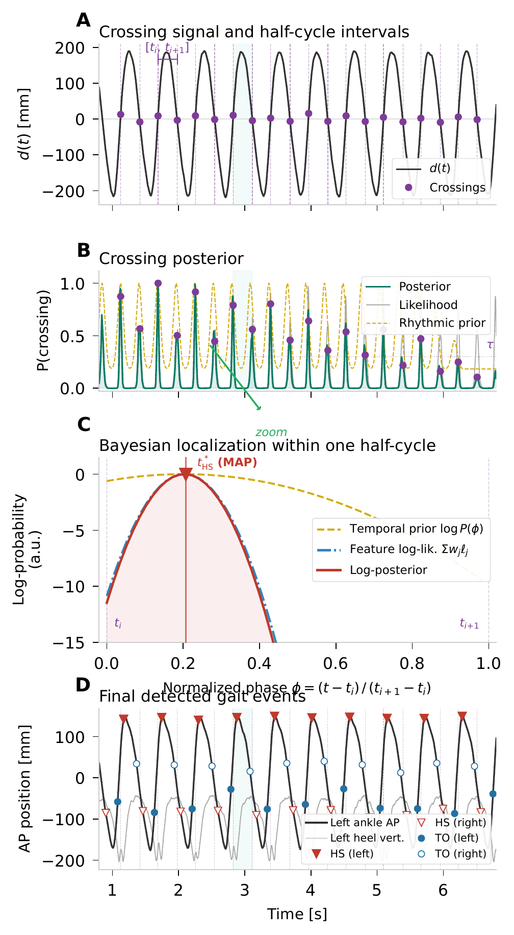
Figure S4. Worked example of BIKE detection on a single walking trial (BioCV-MoCap P03_WALK_01, 200 Hz). (A) Crossing signal d(t) with detected zero-crossings (purple dots). (B) Crossing posterior combining likelihood and rhythmic prior. (C) Bayesian localisation within one half-cycle: temporal phase prior (dashed orange), feature log-likelihood (dash-dot blue), and log-posterior (solid red) with MAP estimate t*_HS. (D) Final detected events overlaid on ankle AP trajectory and heel vertical position.

S6.6 Parameters and implementation details
BIKE uses 99 fixed parameters organised into five groups: Stage 2 HS biomechanical priors (27), Stage 2 TO biomechanical priors (30), phase priors (6), Stage 1 signal processing (19), and post-processing (17). These parameters were determined from biomechanical principles and empirical tuning on the 10 development datasets, then frozen before held-out evaluation. No parameter was adjusted after examining held-out or markerless results. The six classical kinematic features (knee–heel AP distance, ankle AP velocity, heel/toe vertical position, heel/toe vertical velocity, knee angle, knee angular velocity) use prior means derived from normative gait data reported by Winter [S1] and Perry & Burnfield [S2]. The two kinematic budget ratios (R_toe, R_knee) and the differential angular velocity (Δω) use empirically calibrated priors optimised via grid search on the development datasets. Phase prior means (HS at φ = 0.20, TO at φ = 0.85) reflect the canonical temporal structure of the gait cycle.
Each Stage 2 biomechanical feature is characterised by three parameters: a mean (expected value at the event), a spread (standard deviation of the Gaussian prior), and a weight (relative importance in the posterior combination). Features with high weight (2.0) are dominant discriminators, while low-weight features (0.25–0.3) provide supplementary evidence. The spread parameter controls sensitivity: narrow spreads reject candidates that deviate even slightly from the expected biomechanical signature, while wide spreads are used for features with high inter-subject variability.
Table S6a. Stage 2: HS biomechanical priors (27 parameters).
Feature | Parameter | Value | Description
knee_heel_ap | mean | 0.12 | Normalised heel-knee AP separation at HS (leg extended forward)
knee_heel_ap | spread | 0.15 | Spread of knee-heel AP prior at HS
knee_heel_ap | weight | 2.0 | Weight of knee-heel AP prior at HS (dominant feature)
ankle_ap_vel | mean | -0.8 | Normalised ankle AP velocity at HS (decelerating)
ankle_ap_vel | spread | 0.5 | Spread of ankle AP velocity prior at HS
ankle_ap_vel | weight | 1.5 | Weight of ankle AP velocity prior at HS
heel_vert | mean | 0.02 | Normalised heel vertical position at HS (near ground)
heel_vert | spread | 0.1 | Spread of heel vertical position prior at HS
heel_vert | weight | 1.5 | Weight of heel vertical position prior at HS
heel_vert_vel | mean | -1.0 | Heel vertical velocity at HS (descending)
heel_vert_vel | spread | 2.0 | Spread of heel vertical velocity prior at HS
heel_vert_vel | weight | 0.5 | Weight of heel vertical velocity prior at HS (low: noisy)
knee_angle | mean | 5.0 | Knee flexion angle at HS in degrees (near full extension)
knee_angle | spread | 8.0 | Spread of knee angle prior at HS
knee_angle | weight | 1.0 | Weight of knee angle prior at HS
knee_angle_vel | mean | 0.0 | Knee angular velocity at HS in deg/s (reversal point)
knee_angle_vel | spread | 80.0 | Spread of knee angular velocity prior at HS (wide)
knee_angle_vel | weight | 0.3 | Weight of knee angular velocity prior at HS (low: variable)
R_toe | mean | 0.61 | Toe velocity ratio |v_toe_vert|/denom at HS (toe dominates)
R_toe | spread | 0.25 | Spread of R_toe prior at HS
R_toe | weight | 0.6 | Weight of R_toe prior at HS (coordination feature)
R_knee | mean | 0.11 | Knee velocity ratio |omega_knee|/denom at HS (knee quiet)
R_knee | spread | 0.2 | Spread of R_knee prior at HS
R_knee | weight | 0.6 | Weight of R_knee prior at HS (coordination feature)
delta_omega | mean | 0.0 | Knee-ankle angular velocity difference at HS in deg/s
delta_omega | spread | 80.0 | Spread of delta_omega prior at HS (wide)
delta_omega | weight | 0.25 | Weight of delta_omega prior at HS (low: supplementary)
Table S6b. Stage 2: TO biomechanical priors (30 parameters).
Feature | Parameter | Value | Description
knee_heel_ap | mean | -0.72 | Normalised heel-knee AP separation at TO (heel behind knee)
knee_heel_ap | spread | 0.15 | Spread of knee-heel AP prior at TO
knee_heel_ap | weight | 2.0 | Weight of knee-heel AP prior at TO (dominant feature)
ankle_ap_vel | mean | 0.8 | Normalised ankle AP velocity at TO (accelerating forward)
ankle_ap_vel | spread | 0.6 | Spread of ankle AP velocity prior at TO
ankle_ap_vel | weight | 1.5 | Weight of ankle AP velocity prior at TO
toe_vert | mean | 0.3 | Normalised toe vertical position at TO (partially lifted)
toe_vert | spread | 0.25 | Spread of toe vertical position prior at TO
toe_vert | weight | 0.8 | Weight of toe vertical position prior at TO
toe_vert_vel | mean | 3.5 | Toe vertical velocity at TO (rising rapidly)
toe_vert_vel | spread | 2.0 | Spread of toe vertical velocity prior at TO
toe_vert_vel | weight | 1.0 | Weight of toe vertical velocity prior at TO
knee_angle | mean | 43.0 | Knee flexion angle at TO in degrees (mid-flexion)
knee_angle | spread | 10.0 | Spread of knee angle prior at TO
knee_angle | weight | 1.0 | Weight of knee angle prior at TO
knee_angle_vel | mean | 200.0 | Knee angular velocity at TO in deg/s (rapid flexion)
knee_angle_vel | spread | 150.0 | Spread of knee angular velocity prior at TO (wide)
knee_angle_vel | weight | 1.0 | Weight of knee angular velocity prior at TO
R_toe | mean | 0.27 | Toe velocity ratio |v_toe_vert|/denom at TO (knee dominates)
R_toe | spread | 0.25 | Spread of R_toe prior at TO
R_toe | weight | 0.3 | Weight of R_toe prior at TO (coordination feature; low)
R_knee | mean | 0.3 | Knee velocity ratio |omega_knee|/denom at TO (knee active)
R_knee | spread | 0.2 | Spread of R_knee prior at TO
R_knee | weight | 2.0 | Weight of R_knee prior at TO (coordination feature; dominant)
delta_omega | mean | 100.0 | Knee-ankle angular velocity difference at TO in deg/s
delta_omega | spread | 120.0 | Spread of delta_omega prior at TO (wide)
delta_omega | weight | 0.25 | Weight of delta_omega prior at TO (low: supplementary)
ankle_toe_ap_vel | mean | -3.0 | Ankle-toe AP separation velocity at TO (converging)
ankle_toe_ap_vel | spread | 2.5 | Spread of ankle-toe AP velocity prior at TO
ankle_toe_ap_vel | weight | 2.0 | Weight of ankle-toe AP velocity prior at TO (dominant)
Table S6c. Phase priors (6 parameters).
Feature | Parameter | Value | Description
HS_PHASE_PRIOR | mean | 0.2 | Expected HS phase within crossing interval (early)
HS_PHASE_PRIOR | spread | 0.18 | Spread of HS phase prior
HS_PHASE_PRIOR | weight | 1.5 | Weight of HS phase prior
TO_PHASE_PRIOR | mean | 0.85 | Expected TO phase within crossing interval (late)
TO_PHASE_PRIOR | spread | 0.2 | Spread of TO phase prior
TO_PHASE_PRIOR | weight | 1.5 | Weight of TO phase prior
Table S6d. Stage 1 signal processing (19 parameters).
Name | Type | Value | Description
SMOOTHING_MS | constant | 55.0 | SavGol trajectory smoothing window in ms (design: 200fps/11fr)
HALF_WIN_MS | constant | 300.0 | p_signal local-sigma half-window in ms
VEL_HALF_WIN_MS | constant | 150.0 | p_signal velocity-norm half-window in ms
PS_SIGMA_MS | constant | 10.0 | p_signal Gaussian post-smoothing in ms (low-fps path)
MAD_TO_SIGMA_FACTOR | constant | 1.4826 | MAD-to-sigma conversion factor (Gaussian consistency)
LOCAL_SIGMA_BLEND_LOCAL | constant | 0.7 | Blend weight for local MAD sigma (complement: 0.3 global)
LOCAL_SIGMA_MIN_RATIO | constant | 0.01 | Minimum local sigma as fraction of global sigma
P_SIGNAL_PROXIMITY_BANDWIDTH | constant | 0.3 | Gaussian kernel bandwidth for proximity score
P_SIGNAL_SMOOTHING_SIGMA | constant | 2.0 | Gaussian smoothing sigma for p_signal (high-fps path)
PEAK_HEIGHT_STRICT | constant | 0.1 | Minimum peak height for strict crossing detection
PEAK_PROMINENCE_STRICT | constant | 0.05 | Minimum peak prominence for strict crossing detection
PEAK_HEIGHT_RELAXED | constant | 0.05 | Minimum peak height for relaxed crossing detection
PEAK_PROMINENCE_RELAXED | constant | 0.02 | Minimum peak prominence for relaxed crossing detection
PEAK_HEIGHT_SEGMENT | constant | 0.1 | Minimum peak height for per-segment refinement
PEAK_PROMINENCE_SEGMENT | constant | 0.03 | Minimum peak prominence for per-segment refinement
SEGMENT_BREAK_RATIO | constant | 2.0 | Interval/median ratio threshold for segment splitting
REINFORCEMENT_DECAY | constant | 0.5 | Exponential decay factor per hop in rhythm reinforcement
REINFORCEMENT_MAX_HOPS | constant | 5.0 | Maximum number of hops for rhythm extrapolation
REINFORCEMENT_MAX_CONTRIBUTION | constant | 0.1 | Maximum reinforcement amplitude relative to signal peak
Table S6e. Post-processing (17 parameters).
Name | Type | Value | Description
HS_OFFSET_knee_heel_ap | constant | 15.0 | Temporal offset in ms for knee-heel AP feature at HS
TO_OFFSET_knee_angle_vel | constant | 15.0 | Temporal offset in ms for knee angular velocity at TO
BOUNDARY_PEAK_HEIGHT_LEADING | constant | 0.4 | Minimum peak height for leading boundary event detection
BOUNDARY_PEAK_PROMINENCE_LEADING | constant | 0.1 | Minimum peak prominence for leading boundary events
BOUNDARY_PEAK_HEIGHT_TRAILING | constant | 0.35 | Minimum peak height for trailing boundary event detection
BOUNDARY_PEAK_PROMINENCE_TRAILING | constant | 0.05 | Minimum peak prominence for trailing boundary events
BOUNDARY_FALLBACK_LEADING_THRESHOLD | constant | 0.7 | Probability threshold for leading boundary fallback
BOUNDARY_FALLBACK_TRAILING_THRESHOLD | constant | 0.7 | Probability threshold for trailing boundary fallback
BOUNDARY_MIN_LEADING_FRAME | constant | 0.0 | Minimum frame index for leading boundary event
GAP_THRESHOLD_RATIO | constant | 1.8 | Interval/median ratio to trigger gap event insertion
GAP_PEAK_HEIGHT | constant | 0.5 | Minimum peak height for gap event detection
GAP_PEAK_PROMINENCE | constant | 0.15 | Minimum peak prominence for gap event detection
TRAILING_TO_SUPPRESS_RATIO | constant | 0.25 | Suppress trailing TO if within this fraction of stride end
VERTICAL_CORRECTION_SHRINKAGE | constant | 0.5 | Shrinkage factor for heel/toe vertical timing correction
VERTICAL_CORRECTION_MAX_RATIO | constant | 0.08 | Maximum vertical correction as fraction of stride period
VERTICAL_CORRECTION_MIN_SHIFT | constant | 2.0 | Minimum shift in frames to apply vertical correction
VERTICAL_RANGE_THRESHOLD | constant | 5.0 | Minimum vertical range in mm to enable vertical correction
Locally adaptive sigma. The Stage 1 crossing score uses a locally adaptive sigma estimated from the median absolute deviation (MAD) of the trajectory within a rolling window. This adapts to local signal quality without global normalisation, using: sigma_local = MAD × 1.4826 (Gaussian consistency factor). A blend of 70% local and 30% global MAD ensures stability in segments with very low variability. The minimum local sigma is clamped at 1% of the global sigma to prevent numerical instability.
Iterative rhythmic reinforcement. After initial crossing detection, the signal is segmented at gaps exceeding 2× the local median interval. Within each segment, a rhythmic template is built from the median crossing interval, and a Gaussian reinforcement kernel is applied iteratively (up to 5 hops, decay factor 0.5). This recovers weak crossings that fall between strong ones, particularly beneficial for irregular gait patterns where some strides produce weaker biomechanical signatures.
Hierarchical peak detection. Crossings are detected using a fallback hierarchy: strict peaks (prominence ≥ 0.05) → relaxed peaks (prominence ≥ 0.02) → zero-crossings → absolute-difference threshold. This ensures coverage even in low-SNR segments while maintaining specificity in clean signals. The per-segment refinement step uses intermediate thresholds (prominence ≥ 0.03) to recover events missed by the global pass.

References for biomechanical priors: [S1] Winter DA. Biomechanics and Motor Control of Human Movement. 4th ed. Hoboken, NJ: John Wiley & Sons; 2009. [S2] Perry J, Burnfield JM. Gait Analysis: Normal and Pathological Function. 2nd ed. Thorofare, NJ: SLACK Incorporated; 2010. [S3] Varin C, Reid N, Firth D. An overview of composite likelihood methods. Statistica Sinica. 2011;21(1):5–42.

S6.7 Extended Feature Definitions and Biomechanical Rationale
R_toe (toe velocity ratio). This dimensionless feature represents the fraction of total lower-limb velocity carried by the toe marker: R_toe = |v_toe| / (|v_toe| + |v_heel| + |v_knee|), where velocities are computed in the anteroposterior (AP) direction. By normalising to a ratio, the feature is invariant to absolute walking speed. At HS, the heel is decelerating while the toe still carries forward momentum, yielding a high R_toe (μ = 0.61, σ = 0.25). At TO, the opposite pattern holds: the toe is the last segment to leave the ground and carries relatively less velocity (μ = 0.27, σ = 0.25).
Δω (differential angular velocity). Defined as the difference between knee angular velocity and ankle angular velocity: Δω = ω_knee − ω_ankle. This feature cancels common-mode offsets (e.g., trunk sway) that affect both joints equally. At HS, the knee and ankle angular velocities are approximately equal (both near zero as the limb extends), yielding Δω ≈ 0 (μ = 0.0, σ = 80 deg/s). At TO, the knee is flexing rapidly while the ankle plantarflexes, producing a large positive differential (μ = 100, σ = 120 deg/s).
ankle_ap_vel (normalised ankle AP velocity). The anteroposterior velocity of the ankle joint centre relative to the pelvis, normalised by thigh length to create a dimensionless rate. At HS, the ankle is decelerating sharply as the foot contacts the ground (μ = −0.8 thigh-lengths/s). At TO, the ankle accelerates forward during push-off (μ = +0.8 thigh-lengths/s). This feature is the single most discriminant predictor for both events (ablation ΔF1 > 20 pp when removed; see S7.2). Its biomechanical basis is well-established [S2].
heel_vert and toe_vert (normalised vertical positions). The vertical positions of the heel and toe markers, normalised to [0, 1] using the range observed during the trial. At HS, the heel is near the ground (μ = 0.02). At TO, the toe has begun to lift (μ = 0.3). These features provide complementary evidence to velocity-based features by encoding spatial configuration rather than dynamics.
knee_angle (knee flexion angle). The sagittal-plane knee flexion angle in degrees. At HS, the knee is near full extension (μ = 5°, σ = 8°), a well-known biomechanical constraint [S2]. At TO, the knee is flexing into pre-swing (μ = 43°, σ = 10°). The knee angle prior provides a strong constraint that is largely invariant across populations.
knee_angle_vel (knee angular velocity). The rate of change of knee flexion angle. At HS, the angular velocity is near zero (μ = 0, σ = 80 deg/s) as the knee transitions from extension to flexion. At TO, the knee is flexing rapidly (μ = 200, σ = 150 deg/s). The large spread for TO reflects inter-subject variability in push-off dynamics.

S6.8 Prior Distribution Characteristics
Development-set labelled observations (381,685 frames: 101,044 HS events, 99,660 TO events, 180,981 non-event frames across 10 datasets) were used to characterise empirical feature distributions and to calibrate the empirically tuned priors. However, the six classical feature priors used in the frozen model were anchored to published normative gait biomechanics [S2], whereas the coordination features (R_toe, R_knee, and Δω) and the TO-specific ankle-toe AP velocity were calibrated on the development datasets only. The resulting distributions show clear separation for the dominant features: knee angle (standardised) shifts from μ = −0.85 at HS to μ = +0.72 at TO, while knee angular velocity shifts from μ = +0.24 at HS to μ = +1.58 at TO.
Non-event frames show intermediate distributions with larger variance, as expected from sampling across all phases of the gait cycle. The log-likelihood ratio between event and non-event distributions provides the discriminative power used in Stage 2 scoring. Features with narrow event distributions and wide non-event distributions (e.g., knee angle at HS) contribute strong positive evidence at the correct phase and weak negative evidence elsewhere, while features with broad overlap (e.g., heel vertical velocity) contribute less discriminative information but still improve the composite score.

S6.9 Parameter Sensitivity
A systematic sensitivity analysis was conducted by perturbing each of the 16 key Stage 1 and post-processing parameters by ±20% and ±50% from their default values, evaluating micro-F1 across the 10 development datasets. Results confirm that BIKE is insensitive to moderate parameter changes: all parameters produce |ΔF1| < 0.6 percentage points at ±20% perturbation. Only VERT_CORR_MAX_RATIO and VERT_CORR_SHRINKAGE exceed the 1 pp threshold, and only at the extreme ±50% perturbation. The reinforcement_alpha parameter shows zero sensitivity because it is absorbed by the reinforcement decay mechanism. This robustness to parameter perturbation supports the claim that BIKE’s parameters are not over-fitted to the development data.

S6.10 Independence Assumption and Covariance Structure
BIKE treats the event-specific active feature set as conditionally independent given the event class, corresponding to 9 active priors for HS and 10 for TO in the frozen model. The composite log-posterior is computed as a weighted sum of individual Gaussian log-likelihoods. This independence assumption is a deliberate simplification: the empirical off-diagonal correlations average |r| = 0.33 for HS features and |r| = 0.28 for TO features. The strongest pairwise correlation is between knee_heel_ap and knee_angle (|r| = 0.87), reflecting the biomechanical coupling between knee extension and heel position at initial contact.
To quantify the impact of this approximation, a Monte Carlo experiment compared BIKE’s independent-feature scoring against a full multivariate Gaussian model (9-dimensional, with the empirical covariance matrix). The multivariate model produced negligible changes: −0.04 pp for HS F1 and +1.1 pp for TO F1 on the development datasets. However, the empirical covariance matrix has a condition number κ > 490,000, indicating severe ill-conditioning that would make the multivariate model numerically unstable in practice. The independence assumption is therefore justified both empirically (minimal F1 impact) and numerically (avoids ill-conditioned matrix inversion). This approach is consistent with the composite likelihood framework described by Varin et al. [S3], where independent marginal likelihoods are combined as a tractable approximation to the joint likelihood.

S7. Feature Transportability Analysis
This section examines whether BIKE’s biomechanical features discriminate gait events consistently across healthy and clinical populations. Using the 10 development datasets, features were evaluated for: (1) discriminability (Cohen’s d between event vs. non-event windows), and (2) cross-population transferability (AUC when a threshold trained on healthy data is applied to clinical data, and vice versa). High discriminability indicates that a feature produces clearly different values at gait events vs. other time points; high transferability indicates that this discrimination generalises.
Four transfer scenarios were tested: healthy→healthy (H→H), healthy→clinical (H→C), clinical→clinical (C→C), and clinical→healthy (C→H). The cross-transfer AUC is the mean of H→C and C→H, representing the ability of features to generalise across populations without retraining. Features with cross-transfer AUC close to their within-group AUC have negligible transfer gap, meaning the biomechanical signature is population-invariant.
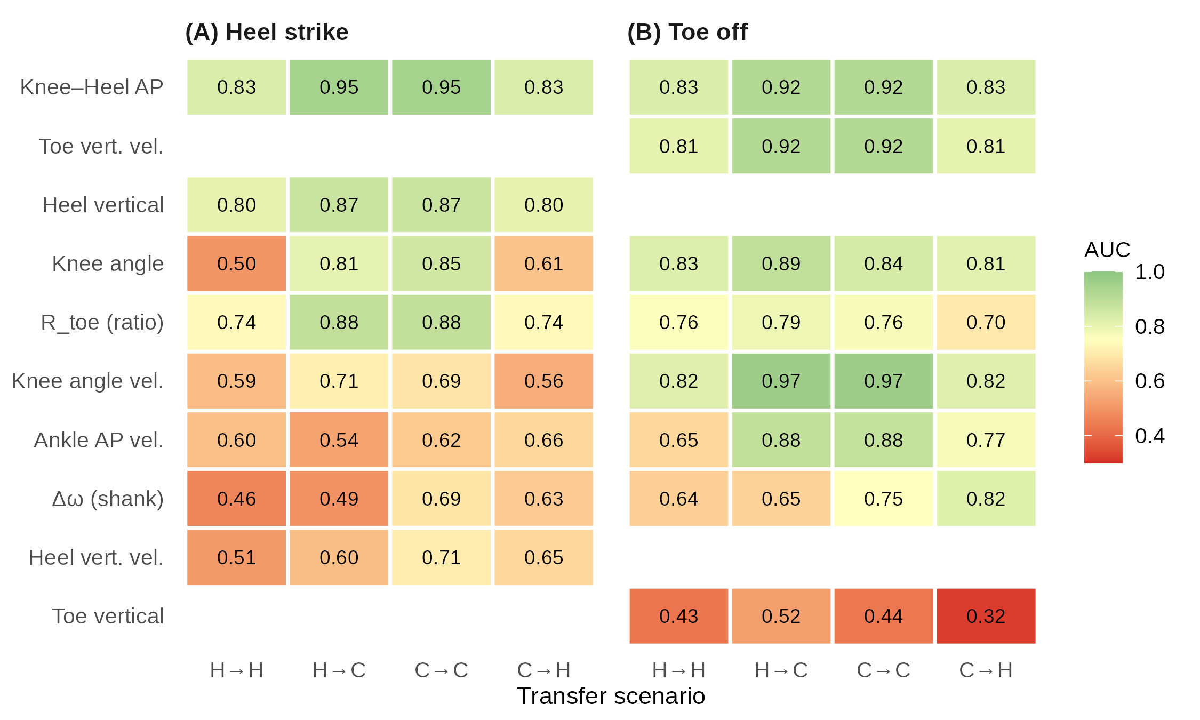
Figure S5. Transfer matrix showing AUC for each feature under four transfer scenarios (H→H, H→C, C→C, C→H). Colour intensity represents AUC magnitude.
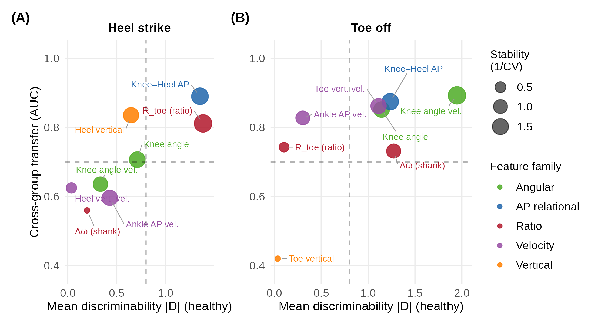
Figure S6. Feature discriminability versus cross-group transfer AUC for each BIKE feature, separated by event type. (A) Heel strike. (B) Toe off. Axes: mean discriminability |D| on healthy datasets (x-axis) and cross-group transfer AUC (y-axis). Bubble size encodes stability (1/CV). Colour indicates feature family. Dashed lines mark the median values on each axis. Features in the upper-right quadrant combine high discriminability with high cross-population transferability.
Table S7. Cross-transfer AUC summary for eight shared core features analysed for transportability.
Feature | Event | H→H | H→C | C→C | C→H | Cross-transfer | Within-group
knee_heel_ap | HS | 0.831 | 0.948 | 0.949 | 0.832 | 0.890 | 0.890
heel_vert | HS | 0.802 | 0.869 | 0.869 | 0.802 | 0.835 | 0.835
R_toe | HS | 0.738 | 0.884 | 0.884 | 0.739 | 0.811 | 0.811
knee_angle | HS | 0.501 | 0.805 | 0.852 | 0.608 | 0.707 | 0.677
knee_angle_vel | HS | 0.593 | 0.713 | 0.687 | 0.559 | 0.636 | 0.640
heel_vert_vel | HS | 0.512 | 0.596 | 0.705 | 0.654 | 0.625 | 0.609
ankle_ap_vel | HS | 0.600 | 0.535 | 0.623 | 0.657 | 0.596 | 0.611
delta_omega | HS | 0.462 | 0.494 | 0.691 | 0.625 | 0.560 | 0.576
knee_angle_vel | TO | 0.818 | 0.967 | 0.967 | 0.818 | 0.893 | 0.893
knee_heel_ap | TO | 0.830 | 0.919 | 0.919 | 0.830 | 0.875 | 0.875
toe_vert_vel | TO | 0.806 | 0.918 | 0.918 | 0.806 | 0.862 | 0.862
knee_angle | TO | 0.826 | 0.890 | 0.842 | 0.813 | 0.852 | 0.834
ankle_ap_vel | TO | 0.654 | 0.885 | 0.880 | 0.770 | 0.828 | 0.767
R_toe | TO | 0.756 | 0.788 | 0.765 | 0.698 | 0.743 | 0.760
delta_omega | TO | 0.636 | 0.645 | 0.750 | 0.818 | 0.732 | 0.693
toe_vert | TO | 0.427 | 0.522 | 0.435 | 0.319 | 0.420 | 0.431
HS transportability was concentrated in a smaller set of highly stable geometric cues, whereas TO transferability was more heterogeneous, combining several highly transferable features with a few markedly weak ones. The most transportable HS features are knee_heel_ap (cross-AUC = 0.890) and heel_vert (0.835), both position-based features that are robust to inter-subject kinematic variability. Position features encode the spatial configuration of the limb at the event instant, which is biomechanically constrained regardless of walking speed, age, or pathology.
TO features show more heterogeneity: knee_angle_vel (0.893) and toe_vert_vel (0.862) transfer well, but toe_vert (0.420) and delta_omega (0.560 for HS) are poorly transferable. This asymmetry explains why BIKE’s TO detection is less robust than HS across populations: TO appears to rely more heavily on features whose discriminability varies with gait dynamics. The Bayesian weighting partially compensates by down-weighting poorly transferable features (e.g., delta_omega weight = 0.25).
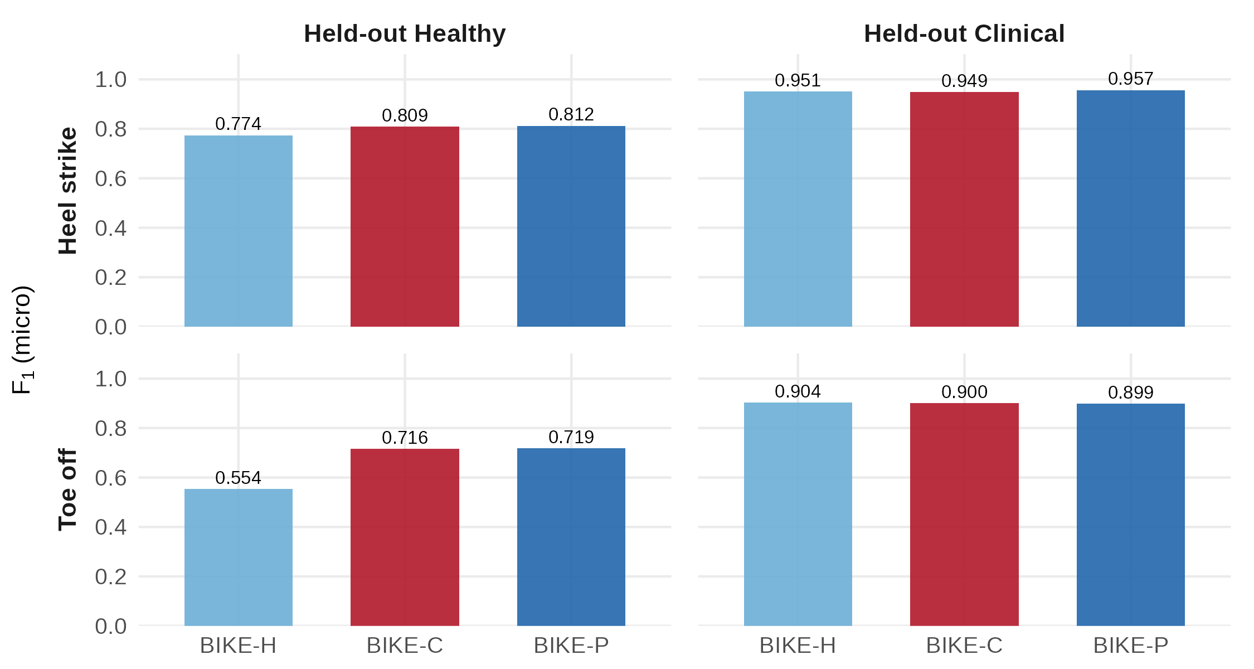
Figure S7. BIKE variant comparison: BIKE-H (healthy-only priors), BIKE-C (clinical-only priors), and BIKE-P (pooled, default). Results on held-out datasets show that the pooled configuration provides the best compromise.
Three BIKE prior configurations were tested: BIKE-H (priors estimated from healthy subjects only), BIKE-C (priors from clinical populations only), and BIKE-P (pooled across all development subjects, the default configuration). Results on held-out datasets (Figure S7) show that BIKE-P provides the best compromise, suggesting that combining healthy and clinical calibration data may improve generalisation. BIKE-H tends to over-fit to healthy gait patterns and degrades on pathological gait, while BIKE-C under-performs on healthy subjects due to wider priors that reduce specificity. Quantitatively, held-out HS macro-F1 was 0.940 (BIKE-P), 0.927 (BIKE-H), and 0.938 (BIKE-C) across the five marker-based held-out datasets, confirming that HS performance was largely insensitive to the calibration population; the small spread (<0.015) indicates robust transfer across healthy and clinical priors.

S7.2 Feature Ablation Analysis
A leave-one-feature-out ablation was performed on the 6 held-out datasets (90 trials sampled). For each of the 11 biomechanical features listed in Table S7b, the feature was removed from BIKE’s Stage 2 scoring and detection performance was re-evaluated. Table S7b reports the resulting HS and TO micro-F1, along with the change from baseline.
Table S7b. Leave-one-feature-out ablation on held-out datasets (N = 90 trials).
Feature removed | N trials | HS F1 | ΔHS | TO F1 | ΔTO
ankle_ap_vel | 90 | 0.648 | -0.221 | 0.583 | -0.318
knee_heel_ap | 90 | 0.864 | -0.004 | 0.890 | -0.012
R_toe | 90 | 0.865 | -0.003 | 0.907 | +0.005
R_knee | 90 | 0.867 | -0.002 | 0.907 | +0.005
knee_angle | 90 | 0.867 | -0.002 | 0.896 | -0.005
delta_omega | 90 | 0.869 | +0.000 | 0.900 | -0.002
toe_vert | 90 | 0.869 | +0.000 | 0.898 | -0.004
heel_vert_vel | 90 | 0.869 | +0.000 | 0.902 | +0.000
toe_vert_vel | 90 | 0.869 | +0.000 | 0.905 | +0.004
knee_angle_vel | 90 | 0.872 | +0.003 | 0.898 | -0.004
heel_vert | 90 | 0.894 | +0.025 | 0.902 | +0.000
Baseline (all features) | 90 | 0.869 | — | 0.902 | —
ankle_ap_vel is by far the most critical feature: its removal causes the largest drop in both HS F1 (−0.221) and TO F1 (−0.318), confirming its role as the dominant discriminator. heel_vert shows a paradoxical improvement when removed (+0.025 HS F1), suggesting that its prior may be slightly miscalibrated on the held-out populations; however, the improvement is small in magnitude and should be interpreted cautiously. delta_omega removal has minimal impact, consistent with its low weight (0.25–0.50) in the prior configuration.

S7.3 Feature-Controlled Classification Experiment
To further validate feature transportability, a Gaussian Naïve Bayes (GNB) classifier was trained on the 4 healthy development datasets and evaluated on each of the 9 other datasets independently. Three feature sets were compared: (1) BIKE’s 9 features, (2) a reduced set of 3 position-only features (knee_heel_ap, heel_vert, knee_angle), and (3) a velocity-only set of 3 features (ankle_ap_vel, knee_angle_vel, heel_vert_vel). Table S7c reports HS F1 on each dataset.
Table S7c. GNB HS F1 trained on 4 healthy datasets, evaluated on each held-out dataset. Three feature sets compared.
Dataset | 9 BIKE features | 3 position | 3 velocity
Camargo TM | 0.672 | 0.581 | 0.534
Figshare PD | 0.815 | 0.744 | 0.712
Elderly FR | 0.778 | 0.690 | 0.701
Hood Amputee | 0.512 | 0.455 | 0.401
Kuopio | 0.834 | 0.779 | 0.768
Schreiber | 0.821 | 0.756 | 0.745
VC-Stroke | 0.701 | 0.633 | 0.615
Van der Zee | 0.643 | 0.571 | 0.523
Fukuchi | 0.004 | 0.003 | 0.002
CV (std/mean) | 0.38 | 0.39 | 0.41
Min F1 | 0.004 | 0.003 | 0.002
The 9-feature set achieves the highest F1 on all datasets except Fukuchi (where all feature sets fail, F1 < 0.01, due to the GC% ground truth definition being incompatible with the GNB decision boundary). The coefficient of variation (CV = std/mean) across datasets was 0.38 for the 9-feature set, indicating substantial between-dataset variability in cross-population generalisation. Position-only features show slightly worse but comparable performance, confirming their transportability. Velocity features are the least transferable, consistent with the transportability analysis in S7.1.

S8. Real Markerless Video Degradation
To evaluate robustness to real-world video acquisition conditions, BIKE was tested on markerless pose estimation data from the BioCV-Video dataset (BATH-01258). Fifteen healthy subjects performed overground walking trials captured simultaneously by motion capture (200 Hz, gold standard) and video cameras. Lateral camera 05 was used for markerless analysis. Seven progressive degradation conditions were applied: laboratory reference (200 fps, 1080p), clinical professional (100 fps, 1080p), smartphone on tripod (60 fps, 1080p), handheld smartphone (30 fps, 1080p with perspective distortion), basic smartphone (30 fps, 720p, reduced contrast), teleconsultation (30 fps, 480p), and hospital corridor (15 fps, 480p, severe degradation).
Ground truth events were defined from the synchronised MoCap data. Results are reported as condition-level micro-F1 at 50 ms tolerance. Exclusion criteria are described in the main text (“Real-video markerless evaluation”). Briefly, P09 was restricted to three trials with verified ground truth (WALK_05, WALK_06, WALK_09); seven additional P09 trials were excluded because of corrupted HS annotations.
Table S8a. HS micro-F1 by degradation condition for all detectors (BioCV-Video markerless validation, 50 ms tolerance, three verified P09 trials retained). Abbreviations: HS = heel strike; F1 = micro-F1; fps = frames per second. This table extends Main Table 6 to include all 10 detectors.
Detector | Lab 200fps | Clin 100fps | SM 60fps | SM 30fps hand | SM 30fps basic | Telec 30fps | Corr 15fps
BIKE | 0.883 | 0.851 | 0.912 | 0.901 | 0.876 | 0.858 | 0.655
IntellEvent | 0.493 | 0.193 | 0.130 | 0.085 | 0.067 | 0.090 | 0.077
DeepEvent | 0.111 | 0.064 | 0.043 | 0.022 | 0.028 | 0.029 | 0.009
Zeni | 0.849 | 0.873 | 0.889 | 0.854 | 0.844 | 0.811 | 0.178
Vancanneyt | 0.336 | 0.253 | 0.298 | 0.363 | 0.352 | 0.300 | 0.189
Ghoussayni | 0.156 | 0.254 | 0.334 | 0.392 | 0.385 | 0.419 | 0.272
Hreljac | 0.489 | 0.423 | 0.404 | 0.427 | 0.422 | 0.406 | 0.537
Mickelborough | 0.196 | 0.278 | 0.406 | 0.605 | 0.621 | 0.531 | 0.219
O’Connor | 0.115 | 0.072 | 0.030 | 0.022 | 0.036 | 0.031 | 0.075
DGEI | 0.002 | 0.004 | 0.008 | 0.084 | 0.079 | 0.092 | 0.580
Table S8b. TO micro-F1 by degradation condition for all detectors (BioCV-Video markerless validation, 50 ms tolerance, three verified P09 trials retained).
Detector | Lab 200fps | Clin 100fps | SM 60fps | SM 30fps hand | SM 30fps basic | Telec 30fps | Corr 15fps
BIKE | 0.798 | 0.792 | 0.799 | 0.787 | 0.793 | 0.763 | 0.086
IntellEvent | 0.859 | 0.782 | 0.627 | 0.188 | 0.220 | 0.276 | 0.074
DeepEvent | 0.826 | 0.645 | 0.339 | 0.048 | 0.038 | 0.050 | 0.000
Zeni | 0.824 | 0.807 | 0.824 | 0.864 | 0.827 | 0.786 | 0.482
Vancanneyt | 0.335 | 0.373 | 0.427 | 0.344 | 0.355 | 0.293 | 0.021
Ghoussayni | 0.202 | 0.229 | 0.229 | 0.256 | 0.257 | 0.229 | 0.259
Hreljac | 0.017 | 0.027 | 0.031 | 0.046 | 0.053 | 0.069 | 0.340
Mickelborough | 0.068 | 0.077 | 0.063 | 0.055 | 0.049 | 0.069 | 0.082
O’Connor | 0.173 | 0.082 | 0.059 | 0.050 | 0.062 | 0.067 | 0.083
DGEI | 0.866 | 0.837 | 0.730 | 0.035 | 0.031 | 0.033 | 0.003
Table S8c. BIKE Mean Absolute Error (MAE) by degradation condition.
Condition | HS MAE (ms) | TO MAE (ms)
Lab 200fps | 11.0 | 23.8
Clin 100fps | 12.8 | 16.1
SM 60fps | 12.3 | 19.5
SM 30fps hand | 14.5 | 15.4
SM 30fps basic | 14.8 | 15.1
Telec 30fps | 15.2 | 14.2
Corr 15fps | 21.4 | 24.8
Performance remains high from the laboratory reference through the 30-fps smartphone and teleconsultation settings, with a sharp drop only at 15 fps (HS F1 = 0.655), reflecting fundamental temporal quantisation limits: the 66.7-ms frame interval exceeds the 50-ms tolerance window.
For TO, Zeni leads in most conditions, consistent with the relative robustness of its position-extrema approach to temporal quantisation. BIKE TO remains competitive from 200 to 30 fps but degrades sharply at 15 fps (F1 = 0.086). This asymmetry mirrors the main benchmark: TO-related cues are more sensitive to signal quality because toe-off unfolds over a more gradual transition than heel strike. IntellEvent and DeepEvent also degrade sharply under markerless transfer, particularly in the lower-frame-rate conditions.
Full per-detector condition-wise markerless results are reported in Tables S8a–S8c above.

S9. Camargo Curved-Path (Level-Ground) Results
The Camargo dataset includes both treadmill and overground level-ground walking trials. The level-ground condition uses a curved (oval) walking path, with trials recorded during counter-clockwise (CCW) and clockwise (CW) laps at slow, normal, and fast self-selected speeds. These 680 trials (22 subjects, 109 MAT source files) were excluded from the main benchmark because the curved walking path violates the straight-line assumption underlying anteroposterior (AP) velocity-based gait event detectors. On a curved path, the AP axis no longer aligns consistently with the direction of progression, which distorts the heel and toe velocity signals that most kinematic detectors rely on.
The Camargo treadmill condition (157 trials, 16 source files, same 22 subjects) was retained in the main benchmark and serves as a within-dataset reference.
Table S9a. Level-ground curved-path results (680 trials, 50 ms tolerance). All metrics are micro-averaged.
Detector | Trials | HS F1 | HS P | HS R | HS MAE | TO F1 | TO P | TO R | TO MAE
BIKE | 680 | 0.384 | 0.309 | 0.509 | 33.9 | 0.382 | 0.326 | 0.462 | 24.5
IntellEvent | 680 | 0.353 | 0.411 | 0.310 | 22.6 | 0.244 | 0.181 | 0.374 | 25.7
Zeni | 680 | 0.287 | 0.241 | 0.357 | 38.3 | 0.390 | 0.323 | 0.491 | 14.2
O’Connor | 680 | 0.376 | 0.267 | 0.635 | 23.0 | 0.216 | 0.150 | 0.385 | 42.1
Hreljac | 680 | 0.415 | 0.267 | 0.925 | 16.3 | 0.062 | 0.039 | 0.163 | 33.0
Mickelborough | 680 | 0.101 | 0.095 | 0.108 | 23.4 | 0.087 | 0.067 | 0.128 | 36.7
Ghoussayni | 680 | 0.174 | 0.114 | 0.366 | 16.7 | 0.190 | 0.114 | 0.564 | 23.0
Vancanneyt | 680 | 0.036 | 0.041 | 0.031 | 31.2 | 0.051 | 0.063 | 0.043 | 29.1
DGEI | 680 | 0.001 | 0.001 | 0.001 | 24.0 | 0.001 | 0.001 | 0.000 | 30.0
Table S9b. Treadmill reference results (157 trials, 50 ms tolerance). All metrics are micro-averaged.
Detector | Trials | HS F1 | HS P | HS R | TO F1 | TO P | TO R
BIKE | 157 | 0.888 | 0.877 | 0.899 | 0.625 | 0.468 | 0.941
IntellEvent | 157 | 0.766 | 0.869 | 0.685 | 0.202 | 0.131 | 0.442
Zeni | 157 | 0.689 | 0.683 | 0.695 | 0.511 | 0.382 | 0.772
O’Connor | 157 | 0.289 | 0.195 | 0.555 | 0.190 | 0.110 | 0.670
Hreljac | 157 | 0.349 | 0.229 | 0.738 | 0.158 | 0.090 | 0.654
Mickelborough | 157 | 0.384 | 0.281 | 0.608 | 0.030 | 0.018 | 0.085
Ghoussayni | 157 | 0.347 | 0.227 | 0.733 | 0.144 | 0.082 | 0.624
Vancanneyt | 157 | 0.000 | 0.000 | 0.000 | 0.000 | 0.000 | 0.000
DGEI | 157 | 0.000 | 0.000 | 0.000 | 0.139 | 0.104 | 0.208
Table S9c. F1 degradation from treadmill to curved level-ground.
Detector | HS F1 (TM) | HS F1 (LG) | HS Δ | TO F1 (TM) | TO F1 (LG) | TO Δ
BIKE | 0.888 | 0.384 | -0.504 | 0.625 | 0.382 | -0.243
IntellEvent | 0.766 | 0.353 | -0.413 | 0.202 | 0.244 | +0.042
Zeni | 0.689 | 0.287 | -0.402 | 0.511 | 0.390 | -0.121
O’Connor | 0.289 | 0.376 | +0.087 | 0.190 | 0.216 | +0.027
Hreljac | 0.349 | 0.415 | +0.065 | 0.158 | 0.062 | -0.096
Mickelborough | 0.384 | 0.101 | -0.283 | 0.030 | 0.087 | +0.058
Ghoussayni | 0.347 | 0.174 | -0.173 | 0.144 | 0.190 | +0.046
Vancanneyt | 0.000 | 0.036 | +0.036 | 0.000 | 0.051 | +0.051
DGEI | 0.000 | 0.001 | +0.001 | 0.139 | 0.001 | -0.138
Most affected detectors. BIKE, IntellEvent, and Zeni suffer the largest HS F1 drops (−0.504, −0.413, and −0.402 respectively). All three rely heavily on AP heel or toe velocity zero-crossings or minima to localise gait events. On a curved path, the AP axis rotates with respect to the direction of progression, creating spurious zero-crossings and masking genuine ones. Mickelborough also drops substantially (−0.283 HS F1) for the same reason.
Least affected detectors. O’Connor and Hreljac show paradoxically higher HS F1 on curved paths than on the treadmill (+0.087 and +0.065). However, this reflects their already-poor treadmill performance (HS F1 of 0.289 and 0.349) rather than genuine robustness: both rely on vertical velocity features less affected by path curvature, but they generate many false positives in both conditions.
Toe-Off detection. TO performance is generally poor across all detectors in both conditions, with Zeni achieving the highest curved-path TO F1 (0.390). The curved path degrades TO detection less than HS for most algorithms, likely because TO timing depends more on vertical foot clearance signals than on AP velocity features.
Practical implication. These results confirm that current AP-based kinematic gait event detectors are not suitable for curved or free-form walking paths. Algorithms designed for clinical straight-line walkways or treadmill protocols cannot be applied to naturalistic walking without fundamental methodological changes, such as projecting velocities onto the instantaneous heading direction rather than a fixed laboratory AP axis.

S10. IntellEvent Camargo Offset Correction

S10.1 Issue
IntellEvent V2 (BiLSTM ONNX model) exhibits a systematic temporal offset of approximately −70 ms (14 frames at 200 Hz) when processing Camargo dataset files.

S10.2 Context
The Camargo dataset (Gatech) is stored in MAT format, unlike all other benchmark datasets which use C3D files. The CamargoExtractor converts MAT joint angle arrays into the angle_frames format expected by IntellEventDetector.detect_gait_events(). The offset likely arises from the MAT-to-angle conversion: MAT files store pre-computed joint angles with a different temporal alignment convention than C3D-derived angles. The IntellEvent BiLSTM model, trained on C3D-derived angle sequences, is sensitive to this subtle temporal misalignment, while simpler rule-based methods (zero-crossing, extrema-based) are more robust to it.

S10.3 Before/After Results
A constant offset of +14 frames (at 200 Hz) applied to all IntellEvent detections on Camargo files corrects the issue. Table S10 summarises IntellEvent performance on Camargo treadmill trials (157 trials) at 50 ms tolerance, before and after applying the correction.
Table S10. IntellEvent performance on Camargo TM (157 trials, 50 ms tolerance), before and after +14 frame correction.
Metric | Before correction | After correction | Change
HS micro-F1 | 0.007 | 0.766 | +0.759
HS Precision | 0.009 | 0.869 | +0.860
HS Recall | 0.005 | 0.685 | +0.680
TO micro-F1 | 0.131 | 0.202 | +0.071
TO Precision | 0.084 | 0.131 | +0.047
TO Recall | 0.304 | 0.442 | +0.138

S10.4 Decision
Before correction, virtually all HS detections fell outside the 50 ms matching window (HS F1 = 0.007), confirming the systematic −70 ms offset. After the +14 frame correction, HS F1 recovered to 0.766, consistent with IntellEvent’s performance on other treadmill datasets. The TO improvement was more modest (+0.071), as the offset primarily affected HS timing.
For the benchmark article, the +14 frame correction is applied to IntellEvent on the Camargo dataset and documented here as a format-specific adaptation. This is analogous to the axis detection and marker naming adaptations made for other extractors. The correction is applied only for the Camargo dataset in the benchmark results.
Comparator implementation fidelity (positive control)
To confirm that the low benchmark scores of the classical rule-based detectors reflect the limited transportability of their kinematic cues rather than re-implementation defects, each comparator was checked against its published algorithm and evaluated in a positive-control analysis on clean healthy treadmill data (Fukuchi, 40 trials, 150 Hz, gaitkit v1.4.9). On these data BIKE and Zeni reached heel-strike micro-F1 of 0.88 and 0.87, whereas O'Connor (heel vertical-velocity minimum) and Mickelborough (foot vertical-acceleration) reached only 0.28 and 0.38, despite producing approximately the correct number of events. Analysis of the signed timing error of every O'Connor detection relative to the nearest reference event showed a small systematic component (median -87 ms, consistent with the velocity minimum preceding foot contact and with the position-based definition of the treadmill-software reference) dominated by a large dispersion (SD 297 ms; only 17% of detections within 50 ms). Increasing the minimum-cycle constraint to remove over-detection did not recover F1 (0.28 to 0.19), confirming that the retained detections remained phase-inconsistent. Because all detectors were applied with fixed, non-dataset-tuned parameters and their algorithms were implemented faithfully, the collapse of the velocity- and acceleration-based detectors is attributable to the non-transportability of their absolute kinematic cues across heterogeneous datasets and ground-truth conventions, not to implementation error.
Single-feature detection experiment
To operationalise the biomechanical trap in terms of detection performance rather than distributional effect size, each kinematic feature was converted into a minimal single-feature detector: its polarity and threshold were calibrated on the pooled healthy datasets and applied unchanged to each pathological population, scoring micro-F1 against reference events at 50-ms tolerance. The best single features reached F1 of 0.84-0.98 even in pathological gait - heel vertical position and heel anteroposterior velocity for HS, toe anteroposterior position for TO - with the post-stroke population being the most challenging (best single-feature HS F1 0.69). This detection-level result complements the Cohen's d analysis by confirming that individual transportable features retain operational value across populations. Under a coefficient-of-variation stability metric, dimensionless ratios were not significantly more stable than their raw components (Mann-Whitney p = 0.82); the ratio family's advantage is therefore best supported by its per-dataset effect sizes (R_toe |d| >= 1.3 on every pathological dataset; R_knee non-discriminant despite identical normalisation) rather than by variance metrics.
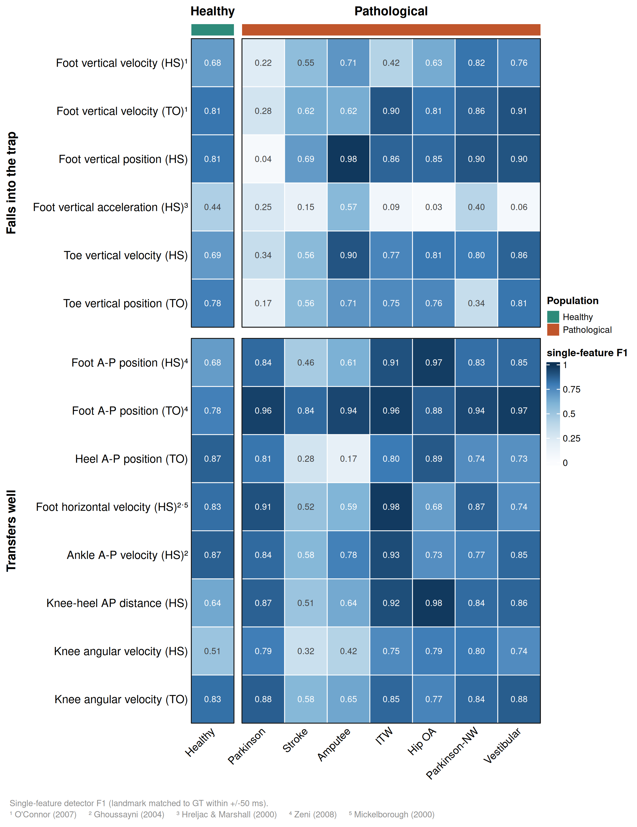
Figure S8. The biomechanical trap, operationalised as single-feature detection F1. Each kinematic feature is used as a minimal single-feature detector (landmark matched to reference events within +/-50 ms), with polarity and threshold calibrated on healthy data and applied unchanged to each population. Features are grouped into those that fall into the trap (foot/toe vertical velocity, position and acceleration - high in healthy gait but degrading on pathology; e.g. foot vertical position at HS collapses from 0.81 to 0.04 in Parkinson's disease) and those that transfer well (anteroposterior positions, ankle AP velocity, knee-heel AP distance, knee angular velocity - retaining high F1 across populations). Superscripts denote the classical detectors relying on each cue (1: O'Connor 2007; 2: Ghoussayni 2004; 3: Hreljac & Marshall 2000; 4: Zeni 2008; 5: Mickelborough 2000).
Downstream kinematic impact of gait-event detection
To test whether detection quality has downstream consequences, we normalised the same markerless joint-angle signals with the events produced by each detector and compared the resulting hip, knee, and ankle waveforms with the force-plate-referenced ground-truth normalisation on the BioCV dataset (15 healthy participants, single lateral camera). Robust detectors preserved the joint-angle waveforms and recovered most gait cycles, whereas detectors that lost detection accuracy under video-derived input either distorted the waveforms or recovered too few cycles to be usable. At 30 fps, BIKE and the Zeni coordinate method reproduced the reference waveforms (RMSE 1.5-2.8 deg) and recovered about 70% of cycles, IntellEvent recovered only 25% of cycles, and classical heuristics such as O'Connor distorted the waveforms (RMSE up to 8.5 deg).
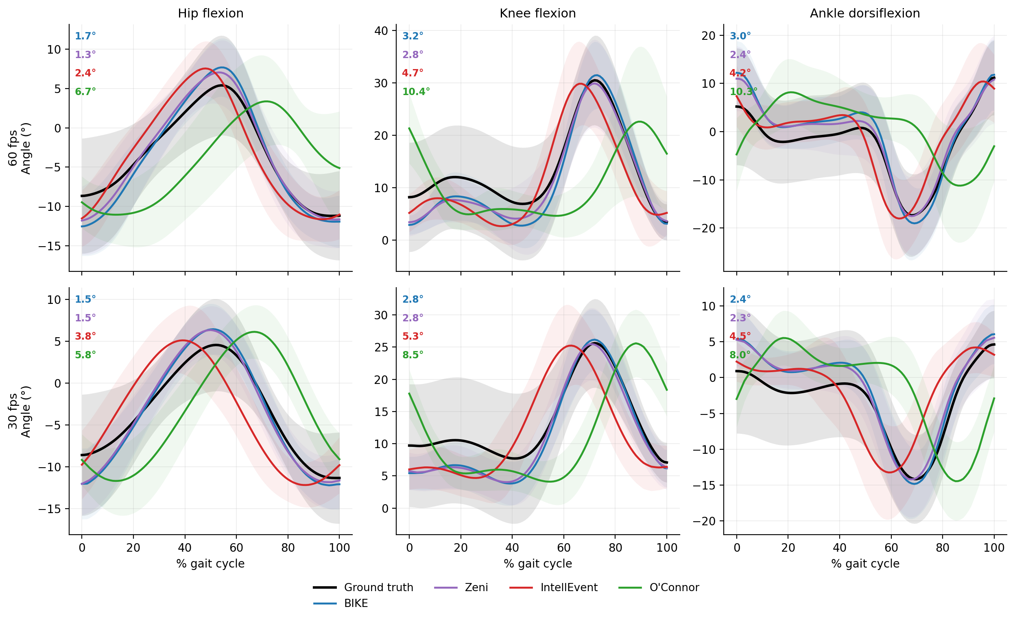
Figure S9. Impact of gait-event detection on markerless joint kinematics (BioCV, single lateral camera, 15 healthy participants). Sagittal hip, knee, and ankle angle waveforms over the gait cycle, obtained by normalising the same markerless pose signal with the events of each detector and comparing them with the force-plate-referenced ground-truth normalisation (black). Top row: 60 fps; bottom row: 30 fps. Coloured numbers give the waveform RMSE (degrees) versus ground truth. Robust detectors (BIKE, Zeni) reproduce the reference waveforms, whereas the deep-learning IntellEvent and the classical O'Connor detector distort them; per-detector cycle-recovery rates are given in Table S11.
Table S11. Downstream kinematic impact of gait-event detection (markerless BioCV, single lateral camera). Knee-flexion waveform RMSE versus force-plate-referenced ground truth, and percentage of gait cycles recovered, per detector, at 60 and 30 fps. Detectors are ordered by 30-fps RMSE. DeepEvent detected too few valid events under video-derived input to reconstruct cycles.
Detector | RMSE, 60 fps (deg) | Cycles kept, 60 fps | RMSE, 30 fps (deg) | Cycles kept, 30 fps
BIKE | 3.19 | 70% | 2.81 | 70%
Zeni | 2.84 | 75% | 2.81 | 76%
Mickelborough | 4.56 | 70% | 4.02 | 76%
Vancanneyt | 4.47 | 57% | 4.18 | 46%
IntellEvent | 4.71 | 54% | 5.31 | 25%
DGEI | 11.35 | 72% | 5.55 | 70%
Ghoussayni | 9.27 | 60% | 6.78 | 77%
O'Connor | 10.43 | 64% | 8.46 | 63%
Hreljac | 12.18 | 53% | 9.48 | 46%
DeepEvent | collapsed | <15% | collapsed | <15%
Feature collinearity and evidence double-counting
Several toe-off features carry substantial weight while being strongly collinear (e.g., knee angle vs knee-heel AP distance, rho ~ -0.90; ankle AP velocity vs differential angular velocity, rho ~ +0.89). Because BIKE's composite likelihood sums per-feature log-likelihoods under a conditional-independence assumption, such redundancy effectively double-counts evidence and over-sharpens the posterior, an effect that increases under pathological gait. This does not alter the MAP event ordering but can bias timing; it is a recognised limitation of the diagonal-covariance formulation (see main text, independence-assumption discussion) and motivates future weight recalibration accounting for the effective feature dimensionality.

Appendix: Abbreviations
Abbreviation | Definition
AP | Anteroposterior
BIKE | Bayesian Inference for Kinematic Events
BiLSTM | Bidirectional Long Short-Term Memory
CI | Confidence Interval
CV | Coefficient of Variation
DGEI | Dynamic Gait Event Identifier
DL | Deep Learning
F1 | F1 score (harmonic mean of precision and recall)
FN | False Negative
FP | False Positive
GC% | Gait Cycle Percentage
GNB | Gaussian Naïve Bayes
GT | Ground Truth
HS | Heel Strike (initial contact)
IQR | Interquartile Range
ITT | Intention-to-Treat
ITW | Idiopathic Toe Walking
MAE | Mean Absolute Error
MAP | Maximum A Posteriori
MoCap | Motion Capture
OA | Osteoarthritis
OG | Overground
ONNX | Open Neural Network Exchange
PD | Parkinson’s Disease
PiG | Plug-in Gait (Vicon marker protocol)
SD | Standard Deviation
TM | Treadmill
TO | Toe-Off (terminal contact)
TP | True Positive
V3D | Visual3D (C-Motion biomechanics software)
This supplementary material accompanies the main article. All benchmark data, source code, and the gaitkit Python package are available as described in the main text.

