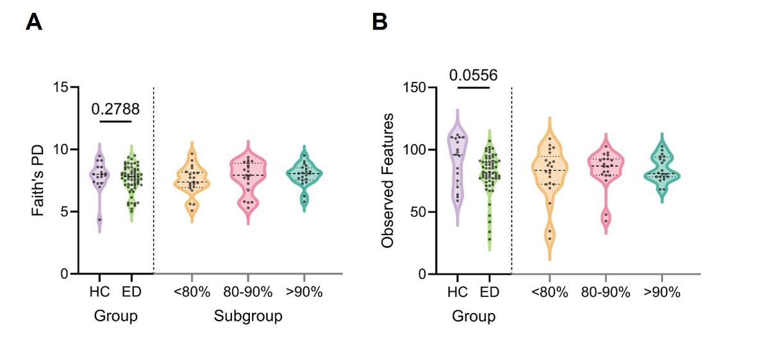
Figure S1. Additional α-diversity metrics. A. Faith’s Phylogenetic diversity. B. Observed features. Data is comparing HC and ED, and HC and the three %TGW subgroups. The α-diversity was analyzed by Mann-Whitney U tests for HC vs ED comparisons and Kruskal-Wallis for subgroup comparisons. The p-value for the HC-ED analysis are depicted in the graph. There were no significant differences between HC and the three %TGW subgroups.

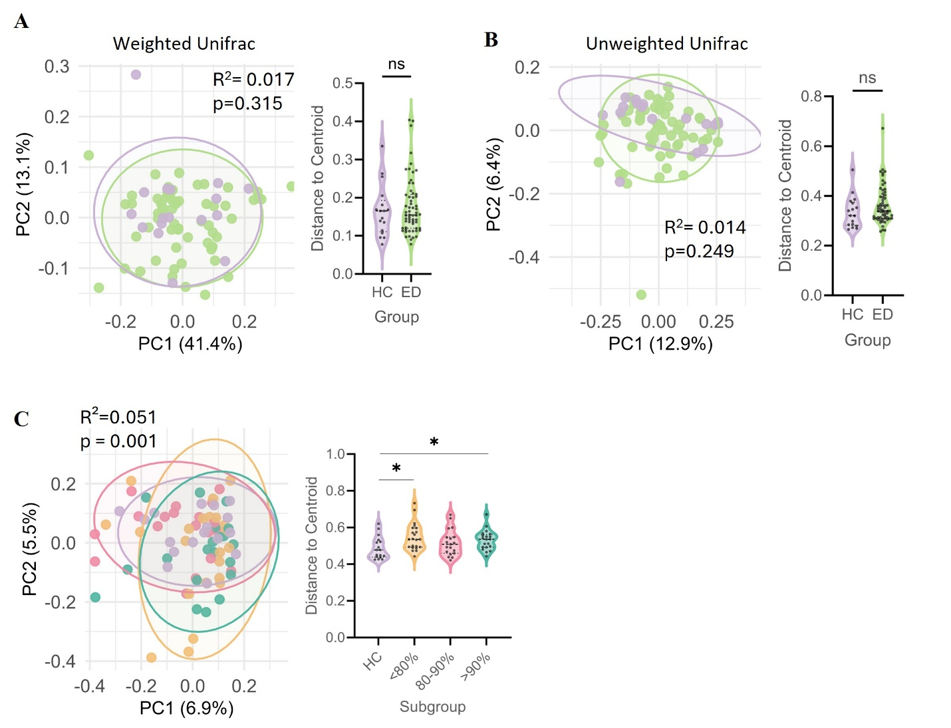
Figure S2. Additional β-diversity metrics. A. Weighted Unifrac Distances, demonstrating no differences in composition (left) or dispersion (right) between HC and ED (A), and HC and TGW subgroups (B) B. Unweighted Unifrac Distances, demonstrating no differences in composition (left) or dispersion (right) between HC and ED (C), and HC and TGW subgroups (D). E. Bray-Curtis Dissimilarity Index demonstrating an overall difference in composition, alongside significant differences between each subgroup compared to HC. We also noted a significantly greater variability in the <80% and the >90% subgroup, but not the 80-90% subgroup compared to controls. Stars represent the degree of significance (*: p<0.05). No stars represent p>0.05. The β-diversity was analysed by PERMANOVA, and the dispersion was assessed by permdisp. Pairwise p-values were adjusted by BH-FDR.

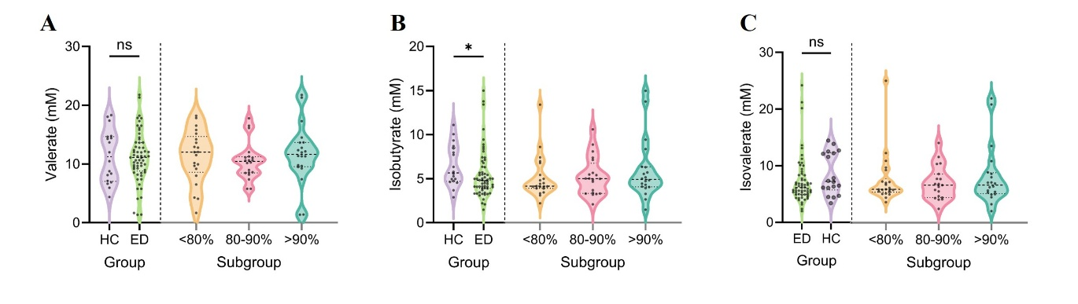
Figure S3. Fecal SCFAs and BCFA concentrations. A-C. SCFA and BCFA concentrations (A: Valerate, B: Isobutyrate, C: Isovalerate) between HC and ED, and the three %TGW subgroups. HC vs ED analyses were performed using Mann-Whitney U tests. Analysis of HC vs each subgroup independently was performed using Kruskal-Wallis tests. Multiple comparisons were not completed as the omnibus test did not reach significance.

