Appendix A: Additional Tables
Table A1: Reporting limits (RLs) (as determined by the SGS laboratory)
Elements | Water (mg/L) | Soil (mg/kg) | Food (mg/kg) | Fish (mg/kg)
Mercury (Hg) | 0.0001 | 1 | 1 | 0.5
Lead (Pb) | 0.0001 | 1 | 0.1 | 0.5
Arsenic (As) | 0.0005 | 2 | 0.1 | 2
Cadmium (Cd) | 0.0001 | 0.3 | 0.3 | 0.5

Results below reporting limits are given as <RL (reporting limits). For further statistical analysis, reporting limits results were divided by the square root of two.

Table A2: Mercury Vapor Concentration (µg/m3) in Air
Region | Site | Number of Samples | Mean | Max | Min | SD
AR | KO | 60 | 0.30 | 2.11 | <RL | 0.52
AR | KZ | 100 | 0.49 | 4.39 | <RL | 0.78
AR | NY | 90 | 0.39 | 4.70 | <RL | 0.85
CR | AK | 100 | 0.29 | 1.58 | <RL | 0.39
ER | AS | 83 | 0.26 | 4.24 | <RL | 0.55
ER | OS | 110 | 0.34 | 5.87 | <RL | 0.72
SR | DA | 106 | 0.36 | 1.73 | <RL | 0.42
SR | TA | 140 | 0.46 | 3.44 | <RL | 0.52
WNR | LA | 80 | 0.33 | 3.01 | <RL | 0.49
WR | PR | 76 | 0.42 | 3.46 | <RL | 0.67
WR | WK | 100 | 1.84 | 150.20 | <RL | 15.00
RL = reporting limit, SD = standard deviation, min = minimum, max = maximum
red = above Ghanaian permissible level of Hg in air of 1 µg/m³
Table A3 Toxic Metals Concentration in Water Samples (mg/L)
 |  |  | Hg |  |  |  | Pb |  |  |  | Cd |  |  |  | As
Region | Site | # Samples | Av | Max | Min | SD | Av | Max | Min | SD | Av | Max | Min | SD | Av | Max | Min | SD
AR | KO | 2 | <RL | <RL | <RL | <RL | 0.0009 | 0.0017 | <RL | 0.0012 | <RL | <RL | <RL | <RL | 1.6519 | 3.3000 | 0.0037 | 2.3308
 | KZ | 3 | <RL | <RL | <RL | <RL | 0.0030 | 0.0090 | <RL | 0.0052 | <RL | <RL | <RL | <RL | 0.0033 | 0.0089 | <RL | 0.0049
 | NY | 8 | 0.0009 | 0.0069 | <RL | 0.0024 | 0.0109 | 0.0570 | <RL | 0.0191 | <RL | <RL | <RL | <RL | 0.0196 | 0.0830 | <RL | 0.0297
CR | AK | 4 | <RL | 0.0001 | <RL | 0.0001 | 0.0046 | 0.0110 | <RL | 0.0055 | 0.0001 | 0.0002 | <RL | 0.0001 | 0.0003 | 0.0013 | <RL | 0.0007
ER | AS | 7 | 0.0021 | 0.0100 | <RL | 0.0037 | 0.1415 | 0.9700 | <RL | 0.3654 | 0.0007 | 0.0051 | <RL | 0.0019 | 0.0032 | 0.0160 | <RL | 0.0059
 | OS | 10 | <RL | 0.0001 | <RL | <RL | 0.0037 | 0.0230 | <RL | 0.0071 | <RL | <RL | <RL | <RL | 0.0029 | 0.0190 | <RL | 0.0058
SR | DA | 10 | <RL | <RL | <RL | <RL | 0.0001 | 0.0011 | <RL | 0.0003 | <RL | <RL | <RL | <RL | <RL | <RL | <RL | <RL
 | TA | 5 | <RL | <RL | <RL | <RL | 0.0003 | 0.0009 | <RL | 0.0005 | <RL | <RL | <RL | <RL | <RL | <RL | <RL | <RL
WNR | LA | 11 | 0.0002 | 0.0011 | <RL | 0.0003 | 0.0010 | 0.0043 | <RL | 0.0017 | <RL | <RL | <RL | <RL | 0.0034 | 0.0140 | <RL | 0.0056
WR | AC | 4 | 0.0002 | 0.0003 | <RL | 0.0001 | 0.0022 | 0.0083 | <RL | 0.0041 | <RL | 0.0001 | <RL | 0.0001 | 0.0747 | 0.1600 | 0.0077 | 0.0728
 | WK | 5 | <RL | <RL | <RL | <RL | <RL | <RL | <RL | <RL | <RL | <RL | <RL | <RL | <RL | <RL | <RL | <RL
RL = reporting limit, SD = standard deviation, AV = mean, min = minimum, max = maximum
red = above reference values per Ghanaian regulations of 0.001 mg/L for mercury, 0.01 mg/L for lead, 0.003 mg/L for cadmium, and 0.01 mg/L for arsenic
Table A4: Toxic Metals Concentration in Fish Samples (mg/kg)
Region | Site | # | Hg |  |  |  | Pb |  |  |  | Cd |  |  |  | As
 |  |  | Av | Max | Min | SD | Av | Max | Min | SD | Av | Max | Min | SD | Av | Max | Min | SD
AR | KZ | 7 | 0.087 | 0.21 | <RL | 0.078 | 0.314 | 1.70 | <RL | 0.628 | 0.081 | 0.20 | <RL | 0.069 | 0.636 | 3.09 | <RL | 1.100
CR | AK | 7 | <RL | <RL | <RL | <RL | 0.457 | 2.80 | <RL | 1.034 | 0.390 | 2.73 | <RL | 1.032 | 0.444 | 2.82 | <RL | 1.050
ER | AS | 4 | 0.070 | 0.16 | <RL | 0.066 | 0.100 | 0.20 | <RL | 0.082 | <RL | <RL | <RL | <RL | 0.120 | 0.24 | <RL | 0.101
 | OS | 7 | 0.046 | 0.32 | <RL | 0.121 | 0.057 | 0.20 | <RL | 0.079 | <RL | <RL | <RL | <RL | 0.049 | 0.20 | <RL | 0.085
WNR | LA | 7 | 0.043 | 0.12 | <RL | 0.056 | 0.200 | 0.60 | <RL | 0.224 | 0.073 | 0.11 | <RL | 0.050 | 0.731 | 1.14 | 0.12 | 0.362
WR | AC | 7 | 0.029 | 0.15 | <RL | 0.057 | 0.114 | 0.50 | <RL | 0.204 | 0.090 | 0.11 | <RL | 0.040 | 0.874 | 1.58 | 0.41 | 0.413
 | WK | 7 | 0.009 | 0.06 | <RL | 0.023 | 0.171 | 0.50 | <RL | 0.189 | 0.100 | 0.12 | 0.08 | 0.013 | 0.199 | 0.60 | <RL | 0.252

RL = reporting limit, SD = standard deviation, AV = mean, min = minimum, max = maximum
red = above maximum levels: 0.5 mg/kg for mercury (European Commission, 2023), 0.3 mg/kg for lead (FAO & WHO, 1995), 0.05 mg/kg for cadmium (European Commission, 2023), and 0.1 mg/kg for arsenic (USDA, 2018).

Table A5: Visualization of Toxic Metals Concentrations Found in Food Samples
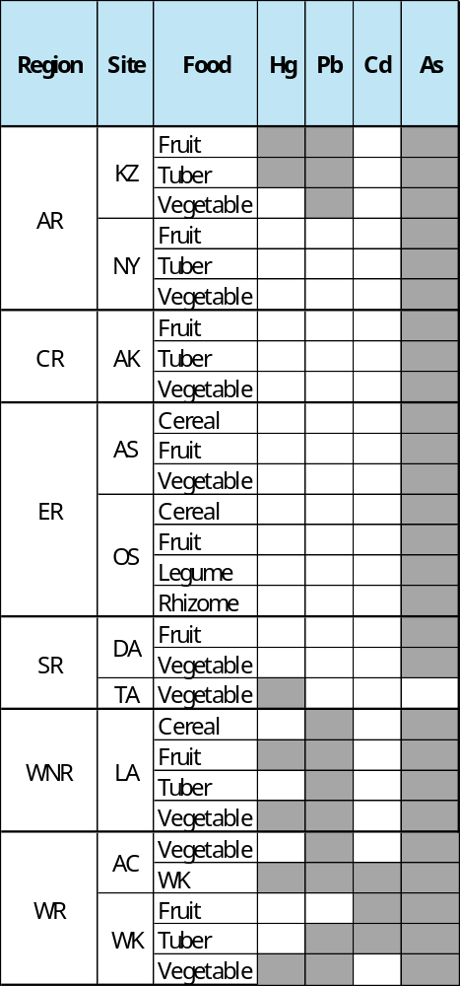
The table identifies the presence of the four heavy metals analyzed by category of the food chain. It is worth noting that arsenic is reported in almost all categories and all regions. The concentration of lead and mercury in certain regions is also identified, allowing us to identify areas that require further study.
Table A6 Mercury Concentration in Food Samples (mg/kg)
Category | Type Food | # Samples | Av | Max | Min | SD
Fruit | Pawpaw | 2 | 1.00 | 2 | <RL | 1.41
Fruit | Tuber | 5 | 0.20 | 1 | <RL | 0.45
Tuber | Cocoyam | 2 | 0.50 | 1 | <RL | 0.71
Vegetable | Kontomire | 1 | 1.00 | 1 | 1 | -
Vegetable | Okro | 3 | 0.33 | 1 | <RL | 0.58
Fruit | Coconut | 2 | 0.50 | 1 | <RL | 0.71
Fruit | Mango | 1 | 1.00 | 1 | 1 | -
Fruit | Orange | 1 | 1.00 | 1 | 1 | -
Vegetable | Garden Eggs | 1 | 2.00 | 2 | 2 | -
Vegetable | Kontomire | 1 | 4.00 | 4 | 4 | -
Vegetable | Tomato | 1 | 4.00 | 4 | 4 | -
Vegetable | Kontomire | 3 | 0.67 | 2 | <RL | 1.15
Vegetable | Pepper | 1 | 2.00 | 2 | 2 | -
Vegetable | Tomato | 1 | 2.00 | 2 | 2 | -

RL = reporting limit, SD = standard deviation, AV = mean, min = minimum, max = maximum

Table A7: Lead Concentration in Food Samples (mg/kg)
Region | Category | Type Food | # Samples | Av | Max | Min | SD
AR | Tuber | Cocoyam | 2 | 0.5 | 1 | <RL | 0.71
AR | Vegetable | Pumpkin Leaves | 1 | 3 | 3 | 3 | -
WNR | Cereal | Sµgarcane | 2 | 0.3 | 0.4 | 0.2 | 0.14
WNR | Fruit | Coconut | 2 | 0.3 | 0.3 | 0.3 | 0.00
WNR | Fruit | Mango | 1 | 0.1 | 0.1 | 0.1 | -
WNR | Fruit | Orange | 1 | 0.1 | 0.1 | 0.1 | -
WNR | Fruit | Plantain | 1 | 0.1 | 0.1 | 0.1 | -
WNR | Fruit | Soursop | 1 | 0.1 | 0.1 | 0.1 | -
WNR | Tuber | Cocoyam | 2 | 0.3 | 0.5 | <RL | 0.35
WNR | Vegetable | Garden Eggs | 1 | 0.5 | 0.5 | 0.5 | -
WNR | Vegetable | Kontomire | 1 | 1.2 | 1.2 | 1.2 | -
WNR | Vegetable | Tomato | 1 | 0.6 | 0.6 | 0.6 | -
WR | Cereal | Sµgarcane | 2 | 0.1 | 0.2 | <RL | 0.14
WR | Tuber | Cassava | 4 | 0.1 | 0.5 | <RL | 0.25
WR | Vegetable | Cloves | 1 | 0.2 | 0.2 | 0.2 | -
WR | Vegetable | Kontomire | 3 | 1.2 | 3.1 | 0.1 | 1.68
WR | Vegetable | Pepper | 1 | 0.4 | 0.4 | 0.4 | -
WR | Vegetable | Turkey Berries | 1 | 0.2 | 0.2 | 0.2 | -

RL = reporting limit, SD = standard deviation, AV = mean, min = minimum, max = maximum

Table A8: Cadmium Concentration in Food Samples (mg/kg)
Region | Category | Type Food | # Samples | Av | Max | Min | SD
WR | Fruit | Cocoa | 2 | 0.2 | 0.4 | <RL | 0.2828
WR | Tuber | Cocoyam | 1 | 1.2 | 1.2 | 1.2 | -

RL = reporting limit, SD = standard deviation, AV = mean, min = minimum, max = maximum

Table A9: Arsenic Concentration in Food Samples (mg/kg)
Region | Category | Type Food | # Samples | Av | Max | Min | SD
AR | Fuit | Cocoa | 7 | 0.7 | 3.5 | <RL | 1.33
AR | Fuit | Plantain | 6 | 0 | 0.2 | <RL | 0.08
AR | Fuit | Watermelon | 1 | 1 | 1 | 1 | -
AR | Tuber | Cocoyam | 2 | 9.8 | 18 | 1.3 | 11.95
AR | Tuber | Kooko | 1 | 0.1 | 0.1 | 0.1 | -
AR | Tuber | Yam | 2 | 0.9 | 1.3 | 0.5 | 0.57
AR | Vegetable | Hibiscus leaves | 1 | 1.4 | 1.4 | 1.4 | -
AR | Vegetable | Palm fruit | 1 | 0.9 | 0.9 | 0.9 | -
AR | Vegetable | Pumpkin Leaves | 1 | 20 | 20 | 20 | -
AR | Vegetable | Turkey berries | 2 | 1.3 | 1.6 | 1 | 0.42
CR | Fruit | Cocoa | 1 | 0.1 | 0.1 | 0.1 | -
CR | Fruit | Tuber | 1 | 0.1 | 0.1 | 0.1 | -
CR | Tuber | Cassava | 1 | 0.1 | 0.1 | 0.1 | -
CR | Vegetable | Turkey berries | 2 | 0.2 | 0.3 | <RL | 0.21
ER | Cereal | Sµgarcane | 2 | 0.2 | 0.2 | 0.2 | -
ER | Fruit | Cocoa | 6 | 0.4 | 2 | <RL | 0.80
ER | Fruit | Coconut | 3 | 0.3 | 0.9 | <RL | 0.52
ER | Fruit | Guava | 1 | 0.2 | 0.2 | 0.2 | -
ER | Fruit | Orange | 3 | 0.3 | 0.6 | <RL | 0.31
ER | Fruit | Pawpaw | 1 | 0.2 | 0.2 | 0.2 | -
ER | Fruit | Plantain | 5 | 0 | 0.1 | <RL | 0.05
ER | Legume | Beans | 1 | 0.2 | 0.2 | 0.2 | -
ER | Legume | Rhizome | 1 | 0.2 | 0.2 | 0.2 | -
ER | Rhizone | Ginger | 1 | 0.2 | 0.2 | 0.2 | -
ER | Vegetable | Fresh pepper | 1 | 0.2 | 0.2 | 0.2 | -
ER | Vegetable | Kontomire | 4 | 0.1 | 0.3 | <RL | 0.15
ER | Vegetable | Turkey berries | 1 | 0.5 | 0.5 | 0.5 | -
SR | Fruit | Lime | 1 | 0.2 | 0.2 | 0.2 | -
SR | Fruit | Soursop | 1 | 0.1 | 0.1 | 0.1 | -
SR | Vegetable | Cassava leaves | 1 | 1 | 1 | 1 | -
SR | Vegetable | Okro | 3 | 0.4 | 0.7 | <RL | 0.38
SR | Vegetable | Tomato | 2 | 0.1 | 0.1 | <RL | 0.07
WNR | Cereal | Sµgarcane | 2 | 0.3 | 0.5 | <RL | 0.35
WNR | Cereal | Fruit | 6 | 0.1 | 0.3 | <RL | 0.12
WNR | Fruit | Plantain | 1 | 0.3 | 0.3 | 0.3 | -
WNR | Tuber | Cocoyam | 2 | 1.1 | 2.1 | 0.1 | 1.41
WNR | Vegetable | Garden eggs | 1 | 0.5 | 0.5 | 0.5 | -
WNR | Vegetable | Kontomire | 1 | 2.1 | 2.1 | 2.1 | -
WNR | Vegetable | Tomato | 1 | 1.6 | 1.6 | 1.6 | -
WR | Fruit | Cocoa | 2 | 0.1 | 0.1 | 0.1 | -
WR | Fruit | Orange | 2 | 0.1 | 0.1 | <RL | 0.07
WR | Fruit | Plantain | 2 | 0.1 | 0.2 | <RL | 0.14
WR | Tuber | Cassava | 4 | 0.1 | 0.2 | <RL | 0.10
WR | Tuber | Cocoyam | 1 | 0.3 | 0.3 | 0.3 | -
WR | Vegetable | Kontomire | 3 | 6.7 | 17 | 1.4 | 9.06
RL = reporting limit, SD = standard deviation, AV = mean, min = minimum, max = maximum

Appendix B: Additional Figures
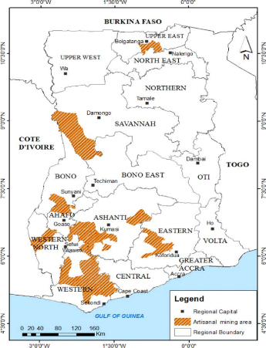
Figure B1: Map showing ASGM areas in Ghana (Takyi et al., 2021)

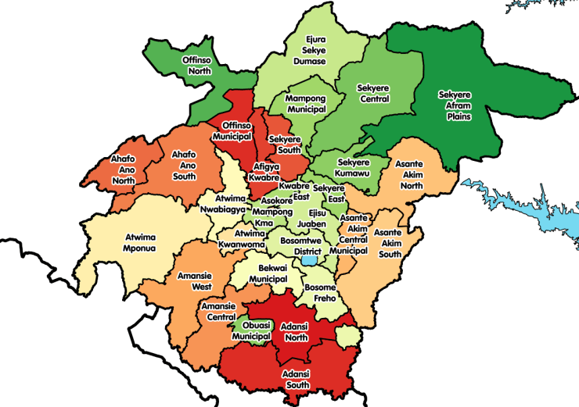
Figure B2: Map showing Districts in Ashanti Region (Ghana LGS, n.d.)

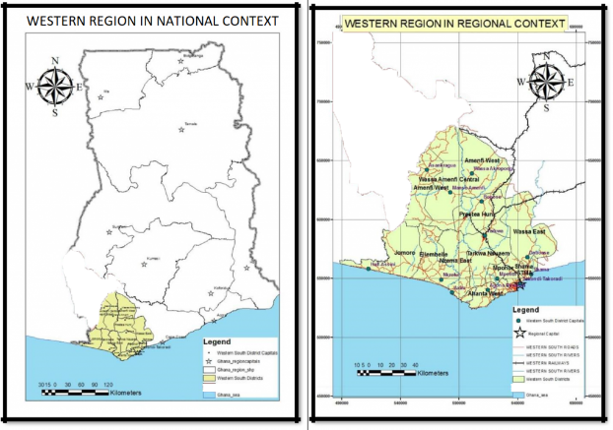
Figure B3: Maps of Western Region (Western Region Co-ordinating Council, 2022)

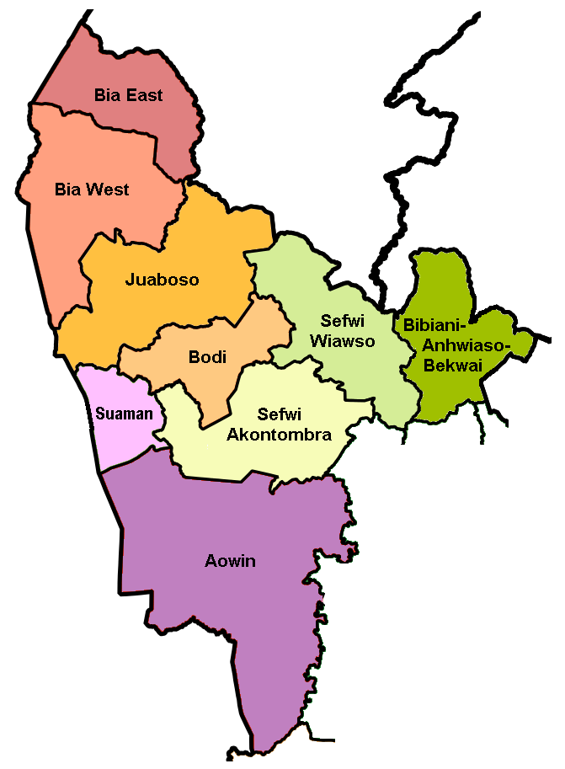

Figure B4: Map of Western North Region (Ghana LGS, n.d.)
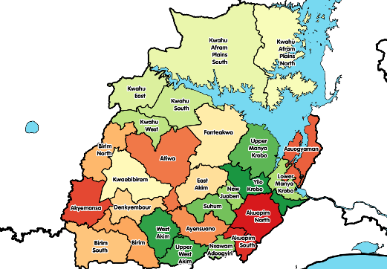
Figure B5: Map showing Districts in Eastern Region (Ghana LGS, n.d)

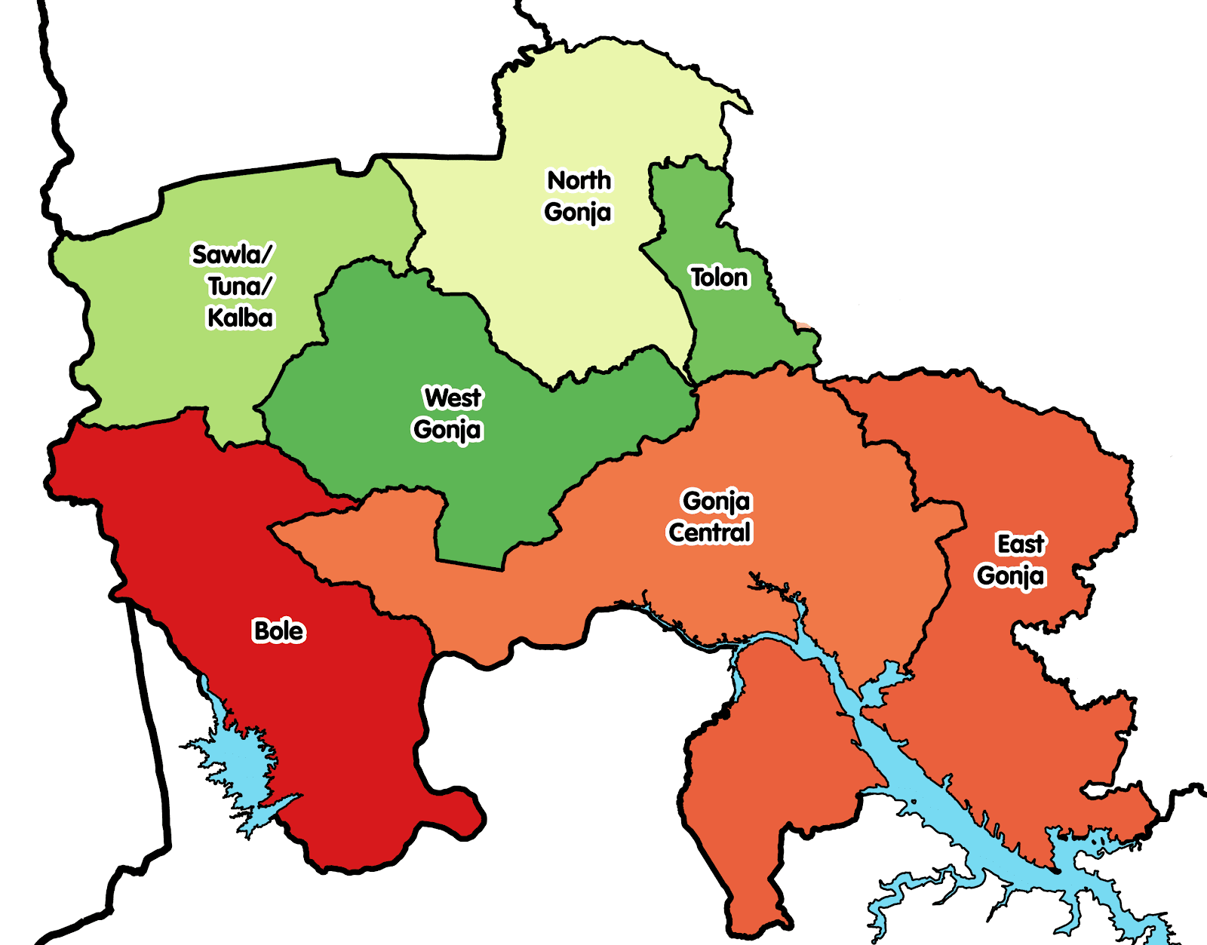
Figure B6: Map of Districts in Savannah Region (Ghana LGS, n.d.)

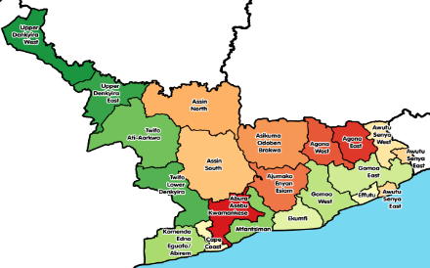
Figure B7: Map of Districts in Central Region (Ghana LGS, n.d.)

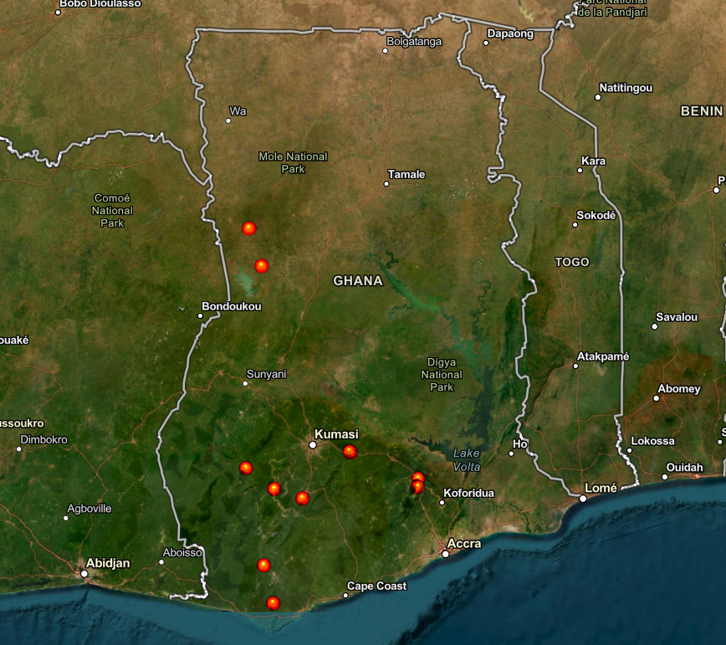
Figure B8: Map Indicating Study Areas

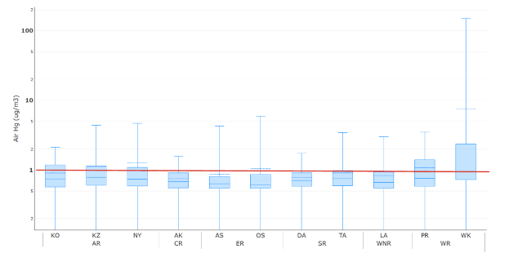
Figure B9: Mercury Vapor Distribution per Site
Boxplots, y axis in µg/m3, log scale red line = Ghana permissible level of Hg in air of 1 µg/m³

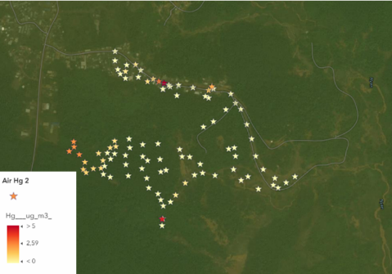
Figure B10: Mercury Vapor Distribution (µg/m³) at Wassa Kayianko

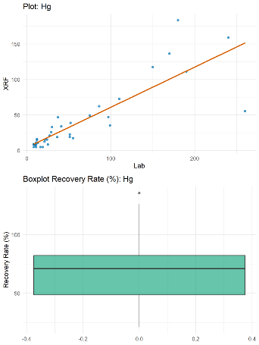

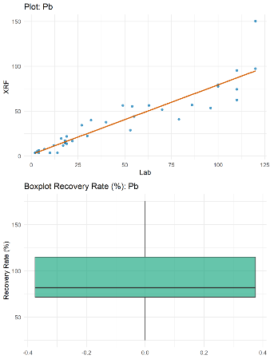

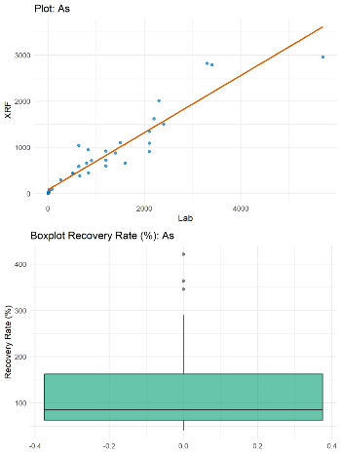

Figure B11: Hg, Pb, and As data correlation between XRF and Lab Results (Soil)

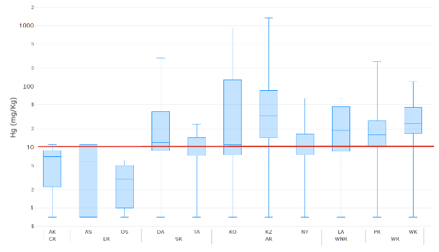

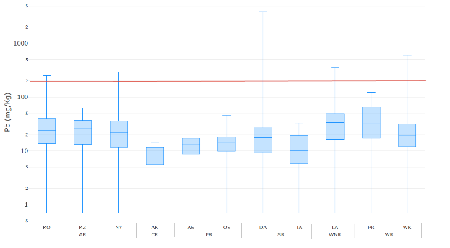

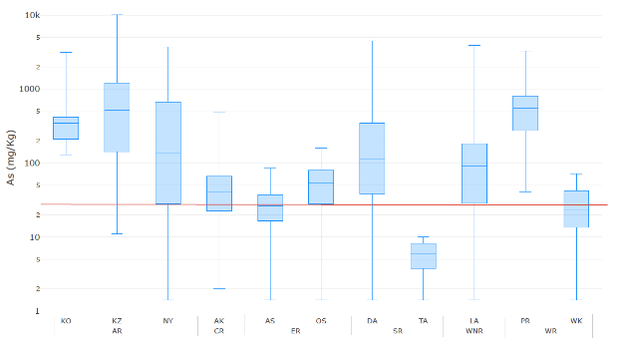
Figure B12: Hg, Pb, and As Concentrations in Soil Samples
y axis in mg/kg, log scale
red line = reference values of 200 ppm for lead (Residential Soil; US EPA, 2024a), 10 ppm for mercury, and 25 ppm for arsenic (German Review values for the soil-human pathway for children's play areas).

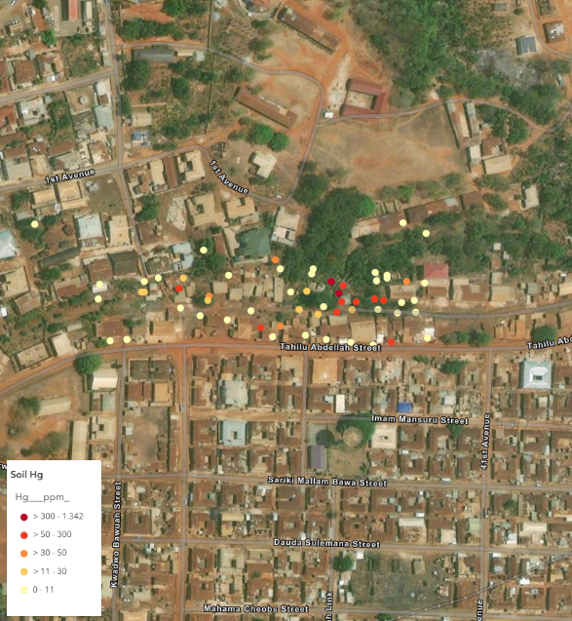
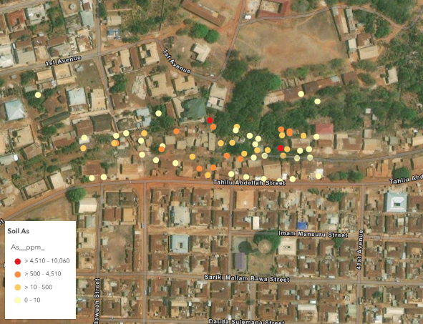
Figure B13: Mercury and Arsenic Concentrations (µg/m³) in Soil at Konongo Zongo

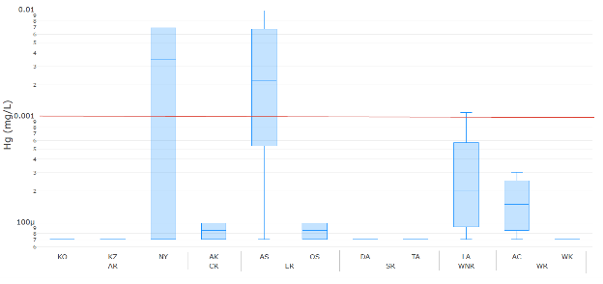
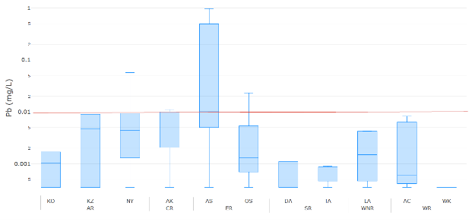
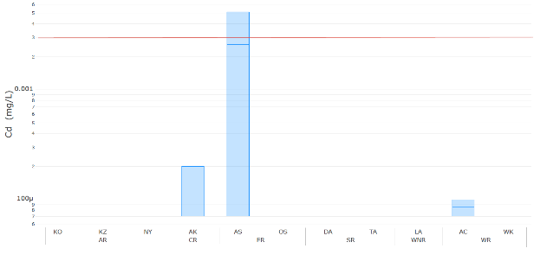
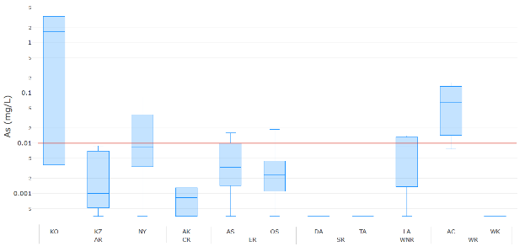
Figure B14: Hg, Pb, Cd an As Concentration in Water Samples
Box plots, y axis in mg/L, log scale.
red line = reference values per Ghanaian regulation of 0.001 mg/L for mercury, 0.01 mg/L for lead, 0.003 mg/L for cadmium, and 0.01 mg/L for arsenic.

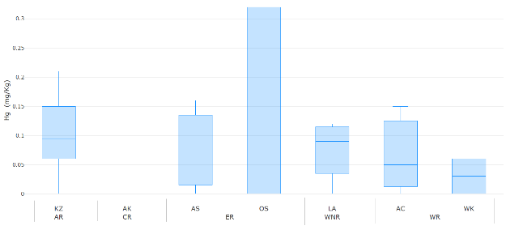
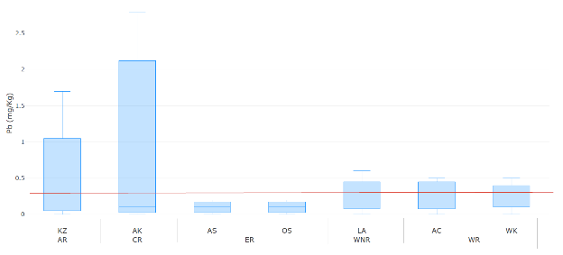

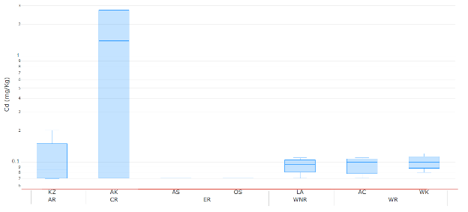

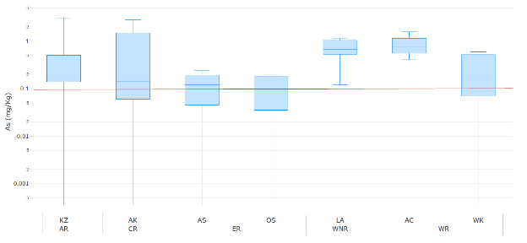
Figure B15: Hg, Pb, Cd an As Concentrations in Fish Samples
Box plots, y axis in mg/kg, log scale.
red line = maximum levels: 0.5 mg/kg for total; mercury (European Commission, 2023), 0.3 mg/kg for lead (European Commission, 2023), 0.05 mg/kg for cadmium (FAO & WHO, 1995), and 0.1 mg/kg for arsenic (USDA, 2018).

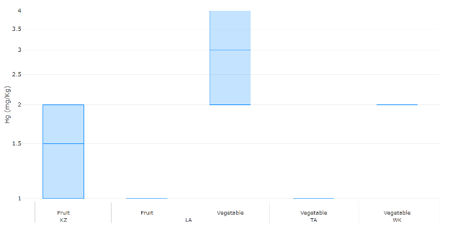

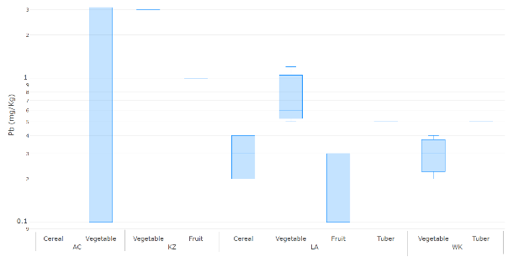
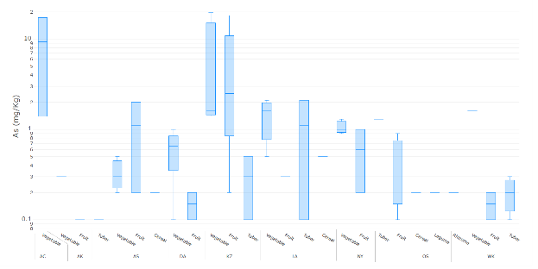

Figure B16: Hg, Pb and As Concentrations in Food Crops from All Sites

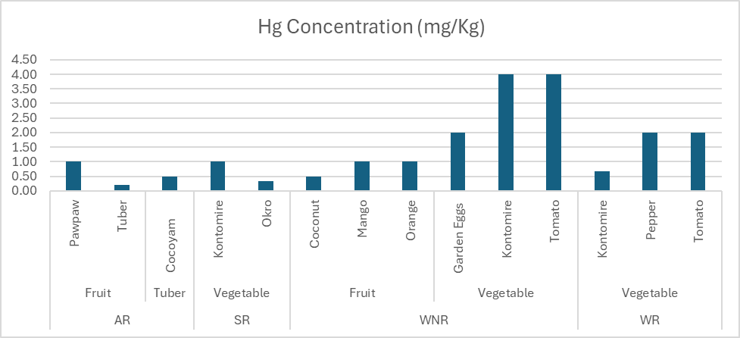
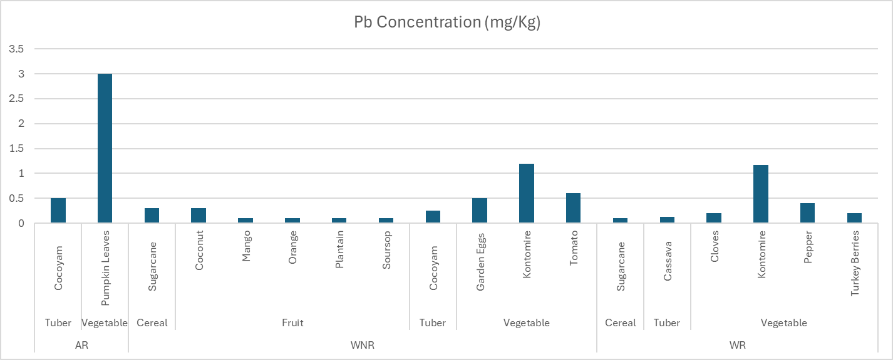

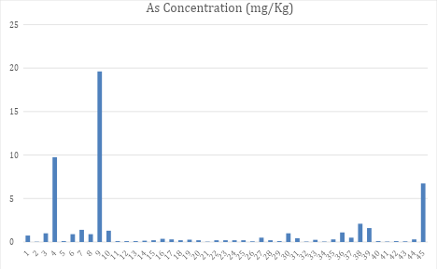
Figure B17: Hg, Pb and As Concentrations in Food, Boxplots
Box plots, y axis in mg/kg, log scale

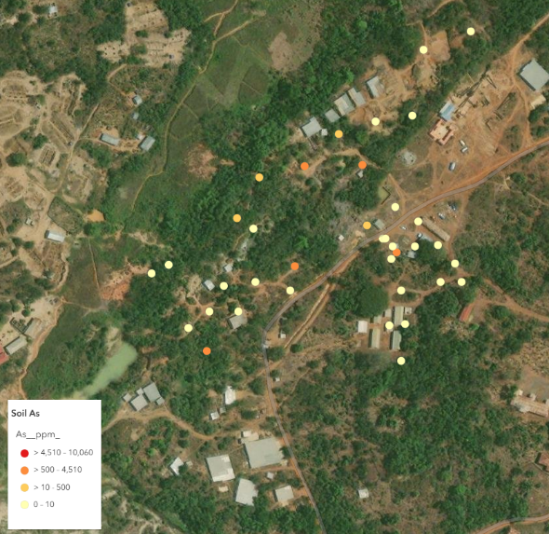
Figure B19: Arsenic distribution in Soil at Konongo Odumase

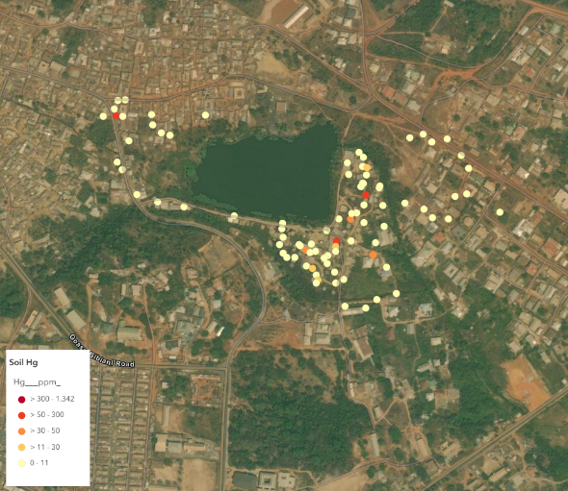
Figure B20: Mercury distribution in Soil at Lake Amponsah

Appendix C: Supplementary Methodology Details
Laboratory Methodology
This section will provide a detailed description of the sample analyses performed by the SGS laboratory in Tema, Ghana. For quality assurance, for every batch of 10 samples processed, one duplicate sample (a repeat analysis of a randomly selected sample to assess precision) and one blank sample (to monitor potential contamination) were systematically inserted into the analytical sequence. This ensured consistent evaluation of method reproducibility and detection of procedural interference.
Water Samples
Test: Major cations & trace metals
Method: APHA 3120, US EPA 200.8, and US EPA 200.7
Equipment: ICP-MS & ICP-OES
Sample Preparation
For dissolved metals, samples were filtered through a 0.45-µm filter and preserved with drops of HNO₃ to pH < 2 for ICP-MS and ICP-OES analysis.
For total metals, 50 mL sample was treated with a 1:1 mixture of concentrated hydrochloric acid (HCl) and nitric acid (HNO₃) and digested on a pre-heated hot block at 110 °C for 2 hours and 30 minutes. After digestion, the mixture was cooled and diluted to the 50 mL mark with deionized water. Metal concentrations in the samples were determined using a Nexion 2000P ICP-MS and AVIO 500 ICP-OES after calibration and tuning of the instrument. Quality control measures, including method blanks, replicates, and certified reference standards, were implemented to ensure the accuracy and precision of the results. The concentrations obtained were expressed in mg/L.

Soil and crops
Test: Metals in soil and crops
Method: US EPA 3050, US EPA 200.8
Sample Preparation and Analysis
Pre-analytical processing of the food samples: All samples were handled in strict accordance with SGS's standard operating procedures. The food samples were meticulously rinsed with deionized water prior to peeling in order to ensure the removal of any surface debris or dust. Thereafter, the samples were dried using an air-drying method and subsequently milled. Following this process, the samples were digested and analyzed. In order to avoid any potential interference with analyte concentrations and to preserve the integrity of the samples, no chemical washing agents were used.
A 2.0-gram portion of the dried sample was weighed into a 50 mL digestion tube, followed by the addition of 2.5 mL of concentrated nitric acid (HNO₃) and 2.5 mL of concentrated hydrochloric acid (HCl). The mixture was heated on a pre-heated hot block at 110 °C for 40 minutes. After cooling, 10 mL of deionized water was added, and the sample reheated for an additional 20 minutes. The digested solution was then cooled and diluted with deionized water to a final volume of 50 mL. Metal concentrations in the samples were determined using a Nexion 2000P ICP-MS and AVIO 500 ICP-OES after calibration and tuning of the instrument. Quality control measures, including method blanks, replicates, and certified reference standards, were implemented to ensure the accuracy and precision of the results. The concentrations obtained from ICP-MS, initially expressed in mg/L, were converted to mg/kg using the formula:
Final concentration (mg/kg) = (ICP-MS result (mg/L) × 50 ÷ 2) × Moisture Factor,
where 50 mL represents the final digestion volume, 2 g is the sample weight, and the moisture factor accounts for variations in sample moisture content.

Fish samples
Test: Metals in fish
Method: US EPA 200.3, US EPA 200.8
Sample Preparation and Analysis
A 2.5-gram portion of fish tissue was subjected to a multi-step acid digestion process to prepare it for heavy metal analysis. Initially, the sample was treated with 5 mL of concentrated nitric acid (HNO₃) and heated at 110 °C until dissolution. After cooling to room temperature, 2.5 mL of HNO₃ was added, and the mixture was heated until the solution turned brown. Following this, 1 mL of HNO₃ was added, and heating continued until the volume reduced to 2.5 mL. Subsequently, 1 mL of hydrogen peroxide (H₂O₂) was added, and heating proceeded until the volume again diminished to 2.5 mL. This cycle of adding HNO₃, heating, and then adding H₂O₂ was repeated, with each cycle aiming to further digest the tissue until 5 mL of H₂O₂ were added. After the final digestion step, 1 mL of hydrochloric acid (HCl) was added, and heating continued until the solution reduced to 2.5 mL. The mixture was then cooled and diluted to the 50 mL mark with deionized water.
Metal concentrations in the samples were determined using a Nexion 2000P ICP-MS after calibration and tuning of the instrument. Quality control measures, including method blanks, replicates, and certified reference standards, were implemented to ensure the accuracy and precision of the results. The concentrations obtained from ICP-MS, initially expressed in mg/L, were converted to mg/kg on wet weight basis using the formula:
Final concentration (mg/kg) = (ICP-MS result (mg/L) × 50 ÷ 2.5),
where 50 mL represents the final digestion volume, 2.5 g is the sample weight, and the moisture factor accounts for variations in sample moisture content.
Reporting limits
The reporting limit (RL) is the lowest quantifiable reporting limit that can be achieved under ordinary conditions. Table 3.1 shows the RLs used for this study.
Table: Reporting limits (RLs) (as determined by the SGS laboratory)
Elements | Water (mg/L) | Soil (mg/kg) | Food (mg/kg) | Fish (mg/kg)
Mercury (Hg) | 0.0001 | 1 | 1 | 0.5
Lead (Pb) | 0.0001 | 1 | 0.1 | 0.5
Arsenic (As) | 0.0005 | 2 | 0.1 | 2
Cadmium (Cd) | 0.0001 | 0.3 | 0.3 | 0.5

Results below reporting limits are given as <RL. For further statistical analysis, reporting limits results were divided by the square root of two.

