Supplementary Material

Humoral immune response in a mouse model induced with dengue virus-like particles serotypes 1 and 4 produced in silkworm larvae

Doddy Irawan Setyo Utomo¹ · Sabar Pambudi² · Enoch Y Park^{1,3,}

E-mails:
doddy.irawan.setyo.utomo.16@shizuoka.ac.jp (DISU)
sabar.pambudi@bppt.go.id (SP)
park.enoch@shizuoka.ac.jp (EYP)

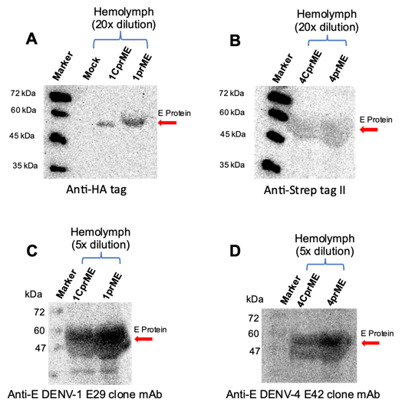

Supplementary Figure S1. Expression of 1CprME, 1prME, 4CprME and 4prME polypeptides in silkworm larvae. In the case of silkworm larvae, hemolymph were collected after recombinant BmNPV infection. The homogenate of each sample was prepared according to the protocol described in Materials and methods. (A) Expressed 1CprME, and 1prME polypeptides were detected by western blot using mouse anti-HA tag, (B) while 4CprME and 4prME polypeptides were detected by western blot using mouse anti-strep tag II as a primary antibody. To determine whether the purified 1CprME, 1prME, 4CprME, and 4prME polypeptides contained E proteins, western blotting was performed using specific serotype monoclonal anti-envelope antibodies, (C) anti-E DENV-1 E29 clone for DENV-1 constructs, and (D) anti-E DENV-4 E42 clone for DENV-4 constructs.

* Enoch Y. Park park.enoch@shizuoka.ac.jp (E.Y. Park) ¹ Laboratory of Biotechnology, Department of Bioscience, Graduate School of Science and Technology, Shizuoka University, 836 Ohya, Suruga-ku, Shizuoka 422-8529, Japan ² Center of Pharmaceutical and Medical Technology, National Research and Innovation Agency (BRIN), Jl. Kawasan Puspiptek, Gedung I LAPTIAB, Kota Tangerang Selatan, Banten 15314, Indonesia ³ Laboratory of Biotechnology, Research Institute of Green Science and Technology, Shizuoka University, 836 Ohya, Suruga-ku, Shizuoka 422-8529, Japan

