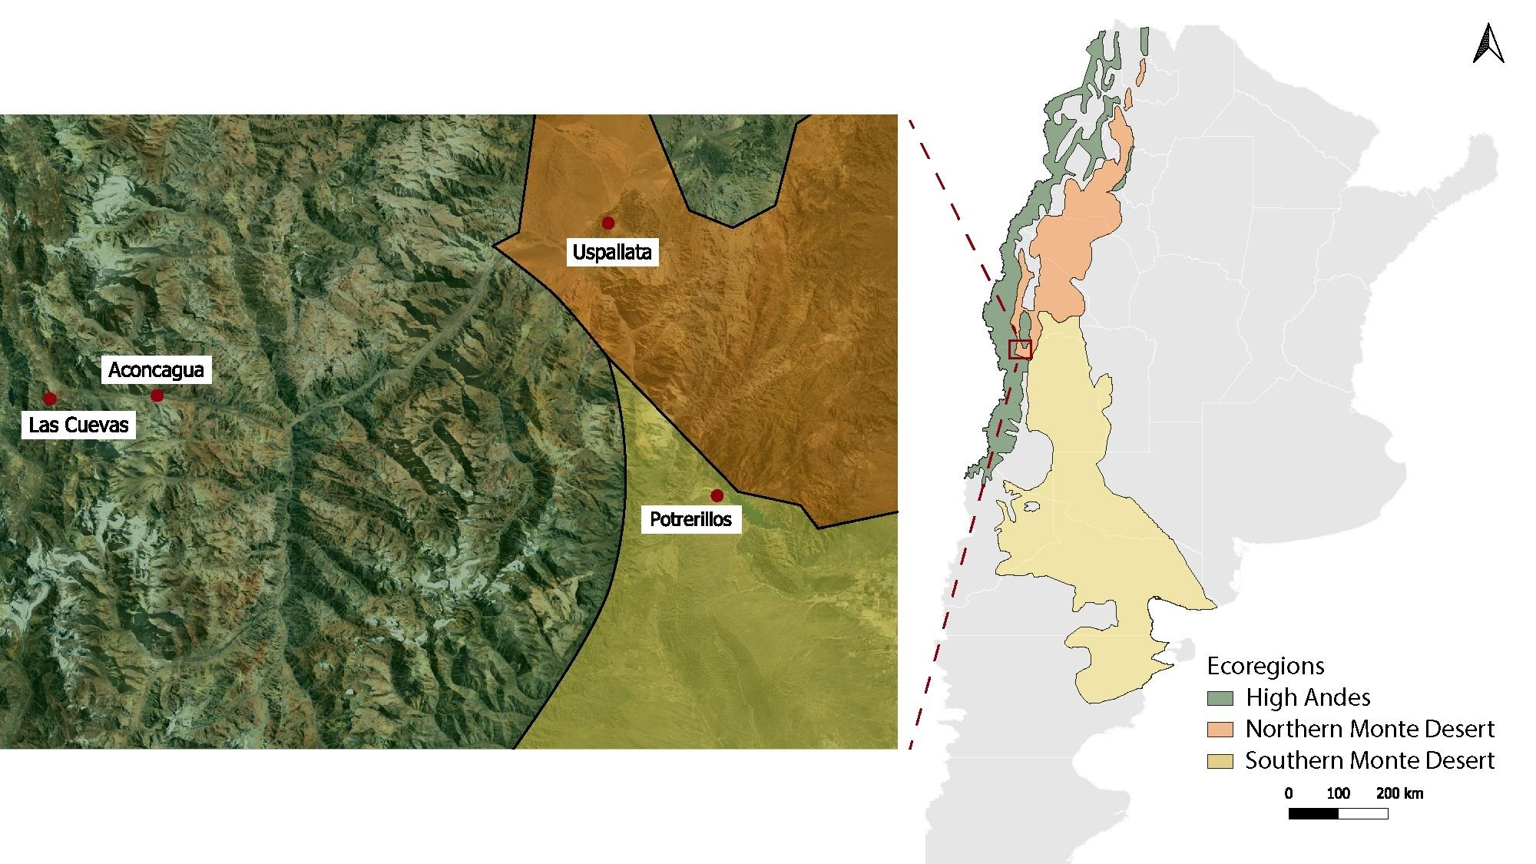Fig. S1 (Online Resource 1) Distribution of the three ecoregions converging along the sampled transect across Mendoza Province, Argentina (High Andes, Northern Monte Desert, and Southern Monte Desert), and the locations of the four identified song dialects named after these areas (Las Cuevas, Aconcagua, Uspallata, and Potrerillos)
Table S1 (Online Resource 2) Metadata for the 44 vocalizations analyzed in this study, deposited in the Colección Nacional de Sonidos Naturales of the Museo Argentino de Ciencias Naturales “Bernardino Rivadavia” (MACN). Catalog numbers correspond to the original audio files; individual songs extracted from the same recording are distinguished by their unique Song IDs. Song IDs 404 and 4035 correspond to the songs with and without a trill produced by the same individual
Song ID | Species | Latitude | Longitude | Date | Recordist
MACN-SN 4034 | Z. capensis | -32.956083 | -69.195594 | 2025-10-13 | Pablo L. Tubaro
MACN-SN 4035 | Z. capensis | -32.957531 | -69.192697 | 2025-10-13 | Pablo L. Tubaro
MACN-SN 4036 | Z. capensis | -32.904594 | -69.264006 | 2025-10-14 | Victoria Blanco
MACN-SN 4037 | Z. capensis | -32.893542 | -69.263100 | 2025-10-14 | Victoria Blanco
MACN-SN 4038 | Z. capensis | -32.893542 | -69.263100 | 2025-10-14 | Pablo L. Tubaro
MACN-SN 4039 | Z. capensis | -32.832100 | -69.289783 | 2025-10-14 | Victoria Blanco
MACN-SN 4040 | Z. capensis | -32.774744 | -69.321453 | 2025-10-14 | Victoria Blanco
MACN-SN 4041 | Z. capensis | -32.774744 | -69.321453 | 2025-10-14 | Pablo L. Tubaro
MACN-SN 4042 | Z. capensis | -32.691000 | -69.352999 | 2025-10-14 | Pablo L. Tubaro
MACN-SN 4043 | Z. capensis | -32.666986 | -69.364039 | 2025-10-14 | Victoria Blanco
MACN-SN 4044 | Z. capensis | -32.645486 | -69.362783 | 2025-10-14 | Victoria Blanco
MACN-SN 4045 | Z. capensis | -32.645575 | -69.362708 | 2025-10-14 | Pablo L. Tubaro
MACN-SN 4046 | Z. capensis | -32.589003 | -69.356367 | 2025-10-14 | Victoria Blanco
MACN-SN 4047 | Z. capensis | -32.590561 | -69.363597 | 2025-10-14 | Victoria Blanco
MACN-SN 4048 | Z. capensis | -32.668689 | -69.517903 | 2025-10-14 | Victoria Blanco
MACN-SN 4049 | Z. capensis | -32.788153 | -69.645708 | 2025-10-14 | Victoria Blanco
MACN-SN 4050 | Z. capensis | -32.789519 | -69.648144 | 2025-10-14 | Victoria Blanco
MACN-SN 4051 | Z. capensis | -32.824611 | -69.909658 | 2025-10-14 | Victoria Blanco
MACN-SN 4052 | Z. capensis | -32.814322 | -70.048492 | 2025-10-14 | Victoria Blanco
MACN-SN 4053 | Z. capensis | -32.939039 | -69.208269 | 2025-10-14 | Pablo L. Tubaro
MACN-SN 4054 | Z. capensis | -32.927617 | -69.231803 | 2025-10-14 | Pablo L. Tubaro
MACN-SN 4055 | Z. capensis | -32.916464 | -69.238406 | 2025-10-14 | Pablo L. Tubaro
MACN-SN 4056 | Z. capensis | -32.841672 | -69.833531 | 2025-10-14 | Pablo L. Tubaro
MACN-SN 4057 | Z. capensis | -32.841356 | -69.838314 | 2025-10-14 | Pablo L. Tubaro
MACN-SN 4058 | Z. capensis | -32.813897 | -70.048908 | 2025-10-14 | Victoria Blanco
MACN-SN 4059 | Z. capensis | -32.666494 | -69.364089 | 2025-10-14 | Pablo L. Tubaro
MACN-SN 4060 | Z. capensis | -33.004253 | -69.127547 | 2025-10-15 | Victoria Blanco
MACN-SN 4061 | Z. capensis | -33.009356 | -69.122736 | 2025-10-15 | Victoria Blanco
MACN-SN 4062 | Z. capensis | -33.019436 | -69.116781 | 2025-10-15 | Victoria Blanco
MACN-SN 4063 | Z. capensis | -33.022156 | -69.114772 | 2025-10-15 | Victoria Blanco
MACN-SN 4064 | Z. capensis | -33.047147 | -69.089731 | 2025-10-15 | Victoria Blanco
MACN-SN 4065 | Z. capensis | -33.037819 | -69.038678 | 2025-10-15 | Victoria Blanco
MACN-SN 4066 | Z. capensis | -33.033931 | -69.106039 | 2025-10-15 | Pablo L. Tubaro
MACN-SN 4067 | Z. capensis | -32.977306 | -69.172667 | 2025-10-08 | Pablo L. Tubaro
MACN-SN 4068 | Z. capensis | -32.977306 | -69.172667 | 2025-10-08 | Pablo L. Tubaro
MACN-SN 4069 | Z. capensis | -32.825222 | -69.911389 | 2025-10-08 | Pablo L. Tubaro
MACN-SN 4070 | Z. capensis | -32.823306 | -69.942083 | 2025-10-08 | Pablo L. Tubaro
MACN-SN 4071 | Z. capensis | -32.814194 | -70.048389 | 2025-10-08 | Pablo L. Tubaro
MACN-SN 4072 | Z. capensis | -32.814000 | -70.049000 | 2025-10-08 | Pablo L. Tubaro
MACN-SN 4073 | Z. capensis | -32.813611 | -70.049778 | 2025-10-08 | Pablo L. Tubaro
MACN-SN 4074 | Z. capensis | -32.813083 | -70.047694 | 2025-10-08 | Pablo L. Tubaro
MACN-SN 4075 | Z. capensis | -32.788861 | -69.647389 | 2025-10-14 | Pablo L. Tubaro
MACN-SN 4076 | Z. capensis | -32.588619 | -69.357786 | 2025-10-14 | Victoria Blanco
MACN-SN 4077 | Z. capensis | -32.588619 | -69.357786 | 2025-10-14 | Pablo L. Tubaro
MACN-SN 4078 | Z. capensis | -32.860056 | -69.268194 | 2025-10-14 | Pablo L. Tubaro

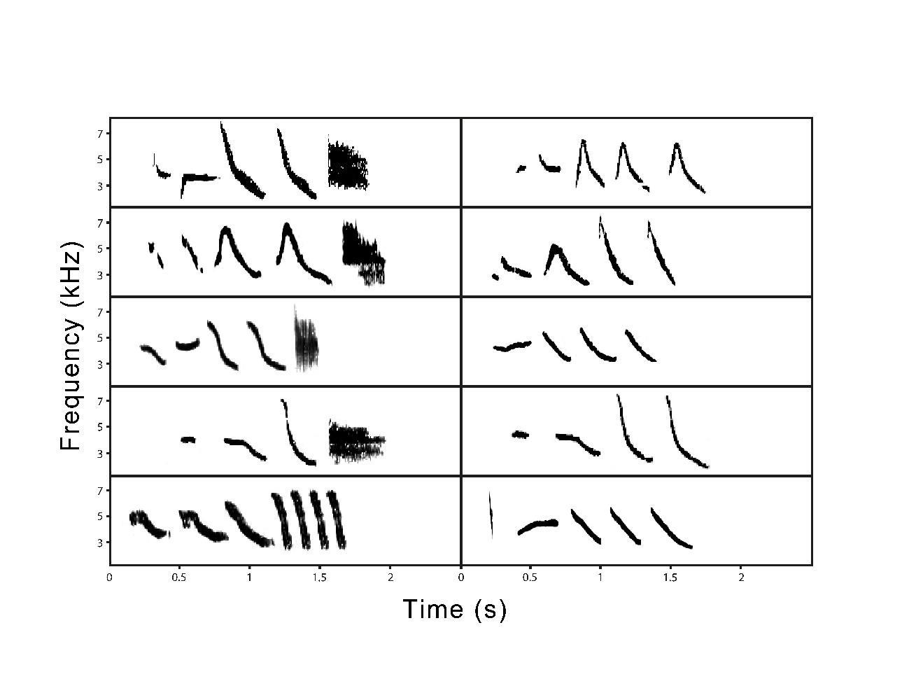
Fig. S2 (Online Resource 3) Spectrograms of the songs of five individuals recorded in Potrerillos that sang two different songs. Their trilled song type is shown on the left panel and their corresponding trill-less song type on the right panel. Note that while the first four individuals present a final fast trill (buzz), the last individual (bottom row) has a slow trill
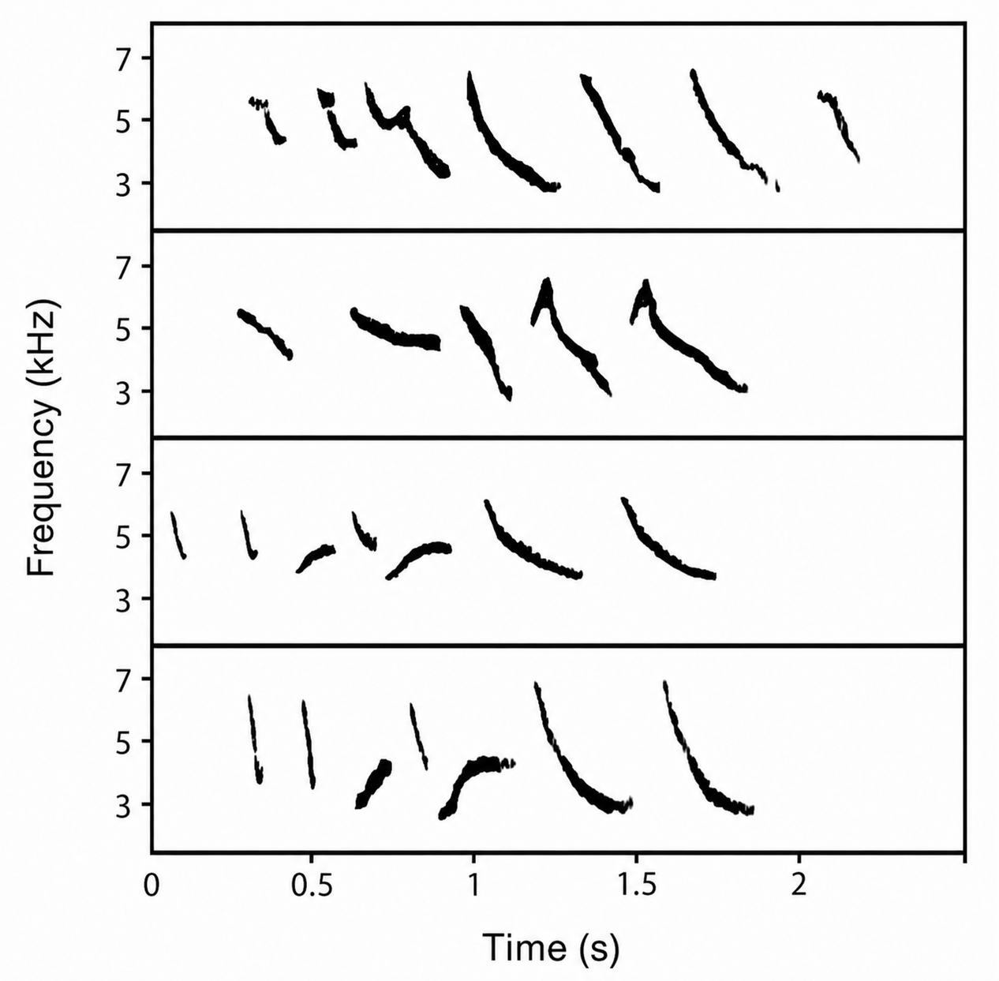
Fig. S3 (Online Resource 4) Spectrograms of the songs of four individuals from Potrerillos that lack the final trill. Note the similarity between the last two songs belonging to neighbouring individuals recorded at Cacheuta hot springs

