Fig. 1.1 Nanomedicine's diverse applications in biomedical research
Fig. 1.2 Material, shape, size and surface properties play an important role on the bio-physicochemical properties of nanoparticles

Fig. 1:3 Different classes of lipid and polymeric nanoparticles.

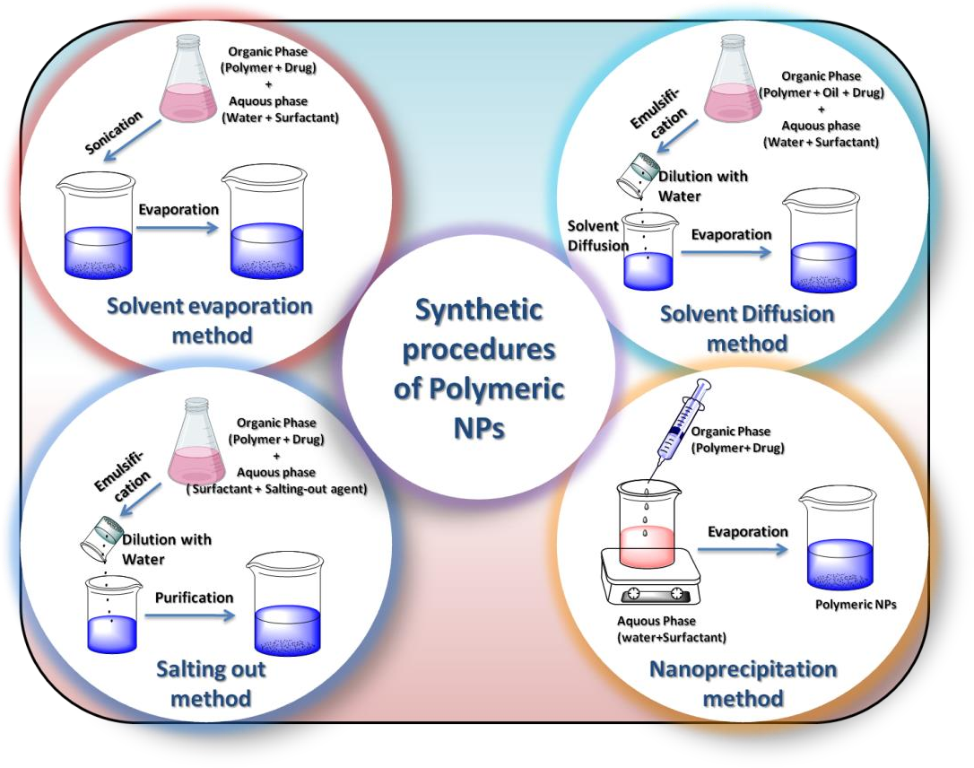
Fig. 1.4: Schematic representation of different methods of polymeric nanoparticles

Fig. 1.5: Schematic representation of different methods of polymeric nanoparticles
Fig.1.6: Nanoparticles used drug delivery in cancer
Fig.1.7: Biomedical applications of Nanoparticles

