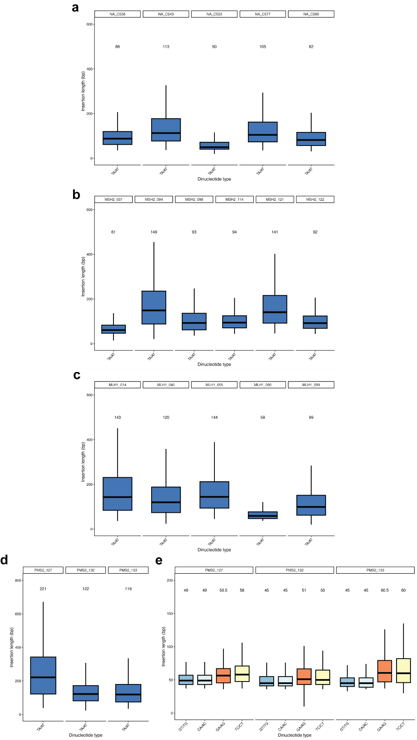
Supplementary Figure 1. Median of insertion length measured in bp in MSI/MMRD tumors. (a) TA repeat length in N/A tumors. (b) TA repeat length in MSH2d tumors. (c) TA repeat length in MLH1d tumors. (d) TA repeat length in PMS2d tumors. (e) Dinucleotide repeat length in PMS2d tumors.

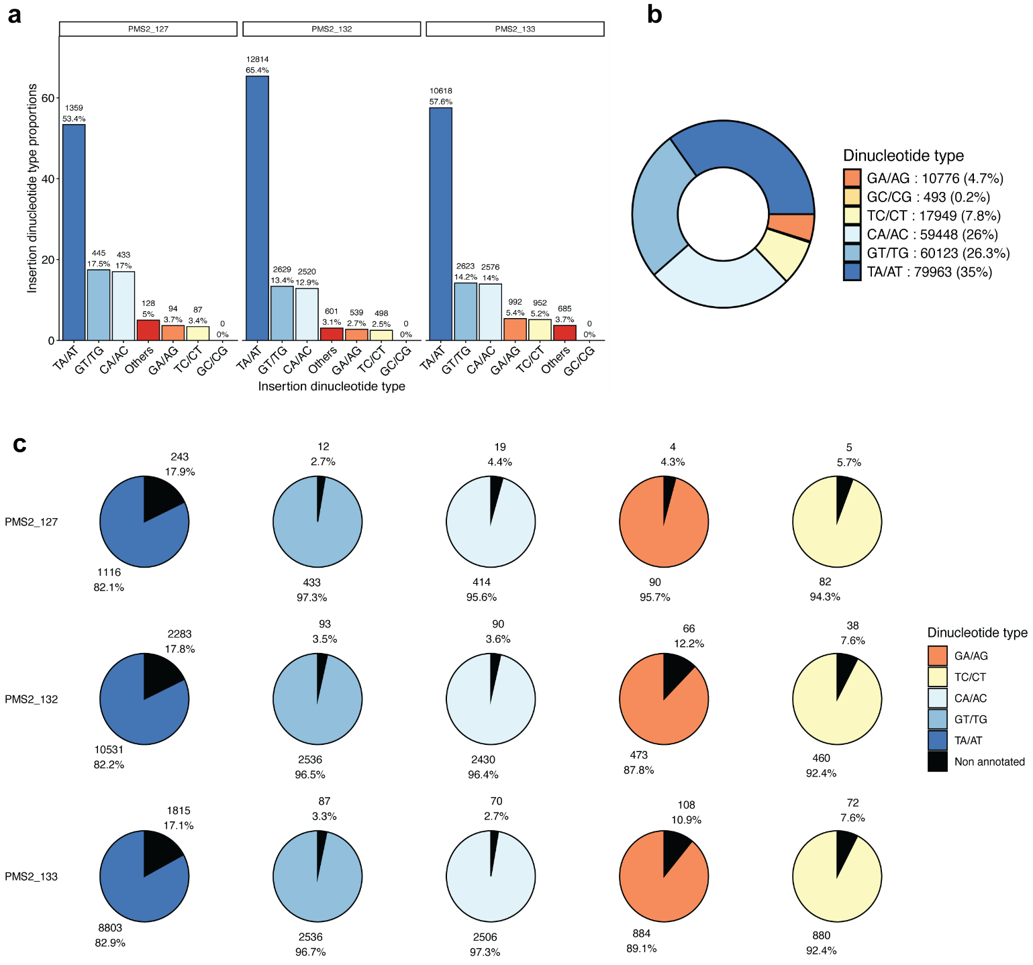
Supplementary Figure 2. Insertions in MSI/PMS2D tumors. (a) Distribution of insertions by dinucleotide repeat type. (b) Proportion of dinucleotide repeats in hg38 genome. (c) Proportions of annotated or non-annotated dinucleotide expanded repeats using hg38 genome as reference.
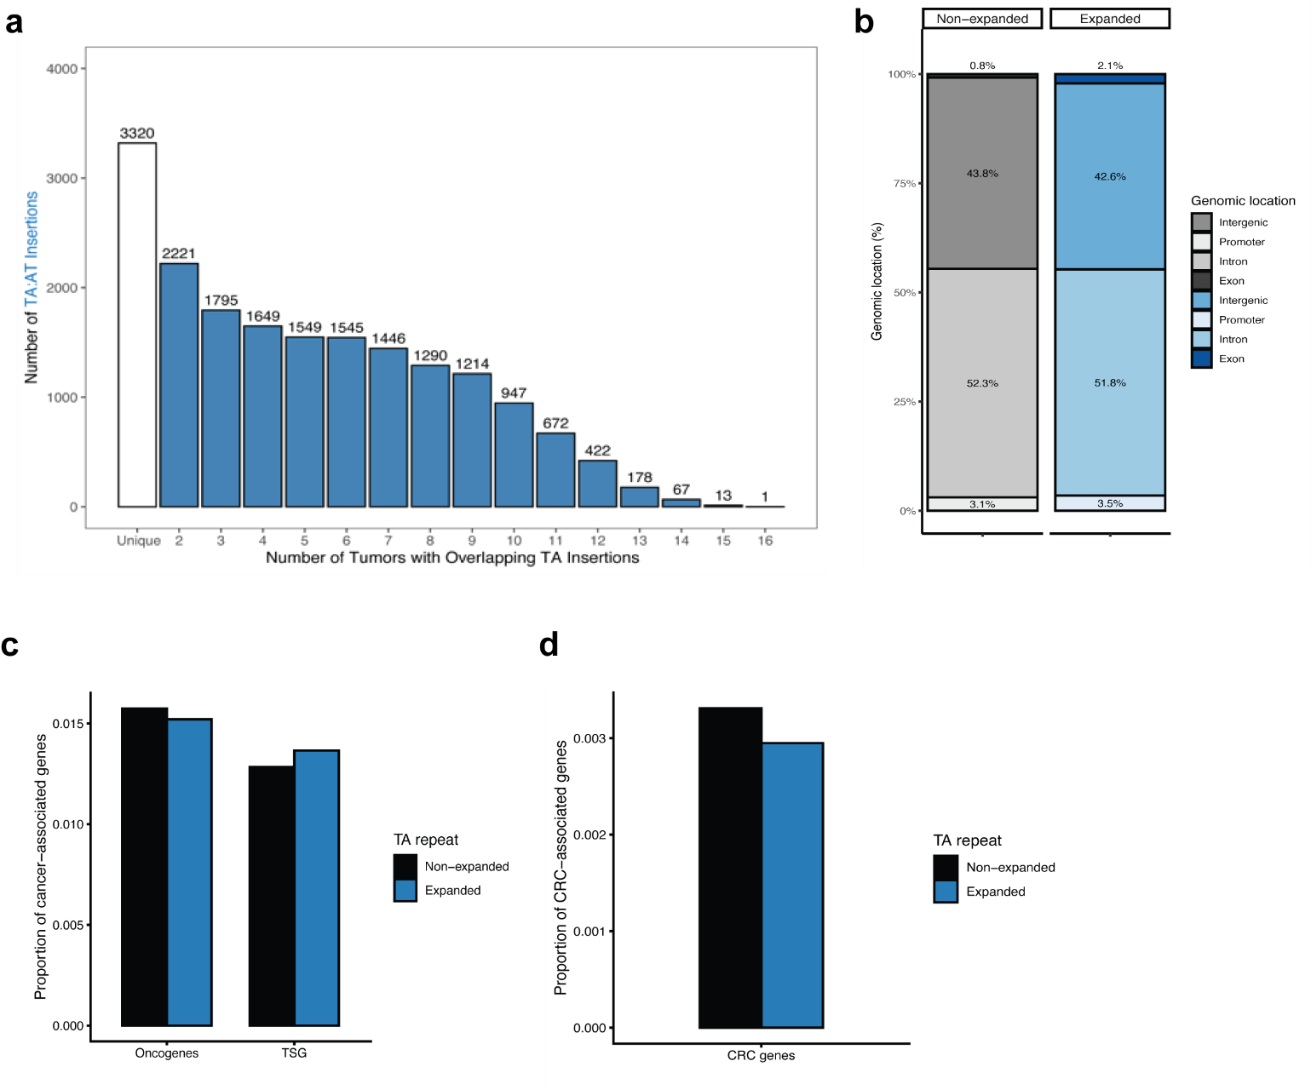
Supplementary Figure 3. Genomic characterization of expanded TA repeats. (a) Number of overlapping TA insertions between tumors. (b) Genomic location of non-expanded and expanded TA repeats. (c) Proportion of cancer-related genes (oncogenes/TSGs) overlapping with non-expanded and expanded TA repeats. (d) Proportions of CRC-related genes overlapping with non-expanded and expanded TA repeats.

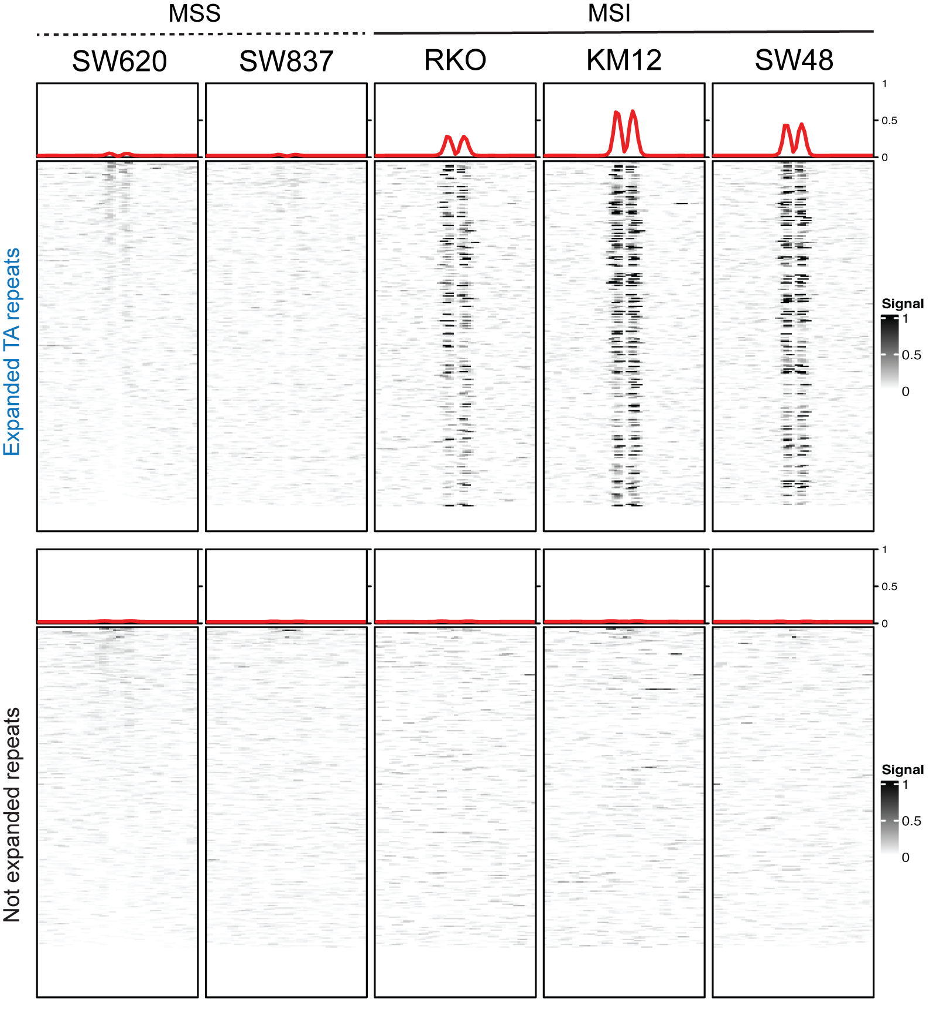
Supplementary Figure 4. S1-END-seq reveals formation of cruciform-like structure at expanded TA repeats in MSI cells but not in MSS cells. S1-END-seq heatmaps comparing the S1-END-seq signal in reads per million (RPM) related to 500 bp from the center of expanded TA repeats (top panel) and non-expanded TA repeats (bottom panel) in MSS (SW620, SW837) and MSI (RKO, KM12, SW48) cell lines.

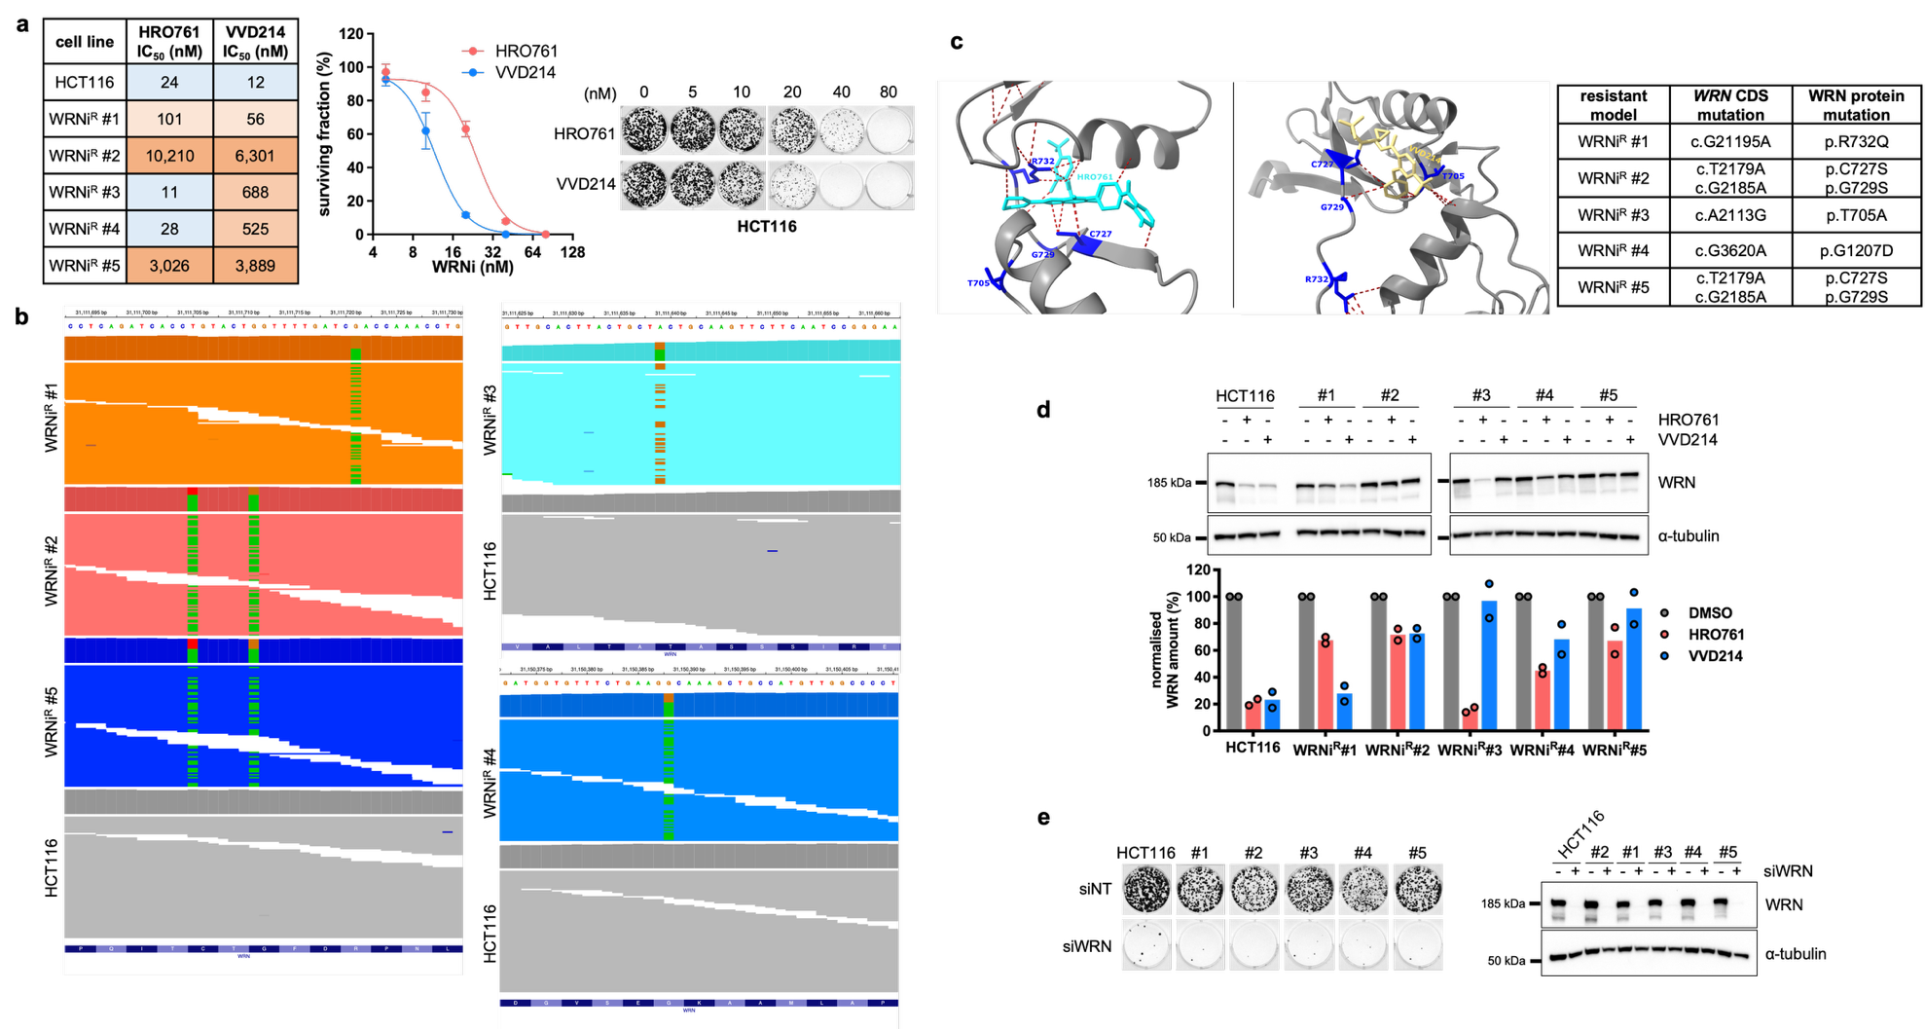
Supplementary Figure 5. Characterization of WRN inhibitor-resistant cell lines. (a) The IC₅₀ values were estimated from the data shown in Fig. 4b using a variable slope four-parameter fit (left table). For the estimation of the IC₅₀ values of the parental HCT116 cell line, survival curves after low doses of WRN inhibitors were used (middle and right panels, n=3). (b) Identification of WRN mutations in WRNi^{R} cell lines by whole-exome sequencing. The images show read alignments on the hg38 reference genome using the IGV software, confirming that the identified variants were absent from the parental HCT116 cell line (see also Supplementary Table 2). (c) The table recapitulates the identified CDS mutations and their consequences at the protein level. Of note, WRNi^{R} #2 and #5 shared the same two mutations, both on the same allele, although the two cell lines were established independently. Protein structures were visualized using UCSF ChimeraX software based on PDB structure 8PFO and PDB structure 7GQU, representing the interaction between WRN and HRO761 and WRN and VVD214, respectively. WRN protein is represented in gray in both panels, while interacting molecules are shown in turquoise for HRO761 (left panel) and yellow for VVD214 (right panel). Residues mutated in resistant cell lines are highlighted in dark blue. Predicted contact sites between WRN and molecules are indicated by red dots. Interactions between residues separated by fewer than 90 amino acids in the primary sequence were excluded from the contact analysis. (d) WB analysis of WRN protein after treatment with 5 μM HRO761 or VVD214 for 24 hours. The same volume of DMSO was used for mock-treated conditions. α-tubulin was used as a loading control. Histograms showed the quantification of WRN normalized to α-tubulin and represented as a percentage of DMSO-treated cells from 2 independent experiments. (e) Clonogenic survival assay of HCT116 and WRNi^{R} cell lines following depletion of WRN by RNA interference. Representative images of crystal violet-stained colonies are shown. WB analysis of WRN protein confirmed the efficiency of the siRNA directed against WRN (siWRN). α-tubulin was used as a loading control.

