Table 2 Colony morphology of bacterial isolates from Station 1 (n = 12)
Code | Photo | Shape | Colour | Size | Margin | Elevation | Appearance
1AS | 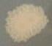 | Circular | Yellowish | Medium | Undulate | Flat | Matte
1BS | 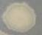 | Circular | Dark cream | Medium | Lobate | Flat | Translucent margin, matte centre
1CS | 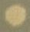 | Circular | Cream | Medium | Entire | Flat | Spotted matte centre
1DS | 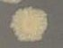 | Circular | Yellowish | Medium | Entire | Convex/pustular | Mucoid, translucent
1SWBA | 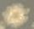 | Filamentous | Dark cream | Medium | Filiform | Flat | Matte
1SWBB | 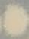 | Circular | Dark cream | Small | Undulate | Flat | Matte, sunken centre
1SWBC | 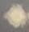 | Filamentous | Yellowish | Small | Filiform | Pustular | Spotted centre
1SWBD | 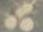 | Circular | Cream | Medium | Entire | Raised | Translucent margin, matte centre
1SWBE | 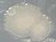 | Circular | Dark cream | Small | Filiform | Flat | Translucent margin, matte spots
1SWBF | 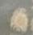 | Circular | Light brown | Medium | Undulate | Flat | Translucent margin, brown-spotted centre
1SWBG | 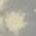 | Filamentous | Cream | Medium | Undulate | Flat | Matte
1SWBH | 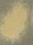 | Circular | Yellowish | Small | Filiform | Flat | Matte, translucent margin
Table 3 Colony morphology of bacterial isolates from Station 2 (n = 2)
Code | Photo | Shape | Colour | Size | Margin | Elevation | Appearance
2AS | 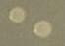 | Circular | Translucent (water-drop-like) | Very small | Entire | Convex | Translucent
2BS | 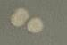 | Circular | Faint translucent cream | Small | Entire | Pustular | Translucent margin, cream centre
Table 4 Colony morphology of bacterial isolates from Station 3 (n = 13)
Code | Photo | Shape | Colour | Size | Margin | Elevation | Appearance
3AS |  | Circular | Cream | Medium | Entire | Flat | Matte cream ring, translucent-spotted centre
3BS | 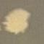 | Filamentous | Matte cream | Small | Filiform | Crateriform | Translucent margin, matte centre
3CS | 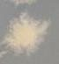 | Filamentous | Matte | Medium | Filiform | Flat | Lichenoid, matte, sunken
3DS | 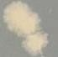 | Circular | Cream/translucent | Medium | Entire | Raised | Cream margin, translucent centre
3ES | 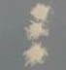 | Circular | Matte cream | Small | Undulate | Flat | Undulate margin
3NS | 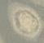 | Circular | Dark cream | Medium | Entire | Flat | Dark-cream centre
3NS1 | 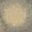 | Circular | Translucent cream | Medium | Undulate | Flat | Translucent margin, cream centre
3NS2 | 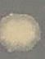 | Circular | Matte cream | Small | Filiform | Flat | Lichenoid margin
3NS3 | 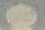 | Circular | Matte translucent cream | Medium | Entire | Flat | Cream ring, translucent centre
3FS | 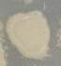 | Circular | Light cream | Medium | Lobate | Convex | Translucent margin, mucoid
3GS | 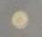 | Circular | Yellowish | Small | Entire | Convex | Translucent margin, yellowish spot
3HS | 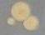 | Circular | Pink | Very small | Entire | Convex | Translucent-spotted centre
3SWBNJ | 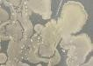 | Irregular | Off-white cream | Large | Undulate | Convex | Matte, dark-cream margin, translucent centre

