Supplementary Materials for
„Species-dependent opioid receptor pharmacology in dogs revealed by binding, signaling, and structural analysis“ by Elena K. Gerdes, Christian Zenner, Sarah Koutnik-Abele, Hermann Ammer

This PDF file includes:
Figure 3 Raw data for calculation binding affinities and statistical evaluation.
Figure 5 Raw data for predicted pK_{i} values and binding energy.
Figure 6 Raw data for pERK1/2 given in given as % of full agonist with subtracted control.
Table 2 Raw data for calculation of binding pockets.
Docking settings used for Boltz-2 docking simulations

.
Figure 3 Raw data for calculation binding affinities and statistical evaluation
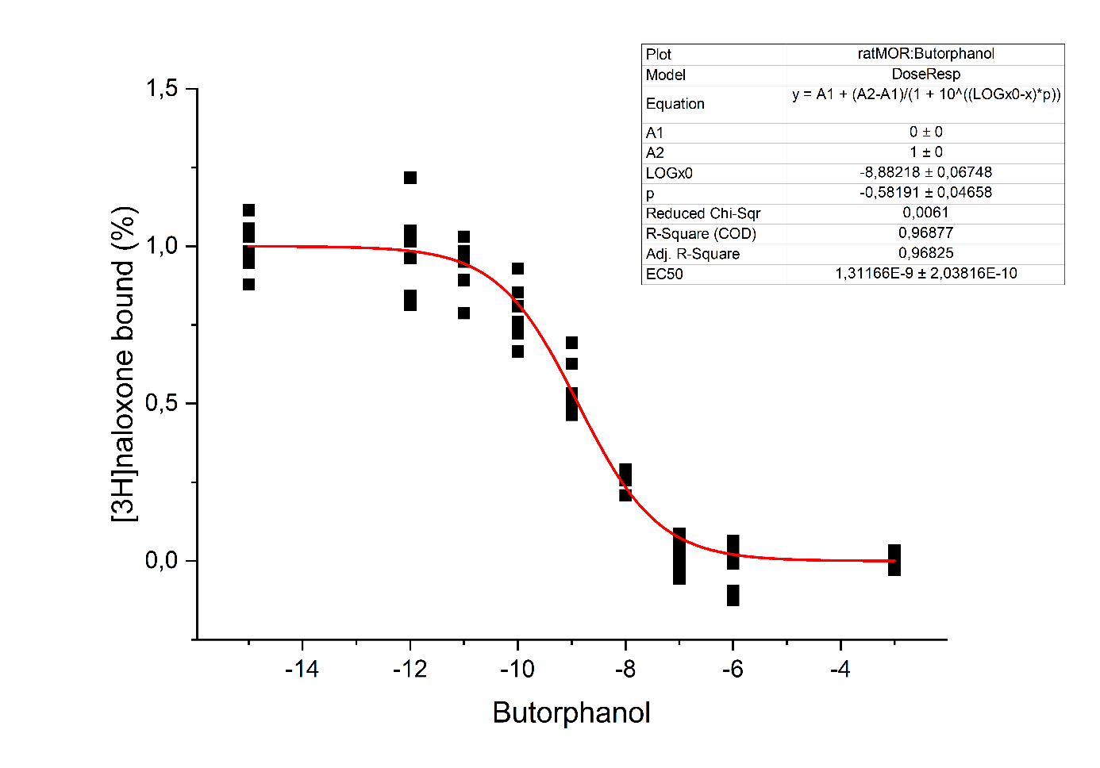
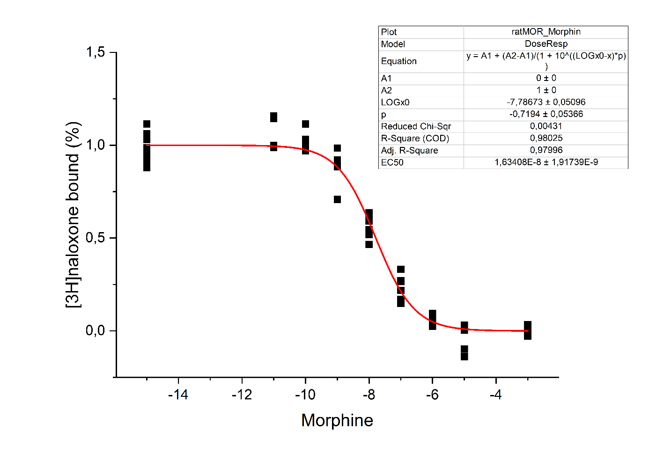
rat MOR:
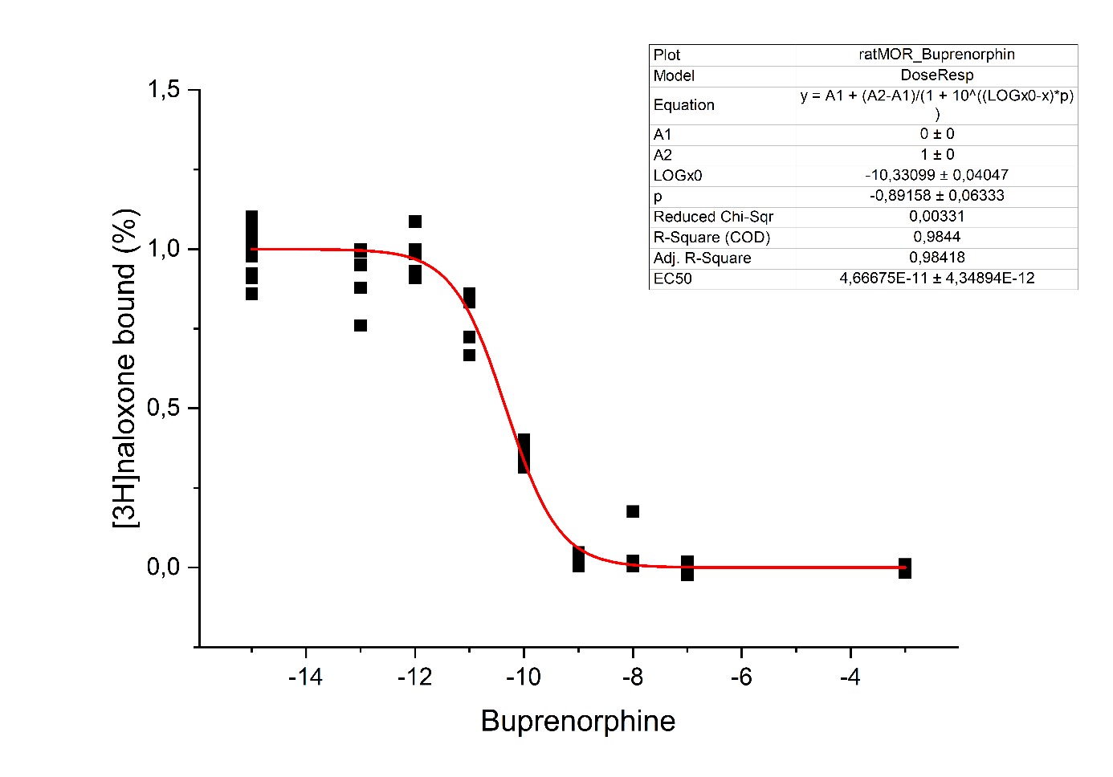

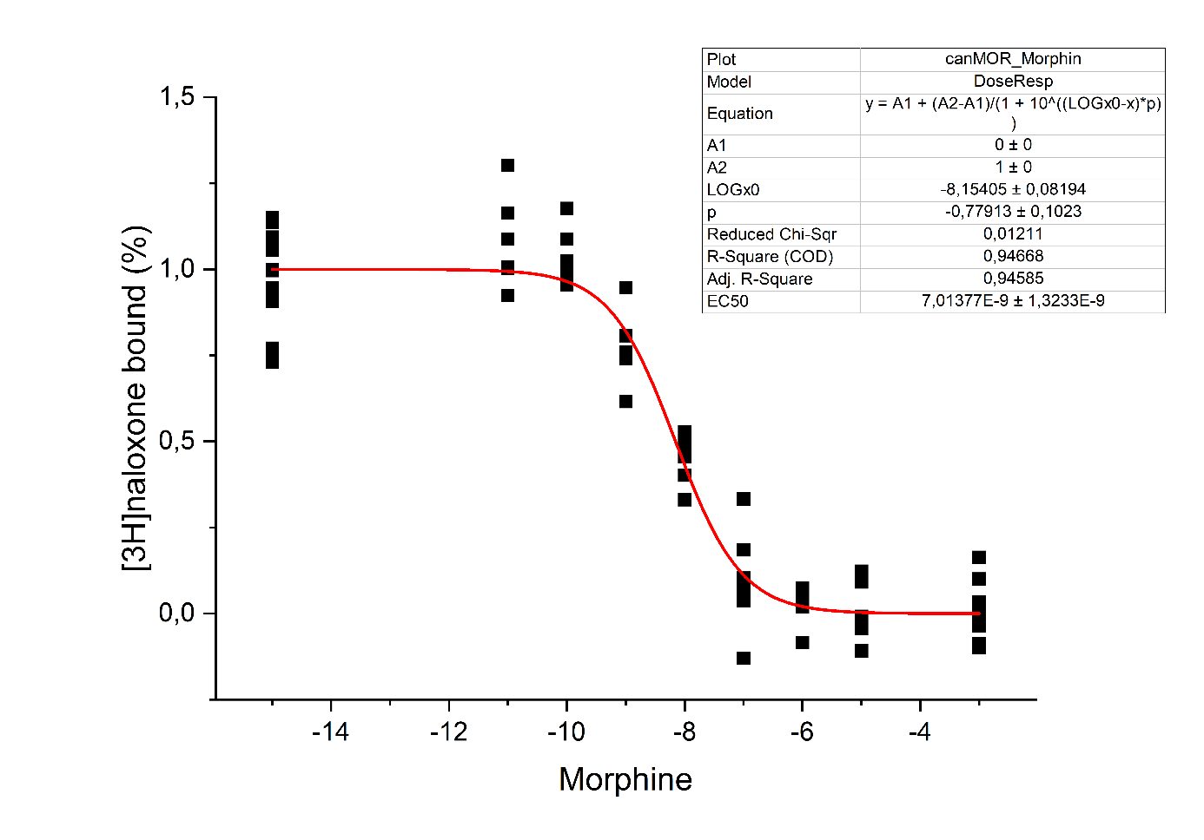
canine MOR:
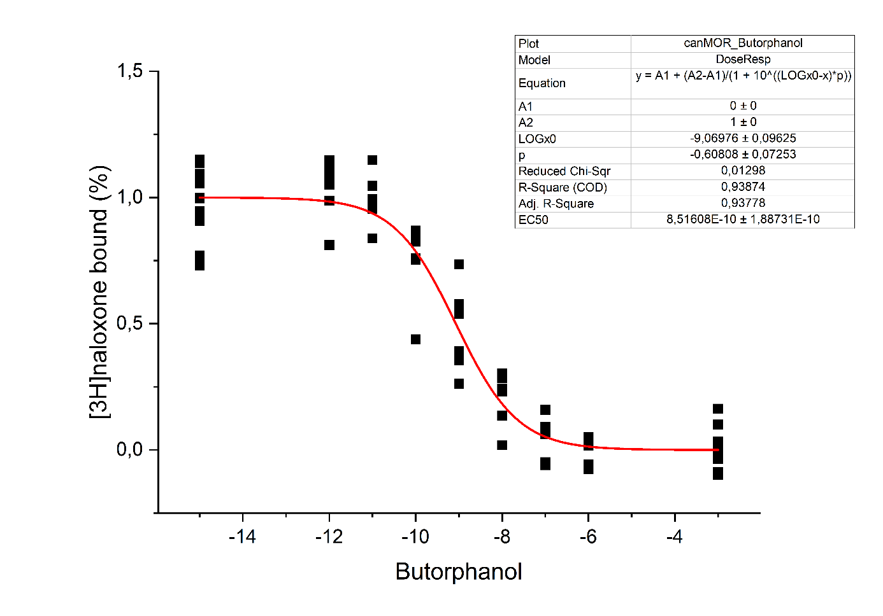
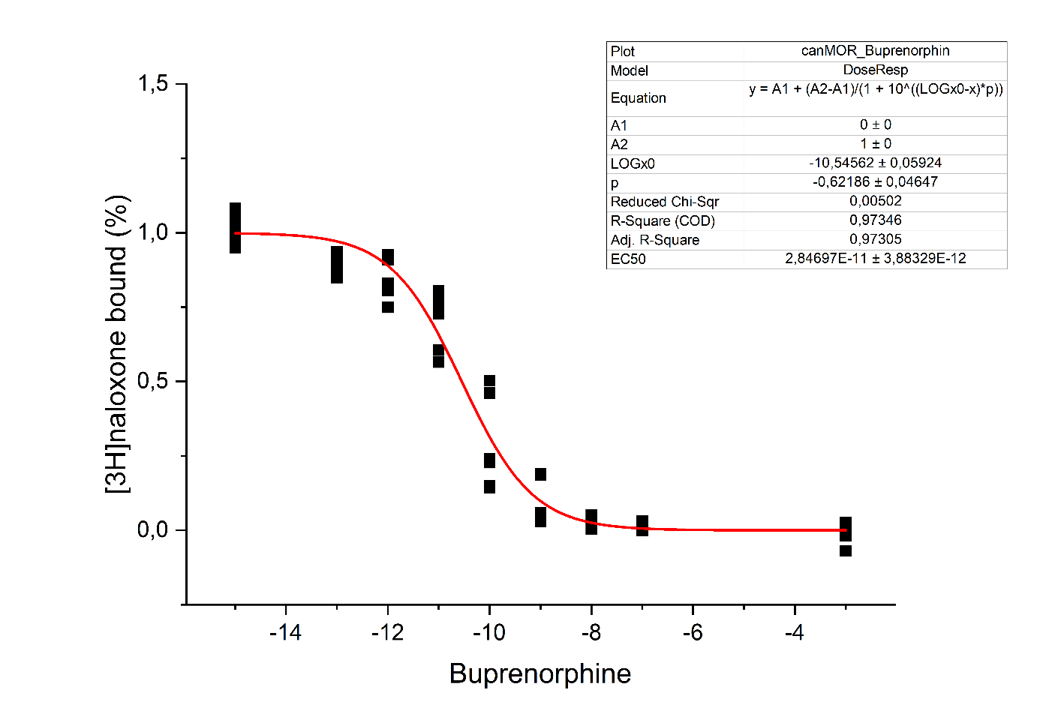

canine KOR:
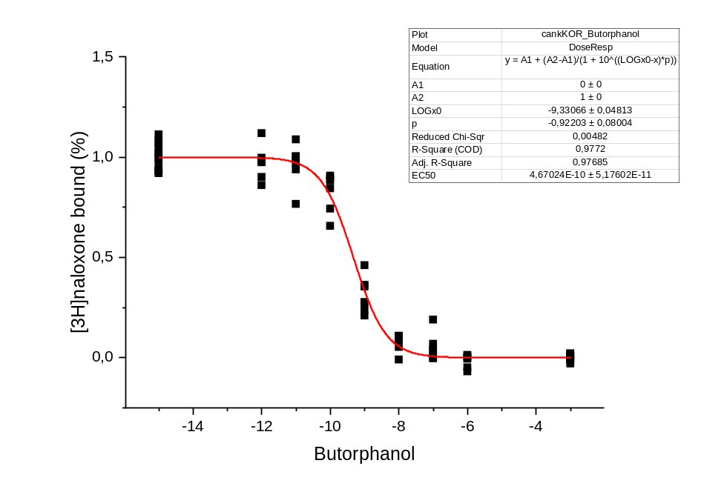
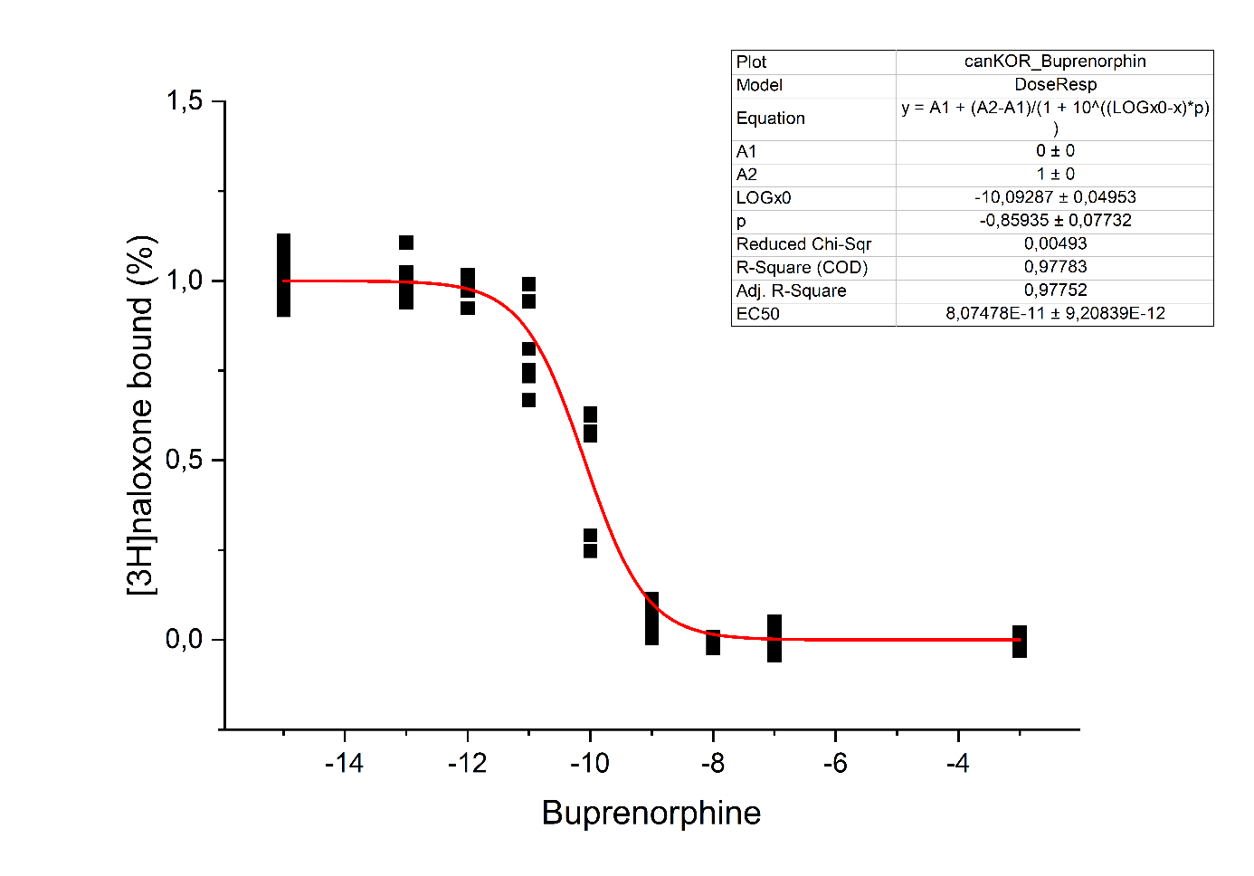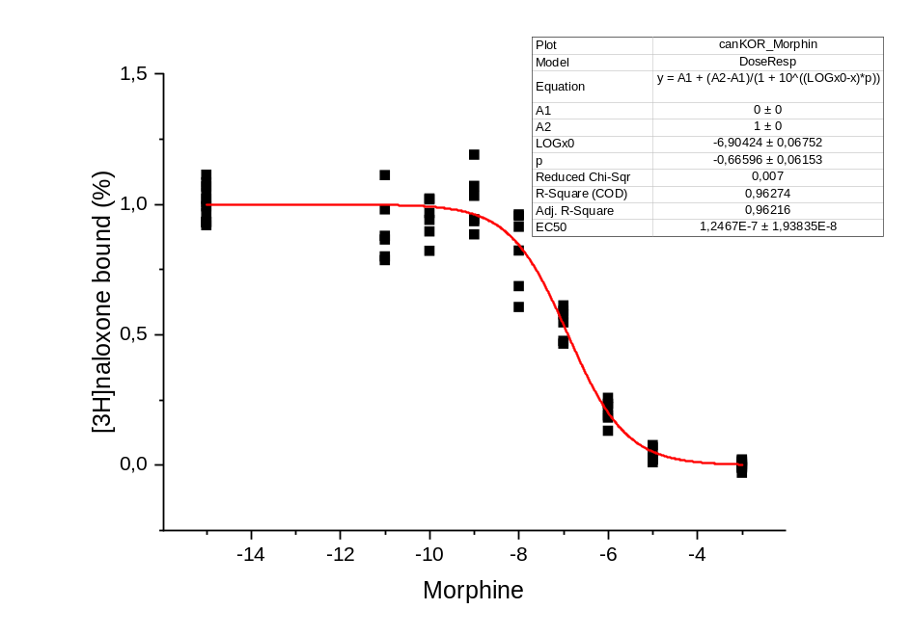

human KOR:
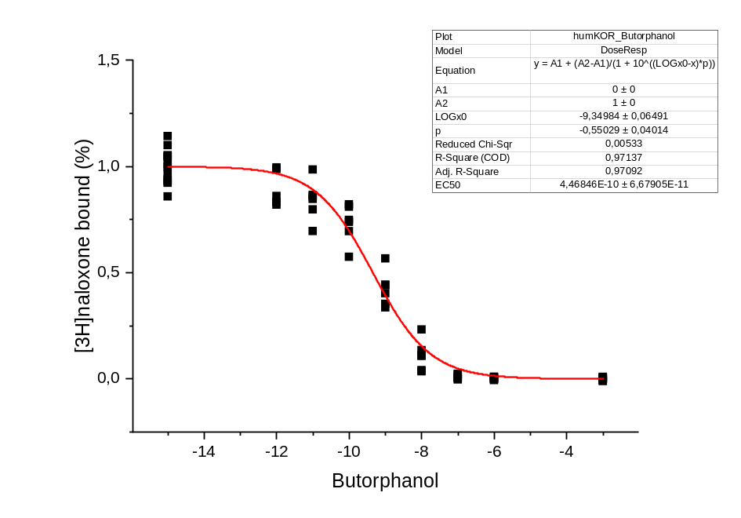
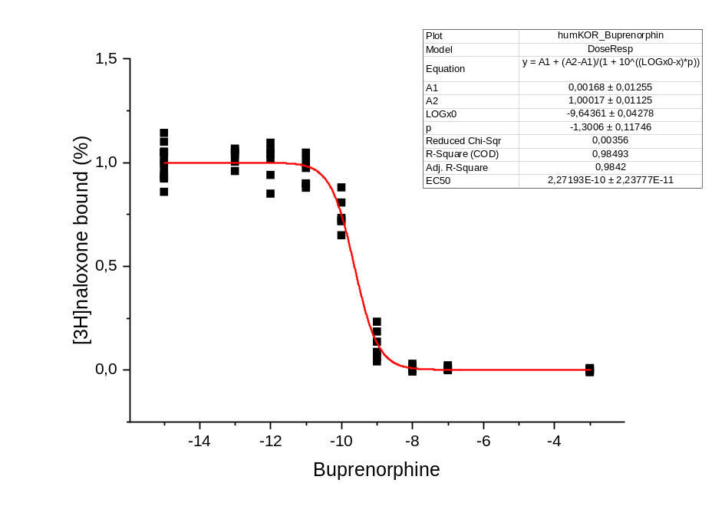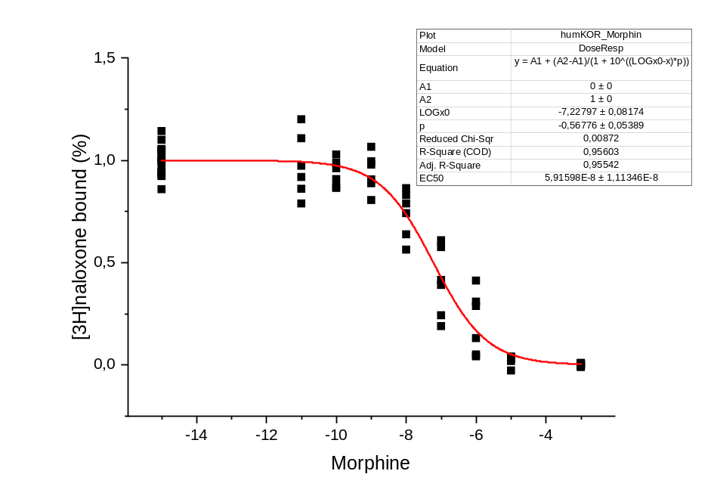

t-test canine receptors vs. reference receptor
 | MOR
 | t-value |  | p-value | Significance
Buprenorphine | 3,63 |  | 0,0222 | *
Morphine | 4,35 |  | 0,0121 | *
Butorphanol | 2,63 |  | 0,0580
 | KOR
 | t-value |  | p-value | Significance
Buprenorphine | 7,18 |  | 0,0020 | **
Morphine | 2,36 |  | 0,0774
Butorphanol | 0,49 |  | 0,6476
t-test selectivity canine receptors
 | t-value |  | p-value | Significance
Buprenorphine | 7,13 |  | 0,0020 | **
Morphine | 12,00 |  | 0,0003 | ***
Butorphanol | 0,61 |  | 0,5754

Figure 5 Raw data for predicted pK_{i} values and binding energy
Receptor | Ligand | Model | Mean predicted binding affinity | Affinity value 1 | Affinity value 2 | pIC50 | pIC50 converted to binding energy (kcal/mol)
canMOR | Buprenorphine | 1 | -2,642631531 | -2,848387241 | -2,436875582 | 11,7885494 | -7,895581392
canMOR | Buprenorphine | 2 | -2,657701492 | -2,85185051 | -2,463552475 | 11,8091048 | -7,923618996
canMOR | Buprenorphine | 3 | -2,861696243 | -3,274133682 | -2,449258804 | 12,0873537 | -8,303150414
canKOR | Buprenorphine | 1 | -2,370863438 | -2,638467789 | -2,103258848 | 11,4178577 | -7,389957942
canKOR | Buprenorphine | 2 | -2,181599379 | -2,674821854 | -1,688376904 | 11,1597016 | -7,037832917
canKOR | Buprenorphine | 3 | -2,384443521 | -2,747160435 | -2,021726608 | 11,436381 | -7,415223634
canMOR | Morphine | 1 | -2,016076565 | -2,103957176 | -1,928196192 | 10,9339284 | -6,729878384
canMOR | Morphine | 2 | -2,12578392 | -2,294427395 | -1,957140326 | 11,0835693 | -6,933988481
canMOR | Morphine | 3 | -1,860432386 | -2,232265472 | -1,488599181 | 10,7216298 | -6,440303013
canKOR | Morphine | 1 | -1,035213828 | -0,984830618 | -1,085597038 | 9,59603166 | -4,904987186
canKOR | Morphine | 2 | -1,154434443 | -1,484832287 | -0,824036479 | 9,75864858 | -5,126796663
canKOR | Morphine | 3 | -0,982367873 | -1,312418818 | -0,652316279 | 9,52394978 | -4,806667499
canMOR | Butorphanol | 1 | -2,331500292 | -2,777824879 | -1,885175705 | 11,3641664 | -7,316722967
canMOR | Butorphanol | 2 | -2,31913805 | -2,535734177 | -2,102541685 | 11,3473043 | -7,293723066
canMOR | Butorphanol | 3 | -2,20284605 | -2,741052628 | -1,664639354 | 11,188682 | -7,077362265
canKOR | Butorphanol | 1 | -1,589422107 | -1,906647205 | -1,272197008 | 10,3519718 | -5,936089472
canKOR | Butorphanol | 2 | -1,33554256 | -1,467006445 | -1,204078674 | 10,0056801 | -5,46374759
canKOR | Butorphanol | 3 | 7,57862258 | -1,57862258 | -1,782711983 | 10,3372412 | -5,915996995
ratMOR | Buprenorphine | 1 | -3,046562672 | -3,357208729 | -2,735916615 | 12,3395115 | -8,647093664
ratMOR | Buprenorphine | 2 | -3,062063217 | -3,333827972 | -2,7902987 | 12,3606542 | -8,675932367
ratMOR | Buprenorphine | 3 | -2,838840246 | -3,228464603 | -2,449215889 | 12,0561781 | -8,260626923
humKOR | Buprenorphine | 1 | -2,282446384 | -2,580724716 | -1,984168053 | 11,2972569 | -7,225458368
humKOR | Buprenorphine | 2 | -2,359653234 | -2,674880981 | -2,044425488 | 11,402567 | -7,369101404
humKOR | Buprenorphine | 3 | -2,306554317 | -2,657649994 | -1,955458522 | 11,3301401 | -7,270311081
ratMOR | Morphine | 1 | -1,897843122 | -2,120501518 | -1,675184608 | 10,772658 | -6,509905538
ratMOR | Morphine | 2 | -2,094874144 | -2,28553772 | -1,904210687 | 11,0414083 | -6,876480965
ratMOR | Morphine | 3 | -2,219848394 | -2,644816875 | -1,794879913 | 11,2118732 | -7,108995058
humKOR | Morphine | 1 | -0,884566665 | -1,141484022 | -0,627649307 | 9,39054893 | -4,624708741
humKOR | Morphine | 2 | -0,876300812 | -1,487547159 | -0,265054524 | 9,37927431 | -4,609330155
humKOR | Morphine | 3 | -0,941894174 | -1,377289653 | -0,506498754 | 9,46874365 | -4,731366342
ratMOR | Butorphanol | 1 | -2,414199829 | -2,804311275 | -2,024088144 | 11,4769686 | -7,470585125
ratMOR | Butorphanol | 2 | -2,135811329 | -2,455384254 | -1,816238642 | 11,0972467 | -6,952644434
ratMOR | Butorphanol | 3 | -1,970787048 | -2,330872059 | -1,610701919 | 10,8721535 | -6,64561742
humKOR | Butorphanol | 1 | -1,23441875 | -1,489558697 | -0,979278862 | 9,86774717 | -5,275607146
humKOR | Butorphanol | 2 | -1,263939977 | -1,529914379 | -0,997965634 | 9,90801413 | -5,330531271
humKOR | Butorphanol | 3 | -1,412942529 | -1,426395178 | -1,39948988 | 10,1112536 | -5,607749923

Figure 6Raw data for pERK1/2 given in given as % of full agonist with subtracted control

rMOR
control | Full Agonist | Morphine | Buprenorphine | Butorphanol
0,10 | 1,11 | 0,56 | 0,52 | 0,33
-0,10 | 0,89 | 0,58 | 0,30 | 0,30
-0,02 | 0,91 | 0,80 | 0,52 | 0,54
0,02 | 1,09 | 0,86 | 0,43 | 0,71
0,03 | 0,85 | 0,89 | 0,49 | 0,56
-0,03 | 1,15 | 0,94 | 0,31 | 0,32
p-value compared to control | 1,02E-08 | 3,17E-06 | 0,010 | 0,005

cMOR
control | Full Agonist | Morphine | Buprenorphine | Butorphanol
0,17 | 1,01 | 0,76 | 0,26 | 0,32
-0,17 | 0,99 | 0,74 | 0,29 | 0,27
-0,03 | 0,98 | 0,82 | 0,06 | 0,07
0,03 | 1,02 | 0,85 | 0,19 | 0,54
0,04 | 1,08 | 0,66 | 0,01 | 0,15
-0,04 | 0,92 | 0,37 | 0,08 | 0,11
p-value compared to control | 1,46E-06 | 4,35E-04 | 0,904 | 0,540

cKOR
control | Full Agonist | Morphine | Buprenorphine | Butorphanol
-0,06 | 0,89 | 0,93 | 0,40 | 0,70
0,06 | 1,11 | 1,25 | 0,29 | 1,23
-0,03 | 1,10 | 0,57 | 0,19 | 0,67
0,03 | 0,90 | 0,54 | 0,24 | 1,29
-0,03 | 1,02 | 0,75 | 0,27 | 1,04
0,03 | 0,98 | 0,99 | 0,05 | 1,40
p-value compared to control | 0,000 | 3,35E-07 | 0,290 | 2,37E-08

hKOR
control | Full Agonist | Morphine | Buprenorphine | Butorphanol
-0,16 | 0,86 | 0,81 | 0,41 | 0,66
0,16 | 1,14 | 0,87 | 0,48 | 0,91
-0,02 | 0,91 | 0,64 | 0,46 | 0,70
0,02 | 1,09 | 0,65 | 0,59 | 0,60
-0,01 | 1,05 | 0,67 | 0,54 | 0,79
0,01 | 0,95 | 0,73 | 0,57 | 1,05
p-value compared to control | 1,80E-09 | 5,89E-06 | 0,001 | 1,54E-06

Table 2Raw data for calculation of binding pockets

Receptor | Ligand | Model | Volume [Å³] | Surface holes
cKOR | Buprenorphine | 1 | 992.9 | 4
cKOR | Buprenorphine | 2 | 1038 | 5
cKOR | Buprenorphine | 3 | 960.1 | 4
cKOR | Morphine | 1 | 737.5 | 6
cKOR | Morphine | 2 | 705.9 | 5
cKOR | Morphine | 3 | 749.9 | 4
cKOR | Butorphanol | 1 | 868 | 7
cKOR | Butorphanol | 2 | 822.3 | 7
cKOR | Butorphanol | 4 | 830 | 6
cMOR | Buprenorphine | 1 | 985.8 | 4
cMOR | Buprenorphine | 2 | 1138 | 4
cMOR | Buprenorphine | 3 | 1086 | 6
cMOR | Morphine | 1 | 563.8 | 2
cMOR | Morphine | 2 | 607.5 | 4
cMOR | Morphine | 3 | 823.5 | 5
cMOR | Butorphanol | 1 | 890.9 | 3
cMOR | Butorphanol | 2 | 830.9 | 3
cMOR | Butorphanol | 3 | 708.5 | 4
cMOR | Fentanyl | 1 | 807 | 2
cMOR | Fentanyl | 2 | 1162 | 6
cMOR | Fentanyl | 3 | 919.7 | 2

Receptor | Ligand | Model | Volume [Å³] | Surface holes
hKOR | Buprenorphine | 1 | 915.4 | 5
hKOR | Buprenorphine | 2 | 1031 | 6
hKOR | Buprenorphine | 3 | 1132 | 6
hKOR | Morphine | 1 | 786.9 | 6
hKOR | Morphine | 2 | 790.9 | 7
hKOR | Morphine | 3 | 728 | 7
hKOR | Butorphanol | 1 | 809.8 | 4
hKOR | Butorphanol | 2 | 680 | 4
hKOR | Butorphanol | 3 | 819.5 | 5
rMOR | Buprenorphine | 1 | 1105 | 5
rMOR | Buprenorphine | 2 | 1049 | 4
rMOR | Buprenorphine | 3 | 1100 | 5
rMOR | Morphine | 1 | 722,9 | 7
rMOR | Morphine | 2 | 641.8 | 5
rMOR | Morphine | 3 | 634.7 | 6
rMOR | Butorphanol | 1 | 857.8 | 5
rMOR | Butorphanol | 2 | 792.7 | 6
rMOR | Butorphanol | 3 | 751.1 | 5
rMOR | Fentanyl | 1 | 1032 | 4
rMOR | Fentanyl | 2 | 1162 | 4
rMOR | Fentanyl | 3 | 927.2 | 3

Docking settings used for Boltz-2 docking simulations
Number Recycles | 6
Sampling Steps | 200
Diffusion Samples | 5
Sampling Steps Affinity | 200
Diffusion Samples Affinity | 5
Step Scale | 1.5

