Supplementary Information
State mindfulness, hope, and ikigai before and after crafting an amulet in a field study at a Zen temple in Kyoto

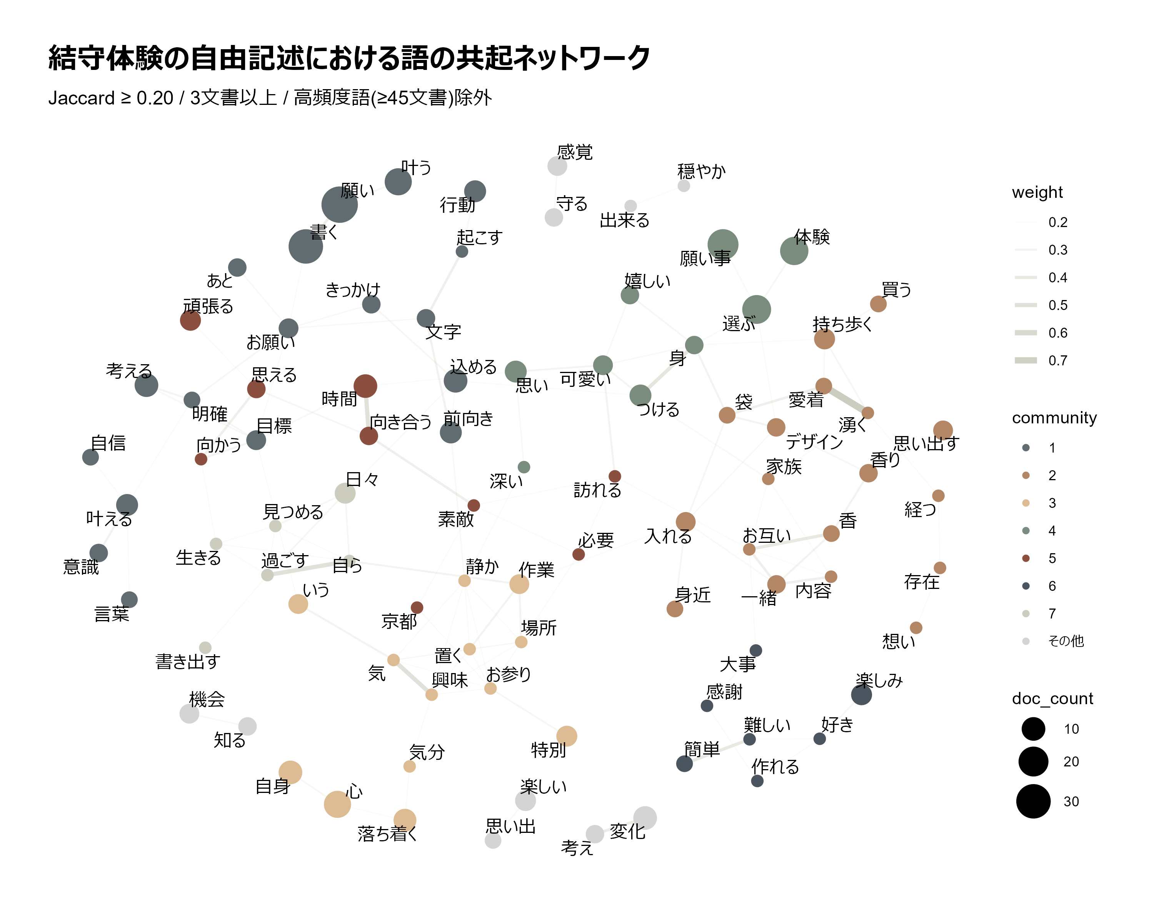
Fig. S1 Japanese-language version of the co-occurrence network shown in Fig. 1 of the main text. Node labels are the original Japanese terms. 90 nodes and 127 edges; modularity Q = 0.70. Node color indicates the Louvain community, node size indicates the number of responses in which the word appeared, and edge width indicates the Jaccard coefficient
Table S1 Words in the co-occurrence network (Study 1): Japanese–English correspondence, Louvain community, and the number of responses in which each word appeared (N = 113). Words are listed by community and, within a community, in descending order of the number of responses. Four hub words appearing in approximately 40% or more of responses (お守り amulet, 作る make, 気持ち feeling, 自分 self) were excluded before the network was constructed and are therefore not listed
Word (Japanese) | English gloss | Community | Responses (n)
願い | wish | 1 Verbalizing wishes and behavioral intentions | 35
書く | write | 1 Verbalizing wishes and behavioral intentions | 30
叶う | come true | 1 Verbalizing wishes and behavioral intentions | 15
考える | think | 1 Verbalizing wishes and behavioral intentions | 10
込める | imbue | 1 Verbalizing wishes and behavioral intentions | 10
前向き | forward-looking | 1 Verbalizing wishes and behavioral intentions | 8
叶える | fulfill | 1 Verbalizing wishes and behavioral intentions | 8
行動 | action | 1 Verbalizing wishes and behavioral intentions | 8
お願い | request | 1 Verbalizing wishes and behavioral intentions | 6
目標 | goal | 1 Verbalizing wishes and behavioral intentions | 6
あと | later | 1 Verbalizing wishes and behavioral intentions | 5
きっかけ | trigger | 1 Verbalizing wishes and behavioral intentions | 5
意識 | awareness | 1 Verbalizing wishes and behavioral intentions | 5
文字 | characters | 1 Verbalizing wishes and behavioral intentions | 5
明確 | clear | 1 Verbalizing wishes and behavioral intentions | 4
自信 | confidence | 1 Verbalizing wishes and behavioral intentions | 4
言葉 | words | 1 Verbalizing wishes and behavioral intentions | 4
起こす | take (action) | 1 Verbalizing wishes and behavioral intentions | 3
持ち歩く | carry around | 2 Attachment to the object and carrying it in daily life | 7
入れる | put in | 2 Attachment to the object and carrying it in daily life | 6
思い出す | remember | 2 Attachment to the object and carrying it in daily life | 6
デザイン | design | 2 Attachment to the object and carrying it in daily life | 5
一緒 | together | 2 Attachment to the object and carrying it in daily life | 5
香り | scent | 2 Attachment to the object and carrying it in daily life | 5
愛着 | attachment | 2 Attachment to the object and carrying it in daily life | 4
袋 | pouch | 2 Attachment to the object and carrying it in daily life | 4
買う | buy | 2 Attachment to the object and carrying it in daily life | 4
身近 | familiar | 2 Attachment to the object and carrying it in daily life | 4
香 | incense | 2 Attachment to the object and carrying it in daily life | 4
お互い | each other | 2 Attachment to the object and carrying it in daily life | 3
内容 | content | 2 Attachment to the object and carrying it in daily life | 3
存在 | existence | 2 Attachment to the object and carrying it in daily life | 3
家族 | family | 2 Attachment to the object and carrying it in daily life | 3
想い | feelings | 2 Attachment to the object and carrying it in daily life | 3
湧く | well up | 2 Attachment to the object and carrying it in daily life | 3
経つ | pass | 2 Attachment to the object and carrying it in daily life | 3
心 | heart | 3 Calmness of mind and introspection | 15
自身 | oneself | 3 Calmness of mind and introspection | 10
落ち着く | feel calm | 3 Calmness of mind and introspection | 9
特別 | special | 3 Calmness of mind and introspection | 7
いう | say | 3 Calmness of mind and introspection | 6
作業 | handwork | 3 Calmness of mind and introspection | 6
お参り | worship | 3 Calmness of mind and introspection | 3
場所 | place | 3 Calmness of mind and introspection | 3
気 | mind | 3 Calmness of mind and introspection | 3
気分 | mood | 3 Calmness of mind and introspection | 3
置く | put | 3 Calmness of mind and introspection | 3
興味 | interest | 3 Calmness of mind and introspection | 3
静か | quiet | 3 Calmness of mind and introspection | 3
願い事 | one's wish | 4 The experience of choosing and instilling a wish | 22
選ぶ | choose | 4 The experience of choosing and instilling a wish | 18
体験 | experience | 4 The experience of choosing and instilling a wish | 17
つける | put on | 4 The experience of choosing and instilling a wish | 8
思い | thoughts | 4 The experience of choosing and instilling a wish | 8
可愛い | cute | 4 The experience of choosing and instilling a wish | 6
嬉しい | happy | 4 The experience of choosing and instilling a wish | 5
身 | body | 4 The experience of choosing and instilling a wish | 5
深い | deep | 4 The experience of choosing and instilling a wish | 3
時間 | time | 5 Time to face oneself | 10
頑張る | do one's best | 5 Time to face oneself | 7
向き合う | face | 5 Time to face oneself | 5
思える | feel | 5 Time to face oneself | 5
京都 | Kyoto | 5 Time to face oneself | 3
向かう | move toward | 5 Time to face oneself | 3
必要 | necessary | 5 Time to face oneself | 3
素敵 | lovely | 5 Time to face oneself | 3
訪れる | visit | 5 Time to face oneself | 3
楽しみ | looking forward | 6 The enjoyment and satisfaction of making | 7
簡単 | easy | 6 The enjoyment and satisfaction of making | 4
作れる | can make | 6 The enjoyment and satisfaction of making | 3
大事 | important | 6 The enjoyment and satisfaction of making | 3
好き | like | 6 The enjoyment and satisfaction of making | 3
感謝 | gratitude | 6 The enjoyment and satisfaction of making | 3
難しい | difficult | 6 The enjoyment and satisfaction of making | 3
日々 | everyday | 7 An opportunity to re-examine oneself | 7
書き出す | write out | 7 An opportunity to re-examine oneself | 3
生きる | live | 7 An opportunity to re-examine oneself | 3
自ら | on one's own | 7 An opportunity to re-examine oneself | 3
見つめる | look at | 7 An opportunity to re-examine oneself | 3
過ごす | spend (time) | 7 An opportunity to re-examine oneself | 3
変化 | change | – Communities with fewer than three nodes | 10
楽しい | fun | – Communities with fewer than three nodes | 7
感覚 | sense | – Communities with fewer than three nodes | 6
機会 | opportunity | – Communities with fewer than three nodes | 6
守る | protect | – Communities with fewer than three nodes | 5
知る | know | – Communities with fewer than three nodes | 5
考え | idea | – Communities with fewer than three nodes | 5
思い出 | memory | – Communities with fewer than three nodes | 4
出来る | be able | – Communities with fewer than three nodes | 3
穏やか | calm | – Communities with fewer than three nodes | 3
Table S2 Complete tabulation of the three multiple-selection items in the post-experience survey (Study 2; N = 426). Participants could select more than one option, so percentages do not sum to 100. Items were administered in Japanese; English translations are provided for reference
Option (Japanese original) | English translation | n | %
Motivation for participating
思い出を形に残したかった | I wanted to preserve a memory in tangible form | 224 | 52.6
デザイン・色に惹かれて | I was drawn to the designs and colors | 220 | 51.6
旅行・訪問の記念に | As a memento of my trip or visit | 214 | 50.2
願いごとを形にしたかった | I wanted to give my wish a tangible form | 171 | 40.1
運勢・運気を上げたかった | I wanted to improve my luck or fortune | 137 | 32.2
気持ちを落ち着けたかった | I wanted to calm my mind | 55 | 12.9
人にすすめられて | It was recommended to me | 52 | 12.2
自分と向き合う時間がほしかった | I wanted time to face myself | 44 | 10.3
紐の結び方をやってみたかった | I wanted to try tying the cord | 31 | 7.3
Content of the wish
健康 | Health | 204 | 47.9
家族 | Family | 118 | 27.7
恋愛・結婚 | Romance and marriage | 117 | 27.5
自分の成長・目標 | Personal growth and goals | 117 | 27.5
心の安定 | Peace of mind | 117 | 27.5
仕事・学業 | Work or studies | 89 | 20.9
人間関係 | Interpersonal relationships | 75 | 17.6
金運 | Financial fortune | 52 | 12.2
Perceived advantages of making (vs. receiving)
自分でデザイン・色を選べた | I could choose the design and colors myself | 313 | 73.5
願いを込めながら作れた | I could make it while putting my wish into it | 299 | 70.2
思い出として残る | It remains as a memory | 269 | 63.1
世界に一つだけのものになる | It becomes the only one of its kind in the world | 215 | 50.5
作る過程に集中できた | I could concentrate on the making process | 124 | 29.1

