Supplementary Information
BiOBr/MoWO₄ p-n heterojunction photoanode for photodegradation of norfloxacin in water
Foluke O.G Olorundare¹, Omotayo A. Arotiba^{1, 2*}, Duduzile Nkosi^{1,2*}

¹Department of Chemical Sciences, University of Johannesburg, South Africa
²Centre for Nanomaterials Science Research, University of Johannesburg, South Africa
*Corresponding author: dnkosi@uj.ac.za
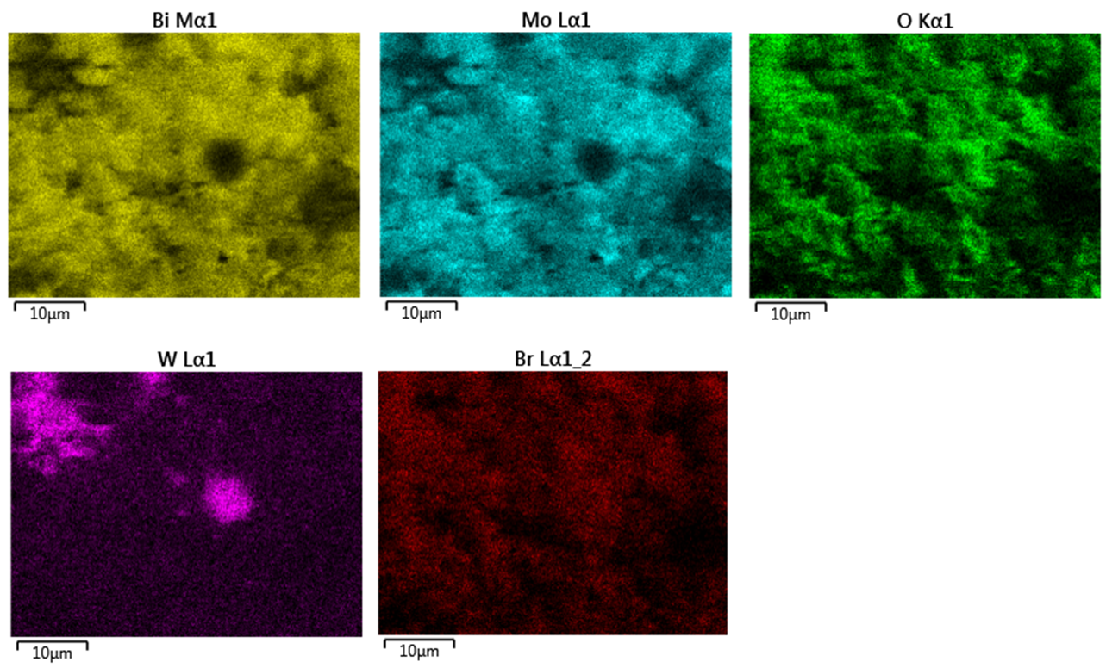
Figure S1. Elemental mapping of BiOBr/MoWO₄

BiOBr, MoWO_{4,} and BiOBr/MoWO₄ heterojunction BET analysis/studies reveal the surface area enrichment stemming from the successful complete development of the BiOBr/MoWO₄ photocatalyst heterojunction. The surface area of 25.31 m² g⁻¹ was obtained for BiOBr/MoWO₄, hence solidifying the surface area enrichment displayed by the heterojunction in comparison to 24.38 m² g⁻¹ and 22.78 m² g⁻¹ obtained for the pristine BiOBr and MoWO₄.
Thus, the surface enrichment highlights the successful formation of the BiOBr/MoWO₄ heterojunction photocatalyst, imparting tremendous benefit to the photocatalytic process. However, the isotherms result from the N₂ gas adsorption-desorption behaviour of BiOBr, MoWO_{4,} and BiOBr/MoWO₄ in Fig. S2 exhibited a type IV pattern for all the photocatalysts. The hysteresis of the adsorption-desorption experimental data noted between p/p_{o} of 0.5-1.0 is typically of mesoporous materials by IUPAC classification.

Figure S2: BET analysis/studies of BiOBr, MoWO_{4,} and BiOBr/MoWO₄

