Distribution of micro- (Fe, Zn, Cu, and Mn) and risk (Al, As, Cr, Ni, Pb, and Cd) elements in the organs of Rumex alpinus L. in the Alps and Krkonoše Mountains

^{ac}* Michaela Jungová, ^{a b} Michael O. Asare, ª Vladimíra Jurasová, ª Michal Hejcman

ª Department of Ecology, Faculty of Environmental Sciences, Czech University of Life Sciences, Prague, Kamýcká 129, Prague 6 – Suchdol CZ165 00, Czech Republic.
^{b} Department of Agroenvironmental Chemistry and Plant Nutrition, Czech University of Life Sciences, Kamýcká 129, CZ-165 21 Prague 6, Czech Republic.
^{c}Crop Research Institute, Drnovská 507/73, 161 06 Prague 6 – Ruzyně, Czech Republic

*Correspond author email: jungovam@fzp.czu.cz (Jungová M.)

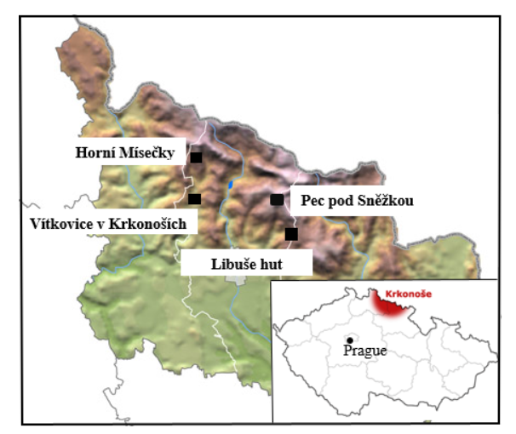

Figure S1. In more detail specific locations of study sites in the Krkonoše (Giant) Mountains; Czech Republic: Horní Mísečky (HM), Vítkovice v Krkonoších (VT), Libuše hut (LB), and Pec pod Sněžkou (PC) where autumn samples were colected.

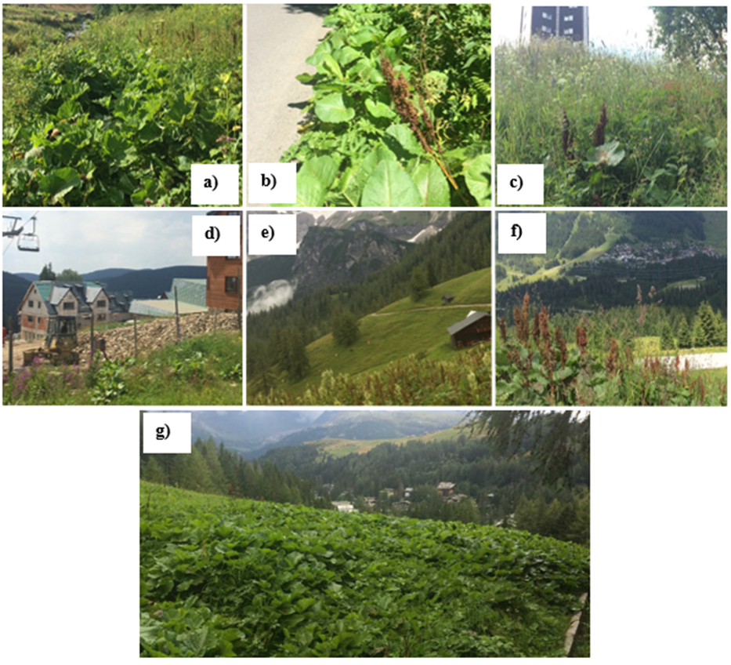
Figure S2. Rumex alpinus stands in (a) Libuše hut, (b) Vítkovice v Krkonoších, (c) Pec pod Sněžkou, (d) Horní Mísečky, (e) Ramsau am Dachstein (DCH), (f) Zillertal (ZL), and (g) Madesimo (MD).

Table S1. The relationship between the content of total and plant-available elements in soil
Total in and Plant available in the soil
Elements | Regression equation | Correlation coefficient (r) | p-value
Fe | y = -28.7837 + 0.0216*x | r = 0.60 | p = 0.21
Zn | y = -10.7392 + 0.2817*x | r = 0.75 | p = 0.09
Cu | y = -0.7257 + 0.2657*x | r = 0.58 | p = 0.22
Mn | y = 17.6659 + 0.1787*x | r = 0.58 | p = 0.23
Al | y = 509.4013 + 0.0373*x | r = 0.49 | p = 0.32
As | y = 0.4386 + 0.0214*x | r = 0.44 | p = 0.39
Cr | y = 0.3272 - 0.0041*x | r = -0.72 | p = 0.11
Ni | y = 0.4131 + 0.0308*x | r = 0.42 | p = 0.40
Pb | y = 9.265 + 0.0167*x | r = 0.04 | p = 0.94
Cd | y = -0.0122 + 0.2758*x | r = 0.76 | p = 0.08

