Supplementary Material
2. Materials and Methods
2.1 Inoculum, food waste and nano iron-modified biochar

Table 1 Characteristics of food waste and sludge
Name | TS（％） | VS（％） | Moisture content(％)
Food Waste | 95.75 | 86.36 | 4.25
Sludge | 7.65 | 36.73 | 92.25
Note: The VS (Volatile Solids) and TS (Total Solids) of food waste were determined after oven-drying pretreatment.

2.3 Batch anaerobic digestion experiment design
Batch anaerobic digestion experiments were conducted in 800 mL working-volume feeding bottles under a 37±1℃ water bath, consisting of a sludge-feeding bottle, a gas-collecting bottle, and a water-displacement bottle. Methane was collected via the water displacement method, where the gas production volume was determined by the displaced water volume. The methane content in the gas-collecting bottle was periodically measured using a portable biogas analyzer (PNT400-CH₄/O₂/CO₂/H₂S). The cumulative methane yield was calculated as the product of the displaced water volume and the measured methane concentration.
Each bottle was loaded with 400 mL of sludge, and five organic loading were tested sequentially by controlling food waste (FW) dosage at 4, 8, 16, 32, and 48 g VS/L. Always connect a DC power supply externally to provide a voltage of 0.5V. The loading process ended when the methane content was lower than 1%, indicating that the substrate had been completely consumed. Then, the corresponding amount of substrate was added to each bottle to start the next loading stage. Experiments proceeded chronologically, with each loading phase terminated when methane content dropped below 1%, lasting 7-11 days depending on the load.Under the same load, both the control group and the experimental group had 3 feeding bottles set up.
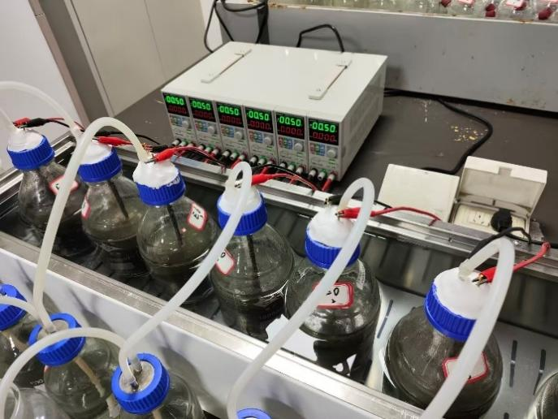
Figure 1 The experimental setup

2.4 Data analysis
The modified Gompertz equation is as follows:
P_{(t)} is cumulative methane yield at time t (mL/g VS); P_{max} is methane production potential (mL/g VS); R_{max} is maximum methane production rate (mL/g VS); λ is methanogenic lag phase (d); e is Euler’s number (2.71828); t is digestion time (d).

2.5 Microorganisms analysis
Experimental procedures of Metagenomic sequencing
1.Sample testing.
DNA was extracted from samples using CTAB method. DNA degradation degree, potential contamination and DNA concentration was measured using Agilent 5400.
2.Library construction.
Sequencing library was generated using NEBNext® UltraTM DNA Library Prep Kit for Illumina(NEB, USA, Catalog#:E7370L) following manufacturer's recommendations and index codes were added to each sample. Briefly, genomic DNA sample was fragmented by sonication to a size of 350 bp. Then DNA fragments were endpolished, A-tailed, and ligated with the full-length adapter for Illumina sequencing, followed by further PCR amplification. After PCR products were purified by AMPure XP system (Beverly, USA). Subsequently, library quality was assessed on the Agilent 5400 system(Agilent, USA）and quantified by QPCR (1.5 nM).
3.Sequencing.
The qualified libraries were pooled and sequenced on Illumina platforms with PE150 strategy, according to effective library concentration and data amount required.
4.Bioinformatics analysis.
4.1 Data quality control and de-host sequences.
The Raw Data of bacteria, fungi and viruses in samples were obtained by metagenomic sequencing using Illumina Novaseq high-throughput sequencing platform. In order to ensure the reliability of data, the Raw sequencing data needs to be preprocessed using Kneaddata software. The specific processing steps are as follows:
(1)Remove the sequencing adapters ( parameter: ILLUMINACLIP :adapters_path:2:30:10) and reads which contain low quality bases(default quality threshold value ≤ 20. parameter:SLIDINGWINDOW:4:20) , and remove sequences with final length less than 50bp (parameter: MINLEN:50)based on Trimmomatic.
(2)Considering the possibility of host pollution may exist in samples, Clean Data need to be blast to the host database which default using Bowtie2 software (Bowtie2, http://bowtie-bio.sourceforge.net/bowtie2/index.shtml. parameters:-very-sensitive) to filter the reads that are of host origin for subsequent analysis.
(3)Finally, FastQC is used to detect the rationality and effect of quality control.
4.2 Taxonomy annotation.
DIAMOND software was used to blast non-redundant proteins to the NCBI NR protein database(parameters: -evalue 1e-5 --max-target-seqs 50 -id 70). BASTA software was used to analyze the result and obtain non-redundant protein species annotation information (parameters: --alen 100 --identity 80 --evalue 0.00001 --minimum 3 -- best_hit 1 --maj_perc 60). Kraken2 and the self-build microbial database (Sequences belonging to bacteria, fungi, archaea and viruses were screened from NT nucleic acid database and RefSeq whole genome database of NCBI) were used to identify the species contained in the samples, and then Bracken was used topredict the actual relative abundance of species in the samples.
4.3 Common functional database annotations based on reads.
MEGAHIT software was used to assemble clean reads after de-host gene and obtain contigs. Prodigal software was used to predict gene sequences in contigs ( parameters: -p meta (metagenomic pattern)). Cd-hit software was used to obtain the de-redundant gene (de-redundant parameters: -G 1 (using the global sequence identity threshold) -c 0.95) . Salmon softwar was used to quantify of de-redundant genes (parameters: --validateMappings (increase sensitivity and specificity) --meta (metagenomic mode)).Transeq command of emboss software was used to translate the de-redundant gene into protein sequences for subsequent blast and annotation.
1) The de-redundant protein sequence (corresponding to the de-redundant gene nucleic acid sequence) was blast to the EggNOG database to obtain the KEGG, GO, and COG annotation information of the protein (parameters: --seed_ortholog_evalue 0.00001) by Eggnog-mapper software (based on DIAMOND). The de-redundant protein sequence.
2) The de-redundant protein sequences are blast to the CAZy database to obtain the annotation information of CAZy by DIAMOND software（ parameters: -e 0.00001 (evalue threshold) --id 80 (identity threshold) --top 3 (bit score is not less than 3% of the maximum score)）.
3) According to the abundance table of the de-redundant gene and the annotation information of each database, the de-redundant gene abundance (TPM) annotated to the same gene family in the database is summed for each database, , and the failed de-redundant genes are screened out to obtain the relative abundance table of each database gene family.
3. Results and discussion
3.1.2 XRD and FT-IR
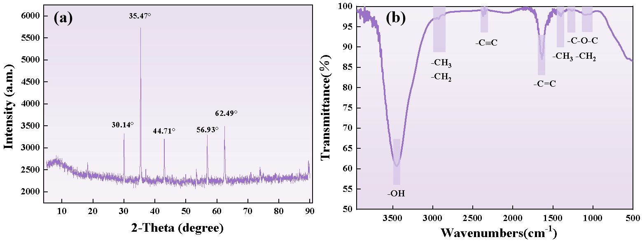
Figure 2 XRD (a) and FTIR (b) of the iron-modified biochar
3.2.3 Stability of the anaerobic system
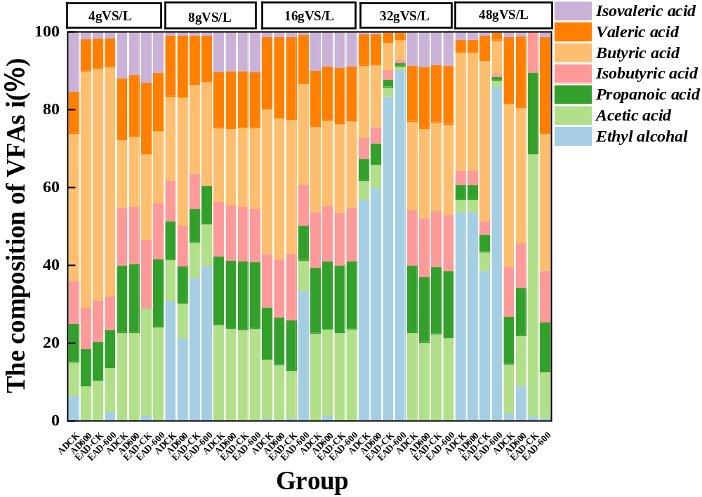
Figure 3 Changes of fermentation components
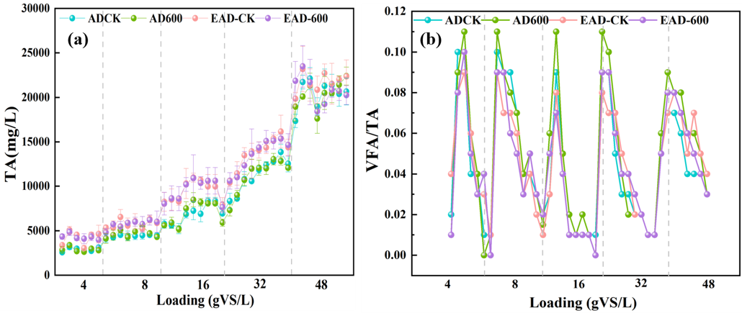
Figure 4 Changes of (a) TA; (b) VFAs/TA
3.3 Effects of nano iron modified biochar on microbial communities in AD system
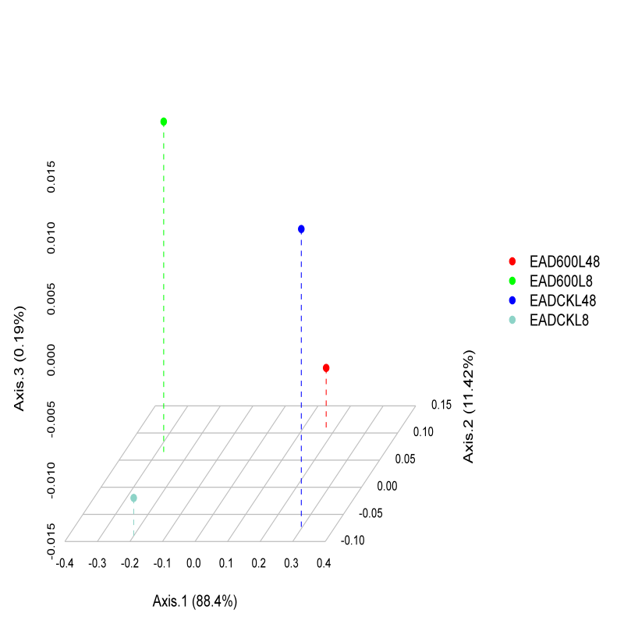
Figure 5 PCoA
Principal component analysis (PCA) was performed on microbial communities using metagenomic datasets. Axis 1, Axis 2 and Axis 3 accounted for 88.4%, 11.42% and 0.19% of the total community variation, respectively. Samples operated at 8 g VS/L and 48 g VS/L organic loading rate (OLR) with identical treatment exhibited clear separation along the first principal component, demonstrating that OLR serves as a critical driver for microbial community succession in anaerobic digestion. Marked spatial differentiation existed between composite material-supplemented groups and blank controls at both 8 g VS/L and 48 g VS/L, which verified that composite material addition substantially reshapes the microbial community structure of food waste anaerobic digestion systems.

3.4.2 methanogenesis process
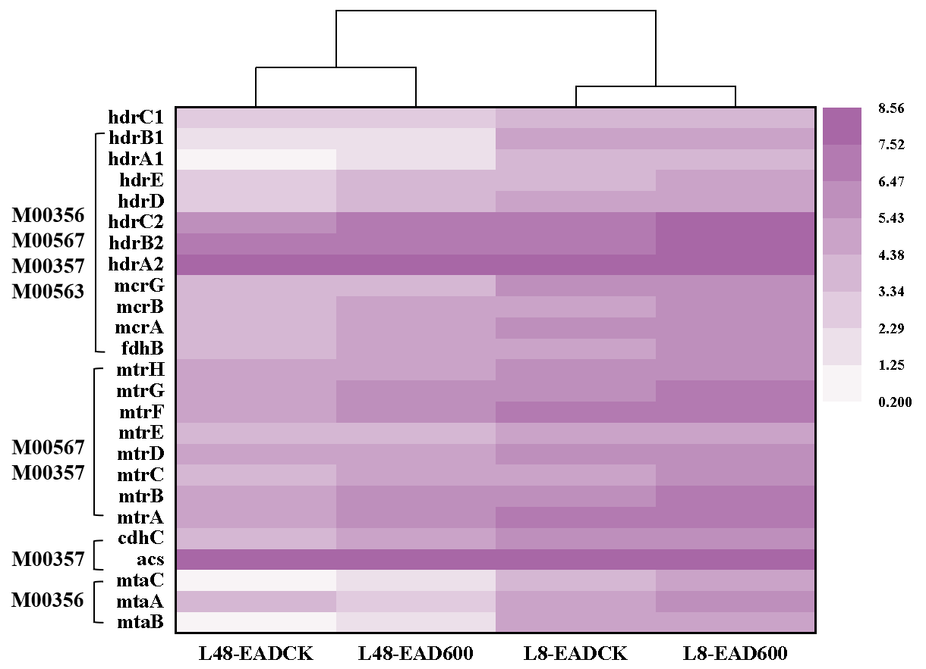
Figure 6 The abundance of key genes in the methanogenesis pathway
3.5 Effects of nano iron modified biochar on the ΔG of VFAs degradation
The ΔG for methane production from propionate, butyrate, and valerate is calculated as follows:
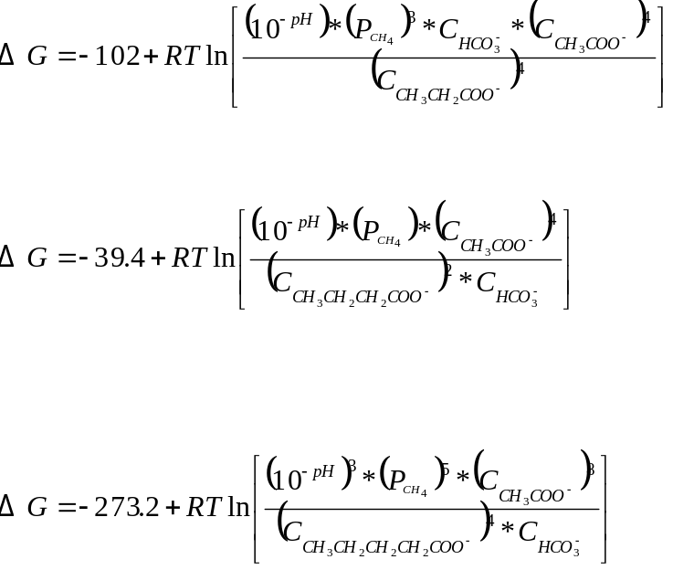
R is the universal gas constant with a value of 8.314 J/(mol·K); T is the thermodynamic temperature of anaerobic digestion, where 37°C = 310.15K; [HCO₃⁻] is calculated using 0.01×PA/molar mass of CaCO₃; [CH₃CH₂CH₂CH₂COO⁻], [CH₃CH₂CH₂COO⁻], [CH₃CH₂COO⁻], and [CH₃COO⁻] represent the concentrations of valerate, butyrate, propionate, and acetate, respectively; P denotes the partial pressure of methane in the reaction system, calculated as methane content × atmospheric pressure.

