Appendix A
Table A. Stimulus descriptions used in the Culinary Violation Task
Food culture | Norm status | Stimulus description
Chinese | Appropriate | Congee with pickled vegetables
Chinese | Appropriate | Egg jianbing
Chinese | Appropriate | Hainanese chicken rice
Chinese | Appropriate | Dim sum with green tea
Chinese | Appropriate | Beef noodle soup
Chinese | Appropriate | Baozi with tea eggs for breakfast
Chinese | Appropriate | Tang shui
Chinese | Appropriate | Stir-fried noodles with pork
Chinese | Appropriate | Soy milk with youtiao
Chinese | Appropriate | Pork dumplings with black vinegar
Chinese | Violation | Hotpot for breakfast
Chinese | Violation | Chestnut biltong smoothie
Chinese | Violation | Raw marinated crab
Chinese | Violation | Mung bean soup with cheese
Chinese | Violation | Marmalade on rice
Chinese | Violation | Cantonese roast duck with coffee
Chinese | Violation | Cheung fun with corn and ham
Chinese | Violation | Ketchup on stir-fried pak choi
Chinese | Violation | Chilli mooncake
Chinese | Violation | Peanut butter on congee
Italian | Appropriate | Cheese and honey
Italian | Appropriate | Cheese and pear
Italian | Appropriate | Chicken with lemon
Italian | Appropriate | Fried steak and potatoes
Italian | Appropriate | Parma ham and melon
Italian | Appropriate | Meat-stuffed peppers
Italian | Appropriate | Polenta with sausage
Italian | Appropriate | Sea urchins
Italian | Appropriate | Spicy chocolate
Italian | Appropriate | Croissant and coffee breakfast
Italian | Violation | Seafood pasta with cappuccino
Italian | Violation | Melted cheese with tea
Italian | Violation | Coffee with cheese
Italian | Violation | Pancakes with beans
Italian | Violation | Grated Parmesan cheese on fish
Italian | Violation | Pasta with ketchup
Italian | Violation | Pizza with pineapple
Italian | Violation | Risotto with strawberries
Italian | Violation | Steak with chocolate glaze
Italian | Violation | Grated Parmesan on seafood pasta

Fig. 2 Examples of AI-generated food-pairing stimuli used in the Culinary Violation Task. Images were generated using Google Gemini and reviewed by members of the relevant cultural team.

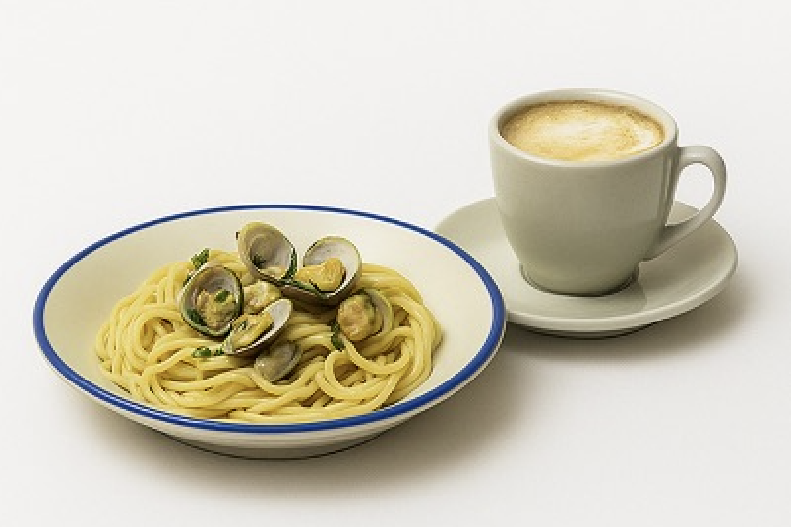 | 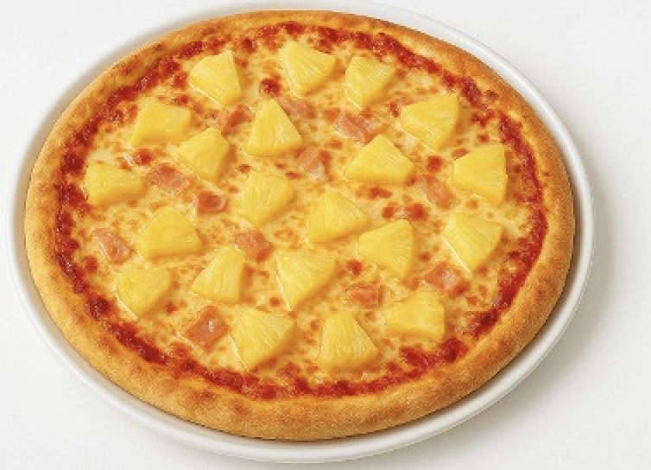
Pasta with cappuccino (Italian violation) | Pineapple on pizza (Italian violation)
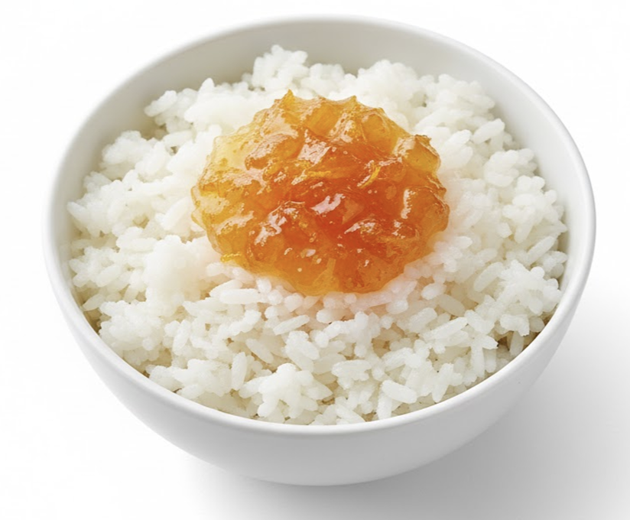 | 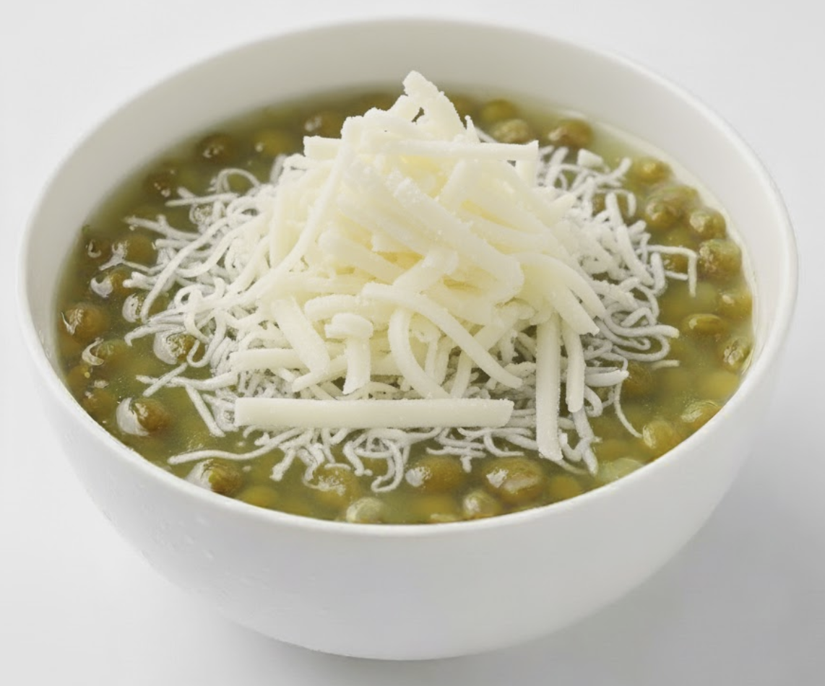
Marmalade on rice (Chinese violation) | Mung bean soup with cheese (Chinese violation)

Appendix B
Table B. Full task descriptives by participant culture, food culture, and norm status
Participant culture | Food culture | Norm status | N | Disgust M | Disgust SD | Appropriate M | Appropriate SD
Chinese | Chinese | Appropriate | 154 | 1.27 | 0.54 | 0.97 | 0.11
Chinese | Chinese | Violation | 154 | 2.58 | 0.75 | 0.46 | 0.22
Chinese | Italian | Appropriate | 154 | 1.84 | 0.62 | 0.79 | 0.18
Chinese | Italian | Violation | 154 | 2.09 | 0.70 | 0.69 | 0.19
Italian | Chinese | Appropriate | 276 | 2.35 | 0.66 | 0.83 | 0.20
Italian | Chinese | Violation | 276 | 3.16 | 0.58 | 0.55 | 0.27
Italian | Italian | Appropriate | 276 | 1.74 | 0.49 | 0.94 | 0.11
Italian | Italian | Violation | 276 | 3.49 | 0.63 | 0.38 | 0.30

Note. Disgust ratings ranged from 1 to 5, with higher scores indicating stronger disgust. Appropriateness values represent the proportion of items judged appropriate.

Appendix C
Table C. Item-level appropriateness judgements and correspondence with intended stimulus classifications within the relevant cultural community
Food culture | Intended status | Stimulus description | N | Judged appropriate (%) | Classification consistency (%) | Disgust M | Disgust SD
Chinese | Appropriate | Congee with pickled vegetables | 154 | 96.8 | 96.8 | 1.35 | 0.76
Chinese | Appropriate | Hainanese chicken rice | 154 | 97.4 | 97.4 | 1.23 | 0.72
Chinese | Appropriate | Dim sum with green tea | 154 | 98.1 | 98.1 | 1.25 | 0.68
Chinese | Appropriate | Beef noodle soup | 154 | 95.5 | 95.5 | 1.18 | 0.61
Chinese | Appropriate | Baozi with tea eggs for breakfast | 154 | 96.8 | 96.8 | 1.23 | 0.62
Chinese | Appropriate | Tang shui | 154 | 98.1 | 98.1 | 1.24 | 0.69
Chinese | Appropriate | Stir-fried noodles with pork | 154 | 98.7 | 98.7 | 1.25 | 0.68
Chinese | Appropriate | Soy milk with youtiao | 154 | 98.1 | 98.1 | 1.29 | 0.75
Chinese | Appropriate | Pork dumplings with black vinegar | 154 | 90.3 | 90.3 | 1.42 | 0.81
Chinese | Appropriate | Egg jianbing | 154 | 98.7 | 98.7 | 1.23 | 0.65
Chinese | Violation | Hotpot for breakfast | 154 | 39.0 | 61.0 | 2.17 | 1.22
Chinese | Violation | Raw marinated crab | 154 | 79.9 | 20.1 | 2.25 | 1.43
Chinese | Violation | Mung bean soup with cheese | 154 | 38.3 | 61.7 | 2.80 | 1.19
Chinese | Violation | Marmalade on rice | 154 | 29.9 | 70.1 | 2.95 | 1.34
Chinese | Violation | Cantonese roast duck with coffee | 154 | 62.3 | 37.7 | 2.03 | 1.10
Chinese | Violation | Cheung fun with corn and ham | 154 | 80.5 | 19.5 | 1.82 | 1.15
Chinese | Violation | Ketchup on stir-fried pak choi | 154 | 22.1 | 77.9 | 3.10 | 1.28
Chinese | Violation | Chilli mooncake | 154 | 17.5 | 82.5 | 3.56 | 1.24
Chinese | Violation | Peanut butter on congee | 154 | 29.9 | 70.1 | 2.93 | 1.27
Chinese | Violation | Chestnut biltong smoothie | 154 | 59.1 | 40.9 | 2.23 | 1.30
Italian | Appropriate | Cheese and honey | 276 | 96.4 | 96.4 | 1.50 | 0.90
Italian | Appropriate | Cheese and pear | 276 | 92.0 | 92.0 | 1.93 | 1.10
Italian | Appropriate | Chicken with lemon | 276 | 98.2 | 98.2 | 1.55 | 0.84
Italian | Appropriate | Fried steak and potatoes | 276 | 98.2 | 98.2 | 1.28 | 0.67
Italian | Appropriate | Parma ham and melon | 276 | 95.3 | 95.3 | 1.77 | 1.04
Italian | Appropriate | Meat-stuffed peppers | 276 | 97.5 | 97.5 | 1.72 | 0.99
Italian | Appropriate | Polenta with sausage | 276 | 96.0 | 96.0 | 1.57 | 0.92
Italian | Appropriate | Sea urchins | 276 | 80.8 | 80.8 | 2.66 | 1.18
Italian | Appropriate | Spicy chocolate | 276 | 90.6 | 90.6 | 2.16 | 1.09
Italian | Appropriate | Croissant and coffee breakfast | 276 | 99.6 | 99.6 | 1.26 | 0.54
Italian | Violation | Seafood pasta with cappuccino | 276 | 18.1 | 81.9 | 3.92 | 0.96
Italian | Violation | Melted cheese with tea | 276 | 36.2 | 63.8 | 3.38 | 1.04
Italian | Violation | Coffee with cheese | 276 | 28.3 | 71.7 | 3.74 | 0.91
Italian | Violation | Pancakes with beans | 276 | 52.9 | 47.1 | 3.28 | 1.23
Italian | Violation | Grated Parmesan cheese on fish | 276 | 38.0 | 62.0 | 3.29 | 0.88
Italian | Violation | Pasta with ketchup | 276 | 22.5 | 77.5 | 4.00 | 0.88
Italian | Violation | Pizza with pineapple | 276 | 39.5 | 60.5 | 3.67 | 1.04
Italian | Violation | Risotto with strawberries | 276 | 69.2 | 30.8 | 2.80 | 1.13
Italian | Violation | Steak with chocolate glaze | 276 | 39.1 | 60.9 | 3.43 | 1.15
Italian | Violation | Grated Parmesan on seafood pasta | 276 | 33.7 | 66.3 | 3.40 | 1

Note. Chinese stimulus results are based on Chinese participants’ judgements (N = 154), and Italian stimulus results are based on Italian participants’ judgements (N = 276). “Judged appropriate” indicates the percentage of participants who classified the item as appropriate. “Classification consistency” indicates the percentage whose response corresponded to the research team’s intended classification: an appropriate response for intended appropriate items and an inappropriate response for intended violation items. Krippendorff’s α was .432 for Chinese participants evaluating Chinese items and .406 for Italian participants evaluating Italian items.

