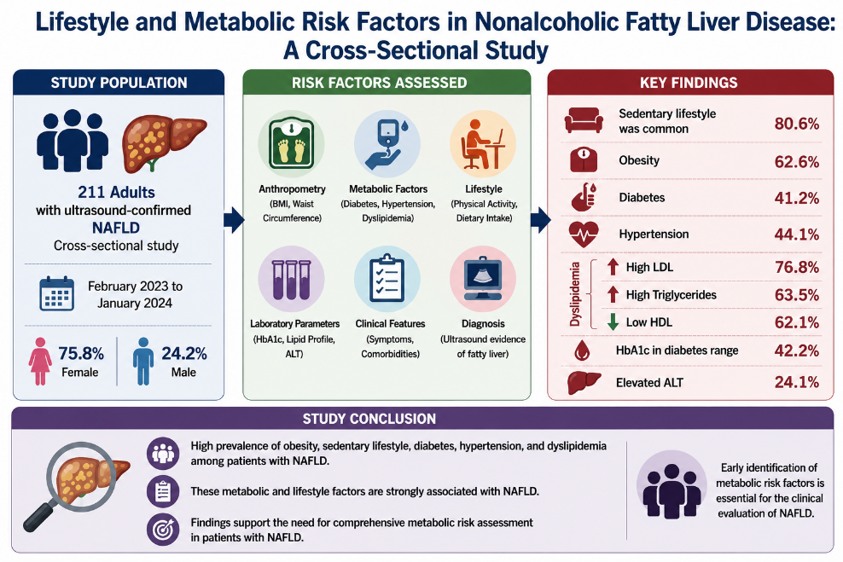
Graphical Abstract: Lifestyle and Metabolic Risk Factors in Nonalcoholic Fatty Liver Disease

