Supplemental Information

Molecular basis of membrane – cation – DNA interactions

Matej Kožić¹, Marta Vukić¹, Katarina Šestić¹, Ivan Barišić ^{2,3,4}, Branimir Bertoša¹, *

¹University of Zagreb, Faculty of Science, Department of Chemistry, Zagreb, Croatia
² Eko Refugium, Crno Vrelo 2, Slunj, 47240, Croatia
³ Department of Health and Molecular Diagnostics, Austrian Institute of Technology, Giefinggasse 4, Vienna, 1210, Austria
⁴ Institute of Chemical, Environmental and Bioscience Engineering, TU Wien, Gumpendorfer Str. 1a, 1060 Vienna, Austria

* Correspondence: bbertosa@chem.pmf.hr; Tel.: +385 1 4606 132

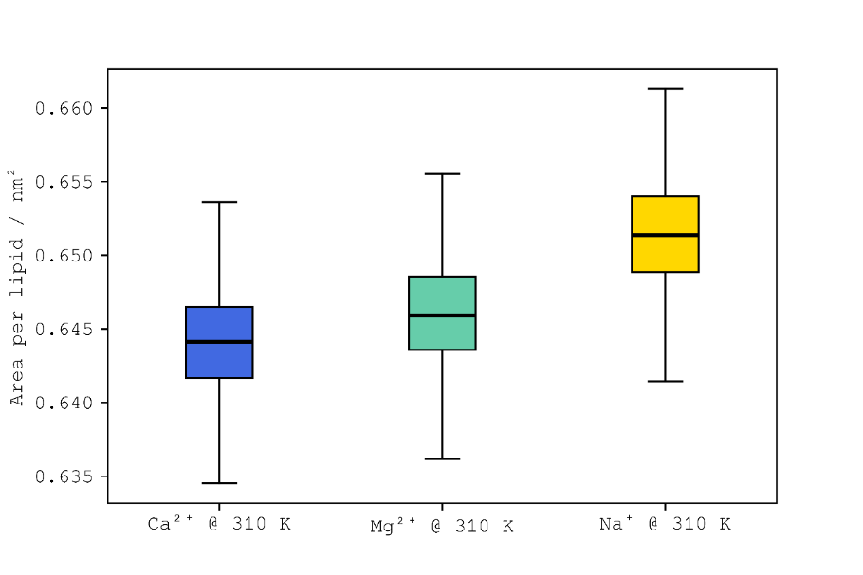
Figure S1. Box plots of areas per lipid for simulations with calcium (blue), magnesium (teal) and sodium (yellow) cations at 310 K.
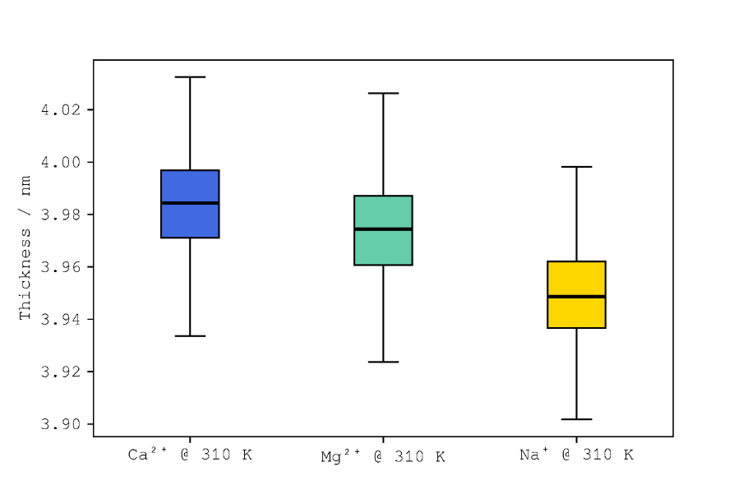
Figure S2. Box plots of membrane thicknesses for simulations with calcium (blue), magnesium (teal) and sodium (yellow) cations at 310 K.
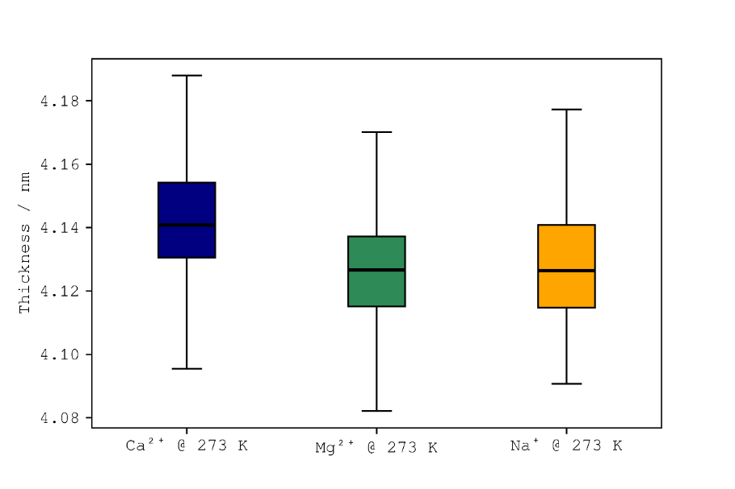
Figure S3. Box plots of thicknesses for simulations with calcium (blue), magnesium (green) and sodium (orange) cations at 237 K.
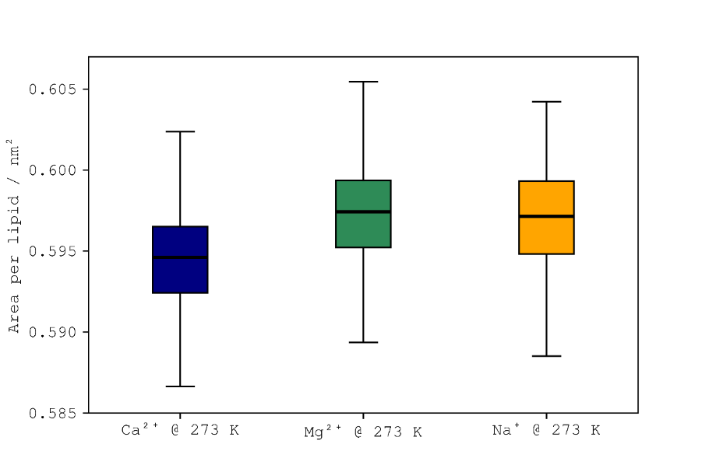
Figure S4. Box plots of areas per lipid for simulations with calcium (blue), magnesium (green) and sodium (orange) cations at 237 K.

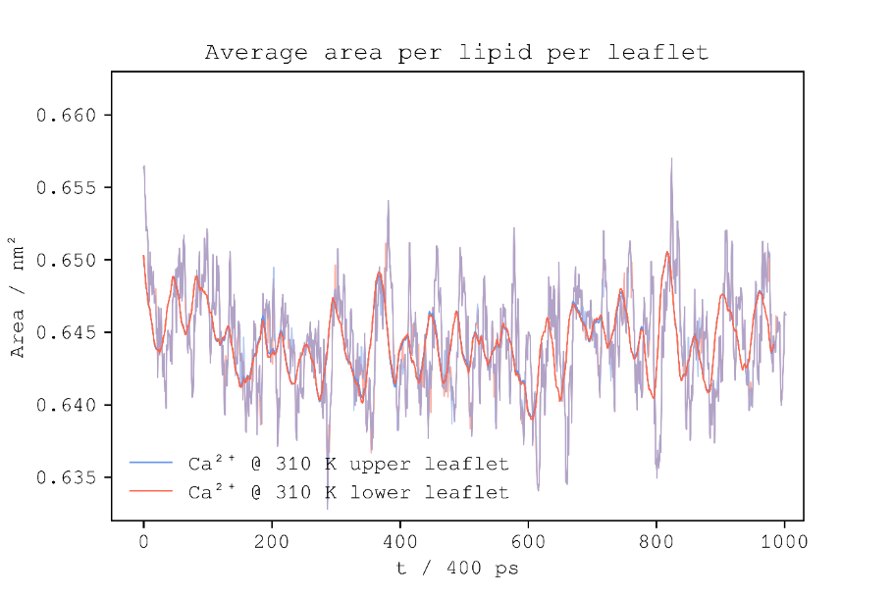
Figure S5. Graph of average area per lipid for each leaflet of ion-only simulation of calcium cation at 310 K.

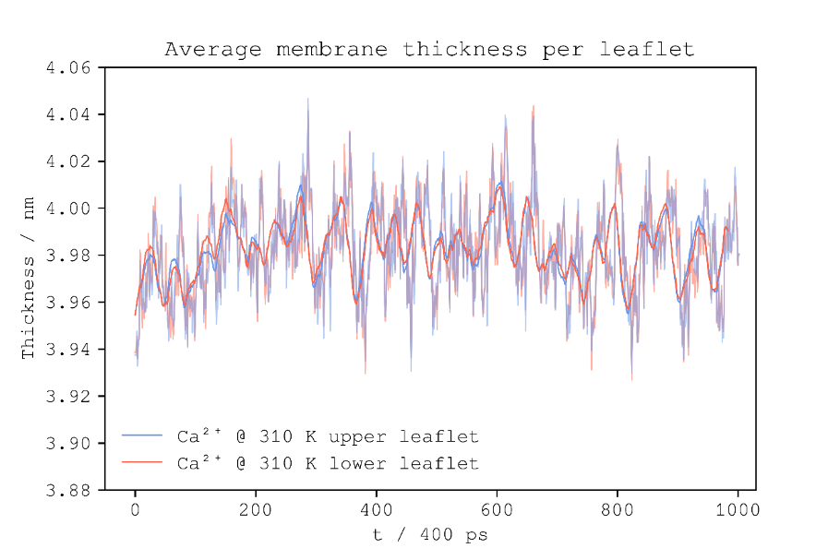
Figure S6. Graph of average thickness for each leaflet of ion-only simulation of calcium cation at 310 K.

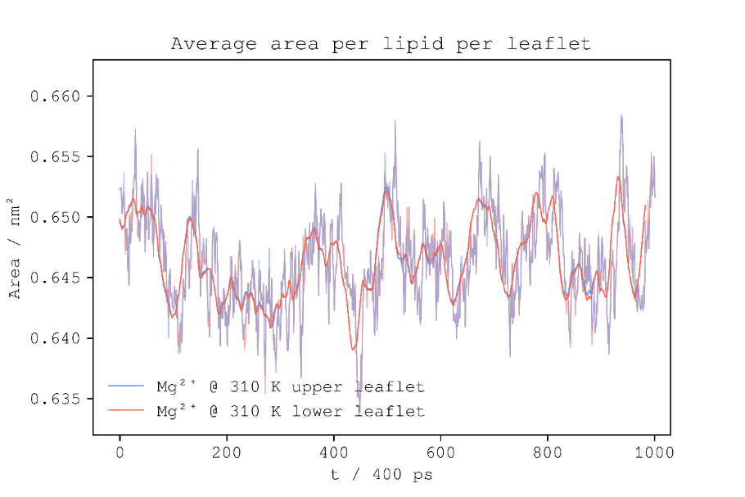
Figure S7. Graph of average area per lipid for each leaflet of ion-only simulation of magnesium cation at 310 K.

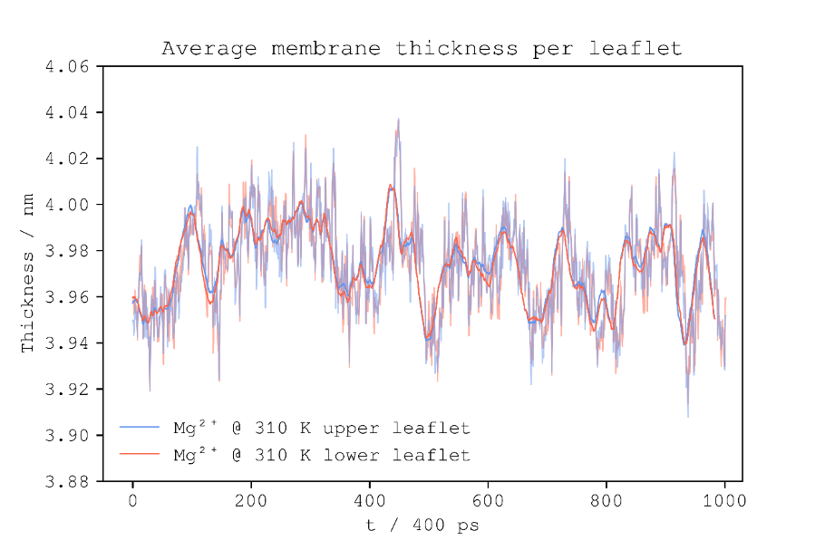
Figure S8. Graph of average thickness for each leaflet of ion-only simulation of magnesium cation at 310 K.

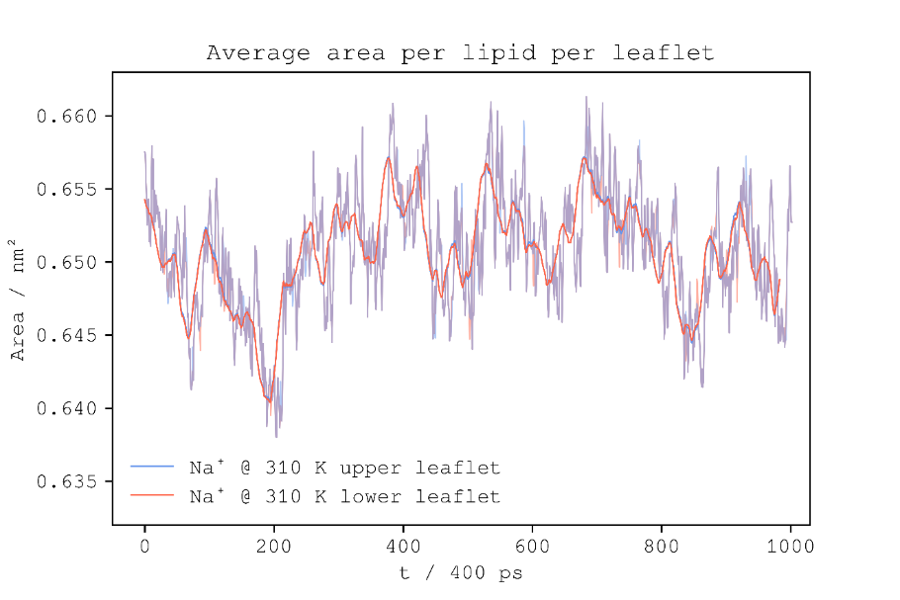
Figure S8. Graph of average area per lipid for each leaflet of ion-only simulation of sodium cation at 310 K.

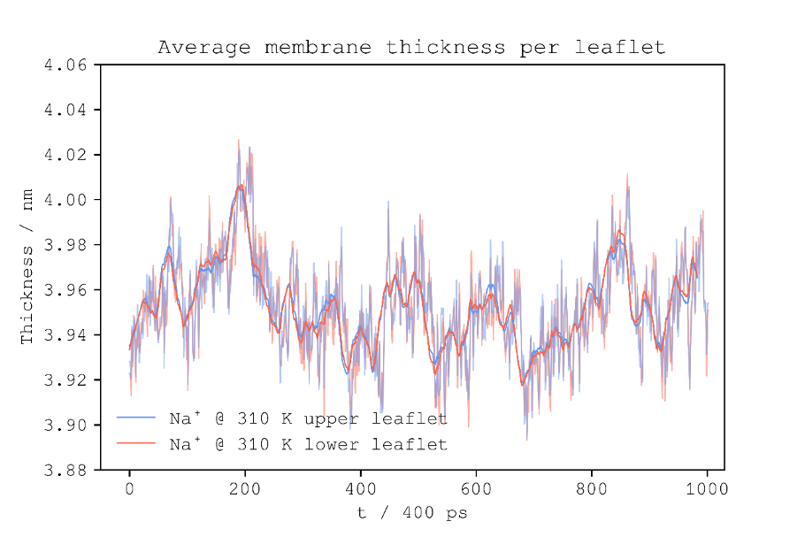
Figure S9. Graph of average thickness for each leaflet of ion-only simulation of sodium cation at 310 K.

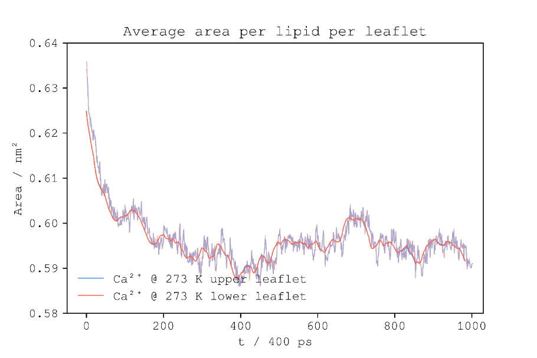
Figure S10. Graph of average area per lipid for each leaflet of ion-only simulation of calcium cation at 273 K.

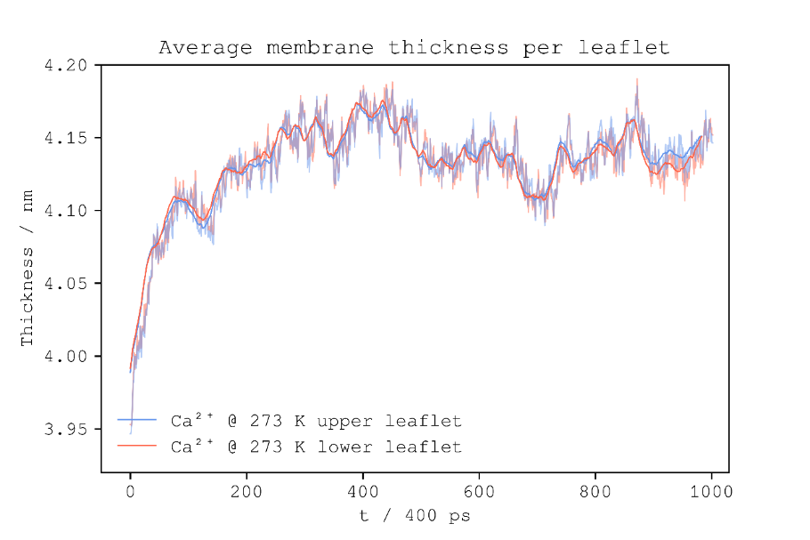
Figure S11. Graph of average thickness for each leaflet of ion-only simulation of calcium cation at 273 K.

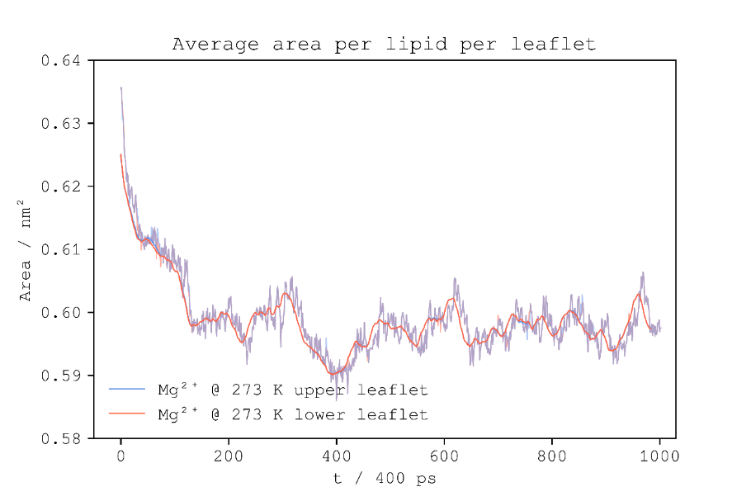
Figure S11. Graph of average area per lipid for each leaflet of ion-only simulation of magnesium cation at 273 K.

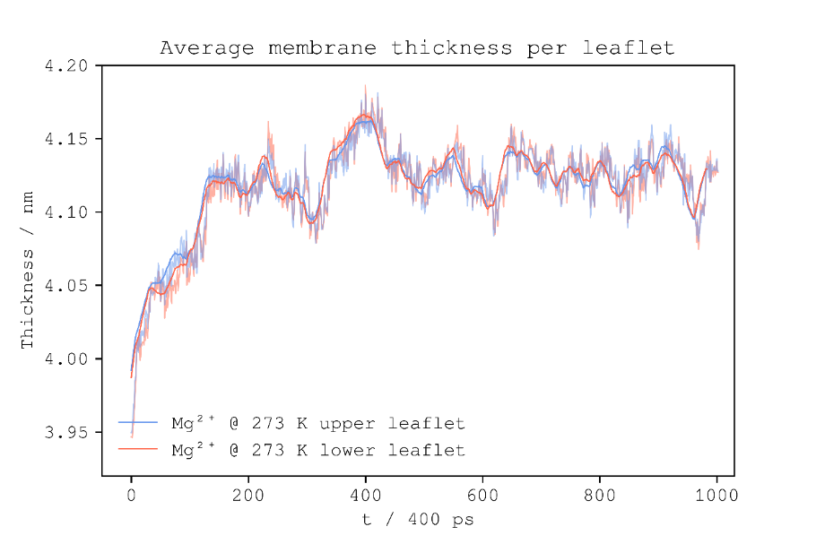
Figure S12. Graph of average thickness for each leaflet of ion-only simulation of magnesium cation at 273 K.

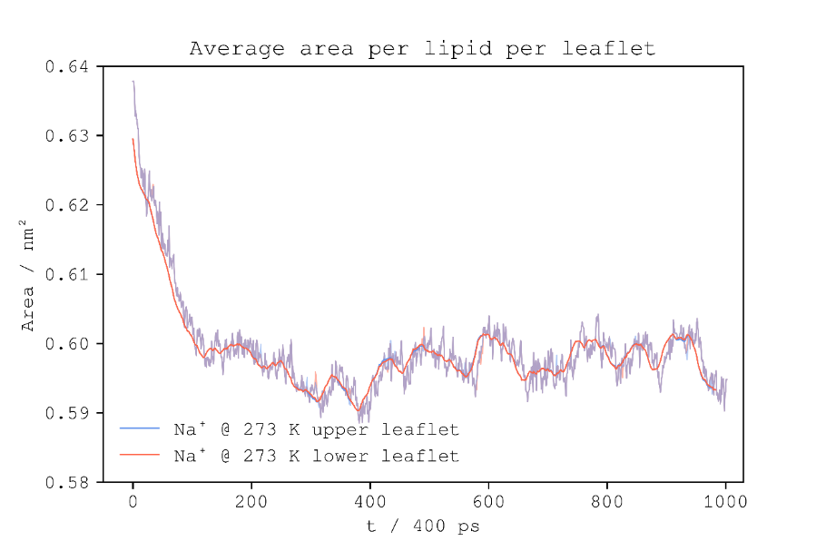
Figure S13. Graph of average area per lipid for each leaflet of ion-only simulation of sodium cation at 273 K.

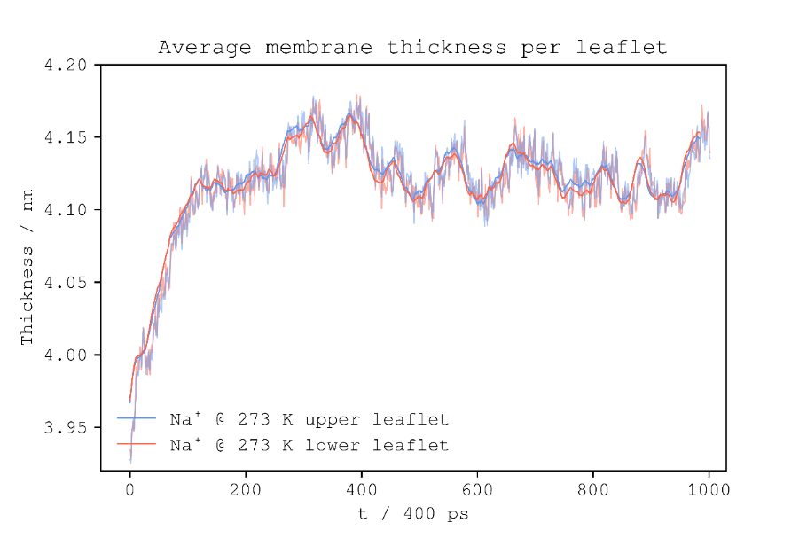
Figure S14. Graph of average thickness for each leaflet of ion-only simulation of sodium cation at 273 K.

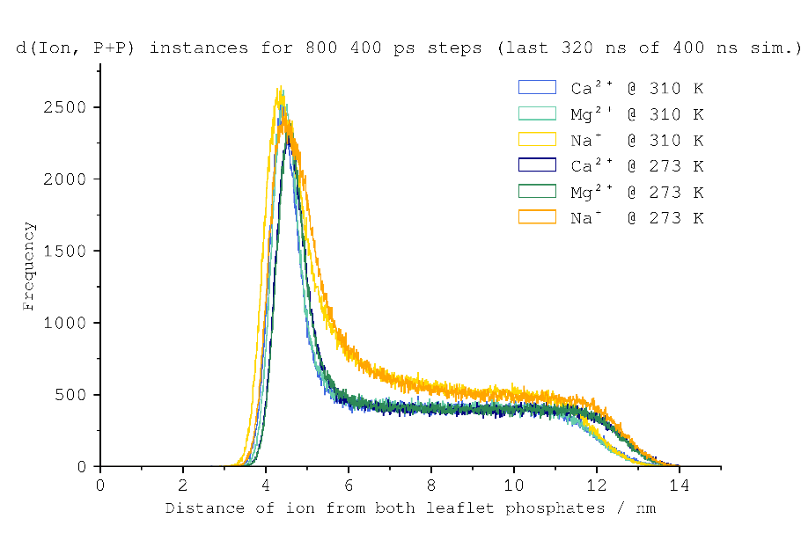
Figure S15. Histograms of sum-distance instances of ions above both leaflets of the bilayer phosphates in membrane simulations solvated with calcium cations at 310 K (sky blue), calcium cations at 273 K (navy blue), magnesium cations at 310 K (ice teal), magnesium cations at 273 K (pine green), sodium cations at 310 K (yellow) and sodium cations at 273 K (burnt orange).

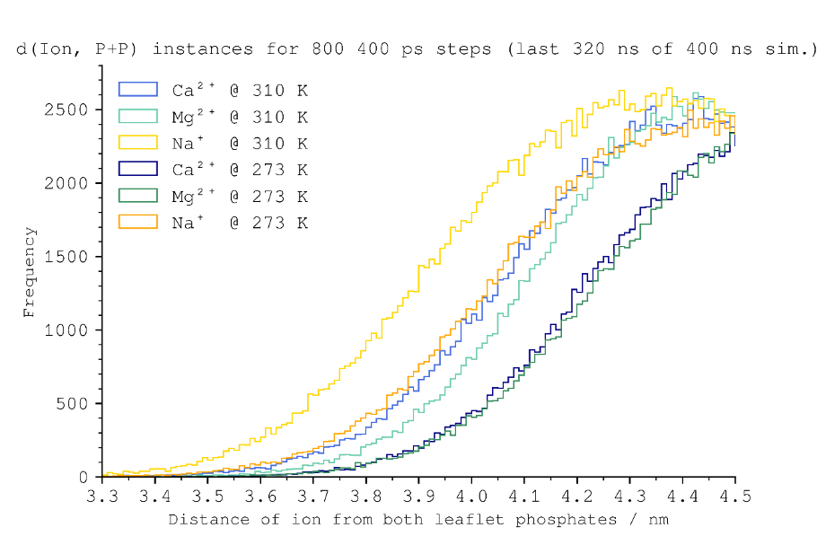
Figure S16. Zoomed in region of the histogram of sum-distance instances of ions above both leaflets of the bilayer phosphates in membrane simulations solvated with calcium cations at 310 K (sky blue), calcium cations at 273 K (navy blue), magnesium cations at 310 K (ice teal), magnesium cations at 273 K (pine green), sodium cations at 310 K (yellow) and sodium cations at 273 K (burnt orange).

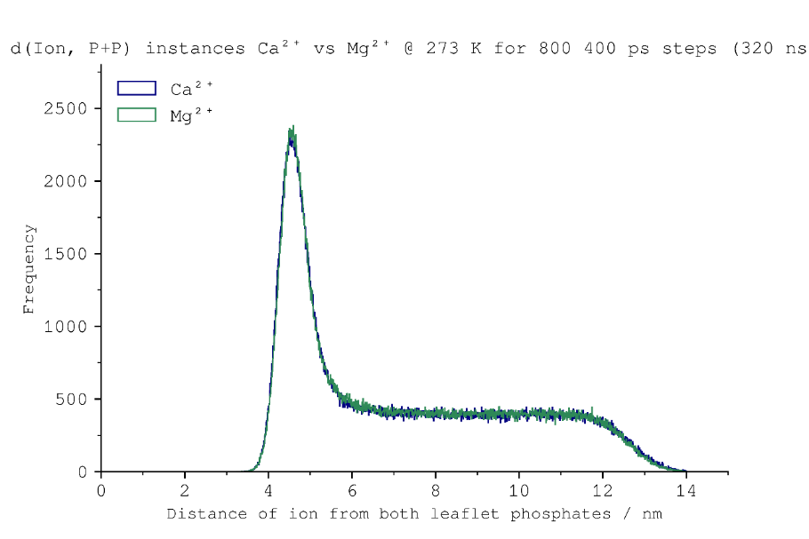
Figure S17. Histogram of sum-distance instances of ions above both leaflets of the bilayer phosphates in membrane simulations at temperature 273 K solvated with calcium cations (blue) and magnesium cations (green).
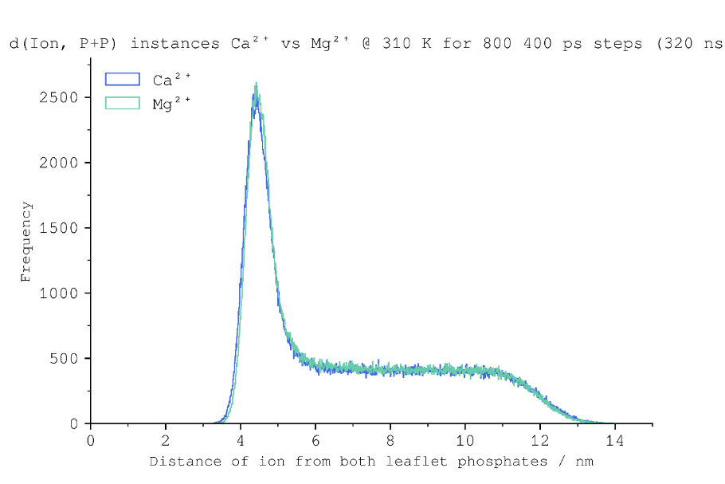
Figure S18. Histogram of sum-distance instances of ions above both leaflets of the bilayer phosphates in membrane simulations at temperature 310 K solvated with calcium cations (blue) and magnesium cations (teal).

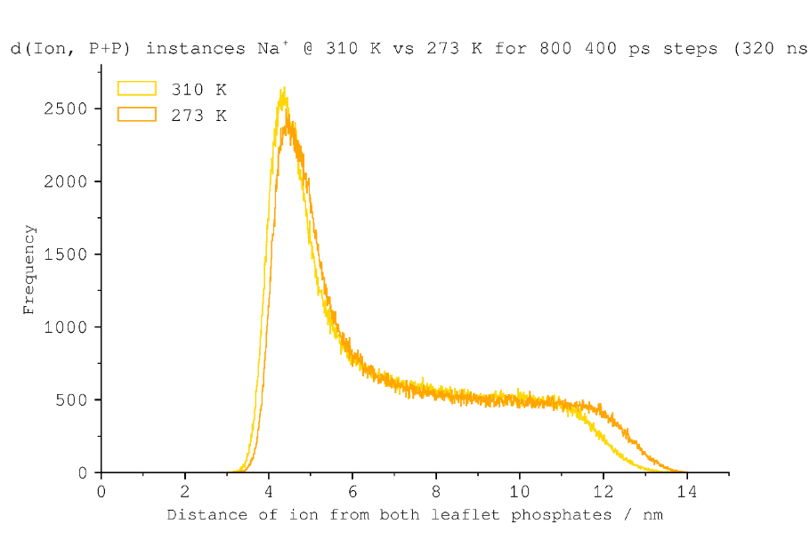
Figure S19. Histogram of sum-distance instances of ions above both leaflets of the bilayer phosphates in membrane simulations with sodium ions at 310 K (yellow) and 273 K (orange).
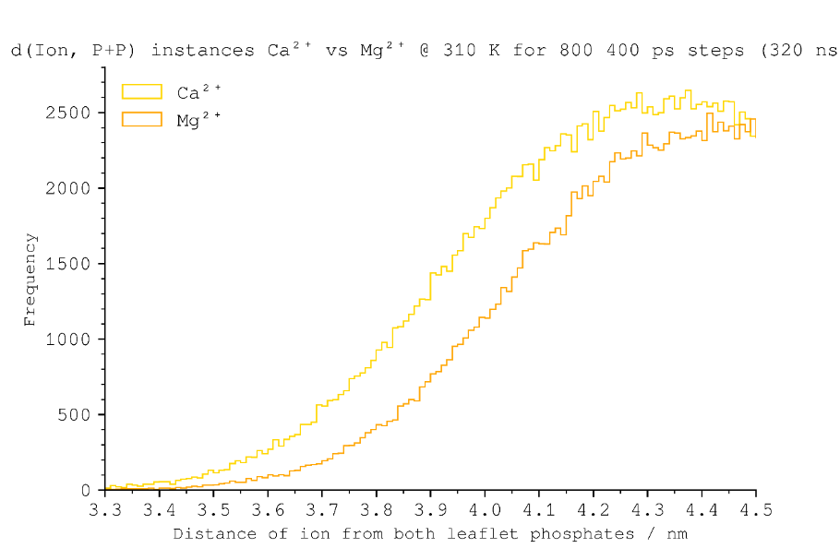
Figure S20. Zoomed in histogram of sum-distance instances of ions above both leaflets of the bilayer phosphates in membrane simulations with sodium ions at 310 K (yellow) and 273 K (orange).

