Supplementary file

The Carcinoembryonic Antigen-to-Skeletal Muscle Index Ratio as a Novel Prognostic Marker in Colorectal Cancer

Supplementary Figure 1. Inclusion criteria

Supplementary Figure 2. Comparison of CEA and CEA/SMI ratio according to the sex.

Supplementary Table 1. Quartile distribution of CEA/SMI ratio according to sex

Supplementary Table 2. Pairwise p-value comparisons of OS according to the CSR quartiles.

Supplementary Figure 3. Kaplan-Meier overall survival curves according to preoperative CEA levels and SMI status.

Supplementary Figure 1. Inclusion criteria.

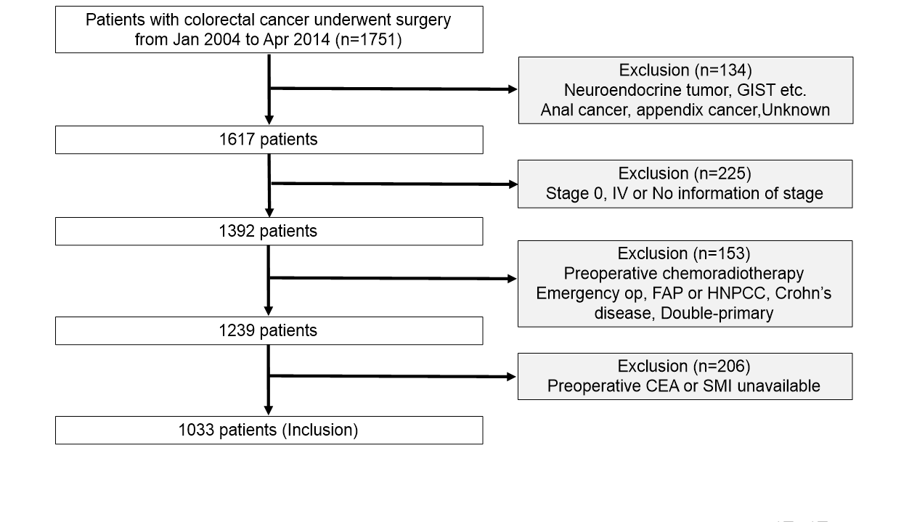

The flowchart illustrates the inclusion and exclusion criteria applied in this study. Patients with stage 0 or IV , a history of other malignancies, emergency surgery, or insufficient preoperative clinical/imaging data, etc(above criteria) were excluded. A total of 1,033 patients were finally included in the analysis.

Supplementary Figure 2. Comparison of CEA and CEA/SMI ratio according to the sex.
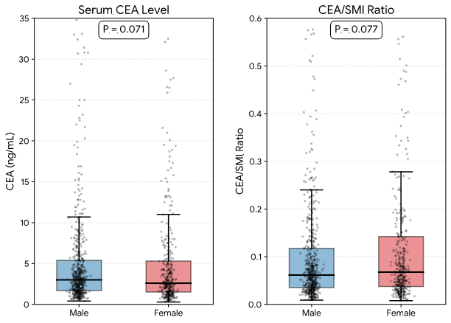
There were no significant differences of median value of CEA (A) [2.60, (interquartile range, IQR) (1.50–5.30) vs. 3.00, IQR (1.70–5.40), P = 0.071] and CEA/SMI ratio (B) [0.07, IQR (0.04–0.14) vs. 0.06, IQR (0.04–0.12), P = 0.077] between female and male respectively.

Supplementary Table 1. Quartile distribution of CEA/SMI ratio according to sex
 | Minimum | 1st Quartile | Median | 3rd Quartile | Maximum
Total | 0.008 | 0.0359 | 0.0626 | 0.1274 | 11.557
Male | 0.009 | 0.0353 | 0.0613 | 0.1173 | 11.557
Female | 0.008 | 0.0376 | 0.0678 | 0.1421 | 10.537

Supplementary Table 2. Pairwise p-value comparisons of OS according to the CSR quartiles.
Subgroups | Total Cohort | Stage I | Stage II | Stage III
Overall log-rank P value | <0.001 | 0.254 | 0.008 | 0.061
Q1 vs Q2 | 0.012 | 0.160 | 0.753 | 0.066
Q1 vs Q3 | <0.001 | 0.040 | 0.061 | 0.082
Q1 vs Q4 | <0.001 | 0.453 | 0.005 | 0.007
Q2 vs Q3 | 0.258 | 0.524 | 0.111 | 0.893
Q2 vs Q4 | 0.002 | 0.905 | 0.011 | 0.352
Q3 vs Q4 | 0.054 | 0.644 | 0.320 | 0.263

P-values were calculated using the log-rank test for pairwise comparisons between the CSR quartiles.

Supplementary Figure 3. Kaplan-Meier overall survival curves according to preoperative CEA levels and SMI status.

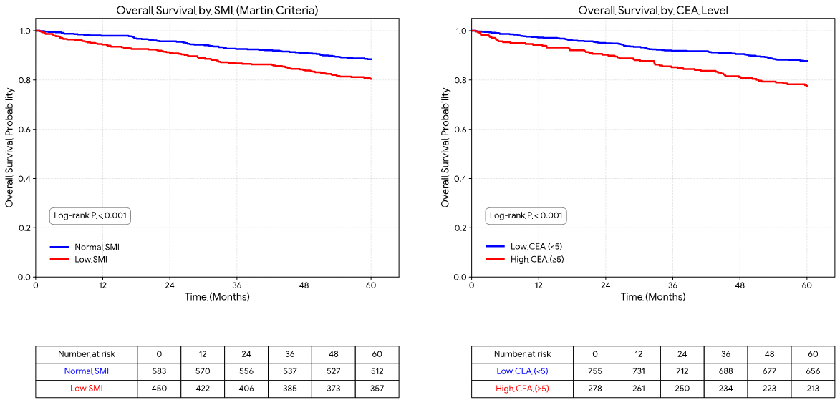

Patients in the low CEA group (<5 ng/mL) showed a significantly better 5-year overall survival rate compared to the high CEA group (87.7% vs. 77.5%, P < 0.001). Similarly, the normal SMI group exhibited superior 5-year survival compared to the low SMI group defined by Martin’s criteria (88.5% vs. 80.5%, P < 0.001).

