Supporting information
A^{1*}, B^{1*}, C², D³, E⁴, F⁵
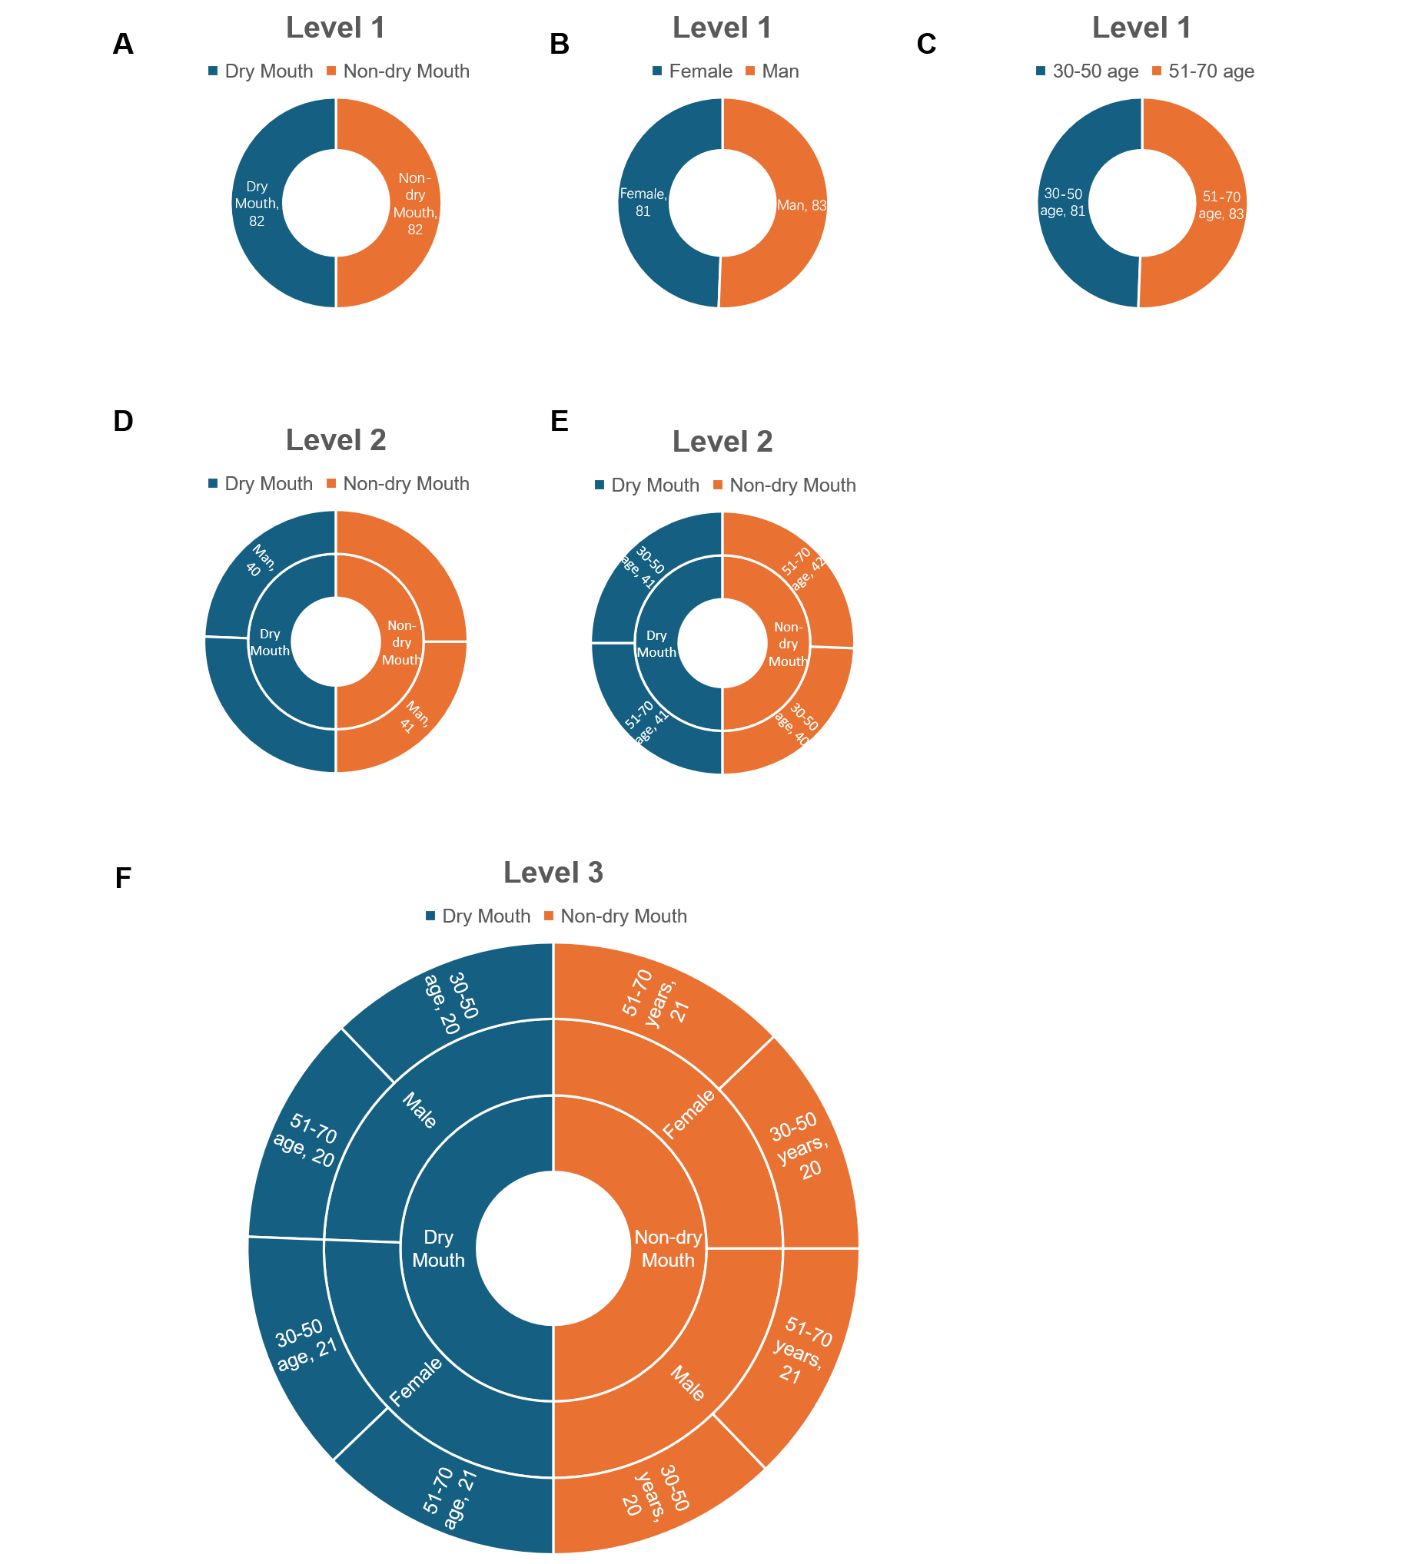
Figure S1. Subgroup allocation and sample size distribution of the study population. (A–C) Level 1 primary distributions according to dry mouth status (A), sex (B), and age (C). (D–E) Level 2 cross-stratified distributions according to dry mouth status and sex (D), and dry mouth status and age (E). (F) Level 3 comprehensive 2 × 2 × 2 factorial stratification integrating dry mouth status (inner ring), sex (middle ring), and age (outer ring). Total n = 164 (n = 20–21 per terminal subgroup).
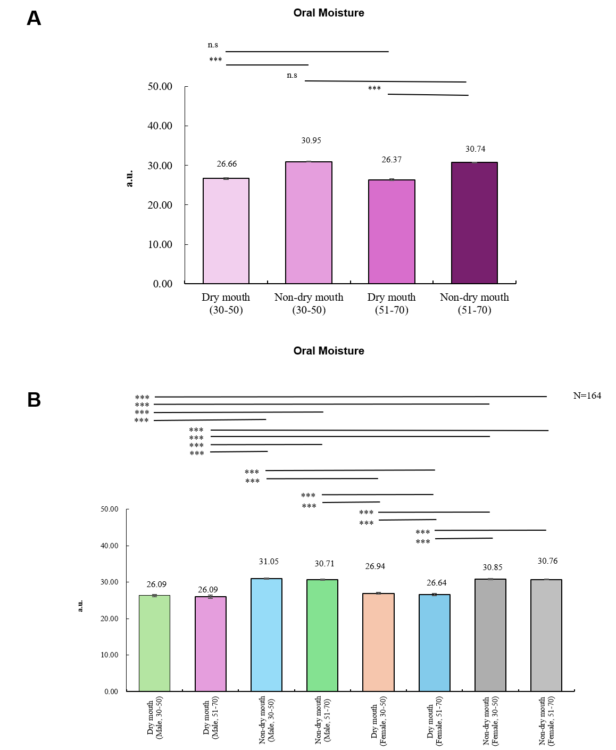
Figure S2. Subgroup analyses of oral moisture according to dry mouth status, age, and sex. (A) Age-stratified subgroup analysis. (B) Cross-stratified subgroup analysis. Data are presented as mean ± SD. n.s. (not significant, P > 0.05), *P < 0.05, **P < 0.01, ***P < 0.001.
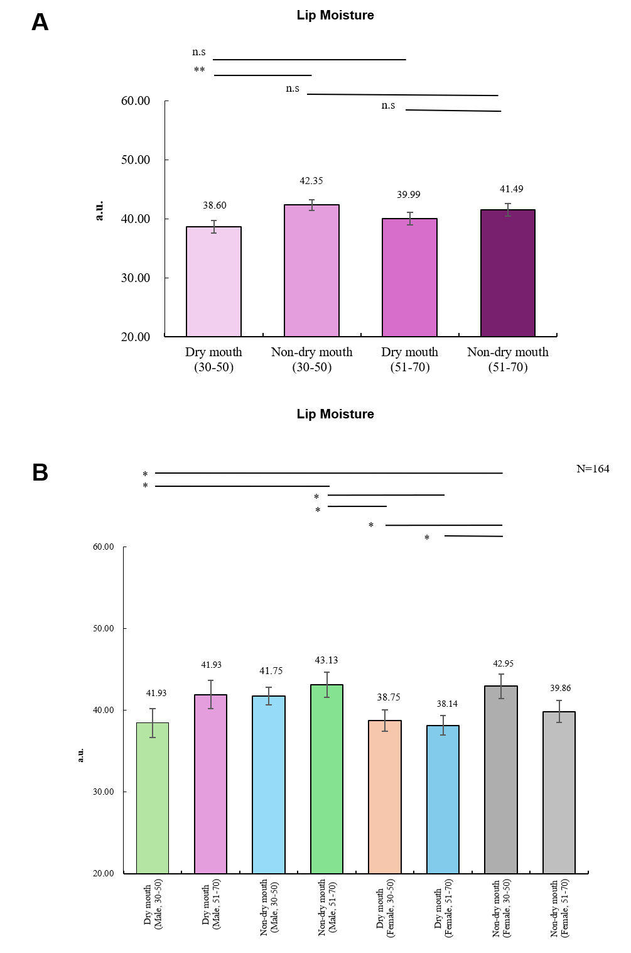
Figure S3. Subgroup analyses of lip moisture according to dry mouth status, age, and sex. (A) Age-stratified subgroup analysis. (B) Cross-stratified subgroup analysis. Data are presented as mean ± SD. n.s. (not significant, P > 0.05), *P < 0.05, **P < 0.01, ***P < 0.001.
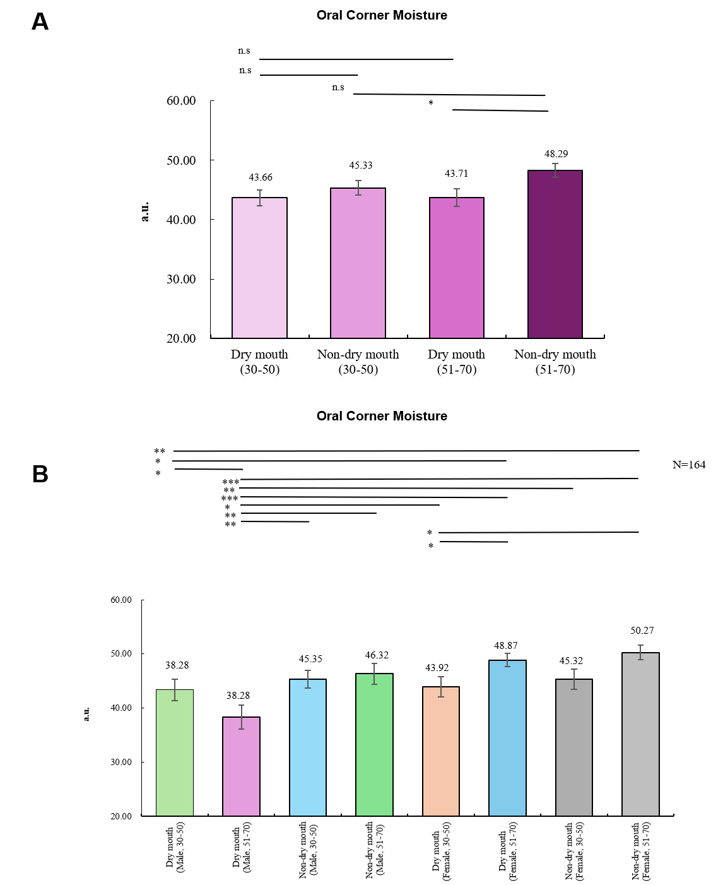
Figure S4. Subgroup analyses of oral corner moisture according to dry mouth status, age, and sex. (A) Age-stratified subgroup analysis. (B) Cross-stratified subgroup analysis. Data are presented as mean ± SD. n.s. (not significant, P > 0.05), *P < 0.05, **P < 0.01, ***P < 0.001.
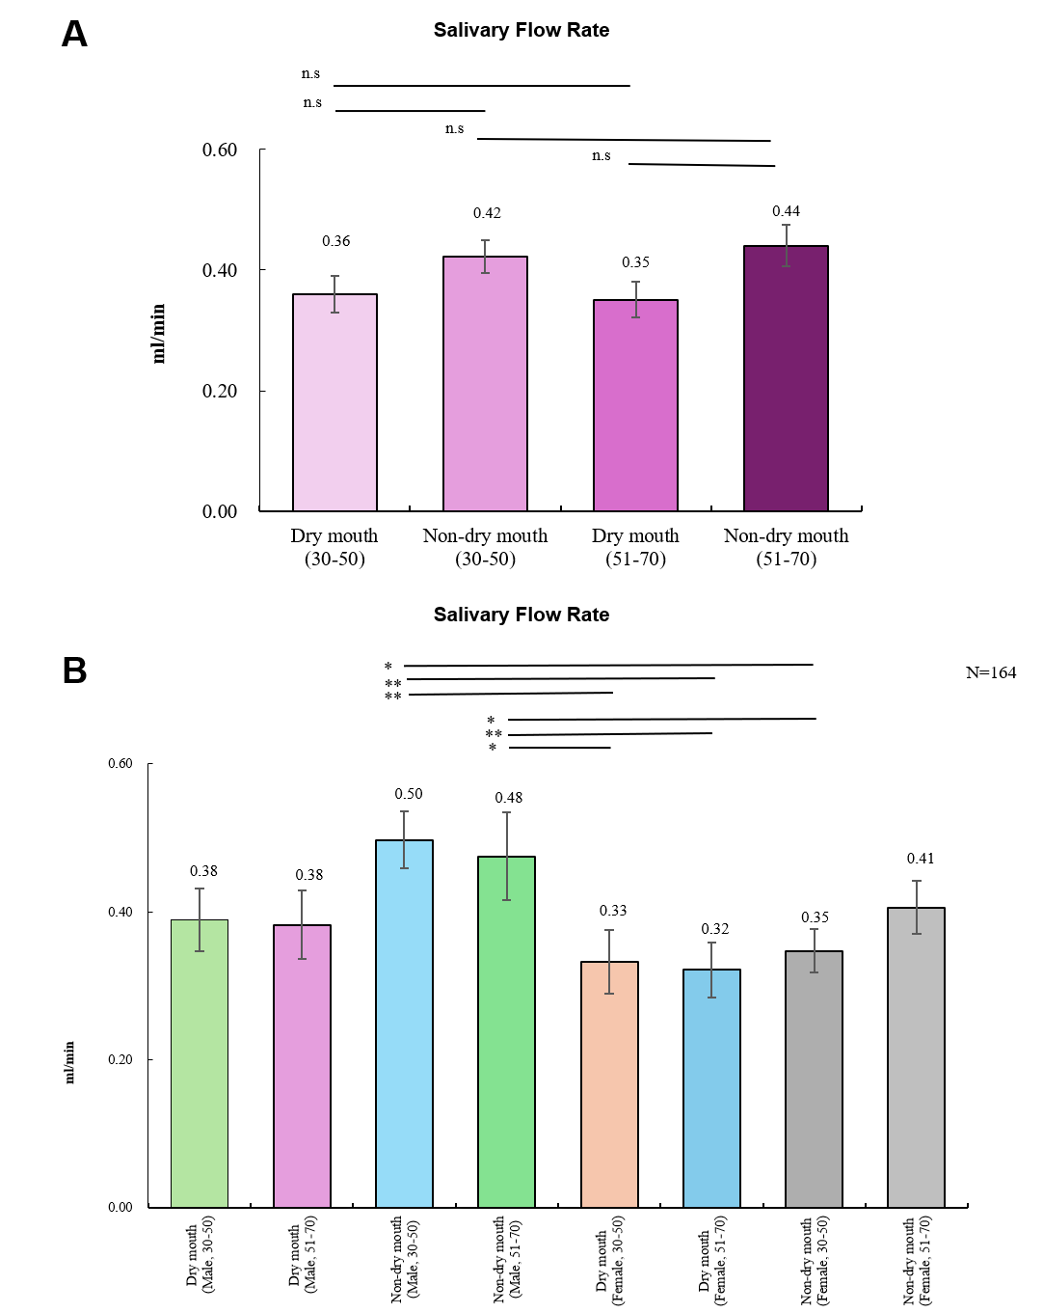
Figure S5. Subgroup analyses of USFR according to dry mouth status, age, and sex. (A) Age-stratified subgroup analysis. (B) Cross-stratified subgroup analysis. Data are presented as mean ± SD. n.s. (not significant, P > 0.05), *P < 0.05, **P < 0.01, ***P < 0.001.
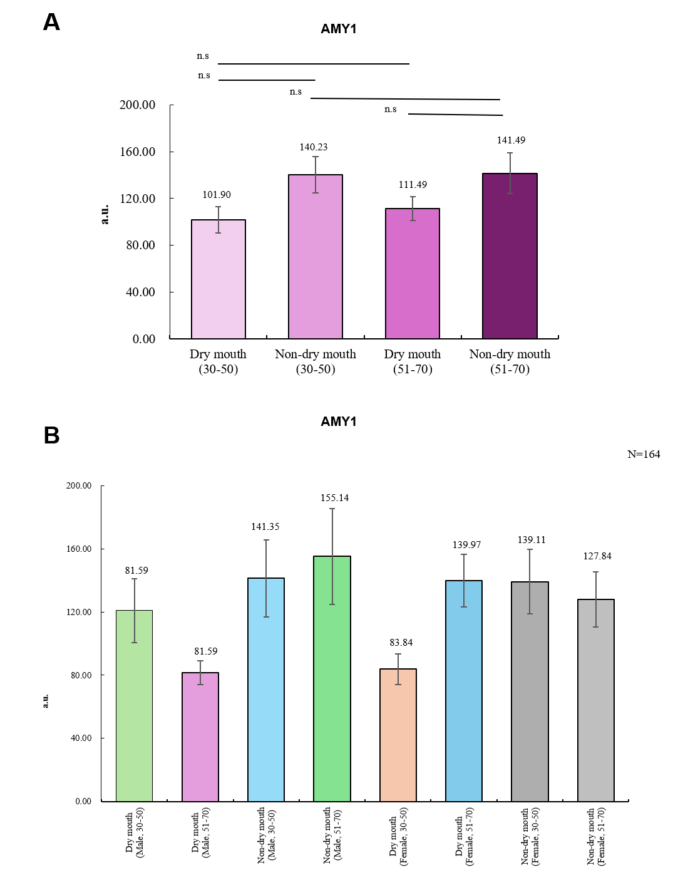
Figure S6. Subgroup analyses of AMY1 according to dry mouth status, age, and sex. (A) Age-stratified subgroup analysis. (B) Cross-stratified subgroup analysis. Data are presented as mean ± SD. n.s. (not significant, P > 0.05), *P < 0.05, **P < 0.01, ***P < 0.001.
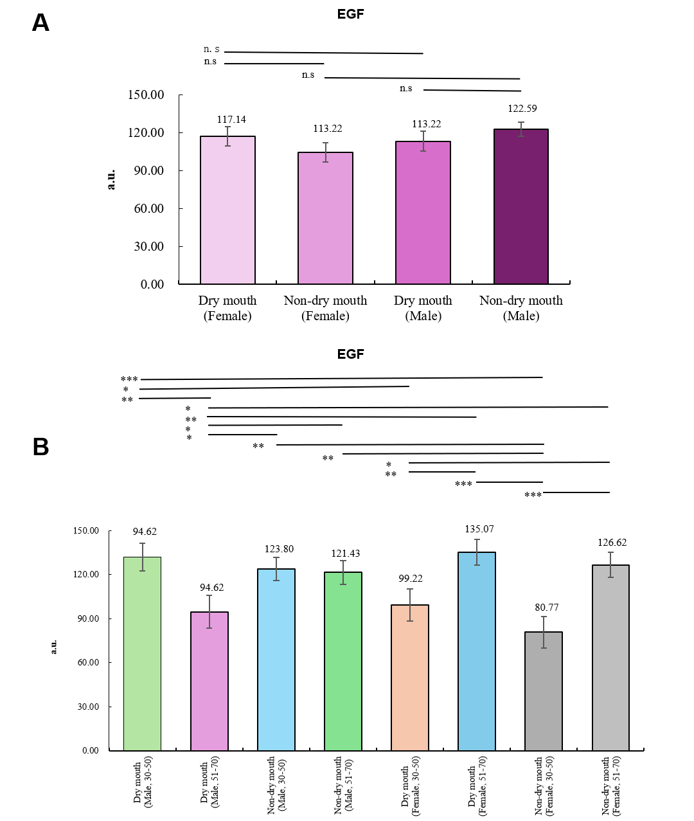
Figure S7. Subgroup analyses of salivary EGF according to dry mouth status, age, and sex. (A) Sex-stratified subgroup analysis. (B) Cross-stratified subgroup analysis. Data are presented as mean ± SD. n.s. (not significant, P > 0.05), *P < 0.05, **P < 0.01, ***P < 0.001.
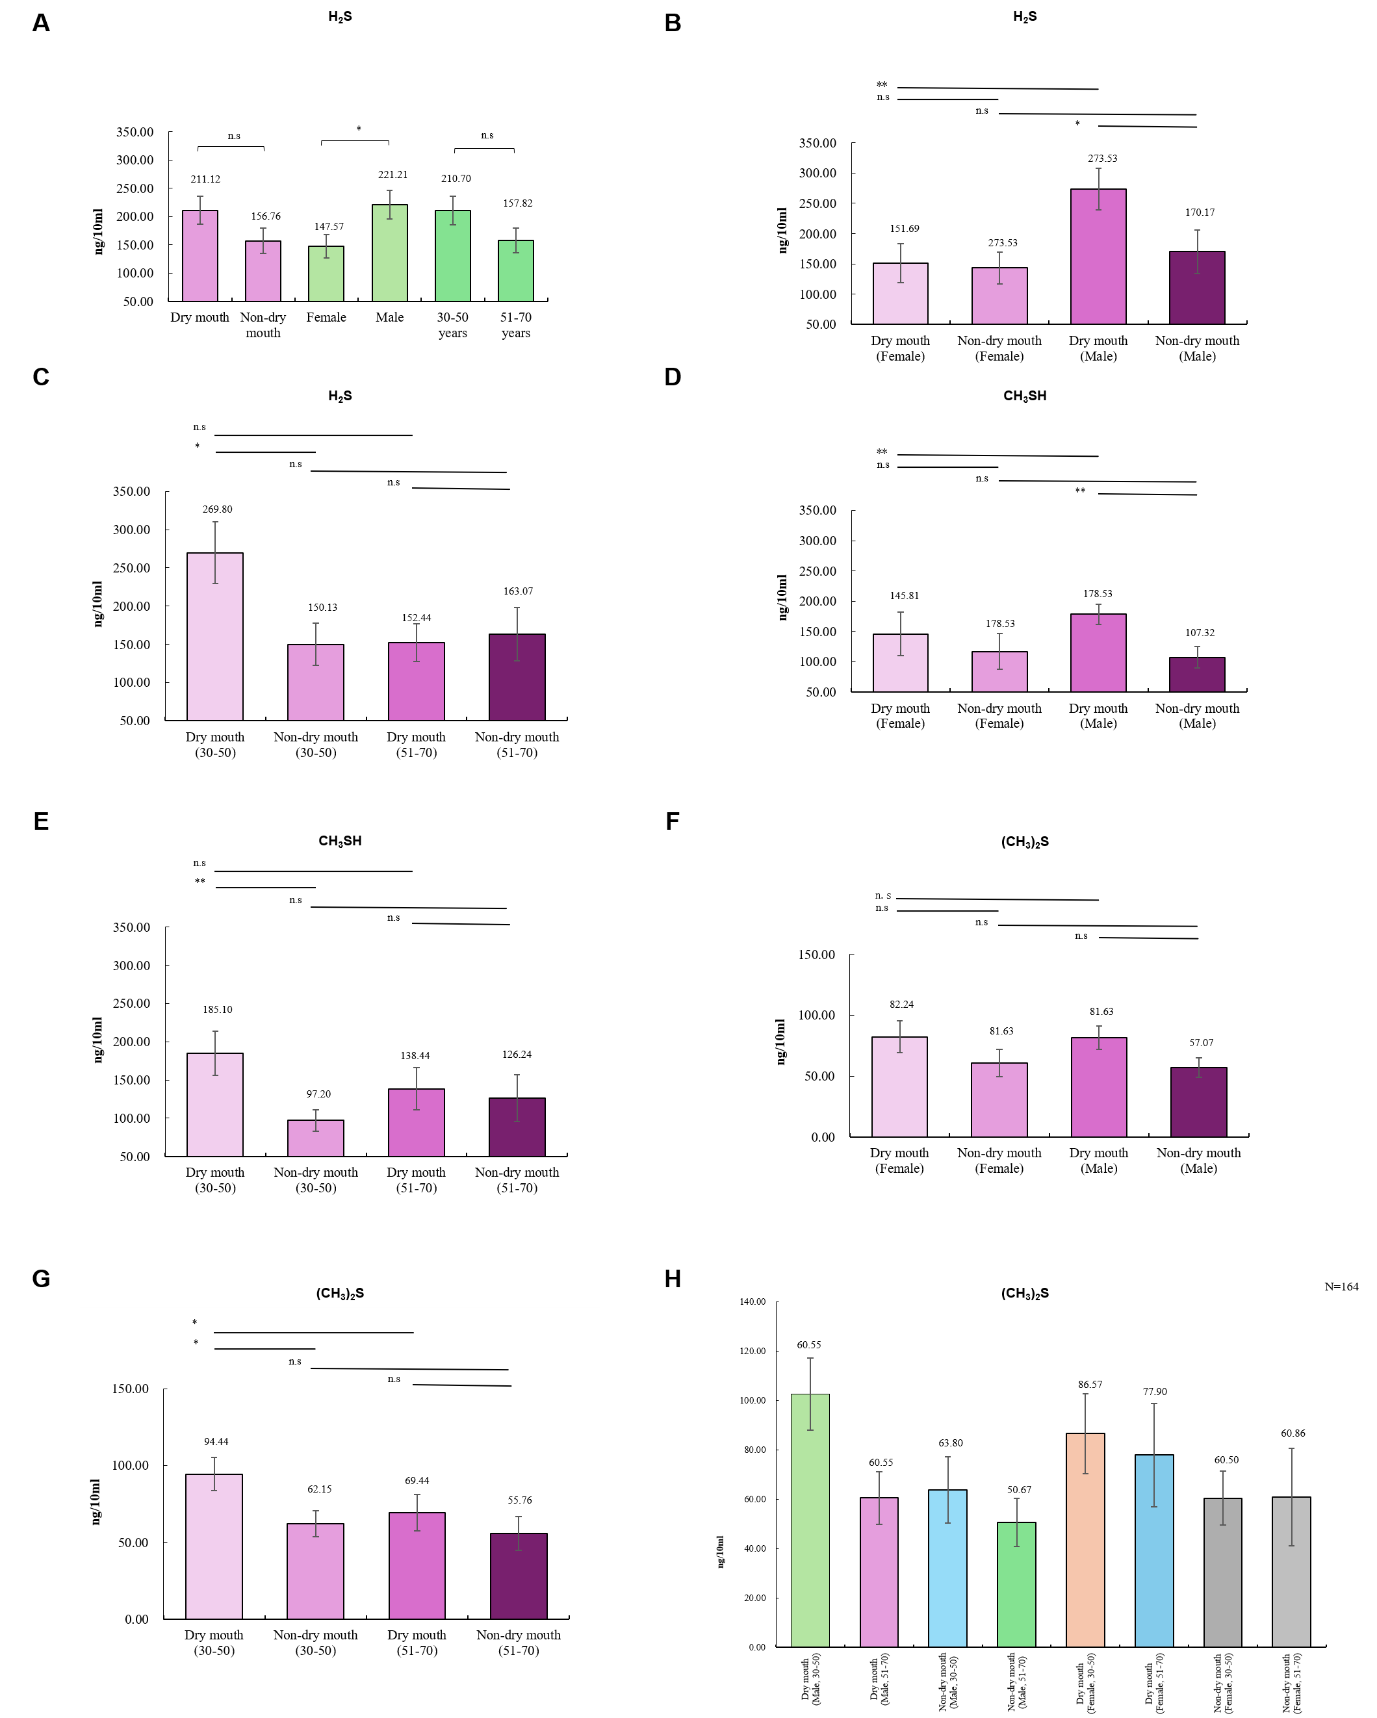
Figure S8. Subgroup analyses of VSCs according to dry mouth status, age, and sex. (A–C) Overall and stratified subgroup analyses for H₂S. (D–E) Stratified subgroup analyses for CH₃SH. (F–G) Stratified subgroup analyses for (CH₃)₂S. (H) Cross-stratified subgroup analysis for (CH₃)₂S. Data are presented as mean ± SD. n.s. (not significant, P > 0.05), *P < 0.05, **P < 0.01, ***P < 0.001.
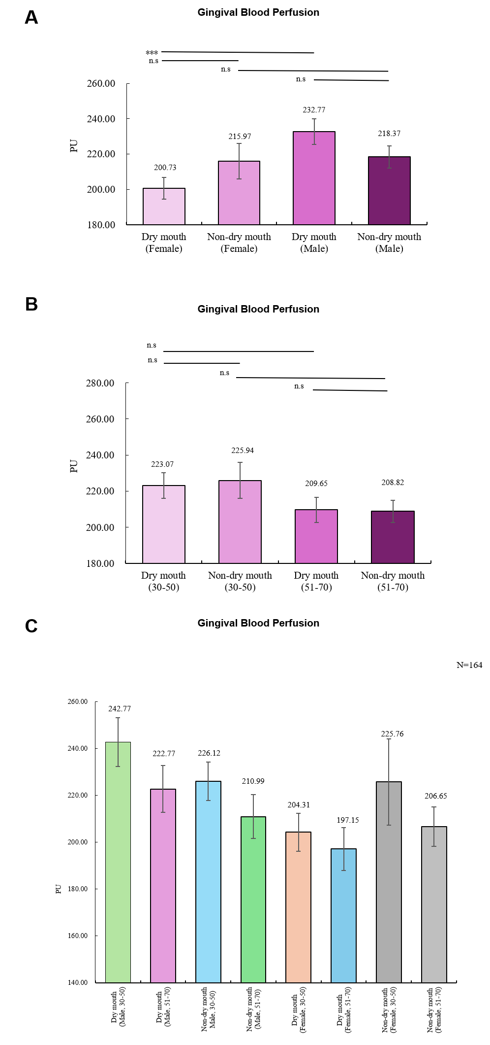
Figure S9. Subgroup analyses of gingival blood perfusion according to dry mouth status, age, and sex. (A) Sex-stratified subgroup analysis. (B) Age-stratified subgroup analysis. (C) Cross-stratified subgroup analysis. Data are presented as mean ± SD. n.s. (not significant, P > 0.05), *P < 0.05, **P < 0.01, ***P < 0.001.

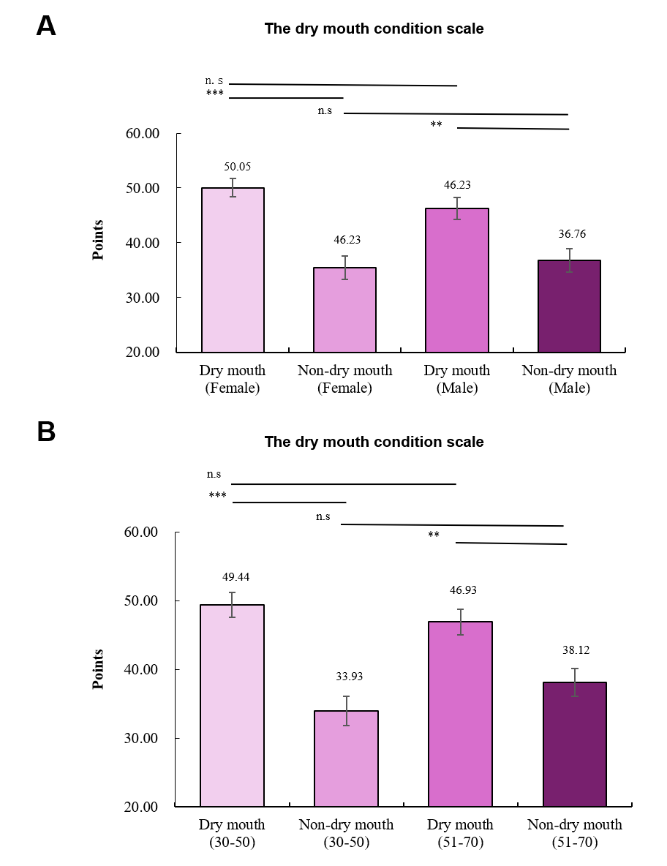
Figure S10. Subgroup analyses of the dry mouth condition scale according to dry mouth status, age, and sex. (A) Sex-stratified subgroup analysis. (B) Age-stratified subgroup analysis. Data are presented as mean ± SD. n.s. (not significant, P > 0.05), *P < 0.05, **P < 0.01, ***P < 0.001.
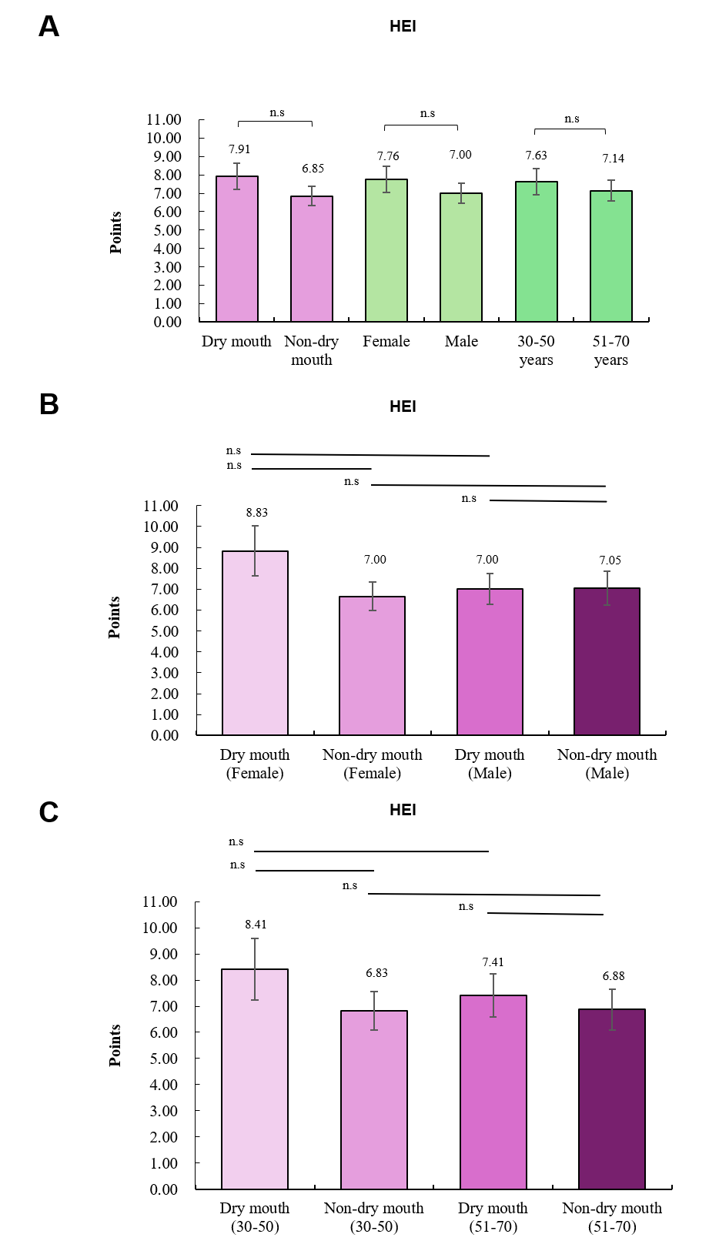
Figure S11. Subgroup analyses of the Huaxi Emotion Index (HEI) according to dry mouth status, age, and sex. (A) Overall comparisons of HEI scores. (B) Sex-stratified subgroup analysis. (C) Age-stratified subgroup analysis. Data are presented as mean ± SD. n.s. (not significant, P > 0.05), *P < 0.05, **P < 0.01, ***P < 0.001.
Table S1. Clinical grading criteria and scoring system for the multidimensional oral assessment.
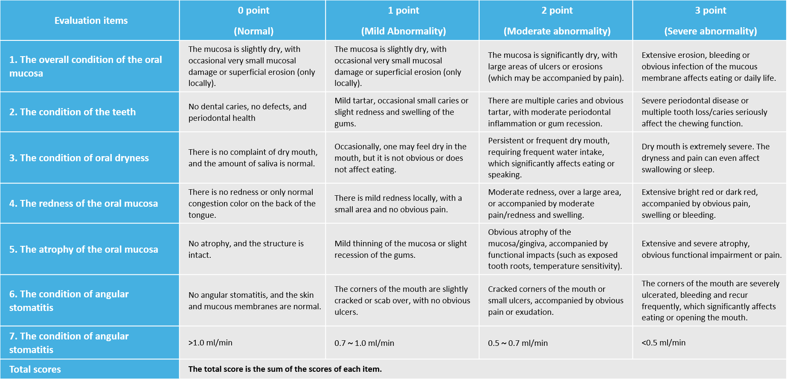
Table S2. Subgroup analyses of the clinical grading for the condition of dry mouth according to dry mouth status, age, and sex. Mean scores are presented across primary (Level 1), bivariate (Level 2), and cross-stratified (Level 3) subgroups.
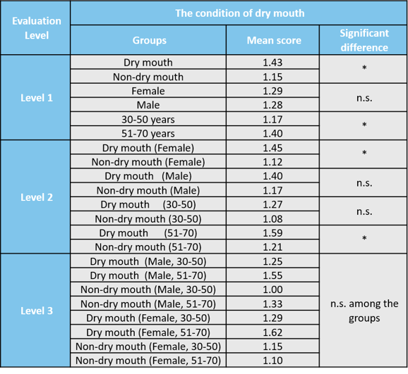
n.s. (not significant, P > 0.05), *P < 0.05, **P < 0.01, ***P < 0.001.
Table S3. Subgroup analyses of the clinical grading for overall oral mucosal condition according to dry mouth status, age, and sex. Mean scores are presented across primary (Level 1), bivariate (Level 2), and cross-stratified (Level 3) subgroups.
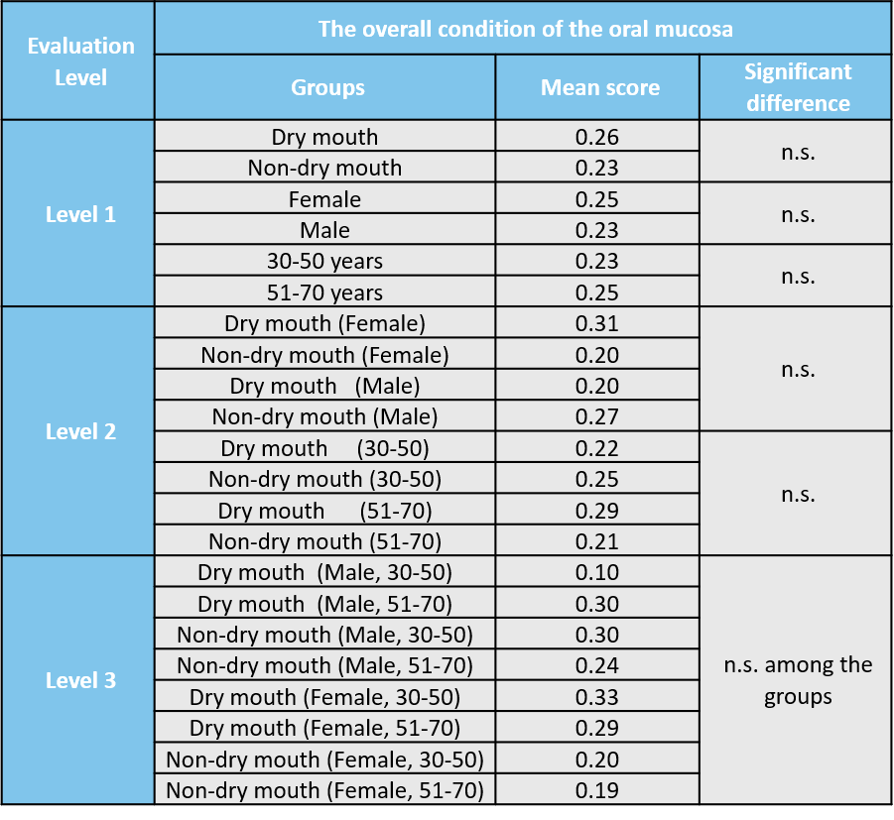
n.s. (not significant, P > 0.05), *P < 0.05, **P < 0.01, ***P < 0.001.
Table S4. Subgroup analyses of the clinical grading for the condition of the teeth according to dry mouth status, age, and sex. Mean scores are presented across primary (Level 1), bivariate (Level 2), and cross-stratified (Level 3) subgroups.
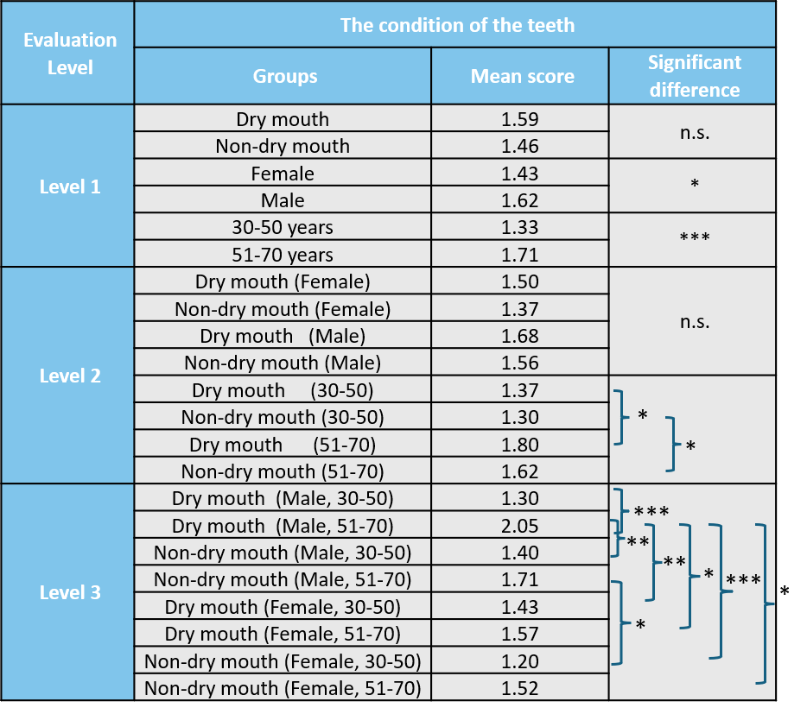
n.s. (not significant, P > 0.05), *P < 0.05, **P < 0.01, ***P < 0.001.
Table S5. Subgroup analyses of the clinical grading for oral mucosal redness according to dry mouth status, age, and sex. Mean scores are presented across primary (Level 1), bivariate (Level 2), and cross-stratified (Level 3) subgroups.
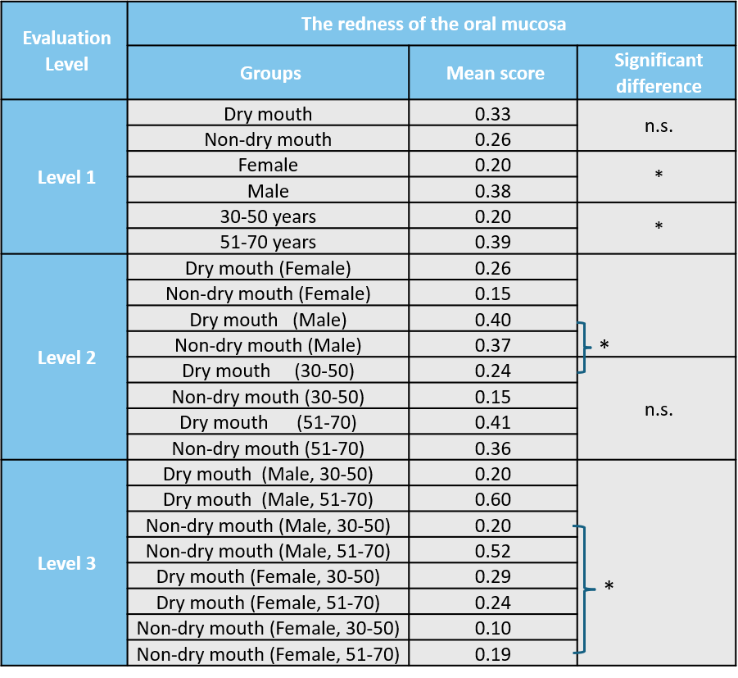
n.s. (not significant, P > 0.05), *P < 0.05, **P < 0.01, ***P < 0.001.
Table S6. Subgroup analyses of the clinical grading for oral mucosal atrophy according to dry mouth status, age, and sex. Mean scores are presented across primary (Level 1), bivariate (Level 2), and cross-stratified (Level 3) subgroups.
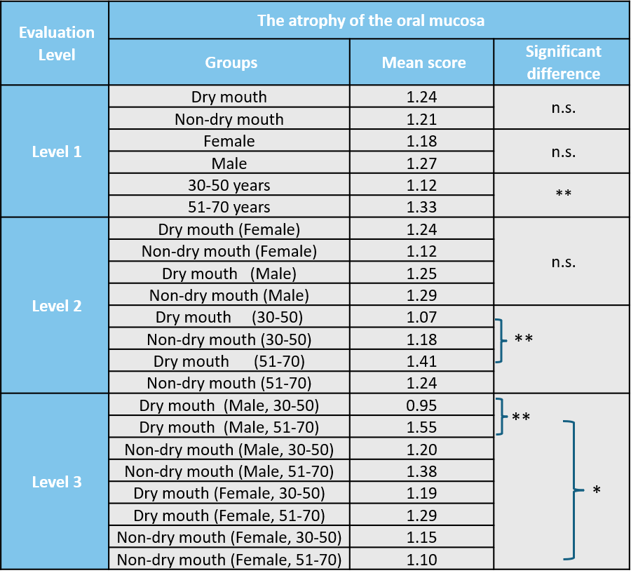
n.s. (not significant, P > 0.05), *P < 0.05, **P < 0.01, ***P < 0.001.
Table S7. Subgroup analyses of the clinical grading for angular stomatitis according to dry mouth status, age, and sex. Mean scores are presented across primary (Level 1), bivariate (Level 2), and cross-stratified (Level 3) subgroups.
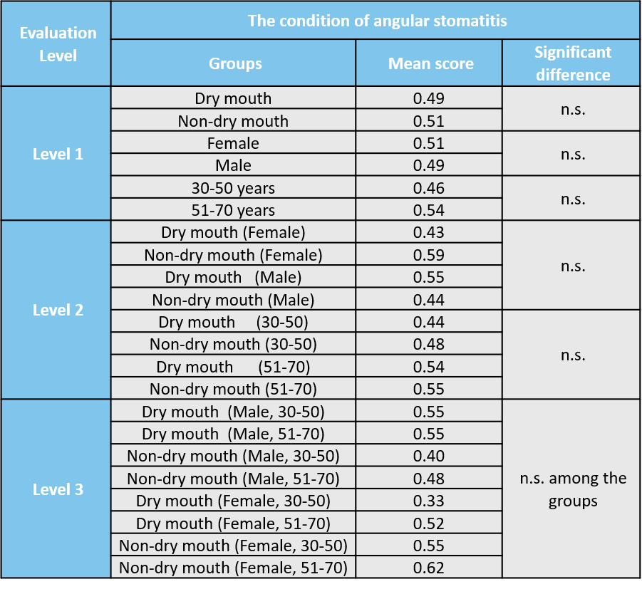
n.s. (not significant, P > 0.05), *P < 0.05, **P < 0.01, ***P < 0.001.
Table S8. Subgroup analyses of clinical grading of salivary secretion according to dry mouth status, age, and sex. Mean scores are presented across primary (Level 1), bivariate (Level 2), and cross-stratified (Level 3) subgroups.
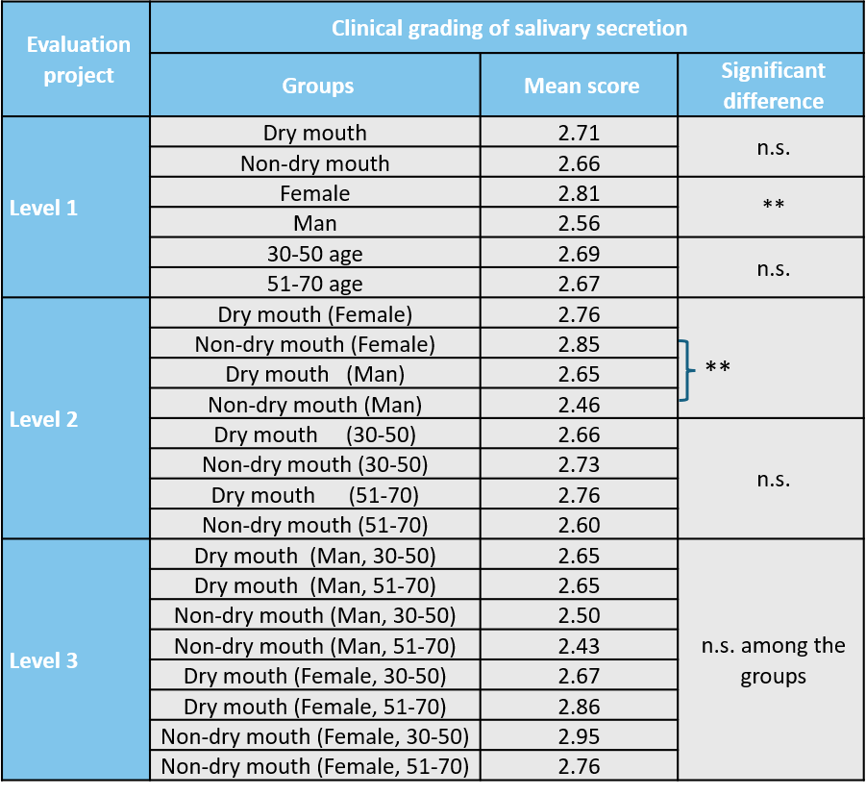
n.s. (not significant, P > 0.05), *P < 0.05, **P < 0.01, ***P < 0.001.
Table S9. Subgroup analyses of the OHIP-14 scores according to dry mouth status, age, and sex. Mean scores are presented across primary (Level 1), bivariate (Level 2), and cross-stratified (Level 3) subgroups.
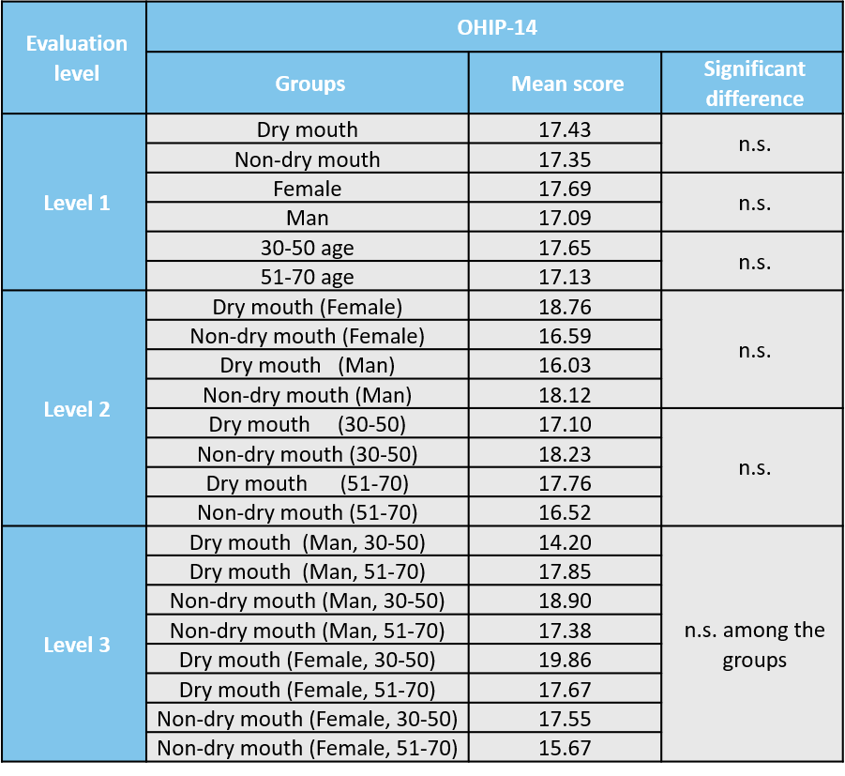
n.s. (not significant, P > 0.05), *P < 0.05, **P < 0.01, ***P < 0.001.
Table S10. Subgroup analyses of the H&N35 questionnaire scores according to dry mouth status, age, and sex. Mean scores are presented across primary (Level 1), bivariate (Level 2), and cross-stratified (Level 3) subgroups.
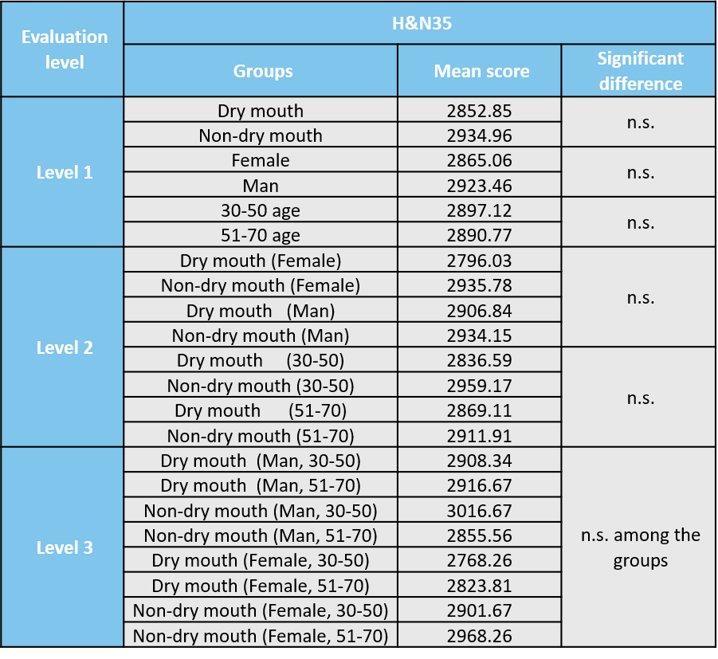
n.s. (not significant, P > 0.05), *P < 0.05, **P < 0.01, ***P < 0.001.

