Supplementary materials

The pro-inflammatory effect of Staphylokinase contributes to community-associated Staphylococcus aureus pneumonia
Yanan Wang^{1#}, Na Zhao^{1#}, Ying Jian¹, Yao Liu¹, Lin Zhao¹, Lei He¹, Qian Liu¹*, Min Li^{1,2}*
Supplementary Methods
Bacterial isolates and growth conditions
The definitions of CA-SA and HA-SA refer to a previously published paper¹. Unless otherwise stated, Escherichia coli was routinely grown in Luria-Bertani medium, and S. aureus was grown in tryptic soy broth (TSB) (Oxoid) or agar plates. TSB medium was also used when measuring the growth of S. aureus, and the absorbance of the bacterial suspension at 600nm wavelength was measured every hour.
Molecular typing
Multi-locus sequence typing (MLST) of S. aureus isolates was performed by detection of seven housekeeping genes (arcC, aroE, glpF, gmk, pta, tpi, and yqiL)². Sequences of these housekeeping genes were submitted to the S. aureus MLST database for comparison (https://pubmlst.org/).
Allelic gene replacement by homologous recombination and genetic complementation
We selected a representative ST398 clinical isolate from respiratory specimens to delete the sak gene. The homologous recombination procedure was performed by using plasmid pKOR1 as described³. The sak complementary plasmid was generated by cloning the sak gene into the vector pOS1.
Lung infection model in mice
In the normal lung infection model, the mice were euthanized 48 hours after infection, and their lungs were dissected out. The left lung was homogenized in 0.5 ml of TSB, the homogenized tissue was diluted and plated on TSB agar for CFU determination. The right lung was fixed in 4% formalin and tissue sections were prepared for HE staining and immunohistochemical staining. The remaining right lungs were used for RNA sequencing. For the fatal pneumonia model, lung tissues were taken out immediately after the mouse died.
Abreviation list of cytokines and genes in Figure 3
G-CSF: Granulocyte Colony Stimulating Factor
GM-CSF: Granulocyte-macrophage Colony Stimulating Factor
KC: keratinocyte chemokine
MCP-1: macrophage chemoattractant protein-1
MIP: macrophage inflammatory protein
RANTES: regulated upon activation normal T cell expressed and secreted factor
Eotaxin: Eosinophil Chemotactic Protein
Casp1/8: caspase 1/8
Tlr2/6/7/8/9/12: toll-like receptor 2/6/7/8/9/12
Tirap: toll-interleukin 1 receptor domain-containing adaptor protein
Mapk3: mitogen-activated protein kinase 3
Nfkb1/2: nuclear factor of kappa light polypeptide gene enhancer in B cells 1/2
Myd88: myeloid differentiation primary response gene 88
Irak1/4: interleukin-1 receptor-associated kinase 1/4
Irf5/7: interferon regulatory factor 5/7
Ripk1: receptor-interacting serine-threonine kinase 1
Mlkl: mixed lineage kinase domain-like

Supplementary Figures
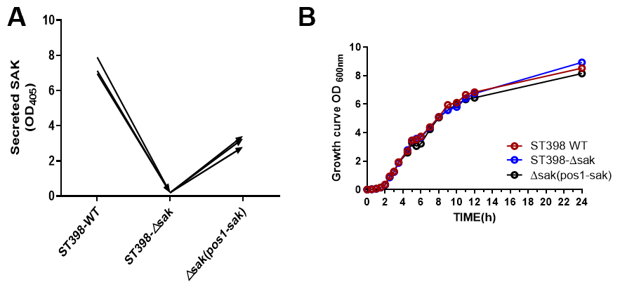
Supplementary Figure 1. The deletion of sak did not affect the growth of ST398. A, Measurement of SAK secretion to confirm the successful construction of sak gene knockout and complemented strains. B, Growth of the sak deletion and complemented mutants was comparable to that of the wild-type strain.
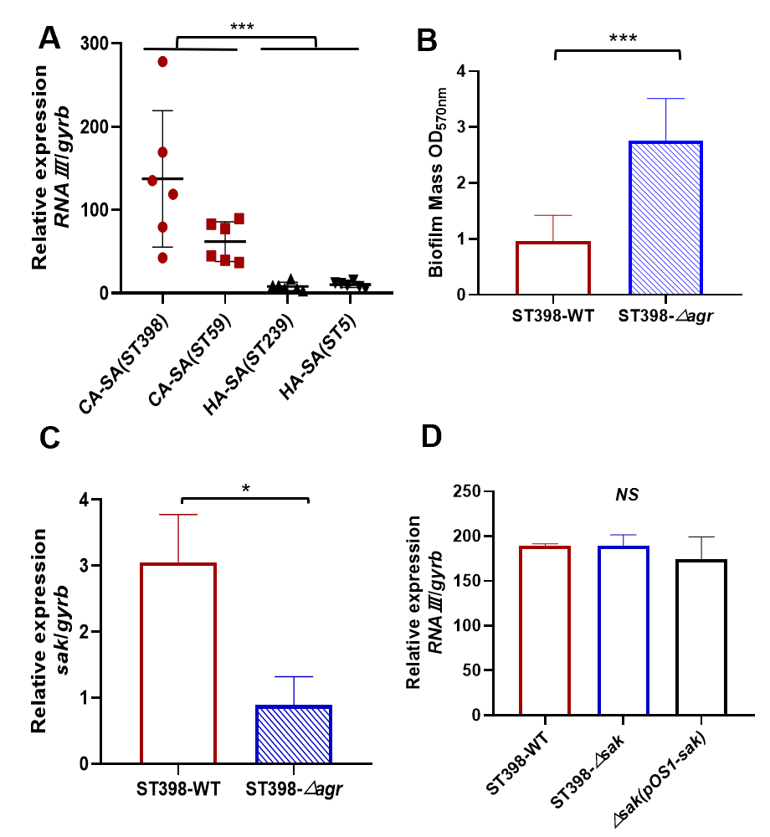
Supplementary Figure 2. The expression level of agr and its effect on biofilm formation and sak expression. A, qRT-PCR analysis of RNAⅢ gene expression in randomly selected clinical CA-SA ST398, CA-SA ST59, HA-SA ST239, and HA-SA ST5 isolates, at 4 h of in-vitro growth. Relative mRNA levels were calculated using gyrb as control and expressed as 2^(-ΔΔCt). Unpaired t test was used for statistical analyses between CA-SA and HA-SA. B, The effect of Agr on the biofilm formation of ST398 isolate and unpaired t test was used for statistical analyses. C, D, qRT-PCR analysis of sak or RNAⅢ gene expression. Relative mRNA levels were calculated using gyrb as control and expressed as 2^(-ΔΔCt). Unpaired t test was used for statistical analyses. All data are presented as mean ± SD and *P<0.05, ** P<0.01, *** P<0.001.
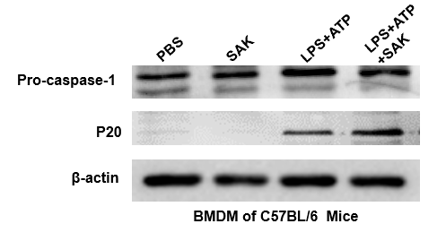
Supplementary Figure 3. Role of SAK in promoting the maturation of caspase-1. Western blot analysis was performed to detect the expression of pro-caspase-1 and its mature cleaved fragment (P20).

Supplementary Tables
Supplementary Table 1. Bacterial strains and plasmids used in this study.
Strains/plasmids | Relevant genotype and property | Source/reference
S. aureus
RN4220 | derived from NCTC8325-4; r-m+ | Ref:⁴
ST398 | CA-SA clinical isolate | This study
ST398-△sak | ST398 sak mutant | This study
△sak (pOS1-sak)  ST398-△agr  △agr (pOS1-agr) | ST398 sak mutant with pOS1-sak  ST398 agr mutant  ST398 agr mutant with pOS1-agr | This study  This study  This study
E. coli
DH5α | endA1 recA1 gyrA96 thi-1 hsdR17(rK-mK+) relA1 supE44 (lacZYA-argF) U169 F-80dlacZM15 deoR phoA | Invitrogen
Plasmids
pKOR1 | cmR and ampR, temperature sensitive vector for allelic replacement via lambda recombination and ccdB selection | Ref:³
pOS1 | E. coli/Staphylococcus shuttle cloning  plasmid, cmR, ampR | Ref:⁵

Supplementary Table 2. Oligonucleotides used in this study.
Oligonucleotide | Sequence
Oligonucleotides for isogenic deletion mutants
sak-att1 | GGGGACAAGTTTGTACAAAAAAGCAGGCTGCAATTAACAGACGGTTTAAACG
sak-rev1 | GGCGCTTCCTCCAAATATAATATA
sak-rev2 | TTATATTTGGAGGAAGCGCCTAGTTGTTTATTATAGAAAGCAA
sak-att2  agr-att1  agr-rev1  agr-rev2  agr-att2 | GGGGACCACTTTGTACAAGAAAGCTGGGTTCTTTTTTATATAAAGGTTTG  GGGGACAAGTTTGTACAAAAAAGCAGGCTACCCTTTCAATTGTCTGACG  GATGAATAATTAATTACTTTCATTGTAAA  AGTAATTAATTATTCATCACTTACCTATTTAACGTTTGTCTACA  GGGGACCACTTTGTACAAGAAAGCTGGGTGGGATGCCTTTATTGGTG
Oligonucleotides for genetic complementation
sak-Sam1-F | GAGCCCGGGAAGCGCCATGCTCAAAAGAGGT
sak-Bamh1-his-R | GAGGGATCCTTAatgatgatgatgatgatgTTTCTTTTCTATAATAACC
Oligonucleotides for qRT- PCR
sak-F | GAGGTAAGTGCATCAAGTTC
sak-R | GACATAATGAGGGGATAGCA
gyrB-F  gyrB-R  RNAⅢ-F  RNAⅢ-R | CAAATGATCACAGCATTTGGTACAG  CGGCATCAGTCATAATGACGAT  ATAGCACTGAGTCCAAGGAAACTAACT  GCCATCCCAACTTAATAACCATGT
NLRP3-mice-F | GGGAGACCGTGAGGAAAGGA
NLRP3-mice-R | CCAAAGAGGAATCGGACAACAAA
ASC-mice-F | GTGTTTACTCTCTGGGATGTTTTTG
ASC-mice-R | GTCTGTGGAATTTAGGTGTTGGA
caspase-1-mice-F | CAGGCAAGCCAAATCTTTATCACT
caspase-1-mice-R | GTGCCATCTTCTTTGTTCTGTTCTT
β-actin-mice-F | TGAGAGGGAAATCGTGCGTGAC
β-actin-mice-R | GCTCGTTGCCAATAGTGATGACC
IFN-α-mice-F | GAGAGCCTTGACACTCCTGG
IFN-α-mice-R | GCTTGAGCCTTCTTGATCTGC
TNF-α-mice-F | CAGGCGGTGCCTATGTCTC
TNF-α-mice-R | CGATCACCCCGAAGTTCAGTAG
IL-8-mice-F | GGCCCAATTACTAACAGGT
IL-8-mice-R | ATATAGAGGCTTTTCATGCTCA
IL-17-mice-F | GTGTCTCTGATGCTGTTG
IL-17-mice-R | AACGGTTGAGGTAGTCTG
IL-1β-mice-F | CAGGCAGGCAGTATCACTCA
IL-1β-mice-R  IL-1β-homo-F  IL-1β-homo-R  GAPDH-homo-F  GAPDH-homo-R | AGCTCATATGGGTCCGACAT  GGACAAGCTGAGGAAGATGC  TCGTTATCCCATGTGTCGAA  TCAAGTGGGGCGATGCTGGC  TGGGGGCATCAGCAGAGG

References
1 Wang, Y. et al. Role of the ESAT-6 secretion system in virulence of the emerging community-associated Staphylococcus aureus lineage ST398. Sci Rep 6, 25163, doi:10.1038/srep25163 (2016).
2 Ji, Y. Methicillin-resistant Staphylococcus aureus (MRSA) protocols. Preface. Methods Mol Biol 391, v, doi:10.1007/978-1-59745-468-1 (2007).
3 Bae, T. & Schneewind, O. Allelic replacement in Staphylococcus aureus with inducible counter-selection. Plasmid 55, 58-63, doi:10.1016/j.plasmid.2005.05.005 (2006).
4 Azavedo, J., Foster, T. J., Hartigan, P. J., Arbuthnott, J. P. & Novick, R. P. Expression of the cloned toxic shock syndrome toxin 1 gene (tst) in vivo with a rabbit uterine model. Infection & Immunity 50, 304 (1985).
5 Wardenburg, J. B., Williams, W. A. & Missiakas, D. Host defenses against Staphylococcus aureus infection require recognition of bacterial lipoproteins. Proceedings of the National Academy of Sciences 103, 13831-13836 (2006).

