Supplementary Material
Clinical expression beyond measured Alzheimer disease molecular pathology: a discovery and external evaluation study
Shiqi Zhang, Rui Bao, Huan He, for the Alzheimer’s Disease Neuroimaging Initiative (ADNI), the Health and Aging Brain Study: Health Disparities (HABS-HD) Study Team, Tonghua Zhang, Weibo Cheng, and Wencai Ding
Reference numbers correspond to the bibliography of the main manuscript.

Contents
Supplementary Methods
Supplementary Results
Supplementary Tables S1–S10
Supplementary Figures S1–S3
Supplementary Figure Legends

Supplementary Methods

Study design, cohort governance, and analytic samples
This observational discovery and external-evaluation study used deidentified data from ADNI and HABS-HD. ADNI served as the discovery cohort and HABS-HD as the external-evaluation cohort. The locked primary samples comprised 436 ADNI participants and 491 HABS-HD participants with complete prespecified multimodal data. Sample sizes were determined by the joint availability of cognition, plasma pTau217 and GFAP, amyloid PET, tau PET, hippocampal MRI, education, age, and sex, rather than by a prospective recruitment target. Participant-level source data remain governed by the cohort-specific data-use agreements and are not redistributed.
ADNI procedures were reviewed by institutional review boards at participating sites, and written informed consent was obtained before enrolment. The HABS-HD protocol was approved by the Institutional Review Board of the University of North Texas Health Science Center; participants or legally authorised representatives, with study partners where applicable, provided written informed consent before study procedures. The available deidentified study materials did not provide a single protocol approval number, which is therefore not inferred in this supplement.

Cognitive endpoint and clinical-expression profile
The primary endpoint was a cohort-standardised four-item PACC4. Within each cohort, delayed episodic memory, global cognition, Logical Memory II, and processing speed measures were standardised against the cohort distribution and averaged with equal weights, with higher values indicating better cognition. HABS-HD used the Spanish and English Verbal Learning Test, Mini-Mental State Examination, Logical Memory II, and Digit Symbol Substitution Test. Because the cohorts used non-identical instruments, languages, and normative distributions, HABS-HD was interpreted as a directional external evaluation using a harmonised PACC-family endpoint, not as an instrument-identical replication.
The prespecified clinical-expression profile was [z(normalised hippocampal volume)+z(education)−z(log GFAP)]/3. In ADNI, hippocampal volume was total hippocampal volume divided by total cerebrum cranial volume. In HABS-HD, it was the sum of left and right hippocampal volumes divided by ICV_HD. Component directions and equal weights were transferred without outcome-derived re-estimation in HABS-HD. The profile was treated as a mixed operational construct rather than a unitary biological biomarker, a direct measure of reserve, or an individual-level prognostic score.

Plasma biomarkers, PET, MRI processing, and temporal linkage
Primary models included natural-log-transformed pTau217, continuous amyloid PET, continuous tau PET, age, and sex; biomarker measures were standardised within cohort. In HABS-HD, the released Quanterix Simoa pTau217 measure was selected a priori as the primary validation biomarker because it provided the broadest available coverage. The released GFAP variable was used in the prespecified glial component and in supportive specificity analyses. Fasting EDTA plasma followed HABS-HD parent-study handling procedures, including storage at −80°C. Available study documentation identifies ultrasensitive Single Molecule Array (Simoa) assays on a Quanterix HD-X analyzer. Exact release-specific kit/prototype and calibration metadata were not present in the deidentified materials and are not inferred.
In HABS-HD, [18F]florbetaben amyloid PET was represented by global FBB SUVR and the corresponding Centiloid field. Global FBB SUVR was the straight, unweighted mean of four cortical regions using whole cerebellum as reference. The released amyloid-positivity indicator was defined as global FBB SUVR >1.08; the corresponding Centiloid transformation was CL=(159.08×SUVR)−151.65. This threshold was used for sensitivity classification; primary models used continuous amyloid PET. [18F]PI-2620 tau PET was represented primarily by medial-temporal SUVR, with FreeSurfer-derived medial temporal, lateral parietal, and posterior cingulate regions and inferior cerebellar grey matter as reference. The MsTL field combines entorhinal cortex, parahippocampal cortex, and amygdala; its published ≥1.26 cut-point was used only as a protocol reference and not as the operational tau-high definition in this study.
Bilateral hippocampal volumes were derived from T1-weighted MRI using HippoDeep after DICOM-to-NIfTI conversion, reorientation/cropping, and N4 bias correction. Segmentations were screened for choroid plexus and fornix exclusion and alveus/fimbria inclusion. PET–MRI linkage used the released MRI_match and Days_between_MRI_PET fields. The available processing documentation identifies dcm2niix v1.0.20181125, FreeSurfer 5.3.0, MATLAB R2019b, FSL 5.0.9, SPM12 release 6685, SUIT 3.0, and Python 3.9/SciPy 1.10. The exact HippoDeep version was not specified in the released documentation. Variables were linked within the same released baseline assessment episode; because no single universal day-level cutoff was available for every modality pair, no unverified numeric timing window was imposed.

Statistical analysis, missing data, and reproducibility
The primary linear model related cohort-standardised PACC4 to pTau217, amyloid PET, tau PET, age, and sex; the profile was then added, and the absolute change in R² was reported. The primary confirmatory estimand was evaluated at a two-sided α=0.05. High-pathology, matching, component-removal, interaction, weighting, longitudinal, and progression analyses were prespecified supportive, sensitivity, or boundary analyses. Nominal two-sided P values are presented for those analyses and are interpreted with effect estimates and 95% confidence intervals rather than as separate multiplicity-adjusted confirmatory claims.
For complete-case selection sensitivity in HABS-HD, inclusion probabilities were estimated from age, sex, education, baseline cognitive-impairment status, and baseline PACC4. Stabilised inverse selection-probability weights were truncated at the first and 99th percentiles, and weighted regression used heteroscedasticity-consistent standard errors. Diagnostics compared included and non-included participants and reported the effective sample size. This procedure addresses measured determinants of complete-case inclusion only and cannot remove bias due to unmeasured participation, assay availability, or imaging completion. Pathology-balanced analyses matched higher- and lower-profile participants on measured pathology and demographic covariates; they are robustness analyses and do not estimate causal effects.
Longitudinal mixed models tested the time-by-profile interaction among repeated PACC4 observations. Cox models evaluated CDX progression and worsening of at least 1 point on the CDR-SB. Pathology-adjusted progression models estimated clinical association; stringent models additionally adjusted for baseline cognition and clinical status to evaluate incremental prognostic information beyond the baseline phenotype. Analyses were run in R 4.5.2 on macOS Sequoia 15.7.5. The public analysis package uses dplyr, readr, ggplot2, patchwork, svglite, and ragg; exact package versions should be supplied from the final execution session before release.

Supplementary Results

Complete-case selection and component robustness
Among 4,134 HABS-HD participants with baseline clinical data, 4,040 (97.7%) had all four PACC4 components and 491 (11.9%) had the complete multimodal set required by the primary model (Supplementary Figure S3). Compared with non-included participants, complete cases were younger, more educated, and had modestly better baseline cognition (Supplementary Table S2 and Supplementary Figure S1). The selection-probability weighted estimate remained similar to the complete-case estimate (β=0.837, 95% CI 0.656–1.017; effective n=469; weighted ΔR²=16.5%; Supplementary Table S3). Removal of education attenuated the profile association more strongly than removal of hippocampal volume or GFAP (Supplementary Figure S2 and Supplementary Table S4).

Longitudinal and clinical-progression boundary analyses
The HABS-HD longitudinal analysis included 988 observations from 491 participants. The time-by-profile interaction was positive (β=0.0407, 95% CI 0.0143–0.0671; P=0.0026; Supplementary Table S8). Pathology-adjusted progression associations were attenuated after adjustment for baseline cognition and clinical status: CDX progression HR=0.51 (95% CI 0.22–1.20; P=0.122) and CDR-SB worsening HR=0.82 (95% CI 0.36–1.89; P=0.640; Supplementary Table S9). These analyses support temporal consistency but do not establish incremental HABS-HD prognostic information beyond the baseline phenotype.

Supplementary Tables

Supplementary Table S1. Locked cohort characteristics used in the active PACC4 reporting line.
characteristic | ADNI discovery | HABS-HD validation
N | 436.000 | 491.000
Age, years | 71.4 (7.6) | 63.8 (8.1)
Female, n (%) | 249 (57.1%) | 193 (39.3%)
Education, years | 16.2 (2.3) | 14.1 (3.5)
Cognitively unimpaired, n (%) | 245 (56.2%) | 355 (72.3%)
MCI, n (%) | 146 (33.5%) | 114 (23.2%)
Dementia, n (%) | 45 (10.3%) | 22 (4.5%)
APOE e4 carrier, n (%) | 178 (40.8%) | 156 (32.0%)
PACC4, mean (SD) | 0.06 (0.97) | 0.13 (0.90)
Modifier profile, mean (SD) | 0.02 (0.62) | 0.10 (0.52)
Values are mean (SD) or n (%), as indicated. The active HABS-HD validation cohort is n=491.

Supplementary Table S2. HABS-HD complete-case selection comparison.
variable | included n | included value | not included n | not included value | abs smd | p formatted
Age, years | 491 | 63.83 (8.07) | 3643 | 65.26 (8.72) | 0.170 | <0.001
Education, years | 491 | 14.05 (3.50) | 3643 | 13.31 (4.27) | 0.192 | <0.001
PACC4, SD | 491 | 0.13 (0.90) | 3549 | -0.02 (1.01) | 0.150 | 0.001
MMSE | 491 | 27.83 (2.43) | 3601 | 27.32 (3.25) | 0.178 | <0.001
Male sex | 491 | 298 (60.7%) | 3643 | 2244 (61.6%) | 0.019 | 0.736
MCI or dementia | 491 | 136 (27.7%) | 3643 | 973 (26.7%) | 0.022 | 0.681
APOE e4 carrier | 488 | 156 (32.0%) | 3216 | 926 (28.8%) | 0.070 | 0.167
Included participants had the complete prespecified multimodal variable set. Standardised mean differences describe observable selection differences and are not causal effects.

Supplementary Table S3. HABS-HD complete-case and selection-probability weighted primary analyses.
analysis | n | beta | conf low | conf high | p value | delta r2 | effective sample size | max weight
Complete case | 491 | 0.818 | 0.657 | 0.979 | <0.001 | 0.155 | 491 | 1.000
Selection-probability weighted; trimmed 1st/99th percentile | 491 | 0.837 | 0.656 | 1.017 | <0.001 | 0.165 | 469 | 1.639
Weights were stabilised and trimmed at the first and 99th percentiles.

Supplementary Table S4. HABS-HD leave-one-component-out analyses.
specification | n | beta per 1sd | conf low | conf high | p value | delta r2
Full: hippocampus + education - GFAP | 491 | 0.422 | 0.339 | 0.505 | <0.001 | 0.155
Without hippocampus | 491 | 0.378 | 0.298 | 0.459 | <0.001 | 0.136
Without education | 491 | 0.127 | 0.023 | 0.231 | 0.016 | 0.011
Without GFAP | 491 | 0.420 | 0.350 | 0.491 | <0.001 | 0.201
Effects are PACC4 differences per 1 SD of the corresponding profile specification after pathology adjustment.

Supplementary Table S5. HABS-HD nonlinearity and prespecified interaction tests.
model | df added | p value | AIC
Quadratic vs linear | 1.000 | 0.131 | 1159.466
Restricted cubic spline (3 df) vs linear | 2.000 | 0.318 | 1161.455
The second component of Table S5 is presented below.

Supplementary Table S5b. HABS-HD prespecified interaction tests.
modifier | p value
Sex | 0.487
Baseline diagnosis | 0.324
APOE e4 status | 0.307
Race/ethnicity | 0.484
Education tertile | 0.300
Nominal P values; these supportive interaction tests do not establish equivalence across subgroups.

Supplementary Table S6. Cross-cohort high-pathology supportive analyses.
cohort | analysis | n | effect | incremental value | p value | role
ADNI discovery | All participants | 436 | 0.703 (0.573, 0.834) | delta R2 12.1% | <0.001 | Primary discovery
HABS-HD validation | All participants | 491 | 0.818 (0.657, 0.979) | delta R2 15.5% | <0.001 | External validation
ADNI discovery | A+T+ | 109 | 0.975 (0.646, 1.304) | delta R2 19.5% | <0.001 | Supportive high pathology
HABS-HD validation | A+Tau-high | 57 | 1.014 (0.343, 1.686) | delta R2 12.1% | 0.004 | Supportive high pathology
The first two rows reproduce the primary analyses for context; A+T+ and A+Tau-high rows are supportive subgroup analyses.

Supplementary Table S7. HABS-HD matching settings and balance for the selected specification.
caliper mult | exact amyloid | n pairs | max abs smd after | amyloid smd after | residual difference | residual p
0.100 | FALSE | 82 | 0.093 | 0.071 | 0.837 | 0.000
0.100 | TRUE | 79 | 0.130 | 0.000 | 0.823 | 0.000
0.150 | FALSE | 82 | 0.208 | 0.036 | 0.920 | 0.000
0.150 | TRUE | 80 | 0.217 | 0.000 | 0.871 | 0.000
0.200 | FALSE | 82 | 0.172 | 0.105 | 0.902 | 0.000
0.200 | TRUE | 80 | 0.235 | 0.000 | 0.861 | 0.000
0.250 | FALSE | 82 | 0.189 | 0.071 | 0.873 | 0.000
0.250 | TRUE | 81 | 0.213 | 0.000 | 0.836 | 0.000
0.300 | FALSE | 82 | 0.219 | 0.036 | 0.881 | 0.000
0.300 | TRUE | 81 | 0.229 | 0.000 | 0.861 | 0.000
The locked specification used exact amyloid matching and a 0.10 caliper, yielding 79 pairs and maximum absolute post-match SMD 0.130.

Supplementary Table S8. HABS-HD longitudinal mixed-model terms.
term | estimate | std.error | df | p.value | conf.low | conf.high
(Intercept) | -0.183 | 0.056 | 495 | 0.001 | -0.293 | -0.074
time_years | -0.003 | 0.007 | 495 | 0.700 | -0.017 | 0.012
modifier_profile | 0.761 | 0.080 | 484 | <0.001 | 0.603 | 0.918
z_log_ptau217 | 0.050 | 0.048 | 484 | 0.298 | -0.044 | 0.143
z_amyloid | -0.033 | 0.051 | 484 | 0.520 | -0.132 | 0.067
z_tau | -0.126 | 0.041 | 484 | 0.002 | -0.207 | -0.045
z_age | 0.116 | 0.043 | 484 | 0.007 | 0.032 | 0.201
sexMale | 0.418 | 0.071 | 484 | <0.001 | 0.279 | 0.558
time_years:modifier_profile | 0.041 | 0.013 | 495 | 0.003 | 0.014 | 0.067
n=491 participants and 988 observations. The time-by-profile term is the prespecified longitudinal estimand.

Supplementary Table S9. HABS-HD clinical-progression models.
outcome | model | n | events | HR 95 CI | p formatted | interpretation
CDX cognitive-status progression | Pathology-adjusted | 358 | 44 | 0.19 (0.10, 0.36) | <0.001 | higher modifier associated with lower progression risk
CDX cognitive-status progression | Plus baseline status/PACC | 358 | 44 | 0.51 (0.22, 1.20) | 0.122 | directionally lower progression risk
CDR-SB worsening >=1 | Pathology-adjusted | 359 | 47 | 0.38 (0.20, 0.71) | 0.002 | higher modifier associated with lower progression risk
CDR-SB worsening >=1 | Plus baseline status/PACC/CDR-SB | 359 | 47 | 0.82 (0.36, 1.89) | 0.640 | directionally lower progression risk
Stringent models include baseline cognition and clinical status, and for CDR-SB worsening also baseline CDR-SB.

Supplementary Table S10. Assay, imaging, and reproducibility metadata available in the deidentified public-facing materials.
Domain | Available metadata | Reporting boundary
Plasma pTau217/GFAP | HABS-HD released variables; Quanterix Simoa on HD-X analyzer; fasting EDTA plasma; −80°C storage | Exact release-specific kit/prototype and calibration metadata were not available and are not inferred.
Amyloid PET | [18F]florbetaben; global FBB SUVR is unweighted mean of four cortical ROIs; whole-cerebellum reference; Centiloid field | Released positivity indicator: global FBB SUVR >1.08; CL=(159.08×SUVR)−151.65.
Tau PET | [18F]PI-2620; medial-temporal primary measure; FreeSurfer ROIs; inferior cerebellar grey matter reference | MsTL field combines entorhinal cortex, parahippocampal cortex, and amygdala.
MRI | HippoDeep bilateral hippocampal volume; ICV_HD normalisation; MRI_match and Days_between_MRI_PET linkage | Exact HippoDeep version not specified in the available documentation.
Processing/software | dcm2niix v1.0.20181125; FreeSurfer 5.3.0; MATLAB R2019b; FSL 5.0.9; SPM12 r6685; SUIT 3.0; Python 3.9/SciPy 1.10 | Exact R package versions should be supplied from the final execution session.

Supplementary Figures

Supplementary Figure S1. Complete-case selection and baseline variable availability in HABS-HD.
Absolute standardised mean differences compare included and non-included participants. The dashed line marks an absolute SMD of 0.10. The availability panel shows that the principal reduction to the complete-case analytic set reflects joint multimodal availability rather than PACC4 availability alone.
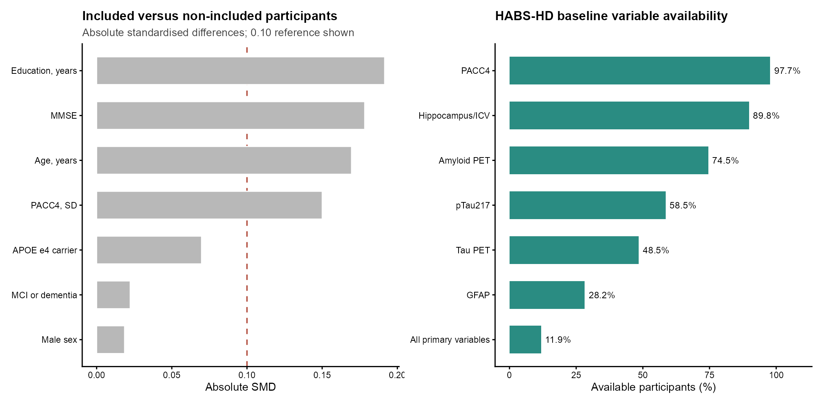

Supplementary Figure S2. Component robustness of the HABS-HD profile association.
Points and horizontal lines show pathology-adjusted PACC4 differences per 1 SD profile (95% CI) for the full profile and for profiles formed after removal of one component. Removal of education produced the greatest attenuation; these component analyses do not identify a causal mechanism.
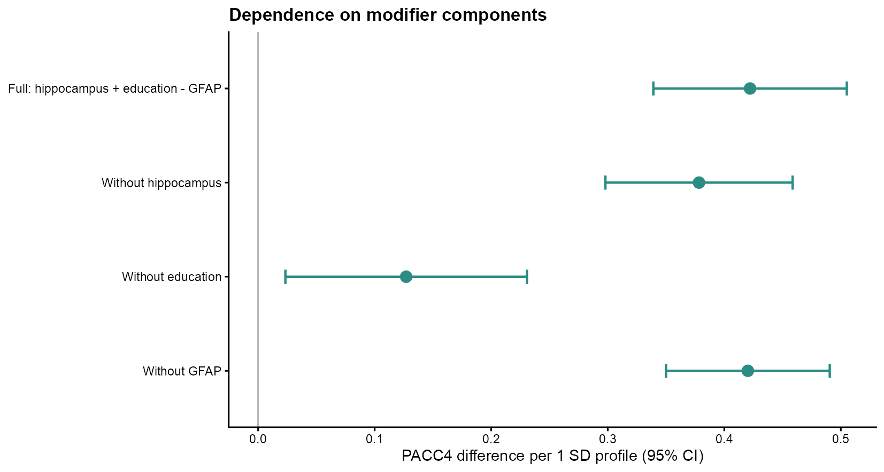

Supplementary Figure S3. HABS-HD analytic sample flow.
Participant counts are shown from the broad baseline clinical cohort to the locked primary complete-case analysis and the supportive A+Tau-high analysis. The major reduction reflects joint plasma biomarker, PET, MRI, and cognitive availability.
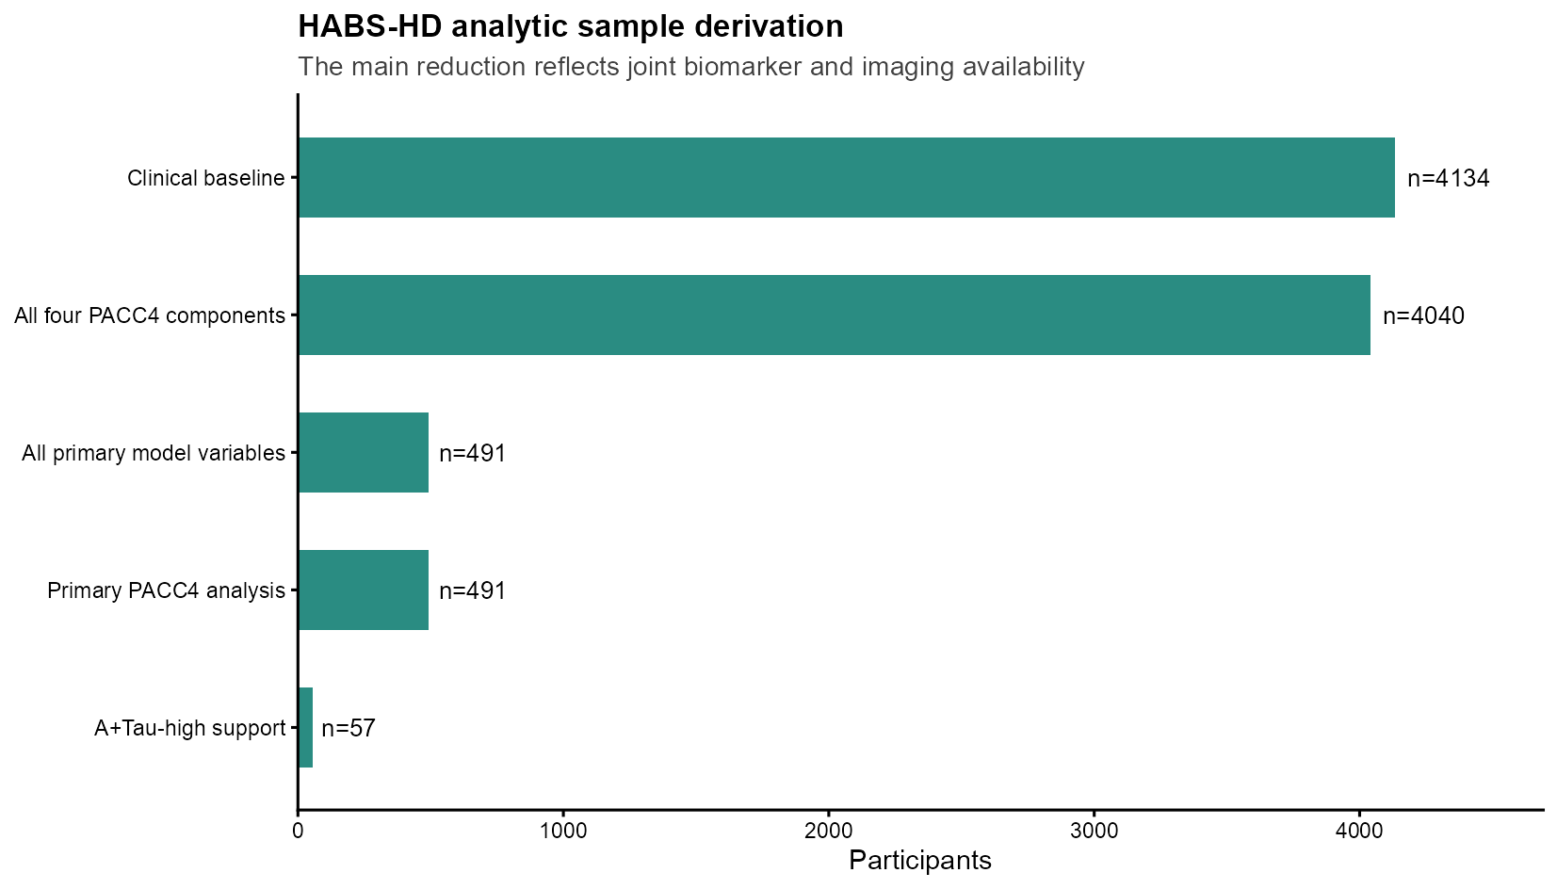

Supplementary Figure Legends
Supplementary Figure S1. Complete-case selection and baseline variable availability in HABS-HD. Absolute standardised mean differences compare included and non-included participants. The dashed line marks an absolute SMD of 0.10. The availability panel shows that the principal reduction to the complete-case analytic set reflects joint multimodal availability rather than PACC4 availability alone.
Supplementary Figure S2. Component robustness of the HABS-HD profile association. Points and horizontal lines show pathology-adjusted PACC4 differences per 1 SD profile (95% CI) for the full profile and for profiles formed after removal of one component. Removal of education produced the greatest attenuation; these component analyses do not identify a causal mechanism.
Supplementary Figure S3. HABS-HD analytic sample flow. Participant counts are shown from the broad baseline clinical cohort to the locked primary complete-case analysis and the supportive A+Tau-high analysis. The major reduction reflects joint plasma biomarker, PET, MRI, and cognitive availability.

