Supplementary figures
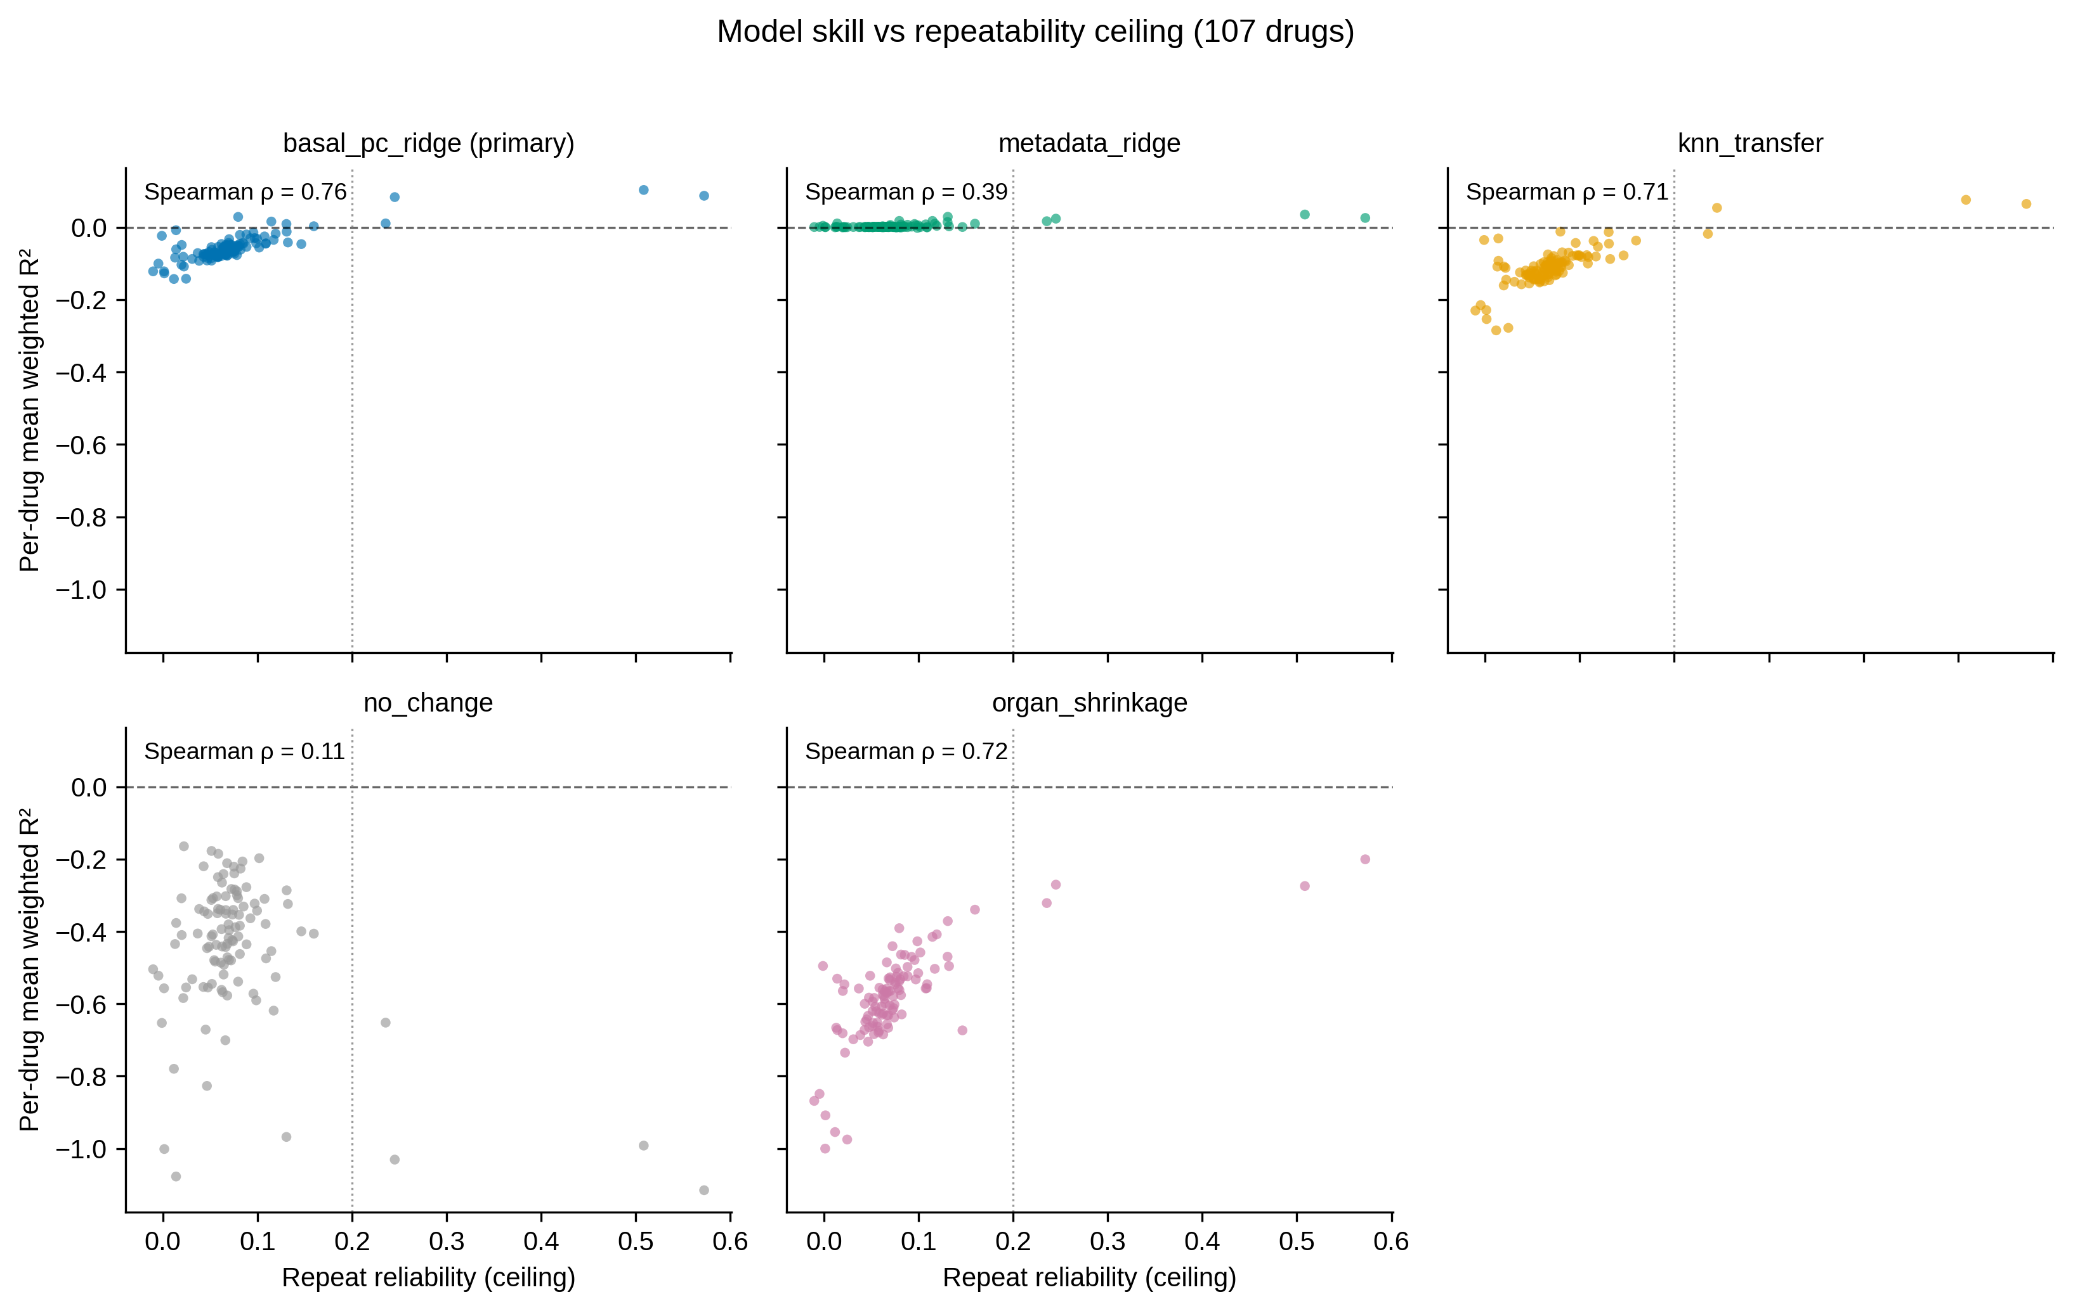
Figure S1. Per-model skill versus the repeatability ceiling. Per-drug mean reliability-weighted residual R² versus repeat reliability for five models (drug_mean omitted: constant 0 by construction) across the 107 drugs with repeat measurements. Spearman ρ: basal_pc_ridge 0.759 (p = 3×10⁻²¹), organ_shrinkage 0.724, knn_transfer 0.711, metadata_ridge 0.389, no_change 0.107 (n.s.). Dashed line: zero skill; dotted line: the 0.2 reliability gate. Supports Tables S1, S3, S4.
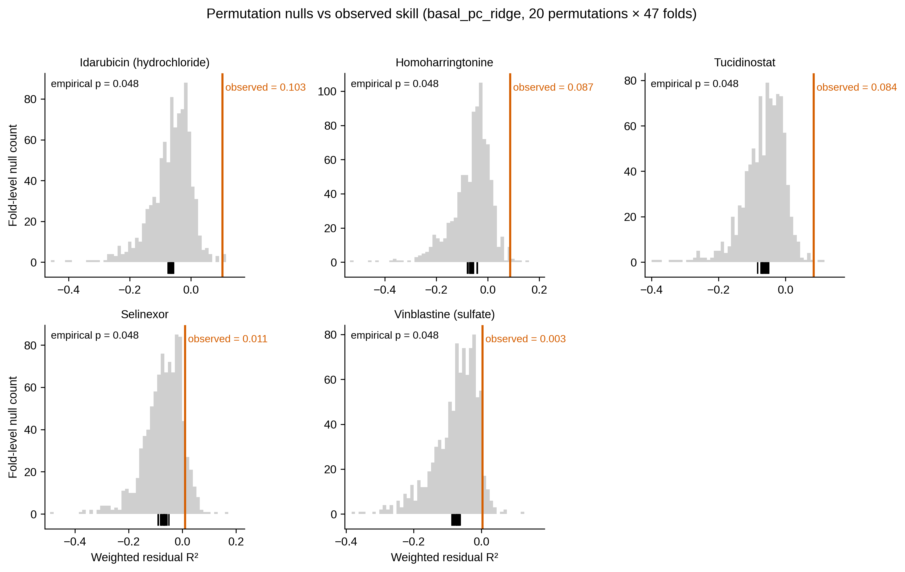
Figure S2. Permutation null distributions for the five high-ceiling drugs. Gray histograms: fold-level permutation-null weighted residual R² with training basal rows shuffled (20 permutations × 47 folds); black ticks: the 20 per-permutation means; orange line: observed basal_pc_ridge skill. All five drugs exceed every permutation mean, but the empirical p is pinned at the 20-permutation floor (1/21 = 0.048) and therefore cannot separate them; per-drug significance against the drug-mean baseline is given by the fold-level tests in §3.3 (Table S8). Supports Table S5.
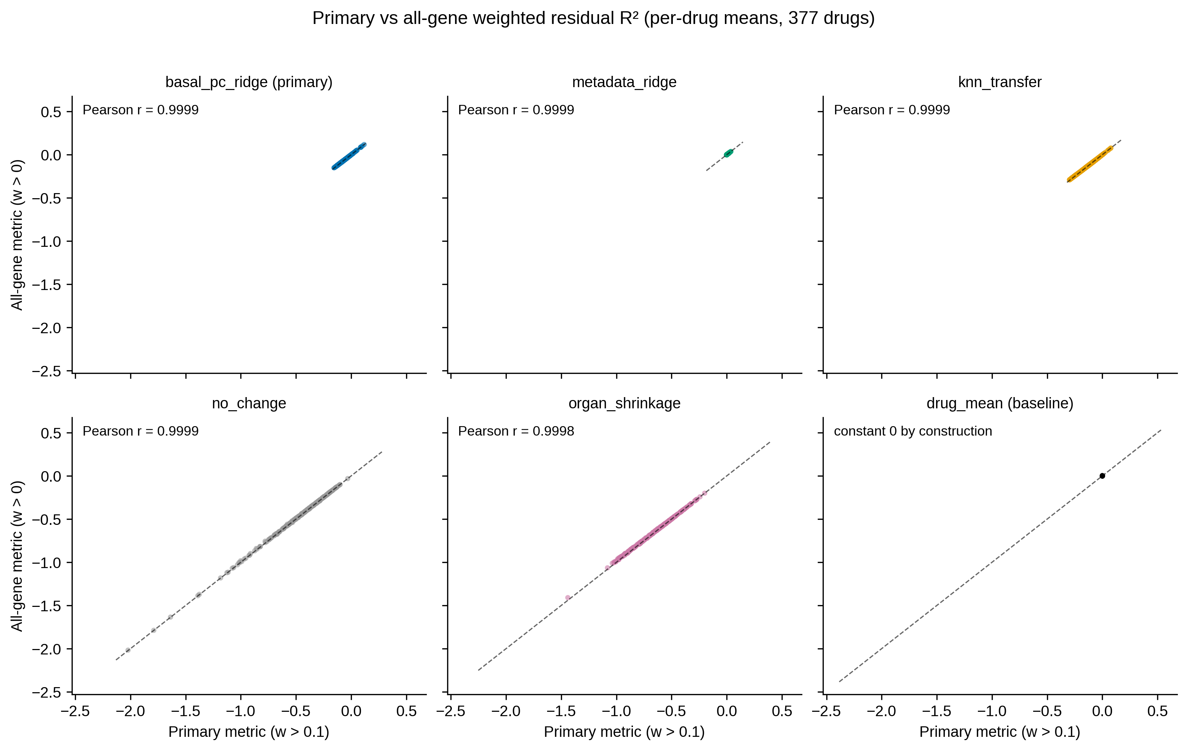
Figure S3. Primary versus all-gene metric. Per-drug mean weighted residual R² under the primary gene filter (reliability weight > 0.1) versus the all-gene filter (weight > 0), per model (377 drugs). Pearson r ≥ 0.9998 for all non-trivial models; drug_mean is constant 0 by construction. Conclusions are insensitive to the weight-floor choice. Supports Table S6.
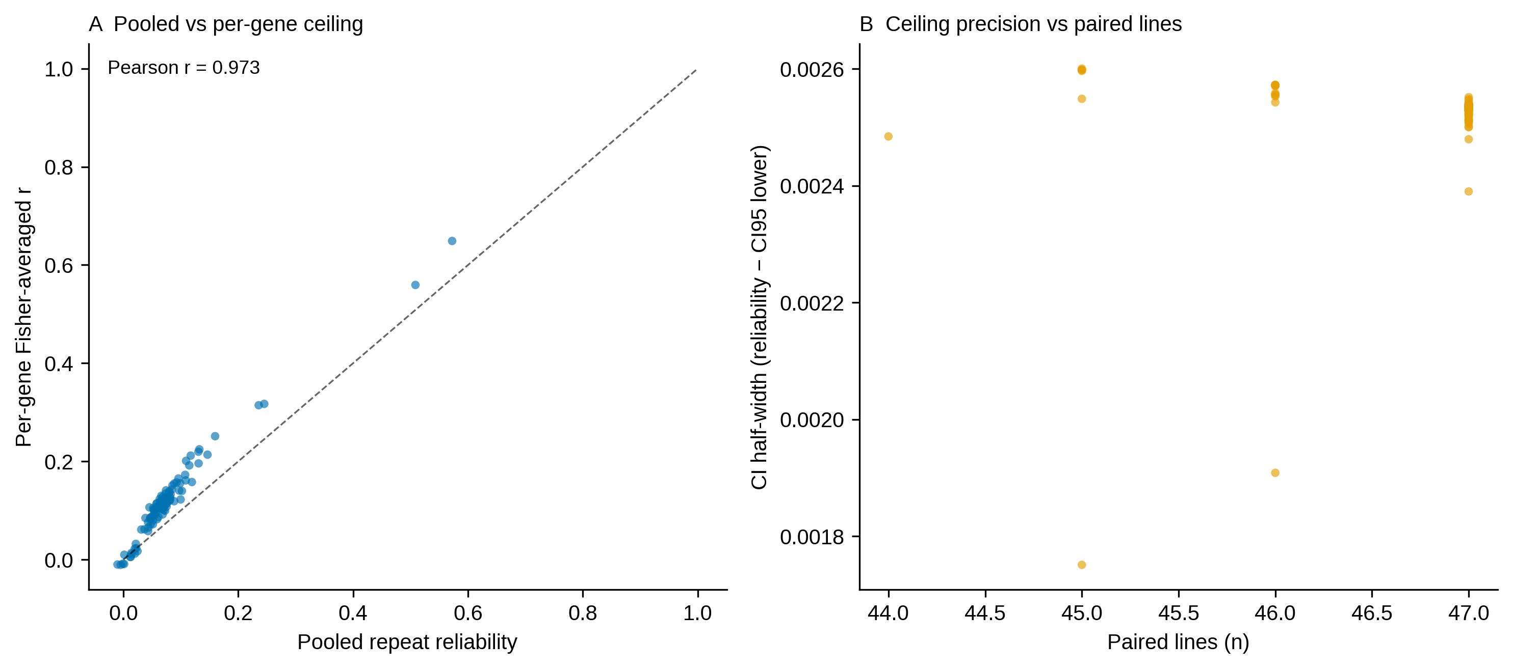
Figure S4. Ceiling estimation diagnostics. (A) Pooled repeat reliability versus the per-gene Fisher-averaged correlation sensitivity estimate (Pearson r = 0.973, n = 107 drugs). (B) Fisher CI half-width versus the number of paired lines; ceiling estimates are least precise for drugs with few paired lines. Supports Table S4.
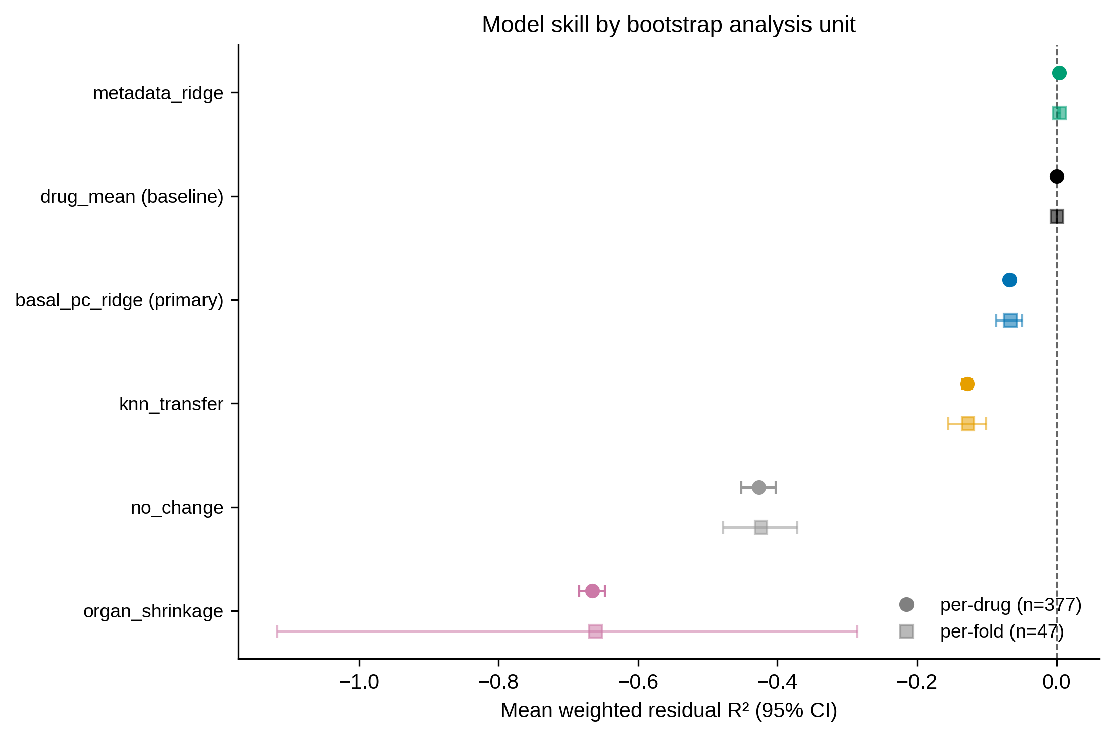
Figure S5. Model skill by bootstrap analysis unit. Mean weighted residual R² with 95% bootstrap CIs computed over drugs (n = 377; circles) or over outer LOCO folds (n = 47; squares). Model ranking is consistent across analysis units; per-fold CIs are wider, reflecting between-line heterogeneity. Supports Table S6.
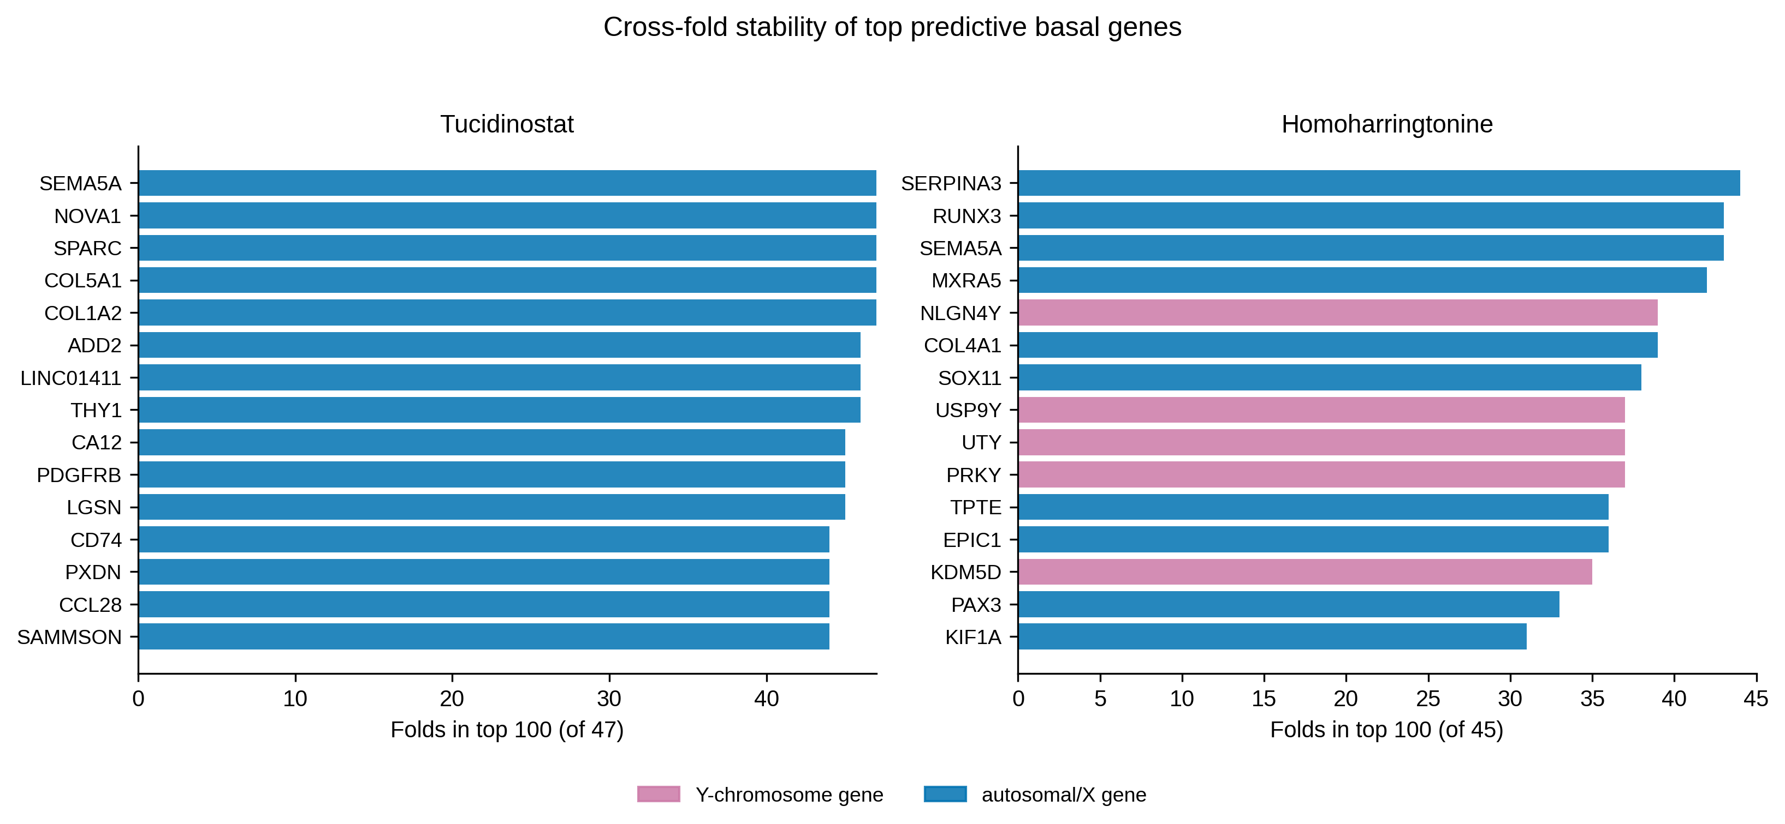
Figure S6. Cross-fold stability of predictive basal genes for Tucidinostat and Homoharringtonine. Top 15 basal genes by the number of LOCO folds in which the gene ranks in the top 100 by predictive importance (analogous to Figure 3A for Idarubicin). Y-chromosome genes in pink. Tucidinostat’s axis is dominated by MHC-II/stromal genes (CD74, SPARC, PDGFRB, COL5A1, CA12); Homoharringtonine’s by ECM/inflammatory genes (SERPINA3, RUNX3, MXRA5) with a partial Y-chromosome component. Supports Table S7.
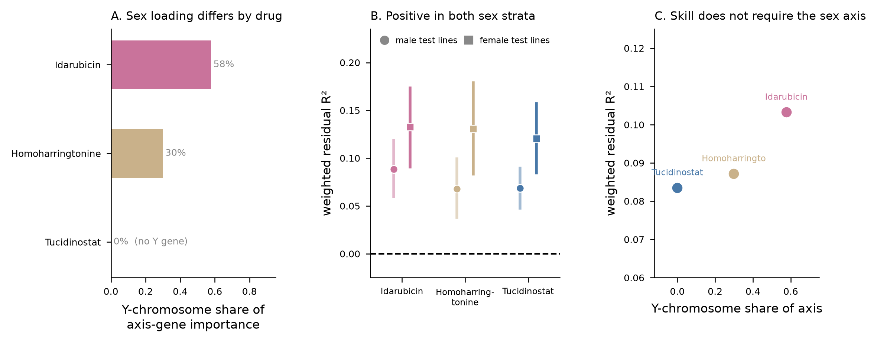
Figure S7. The positive regime does not reduce to donor sex. (A) Y-chromosome share of axis-gene importance for the three drugs that clear the drug-mean baseline; tucidinostat’s axis contains no Y-chromosome gene yet its skill matches the other two. (B) Weighted residual R² with 95% fold-bootstrap CIs computed within each sex stratum of test lines (circles: 30–31 male; squares: 14–15 female); all six strata are significantly positive. (C) Per-drug skill against Y-chromosome share of the axis — skill is flat in sex loading. Donor sex from Cellosaurus for all 47 primary lines (31 male, 15 female, 1 unspecified; the unspecified line is omitted from the stratified panels). Supports Tables S9–S10.

