We would like to thank the editors and reviewers for taking their precious time to help us improve the manuscript. We have revised the manuscript accordingly and provided a point-by-point response report. We are available for further clarifications and corrections in this manuscript in order to fit it in the quality standards of the journal Plant Methods.

Response report for Reviewer 1
Reviewer #1: In this paper, a new spectral fractal dimension index (SFDI) is proposed, compared with other VIs, its constructed model can accurately estimate the value of SPAD. This work provides an in-depth insight for accurately and robustly estimating the SPAD values of rice leaves under disease stress, and it is of great significance for monitoring the chlorophyll content in large-scale fields non-destructively.
There are some problems that need to be modified. The specific suggestions are as follows:
1. In the Materials and methods, it is suggested to add a workflow diagram to facilitate the understanding of the overall technical process and research ideas.

RESPONSE
- We thank the reviewer for this comment, we have added a workflow diagram to present the overall process that we followed to predict the SPAD value of diseased rice leaves (please see Figure 3). We have also provided a brief explanation about Figure 3 in Lines 106-110.

2. In the Calculation of fractal dimension, the expression of SFDI seems to be unclear, and it is suggested to be further clarified here.

RESPONSE
- We thank the reviewer for pointing out this issue. In general, the calculation of fractal dimension consists of three steps, namely (i) spectral normalization, (ii) Iteration of radius, and (iii) fractal dimension logarithmic fitting. To better clarify the calculation process, we improved Figure 10. Meanwhile, we have replaced some misleading names of parameters. For instance, the number of arcs is now denoted by $N(r_{j})$, instead of $T(r_{j})$. We have also added a new figure (please see Figure 11) to present how the radius is iterated for calculating the hyperspectral curve length. After reaching the terminal condition, we could obtain the number of arcs ($r_{j}$) counted in the last iteration. Lastly, we used both $N(r_{j})$ and $r_{j}$ to perform the logarithmic fitting, thereby obtaining the value of SDFI.

3. In the Results, the "Changes of spectral characteristics of disease leaves" and "the Analysis of variation of SPAD value in leaves under different disease levels" are suggested to be put into the discussion section for further description.

RESPONSE
- We thank the reviewer for giving us the opportunity to clarify this issue.
- In the Results section, the change of spectral characteristics of diseased leaves is a part of the experiment that we would like to verify. According to Figure 13, the result shows that the spectral characteristics of rice leaves under different disease levels indeed has a major difference and this is the foundation that we can distinguish diseased and healthy rice leaves by using SDFI. While in the Discussion section, we further illustrated that different disease levels were correlated to different sensitive bands (Lines 416-431).
- Regarding the analysis of variation of SPAD values under different disease levels, this is also a part of the experiment. Because the SPAD values were measured for establishing the ground truth when performing the correlation analysis (mapping spectral characteristics to SPAD values). It is important to verify that rice leaves under different disease levels have distinguishable SPAD values. Therefore, we analyzed the variation of SPAD values for all the samples and visualized the results using an error box in Figure 14.
- We hope the above explanations would address the reviewer’s concern.

4. In order to reduce the noise of hyperspectral images (in the hyperspectral information pre-processing, line 149), the authors used three smoothing methods. Why these three smoothing methods? It is suggested to add some relevant references here. In addition, for the comparison of these three smoothing methods, it is suggested to further discuss them in the discussion part.

RESPONSE
- We thank the reviewer for this comment. Smoothing operation is a standard protocol to follow when pre-processing hyperspectral images because the raw hyperspectral data contains noise. Since smoothing operation is not the focus of this manuscript and for avoiding misleading the readers, we maintained only SG smoothing in this manuscript and removed the other two. SG smoothing is widely adopted in hyperspectral pre-processing. We have added new references ([35] and [36]) to demonstrate the effectiveness of SG smoothing. In fact, we tested SNV, MSC, and SG smoothing methods and we found that SG smoothing worked the best. Therefore, the manuscript now only keeps the SG smoothing (Lines 138-149).

5. In the Empirical design, it is recommended to describe the parameters of hyperspectral camera in the hyperspectral image acquisition part and the introduction of SPAD-502 instrument in the SPAD measurement part.

RESPONSE
- We thank the reviewer for reminding us that we missed this important information. We have added new tables (Tables 1 and 4) for providing the specifications of the hyperspectral imaging system and SPAD-502 meter respectively.

6. In the SPAD measurement section, lines 170-174. It has been described in the Background section for the relationship between SPAD value and chlorophyll content. It is recommended to be simplified here.

RESPONSE
- We thank the reviewer for pointing out this redundancy. We have simplified the description about relation between SPAD values and chlorophyll content in the revised manuscript (please see Lines 157-160).

7. In the Changes of spectral characteristics of disease leaves, line 310. "It is noted that the reflectance in the near-infrared region is negatively correlated with the SPAD value...". Is there any literature support for this statement? It is suggested to add some relevant references here.

RESPONSE
- We thank the reviewer for this comment. We have cited reference [3] to support this statement (the reflectance in the near-infrared region is negatively correlated with the SPAD value).

Response report for Reviewer 2
Reviewer #2: The article is not well written. The author tried to find a new index, SFDI, to better predict the SPAD values related to chlorophyll, however, based on current study it is hard to reach the conclusion. Besides mistakes in experimental design and data analysis, I haven't seen even one citation in the discussion section. Other mistakes are listed below.

RESPONSE
- We thank the reviewer for giving us the opportunity to clarify our work. We have revised the manuscript according to your comments and provided a point-by-point response report below. For better demonstrating the overall workflow, we have added a new figure (Figure 1). First, we captured raw hyperspectral images and performed pre-processing operations over selected ROIs. Second, we measured the SPAD value using a SPAD-502 meter for building the ground truth that was later used for correlation analysis. 4 machine learning models were adopted for building the SPAD prediction model. At this stage, the obtained hyperspectral images were divided into a training set (for regression analysis) and a testing set (for verifying the performance of the prediction models).
- Regarding the Discussion section, we have added new citations to support our findings and discuss the potential research topics in future work. For instance, in Lines 388-390, we have added the reference [25] to support the statement that outbreaks of bacterial blight would affect the rice leaf structure, thereby causing changes of hyperspectral characteristics. In Line 418, we have added the reference [60] to support our finding that SPAD values of rice leaves under different disease levels are sensitive to different bands in the hyperspectral data.
- We really appreciate that the reviewers provided these valuable suggestions to help us improve the manuscript. We hope that the following responses would address the reviewer’s concerns.

- It is not appropriate to separate the different diseases levels in advance and then correlate the SFDI with SPAD values (Fig. 18). Your finding would not make any sense if the different disease levels are given already. The SFDI should be used to predict different disease levels instead.

RESPONSE
- We thank the reviewer for putting forward this concern. Separating the whole dataset into a training set and a testing set is a common approach in machine learning. In general, each data in the training dataset contains two inputs, including a pre-processed hyperspectral image and a disease level, while each data in the testing dataset only has a pre-processed hyperspectral image as the input. The objective of the machine learning model is to learn a function that maps an input to an output based on example input-output pairs (also called labeled training data). In this case, the machine learning models used in this manuscript tried to predict the output of the testing samples and the output is the disease level corresponding to the current image. Separating the different disease levels in advance is the process that we created the labels for the machine learning models. This is a typical process in the domain of supervised learning (a research line of machine learning). Below, we have listed some research works that followed a similar process of labeling annotations in advance:
  - Appeltans S, Pieters JG, Mouazen AM. Detection of leek white tip disease under field conditions using hyperspectral proximal sensing and supervised machine learning. Computers and Electronics in Agriculture, 2021, 190: 1-8.
    - In the above work, the authors divided five classes in advance, including healthy, early disease, moderate disease, and so on. Later, the authors used a machine learning model map the hyperspectral data to these five classes. The authors also split the training and testing dataset by the ratio of 7:3.
  - Selvaraj MG, Vergara A, Montenegro F, et al. Detection of banana plants and their major diseases through aerial images and machine learning methods: A case study in DR Congo and Republic of Benin. ISPRS Journal of Photogrammetry and Remote Sensing. 2020, 169: 1-15.
    - In the above work, the authors used the LabelImg software to perform the labelling work (please see Figure 4 in the above work). The authors input the aerial images and labels to a machine learning model to train their classifier. They divided the training and testing dataset by the ratio of 9:1.

- During the regression analysis, these non-linear algorithms would help much when there was only one predictor, i.e. each of these VIs; it is also hard to believe there were huge differences between different algorithms used in these regression analyses.

RESPONSE
- We thank the reviewer for this comment and we totally agree with the reviewer that the non-linear algorithm (e.g., support vector regression and decision tree) is a powerful method to solve the classification problems. The performance of these machine learning models not only rely on the selection of VIs, but also would be affected by the complexity of tasks. For instance, if these models are deployed to solve a binary classification task (to predict whether the given image is a healthy plant leaf or a diseased one), no matter what VIs are selected, the performance of these models would be acceptable, because there exist huge differences between healthy and disease leaves. However, in this manuscript, we are dealing with a multi-annotation classification problem, and there are 6 annotations (Level 0-5) in total. The complexity of the classification task surely increases. At this time, the use of appropriate VIs plays a key role. Because certain VIs like MCARI and MTCI are less sensitive to the SPAD values of rice leaves under different disease levels. Consequently, the result of the regression analysis varies in the selection of machine learning models and VIs.
- For addressing the reviewer’s concern, we would like to provide the following references to prove that the selection of VIs may have an influence when generating the predictor.
  - Osco LR, Ramos APM, Pereira DR, et al. Predicting Canopy Nitrogen Content in Citrus-Trees Using Random Forest Algorithm Associated to Spectral Vegetation Indices from UAV-Imagery. Remote Sensing, 2019, 11(24): 1-17.
    - In the above work, Table 3 listed the regression analysis (using the random forest algorithm) between the spectral vegetation indices and the canopy nitrogen content. The R² ranged from 0.11 to 0.63, while the RMSE ranged from 1.022 to 2.175.
  - Zhang YC, Yang W, Sun Y, et al. Fusion of Multispectral Aerial Imagery and Vegetation Indices for Machine Learning-Based Ground Classification. Remote Sensing, 2021, 13(8): 1-19.
    - In the above work, Table 4 listed the classification accuracy under different machine learning models and VIs. The result suggested that the accuracy ranged from 0.7383 to 0.9417.
- We hope that the above explanations would solve the reviewer’s concern about the regression analysis.

- From line 301 to 311, almost the whole paragraph was used to describe how the reflectance looks, which was not necessary.

RESPONSE
- We thank the reviewer for pointing out this issue. After revising the manuscript, these contents are now in Lines 297-307 with simplified description. We would like to keep these contents because Figure 13 illustrated that the reflectance under different disease levels vary. To support our finding about the reflectance changes, we have also cited references [57] and [3]. This finding is the key foundation that we built the prediction model later because reflectance under different disease levels shower distinguishable features.

- Line 325-326, did you do chlorophyll extraction in this study? If not it is better to put a citation. Fourth, in Fig. 15, it is better to show a figure with error bars rather than showing the maximum, minimum and median.

RESPONSE
- We thank the reviewer for this comment. Indeed, we did not perform the chlorophyll extraction in this study and we total agree with the reviewer that a citation is needed here. We have added a reference [39] in Line 160 to support the statement that the change of SPAD value can reflect the change of the chlorophyll content accordingly.
- We replaced the maximum, minimum, and median SPAD value with error bars, shown in Figure 14. The explanations about Figure 14 have been added in Lines 330-338.

- In Fig. 17, the title says the correlation between VIs and SPAD value, however, the correlations between all VIs were also shown in the figure, which is too vague to reflect what the title says.

RESPONSE
- We thank the reviewer for detecting this misleading figure. Previously, we would like to analyze the correlation coefficient of selected VIs under different disease levels. Meanwhile, we admitted that we put the wrong title for Figure 17. As the reviewer suggested that Figure 17 is vague, we have removed this Figure in the revised manuscript.

- In Fig. 17, it is strange that both SFDI and MSAVI are positively correlated to SPAD significantly, while they themselves had very low correlation, close to zero.

RESPONSE
- We thank the reviewer for this comment. We found similar analysis in the following work: Zhang YC, Yang W, Sun Y, et al. Fusion of Multispectral Aerial Imagery and Vegetation Indices for Machine Learning-Based Ground Classification. Remote Sensing, 2021, 13(8): 1-19. (Please see Section 2.5, Figure 4 in this work). Figure 4 in Zhang’s work is presented below:
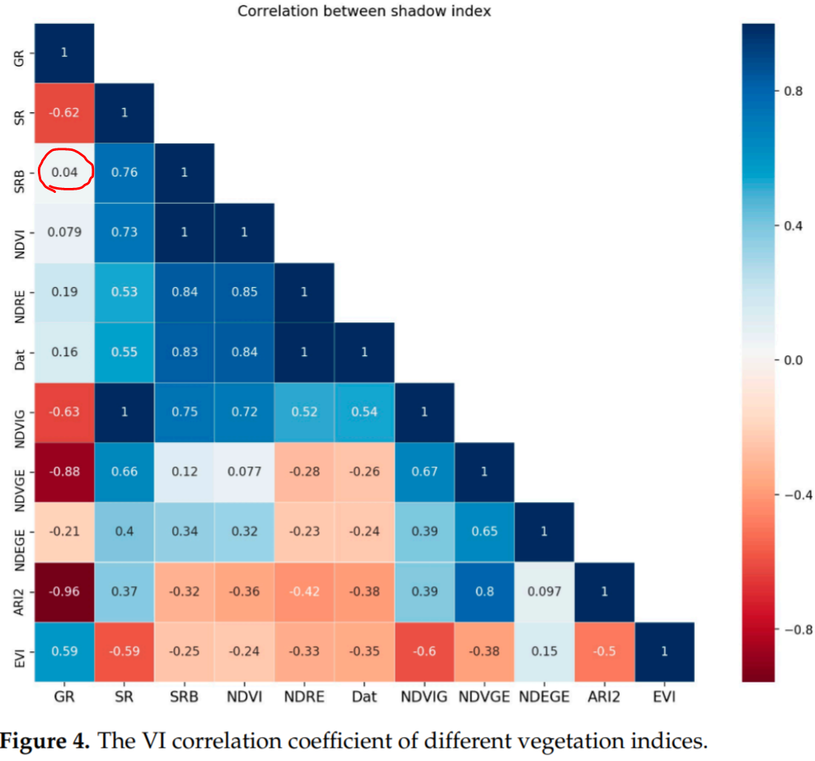
In the above figure, the correlation between GR and SRB achieved 0.04 (in red circle), indicating these indices had low correlation. However, in the classification task, when using SVM-GR and SVM-SRB, the accuracy achieved 0.9267 and 0.8983 (with red lines highlighted) respectively (please see below table).
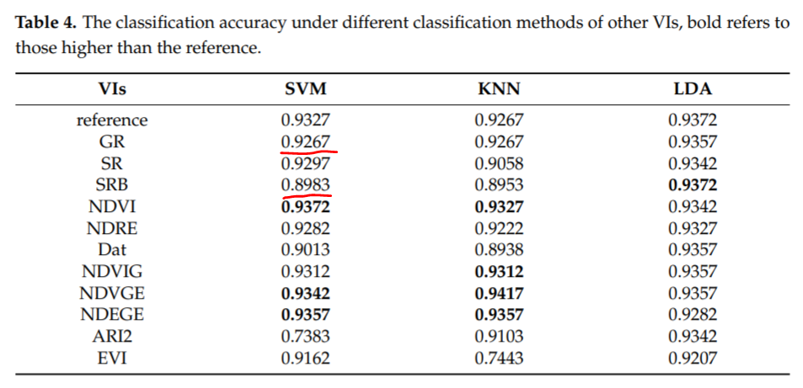
Therefore, it is possible that two indices have low correlation but both could achieve reasonable classification accuracy. We have not investigated the principle of this phenomenon, but we guess the reason is probably because these indices would select different sensitive and anti-sensitive wavelengths. Consequently, these indices judge the prediction from different dimensionalities.
- We hope the above explanations would solve the reviewer’s concern.

- In Fig. 9, it is hard to understand where the ROI was located. If the ROI was close to the cutting point, how could you tell whether the loss of chlorophyll content was due to disease or physical stress from cutting?

RESPONSE
- We thank the reviewer for giving us the opportunity to clarify the selection of ROI. Cutting the head of rice leaves is a common protocol for bacterial infection. We have added description of ROI selection in Lines 171-175. The ROI is selected at 1 cm below the cutting point, because the pathogen would spread along the leaf structure from top to bottom. At the tip of the rice leaf, the symptoms are more obvious since this is where the pathogen first infected. For obtaining a stable measurement, we calculated the average value of the measurements. This averaging method was used in references [3] and [7] as well.

- The hyperspectral image preprocessing part is also hard to understand: whether a preprocessing method is superior to the other ones is dependent on whether it can help you get better prediction or classification results rather than whether they fall out of 0-1 range. It is preprocessing, the data can be of any range, like data transformation.

RESPONSE
- We thank the reviewer for this comment. We have revised the hyperspectral pre-processing part in Lines 134-155. Smoothing operation is a standard protocol to follow when pre-processing hyperspectral images because the raw hyperspectral data contains noise. Since smoothing operation is not the focus of this manuscript and for avoiding misleading the readers, we maintained only SG smoothing in this manuscript and removed the other two. We did not intend to compare the performance of different smoothing methods. SG smoothing is widely adopted in hyperspectral pre-processing. We have added new references ([35] and [36]) to demonstrate the effectiveness of SG smoothing. In fact, we tested SNV, MSC, and SG smoothing methods and we found that SG smoothing worked the best. Therefore, the manuscript now only keeps the SG smoothing (Lines 138-149). As the reviewer suggested, we only wanted to obtain better results with pre-processed data.
- We have also provided a short explanation about removing both ends of the hyperspectral images in Lines 150-155 with references.

- From Fig. 5, it is hard to know how you correlate chlorophyll content with diseases levels, the total amount of the selected leaf segment or any ROI you would like to choose from the leaf.

RESPONSE
- We thank the reviewer for putting forward this question. We would like to clarify that we did not intend to correlate the chlorophyll content with disease levels in Figure 5. Instead, we were annotating classes over our dataset according to the GB/T 17980.19-2000 standard. Rice leaves under different disease levels would show various symptoms. Based on the annotation result, rice leaves labelled by level 0-5 is 200, 170, 160, 200, 140, and 130 respectively, suggesting that this is a balanced dataset. Our dataset was later divided into a training and a testing dataset by the ratio of 8:2 and used for training machine learning based classifiers.

- You said many times that SFDI can better predict SPAD because it takes more information from spectral curve, however, it is not the more information you can capture the better prediction accuracy you will have; it is the important information that are important, e.g. certain wavelengths selected for VI calculation, rather all the spectral information.

RESPONSE
- We thank the reviewer for this suggestion. Current vegetation indices usually adopt two or three wavelengths to predict the SPAD value of plants. In this manuscript, we found that these indices may achieve poor performance when being deployed to predict diseased rice leaves. This is the gap that we identified. Consequently, we considered to use all the spectral information ranging from 420 to 950 to predict the SPAD value of diseased rice leaves and we achieved better accuracy. The reason of this improvement is that the SPAD value of rice leaves under different disease levels is positively correlated with different sensitive wavelengths.
- We are aware that using all the spectral information for prediction has high computational cost. It is challenging to balance the computational cost and prediction accuracy. Many researchers tried to solve this issue. For instance, Shi et al. [RR-1] compared the performance of a machine learning model by using selected spectral variables and full spectra. Sadeghi-Tehran et al. [RR-2] developed two CNNs to classify wheat canopies by using hyperspectral images. The first CNN used pixel vectors of the full spectra features, while the second one used dimension reduction technique to select feature bands. Sadeghi-Tehran et al. discussed the computational efficiency and classification accuracy among proposed two models.
- In this manuscript, we adopted all the spectral information. However, we would like to remind the reviewer that this is only the prototype of our proposal. Since we have already obtained the correlation between sensitive wavelengths and disease levels, we could further reduce the irrelevant spectral information and only use the sensitive ones for improving the index when using the proposed index for large-scale field monitoring.

The references in bullet 2 are listed as follows.
[RR-1] Shi TZ, Chen YY, Liu YL, et al. Visible and near-infrared reflectance spectroscopy—An alternative for monitoring soil contamination by heavy metals. Journal of Hazardous Materials, 2014, 265: 166-176.
[RR-2] Sadeghi-Tehran P, Virlet N, Hawkesford MJ. A Neural Network Method for Classification of Sunlit and Shaded Components of Wheat Canopies in the Field Using High-Resolution Hyperspectral Imagery. Remote Sensing, 13: 1-17.

- The reason to remove both ends of the reflectance, eg. trim 373-1003 to 420-900 was not convincing, especially when SPAD value is calculated based reflectance of 650 and 940nm.

RESPONSE
- We thank the reviewer for raising this concern. For removing both ends of the spectrum, we have added a reference [18] to support our operation. Because both ends of the spectrum contain noise and would have an influence on the prediction result, we have to cut them from the raw spectrum.
- For the selection of wavelengths, based on our experiment, we found that wavelength from 900-940 nm had a minor influence on the prediction results. As the reviewer suggested, we included 900-940 nm in the full spectrum for prediction. In conclusion, wavelengths from 420 to 950 were used in the revised manuscript. We have performed new experiments due to the change of wavelengths. We have updated the experimental results in the whole manuscript accordingly. We would like again to thank the reviewer for this professional advice and help us improve the accuracy of the SPAD prediction model.
  - In Abstract, the correlation between the SPAD value and our proposal reaches a correlation coefficient of 0.8263. (Previously, the correlation coefficient was 0.8261.)
  - In Abstract, the SPAD prediction model built with our proposal and SVR has improved a little, reaching R², RMSE, and RE at 0.8752, 3.7715, and 7.8614% respectively. (Previously, they are 0.8637, 3.6546, and 7.3847%, respectively.)
  - We have calculated the new values of SFDI with 420 to 950 nm, therefore, we have updated Table 6. (There are very minor changes.)
  - We have updated Table 7, in particular, the correlation between the SPAD value and SFDI is 0.8263. (Previously, it is 0.8261.)
  - We have updated Table 8 regarding SFDI and the 4 machine learning models. In general, with the inclusion of 900-940 nm, the prediction accuracy is improved about 1% in average. Please see Table 8 for more details.

