Table S1 Selected CMIP6 GCMs used in CORDEX Australasia simulations by four modelling groups and their global change in temperature between 2071-2100 and 1985-2014
GCM | tas delta (ºC) for 2070-2100 minus 1985-2014 |  | Ensemble composition
GCM | ssp370 | ssp126 | BARPA-ACS | NARCliM2.0 | CCAM-ACS | QldFCP-2
ACCESS-CM2_r2i1p1f1 | 3.58 | 1.95 |  |  |  | 1
ACCESS-CM2_r4i1p1f1 | 3.95 | 1.89 | 1 |  | 1 | 1
ACCESS-ESM1-5_r20i1p1f1 | 3.15 | 1.40 |  |  |  | 1
ACCESS-ESM1-5_r40i1p1f1 | 3.16 | 1.41 |  |  |  | 1
ACCESS-ESM1-5_r6i1p1f1 | 3.23 | 1.54 | 1 | 1 | 1 | 1
CESM2_r11i1p1f1 | 3.12 | 1.70 | 1 |  | 1
CMCC-ESM2_r1i1p1f1 | 2.96 | 1.93 | 1 |  | 1 | 1
CNRM-CM6-1-HR_r1i1p1f2 | 3.51 | 1.82 |  |  |  | 1
CNRM-ESM2-1_r1i1p1f2 | 3.13 | 1.37 |  |  | 1
EC-Earth3_r1i1p1f1 | 3.40 | 1.45 | 1 |  | 1 | 1
EC-Earth3-Veg_r1i1p1f1 | 3.29 | 1.32 |  | 1
FGOALS-g3_r4i1p1f1 | 2.18 | 0.62 |  |  |  | 1
GFDL-ESM4_r1i1p1f1 | 2.55 | 0.92 |  |  |  | 1
GISS-E2-1-G_r2i1p1f2 | 2.62 | nan |  |  |  | 1
MPI-ESM1-2-HR_r1i1p1f1 | 2.41 | 0.86 | 1 | 1
MPI-ESM1-2-LR_r9i1p1f1 | 2.33 | 0.72 |  |  |  | 1
MRI-ESM2-0_r1i1p1f1 | 2.82 | 1.20 |  |  |  | 1
NorESM2-MM_r1i1p1f1 | 2.38 | 0.97 | 1 | 1 | 1 | 1
UKESM1-0-LL_r1i1p1f2 | 4.56 | 2.20 |  | 1

Table S2 Weighted Mean Change in global temperature for four modelling groups (2071-2100 minus 1985-2014) oC

Weighted Mean Change in Global Temperature (2071-2100 minus 1985-2014) ºC
SSP | BARPA-ACS | NARCliM2.0 | CCAM-ACS | QldFCP-2
SSP3-7.0 | 3.06444969 | 3.175728 | 3.16720577 | 2.988174
SSP1-2.6 | 1.47868613 | 1.38034 | 1.55161583 | 1.370381

Table S3 Normalised root mean square error (NRMSE) for frequency of extreme events exceeding 10, 20 and 30 mm h⁻¹. They are ratios of RMSE and the observed mean frequency.
Simulations | prhmax > 10 mm h⁻¹ | prhmax > 20 mm h⁻¹ | prhmax > 30 mm h⁻¹
BARPA-ACS | 0.55 | 0.87 | 1.28
NARCliM2.0-R3 | 1.06 | 1.01 | 1.17
NARCliM2.0-R5 | 1.23 | 1.29 | 1.33
CCAM-ACS | 1.01 | 1.04 | 1.39
QldFCP-2 | 1.18 | 1.33 | 1.5

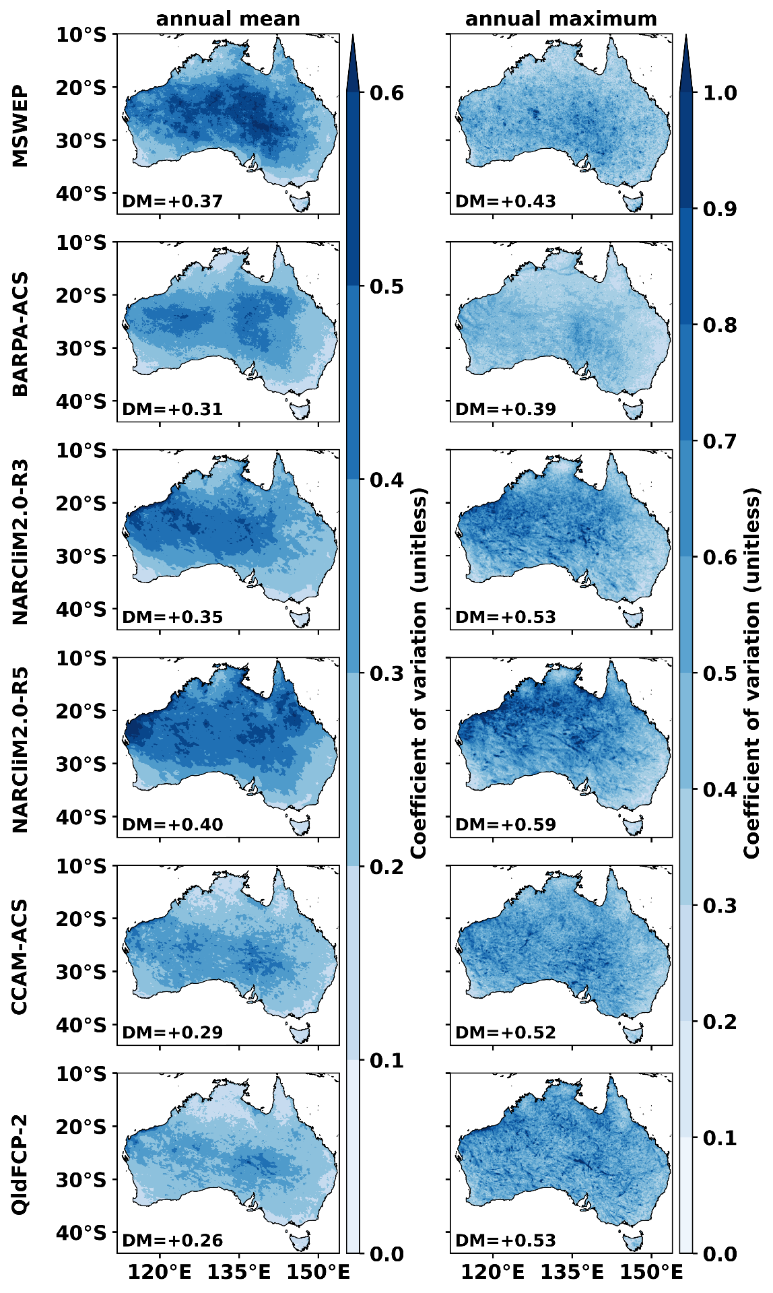
Figure S 1 Coefficient of Variation (CV) of annual mean and annual maximum prhmax for MSWEP and five simulations

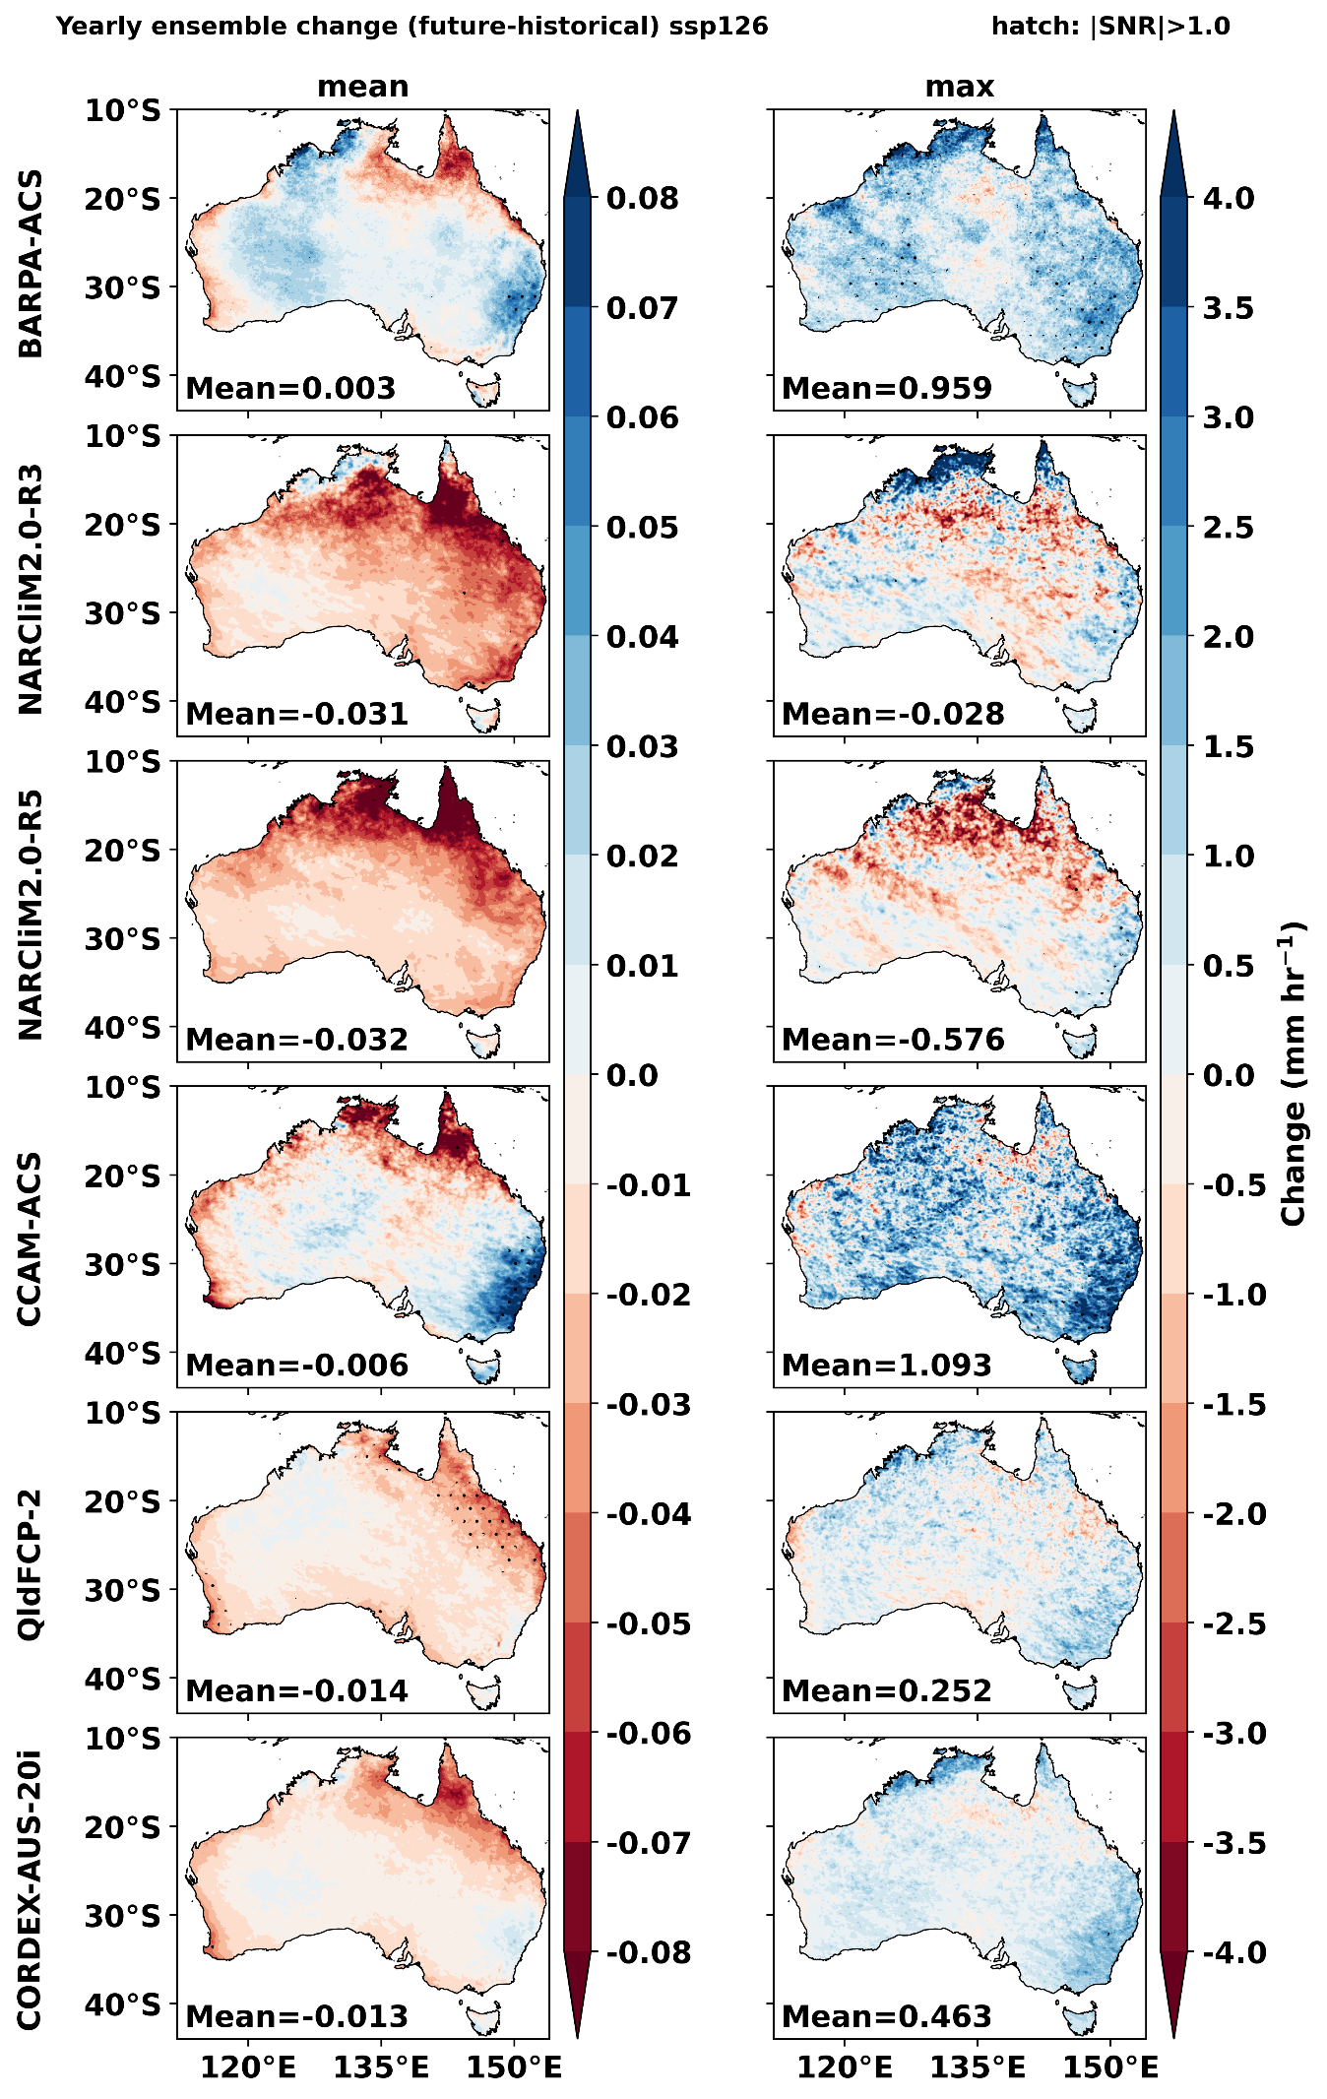
Figure S 2 future projection of annual mean and annual maximum prhmax for ssp126. Stippled areas indicate locations where the signal-to-noise ratio is greater than 1.
.

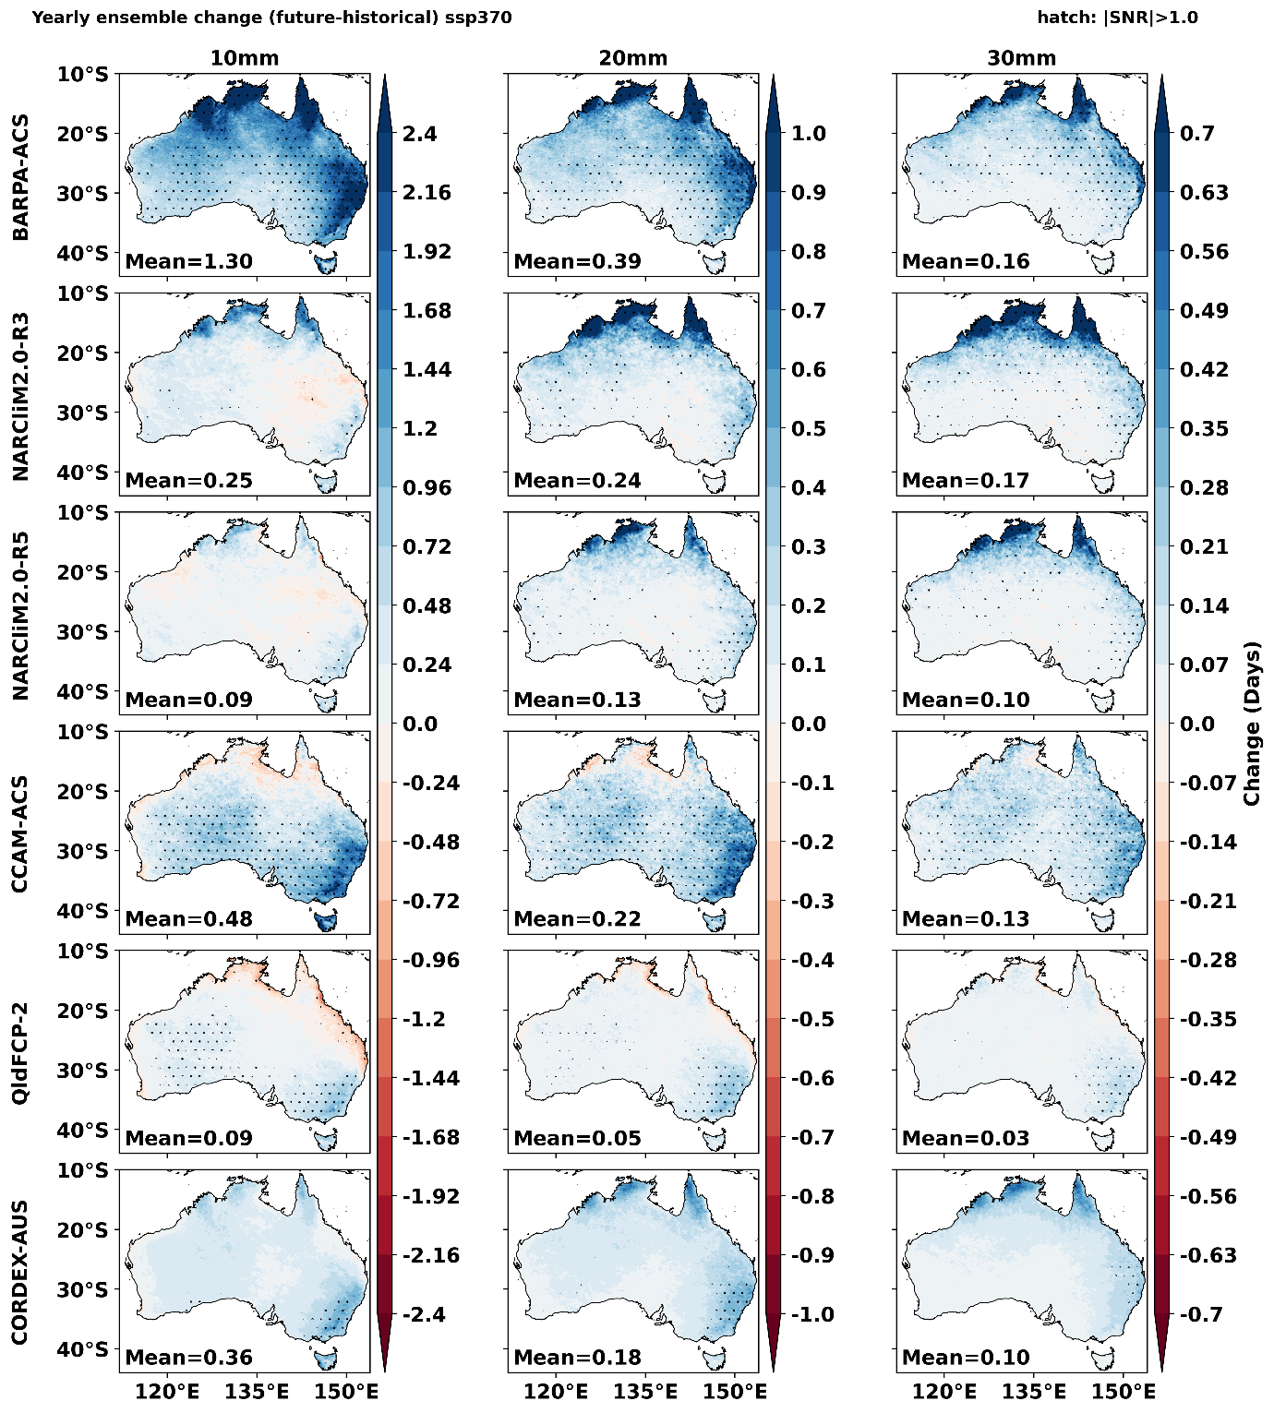
Figure S 3 future changes in days with prhmax exceeding 10, 20 and 30 mm hr-1 for ssp3-7.0. Stippled areas indicate locations where the signal-to-noise ratio is greater than 1

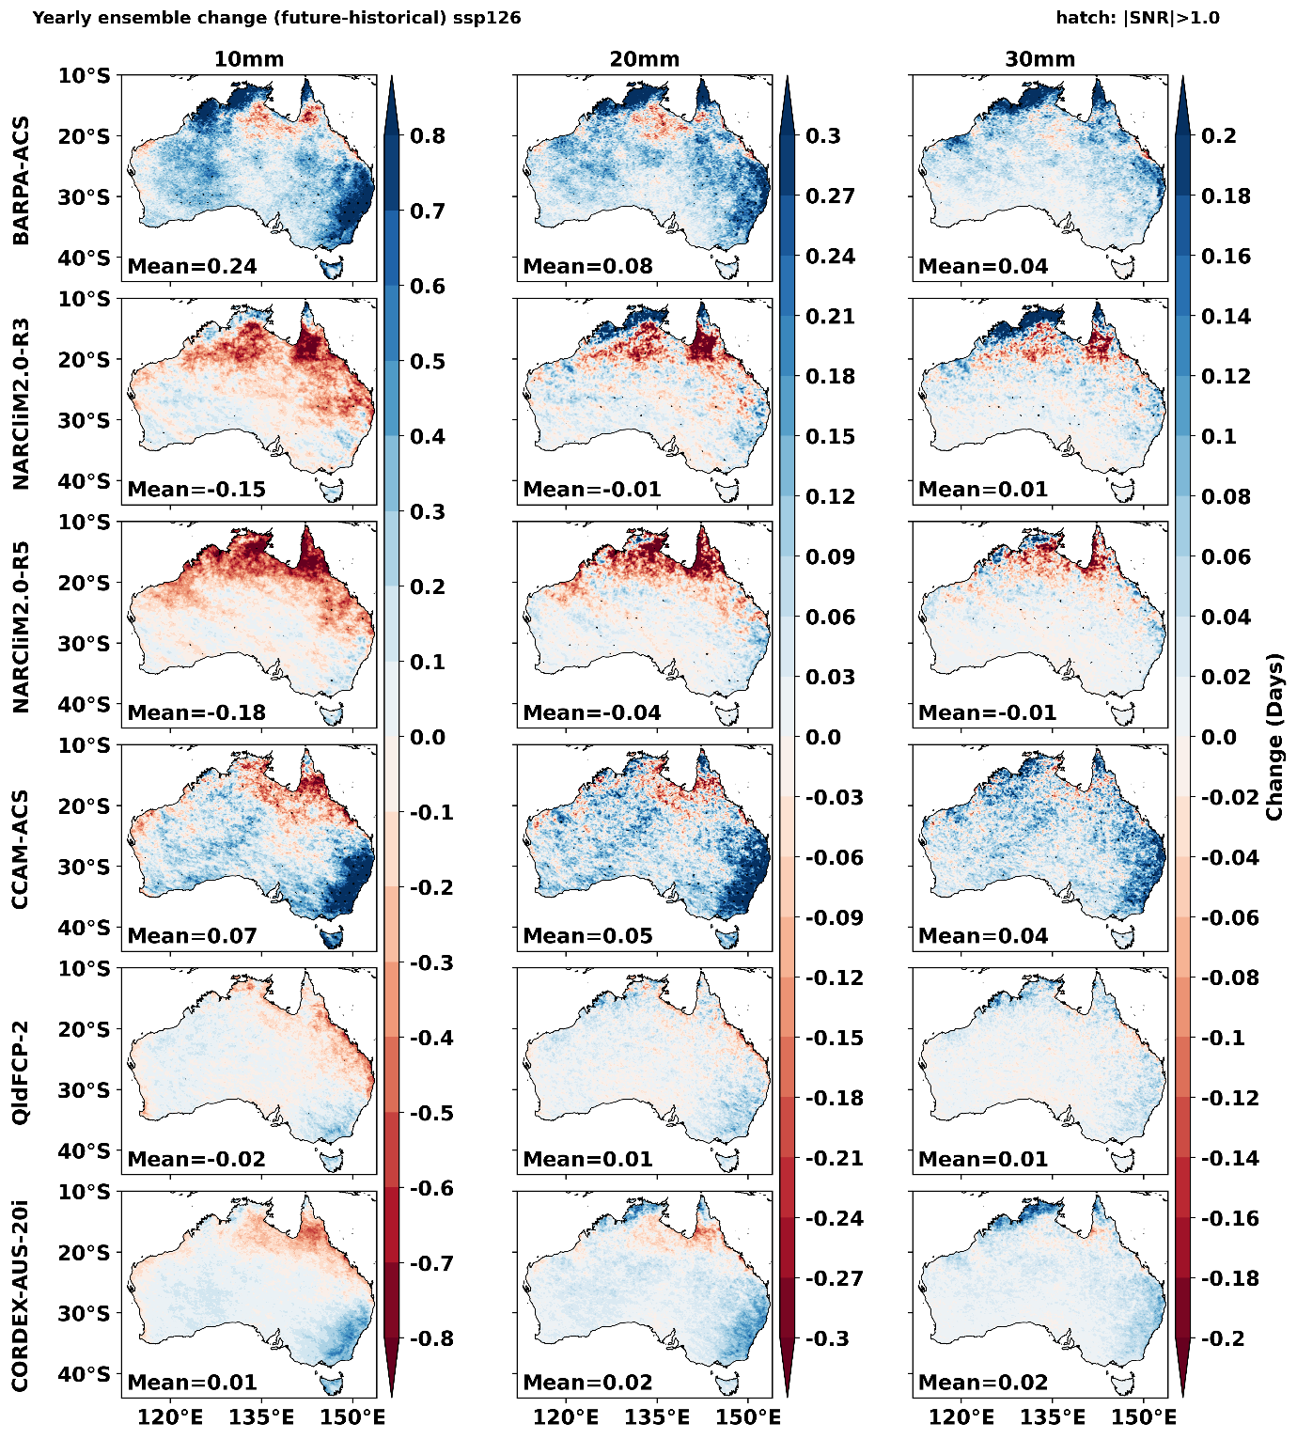
Figure S 4 future changes in days with extreme events exceeding 10, 20, and 30 mmhr-1 for ssp126. Stippled areas indicate locations where the signal-to-noise ratio is greater than 1

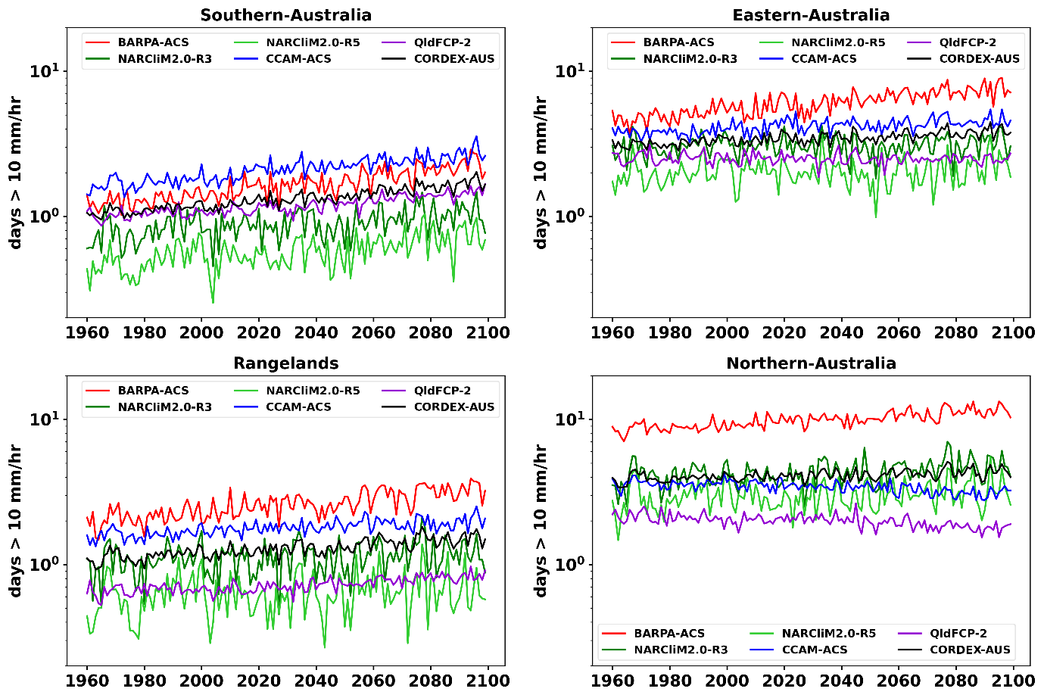
Figure S 5 Interannual variation of days with prhmax exceeding 10 mm hr⁻¹ for five simulations and their ensemble mean over four NRM regions for SSP3-7.0
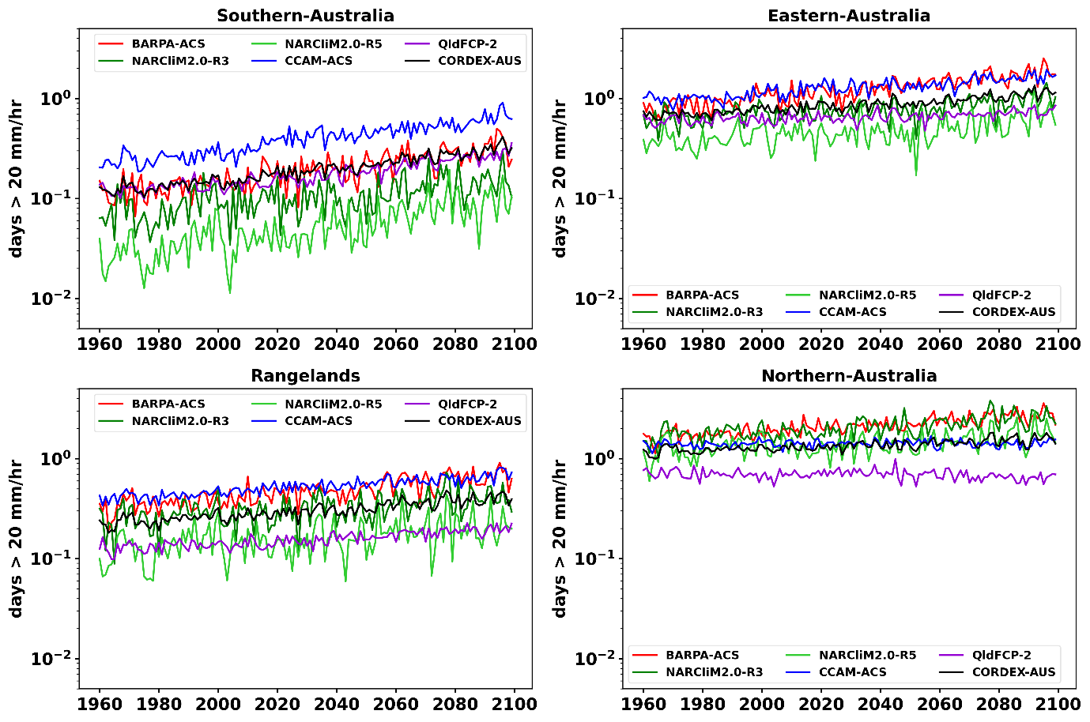
Figure S 6 Interannual variation of days with prhmax exceeding 20 mm hr⁻¹ for five simulations and their ensemble mean over four NRM regions for SSP3-7.0

