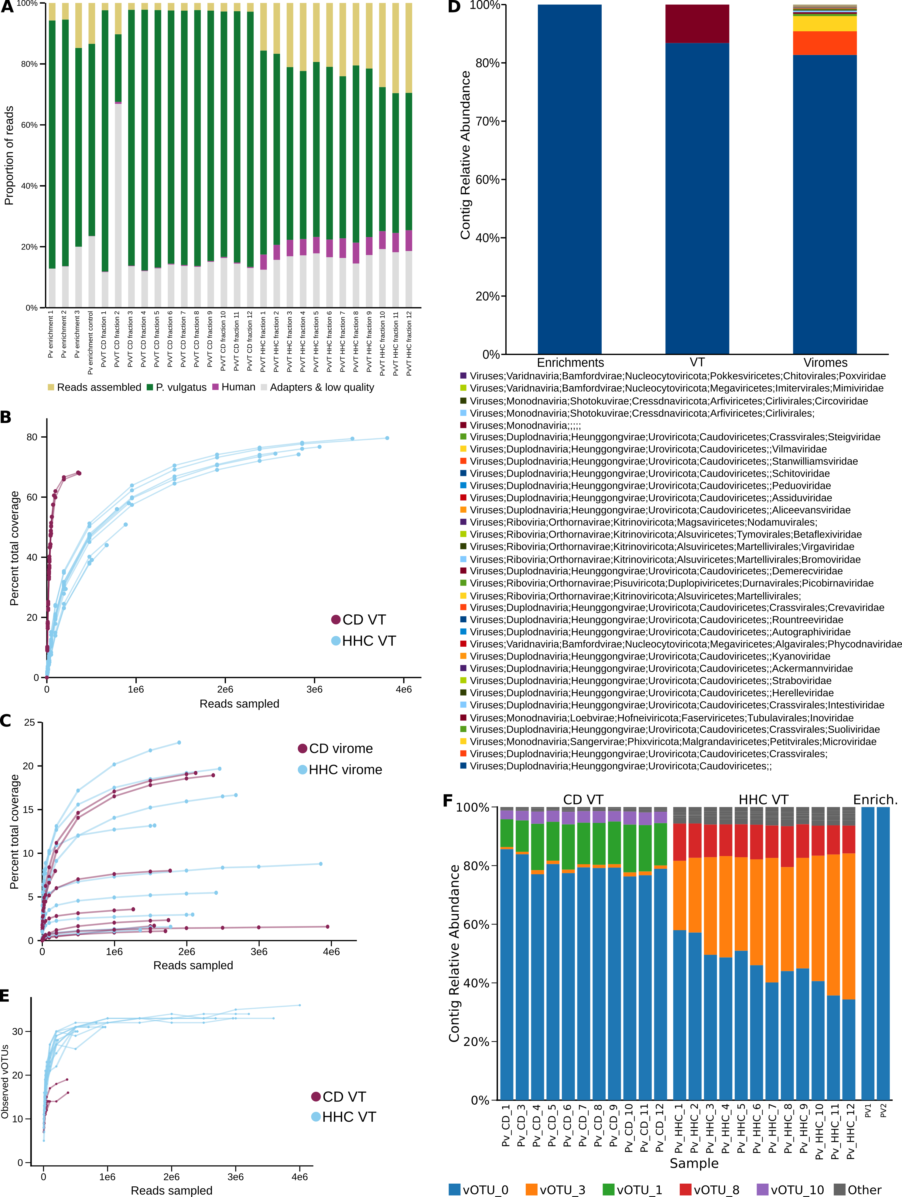
Figure S1. (A) Sequencing reads from VT and enrichment experiments were trimmed, and then filtered to remove adapters, human, and P. vulgatus genome sequence. Reads that aligned with the bacterial genome with an identity of ≥98% were removed. (B) Coverage rarefaction curves for all 365 VT contigs were generated by mapping trimmed reads from individual VT fractions. Reads were subsampled to specified read counts prior to mapping. (C) Coverage rarefaction curves for all metavirome contigs by mapping trimmed reads from individual small cohort viromes (CD, n = 9; HHC, n = 10). (D) Full taxonomic classification of VT, enrichment, and virome contigs was performed with GeNomad³⁴. Only contigs classified as viruses are shown. (E) Richness rarefaction curves were generated by mapping trimmed reads from VT to the longest representative contigs of each vOTU. Reads were subsampled to specified read counts prior to mapping. Counts of contigs according to vOTU assignment. Count of vOTUs detected by read mapping. (F) Relative abundance of vOTUs in individual VT and enrichment samples, calculated by normalizing mapped read counts to total sample mapped reads.

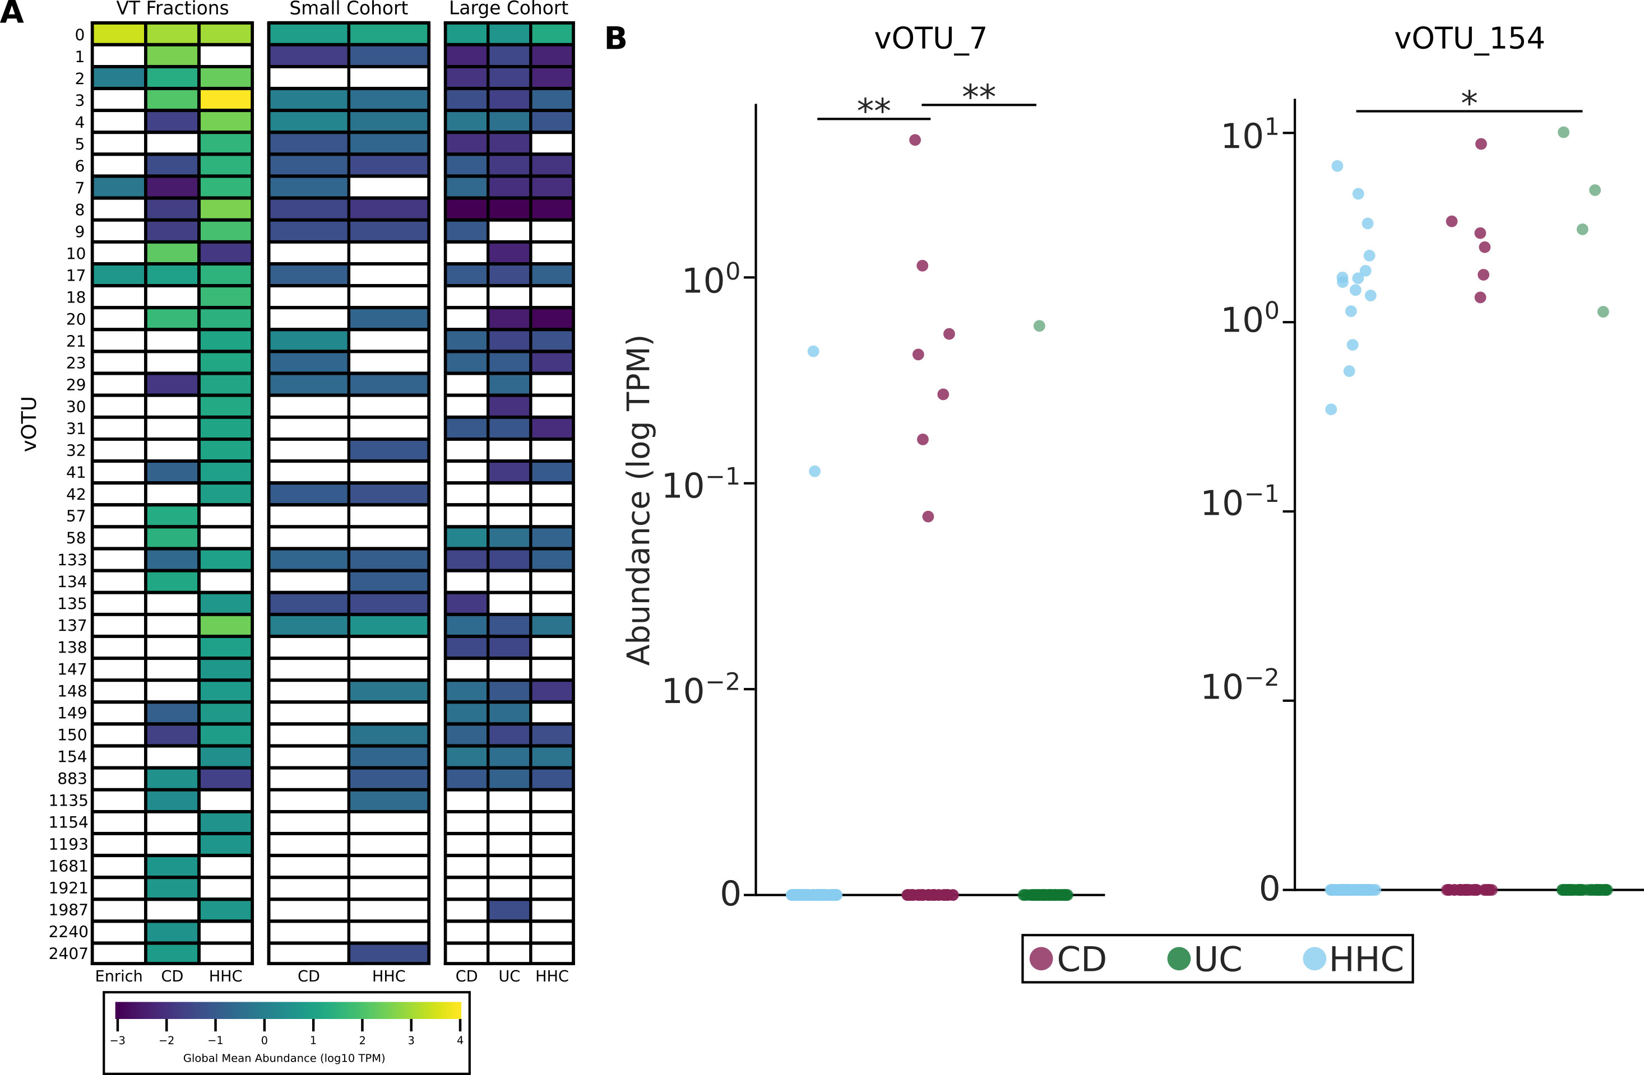
Figure S2. (A) vOTU relative abundance across three sample cohorts: experimental (enrichment, n = 2; VT, n = 23), small cohort viromes used as inputs for VT (n = 19), and a large previously published IBD cohort (n = 169)³. Only vOTUs observed by VT and/or enrichment assemblies shown. Coverage of vOTU_10 in UC from the large cohort represents a single sample. vOTU relative abundances were calculated as transcripts per million (TPM) by normalizing raw mapped read counts by contig length in kilobases (RPK) and scaling to total sample RPK. A detection floor threshold of 0.5 TPM was applied to eliminate non-specific mapping noise (values < 0.5 TPM set to 0; shown as white). Individual contig TPMs were aggregated by summing across vOTU clusters. (B) Differentially abundant vOTUs between at least two conditions in the large cohort. Only vOTUs occurring in at least 5% of samples in any individual condition were considered. No significantly different comparisons were observed in the small cohort or for any other vOTU. Asterisks denote statistically significant pairwise differences calculated via uncorrected two-sided Mann-Whitney U test (* p < 0.05, ** p < 0.01).
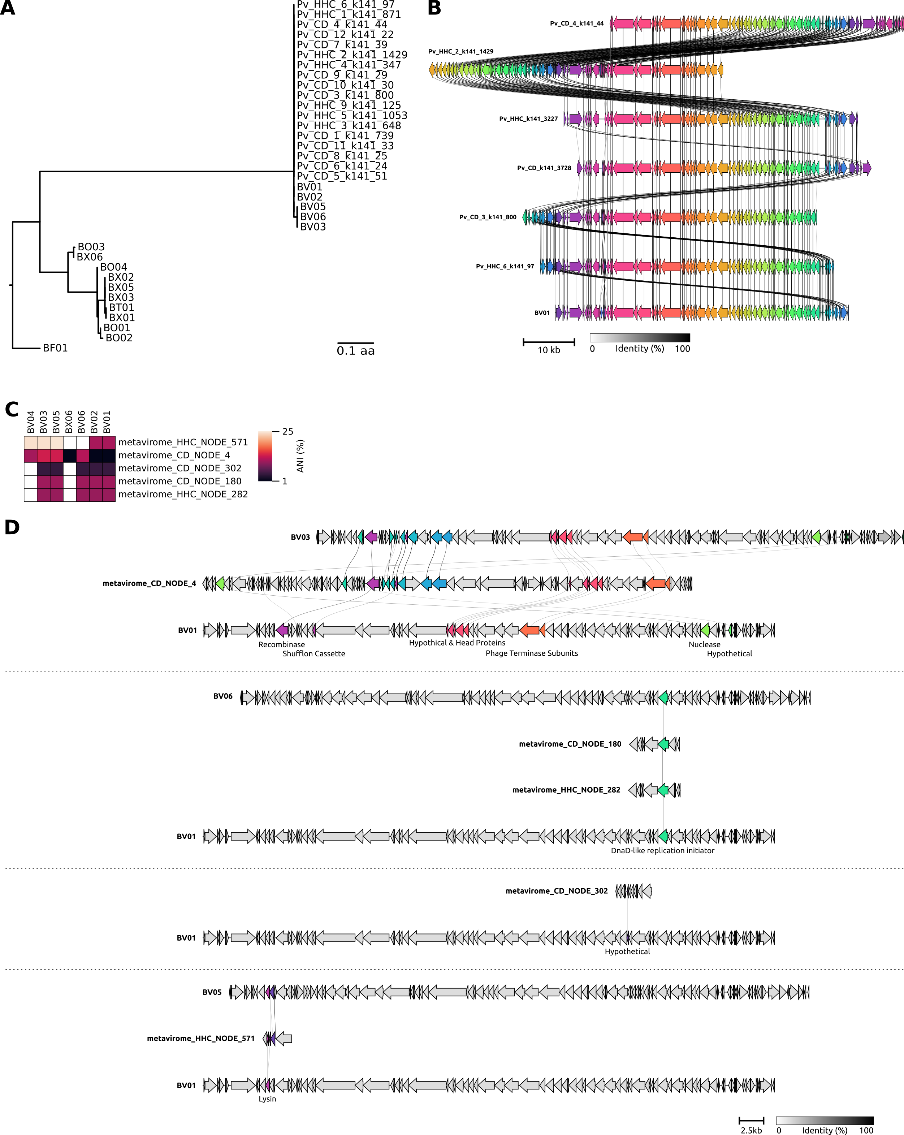
Figure S3. (A) Phylogeny of BV01-like contigs and select Salyersviridae phages by multilocus sequence alignment of a concatenation of 6 conserved proteins: portal protein, major capsid protein, head maturation protease, ssDNA binding protein, RNA polymerase sigma factor, and RecE-like recombination exonuclease. Only contigs with completeness great enough to include all marker genes were included. (B) Protein similarity alignment of phage BV01, consensus contigs generated by co-assembly of all CD or HHC VT reads, and 4 additional complete BV01-like contigs from individual VT fraction assemblies. Terminal shifted genome regions are due to differential assembly breaks of the circular genome. The alignment was generated with Clinker⁷¹. (C) Average nucleotide identity (ANI) between vOTU-related metavirome contigs and related Salyersviridae phages. ANI was calculated as the length-weighted ANI of reciprocal local alignments >2 kb based on reciprocal BLASTn³³ outputs. (D) Protein-similarity alignments of 5 related virome contigs outside vOTU_0 with BV01 and other related Salyersviridae phage genomes. The alignments were generated with Clinker⁷¹.
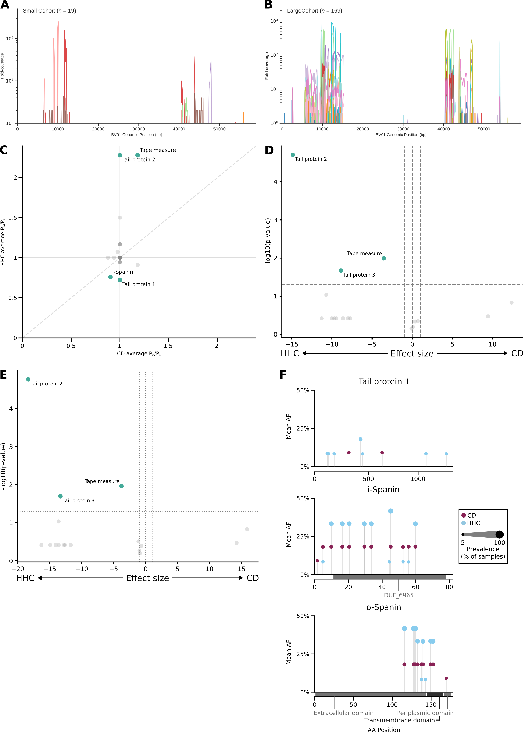
Figure S4. (A, B) Raw depth coverage profiles of the BV01 genome for input (n = 19) (A) and large (n = 169) (B) cohort viromes. Each curve represents an individual virome; curves depict a 50 bp rolling-mean smoothed read depth. (C) Average P_{n}/P_{s} was calculated for each gene (n = 84) in CD and HHC from self-mapping data. Highlighted and labeled genes exhibit significant divergence from neutral selection (P_{n}/P_{s} = 1) in HHC VT samples. A pseudocount of 10⁻⁷ was applied to all genes. No genes were significantly different from neutral selection in CD VT. Significant genes were identified by Wilcoxon signed-rank test with Benjamini-Hochberg False Discovery Rate multiple testing corrections q < 0.05. (D) Volcano plot of effect size and significance of nucleotide diversity (π) for all BV01 genes (n = 84) based on BV01-mapping. Statistical significance was calculated using a two-sided Fisher’s exact test. Effect sizes are expressed on the horizontal axis as the log₂-fold change between CD and HHC. Highlighted points indicate genes crossing a nominal significance threshold of raw p < 0.05. (E) Volcano plot of effect size and significance of mutation density for all BV01 genes (n = 84) based on BV01-mapping. Statistical significance was calculated using a two-sided Fisher’s exact test. Effect sizes are expressed on the horizontal axis as the log₂-fold change between CD and HHC. Highlighted points indicate genes crossing a nominal significance threshold of raw p < 0.05. (F) Lollipop plots depicting mean allele frequency across samples and sample prevalence for additional proteins of interest. Blue indicates alleles in HHC; maroon indicates alleles in CD. Only nonsynonymous SNPs are shown.

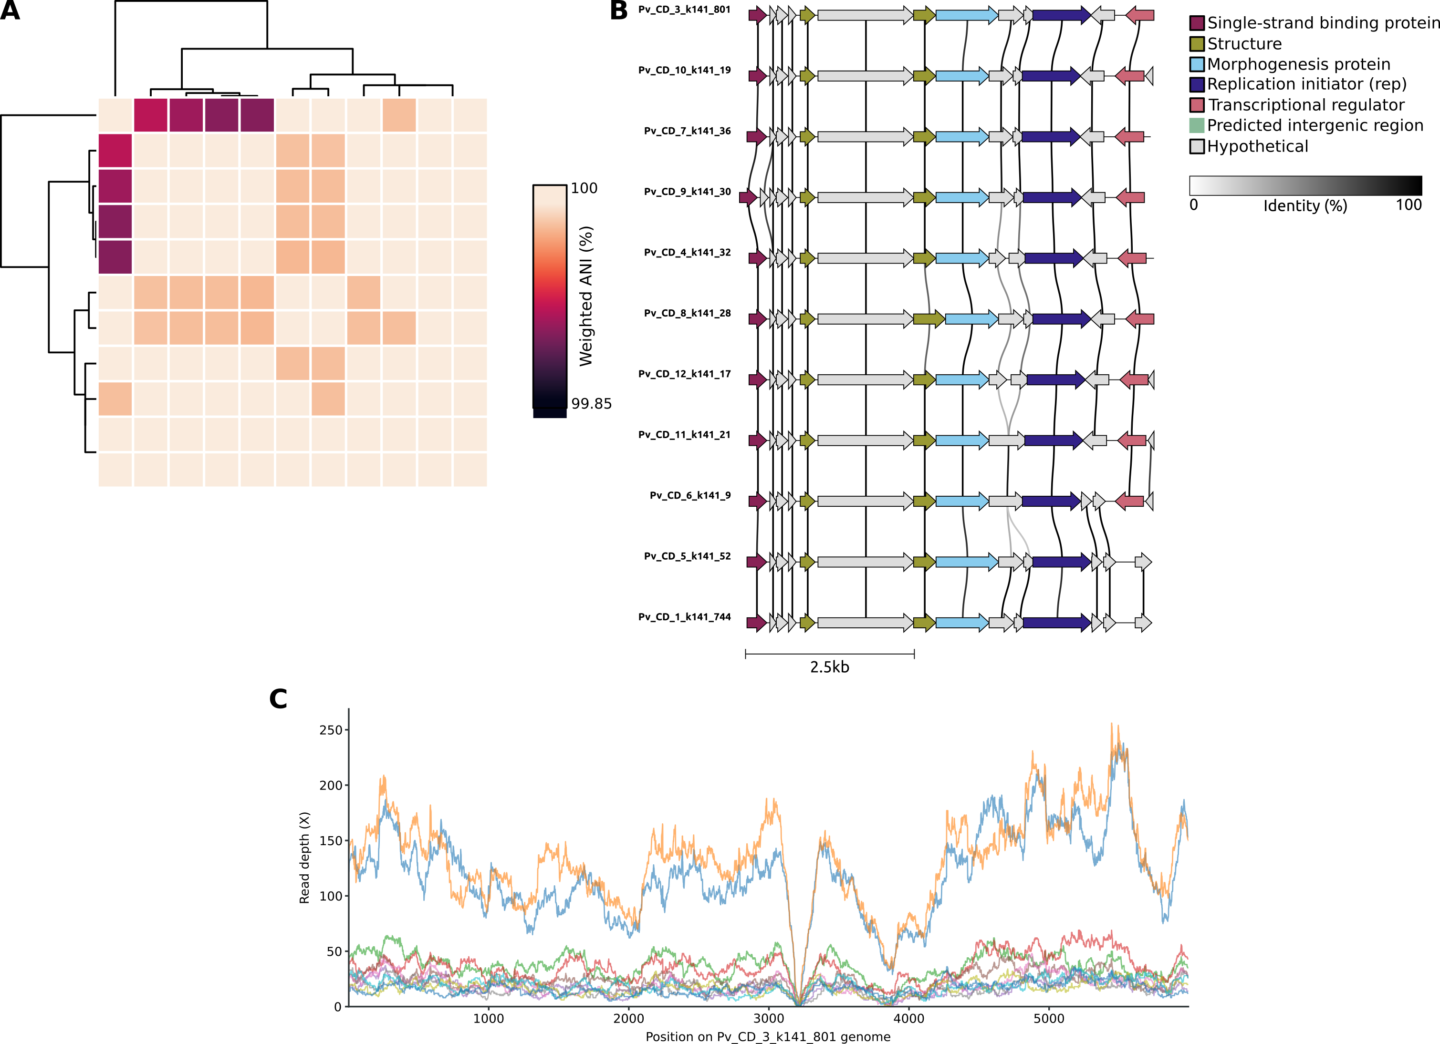
Figure S5. (A) ANI similarity matrix of all 11 PvIno1 genomes based on weighted ANI. ANI was calculated as the length-weighted average nucleotide identity of reciprocal local alignments >500 bp based on reciprocal BLASTn³³ outputs. (B) Protein-similarity alignment of all pvIno1 genomes. The alignment was generated with Clinker⁷¹. (C) Raw coverage curve of PvIno1 representative contig Pv_CD_3_k141_801 by individual CD VT fractions.

