Supporting Information

Enhancing carbon utilization and adsorption performance of sludge derived activated carbon through molten salt synthesis method

En Shi ª, Xinyu Wang ª, Miao Zhang ^{b*}, Xin Wang ª, Jianchun Gao ^{b}, Yunbin Zheng ª

ª School of Municipal and Environmental Engineering, Shenyang Jianzhu University, Shenyang, 110168, China
^{b} School of Material Science and Engineering, Shenyang Jianzhu University, Shenyang, 110168, China

E-mail: zhangmiao@sjzu.edu.cn (Miao Zhang)

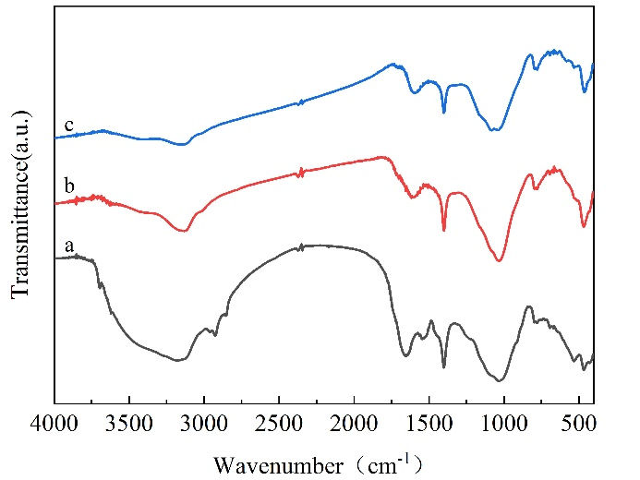
Fig. S1 FTIR spectra of sludge and SDAC, (a) sludge, (b) SDAC-0 and (c) SDAC-1

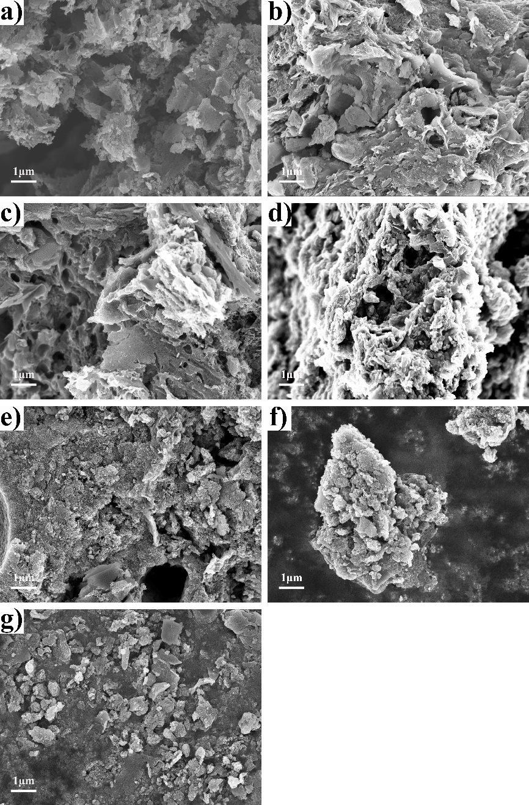
Fig. S2 SEM of SDAC, (a) SDAC-0, (b) SDAC-0.1, (c) SDAC-0.5, (d) SDAC-1, (e) SDAC-2, (f) SDAC-5 and (g) SDAC-10
Table S1 Textural properties of SDAC
Samples | S_{BET} (m²/g) | V_{Total} (cm³/g) | S_{Micro} (m²/g) | V_{Micro} (cm³/g)
SDAC-0.1 | 182.35 | 0.17 | 90.41 | 0.04
SDAC-0.5 | 414.60 | 0.28 | 276.84 | 0.13
SDAC-1 | 549.72 | 0.37 | 273.85 | 0.13
SDAC-2 | 416.46 | 0.27 | 208.35 | 0.10
SDAC-5 | 503.19 | 0.41 | 152.37 | 0.07
SDAC-10 | 549.60 | 0.45 | 153.39 | 0.07

Table S2 Adsorbing capacity of CO₂ and methylene blue (MB) on SDAC
Samples | CO₂ adsorbing capacity ª  (mg/mg_{(SDAC)}) | MB adsorbing capacity  (mg/mg_{(SDAC)})
SDAC-0.1 | 0.0401 | 0.0080
SDAC-0.5 | 0.0565 | 0.0411
SDAC-1 | 0.0575 | 0.0786
SDAC-2 | 0.0458 | 0.0771
SDAC-5 | 0.0451 | 0.0659
SDAC-10 | 0.0512 | 0.0784
ª CO₂ adsorption isotherms were measured at 298K and 1.0 bar

Table S3 The yield and carbon utilization potential of SDAC
Samples | Carbon mass fraction  (mg_{(carbon)}/mg_{(SDAC)}) | Yield  (mg_{(SDAC)} /g_{(sludge)}) | Carbon utilization potential  (mg_{(carbon)} /g_{(sludge)})
SDAC-0.1 | 0.2747 | 494.73 | 135.90
SDAC-0.5 | 0.3316 | 482.07 | 159.85
SDAC-1 | 0.3448 | 517.87 | 178.56
SDAC-2 | 0.3593 | 484.73 | 174.16
SDAC-5 | 0.3510 | 455.90 | 160.02
SDAC-10 | 0.2816 | 448.00 | 126.16

