New approach for estimating socioeconomic indicators in small-areas with sparse samples and high within-region heterogeneity: application in the Peruvian Amazon

This supplementary file provides supplemental data, figures, and more detailed results for “New approach for estimating socioeconomic indicators in small-areas with sparse samples and high within-region heterogeneity: application in the Peruvian Amazon”
Table of contents
Section 1. Supplementary Information 2
1.1. Characteristics of the Loreto region 2
1.2. ENDES survey 3
1.3. National census 5
Section 2. Supplementary Methods 6
2.1. Principal Component Analysis (PCA) for census variables 6
2.2. Model specification 7
Section 3. Supplementary Results 12

Section 1. Supplementary Information

Characteristics of the Loreto region
Loreto is the largest department (administrative level 1) in the Peruvian Amazon. It currently comprises eight provinces (administrative level 2) and 53 districts (administrative level 3). Before 2016, Loreto had 51 districts, since the districts of the Province of Putumayo (in northern Loreto) were considered as one. This difference can be seen in Supplementary figure 1. In addition to the creation of new districts, Loreto underwent a reorganization of its geographic location codes (UBIGEO) following the creation of districts in the province of Putumayo.
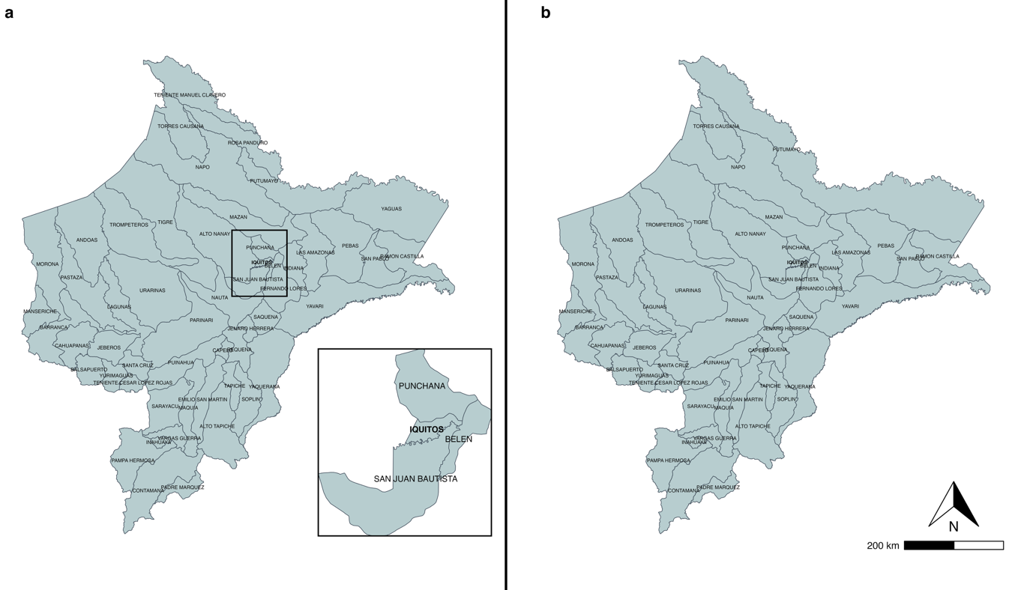

Supplementary figure 1.1. Administrative division of the districts of Loreto. Since each district is delineated according to the rivers that traverse the region, their shapes and boundaries are highly irregular. The region includes large districts such as Napo, Tigre, and Yaguas, as well as smaller ones such as Iquitos, Inahuaya, and Belén. A. Current administrative division of Loreto, comprising 53 districts. The location of its capital, Iquitos, is indicated. B. Administrative division of Loreto before 2016, when it had 51 districts
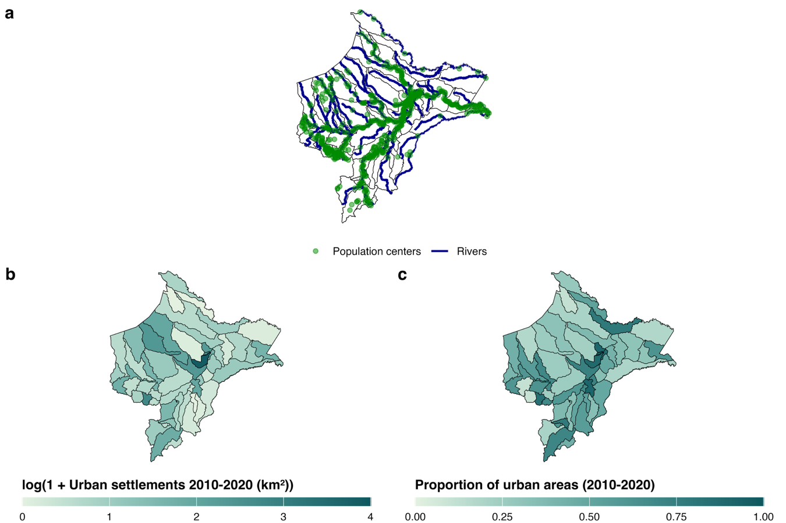
Loreto is a department characterized by distinctive geographic and socio-demographic heterogeneity. As shown in Supplementary Figure 2, river transportation is the main transportation route, resulting in most population centers being located along the riverbanks. In addition, about 70% of the houses are in urban areas (1). However, there are districts with almost 98% urban areas such as Iquitos, the capital of Loreto, and districts such as Alto Nanay with 100% of housing in rural areas (1). It is a department with high extractive activities such as mining, oil, logging and agriculture, but it is one of the departments with the highest monetary poverty by 2024 (2). In addition, due to its location in the Amazon region and its climatic and environmental characteristics, diseases such as malaria, dengue fever, yellow fever and other vector-borne diseases are endemic (3,4). For example, more than 90% of malaria cases are concentrated in this department, with P. vivax being the main species found (5).
Supplementary figure 1.2. Geographical and urban characteristics of the Loreto region. A. The entire region is traversed by a dense network of rivers, which largely shapes its administrative divisions. For this reason, most population centers are located along riverbanks, and river transport is the primary means of mobility. B. Area (in km², transformed as log(1 + value)) covered by human settlements in general. C. Proportion of human settlements classified as urban.

ENDES survey
ENDES (Demographic and Family Health Survey) is a survey conducted annually in Peru. Its complex sampling (two-stage, probabilistic, balanced, stratified, and independent probability sampling) allows for inference at the national, rural national, urban national, natural region, and departmental levels (6). Since 2015, the sampling method used has been changed due to the fact that variability has been observed in the estimation of some indicators (malnutrition rate, anemia, among others). The method used for sampling from 2015 onwards was the cube method, which allows samples to be obtained with estimates approximately equal to the characteristics of the population of interest in the survey, thereby improving the coverage of the target populations and estimates of the main indicators (6).
Because this is a two-stage sampling design, the primary sampling unit (PSU) consists of clusters of blocks of approximately 120 dwellings in urban areas, or population centers with fewer than 2,000 inhabitants in rural areas (6). The secondary sampling unit (SSU) is the private dwelling within the selected PSU, in both urban and rural settings. The sampling frame is based on information from the most recent national census (6).

National census
For the national census, variables related to the socioeconomic indicators of interest obtained from ENDES were selected. The total number of variables, as well as those included in the study, are shown below.
Supplementary table 1. Full list of census variables included
Module | Variable | Description
Dwelling | c2_p1 | Type of dwelling
Dwelling | c2_p3 | Predominant building material on walls
Dwelling | c2_p4 | Predominant roofing material
Dwelling | c2_p5 | Predominant material in the floors
Dwelling | c2_p6 | water supply in the house
Dwelling | c2_p10 | toilet that the house has
Dwelling | c2_p11 | The house has electric lighting
Dwelling | t_c4_p1 | total population in the dwelling
household | c3_p2_6 | Your household has: Microwave oven
household | c3_p2_7 | Your household has: Blender
household | c3_p2_8 | Your household has: Electric iron
household | c3_p2_9 | Your household has: Computer/laptop/tablet
household | c3_p2_10 | Your household has: Cell phone
household | c3_p2_11 | Your household has: Landline
household | c3_p2_12 | Your household has: Cable or satellite TV connection
household | c3_p2_13 | Your household has: Internet connection
household | c3_p2_14 | Your household has: car, truck
household | c3_p2_15 | Your household has: Motorcycle
household | c3_p2_16 | Your household has: Boat, Motor Boat, Peque-peque, Canoe
household | c4_p1 | Total people in the household
population | c5_p8_2 | Affiliated population: EsSalud
population | c5_p8_3 | Affiliated population: Armed forces or police insurance
population | c5_p8_4 | Affiliated population: Private health insurance
population | c5_p8_5 | Affiliated population: to other insurance
population | c5_p8_6 | Affiliated population: no insurance
population | c5_p11 | language or language you learned to speak
population | c5_p12 | Can read and write
population | c5_p13_niv | Last level of study passed
population | c5_p15 | The educational institution you attend is located:
population | c5_p16 | Last week - he worked for some payment in money or kind
population | c5_p23 | your workplace is located

Section 2. Supplementary Methods

2.1. Principal Component Analysis (PCA) for census variables
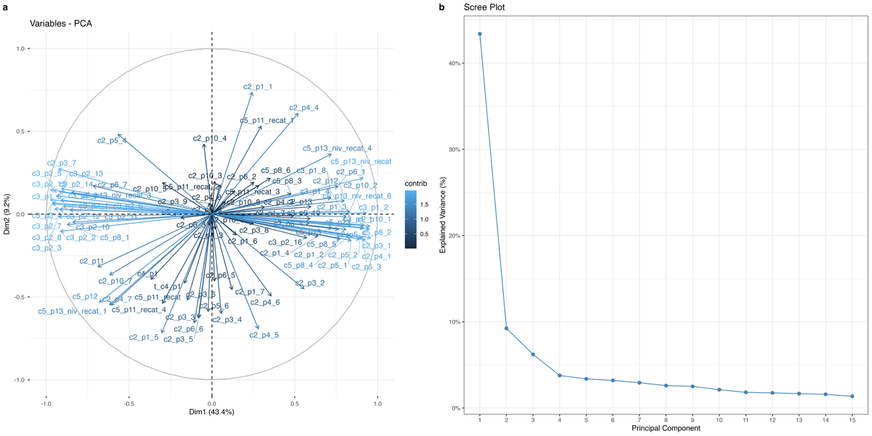
From a total of 31 variables selected from the national census, dummy variables were created to obtain proportions for each category at the district–year level. This resulted in 94 variables, excluding the ubigeo and year. A PCA was then performed to reduce dimensionality, yielding 53 components. The proportion of variance explained by each component was evaluated using a scree plot. The first 10 components were retained, as they together accounted for nearly 80% of the total variance. Supplementary figure 3 presents the correlation circle and scree plot summarizing the PCA results.
Supplementary figure 2.1. Results of the principal component analysis applied to the variables of the national census. A. Correlation circle of the variables included in the PCA. The representation of the variables on the first two principal components is shown, which explain approximately 50% of the total variability. B. Scree plot showing the variance explained by each component. The first component explains over 40% of the variability, followed by the second component, such that together they account for 52% of the total variance in the data.

2.2. Model specification
Elementary education
The model is specified as:
$${ y}_{it}|p_{it }\sim Binomial (n_{it},p_{it})$$
where $μ_{it}=E(p_{it}∣ξ,v,w)$ is the expected prevalence of elementary education completion given all random effects. The mean is linked to a linear predictor through a logit transformation:
$$η_{it}=β_{0}+\sum_{k=1}^{K}{β_{k}} {\text{pc}}_{k,it}+ξ\left(s_{i}\right)+w_{p(i)}+ v_{t}$$
Where:
- $β_{0}$ is the intercept
- ${\text{pc}}_{k,it}$ is the value of the $k$-th principal component for PSU $i$ at time $t$.
- $ξ(s_{i})$ is a spatial random effect modeled as a Gaussian random field (GRF) with Matérn covariance structure, approximated via the SPDE approach fitted on a triangular mesh over the Loreto region
- $v_{t}$ is a temporal random effect modeled as a second-order random walk (RW2), allowing for smooth nonlinear temporal variation over the study period
- $w_{p(i)}$ is a province-level iid random effect capturing residual heterogeneity at an intermediate spatial scale (included only in selected model specifications)
Prior specifications
Penalized complexity (PC) priors were specified for all random effects in the education models. For the temporal random effect (RW2), a PC prior was specified as $P(σ>1.0)=0.01$. For the province-level iid random effect included in some model candidates, the same PC prior structure was applied: $P(σ>1.0)=0.01$. PC priors for the spatial field (SPDE) are described in the Spatial random effects section below.
Spatial random effects
The spatial random effect $ξ(s_{i})$ is modeled as a Gaussian random field with Matérn covariance structure using the stochastic partial differential equation (SPDE) approach:
$$\left(κ^{2}-Δ)^{α/2}ξ(s)=W(s\right)$$
where $W(s)$is Gaussian white noise, $Δ$ is the Laplacian operator, and $κ$ and $α$ control the spatial scale and smoothness of the field. The field was approximated using $α=2$ (equivalent to smoothness $ν=1$). The model is parameterized in terms of the marginal standard deviation $σ_{ξ}$ and spatial range $ρ_{ξ}$, where $ρ_{ξ}$ represents the distance beyond which spatial correlation becomes negligible and $σ_{ξ}$ governs the magnitude of spatial variability. The triangulated mesh was constructed over the observed PSU coordinates constrained to the boundary of the Loreto region, with an interior maximum edge length of 0.25°, an outer buffer of 0.5° with maximum edge length of 0.6°, a cut-off distance of 0.08° to avoid redundant nodes in dense PSU clusters, and a boundary offset of 0.1°. Penalized complexity priors were placed on the range ($P(ρ_{ξ}>1.0°)=0.01$) and marginal standard deviation ($P(σ_{ξ}>1.0)=0.01$).
Temporal random effects
Temporal dependence is modeled through a second-order random walk process:
$$v_{t}-2v_{t-1}+v_{t-2}∼N(0,τ_{v}^{-1})$$
where $v_{t}$denotes the temporal random effect at time $t$, and $τ_{v}$is the precision parameter controlling the degree of smoothness, with larger values implying smoother temporal trajectories. This specification penalizes abrupt changes in the slope of the temporal trend, allowing for flexible but smooth nonlinear temporal evolution.
Poverty status
The model is specified hierarchically as:
$$p_{it}\sim Beta \left(α_{it},β_{it}\right),$$
$${ y}_{it}|p_{it }\sim Binomial (n_{it},p_{it})$$
with $α_{it}= μ_{it}ϕ$ and $β_{it}=\left(1- μ_{it}\right)ϕ,$ where $μ_{it}=E(p_{it}∣u,v,w)$is the expected poverty prevalence given all random effects and $ϕ>0$is a precision parameter controlling overdispersion. The mean is linked to a linear predictor through a logit transformation:
$$η_{it}=β_{0}+\sum_{k=1}^{K}{β_{k}} {\text{pc}}_{k,it}+ u_{s(i)}+w_{p(i)}+ v_{t}$$
Where:
- $β_{0}$ is the intercept
- ${\text{pc}}_{k,it}$ is the value of the $k$-th principal component for PSU $i$ at time $t$.
- $u_{s(i)}$ is a district-level spatial random effect defined over districts in the Loreto region, modeled using the BYM2 formulation, combining a structured component defined through an intrinsic conditional autoregressive (ICAR) model and an unstructured independent and identically distributed (iid) component capturing area-level heterogeneity
- $v_{t}$ is a temporal random effect modeled as a second-order random walk (RW2), allowing for smooth nonlinear temporal variation over the study period
- $w_{p(i)}$ is a province-level iid random effect capturing residual heterogeneity at an intermediate spatial scale (included only in selected model specifications)
Prior specifications
Penalized complexity (PC) priors were specified for all random effects in the poverty models. For the spatial random effect (BYM2), PC priors were placed on the mixing parameter and the marginal standard deviation: P(φ < 0.5) = 2/3, reflecting prior uncertainty about the relative contribution of the spatially structured component, and P(σ > 1.0) = 0.01. For the temporal random effect (RW2), a PC prior was specified as P(σ > 1.0) = 0.01. For the province-level IID random effect included in some candidate models, the same PC prior structure was applied: P(σ > 1.0) = 0.01. To account for overdispersion in the Beta-Binomial likelihood, a Gaussian prior was placed on the logit-transformed overdispersion parameter: logit(ρ) ~ N(0, 0.4).
Spatial random effects
The spatial random effect $u_{s}$is modeled using the Besag–York–Mollié (BYM2) specification:
$$u_{s}= \frac{1}{\sqrt{τ_{u}}}\left(\sqrt{ϕ}{\tilde{u}}_{s}+\sqrt{1-ϕ}v_{s}\right)$$
where ${\tilde{u}}_{s}$ follows an intrinsic conditional autoregressive (ICAR) model capturing spatial dependence between neighboring districts, and $v_{s}∼N(0,1)$ represents unstructured spatial heterogeneity. The parameter $τ_{u}$ controls the overall spatial precision, while $ϕ∈[0,1]$ determines the proportion of variance attributed to the spatially structured component.
Temporal random effects
Temporal dependence is modeled through a second-order random walk process:
$$v_{t}-2v_{t-1}+v_{t-2}∼N(0,τ_{v}^{-1})$$
where $v_{t}$denotes the temporal random effect at time $t$, and $τ_{v}$is the precision parameter controlling the degree of smoothness, with larger values implying smoother temporal trajectories. This specification penalizes abrupt changes in the slope of the temporal trend, allowing for flexible but smooth nonlinear temporal evolution.

Supplementary table 2. Model specification
Model | Fixed effects | Spatial ($u_{s}$) | Temporal ($v_{t}$)
Elementary education
Me-1 | - | SPDE | RW2
Me-2 | - | SPDE + IID(province) | RW2
Me-3 | $$β_{0}+β_{1}pc1$$ | SPDE | RW2
Me-4 | $$β_{0}+β_{1}pc1+β_{2}pc2$$ | SPDE | RW2
Poverty status
Mp-1 | - | BYM2 | RW2
Mp-2 | - | BYM2 + IID(province) | RW2
Mp-3 | $$β_{0}+β_{1}pc1$$ | BYM2 | RW2
Mp-4 | $$β_{0}+β_{1}pc1+β_{2}pc2$$ | BYM2 | RW2

Section 3. Supplementary Results
Supplementary results 3.1. Summary of goodness-of-fit metrics and accuracy of the models
Socioeconomic indicator | Model | DIC | WAIC | - LogML | -2log(CPO) | MAE | RMSE | SMAPE
Elementary education | Me-1 | 5,814.10 | 5,822.25 | -2,973.15 | 5832.63 | 0.062 | 0.074 | 8.337
Elementary education | Me-2 | 5,813.02 | 5,820.24 | -2,974.88 | 5831.19 | 0.061 | 0.073 | 8.237
Elementary education | Me-3 | 5,803.61 | 5,815.07 | -2,962.34 | 5820.08 | 0.053 | 0.064 | 7.185
Elementary education | Me-4 | 5,804.20 | 5,815.00 | -2,968.26 | 5819.82 | 0.052 | 0.063 | 7.022
Poverty status | Mp-1 | 4,894.35 | 4,969.69 | -2,527.03 | 4999.72 | 0.046 | 0.071 | 5.910
Poverty status | Mp-2 | 4,893.67 | 4,969.42 | -2,528.24 | 5008.95 | 0.051 | 0.079 | 6.408
Poverty status | Mp-3 | 4,913.79 | 4,974.62 | -2,514.20 | 5003.45 | 0.043 | 0.062 | 5.394
Poverty status | Mp-4 | 4,915.61 | 4,977.41 | -2,509.01 | 5003.95 | 0.042 | 0.063 | 5.379
DIC: Deviance Information Criterion, WAIC: Watanabe-Akaike Information Criterion, -LogML: negative Log Marginal Likelihood, MAE: Mean Absolute Error, RMSE: Root Mean Squared Error, SMAPE: Symmetric Mean Absolute Percentage Error.

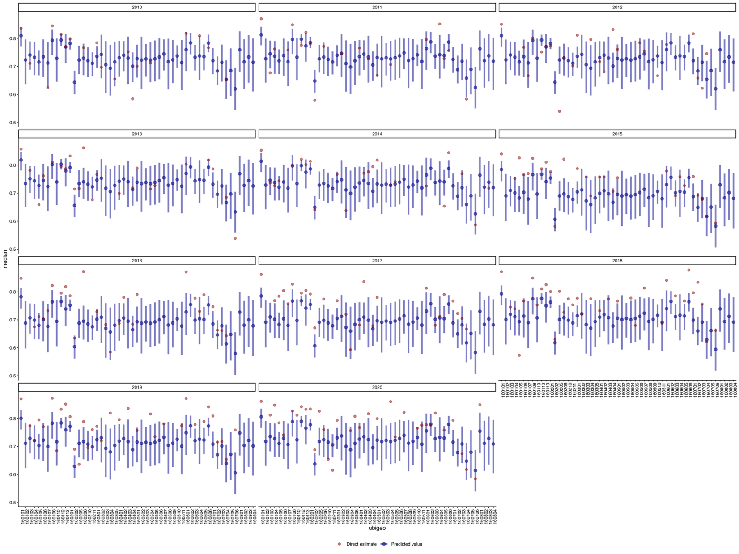
Supplementary figure 3.2. Predicted values and direct estimates of primary education for 2010-2020. Point estimates and their confidence intervals for all years 2010–2020 for the elementary education indicator constructed using the selected model (Me-3). In red, the direct estimates obtained from the DHS are shown.
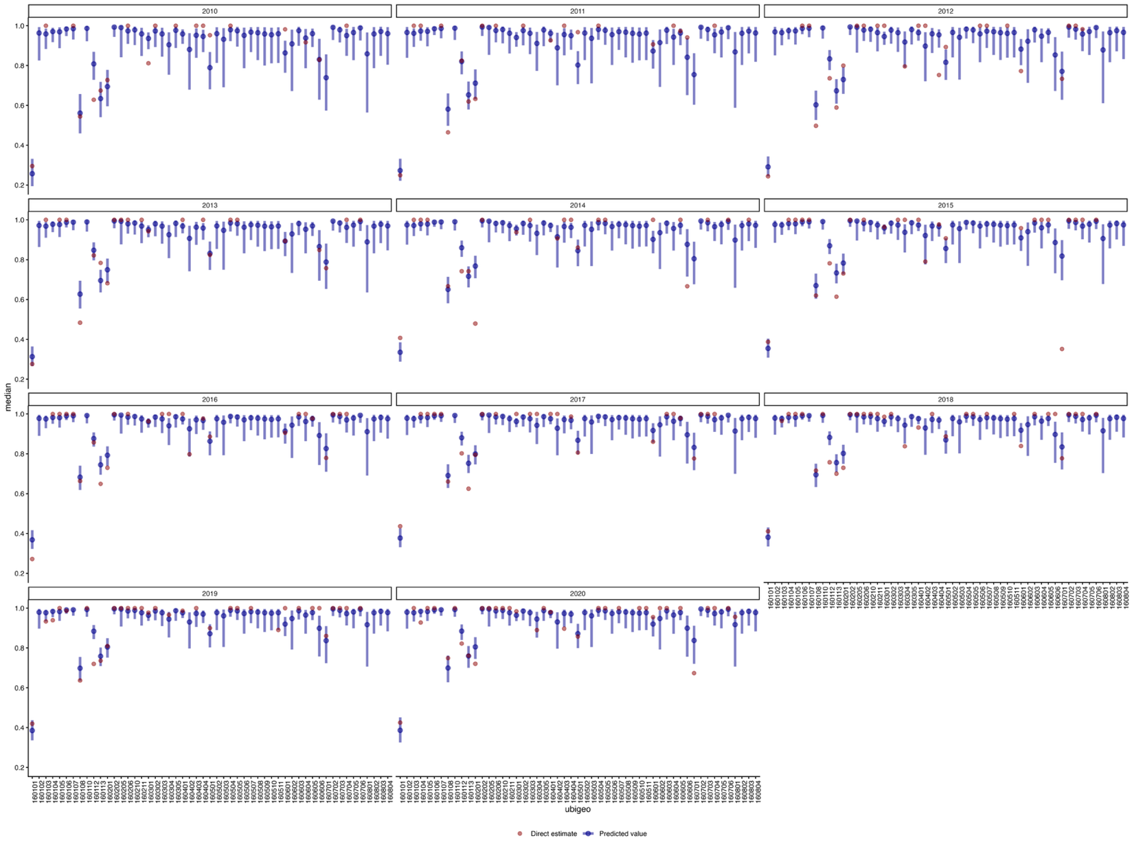
Supplementary figure 3.3. Predicted values and direct estimates of poverty status for 2010-2020. Point estimates and their confidence intervals for all years 2010–2020 for poverty status indicator constructed using the selected model (Mp-3). In red, the direct estimates obtained from the DHS are shown.
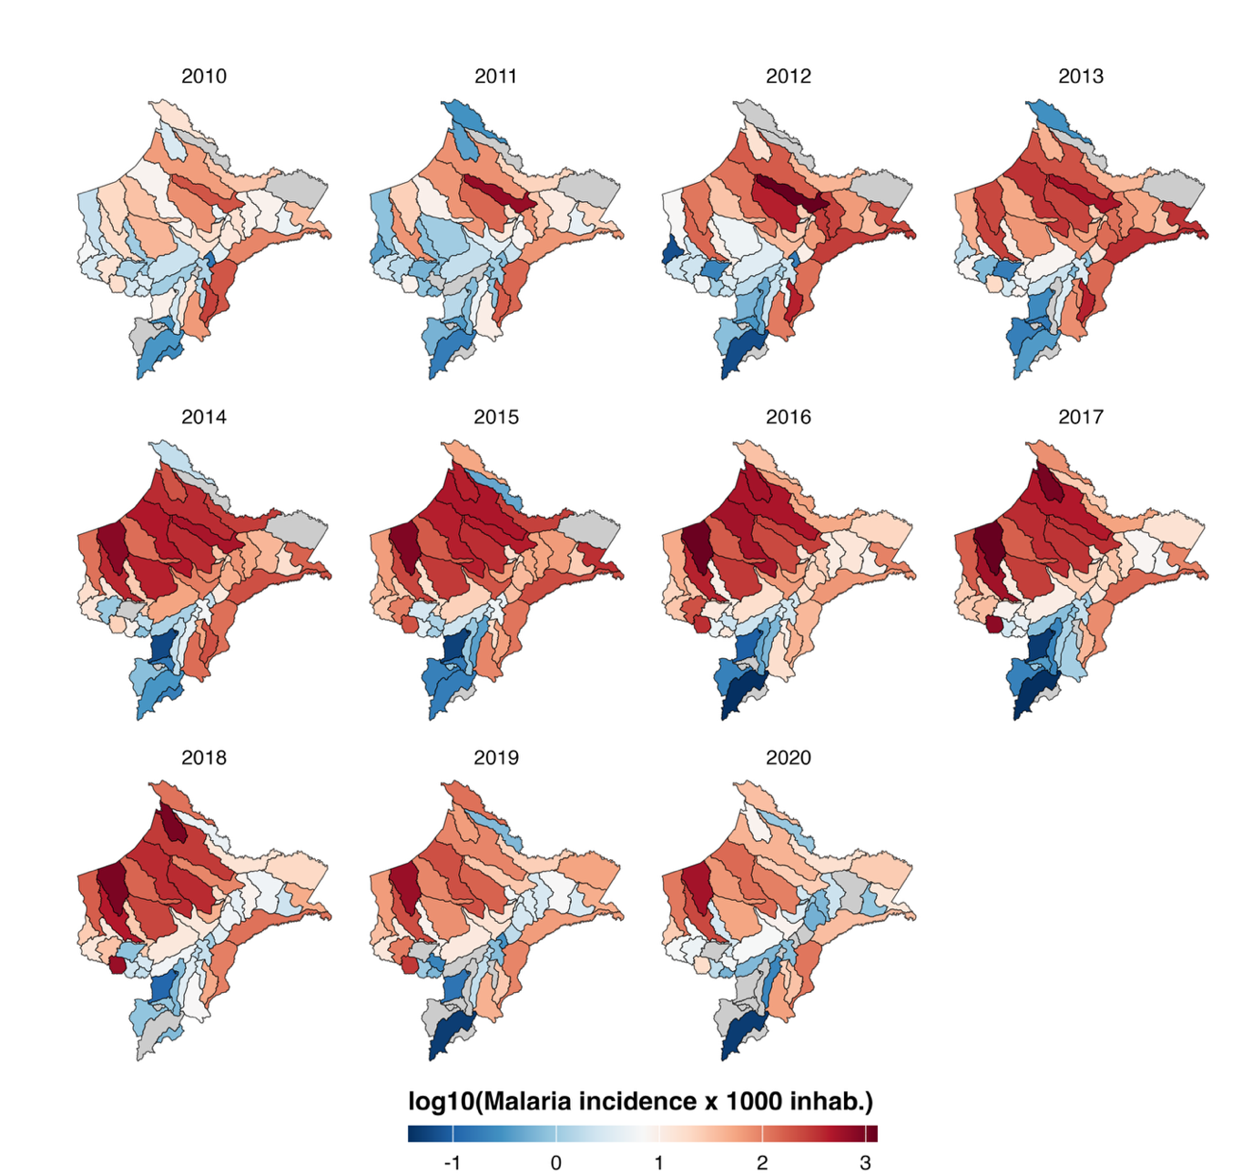
Supplementary figure 3.4. Malaria incidence in Loreto region 2010-2020 at district. Incidence of malaria cases per 1,000 inhabitants (log10-transformed) for all years 2010–2020. A pronounced burden is observed in the northern region of the department, along the border with Ecuador.
Supplementary figure 3.5. Accuracy metrics in-sample by year for elementary education 2010-2020. Accuracy metrics (MAE, SMAPE, RMSE) are reported globally and by year for each evaluated model. From 2015 onwards, the accuracy metrics exhibit a different pattern compared to the 2010–2014 period.
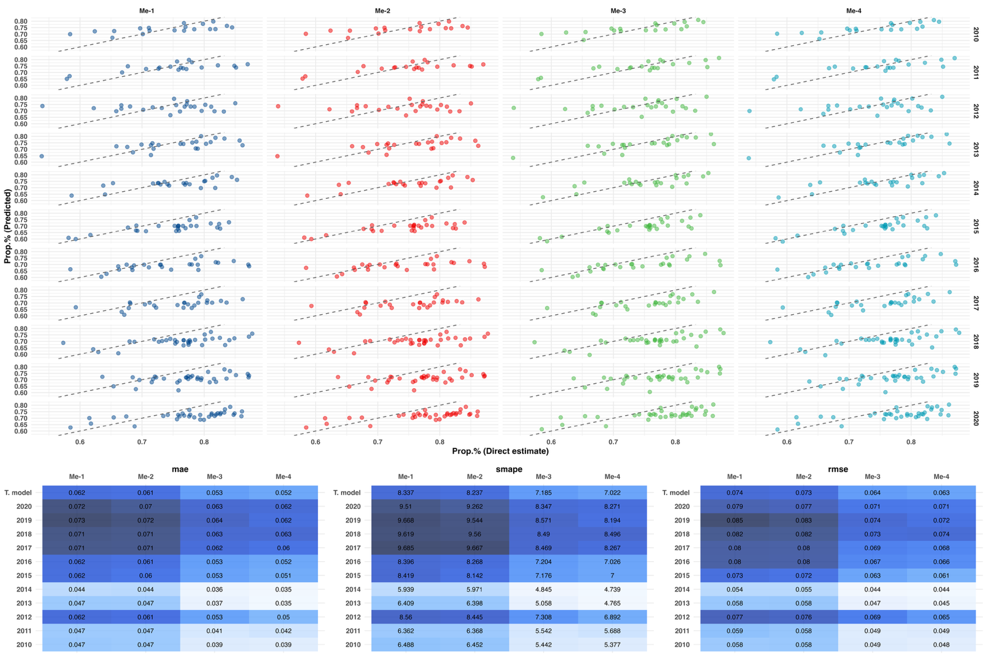

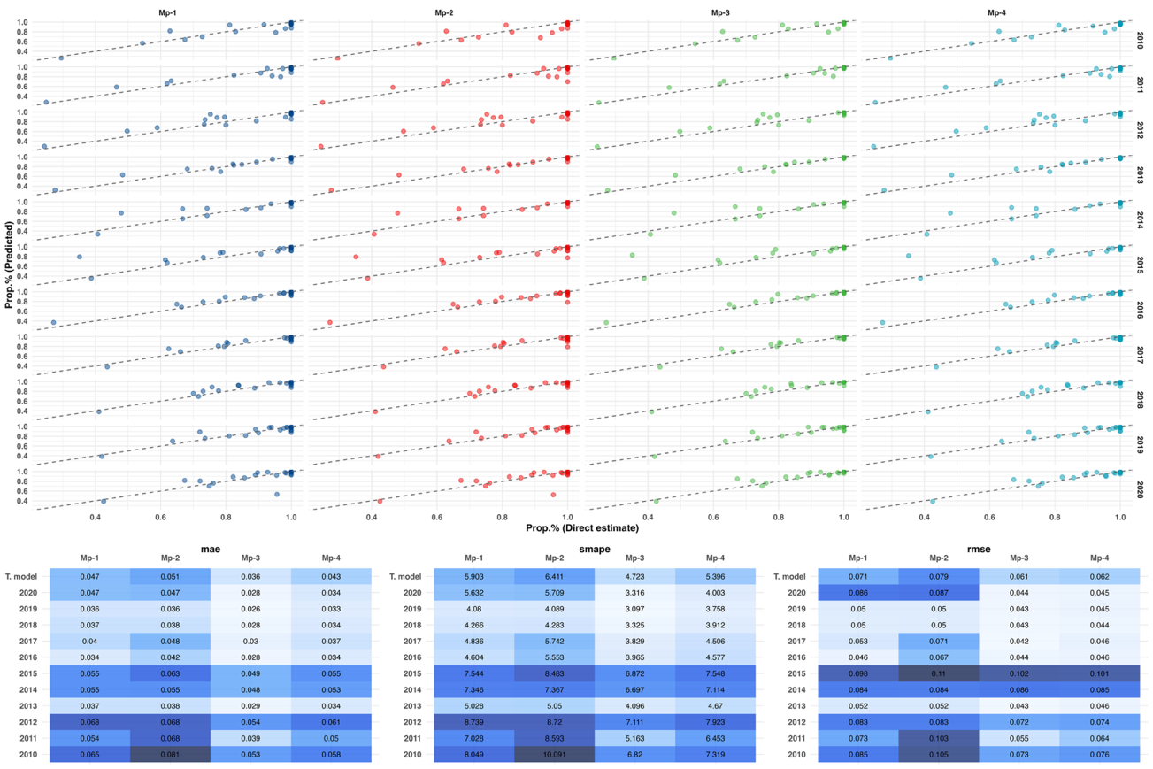
Supplementary figure 3.6. Accuracy metrics in-sample by year for poverty for 2010-2020. Accuracy metrics (MAE, SMAPE, RMSE) are reported globally and by year for each evaluated model. In contrast to education, the models show improved error metrics over the 2015–2020 period. However, Mp-3 and Me-3 consistently perform better throughout the study period.
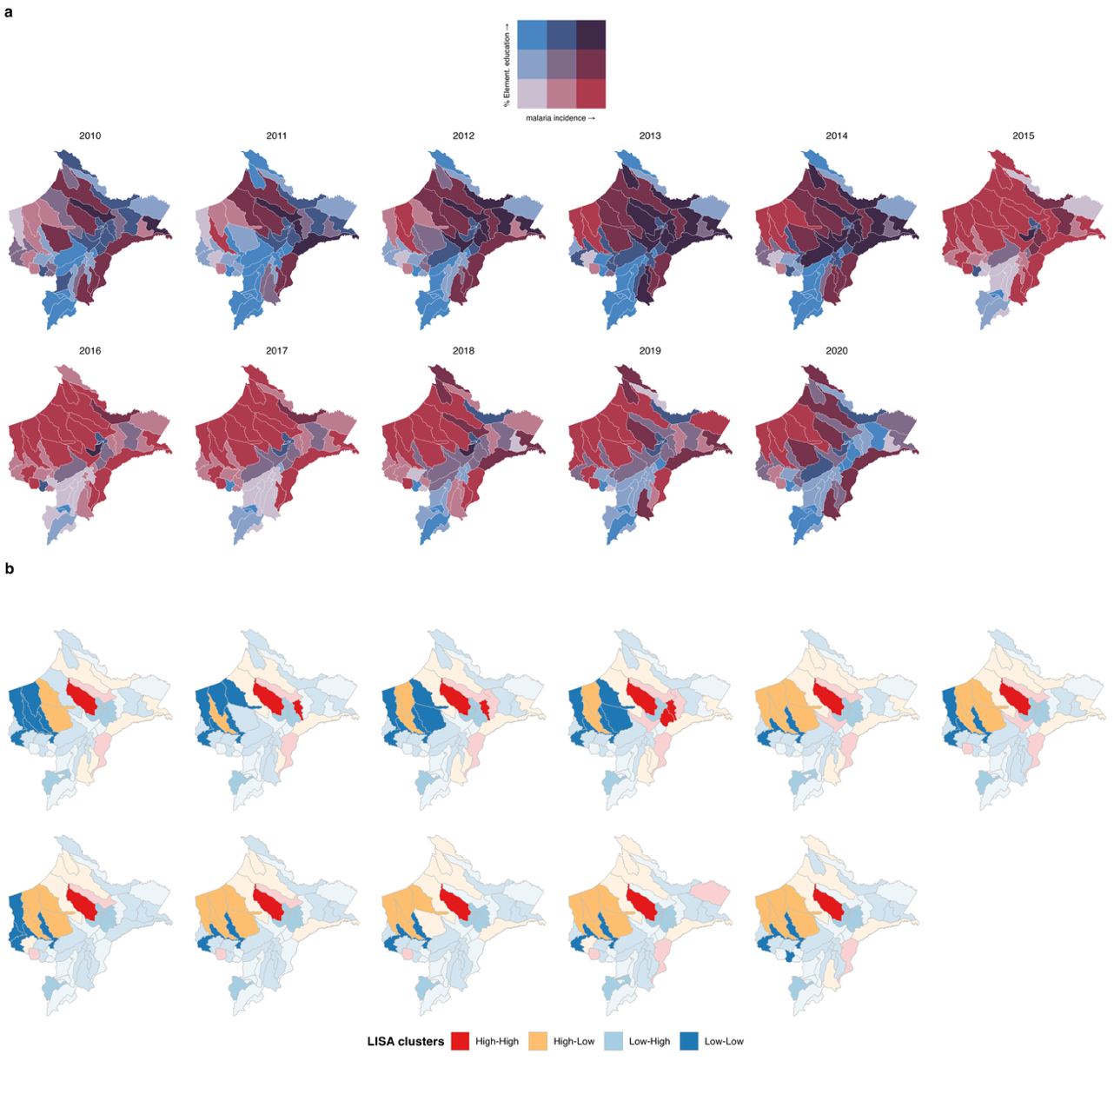
Supplementary figure 3.7. Spatial patterns of education and malaria incidence for 2010-2020. Bivariate descriptive maps and bivariate LISA analysis for the elementary education indicator. The evolution of the cluster identified in the northern region is shown, shifting from Low–Low up to 2014 to High–Low from 2015–2020. Non-significant clusters are shown as transparent.
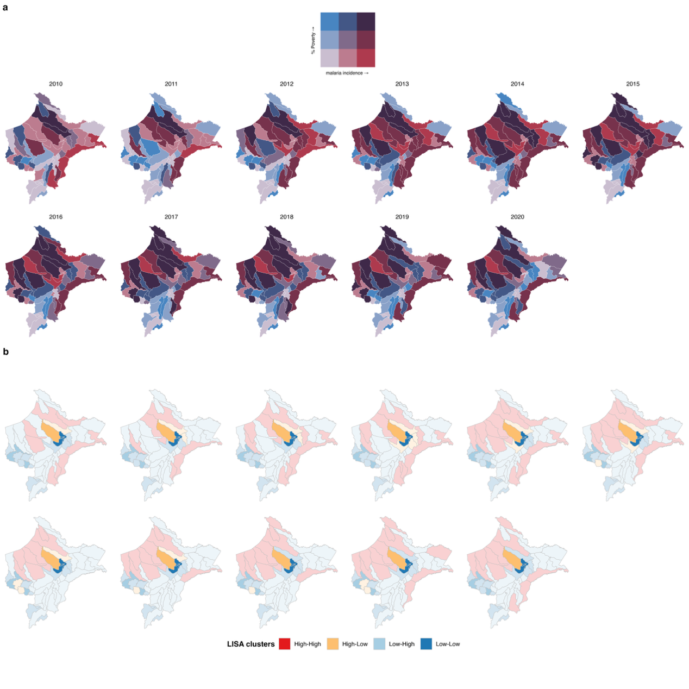
Supplementary figure 3.8. Spatial patterns of poverty and malaria incidence for 2010-2020. Bivariate descriptive maps and bivariate LISA analysis for the poverty status indicator. A consistent cluster over time is observed in the central area of Loreto, where the capital city, Iquitos, is located. Similarly, a neighboring district (Alto Nanay) maintains its characteristic of high malaria cases with low levels of poverty, consistent with the economic activities associated with the area. Non-significant clusters are shown as transparent.
Supplementary references
1. Censos Nacionales 2017 – XII de Población, VII de Vivienda y III de Comunidades Indígenas [Internet]. 2017 [cited 2025 Jun 19]. Available from: https://censo2017.inei.gob.pe/
2. Perú: Evolución de la Pobreza Monetaria, 2015-2024 [Internet]. [cited 2025 Jun 19]. Available from: https://www.gob.pe/institucion/inei/informes-publicaciones/6763186-peru-evolucion-de-la-pobreza-monetaria-2015-2024
3. Sanchez JF, Valdivia HO, Pannebaker DL. Malaria Surveillance: A Cross-sectional Study in the Peruvian Amazon Basin, 2012-2023. J Infect Dis. 2025 Feb 10;231(Supplement_1):S58–65. doi:10.1093/infdis/jiae570 PubMed PMID: 39928389.
4. Rufasto Goche KS, Lizarbe Castro MV, Lozano Zanelly GA, Lira Camargo WM, Ascayo Velasquez EY, Murillo Carrasco AG, et al. Epidemiological dynamics of dengue in Peru: Temporal and spatial drivers between 2000 and 2022. PloS One. 2025;20(3):e0319708. doi:10.1371/journal.pone.0319708 PubMed PMID: 40106473; PubMed Central PMCID: PMC11922284.
5. Fine S, Quiroz AA, Calle VS, Manrique P, Rodriguez H, Carrasco G, et al. FocaL mass drug Administration for Plasmodium vivax Malaria Elimination (FLAME): study protocol for an open-label cluster randomized controlled trial in Peru. Res Sq. 2025 Apr 17;rs.3.rs-5594891. doi:10.21203/rs.3.rs-5594891/v1 PubMed PMID: 40321759; PubMed Central PMCID: PMC12047980.
6. Encuesta Demográfica y de Salud Familiar - ENDES 2025 [Internet]. 2025 [cited 2025 Jun 21]. Available from: https://www.gob.pe/institucion/inei/informes-publicaciones/3364616-encuesta-demografica-y-de-salud-familiar-endes-2025

