Appendix 1. Detailed descriptions of the various mind-calming exercises
The specific focus of the mind-calming exercise in each session was one of the following:
- Being consciously aware of one’s breathing by focusing on one of the following: i) the temperature change and air flow at the nostrils; ii) the sensation of airflow in the throat; iii) the rising and falling of one’s chest; iv) counting successive exhalations up to five and then back down again; v) repeatedly breathing in slowly and fully, and holding each breath for a count of 3 (i.e. about 3 seconds), and then gently releasing; or vi) focusing on the corresponding contraction and expansion of the abdomen (i.e. the stomach area) with each inhalation and exhalation. [For the latter, I often provided a visual explanation of the breathing action that is generated by the diaphragm muscles which connect across the bottom of the ribcage and separate the chest space above (which contains the lungs) from the abdomen below. In their relaxed state, these muscles resemble a ‘dome’—that I illustrate using the interlocking fingers of my upturned cupped hands. When the diaphragm contracts (i.e. inhalation), it forms a flattish disc (a collapsed ‘dome’) that causes the lungs to expand downwards via suction into the increased chest space. Consequently, the lungs’ internal volume is enhanced, and so air is pulled inwards through the nose/mouth. On exhalation, the diaphragm muscles relax (resembling an erected ‘dome’), which pushes the base of the lungs back upwards via elasticity, thereby reducing their internal volume and causing air to be expelled out through the nose/mouth. The direct impact of this breathing action is that the abdomen area below the diaphragm is pressed down (and hence expands outwards) during inhalation, and is allowed to come back inwards during exhalation. Participants can be encouraged to put their hands on their tummies to feel and relate this sensation during their breathing.]
- Focusing on the physical aspects of one’s hand: noting the overall structure comprising of 27 different bones; and then starting at the thumb, sensing the base connection to the palm, and then travelling out to the tip, then the index finger and so on all the way to the little finger, and then the palm itself and reflecting on all the intricate movements this organ is capable of, and then switching to repeat the action on the other hand.
- Focusing on the relational aspects of one’s hand: the fundamental structural similarity to a whale’s fin or to a bat’s ‘wing’ reflecting our evolutionary relationship to these organisms all of which have evolved from a common ancestor; consideration of who has ‘held that hand’ – parents/guardians, maybe grandparents, each of whom had their hands held by their parents, grandparents and so on... implying a tangible temporal connection back through many generations in which each hand-hold was focussed on caring for, nurturing, protecting, consoling, loving.
- Directing one’s breathing (–either actively with a finger, or more passively via nostril movement) so that the airflow is primarily through the left or right nostril and inhaling 3 times, and then switching to the other nostril, and back again, or alternating between nostrils with each inhalation, and finishing with 3 inhalations using both nostrils.
- Concentrating attention on one’s feet and their connection to the ground, starting with awareness of the sensations in the big toe of one foot, and then the next toe and so on all the way to the little toe, and then switching to the other foot.
- ‘This Too Shall Pass’ mind-calming moment (written by BIOL 510 course student Victoria Jay):
- Start by taking a few breaths.
- Pinpoint something in your life that is causing you stress, anxiety or worry. It could be an upcoming deadline, a relationship that you’re not benefiting from anymore, or tension within your family. Take a few minutes to focus on, and think about, that source of stress. How does it make you feel to sit with that stress? Has your heart rate increased? Are you palms beginning to feel sweaty? Do you find yourself trying to avoid thinking about whatever it is that is causing you this stress?
- Now remind yourself that nothing is permanent and that ‘this too shall pass’. Eventually, this too will be behind you.
- Now be aware of how you feel, with the reminder that ‘this too shall pass’. Does this reminder give you comfort? Does it feel like a little weight has been lifted off your chest?
- Take a minute to ponder this while you take a few more breaths before slowly coming back to the reality directly around you right here and now.
- Imagining a “Google Earth” image focussed on the hair spiral at the crown of one’s head, and then zooming slightly out to see the whole head, and then zooming out a little further to see the shoulders and the knees, then one’s neighboring classmates sitting in a similar position, then the whole lecture hall (“all of us here together”), then through the roof (via an imaginary ‘exploded view’) to see the whole building, and then the campus, and the city, with its particular geographic location near a very large lake, the region, and then further out to the continent, the whole Earth, and further out again as a planet in the solar system that itself is within the Milky Way galaxy, and finally out further as a tiny speck in the Universe. After a considerable pause, I would paraphrase Singer (2007) by slowly saying: “Here we are, you and I, sitting in a classroom, in a building, on the edge of a planet, spinning around in the middle of nowhere”. For specific sustainability-related lectures/seminars in certain courses, I would often directly follow the above statement after a pause with: “Here we are together, all of humanity, on the edge of a planet, spinning around in the middle of nowhere”.
- Performing a brief “body scan” where the students are asked to imagine a gentle heat or light beam focused on their toes, and then it’s slow movement up to their ankles, calves, knees, thighs, waist, shoulders, stomach and arms, shoulders, and finally the top of the head.
- For courses with field trips, visualizing a field site that we had visited earlier in the semester and imagining being there now, what it would look like, what sounds might be heard, what one might feel, and smell.
- For courses with multiple “active learning” sessions in a specialized room with large tables at which groups sat and discussed or solved problems, encouraging students to imagine watching a video from just above their heads, looking down on themselves listening, talking, and interacting with others.
During several of the mind-calming exercise sessions for each course, students were reminded of the ‘chattering mind’/‘monkey mind’ that inevitably leads almost all practitioners to become distracted from the primary focus, and of the need to recognize and acknowledge when this happens, and then to direct their attention back to the chosen focus. I explained that this deliberate redirection is the act of mindfulness and that one’s emphasis should be more on its value as an ongoing process, rather than as an end goal (i.e., don’t get frustrated – there’s no such thing as a ‘bad’ mind-calming session; it is just that some are better than others).

Example video recordings of three such mind-calming exercise sessions are available at the following weblinks:
https:xxxx; yyyy; zzzz (not included at this stage in keeping with blind peer-review protocol)

Appendix 2. Survey statements grouped according to perceived enjoyment, appropriateness, in-class learning value, and life-skill value. The sequential order of the statements in the actual distributed surveys is indicated by the numbers in parentheses; this order was deliberately chosen so that the thematic groupings were not apparent, and so that clearly contrasting statements came next to each other, all in order to reduce the potential for bias in one response to influence subsequent responses. Furthermore, successive statements were often deliberately worded so that positive ‘strongly agree/agree’ responses represented opposing (i.e. favourable versus negative) views for statements within the same category. Almost exactly identical statements were used across all surveys reported in this manuscript for both the primary (immediately after the course) and retrospective investigations.

Enjoyment of the exercise
- The mind-calming exercise is enjoyable and relaxing (#2)
- I looked forward to the mind-calming exercise in each class session (#5)
- When the mind-calming exercise was conducted on the first occasion in this course, it made me uncomfortable (#1)
Appropriateness of the exercise within class time
- The mind-calming exercise in this course was inappropriate and should not be repeated in future courses (#3)
- This exercise is really only appropriate for 4th year courses with small class sizes (<20 students) (#8)
- Mind-calming exercises may be useful to some students, but they should be provided as an extracurricular university-supported activity because they are not course-related material and therefore are inappropriate within class time (#6)
Perceived in-class learning value
- The exercise was a valuable use of my time in the class time-slot because I feel it enhanced the depth and quality of my learning (#4)
- There were times during our classes when I noticed myself drifting away into distractions, and was able to refocus using this mind-calming approach (#7)
Perceived life-skill value
- This exercise has introduced me to a valuable perspective that has been useful outside the course in learning how to achieve calm/balance in my life (#9)
- I have used this mind-calming practice to help me cope with nervous or stressful situations in my life (#10)

Appendix 3. Examples of the initial and reminder e-mail texts circulated in each course for the primary and retrospective surveys, highlighting that both were deliberately phrased to encourage responses from the full range of students (i.e., from those that felt negatively about the exercises as well as those who were in favour).

PRIMARY SURVEY EXAMPLE:
BIOL 411 Global Change Biology F25 - Announcements: BIOL 411 - Global Change Biology Fall 2025 - Mind-calming exercise survey
December 5th, 2025
Hi everyone,
I have a request which is intended to provide the basic data for an educational study and publication I am working on. Every seminar session in this course has been started with a ~3 minute mind-calming exercise aimed at helping you to focus your mind so as to actively engage with the concepts and ideas discussed in seminar, and therefore to help you achieve deep learning. There is now a growing body of pedagogical literature indicating that this kind of practice is very helpful for primary and high school students, and I know of several colleagues at other universities who are using is it in their undergraduate teaching. However, there are very few quantitative measures of its impacts in university teaching - and as scientists you know that data is very, very important!

Hence, I would be very grateful if you could complete a short survey to help me understand your views on whether the mind-calming exercise in this 4th year course was worthwhile (or should be dropped), and its potential for follow-on impacts after the course is over. This exercise is fairly novel in undergraduate courses, and I am keen to continue to develop my own teaching skills as well as exploring the potential of this approach for other teachers and profs. I have already published one paper using similar earlier data in an educational research journal (attached), and I anticipate that I will use the data collected here as part of a second follow-up publication.

The survey will only be of value if you are totally honest. In order for me to form a balanced opinion as to the overall value of the practice, it is really important that the survey is completed by those who feel positive about it, but also by those who were not enthused and would prefer not to have it, as well as those who are neutral. In that context, the data will be collected entirely anonymously (i.e. all potential identity-revealing mechanisms such as collecting IP addresses have been turned off in the survey software), so you can take the survey with absolute confidence that I will never know your identity. This survey has been cleared by the Queen’s General Research and Ethics Board (GREB – GBIOL-018-18), and formally renewed each year since then. I am attaching the official documentation on ethics clearance to conduct the survey, including the formal Letter of Information to Students.
It should take less than 5 minutes – The survey is entirely voluntary, but obviously it would be very helpful to the research if you ALL completed it.
There is a comment box at the end that I invite you to use freely – your reflections on the exercise will be greatly appreciated. I would like the survey done within the next few days if at all possible, and definitely by next Friday (i.e. December 12th).
Thanks in advance. You will be contributing to pedagogy!

The survey is available at: https....
Okay, I hope you all have a great weekend.

BIOL 411 Global Change Biology F25 - Announcements: Please do complete the quick mind-calming survey!
December 9th, 2025
Hi everyone,
If you have not already done so, PLEASE complete the survey below which should take ~5 minutes. The survey will only be of value if you are totally honest. In order for me to form a balanced opinion as to the overall value of the practice, it is really important that the survey is completed by those who feel positive about it, but also by those who were not enthused and would prefer not to have it, as well as those who are neutral. In that context, I assure you that it is entirely anonymous, but the data will be really valuable to me for a synthesis publication I am working on.

And thanks to those of you who have already responded. Full details of the survey were in last Friday’s email if want them, so here is just the direct link:

The survey is available at: https....

RETROSPECTIVE SURVEY EXAMPLE:

BIOL 411 - Global Change Biology Winter 2023: A quick retrospective survey to determine if the mind-calming exercises have had any post-course impacts!
April 29th, 2026.
Hi (first names of all 27 students added here), I hope all is going well for you, and that you have not completely forgotten all the fun and learning we had in BIOL411 Global Change Biology in Winter of 2023!

I have one final request related to that course which is intended to provide critical data for an educational study and publication I am writing aimed at determining if there are any longer term (post-course) impacts of the mind-calming exercises. Every seminar session in this course was started with a ~3 minute mind-calming exercise aimed at helping you to focus your mind so as to actively engage with the concepts and ideas discussed in each seminar, and therefore to help you achieve deep learning. There is now a growing body of pedagogical literature indicating that this kind of practice is very helpful for primary and high school students, and I know of several colleagues at other universities who are using is it in their undergraduate teaching. However, there are very few quantitative measures of its impacts in university teaching - and as scientists you know that data is very, very important!

I would be very grateful if you could complete this short survey which should 2-4 minutes to help me understand your views on whether the mind-calming exercise in this 4th year course was worthwhile (or should be dropped), and in particular on its potential for follow-on impacts after the course is over. The survey will only be of value if you are totally honest. In order for me to form a balanced opinion as to the overall value of the practice, it is really important that the survey is completed by those who feel positive about it, but also by those who were not enthused and would prefer not to have it, as well as those who are neutral. In that context, the data will be collected entirely anonymously (i.e. all potential identity-revealing mechanisms such as collecting IP addresses have been turned off in the survey software), so you can take the survey with absolute confidence that I will never know your identity. This survey has been cleared by the Queen’s General Research and Ethics Board (GREB – GBIOL-018-18), and formally renewed each year since then. I am attaching the official documentation on ethics clearance to conduct the survey, including the formal Letter of Information to Students.
The survey is entirely voluntary – but obviously it would be very helpful to the research if you ALL completed it. If you’ve taken more than one course with me and therefore receive more than one survey, please fill out the survey for the earliest course you took with me.

There is a really important comment box at the end that I invite you to use freely – your current reflections on the exercise will be greatly appreciated and particularly valuable for the final publication I am writing. Please complete the survey within the next couple of days if at all possible, and definitely by Monday of next week (i.e. May 4th).

Thanks in advance. You will be contributing to pedagogy!

The survey is available at: https....

FINAL REMINDER: BIOL 411 - Global Change Biology Winter 2023: A quick retrospective survey to determine if the mind-calming exercises have had any post-course impacts!
May 4th, 2026
Hi (first names of all 27 students added here),
Many thanks to those few of you who responded. For the remainder, PLEASE do consider completing the survey (2-4 mins max.). These are the critical data I need to complete the study I will submit for publication. I’d really appreciate your input (which would be completely anonymized and unidentifiable) as a real help to me, but also much more importantly, to future university students.

This will be my only reminder. Full survey details were circulated last week. Survey will close tomorrow night (Tuesday May 5th), and is available at: https....

Appendix 4. Retrospective survey data for statements #1-8 (-which are not reported in the main manuscript).
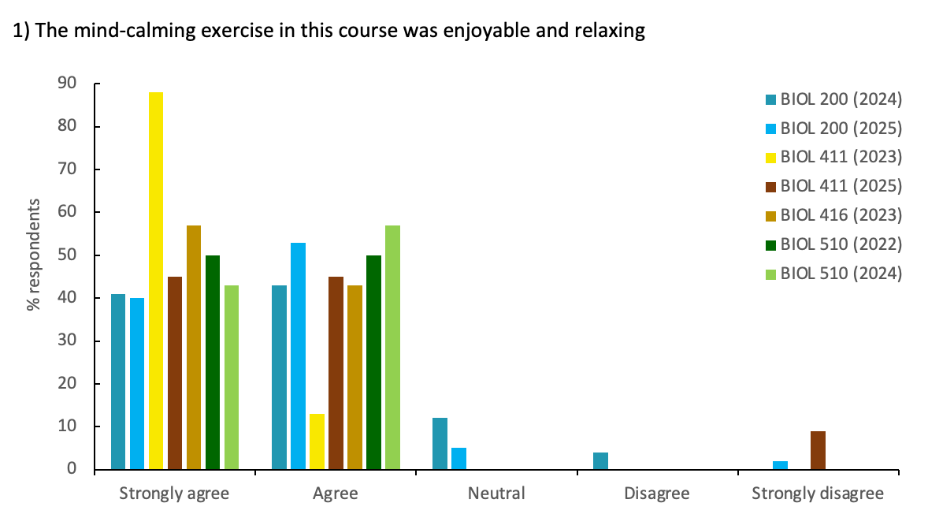
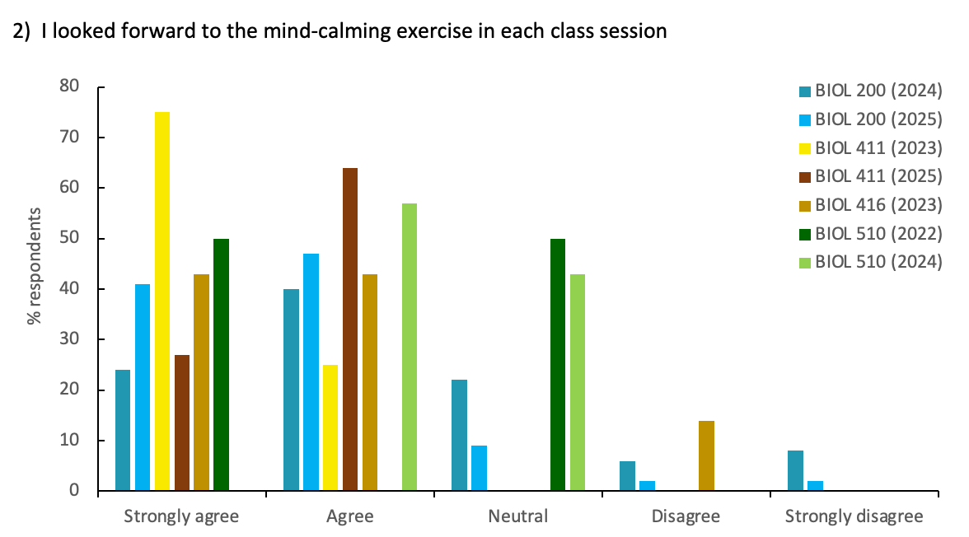
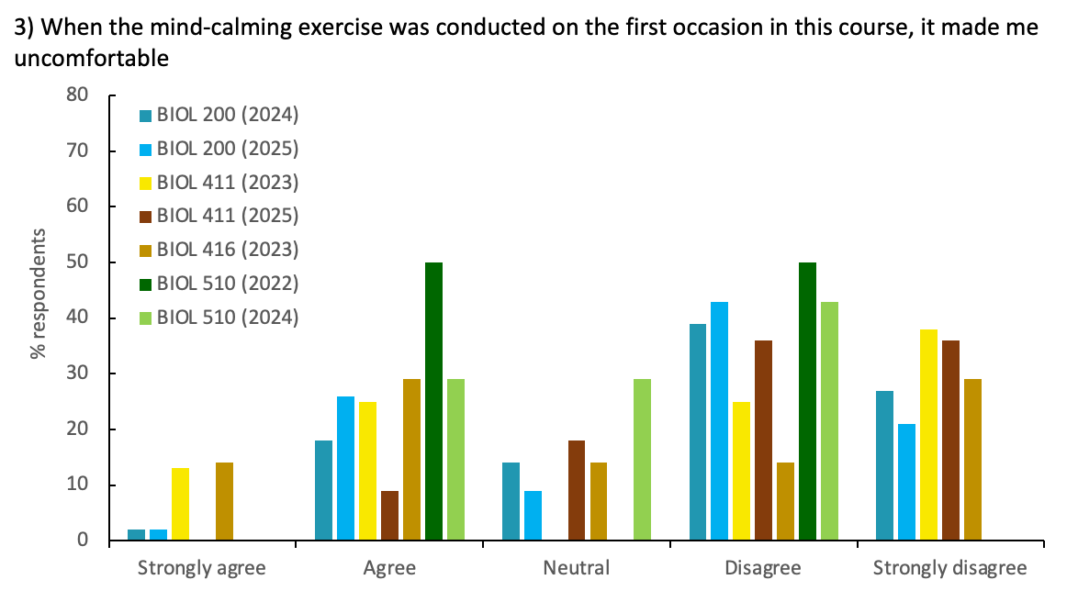

Figure 1. Retrospective survey responses to statements (#1, 2 and 3) relating to student enjoyment of the in-class mind-calming exercises for 7 different Biology undergraduate program courses between 2022 and 2025 (data are % respondents of total enrolment for each course – see Table 2 for full details including enrolment and typical attendance etc.). These retrospective surveys were conducted one to four years after the students had originally taken their first course that included this practice. See Figure 1 legend in the main manuscript for explanation of the colour shade groupings, and note that some additional shades are present in this figure compared to Figures 1-4 in the main manuscript because some different courses were included in the retrospective survey investigation.

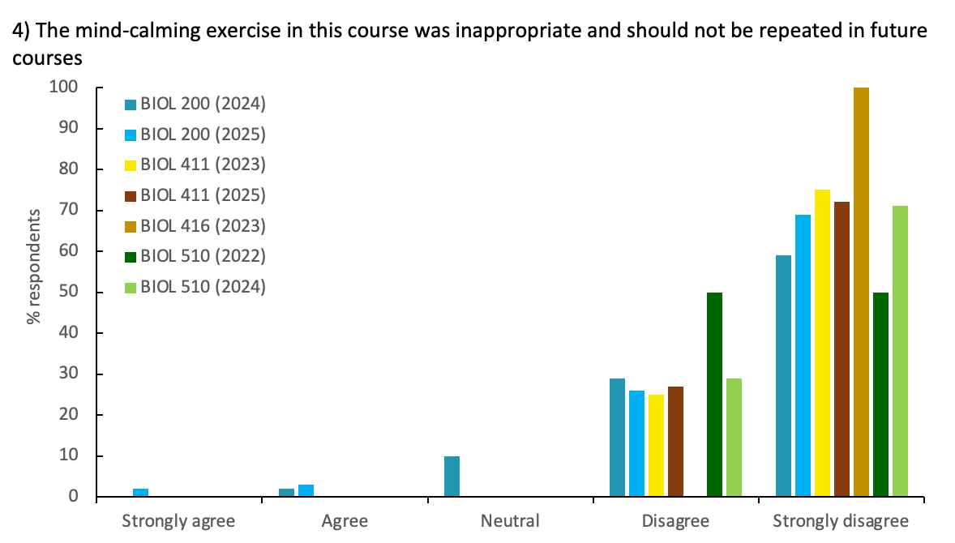
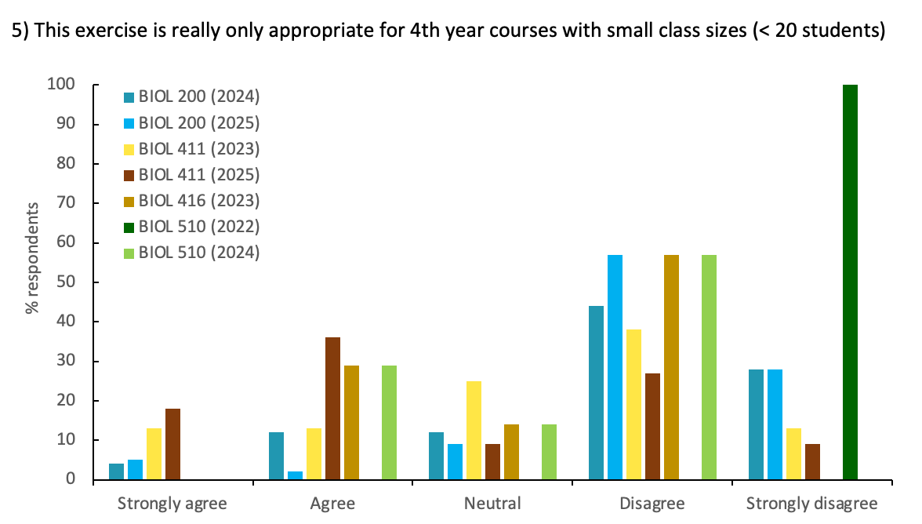
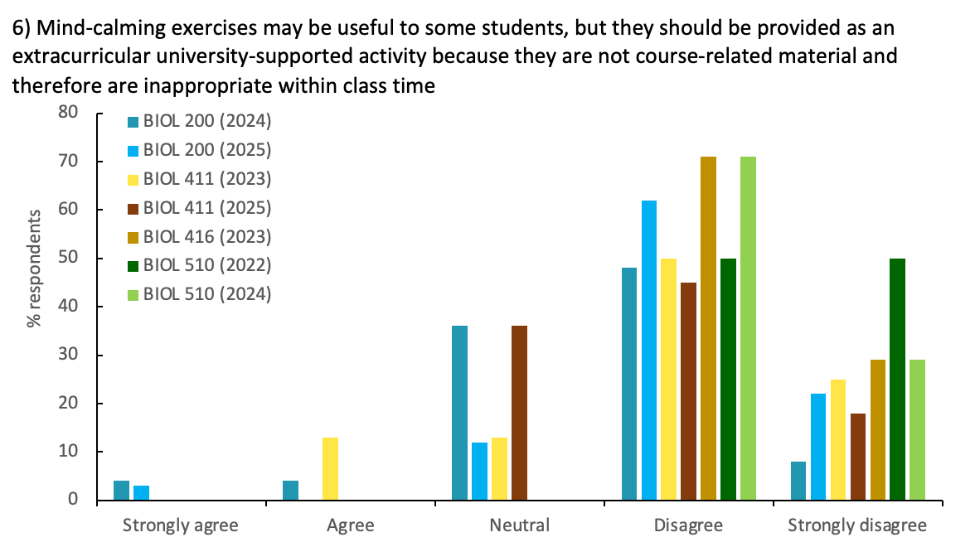

Figure 2. Retrospective survey responses to statements (#4, 5 and 6) relating to student perception of the appropriateness of the mind-calming exercises within class time for 7 different Biology undergraduate program courses between 2022 and 2025 (data are % respondents of total enrolment for each course – see Table 2 for full details including enrolment and typical attendance etc.). These retrospective surveys were conducted one to four years after the students had originally taken their first course that included this practice. See Figure 1 legend in the main manuscript for explanation of the colour shade groupings, and note that some additional shades are present in this figure compared to Figures 1-4 in the main manuscript because some different courses were included in the retrospective survey investigation.

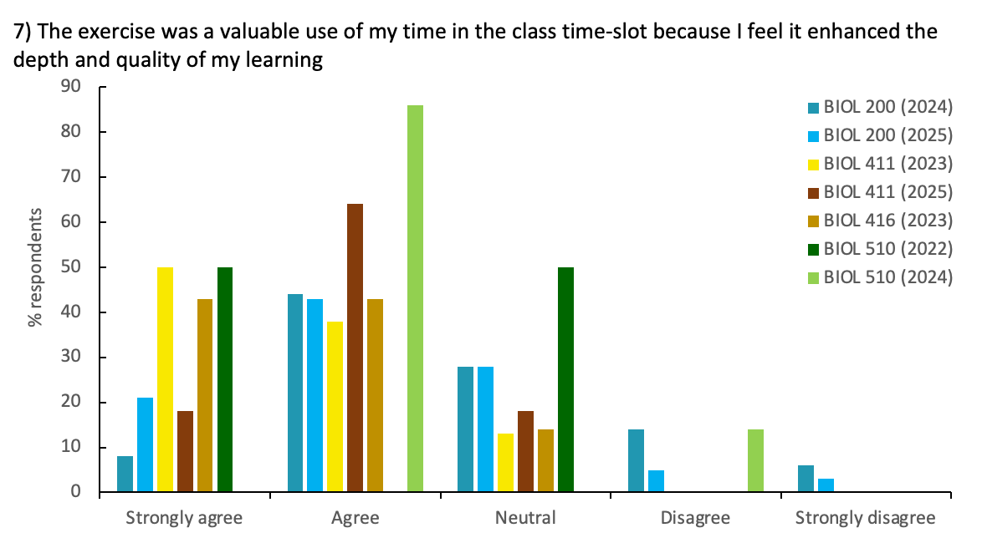
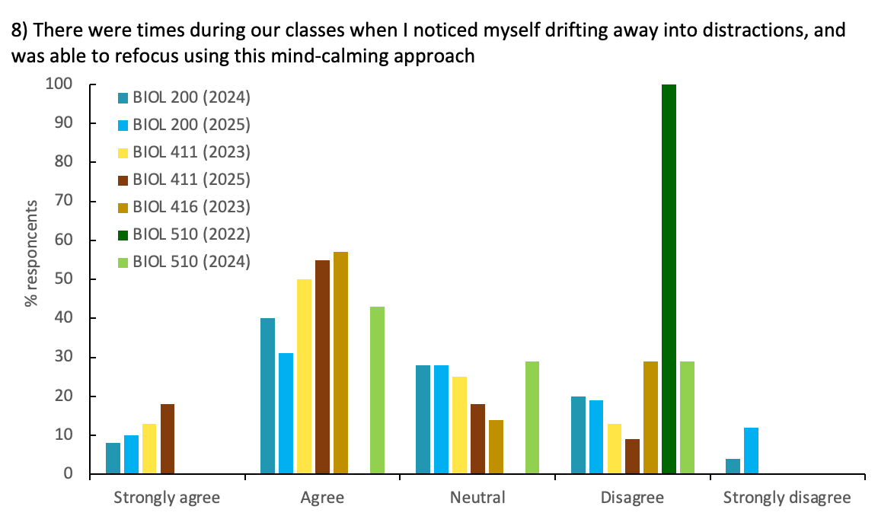

Figure 3. Retrospective survey responses to statements (#7 and 8) relating to student perception of the in-class learning value of the mind-calming exercises for 7 different Biology undergraduate program courses between 2022 and 2025 (data are % respondents of total enrolment for each course – see Table 2 for full details including enrolment and attendance etc.). These retrospective surveys were conducted one to four years after the students had originally taken their first course that included this practice. See Figure 1 legend in the main manuscript for explanation of the colour shade groupings, and note that some additional shades are present in this figure compared to Figures 1-4 in the main manuscript because some different courses were included in the retrospective survey investigation.

Appendix 5. Word cloud based on a composite of all the comments in the primary and retrospective surveys (i.e. a total of ~780 respondents’ text entries) developed using Wordcloudplus.com after eliminating the following ‘stop’ words in addition to the software defaults: mind; calm; calming; mind-calming; class; exercise; exercises; lecture; seminar; time; professor.

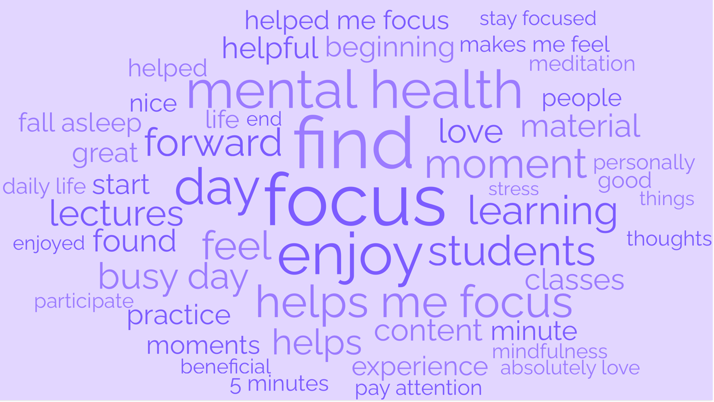
Appendix 6. The complete set of comments for each of the retrospective surveys in response to the following survey text:
Please use this text space to help me understand how this experience of mind-calming exercise has been for you, and to offer suggestions or criticisms of the practice and of its potential for you.
Minor grammatical and typographic errors have been corrected, and occasional personal identifiers removed. Comments were entered by 82 of the 209 retrospective survey respondents in total.

BIOL 200 2024
- It allowed my body and brain to slow down and bring my attention to the class and the content after the higher intensity demands of getting to class (e.g., walking to class, rushing in, trying to move quickly, etc.)

- It helped me build on mindfulness practices that I had already been working on, and brought me closer to where I would like to be in terms of maintaining a calm and clear mind.

- As someone who had meditated in the past, these experiences in class furthered my connection with the practice.

- Yes, I now use deep breathing for focus/distress.

- I would often remind myself during other lectures to take some deep breaths and refocus my attention.

- Yes, I have tried to create more exercises for myself to handle my stress.

- I thought it was cool in retrospect.

- It has helped me re-focus on other activities both in and outside of the classroom.

- Yes - Before I do any studying myself, I spend ~5-10min of doing absolutely nothing. I just sit and breathe, and think—a sort of meditation. And then I begin my studying. The idea is to de-stimulate my brain from all the constant distractions of daily life (especially technology), so that I can harness my focus and apply it to one single task. This first time I did something like this was in your lectures.

- I was introduced to how a simple activity can help calm distracting emotions and refocus my energy. This encouraged me to look more into meditation and adopt it into my regular routine.

- While I enjoyed the exercises in the moment, and I found they helped me take a second after rushing class to class to allow me to refocus, I don’t know that it had lasting impacts. I still do just regular breathing exercises, but I can’t remember exactly the routines we conducted in class.

- Not really. It was an enjoyable time and a good focusing tool as we regularly were all walking across campus right before lecture from our BIOL206 classes in Dunning hall. I'm not sure if it necessarily improved my learning or had a lasting impact on me specifically, but it wasn't uncomfortable or a nuisance in any way.

- Yes! I personally loved having this be a part of my learning and I felt that it gave a sense that the professor actually cared about the quality of my learning and allowed all students to have a moment in class to just relax and calm our brains through our busy days. I often use this now and give myself a few minutes of calmness before I start an activity to reset my brain and focus on the task at hand. Truly one of the most memorable classes and professors, thank you so much!!

- Not specifically. However, I will say when I think back to my four years of undergrad, BIOL 200 was probably my favourite course. You always made class entertaining and inviting, and I think part of the positive emotion tied to the course is associated with the mind-calming exercises.

- I think I became more mindful in general over the past two years. Just trying to notice the little things more and be in the moment.

- I wouldn't say so, but I do look back on them fondly!

- The mind-calming exercise allowed me to re-center my focus and attention at the start of each class, especially since sometimes you arrive to lectures feeling frazzled and stressed from the previous events of the day. This exercise allowed me to pause and reset my brain and I feel it allowed me to remember course content better and ponder interesting questions around it. I took this practice home with me and often used it if I was having trouble falling asleep due to stress. I have sought out more meditation and mindfulness activities since being introduced to them in this course.

- No lasting impacts I can recall, but having the mind-calming practices at the beginning of class made me calm down from the rest of my day previously and gave me something to look forward to when coming to class.

- Made me approach class with a less tense, calmer approach during the lectures.

- I used this tactic in my final exam by giving myself a few deep breaths before beginning and have continued to do this before each exam. I think this prepares my mind for calmer thought and to slow down. I will note that I began meditating in the mornings before taking this course, but I had never integrated it much into my academics, and hence have found it really useful to manage my anxiety.

- Although I might not have used these after biol 200, I LOVED that the professor included them at the start of every class. I know that it made me feel relaxed and made me feel like I wasn’t so rushed into opening a book to absorb information.

- Over the course of my undergrad, I have found myself returning to this mindfulness practice because it helps me to refocus my attention on the task while making it less daunting.

- Yes, I have found myself using this technique often to help quiet and re-center my mind when I am stressed or mentally over-active and needing to get some work done. I really enjoyed getting to practice this technique in class, and I am glad that I was introduced to it early in my academic training. I believe that it is a very valuable technique, and as it does not take up a significant portion of class time, I think that it should be continued in future iterations of the course.

- It made me reflect on whether I was being an active listener during my other classes or simply drifting off/taking notes.

- The mind-calming exercises in BIOL200 were unique, and so therefore stuck with me. When I find myself in a stressful situation, like before a presentation or an exam, I use a mind-calming exercise to prepare myself to do good work.

- I’ve always been interested in mindfulness and meditation, but have since started implementing shorter sessions based on the ones we did in class.

- No lasting impacts. While I think the exercise itself was kind of nice, lectures often went over time by the amount of time we spent doing the mind calming exercises. I believe students would be better off if the exercise was dropped in favour of having the lecture finish a little before time so that they are not having to rush to their next lecture, or alternatively that the lectures are planned to be shorter to accommodate the exercise.

BIOL 200 2025
- These exercises made me realize more that it is okay to take a minute or two to relax, breathe, and not to worry about ‘all the stuff I’m not doing’.

- Having a professor express and practice the importance of mind-calming allowed me to actually perform and reap the benefits of learning with a calm, clear mind. I wouldn't have made it a point to practice the techniques daily as student life prioritizes academic performance so much that we tend to forget mindfulness. Because of the regular mind-calming exercises implemented in BIOL200, I made it part of my routine before my study sessions or during the few minutes before my lecture starts, to calm and clear my mind. I was able to be more attentive and intentional to my studies.

- It really stuck out to me that a professor cared to take the time to help us calm our minds before lecture. I felt that this showed you cared about our success and wanted us to actually enjoy learning the material.

- I believe that this portion of the course helps to calm some students before class and even though other students may see it as not very valuable, they’ve been exposed to it and may later on appreciate it as we require time to calm our minds. I hope the mind-calming sessions will continue as it will help students (even if it is a small proportion) to alleviate stress.

- I would say I am able to draw my focus back to whatever I am working on better, even when writing exams. I also do mind-calming when my anxiety is bad and it helps a lot. Thank you for everything!!

- Sometimes I do the exercises when I'm anxious after going to bed and can't sleep.

- Yes, the large lecture halls used to trigger my anxiety and the mind-calming exercise would calm my nervous system so that I could focus in class. I was able to practice that skill of focusing inward and on the professor instead of getting overstimulated by the environment around me.

- Made me consider how valuable mindfulness is.

- Yes, it helps me calm down and focus when I feel distracted or overwhelmed.

- I think it was inconsiderate that you went over class time and still did these exercises. Lots of us had class after you did these. So why you would do them, and then not have enough time for your lecture is beyond me. Additionally, in a large class setting, people are whispering, talking, and making noise, making an exercise like this close to useless in my opinion.

- No, but it was still useful in the short term, and I enjoyed it.

- The year following my introduction to mind-calming I developed anxiety due to stress, but was able to complete my goals due to techniques learnt in the course.

- The introduction of the mind-calming exercises in the context of a classroom environment taught me—and has since served as a reminder—that they can be a useful tool in academics to improve focus which is not something I had previously considered (despite being introduced to similar exercises in the past).

- I still use them at the start of every one of my lectures; helped me a lot. If it had the same impact on other students as it did on me, I think this is amazing and should be applied more widely.

- Yes, I found that the mind-calming exercises had a lasting effect for myself and classmates as I know that I myself and others still use them from time-to-time. I also enjoyed them as I enjoy doing different things to ground myself and my mind, especially in regards to my academics because school can be very stressful at times. Going to your class I always looked forward to the mind-calming exercises, knowing that there would be a few minutes were I could feel calm and grounded. Thanks for including them in the lectures—I know myself and other students really appreciated/enjoyed them.

- After doing these exercises in class I was able to appreciate the value of slowing down and processing things in the moment. It brought me back to the present as opposed to getting lost in thinking about either the past or future.

- I had done meditation in the past, but it was nice to have it presented in a setting that I would otherwise consider slightly stressful.

- It helped to set the tone for the class, and was a rare calm point of the day. Definitely helped me focus and be present in the lecture.

- I have used deep breathing/closing eyes to focus better—makes work feel less rushed or stressful and allows for better listening afterwards.

- The exercise was an excellent way to refocus before starting lecture. It provided a way to take a breath and relax after running between classes before diving into the content. For myself, I now use a similar ‘take a moment and breathe’ in between classes as I sit down to prepare myself for learning. However, nothing can hold a candle to having someone guide you through a mindfulness moment like you did.

- I look back on the mind-calming activities quite fondly. I believe they centered me well for class. While I maybe was not as engaged as some of my classmates, it felt nice to pause and collect myself before lecture. Taking that time to re-center, whether it was on-task or not, made me feel more prepared for each lecture.

- I had already done this type of exercise and so it was a good reminder and felt validating to do it with such a large group that I otherwise never would be able to do it with.

- I try to incorporate the practice into my daily life when I am stressed a lot as I learned that they help me calm down and focus.

- Absolutely. The mind-calming exercises improved my focus in lecture by allowing me a couple of minutes to catch my breath and let go of worries, or to stop thinking about other courses. I have immense difficulty focusing in lectures, and by the end of my fourth year had stopped going to them entirely. BIOL200 was the sole exception, and I attribute a large part of it to the mind-calming exercises (in addition to the incredible professor). I found myself incredibly focused in class, and in a much more positive mindset than I would have been otherwise. I think about these exercises all the time, and they have become an integral part of my self-care throughout busy days. Before BIOL200 I had never considered it beneficial to take a few moments to close my eyes and focus on my breathing. In fact, I would have considered it rather counterproductive! But having experienced the benefits to my mood and focus firsthand in the course, I now do it all the time. You have my sincerest thanks for introducing me to this technique.

- I do use breathing exercises before some stressful events (e.g. before taking an exam).

- I was already introduced to mindfulness exercises before this course, but overall these sorts of exercises (when I remember them) can help me slow down and be present.

- Learning to re-center myself when I am drifting into thought.

- The mind-calming exercises are consistently mentioned in every conversation I have about BIOL200, and I found them very relaxing. But I do not feel they helped me focus, and I believe they had very little impact on my learning if any.

- The mind-calming strategies really help when I’m stressed out and thinking about things unrelated to class. I have become more calm and present in my classes because of it.

- Relaxing and listening with purpose.

BIOL 411 2023
- The mind-calming exercises introduced me to a way to create a sense of peace within myself during a regular busy/stressful schedule, as well as a greater sense of awareness that fosters gratitude, all of which has impacted my life today.

- Though they were short in length, they did make the course memorable and allowed me to calm down after the hustle and bustle of commuting to classes.

- I find myself able to focus better when I use the exercises that were given in class. Not only focus, but I find it easier to relax my mind during the day when I feel anxious or stressed as well.

- Yes - in conjunction with the course material - I make sure to check in with myself and take a mindful moment or two when I receive overwhelming news, so that I can focus on the situation realistically and in a balanced way.

- I'm in law school at the moment, which has been generally more demanding than my undergraduate studies. Whenever I've felt overwhelmed by a multitude of responsibilities, I found myself using some version of the mind-calming exercises to regain focus and clarity through all the noise. It's been incredibly helpful not only in my studies, but in every facet of my life when it all feels too much. I'm grateful to have learned this technique and will continue to use it throughout my life.

- I believe it made the courses (and content) more memorable and impactful long-term. And I believe it is an effective pedagogical tool so if I teach in the future, I would use it myself. But mostly I feel the direct effects were short-term and immediate; specifically, better focus and presence during that session of the class.

- I consistently use breathwork to calm myself when overwhelmed which I remember first really feeling the effects of during BIOL 411. I also think it is relevant for such a course covering massive concepts about our destruction of the natural world, and that it helps ground oneself.

- Yes, to this day I try to implement mind-calming meditation into my daily routine or when I’m feeling stressed. It’s important to balance out heavy topics that are touched on with this kind of practice to reduce anxiety and hopelessness.

BIOL 411 2025
- I think in times of stress just taking a moment to breathe really helped. It brought me back to the beginning of our seminar classes.

- This exercise helped me remember to shut off my mind from the past in order to focus on what I’m currently doing, rather than going into fresh tasks with a stressed mind.

- Being able to incorporate this into my life, for example, before exams and presentations, I find myself always doing this now.

- Lasting impacts: Helped in slowing down my brain, and with practice, to refocus my thoughts. The way my brain works is that I am constantly waiting for the next thing to come, and this helped me take a step back and be present.

- It just takes a few minutes of deep breathing and slow thinking to get into a certain mindset—very helpful when doing stressful studying.

- Yes, I've been able to use some of them in other lectures or while studying once my mind has started to drift, and it had helped me regain focus on the lecture/studying. I also found that after completing these mind-calming exercises I am not just focusing better, but also less likely to have an urge to do something other than what is currently happening (e.g., look at my phone, or fixate on things like hunger).

- Yes, the mind-calming exercises have had lasting impacts on me since being introduced to them in the course. With completing an undergraduate degree, a lot of thoughts of nervousness and anxiety about the future and what’s coming next come with it. It has been very helpful to understand how to calm these racing thoughts and let my mind “slow down” a little when the future begins to feel overwhelming.

BIOL 416 2023
- I find the mind-calming exercises have helped me immensely in stressful/overwhelming situations as they help me feel grounded. Whenever I am feeling overly stressed, I do the exercise myself and it helps calm me down a lot.

- I have a lasting memory of the course and how it always managed to bring a sense of calm into my day. I personally believe in the efficacy of these practices and have heard lots of the science supporting it (which may have biased me). In any event, I found them to be very useful.

- Yes, I am more likely to take a moment for self-reflection when I am feeling stressed. I would say I don't necessarily use the exact same routines/stories practiced in class, but often times when I feel my brain is being pulled in multiple directions, I use the same focusing method to clear away the racing thoughts.

- Yes. I have utilized the mind-calming exercises I first learned when I took Biodiversity of Life (BIOL 200) course, and it has had a lasting impact on me to this day. The echoes of the teachings on calming the mind still help me remain calm when I am in situations of chaos and loudness, as well as to stay present in my daily life, taking notice of all the little things that I otherwise would miss if I were not paying attention.

- I feel like the biggest benefit of the mind-calming practice was its ability to force me to take my mind off my other tasks and responsibilities, thereby allowing me to transfer focus on to the course content and de-stress. On occasion, I still use this to help me switch focus and de-stress in a school context.

- We were introduced to many different exercises over the course. I have found one of them extremely helpful to me in aiding me to fall asleep when I am having trouble getting to sleep. I was not familiar with this specific technique prior to its introduction in the course, and I still use it relatively regularly to this day—even 3 years after the course finished.

BIOL 510 2022
- I am now a high school teacher and sometimes I use these practices in my classes.

- I didn’t do much intentional meditation before our mind-calming moments in class. But now I have actually used some of them (specifically the google earth zoom out one) in my own life when I needed to gain some perspective on a stressful situation and calm myself. It helps me remember that I am a part of a much larger world and my problems are much smaller than I feel they are.

BIOL 510 2024
- I think the mind-calming exercises that I conducted during my seminars and courses aided in my well-being. It reminded me throughout my courses and seminar to remind myself of the small things and be grateful for the things I do have. Those reminders, especially for students going through post-secondary stressors like work, homework, and balancing social lives (especially extracurriculars like I was in), really aided in reminding myself of my abilities and also my work.

- One lasting impact is that taking a moment to do a mind-calming practice is something I do a bit more regularly now. Although I don't do it as a daily practice, I am more likely now to do a little meditation when feelings of stress or being overwhelmed arise compared to before taking BIOL 510. I believe that having done a mind-calming moment twice a week in this course helped to make such meditative practices seem a bit more accessible; doing it so regularly for a semester helped me to realize I could integrate them into my life and routine even outside of class.

