Position of biphenyl group turning the structure and photophysical property of D-π-π-A prototype fluorescent material
Dong-En Wu, Qin-Yuan Yin, Qing-Hui Guo*,
School of Chemical Engineering & Pharmacy, Changzhou Vocational Institute of Engineering, Changzhou 213164, P. R. China
Telephone number: 0519-86332045, Fax number: 0519-86332045,
Email: gqhappy1986@126.com

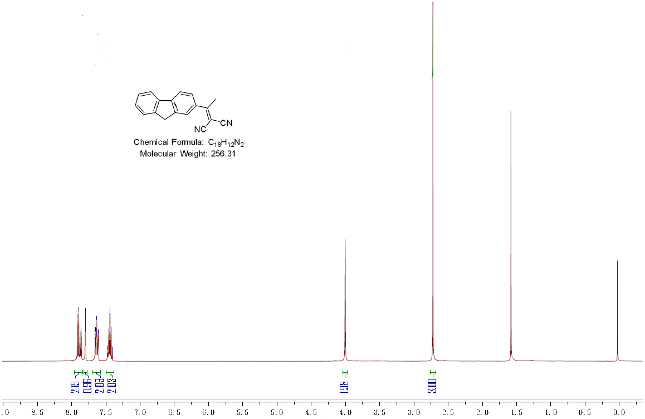

Fig.S1 The ¹H-NMR spectra of compound 2
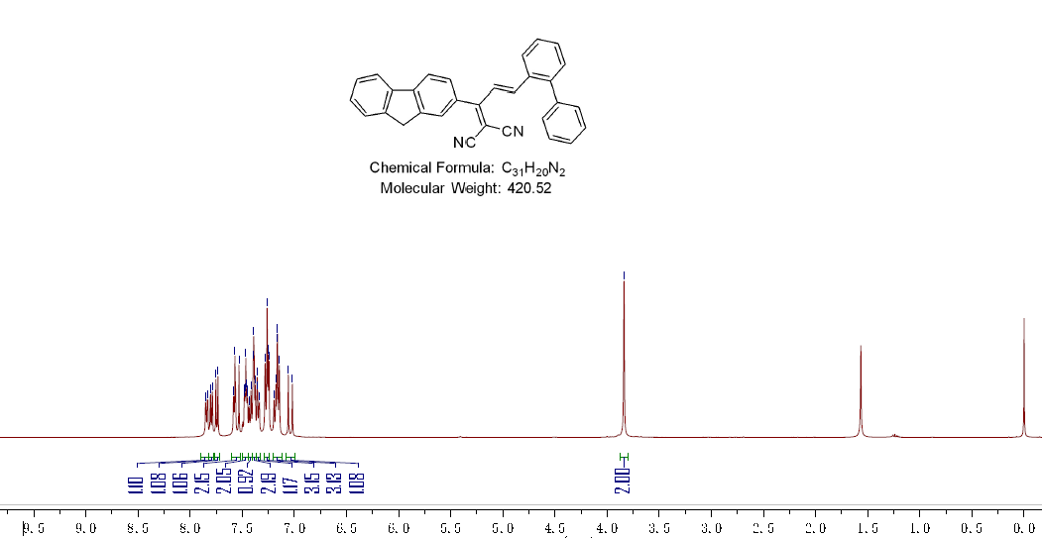
Fig.S2 The ¹H-NMR spectra of 2-BAM
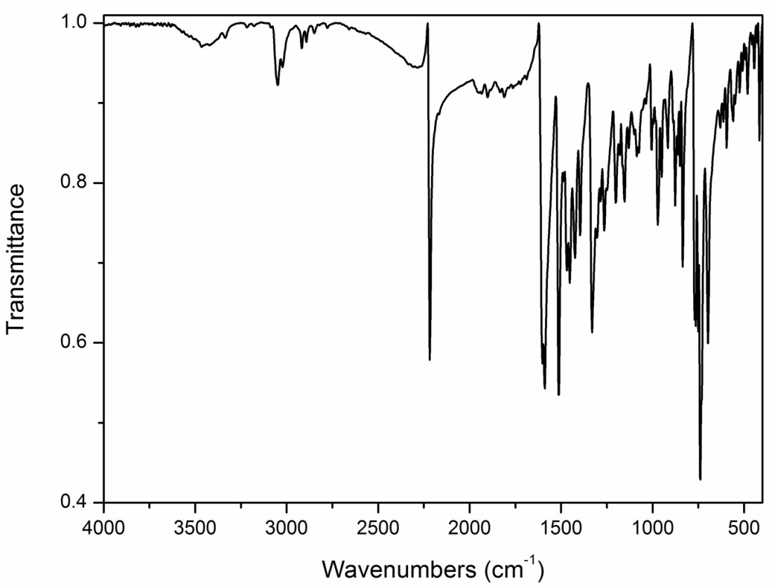
Fig. S3 The IR spectra of 2-BAM
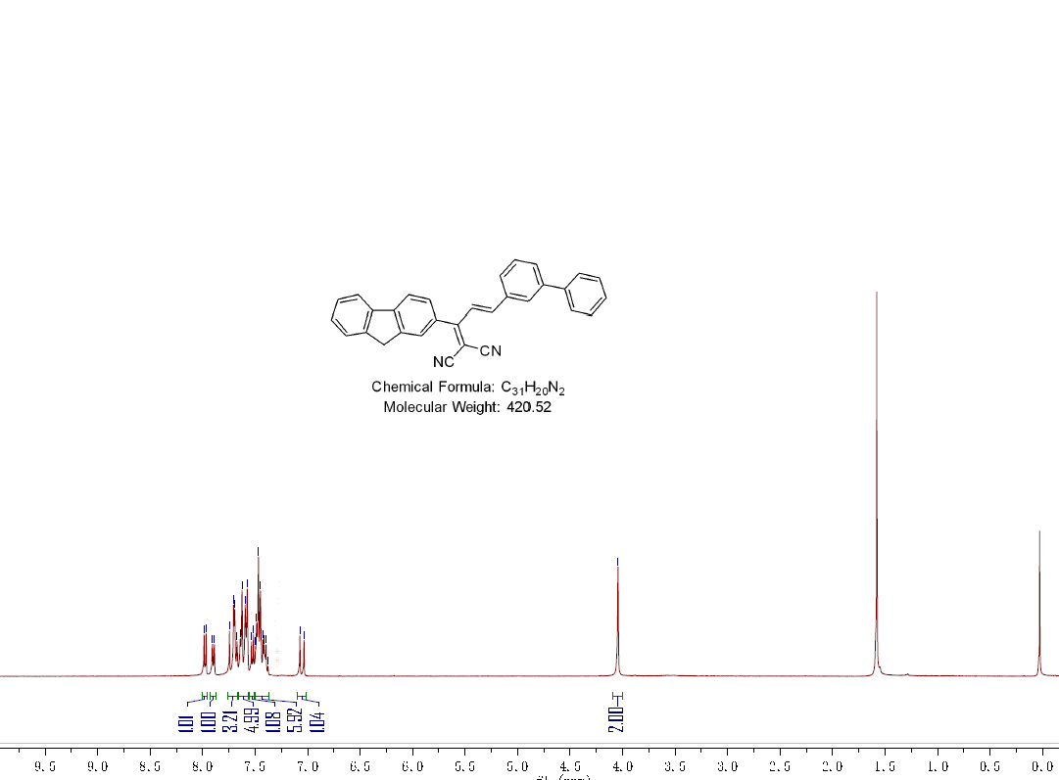
Fig.S4 The ¹H-NMR spectra of 3-BAM
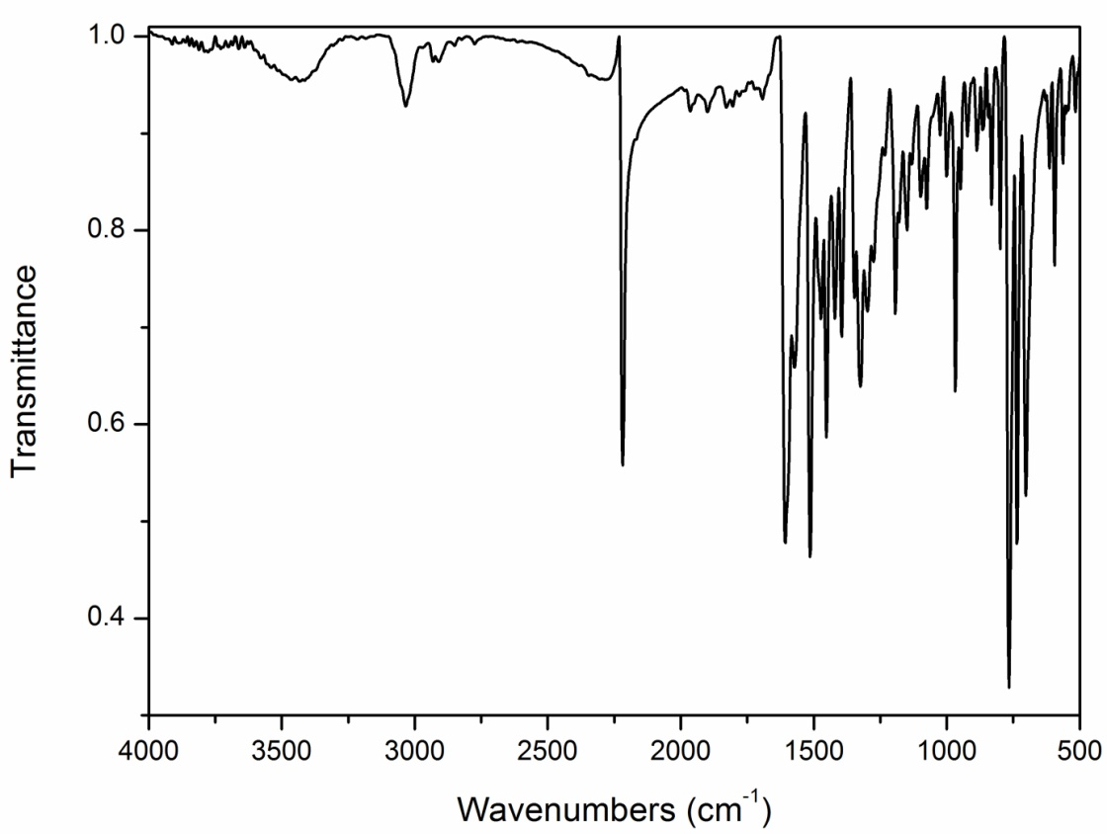
Fig. S5 The IR spectra of 3-BAM

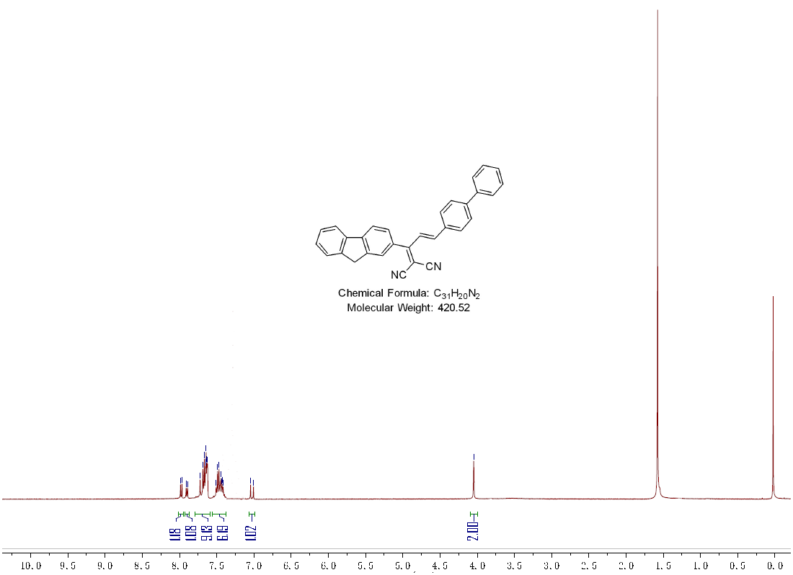
Fig.S6 The ¹H-NMR spectra of 4-BAM
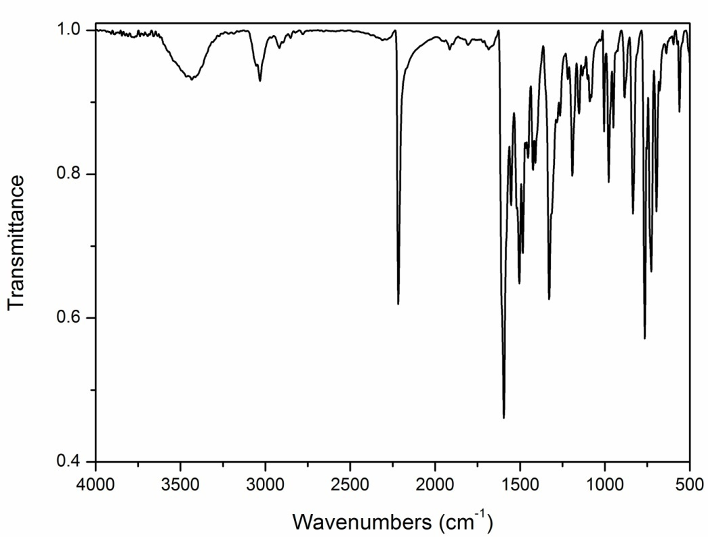
Fig. S7 The IR spectra of 4-BAM

Fig. S8 DSC and TGA profiles of three compounds

