Supplementary Table 1. Candidate Model AIC Values
Model | Total Birds | Total Roosts | N Comm. | Mean Roost Size | Mean Comm. Size | Roosts per Comm. | Mean Gini | Mean Degree | Clustering Coeff.
GAM: te(year, n_birds) | — | 139.03 | 91.59 | 336.87 | 423.68 | 32.10 | -90.45 | -29.23 | -69.94
GAM: s(year) + s(n_birds) | — | 140.20 | — | — | — | — | — | — | —
GAM: s(year) | 551.04 | 142.98 | 96.07 | 363.94 | 430.95 | 48.87 | -93.33 | -30.16 | -41.54
GAM: s(n_birds) | — | 149.97 | 101.34 | 348.55 | 436.15 | 40.88 | -92.84 | -14.69 | -42.30
LM: year × n_birds | — | 140.34 | 91.59 | 339.02 | 423.92 | 48.94 | -90.45 | -20.94 | -39.67
LM: year + n_birds | — | 143.75 | — | — | — | — | — | — | —
LM: year | 559.60 | 142.98 | 96.74 | 374.92 | 438.04 | 49.05 | -92.71 | -24.66 | -41.54
LM: n_birds | — | 151.82 | 101.34 | 350.80 | 436.60 | 47.21 | -92.84 | -11.59 | -42.30
Supp. Table 1: A table of AIC values derived from each candidate model per response variable. Rows are model designs, and columns are response variables. Bold values indicate the lowest AIC within each column.

Supplementary Figure 1. Spatial Sampling Range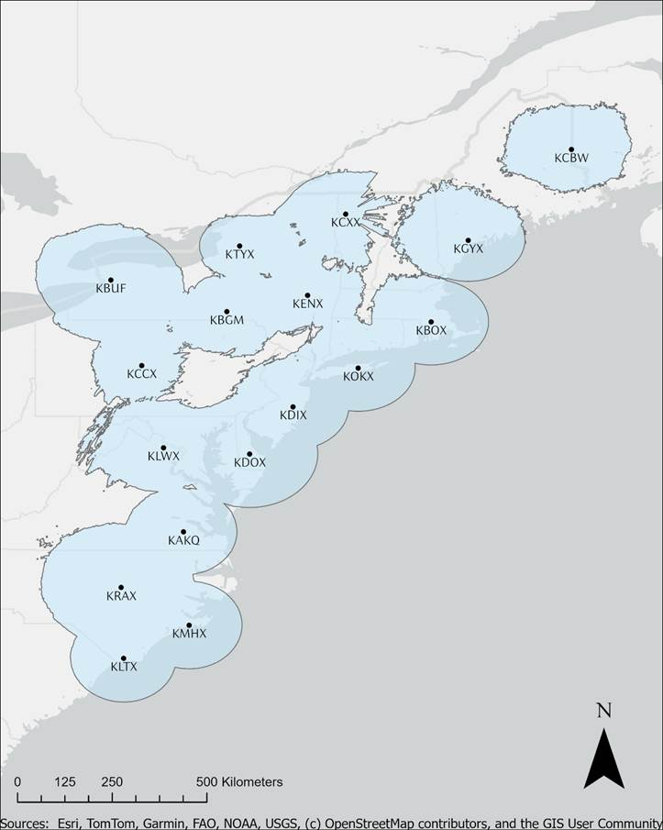
Supp. Figure 1. A map delineating the full coverage of the NEXRAD-derived roost data used to detect roosts. Blue shaded areas represent covered areas, and labels denote NEXRAD station names.

Supplementary Figure 2. Switch-rate Dependent Weight Histograms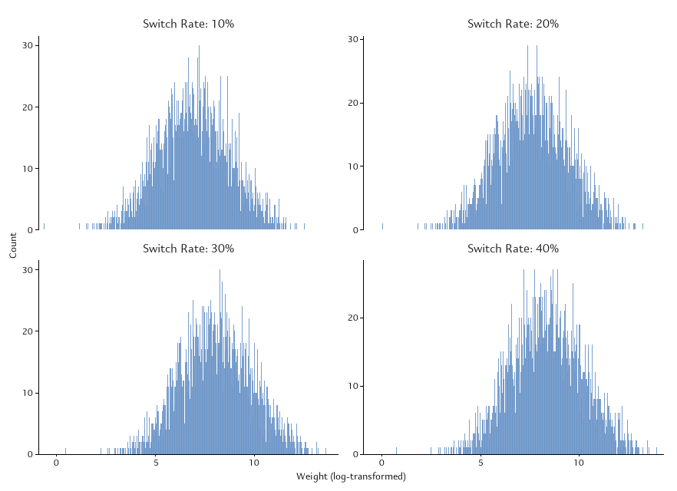
Supp. Figure 2. Variation in weight distributions across networks created with varying roost-switching probabilities (indicated by each facet header). Similar distributions of edge weights provide evidence that our roost-to-roost switch rates for individuals does not have an effect on demonstrating the relative connectivity between roosts, and our edge weight metric ultimately functions as an index of connectivity.

Supplementary Figure 3. Sample Roost-Site Day-of-year/Size Distributions
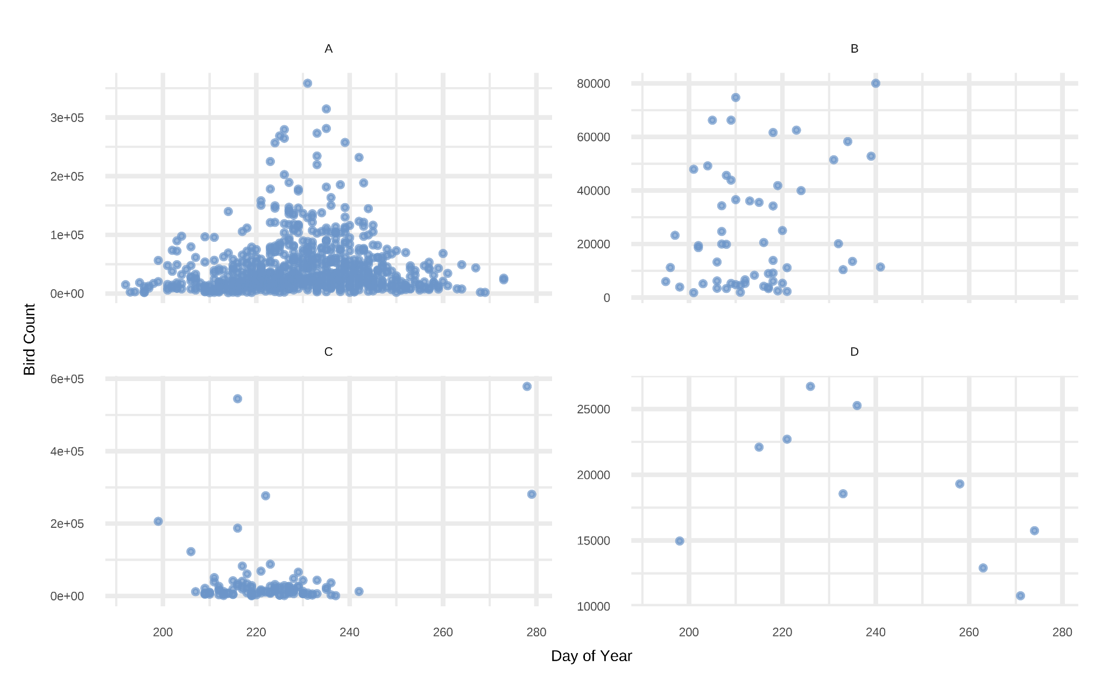
Supp. Figure 3. provides 4 examples of the day-of-year by bird count plots used to filter false-positives and contaminated roost emergence tracks from within HDBSCAN-derived point clusters. Points are single roost emergences across all years of detections. A. provides a standard persistent roost distribution with a clear quadratic distribution across the season. B. is an example of a cluster lacking a seasonal trend, those of which were removed upon manual inspection of the radar imagery. C. Is an example of a small roost which had outliers removed with a 2KDE outlier detection algorithm, removing a percentage of outliers relative to the total number of points in the cluster. D. Is an example of purely noise detections or ephemeral roosts, which were manually screened for and removed from the dataset.

