Additional file 1

Supplementary figures and tables
Manuscript title: MMP8⁺ cells in peripheral blood mononuclear cells as an independent prognostic marker of 60-day mortality in sepsis: a prospective observational cohort study
Corresponding author: Guangju Zhao (zgj_0523@126.com)
Fig. S1. Spearman correlation heatmap of flow-cytometric indicators, severity scores, cytokines and lymphocyte subsets.
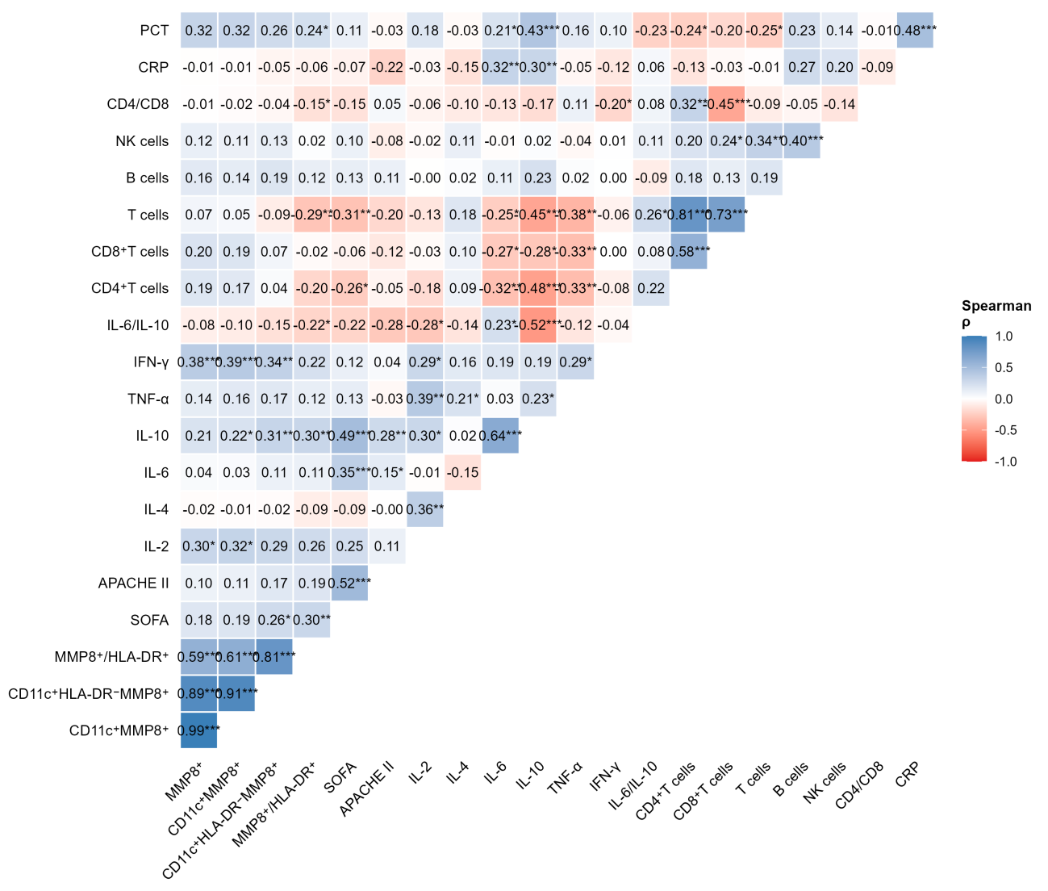
Fig. S2. Restricted cubic spline analysis of MMP8⁺ cells and the 60-day mortality log-hazard (4 knots; P for non-linearity = 0.474).
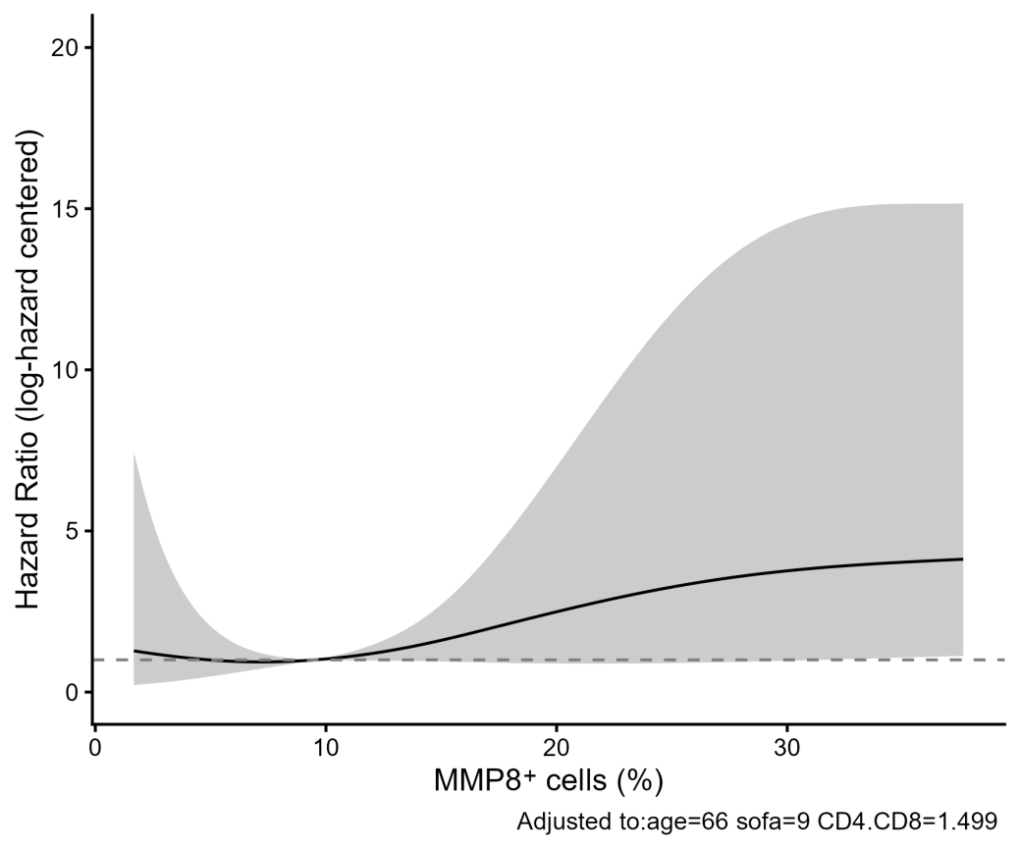
Fig. S3. Risk reclassification scatter plot for the combined vs. baseline model (continuous NRI 0.579, 95% CI 0.069–1.046, P = 0.023; IDI 0.106, 95% CI 0.017–0.199, P = 0.026; categorical NRI −0.030, 95% CI −0.341–0.263, P = 0.847).
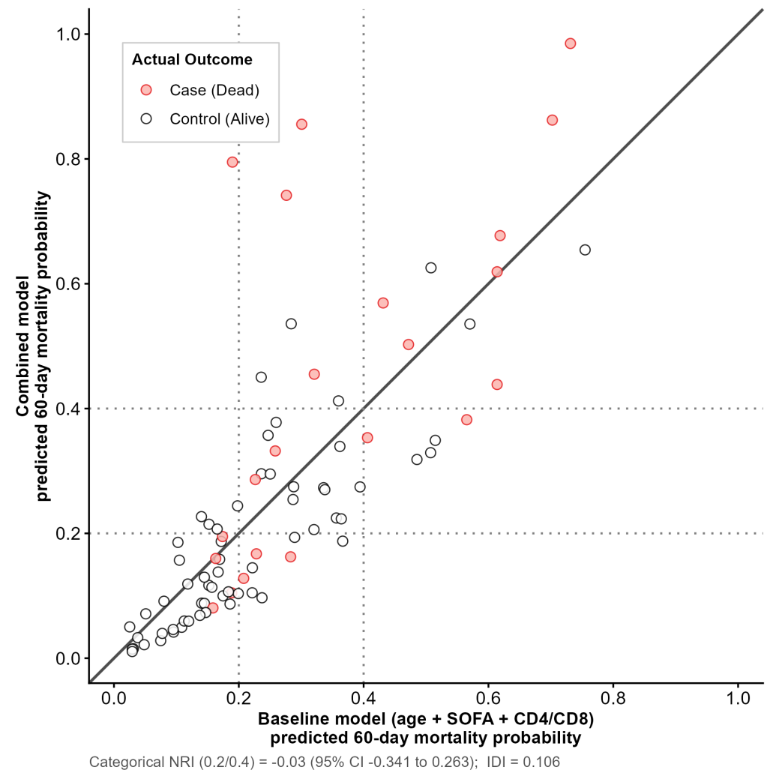
Table S1. Infection site distribution according to 60-day outcome.
Infection site, n (%) | Overall (n = 85) | Survivors (n = 63) | Non-survivors (n = 22)
Digestive tract | 29 (34.1) | 26 (41.3) | 3 (13.6)
Urinary tract | 16 (18.8) | 14 (22.2) | 2 (9.1)
Respiratory tract | 22 (25.9) | 12 (19.0) | 10 (45.5)
Other | 18 (21.2) | 11 (17.5) | 7 (31.8)
Chi-square P = 0.011.
Table S2. Proportional hazards assumption diagnostics (scaled Schoenfeld residuals) per variable across imputations.
Cox model | Variable | P (median) | P (min)
MMP8⁺ cells | MMP8⁺ cells, % | 0.2102 | 0.2069
 | Age, years | 0.0523 | 0.0490
 | SOFA score | 0.1090 | 0.0888
 | CD4/CD8 ratio | 0.7099 | 0.2548
 | GLOBAL | 0.0259 (0.0218–0.0350)
CD11c⁺MMP8⁺ cells | CD11c⁺MMP8⁺ cells, % | 0.2748 | 0.2704
 | Age, years | 0.0517 | 0.0488
 | SOFA score | 0.1152 | 0.0937
 | CD4/CD8 ratio | 0.7076 | 0.2554
 | GLOBAL | 0.0271 (0.0206–0.0401)
CD11c⁺HLA-DR⁻MMP8⁺ cells (Q3) | Q3 cells, % | 0.6539 | 0.6298
 | Age, years | 0.0549 | 0.0495
 | SOFA score | 0.1285 | 0.1017
 | CD4/CD8 ratio | 0.7243 | 0.2517
 | GLOBAL | 0.0799 (0.0626–0.0887)
ln(MMP8⁺/HLA-DR⁺ ratio) | ln(MMP8⁺/HLA-DR⁺ ratio) | 0.3013 | 0.1972
 | Age, years | 0.0626 | 0.0605
 | SOFA score | 0.0632 | 0.0547
 | CD4/CD8 ratio | 0.5520 | 0.1114
 | GLOBAL | 0.0727 (0.0221–0.0925)
GLOBAL rows show the median P across the 20 imputations with the range (min–max) in parentheses; per-variable rows show median and minimum P. P values are from scaled Schoenfeld residual tests (cox.zph) computed within each imputed dataset.
Table S3. Cox regression for 30-day all-cause mortality (hazard ratio per 1% increment, 95% CI, P).
Indicator | Unadjusted | Model 3 (age + SOFA + CD4/CD8)
MMP8⁺ cells | 1.026 (1.000–1.053), P = 0.052 | 1.010 (0.983–1.038), P = 0.47
CD11c⁺MMP8⁺ cells | 1.023 (1.002–1.045), P = 0.035 | 1.008 (0.985–1.031), P = 0.51
CD11c⁺HLA-DR⁻MMP8⁺ cells (Q3) | 1.036 (1.008–1.066), P = 0.012 | 1.017 (0.985–1.049), P = 0.30
ln(MMP8⁺/HLA-DR⁺ ratio) | 1.522 (1.093–2.120), P = 0.013 | 1.344 (0.953–1.896), P = 0.092
Cox models with follow-up censored at day 30 (14 events); pooled across multiply imputed datasets.
Table S4. Logistic regression for persistent organ dysfunction (POD).
Indicator | Unadjusted OR per 1% (95% CI), P | Adjusted OR per 1% ᵃ (95% CI), P
MMP8⁺ cells | 1.034 (1.001–1.068), P = 0.042 | 1.038 (1.000–1.078), P = 0.052
CD11c⁺MMP8⁺ cells | 1.035 (1.005–1.066), P = 0.022 | 1.038 (1.003–1.074), P = 0.033
CD11c⁺HLA-DR⁻MMP8⁺ cells (Q3) | 1.059 (1.018–1.101), P = 0.005 | 1.075 (1.018–1.136), P = 0.010
ln(MMP8⁺/HLA-DR⁺ ratio) | 1.772 (1.213–2.590), P = 0.003 | 1.893 (1.240–2.890), P = 0.003
POD was defined as a day 1-to-7 SOFA decrease of < 2 points (19 events among 85 patients); the last observation was carried forward for 10 patients without a day-7 score, and patients dying before day 7 were classified as POD. ᵃ Adjusted for age, day-1 SOFA score and CD4/CD8 ratio; pooled across multiply imputed datasets.

