Title
Scaffold Geometry Governs Mechanobiological Responses to Combined Biophysical Stimulation in Human Bone Tissue-Like Models

Running Title
Scaffold Geometry Governs Bone Mechanobiology

Authors
Farah Daou^{1°}, Stefano Gabetti^{2,3°}, Shahd Alahmad¹, Beatrice Masante^{2,3}, Elisa Scatena^{4,5}, Carlotta Achille⁴, Cristina Bignardi^{2,3}, Diana Massai^{2,3}, Andrea Cochis¹, Lia Rimondini^{1*}

Affiliations
1. Department of Health Sciences, Center for Translational Research on Autoimmune and Allergic Diseases (CAAD), Università del Piemonte Orientale (UPO), 28100 Novara, NO, Italy
2. Department of Mechanical and Aerospace Engineering and PolitoBIOMed Lab, Politecnico di Torino, 10129 Turin, TO, Italy
3. Centro 3R, Interuniversity Center for the Promotion of the 3Rs Principles in Teaching and Research, 10129 Turin, TO, Italy
4. E. Amaldi Foundation, 00133 Rome, RM, Italy
5. Hypatia Research Consortium, 00133 Rome, RM, Italy

Authors' Official Email Addresses
Author 1: farah.daou@uniupo.it
Author 2: stefano.gabetti@polito.it
Author 3: 20063852@studenti.uniupo.it
Author 4: beatrice.masante@gmail.com
Author 5: elisa.scatena@consorzioipazia.it
Author 6: carlotta.achille@fondazioneamaldi.it
Author 7: cristina.bignardi@polito.it
Author 8: diana.massai@polito.it
Author 9: andrea.cochis@med.uniupo.it
Author 10: lia.rimondini@med.uniupo.it

*Corresponding Author Details
Lia Rimondini
lia.rimondini@med.uniupo.it
+39 0321 660673
° These authors have contributed equally to this work.

Supplementary
Supplementary Table 1. Description of the designed primers.
Gene | Forward Primer | Reverse Primer
Runt-related transcription factor 2 (RUNX2) | 5’- GAA TGC CTC TGC TGT TAT GA -3’ | 5’- GAA GAC GGT TAT GGT CAA GG -3’
Alkaline phosphatase (ALP) | 5’- GAG TAT GAG AGT GAC GAG AAA G -3’ | 5’- GAA GTG GGA GTG CTT GTA TC -3’
Osteopontin (OPN) | 5’- CCC ATC TCA GAA GCA GAA TC -3’ | 5’- TGG CTT TCG TTG GAC TTA C -3’
Osteocalcin (OCN) | 5’- AGG CGC TAC CTG TAT CAA -3’ | 5’- CTC CTG AAA GCC GAT GTG -3’
Collagen Type I Alpha 1 Chain (COL1A1) | 5’- GGA TTC CAG TTC GAG TAT GG -3’ | 5’- CAG TGG TAG GTG ATG TTC TG -3’
Matrix metalloproteinase 3 (MMP3) | 5’- TTT GAT GGA CCT  GGA AAT GT -3’ | 5’- GGT CCC TGT TGT  ATC CTT TG -3’
Matrix metalloproteinase 9 (MMP9) | 5’- TTG ACA GCG ACA  AGA AGT G -3’ | 5’- GGC ACT GAG GAA  TGA TCT AAG -3’
Bone morphogenetic protein 2 (BMP2) | 5’- CGT CAA GCC AAA CAC AAA C -3’ | 5’- AGC CAC AAT CCA GTC ATT C -3’
Bone morphogenetic protein 4 (BMP4) | 5’- GCT GGA ATG ACT GGA TTG T -3’ | 5’- ATG GTT GGT TGA GTT GAG G -3’
Bone morphogenetic protein 6 (BMP6) | 5’- CGA CAC CAC AAA GAG TTC A -3’ | 5’- CCC ATA ACA CAG TCC TTG TAG -3’
Piezo-type mechanosensitive ion channel component 1 (PIEZO1) | 5’- AAG GAG ATG ATG GAC AGA GA -3’ | 5’- CTG ACG TGC AGG TAG TAA TG -3’
Yes-associated protein 1 (YAP1) | 5’- AGA ACC GTT TCC CAG ACT A -3’ | 5’- TCA GCT CCT CTC CTT CTA TG -3’
WW domain-containing transcription regulator protein 1 (WWTR1 / TAZ) | 5’- AAA TCA CCA CAT GGC AAG A -3’ | 5’- GAG ATT TGG CTG GGA TAC TG -3’
Connective Tissue Growth Factor (CTGF) / Cellular Communication Network Factor 2 (CCN2) | 5’- AAG CTG ACC TGG AAG AGA A -3’ | 5’- CAG CCA GAA AGC TCA AAC T -3’
Mitogen-activated protein kinase 1 (MAPK1) | 5’- GTA CAG GAC CTC ATG GAA AC -3’ | 5’- CTC TGA GGA TCT GGT AGA GAA -3’
Janus kinase 1 (JAK1) | 5’- TGG AAC CAA CGA CAA TGA G -3’ | 5’- GTC CCT GAG CAA ACA GAT AC -3’
Prostaglandin-endoperoxide synthase 2 (PTGS2) | 5’- GCC TGG TCT GAT GAT GTA TG -3’ | 5’- CTG CTT GTC TGG AAC AAC T -3’
Interleukin 6 (IL-6) | 5’- CCC AGG AGA AGA TTC CAA AG -3’ | 5’- GTC GAG GAT GTA CCG AAT TT -3’
Nuclear factor kappa B subunit 1 (NFKB1) | 5’- AGT ACA GGT CCA GGG TAT AG -3’ | 5’- TGC TTC ATC CCA GCA TTA G -3’
Snail family transcriptional repressor 1 (SNAI1) | 5’- GAT GAG GAC AGT GGG AAA G -3’ | 5’- XCTC CAA GGA AGA GAC TGA AG -3’
Twist family bHLH transcription factor 2 (TWIST2) | 5’- CAA GAT CCA GAC GCT CAA G -3’ | 5’- CTG CAG CTG GTC ATC TTA TT -3’
Transforming growth factor beta 1 (TGF-β1) | 5’- GTG GAG CTG TAC CAG AAA TAC -3’ | 5’- CAA CTC CGG TGA CAT CAA A -3’
Tyrosine 3-monooxygenase/tryptophan 5-monooxygenase (YWHAZ) | 5’- GGA GGG TCG TCT CAA GTA T -3’ | 5’- ATC TCT TAG CTC CGT CTC AA -3’

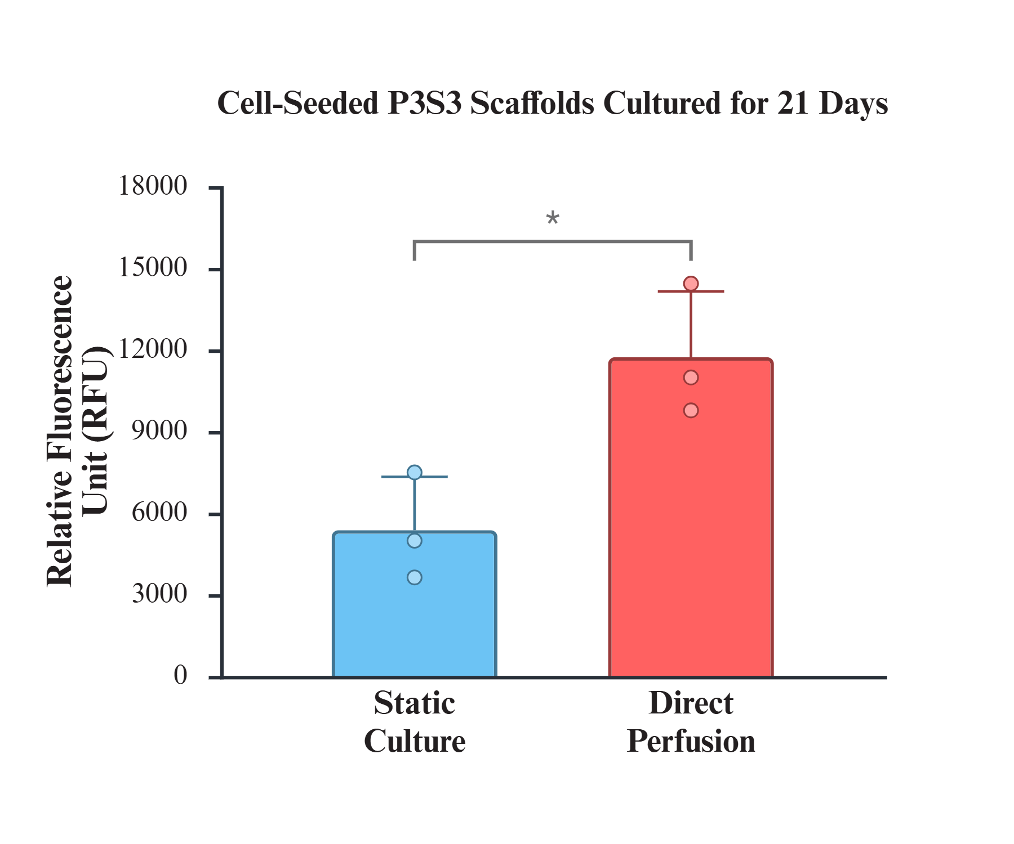
Supplementary Figure 1. Metabolic activity of bone marrow-derived mesenchymal stem cells (BM-MSCs) within P3S3 scaffolds over 21 days, cultured under static conditions or continuous direct perfusion. Metabolic activity was assessed using the resazurin reduction assay to determine cell viability (*p < 0.05).
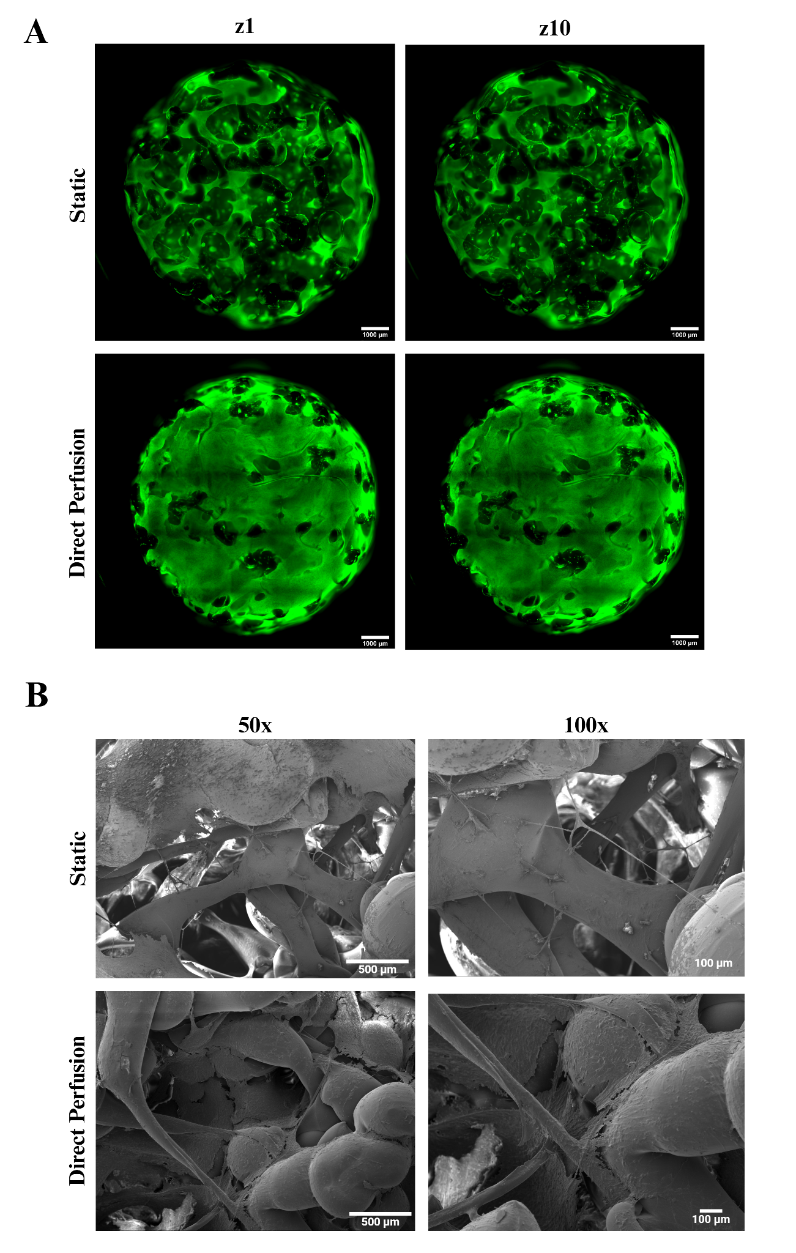
Supplementary Figure 2. Live/dead and scanning electron microscopy (SEM) analyses of bone marrow-derived mesenchymal stem cells (BM-MSCs) within P3S3 scaffolds on day 21, cultured under static culture or continuous, direct perfusion. (A) Live/dead staining showing 3D z-stack reconstructions of cell-seeded scaffolds, where green fluorescence represents live cells (due to calcein AM staining), and red fluorescence represents dead cells (due to ethidium homodimer-1 staining). Scale bar: 1000 µm (B) SEM of cell-cell, cell-scaffold, and cell-extracellular matrix (ECM) interactions. Scale bars: 500 µm (50x) and 100 µm (100x).

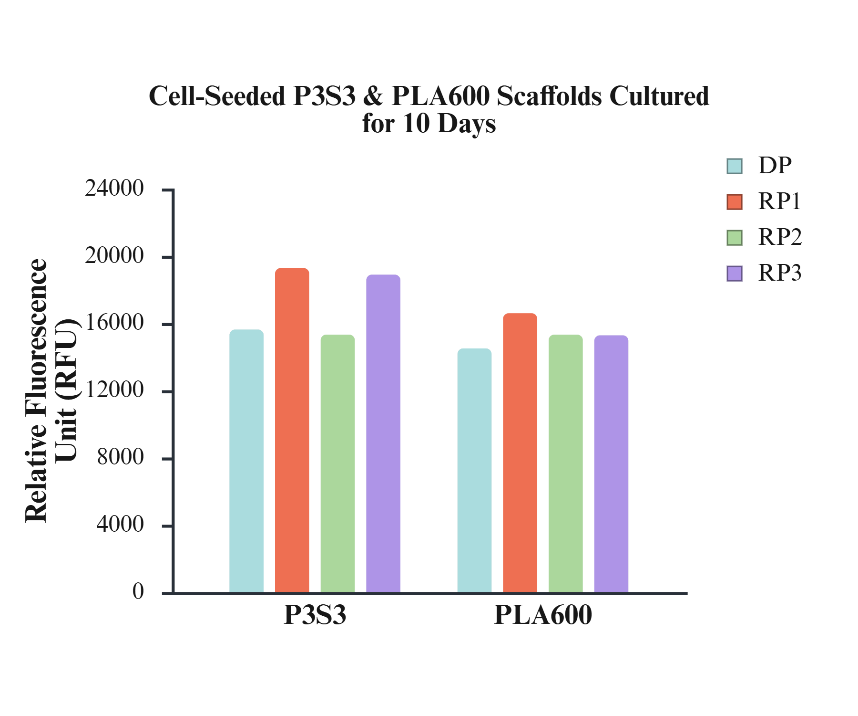
Supplementary Figure 3. Metabolic activity of bone marrow-derived mesenchymal stem cells (BM-MSCs) within P3S3 and PLA600 scaffolds over 10 days. Cells were cultured under direct perfusion (DP) alone, or combined with intermittent hydrostatic pressure (HP, 15 kPa) for 2 h/day (rehabilitation program 1 [RP1]), pulsed electromagnetic field (PEMF) stimulation (75 Hz, 1.5 mT) for 4 h/day (rehabilitation program 2 [RP2]), or RP1 and RP2 sequentially (rehabilitation program 3 [RP3]). Metabolic activity was assessed using the resazurin reduction assay to determine cell viability.

