Supplementary file
Supplemental Methods
IgG immunofluorescence staining
To assess BBB damage, brain parenchymal mouse IgG was measured through immunohistomchemistry. Briefly, free-floating brain sections from control and LRP1-silenced groups were washed three times in 1× PBS for 5 minutes each, then blocked for 60 minutes at room temperature using a blocking solution containing 0.5% BSA and 0.3% Triton X-100 in PBS. Sections were incubated overnight at 4°C with primary antibodies against mouse IgG (rabbit, JacksonImmuno #315-005-003, 1:200). All subsequent steps were performed in the dark. The following day, sections were washed three times in 1× PBS and incubated for 2 hours at room temperature with corresponding secondary antibodies, including Alexa Fluor 488 donkey anti-rabbit IgG for mouse IgG, prepared in 0.5% BSA with 0.3% Triton X-100 in PBS. After incubation, sections were washed in PBS, briefly rinsed with distilled water to remove residual salts, mounted onto positively charged glass slides, and coverslipped with Vectamount aqueous mounting medium after complete air-drying. Three brain sections were imaged per mouse, and for each brain section, two regions each in the cerebral cortex and hippocampus, and one region each in the amygdala and entorhinal cortex, were imaged using a Nikon Ti-E Confocal Microscope. Positive IgG area (% of brain section area) was quantified using NIH ImageJ (version 1.53e; National Institutes of Health, Bethesda, MD, USA) by two blinded independent readers.
6E10, CD31, and ApoB-triple immunofluorescence staining
6E10, a marker for Aβ deposition targeting hAβ residues 1–16, CD31 (also known as platelet endothelial cell adhesion molecule 1 (PECAM-1)), a marker for endothelial cells lining the blood vessels in the brain, and ApoB, were visualized with immunofluorescence staining. Briefly, sections were washed three times in 1× PBS for 5 minutes, then blocked for 60 minutes at room temperature. Sections were then incubated overnight at 4°C with primary antibodies against 6E10 (clone 6E10, 1:1000; BioLegend, CA, USA), CD31 (goat, BioTechne #AF3628, 1:250), and ApoB (rabbit, Abcam #Ab20737, 1:500).
All subsequent steps were performed in the dark. The following day, sections were washed three times in 1× PBS and incubated for 2 hours at room temperature with corresponding secondary antibodies, including Alexa Fluor 647 donkey anti-goat IgG for CD31 and Alexa Fluor 594 donkey anti-rabbit IgG for ApoB, prepared in 0.5% BSA with 0.3% Triton X-100 in PBS. After incubation, sections were washed in PBS, briefly rinsed with distilled water to remove residual salts, mounted onto positively charged glass slides, and coverslipped with Vectamount aqueous mounting medium after complete air-drying. Three brain sections were imaged per mouse, and for each brain section, two regions each in the cerebral cortex and hippocampus, and one region each in the amygdala and entorhinal cortex, were imaged using a Nikon Ti-E Confocal Microscope (Nikon Instruments Inc., NY, USA). Total positive area (% of brain section area) of ApoB was quantified using NIH ImageJ (version 1.53e; National Institutes of Health, Bethesda, MD, USA) by two blinded independent observers.

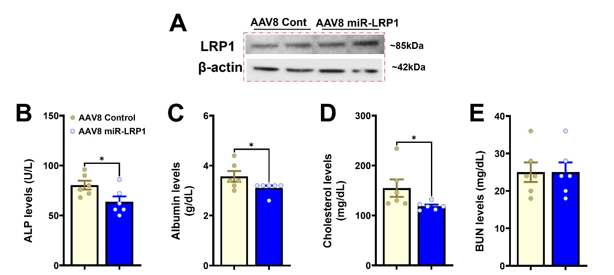
Supplemental Figures
Supplemental Figure 1. Effects of AAV8-mediated LRP1 silencing on renal LRP1 expression and systemic metabolic markers.
(A) Representative western blot of kidney tissue from AAV8 Control and AAV8 miR-LRP1 treated animals, showing no change in LRP1 protein expression. (B-D) Significant decrease in alkaline phosphatase (ALP), albumin, and total cholesterol in the plasma of AAV8 miR-LRP1-treated animals relative to controls. (E) Blood urea nitrogen (BUN) levels, a marker of renal function, showed no significant difference between groups. Data are expressed as mean ± SEM. Statistical comparisons were performed using unpaired t-tests. *p<0.05.

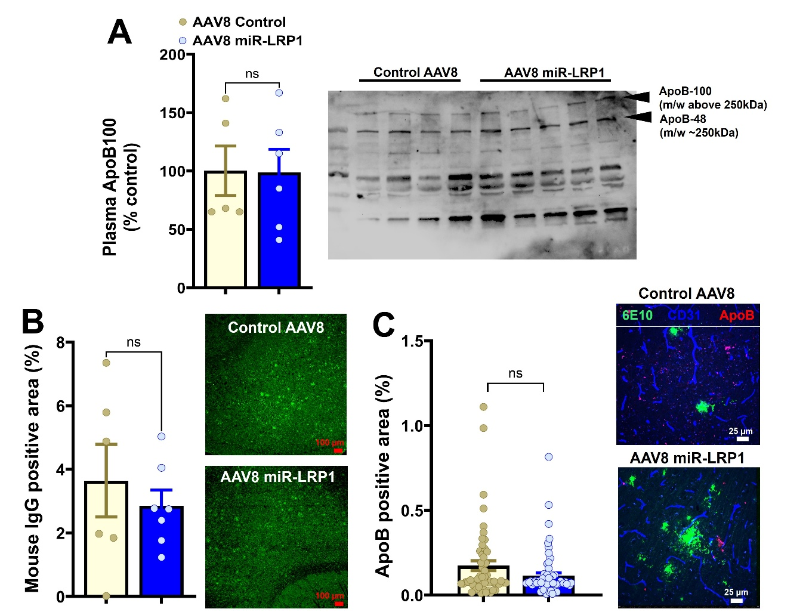
Supplemental Figure 2. AAV8-mediated LRP1 silencing does not alter plasma ApoB100 levels, or brain IgG and brain ApoB immunoreactivity.
(A) Plasma ApoB100 levels measured by Western blotting, (B) brain IgG-positive area (marker of BBB disruption), and (C) brain ApoB-positive area, remain unchanged between AAV8 Control and AAV8 miR-LRP1 animals. Representative images showing mouse IgG (green), and 6E10-positive Aβ (green), CD31-positive blood vessels (blue), and ApoB (red) in B and C, respectively. Notably, ApoB immunoreactivity in the brain represents total ApoB and cannot differentiate between ApoB48 and ApoB100. Data are expressed as mean ± SEM. Statistical comparisons were performed using unpaired t-tests in A-B and using the LME model with treatment as the fixed effect and mouse as the random effect in C. ns = not significant.
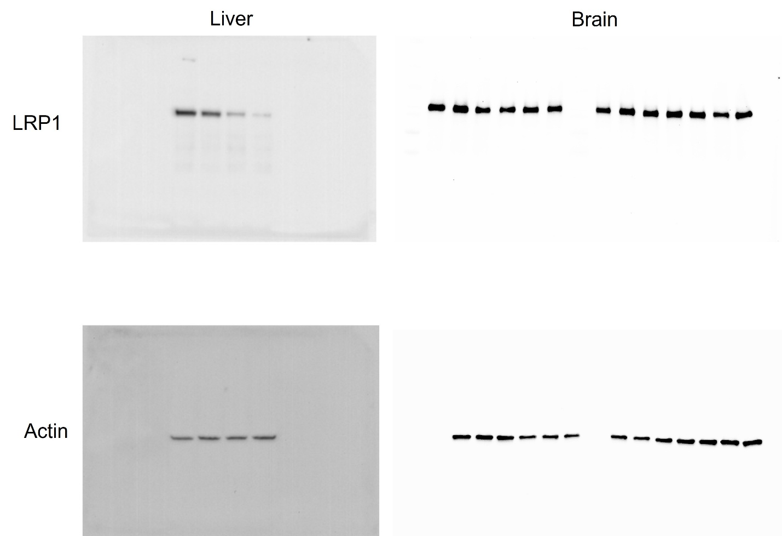
Supplemental Figure 3. Full gel images for Figure 1B.

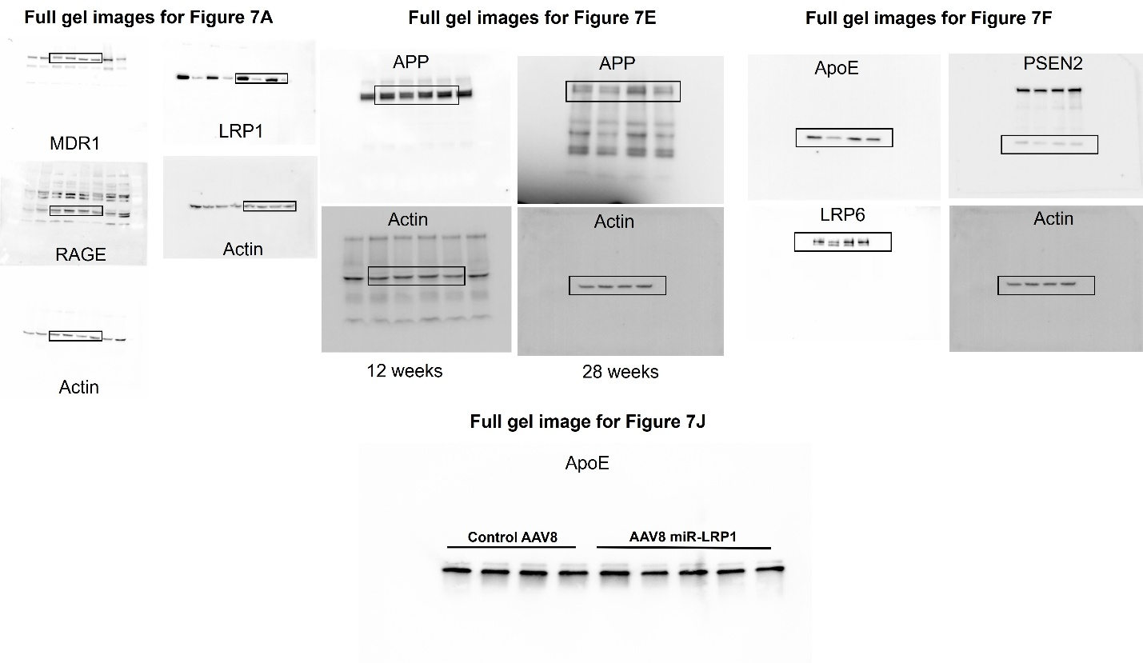
Supplemental Figure 4. Full gel images for Figure 7. Note that the same gel was stripped and probed for 28-week LRP1 (Fig. 1B), APP (Fig. 7E), and ApoE, PSEN2, and LRP6 (Fig. 7F).

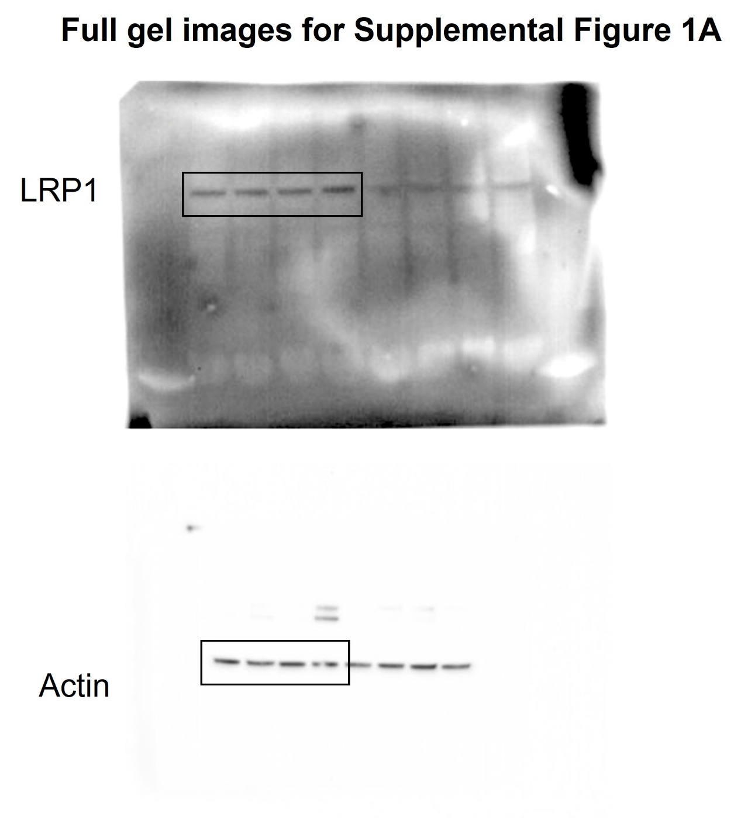
Supplemental Figure 5. Full gel images for Supplemental Figure 1A.

