EXTENDED DATA
Extended Data Figure 1. Time to onset and recovery of lymphopenia and change in lymphocyte count
a, Lymphopenia onset and recovery from start of treatment. b, Median percentage change in lymphocyte count from baseline by dose level over time for all patients treated in the dose escalation cohort.
a
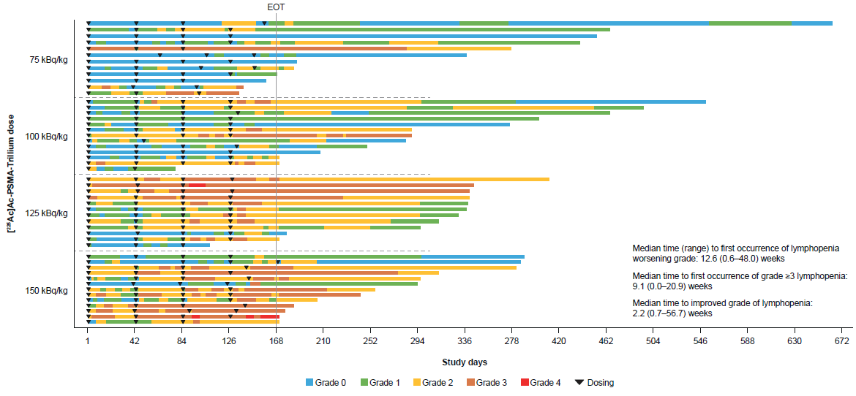

b
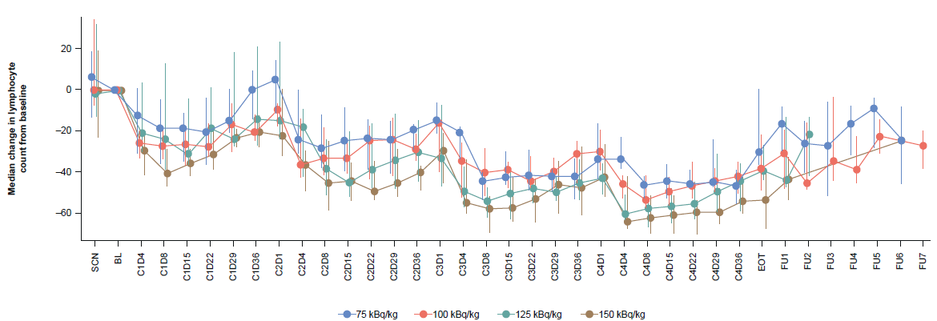

Error bars represent the interquartile range.
²²⁵Ac, 225-actinium; BL, baseline; C, cycle; D, day; EOT, end of treatment; FU, follow-up; PSMA, prostate-specific membrane antigen; SCN, screening.

Extended Data Figure 2. Xerostomia onset, resolution and association with PSA response
a, Spider plot showing patient-reported outcome scores based on the Xerostomia Incidence Questionnaire from start of treatment. b, PSA change by worst grade.
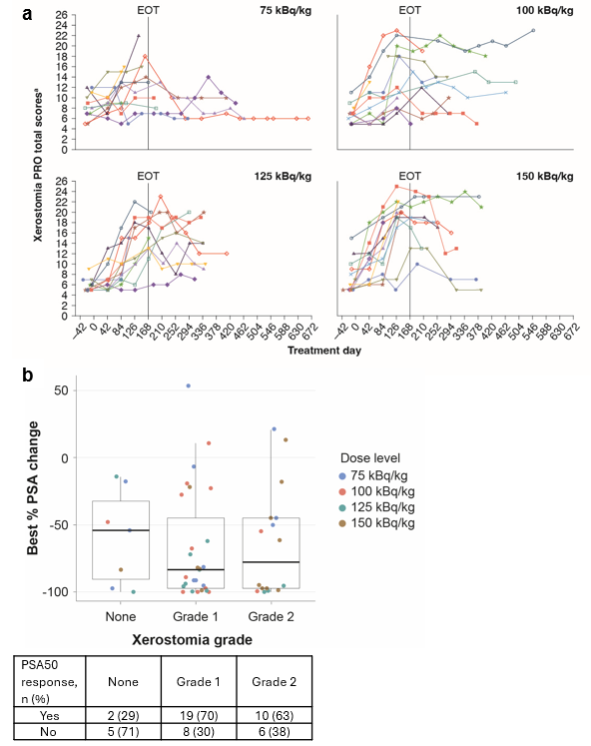
ªSummated Xerostomia Inventory scores shown are based on the five items of the Xerostomia Inventory. Scores can range from 5 to 25 with a higher score indicating more severe symptoms of xerostomia.
EOT, end of treatment; PRO, patient-reported outcomes; PSA, prostate-specific antigen, PSA50, ≥50% decline in prostate-specific antigen from baseline.
Extended Data Figure 3. Salivary and pancreatic amylase analysis and salivary gland absorption
a, Salivary amylase and b, pancreatic amylase concentration over time shown by dose level. c, Comparison of maximum salivary amylase concentration with xerostomia grade. d, Absorbed dose per cycle, across all available cycles (1–4), in the salivary glands.
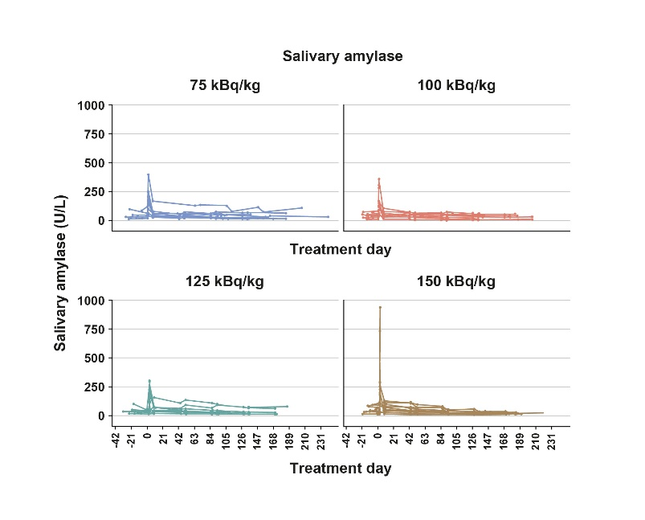
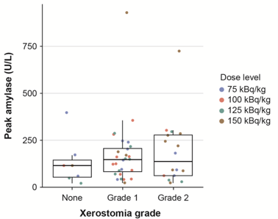
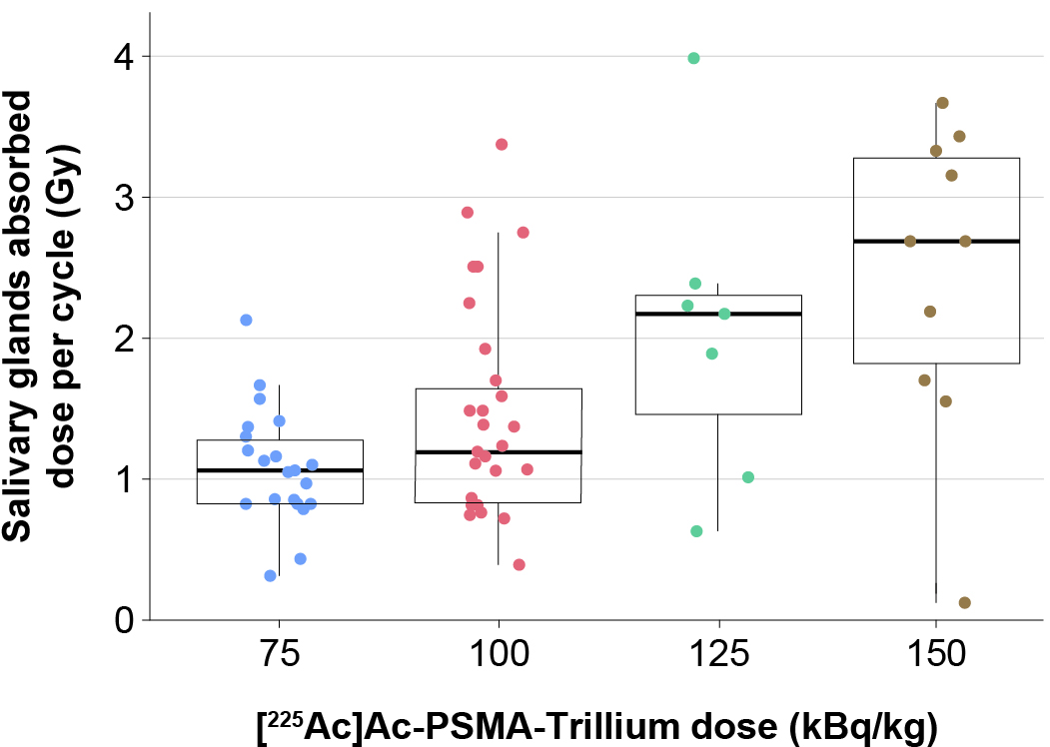
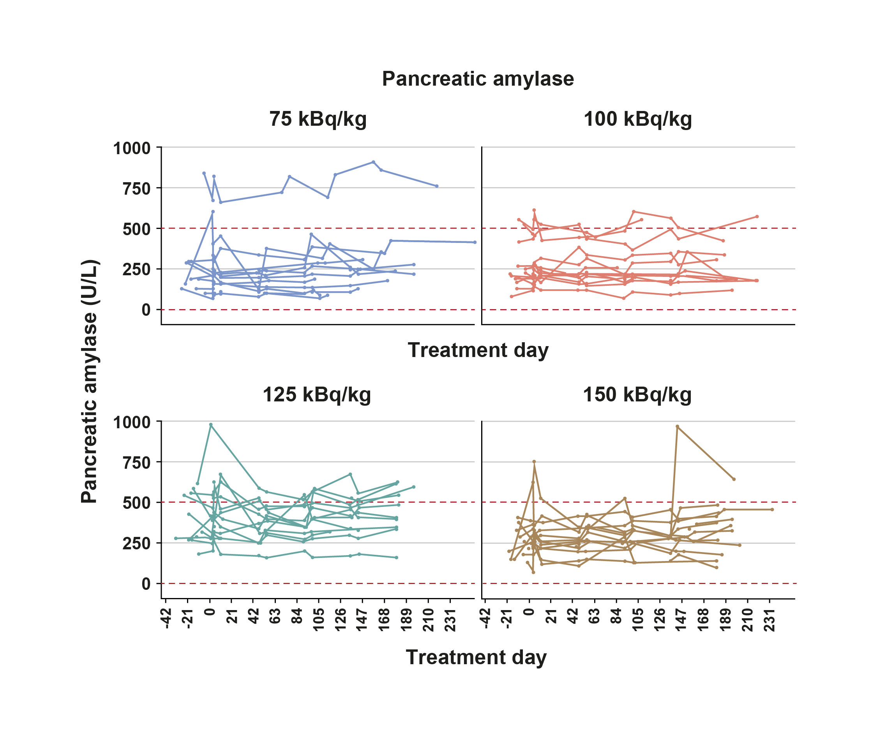
d
a
Peak salivary amylase (U/L)
c
b

²²⁵Ac, 225-actinium; PSMA, prostate-specific membrane antigen.

Extended Data Figure 4. Geometric mean concentration time profiles in whole blood for ²²⁵Actinium and PSMA-Trillium
Geometric mean concentration time profiles for both a, PSMA-Trillium and b, ²²⁵Ac measured following a single dose of 0.001 mg/kg PSMA-Trillium at Cycle 1. For ²²⁵Ac, decay is corrected to timepoint of sampling.
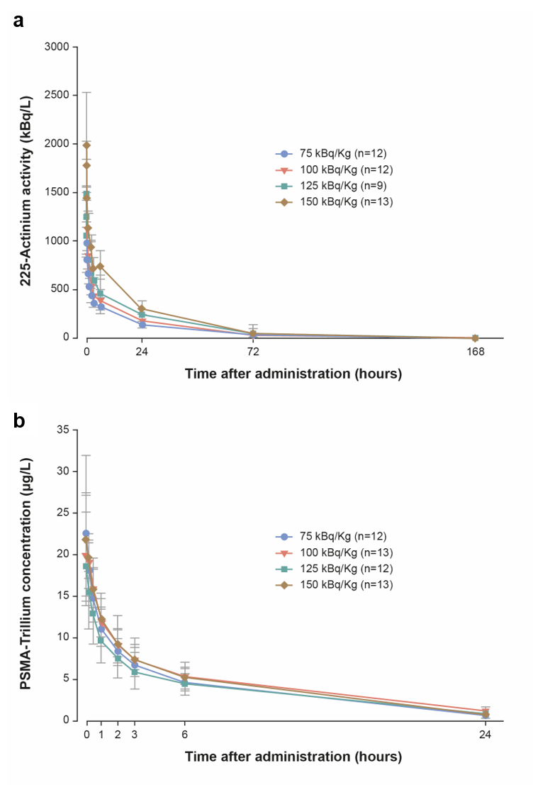
Data cutoff: 13 March 2026.
²²⁵Ac, 225-actinium.
Extended Data Table 1. ²²⁵Ac-PSMA-Trillium-related TEAEs seen in >10% of patients
Event | 75 kBq/kg  (n=12) |  | 100 kBq/kg  (n=13) |  | 125 kBq/kg  (n=12) |  | 150 kBq/kg  (n=13) |  | Total  (N=50)
Event | Any Grade | Grade ≥3 | Any Grade | Grade ≥3 | Any Grade | Grade ≥3 | Any Grade | Grade ≥3 | Any Grade | Grade ≥3
²²⁵Ac-PSMA-Trillium-related TEAEs, n (%) | 12 (100) | 0 | 13 (100) | 2 (15) | 12 (100) | 7 (58) | 12 (92) | 8 (62) | 49 (98) | 17 (34)
Dry mouth | 9 (75) | 0 | 11 (85) | 0 | 10 (83) | 0 | 12 (92) | 0 | 42 (84) | 0
Fatigue | 5 (42) | 0 | 4 (31) | 0 | 8 (67) | 0 | 6 (46) | 0 | 23 (46) | 0
Nausea | 6 (50) | 0 | 5 (39) | 0 | 4 (33) | 0 | 6 (46) | 1(8) | 21 (42) | 1 (2)
Decreased appetite | 1 (8) | 0 | 4 (31) | 0 | 4 (33) | 0 | 8 (62) | 0 | 17 (34) | 0
Anemia | 2 (17) | 0 | 8 (62) | 0 | 2 (17) | 1 (8) | 4 (31) | 0 | 16 (32) | 1 (2)
Lymphopeniaª | 0 | 0 | 4 (31) | 2 (15) | 4 (33) | 4 (33) | 7 (54) | 7 (54) | 15 (30) | 13 (26)
Neutropenia^{b} | 1 (8) | 0 | 3 (23) | 0 | 5 (42) | 1 (8) | 2 (15) | 1 (8) | 11 (22) | 2 (4)
Dysgeusia | 0 | 0 | 3 (23) | 0 | 2 (17) | 0 | 4 (31) | 0 | 9 (18) | 0
Amylase increased | 0 | 0 | 2 (15) | 0 | 3 (25) | 1 (8) | 3 (23) | 0 | 8 (16) | 1 (2)
Thrombocytopenia^{c} | 0 | 0 | 1 (8) | 0 | 3 (25) | 0 | 2 (15) | 0 | 6 (12) | 0
ªIncludes lymphocyte count decreased.
^{b}Includes neutrophil count decreased.
^{c}Includes platelet count decreased.
Data cutoff: 13 March 2026.
²²⁵Ac, 225-actinium; PSMA, prostate-specific membrane antigen; TEAE, treatment-emergent adverse event.

Extended Data Table 2. TEAEs seen in ≥10% of patients
Event | 75 kBq/kg  (n=12) |  |  | 100 kBq/kg  (n=13) |  |  | 125 kBq/kg  (n=12) |  |  | 150 kBq/kg  (n=13) |  |  | Total  (N=50)
Event | Any Grade | Grade 3 | Grade 4 | Any Grade | Grade 3 | Grade 4 | Any Grade | Grade 3 | Grade 4 | Any Grade | Grade 3 | Grade 4 | Any Grade | Grade 3 | Grade 4
TEAEs, n (%) | 12 (100) | 5 (42) | 0 | 13 (100) | 2 (15) | 0 | 12 (100) | 6 (50) | 1 (8) | 13 (100) | 9 (69) | 1 (8) | 50 (100) | 22 (44) | 2 (4)
Dry mouth | 9 (75) | 0 | 0 | 12 (92) | 0 | 0 | 10 (83) | 0 | 0 | 12 (92) | 0 | 0 | 43 (86) | 0 | 0
Fatigue | 6 (50) | 0 | 0 | 4 (31) | 0 | 0 | 9 (75) | 0 | 0 | 8 (62) | 0 | 0 | 27 (54) | 0 | 0
Nausea | 6 (50) | 0 | 0 | 7 (54) | 0 | 0 | 5 (42) | 0 | 0 | 6 (46) | 1 (8) | 0 | 24 (48) | 1 (2) | 0
Decreased appetite | 2 (17) | 0 | 0 | 5 (39) | 0 | 0 | 4 (33) | 0 | 0 | 9 (69) | 0 | 0 | 20 (40) | 0 | 0
Anemia | 3 (25) | 0 | 0 | 8 (62) | 0 | 0 | 3 (25) | 2 (17) | 0 | 5 (39) | 1 (8) | 0 | 19 (38) | 3 (6) | 0
Lymphopenia^{b} | 0 | 0 | 0 | 4 (31) | 2 (15) | 0 | 4 (33) | 3 (25) | 1 (8) | 7 (54) | 6 (46) | 1 (8) | 15 (30) | 11 (22) | 2 (4)
Neutropenia^{b} | 1 (8) | 0 | 0 | 3 (23) | 0 | 0 | 5 (42) | 1 (8) | 0 | 2 (15) | 1 (8) | 0 | 11 (22) | 2 (4) | 0
Constipation | 2 (17) | 0 | 0 | 4 (31) | 0 | 0 | 1 (8) | 0 | 0 | 3 (23) | 0 | 0 | 10 (20) | 0 | 0
Diarrhea | 2 (17) | 0 | 0 | 2 (15) | 0 | 0 | 1 (8) | 0 | 0 | 5 (39) | 0 | 0 | 10 (20) | 0 | 0
Dysgeusia | 0 | 0 | 0 | 3 (23) | 0 | 0 | 2 (17) | 0 | 0 | 5 (39) | 0 | 0 | 10 (20) | 0 | 0
Vomiting | 2 (17) | 0 | 0 | 3 (23) | 0 | 0 | 0 | 0 | 0 | 5 (39) | 1 (8) | 0 | 10 (20) | 1 (2) | 0
Amylase increased | 0 | 0 | 0 | 2 (15) | 0 | 0 | 3 (25) | 1 (8) | 0 | 4 (31) | 0 | 0 | 9 (18) | 1 (2) | 0
Arthralgia | 3 (25) | 0 | 0 | 4 (31) | 0 | 0 | 0 | 0 | 0 | 1 (8) | 0 | 0 | 8 (16) | 0 | 0
Pain in extremity | 0 | 0 | 0 | 4 (31) | 0 | 0 | 1 (8) | 0 | 0 | 2 (15) | 0 | 0 | 7 (14) | 0 | 0
Thrombocytopenia^{c} | 0 | 0 | 0 | 2 (15) | 0 | 0 | 3 (25) | 0 | 0 | 2 (15) | 0 | 0 | 7 (14) | 0 | 0
Cough | 0 | 0 | 0 | 2 (15) | 0 | 0 | 0 | 0 | 0 | 4 (31) | 0 | 0 | 6 (12) | 0 | 0
Dizziness | 3 (25) | 0 | 0 | 1 (8) | 0 | 0 | 1 (8) | 0 | 0 | 1 (8) | 0 | 0 | 6 (12) | 0 | 0
Oedema peripheral | 2 (17) | 0 | 0 | 0 | 0 | 0 | 3 (25) | 0 | 0 | 1 (8) | 0 | 0 | 6 (12) | 0 | 0
Hypokalemia | 0 | 0 | 0 | 0 | 0 | 0 | 0 | 0 | 0 | 5 (39) | 2 (15) | 0 | 5 (10) | 2 (4) | 0
Dyspnea | 1 (8) | 0 | 0 | 1 (8) | 0 | 0 | 1 (8) | 0 | 0 | 2 (15) | 1 (8) | 0 | 5 (10) | 1 (2) | 0
Headache | 0 | 0 | 0 | 1 (8) | 0 | 0 | 1 (8) | 0 | 0 | 3 (23) | 0 | 0 | 5 (10) | 0 | 0
Oral candidiasis | 1 (8) | 0 | 0 | 0 | 0 | 0 | 2 (17) | 0 | 0 | 2 (15) | 0 | 0 | 5 (10) | 0 | 0
Weight decreased | 0 | 0 | 0 | 1 (8) | 0 | 0 | 1 (8) | 0 | 0 | 3 (23) | 0 | 0 | 5 (10) | 0 | 0
ªIncludes lymphocyte count decreased.
^{b}Includes neutrophil count decreased.
^{c}Includes platelet count decreased.
Data cutoff: 13 March 2026.
TEAE, treatment-emergent adverse event.

Extended Data Table 3. Serious TEAEs
Event | 75 kBq/kg  (n=12) |  | 100 kBq/kg  (n=13) |  | 125 kBq/kg  (n=12) |  | 150 kBq/kg  (n=13) |  | Total  (N=50)
 | Any grade | Grade ≥3 | Any grade | Grade ≥3 | Any grade | Grade ≥3 | Any grade | Grade ≥3 | Any grade | Grade ≥3
Serious TEAEs, n (%) | 2 (17) | 1 (8) | 1 (8) | 0 | 1 (8) | 1 (8) | 4 (31) | 1 (8) | 8 (16) | 3 (6)
Dry mouth | 0 | 0 | 1 (8) | 0 | 0 | 0 | 2 (15) | 0 | 3 (6) | 0
Blood creatinine increased | 1 (8) | 0 | 0 | 0 | 0 | 0 | 0 | 0 | 1 (2) | 0
Pseudomonal bacteremia | 0 | 0 | 0 | 0 | 1 (8) | 1 (8) | 0 | 0 | 1 (2) | 1 (2)
Fecaloma | 1 (8) | 0 | 0 | 0 | 0 | 0 | 0 | 0 | 1 (2) | 0
Diarrhea | 0 | 0 | 0 | 0 | 0 | 0 | 1 (8) | 0 | 1 (2) | 0
Hydronephrosis | 1 (8) | 1 (8) | 0 | 0 | 0 | 0 | 0 | 0 | 1 (2) | 1 (2)
Hypoxia | 0 | 0 | 0 | 0 | 0 | 0 | 1 (8) | 1 (8) | 1 (2) | 1 (2)
Pyrexia | 0 | 0 | 0 | 0 | 0 | 0 | 1 (8) | 0 | 1 (2) | 0
Vomiting | 0 | 0 | 0 | 0 | 0 | 0 | 1 (8) | 1 (8) | 1 (2) | 1 (2)
Data cutoff: 13 March 2026.
TEAE, treatment-emergent adverse event.

Extended Data Table 4. Xerostomia incidence, resolution and patient-reported outcomes
 | 75 kBq/kg  (n=12) | 100 kBq/kg  (n=13) | 125 kBq/kg  (n=12) | 150 kBq/kg  (n=13) | All patients  (N=50)
Xerostomia at screeningª, n (%) | 0 | 1 (8) | 1 (8) | 2 (15) | 4 (8)
Treatment-emergent xerostomia incidence, n (%) | 9 (75) | 12 (92) | 10 (83) | 12 (92) | 43 (86)
Grade 1 | 6 (50) | 11 (85) | 7 (58) | 4 (31) | 28 (56)
Grade 2 | 3 (25) | 1 (8) | 3 (25) | 8 (62) | 15 (30)
Grade ≥3 | 0 | 0 | 0 | 0 | 0
Best improvement in xerostomia Grade^{b}, n (%) | 4 (33) | 3 (23) | 3 (25) | 3 (23) | 13 (26)
Grade 1→grade 0 | 1 (25) | 2 (67) | 0 | 2 (67) | 5 (38)
Grade 2→grade 1 | 2 (50) | 1 (33) | 3 (100) | 1 (33) | 7 (54)
Grade 2→grade 0 | 1 (25) | 0 | 0 | 0 | 1 (8)
Pt-reported xerostomia scores^{c}
Baseline, n | 11 | 11 | 12 | 13 | 47
Score, median (range) | 8 (5–12) | 7 (5–11) | 5.5 (5–9) | 6 (5–15) | 7 (5–15)
5–9, n (%) | 7 (64) | 10 (91) | 12 (100) | 10 (77) | 39 (83)
10–19, n (%) | 4 (36) | 1 (9) | 0 | 3 (23) | 8 (17)
C2D1, n | 11 | 11 | 12 | 12 | 46
Score, median (range) | 9 (6–15) | 10 (5–16) | 6.5 (5–13) | 10.5 (6–18) | 9 (5–18)
C3D1, n | 12 | 10 | 12 | 13 | 47
Score, median (range) | 10.5 (5–15) | 10 (5–22) | 9 (5–17) | 15 (6–21) | 10 (5–22)
C4D1, n | 7 | 9 | 10 | 12 | 38
Score, median (range) | 11 (7–18) | 12 (7–23) | 13 (5–22) | 20 (5–25) | 16.5 (5–25)
End of treatment, n | 10 | 7 | 12 | 9 | 38
Score, median (range) | 11.5 (7–22) | 15 (5–19) | 15 (6–20) | 19 (10–24) | 15 (5–24)
12-week FU, n | 5 | 5 | 8 | 6 | 24
Score, median (range) | 7 (6–10) | 13 (7–22) | 15 (8–19) | 17.5 (5–23) | 12.5 (5–23)
24-week FU, n | 4 | 5 | 6 | 2 | 17
Score, median (range) | 8.5 (7–14) | 14 (5–19) | 13 (9–19) | 14.5 (5–24) | 12 (5–24)
ªXerostomia was grade 1 in all patients with xerostomia at screening; one patient (treated at 150 kBq/kg) developed grade 2 xerostomia.
^{b}Includes one patient treated at 100 kBq/kg who developed grade 2 xerostomia 56 days after his last dose which was not considered to be treatment-emergent.
^{c}Scores range from 5–25; higher scores indicate more severe symptoms.
C, cycle; D, Day; FU, follow-up.
Extended Data Table 5. Pharmacokinetic analysis of PSMA-Trillium and [²²⁵Ac]Ac following a single dose of ²²⁵Ac-PSMA-Trillium
Parameter | 75 kBq/kg  (n=12) | 100 kBq/kg  (n=13) | 125 kBq/kg  (n=12) | 150 kBq/kg  (n=13)
PSMA-Trillium pharmacokinetics
Total PSMA-Trillium dose, mg/kg | 0.001 | 0.001 | 0.001 | 0.001
C_{max}, mg/L (%CV) | 22.5 (19) | 21.8 (19) | 18.7 (30) | 23.6 (15)
AUC₀₋₂₄, mg·h/L (%CV) | 88 (25) | 105 (27) | 84 (44) | 99 (23)
t_{max}, hours (range) | 0.108  (0.083–0.133) | 0.1  (0.083–0.25) | 0.100  (0.083–0.183) | 0.100  (0.083–0.25)
C_{max}/D, 1/L (%CV) | 0.269 (20) | 0.327 (68) | 0.249 (29.5) | 0.279 (15)
[²²⁵Ac]Ac pharmacokinetics
Total PSMA-Trillium dose, mg/kg | 0.001 | 0.001 | 0.001 | 0.001
Cmax, kBq/L (%CV) | 977 (16) | 1,180 (15) | 1,480 (21.7) | 2,080 (14.6)
AUC, kBq·h/L (%CV) | 10,800 (22) | 13,700 (26) | 17,000 (34) | 22,500 (19)
t_{max}, hours (range) | 0.108  (0.083–1.33) | 0.100  (0.083–0.25) | 0.1  (0.083–0.3) | 0.100  (0.083–0.267)
Terminal t_{1/2}, hours (%CV) | 20.0 (27) | 20.9 (21) | 20.6 (19) | 19.6 (30)
C_{max}/D, 1/L (%CV) | 0.151 (25) | 0.144 (18) | 0.169 (22) | 0.167 (18)
CL, L/h (%CV) | 0.60 (39) | 0.596 (31) | 0.517 (33) | 0.554 (23)
Data are geometric mean values with the exception of t_{max}, for which median values are shown.
²²⁵Ac, 225-actinium; AUC, area under the concentration-vs.-time curve; Cmax, maximum drug concentration; Cmax/D, Cmax divided by dose per kg body weight; CV, coefficient of variation; CL, clearance; t_{1/2}, half-life; tmax, time to reach maximum drug concentration in plasma; PSMA, prostate-specific membrane antigen.

Extended Data Table 6. PSA50 and PSA90 response rates by baseline SUVmean
 | Baseline SUVmean
 | ≤6  (n=10) | >6 – ≤10  (n=21) | >10  (n=15)
Best % change in PSA from baseline, median (IQR) | -35 (40) | -68 (76) | -95 (6)
PSA50 response rate, % | 20 | 57 | 93
PSA90 response rate, % | 10 | 38 | 73
Relative chance of achieving PSA50, odds ratio (95% CI) | 0.02 (0–0.16) | 0.10 (0–0.61) | Reference
p-value | 0.002 | 0.037 | –

CI, confidence interval; IQR, interquartile range; PSA50/90, ≥50/90% decline in prostate specific antigen levels from baseline; SUVmean, mean standardized uptake values.
SUPPLEMENTARY INFORMATION
Supplementary Figure 1. The structure of ²²⁵Ac-PSMA-Trillium
MacropaTM chelator
Stable and efficient labeling with ²²⁵Ac
Targeting agent
PSMA-targeting small molecule
Albumin-binding moiety
Increased plasma residence time due to albumin binding

²²⁵Ac, 225-actinium; PSMA, prostate-specific membrane antigen.
Supplementary Figure 2. PAnTHA study design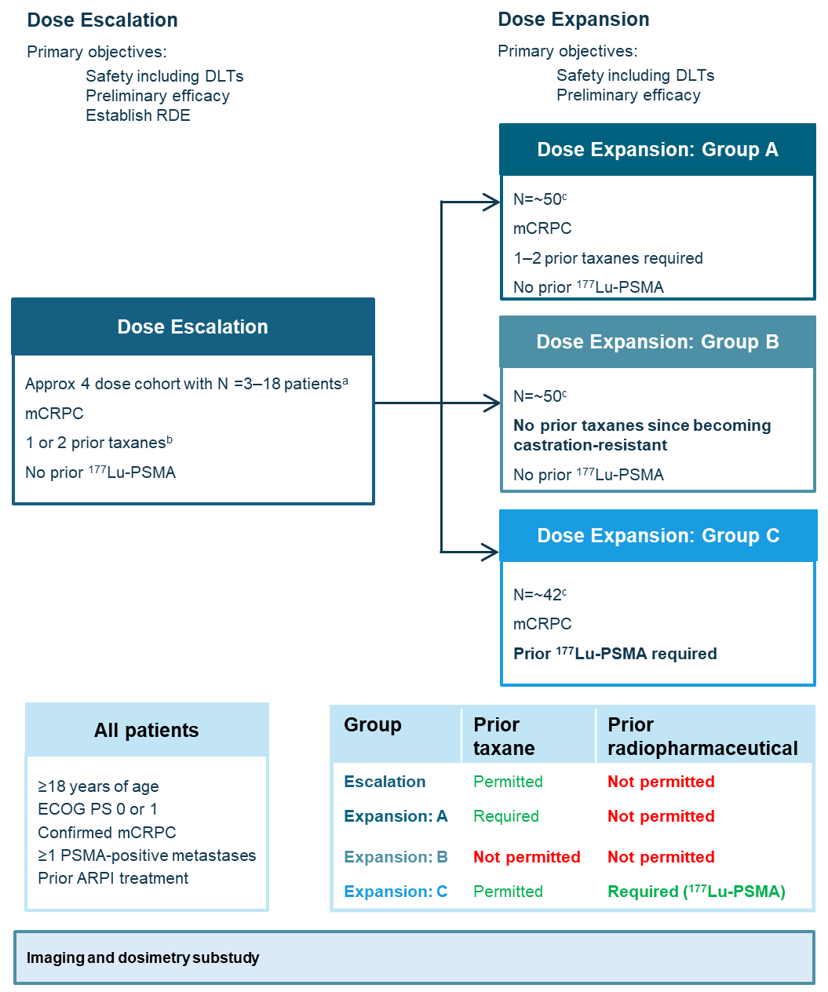
ªIncluding an initial 3–4 patients per cohort with cohorts back-filled based on safety and preliminary antitumor activity data.
^{b}Unless refused or ineligible.
^{c}Futility assessments after 15 patients
ARPI, androgen receptor pathway inhibitor; ¹⁷⁷Lu-PSMA, prostate-specific membrane antigen-targeted lutetium-177 labelled therapy; DLTs, dose-limiting toxicities, ECOG PS, Eastern Cooperative Oncology Group Performance Status; mCRPC, metastatic castration-resistant prostate cancer; PSMA, prostate-specific membrane antigen; RDE, recommended dose for expansion phase.
Supplementary Figure 3. In vivo efficacy of [²²⁵Ac]Ac-PSMA-Trillium vs [¹⁷⁷Lu]Lu-PSMA-617 in the LNCaP prostate cancer xenograft models
a, Time course of LNCap tumor growth in SCID mice treated with two intravenous injections at Day 0 and Day 7 (2QW) of either vehicle, 2 x 150 kBq/kg [²²⁵Ac]Ac-PSMA-Trillium, 2 x 150 MBq/kg [¹⁷⁷Lu]Lu-PSMA-617 or 2 x 300 MBq/kg. b, Relative percent body weight changes after start of therapy in the LNCaP model. N=9 per treatment group; error bars represent standard deviation.
a
b

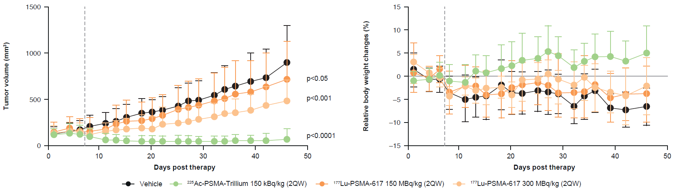

2QW, two doses given once weekly; SCID, severe combined immunodeficiency;

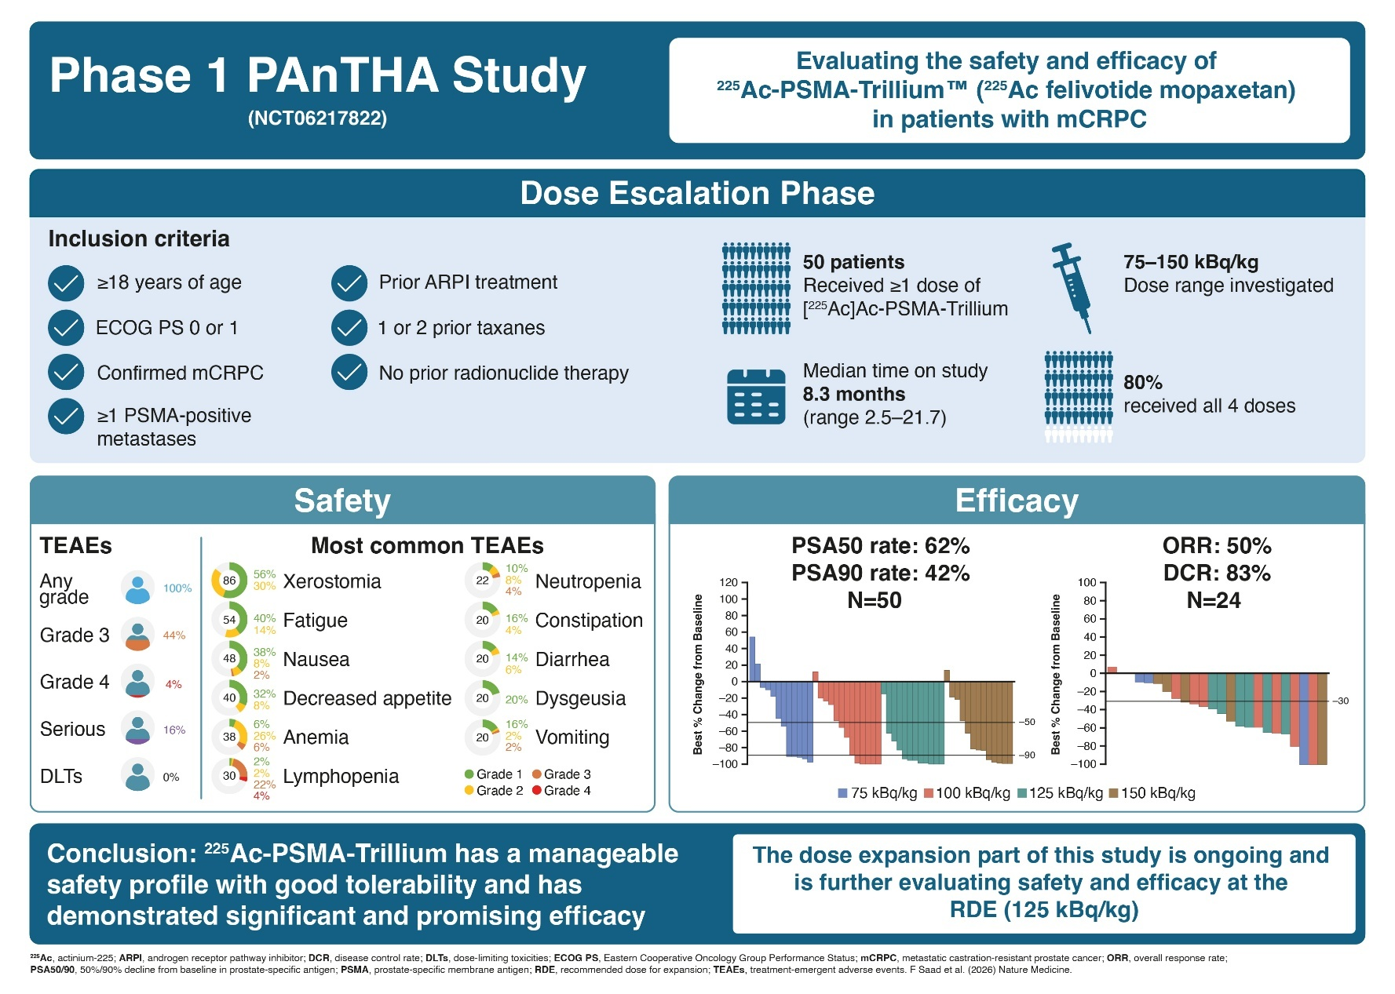
Supplementary Figure 4. Topline overview of the results of the dose escalation of the PAnTHA trial

Supplementary Information – Details of statistical analyses
- Analysis of preclinical experiments
In preclinical experiments, a one-way ANOVA was used to compare differences in tumor volume between vehicle-treated mice and mice that had been treated with either [²²⁵Ac]Ac-PSMA-Trillium or [¹⁷⁷Lu]Lu-PSMA-617. The mean tumor values with standard deviations for each treatment group (n = 9 animals/ group) are presented (Supplementary Table S1). Similarly, body weight changes are presented in % referring to prior treatment start.

Supplementary Table 1. Mean tumor volumes over time
Days post therapy | Vehicle |  |  | [²²⁵Ac]Ac-PSMA-Trillium 150 kBq/kg (2QW) |  |  | [¹⁷⁷Lu]Lu-PSMA-617 150 MBq/kg (2QW) |  |  | [¹⁷⁷Lu]Lu-PSMA-617 300 MBq/kg (2QW)
Days post therapy | N | Mean Tumor volume (mm³) | SD | N | Mean Tumor volume (mm³) | SD | N | Mean Tumor volume (mm³) | SD | N | Mean Tumor volume (mm³) | SD
1 | 9 | 129.91 | 82.39 | 9 | 117.19 | 72.29 | 9 | 147.76 | 104.03 | 9 | 128.51 | 84.38
4 | 9 | 149.15 | 99.27 | 9 | 140.46 | 94.84 | 9 | 186.94 | 126.56 | 9 | 160.52 | 97.17
6 | 9 | 175.64 | 98.56 | 9 | 125.84 | 96.16 | 9 | 160.63 | 127.18 | 9 | 151.55 | 91.86
8 | 9 | 211.46 | 117.78 | 9 | 106.56 | 86.02 | 9 | 152.91 | 148.44 | 9 | 118.67 | 77.12
11 | 9 | 241.68 | 121.59 | 9 | 67.87 | 67.88 | 8 | 185.79 | 177.02 | 9 | 154.00 | 92.01
13 | 9 | 265.60 | 133.87 | 9 | 63.07 | 60.39 | 8 | 234.00 | 206.60 | 9 | 177.07 | 99.85
15 | 9 | 307.91 | 138.75 | 9 | 52.70 | 52.30 | 8 | 265.06 | 230.58 | 9 | 179.62 | 123.51
18 | 9 | 347.92 | 157.21 | 9 | 52.95 | 60.10 | 8 | 271.73 | 209.98 | 9 | 190.37 | 141.00
20 | 9 | 364.00 | 138.44 | 9 | 53.14 | 58.13 | 8 | 298.44 | 215.31 | 9 | 175.37 | 143.78
22 | 9 | 384.91 | 147.50 | 9 | 48.41 | 57.97 | 8 | 321.29 | 231.63 | 9 | 235.13 | 183.06
25 | 9 | 427.00 | 198.40 | 9 | 50.13 | 62.86 | 8 | 392.06 | 263.60 | 9 | 241.39 | 144.47
27 | 9 | 483.13 | 196.64 | 9 | 48.23 | 66.38 | 8 | 415.50 | 284.03 | 9 | 265.35 | 152.62
29 | 9 | 491.42 | 208.94 | 9 | 45.31 | 55.09 | 8 | 436.95 | 283.79 | 9 | 281.20 | 128.09
32 | 9 | 546.11 | 246.18 | 9 | 47.18 | 55.67 | 8 | 487.85 | 302.51 | 9 | 314.08 | 141.13
34 | 9 | 606.31 | 252.59 | 9 | 46.68 | 57.25 | 8 | 511.77 | 339.06 | 9 | 344.34 | 156.13
36 | 9 | 642.52 | 278.52 | 9 | 52.67 | 70.42 | 8 | 554.54 | 362.22 | 9 | 355.62 | 154.05
39 | 9 | 692.93 | 308.32 | 9 | 51.17 | 63.37 | 8 | 578.44 | 339.05 | 9 | 379.94 | 178.61
42 | 9 | 733.65 | 307.48 | 9 | 54.18 | 77.20 | 8 | 636.26 | 364.49 | 9 | 438.13 | 206.84
46 | 9 | 900.78 | 399.03 | 9 | 73.15 | 109.13 | 8 | 712.77 | 419.79 | 9 | 478.97 | 230.42
2QW, 2 doses given once weekly; ²²⁵Ac, 225-actinium; PSMA, prostate-specific membrane antigen; SD, standard deviation.

- Regression model peak sAA and xerostomia grade
Correlative analysis between mean sAA peak and xerostomia grade used ANOVA with log peak sAA values. In total, there were 7, 27 and 16 patients with no, grade 1 or grade 2 xersostomia, respectively, for whom sAA data were available. The respective mean (standard deviation) peak sAA levels were 132.86 (127.06), 175.7 (174.07) and 188.5 (177.54) U/L. Results are shown in Supplementary Table 2.

Supplementary Table 2. Results of correlative analysis between mean sAA peak and xerostomia grade (none vs grade 1 vs grade 2)
Term | DF | Sum of squares | Mean squares | F | p-value
Xerostomia grade | 2 | 0.62 | 0.31 | 0.39 | 0.6791
Residuals | 47 | 37.27 | 0.79 | – | –
DF, degrees of freedom; sAA, serum α-amylase.

- Trend analyses for assessing changes in lymphocyte count
Assessment of changes in lymphocyte count over time was performed for all 50 patients and included 40 visits with a total of 1,488 observations. The percentage change in lymphocyte count from baseline (%CfB) was calculated as:
$\%CfB=100\left(\frac{Biomarker\left(ti\right)-Biomarker(t0)}{Biomarker(t0)}\right)$

where Biomarker(t0) was the lymphocyte count at baseline and Biomarker(ti) was the lymphocyte count at timepoint i.
To study the significance of the observed decline in lymphocytes count during the treatment phase and the recovery in lymphocytes count during the follow up phase, the following models were presented studying their slopes and analyzing the reliability of the observed trends.
%CfB = Biomarker(t0) + Dose + Treatment day + Dose⋅Treatment day

%CfB = Biomarker(t0) + Dose + Follow-Up day + Dose⋅Follow-up day

Treatment day was the amount of days between the measurement day and the first day of treatment. Follow-up day was the number of days between the measurement day and the end of treatment day. Data excluded were: (i) any values with missing corresponding baseline value and (ii) the Screening visit.
Parameter estimates and the results of the ANOVA tests for the lymphocytes count by baseline lymphocytes count, time and dose level for the treatment period and follow up period are shown in Supplementary Tables 3 and 4 respectively.

Supplementary Table 3. Parameter estimates and ANOVA F statistic for treatment period model for lymphocytes count by baseline lymphocytes level, time and dose level
Term | Estimate | Std. Error | t value | F value | p-value
(Intercept) | 8.734 | 2.525 | 3.46 | – | 0.0006
Baseline | -11.183 | 0.974 | -11.49 | – | < 0.0001
ADY | -0.219 | 0.023 | -9.33 | – | < 0.0001
100 kBq/kg | -2.485 | 2.884 | -0.86 | – | 0.3890
125 kBq/kg | 0.068 | 2.945 | 0.02 | – | 0.9817
150 kBq/kg | -15.936 | 2.877 | -5.54 | – | < 0.0001
ADY: 100 kBq/kg | -0.020 | 0.032 | -0.62 | – | 0.5371
ADY: 125 kBq/kg | -0.137 | 0.033 | -4.13 | – | < 0.0001
ADY: 150 kBq/kg | -0.019 | 0.031 | -0.61 | – | 0.5434
F statistic | – | – | – | 102.37 | < 0.0001
ADY, treatment day which is the number of days after first treatment administration.

Supplementary Table 4. Parameter estimates and ANOVA F statistic for follow-up period model for lymphocytes count by baseline lymphocytes level, time and dose level
Term | Estimate | Std. Error | t value | F value | p-value
(Intercept) | -5.466 | 6.574 | -0.83 | – | 0.4069
Baseline | -17.572 | 3.028 | -5.80 | – | < 0.0001
FUPDY | 0.055 | 0.025 | 2.23 | – | 0.0270
100 kBq/kg | -3.857 | 6.340 | -0.61 | – | 0.5438
125 kBq/kg | -13.309 | 6.789 | -1.96 | – | 0.0516
150 kBq/kg | -25.524 | 6.884 | -3.71 | – | 0.0003
FUPDY: 100 kBq/kg | -0.018 | 0.036 | -0.51 | – | 0.6115
FUPDY: 125 kBq/kg | 0.010 | 0.049 | 0.20 | – | 0.8423
FUPDY: 150 kBq/kg | 0.162 | 0.059 | 2.74 | – | 0.0068
F statistic | – | – | – | 9.62 | < 0.0001
FUPDY, the follow-up day which is the number of days after end of treatment.
Given both statistically significant models (both p<0.05), with a negatively significant slope in the on-treatment model and a positively significant slope in the follow-up model, it can be said that there is a consistent decline in the lymphocytes count observed among all dose levels during the treatment phase of the study, with a positive recovery trend also among all doses.
A logistic model was used to assess whether there was an increased chance of developing lymphopenia based on lymphocytes count at baseline. Results are shown in Supplementary Table 5.

Supplementary Table 5. Summary of logistic model for lymphopenia onset by baseline lymphocyte levels
Term | Odds ratios | 95% confidence intervals | p-value
(Intercept) | 0.58 | [0.29, 1.14] | 0.117
Log lymphocyte count | 0.09 | [0.01, 0.46] | 0.008

- Comparative analysis between best PSA change and SUVmean
The Kruskall-Wallis test was used to assess differences in best percentage change in PSA from baseline. Results are shown in Supplementary Table 6.

Test statistic H (chi-square) | 10.466
Degrees of freedom | 2
p-value | 0.0053
Effect size (eta² [H]) | 0.197 (large)
Supplementary Table 6. Results of the Kruskall-Wallis test for differences in best percentage change in PSA from baseline based on baseline SUVmean groups (<6 vs ≥6–≤10 vs >10)

- Assessment of trend in salivary gland absorbed dose and administered dose
The absorbed dose for salivary glands was available for 22, 27, 7 and 10 cycles treated with [²²⁵Ac]Ac-PSMA-Trillium at the 75, 100, 125 and 150 kBq/kg doses, respectively. To assess if there was an ordered trend between the administered dose and the salivary gland absorbed dose, the Jonckheere–Terpstra nonparametric trend test was used. The null hypothesis (H0) was that there was no ordered trend across dose cohorts. The alternative hypothesis (H1) was that the absorbed dose increased monotonically with dose cohort (Supplementary Table 7).

Supplementary Table 7. Results of the Jonckheere–Terpstra nonparametric trend test
p-value (permutation) | 0.00007
p-value (normal approx.) | 0.000082
H1 | Increasing trend
Decision (α=0.05) | Reject H0 – significantly increasing trend detected
H0, null hypothesis; H1, alternative hypothesis.

